**Pre Back End**

Data Types, Numbers, Operators, Type Conversion, f-strings

**1.1 Terminal**

Command line is used in server side. Install different packages via cmd prompt in terminal/cli.

ls: list

cd: cgange directory

cd .. : up

cd / :root

cd ~ :user

**1.2 Git/Github and version control**

Start a project > Give a name >

* Cloning: **git** **clone** url_from_github_project
* It download zip and extract on the current folder. You can manually do it.
* Git status: *git status*
* Git add: *git add <file>* or"***git add .***"to add all files.
* Commit: *git commit –m "message goes here"*
* Git push: *git push* to upload in github
* To update in your pc files from github: *git pull*

**1.3 Branch Master**

Branches. Create different versions.

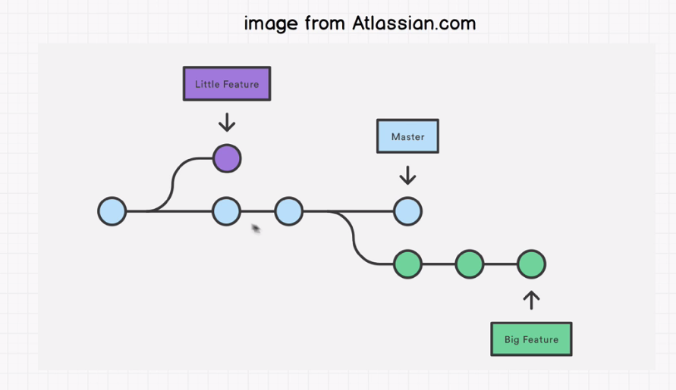

* Make you own branch, work on it, no one will be effected. After you are done with your branch, you can merge it to main branch.
* To show current branch: *git branch*
* To create a branch: *git branch <name_new>*
* To give control in new_branch: *git checkout <branch_name>*
* Git conflict: Happens when merging to main branch is failed.

**1.4 Contribute to Open Source**

* What is Open Source?: Open source software is software with *source code* that *anyone can inspect*, *modify*, and *enhance*.
* Zero-to-Mastery open source. (Its for testing no one will yell at you.)
* How to get into an open source.
* Start here guide lines.
* Find out the project: Google spread-sheet. User name.
* Sign up with google-form.
* Mark the fork.
* Then clone the repo.
* Add your name to the list of contributors.
* To make the contribution: *git push origin <branch_name>*
* Show on Github pages: settings => github_pages => select master_branch => save => get the link.
* "Pull request => merge request" for the open-source-contribution.

**1.5 Work flow for a Developer**

(trello-board: <https://trello.com>)

9:00 = git checkout master . Checkout the changes.

Git pull

10:00 am Meet with your team.

10:30 : fix bugs.

2:00 after lunch (push changes to github)

3:00 QA (call for analysis QA.)

4:00 marge to master.

Next day.