Bootsrap1

**Andrei**

**1.1 Basics**

* Navbar
* Jumbotron
* Button
* Modal
* Including JS and Jquery
* Override by custom CSS style

<!DOCTYPE html>

<html lang="en">

  <head>

    <meta charset="UTF-8" />

    <meta name="viewport" content="width=device-width, initial-scale=1.0" />

    <meta http-equiv="X-UA-Compatible" content="ie=edge" />

    <link rel="stylesheet" href="./BS_dist_min/bootstrap.min.css"/>

    <!-- Include overriden CSS styles -->

    <link rel="stylesheet" href="./BS_1_1_intro.css" />

    <title>Bootstrap 4</title>

  </head>

  <body>

    <!-- |Navbar  -->

    <nav class="navbar navbar-expand-lg navbar-light bg-light">

      <a class="navbar-brand" href="#">Navbar</a>

      <button

        class="navbar-toggler"

        type="button"

        data-toggle="collapse"

        data-target="#navbarSupportedContent"

        aria-controls="navbarSupportedContent"

        aria-expanded="false"

        aria-label="Toggle navigation"

      >

        <span class="navbar-toggler-icon"></span>

      </button>

      <div class="collapse navbar-collapse" id="navbarSupportedContent">

        <ul class="navbar-nav mr-auto">

          <li class="nav-item active">

            <a class="nav-link" href="#"

              >Home <span class="sr-only">(current)</span></a

            >

          </li>

          <li class="nav-item">

            <a class="nav-link" href="#">Link</a>

          </li>

          <li class="nav-item dropdown">

            <a

              class="nav-link dropdown-toggle"

              href="#"

              id="navbarDropdown"

              role="button"

              data-toggle="dropdown"

              aria-haspopup="true"

              aria-expanded="false"

            >

              Dropdown

            </a>

            <div class="dropdown-menu" aria-labelledby="navbarDropdown">

              <a class="dropdown-item" href="#">Action</a>

              <a class="dropdown-item" href="#">Another action</a>

              <div class="dropdown-divider"></div>

              <a class="dropdown-item" href="#">Something else here</a>

            </div>

          </li>

          <li class="nav-item">

            <a class="nav-link disabled" href="#">Disabled</a>

          </li>

        </ul>

        <form class="form-inline my-2 my-lg-0">

          <input

            class="form-control mr-sm-2"

            type="search"

            placeholder="Search"

            aria-label="Search"

          />

          <button class="btn btn-outline-success my-2 my-sm-0" type="submit">

            Search

          </button>

        </form>

      </div>

    </nav>

    <!-- Jumbotron -->

    <div class="jumbotron">

      <h1 class="display-4">Hello, world!</h1>

      <p class="lead">

        This is a simple hero unit, a simple jumbotron-style component for

        calling extra attention to featured content or information.

      </p>

      <hr class="my-4" />

      <p>

        It uses utility classes for typography and spacing to space content out

        within the larger container.

      </p>

      <p class="lead">

        <a class="btn btn-primary btn-lg" href="#" role="button">Learn more</a>

      </p>

    </div>

    <!-- Button trigger modal -->

    <button

      type="button"

      class="btn btn-danger"

      data-toggle="modal"

      data-target="#exampleModal"

    >

      Launch demo modal

    </button>

    <!-- Modal -->

    <div

      class="modal fade"

      id="exampleModal"

      tabindex="-1"

      role="dialog"

      aria-labelledby="exampleModalLabel"

      aria-hidden="true"

    >

      <div class="modal-dialog" role="document">

        <div class="modal-content">

          <div class="modal-header">

            <h5 class="modal-title" id="exampleModalLabel">Modal title</h5>

            <button

              type="button"

              class="close"

              data-dismiss="modal"

              aria-label="Close"

            >

              <span aria-hidden="true">&times;</span>

            </button>

          </div>

          <div class="modal-body">

            ...

          </div>

          <div class="modal-footer">

            <button

              type="button"

              class="btn btn-secondary"

              data-dismiss="modal"

            >

              Close

            </button>

            <button type="button" class="btn btn-primary">Save changes</button>

          </div>

        </div>

      </div>

    </div>

    <!-- JavaScript files incusion in order -->

    <!-- Include "Jquery" JS. Adds interactivity in Bootstrap.

        It is a JS librarry.

        It's a library of JavaScript functions that make it easy for webpage developers to do common tasks-- like

        - manipulating the webpage,

        - responding to user events,

        - getting data from their servers,

        - building effects and animations, and much more. -->

    <script src="./BS_dist_min/jquery-3.5.1.min.js"></script>

    <!-- Include "Popper" JS

        Popper. js is a library to help you position tooltips, popovers, dropdowns and

        any contextual element that should appear near a button or similar (I call them "poppers").

        In short, it's a piece of code that saves you hours of work on any of your projects,

        since almost all of them end up featuring some "popper".-->

    <script src="./BS_dist_min/popper.min.js"></script>

    <!--    Include "Bootstap" JS.

            Bootstrap provides custom events for most plugins' unique actions. -->

    <script src="./BS_dist_min/bootstrap.min.js"></script>

  </body>

</html>

**Overridden styles:**

.btn-danger {

  background-color: orange;

}

.btn-danger:hover {

  background-color: black;

}

**1.2 Bootstrap 4 Grid**

Make responsive easily using Bootstrap Grid-system.

<!DOCTYPE html>

<html lang="en">

  <head>

    <meta charset="UTF-8" />

    <meta name="viewport" content="width=device-width, initial-scale=1.0" />

    <meta http-equiv="X-UA-Compatible" content="ie=edge" />

    <link rel="stylesheet" href="./BS_dist_min/bootstrap.min.css"/>

    <!-- Include overriden CSS styles -->

    <link rel="stylesheet" href="./BS_1_2_Grids.css" />

    <title>BStp Grid</title>

  </head>

  <body>

    <div class="container">

      <div class="row">

        <div class="col col-sm-6 col-xs-12 col-lg-12">

          1 of 2

        </div>

        <div class="col col-sm-3 col-md-6 col-lg-12">

          2 of 2

        </div>

        <div class="col col-sm-3 col-md-6 col-lg-12">

          Extra

        </div>

      </div>

    </div>

        <!-- JavaScript files incusion in order -->

    <!-- Include "Jquery" JS. -->

    <script src="./BS_dist_min/jquery-3.5.1.min.js"></script>

    <!-- Include "Popper" JS -->

    <script src="./BS_dist_min/popper.min.js"></script>

    <!--    Include "Bootstap" JS. -->

    <script src="./BS_dist_min/bootstrap.min.js"></script>

    <!--

    <script src="https://code.jquery.com/jquery-3.2.1.slim.min.js" integrity="sha384-KJ3o2DKtIkvYIK3UENzmM7KCkRr/rE9/Qpg6aAZGJwFDMVNA/GpGFF93hXpG5KkN" crossorigin="anonymous"></script>

    <script src="https://cdnjs.cloudflare.com/ajax/libs/popper.js/1.12.9/umd/popper.min.js" integrity="sha384-ApNbgh9B+Y1QKtv3Rn7W3mgPxhU9K/ScQsAP7hUibX39j7fakFPskvXusvfa0b4Q" crossorigin="anonymous"></script>

    <script src="https://maxcdn.bootstrapcdn.com/bootstrap/4.0.0/js/bootstrap.min.js" integrity="sha384-JZR6Spejh4U02d8jOt6vLEHfe/JQGiRRSQQxSfFWpi1MquVdAyjUar5+76PVCmYl" crossorigin="anonymous"></script>

    -->

  </body>

</html>

**Extra Styles**

.col {

  background-color: rgb(175, 255, 211);

  border: 2px solid rgb(164, 211, 255);

}

**1.3 startup page using Bootstrap**

<!DOCTYPE html>

<html>

  <head>

    <title>Startup</title>

    <!-- Google Fonts -->

    <link href="https://fonts.googleapis.com/css?family=Montserrat" rel="stylesheet">

    <!-- Bootstrap CSS from a CDN. This way you don't have to include the bootstrap file yourself -->

    <!-- <link rel="stylesheet" href="https://maxcdn.bootstrapcdn.com/bootstrap/4.0.0-alpha.6/css/bootstrap.min.css" integrity="sha384-rwoIResjU2yc3z8GV/NPeZWAv56rSmLldC3R/AZzGRnGxQQKnKkoFVhFQhNUwEyJ" crossorigin="anonymous"> -->

    <link rel="stylesheet" href="./BS_dist_min/bootstrap.min.css">

    <!-- My own stylesheet -->

    <link href="./BS_1_3_LndPg_prj_soln.css" rel="stylesheet">

  </head>

  <body>

    <header class="startup text-center text-white d-flex">

      <div class="container my-auto">

        <div class="row">

          <div class="col-lg-12 my-auto">

            <h1 class="text-uppercase faded">

              <strong>the biggest startup event of the year</strong>

            </h1>

            <hr>

          </div>

          <div class="col-lg-12 my-auto">

            <button class="btn btn-primary btn-xl">Find Out More</button>

          </div>

        </div>

      </div>

    </header>

  </body>

</html>

**Extra CSS**

* Notice the Button and Button-hover margins: when extra 5px border is added, the margin decreases 4px (1px border was in default) . It is done because other elements will jump off.

body,

html {

  width: 100%;

  height: 100%;

}

body {

  font-family: 'Montserrat', sans-serif;

}

hr {

  max-width: 65px;

  border-width: 3px;

  border-color: *#F05F44*;

}

.faded {

  color: rgba(255, 255, 255, 0.8);

}

header.startup {

  background-position: center;

  background-image: url("BS_1_3_LndPg_prj.jpg");

  background-size: cover;

  height: 100%;

}

header.startup hr {

  margin-top: 200px;

  margin-bottom: 30px;

}

header.startup h1 {

  font-size: 2rem;

}

.btn {

    margin: 10px;

    font-weight: 700;

    text-transform: uppercase;

    border-radius: 300px;

    font-family: 'Montserrat', sans-serif;

}

.btn-xl {

  padding: 1rem 2rem;

}

.btn-primary {

    background-color: *#F05F44*;

    border-color: *#F05F44*; }

.btn-primary:hover {

    margin: 6px;

    background-color: *#e04d12*;

    border-color: *#e04d12*;

    border-width: 5px;

    cursor: pointer;

}

**1.4 Creative Tim (Pre build Bootstrap Themes)**

Fully Coded UI Tools to create web and mobile apps

UI Kits, Templates and Dashboards built on top of Bootstrap, Vue.js, React, Angular, Node.js and Laravel. Join over 2,002,066 creatives to access all our products!

As we search "UI kits" we've got following result:

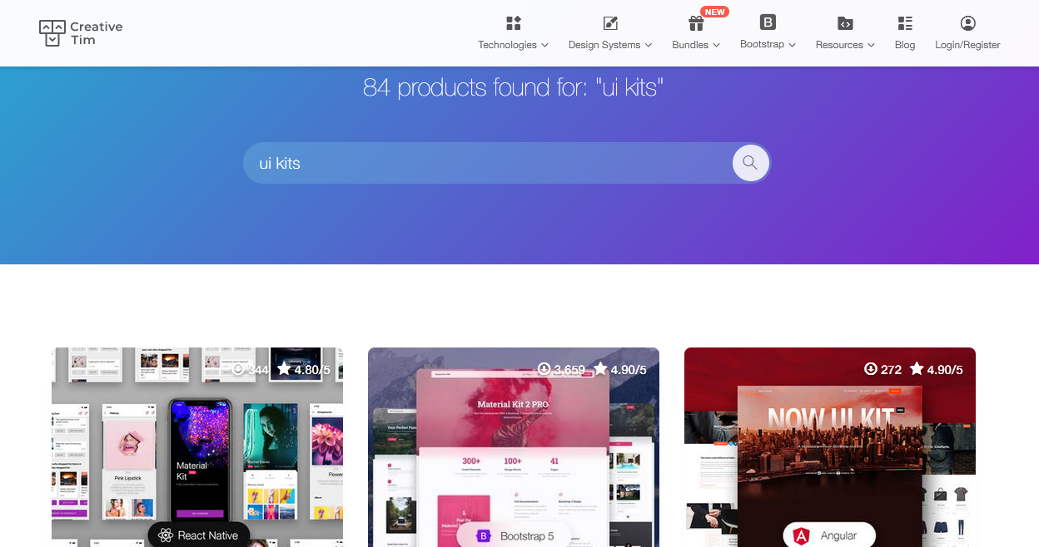

**1.5 Animate CSS**

It's use is similar to Bootstrap. Just use the classes and CSS animation happens.

<https://cdnjs.cloudflare.com/ajax/libs/animate.css/4.1.1/animate.min.css>

