CSS 3

**Andrei**

Data Types, Numbers, Operators, Type Conversion, f-strings

**3.1 sites for color palette**

*paletton.com*

**3.2 Basic styles**

/* selector {

    Property: value;

    } */

body{

    background-image: url(backgroundimage.jpg);

    background-size: cover;

}

h2{

    color: *#AA4139*; text-align: center;

    border: 5 solid rgba(255, 176, 170, 0.5);

    cursor: pointer;

}

p{

    color: pink;

}

P{

    color: green;

}

li{

    list-style: none;

    display: inline-block;

}

**3.3 CSS Cheat Sheet**

Reference:

*https://www.w3schools.com/cssref/css_selectors.asp

*https://css-tricks.com/almanac/

Cascading Style Sheets at the most basic level it indicates that the order of CSS rules matter.

.class

#id

*

element

element, element

element element

element > element

element + element

:hover

:last-child

:first-child

!important (not recommended)

What seletors win out in the cascade depends on:

-Specificity

-Importance

-Source Order

**3.4 Basic selectors**

Tag-names

Attributes

Ids

Classes

Pseudo-class

Parent-child

Nested

* Specificity: Calculate by Specificity calculator
* File Inclusion: The file inclusion in .html matters. The .css file that is included last will affect the most.

**3.5 Text styling**

Text decoration: underline, line-through

Text-transform: Upeercase/lowercase

Line-height

Font-style: italic

Font-weight

Font-size

Font-family

Add font in HTML from google-fonts.

**3.6 Image and floating**

* Adding an image.
* Float and clear.

**3.7 CSS box model**

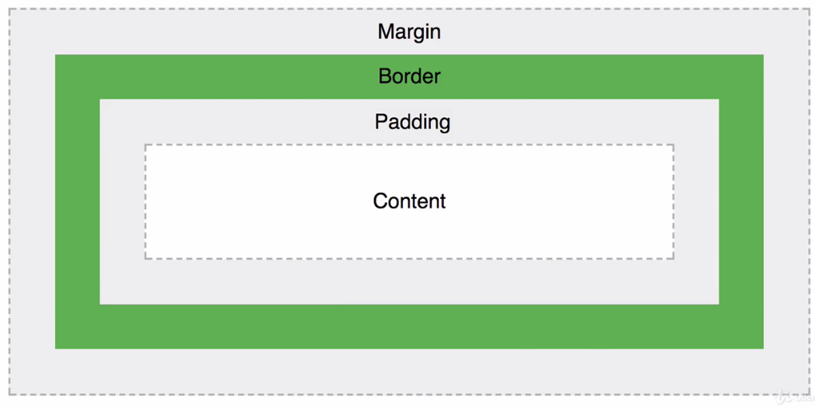

**3.8 Px, em, rem**

Em: times to units of parent element. Relative to parent element.

Rem: Size of the root element (approximately 16px).

**3.9 Critical render paths**

A path that a website takes to display something to user.

* Display the page, after getting CSS and through transformation.
* One way is to minify your .css and .html.

**3.10 Flexbox**

It is used for easy layout job in css.

.container {

    display: flex;

    flex-wrap: wrap;

    justify-content: center;

}