CODEALPHA • CYBERSECURITY INTERNSHIP
Task 1 — Secure Coding Review
Submitted by Sameer Azam Program CodeAlpha Cybersecurity Internship Date July 2026

1. Scope
Application audited: DVWA (Damn Vulnerable Web Application) — PHP codebase, including its GitHub Actions CI/CD workflows.
Method: Static Application Security Testing (SAST) via Semgrep, supplemented by manual code inspection.

2. Tools & Process
Environment | Kali Linux
Target | DVWA — cloned from github.com/digininja/DVWA
Scanner | Semgrep v1.168.0 (pip install --break-system-packages semgrep)
Command | semgrep --config=auto . > scan_results.txt
Coverage | 232 files scanned (PHP, JS, YAML, Dockerfile, JSON, HTML) with 1074 community rules

3. Summary of Findings
85 blocking findings identified across the codebase and CI pipeline.
Vulnerability Category | Count | Severity
Command Injection (exec / tainted-exec) | 17 | Critical
Weak Hash Comparison (md5 loose equality) | 8 | High
SQL Injection (tainted SQL string) | 7 | Critical
Path/File Injection (tainted filename, SSRF) | 6 | High
Mutable CI/CD Action Tags (GitHub Actions) | 5 | Medium
Permissive CORS Policy | 2 | Medium
Unsafe eval() Usage | 2 | Critical
Non-literal RegExp (ReDoS risk) | 2 | Low
Shell Injection in CI Workflow | 1 | High
Unsafe unlink() with User Input | 1 | Medium
phpinfo() Information Disclosure | 1 | Low
OpenSSL Decrypt Without Validation | 1 | Medium

4. Key Vulnerabilities & Fixes
- SQL Injection: User input concatenated directly into SQL queries. Fix: use prepared statements / parameterized queries.
- Command Injection (exec/eval): User-controlled data passed to exec() or eval(). Fix: eliminate exec/eval on user input; use safe APIs or allow-lists.
- Weak Hashing (md5 ==): Loose (==) comparison of MD5 hashes is spoofable. Fix: use hash_equals() with a strong algorithm (bcrypt/Argon2).
- Path/Filename Injection: User input used to build file paths, risking SSRF/LFI. Fix: validate against a strict allow-list and sanitize input.
- CI/CD Supply-Chain Risk: GitHub Actions pinned to mutable tags (e.g. @v6.0.2). Fix: pin to full-length commit SHAs.
- Shell Injection in Workflows: Untrusted GitHub context interpolated directly into run: steps. Fix: pass via env: variables, quoted.

5. Recommendations
- Adopt parameterized queries / ORM across all database access.
- Ban exec(), eval(), and unlink() on unsanitized user input; enforce via linting.
- Replace MD5 comparisons with modern password hashing (bcrypt/Argon2) and hash_equals().
- Pin all GitHub Actions to commit SHAs; restrict CORS to trusted origins.
- Integrate Semgrep/SAST scanning into CI as a blocking check on every pull request.

6. Conclusion
The review identified critical injection and authentication weaknesses typical of an intentionally vulnerable application, plus real-world CI/CD supply-chain risks. Remediation should prioritize SQL/command injection and weak hashing first, followed by CI pipeline hardening.

7. Appendix — Execution Evidence
A. Cloning the target application
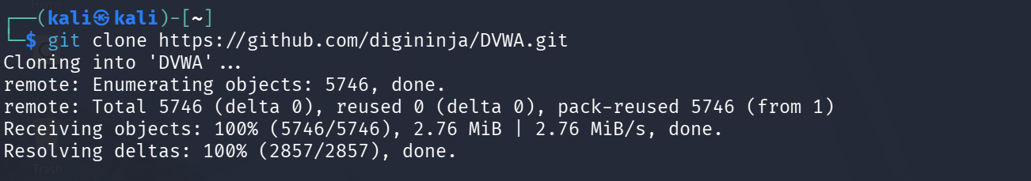
git clone of DVWA into the Kali working directory.
B. Installing the scanner
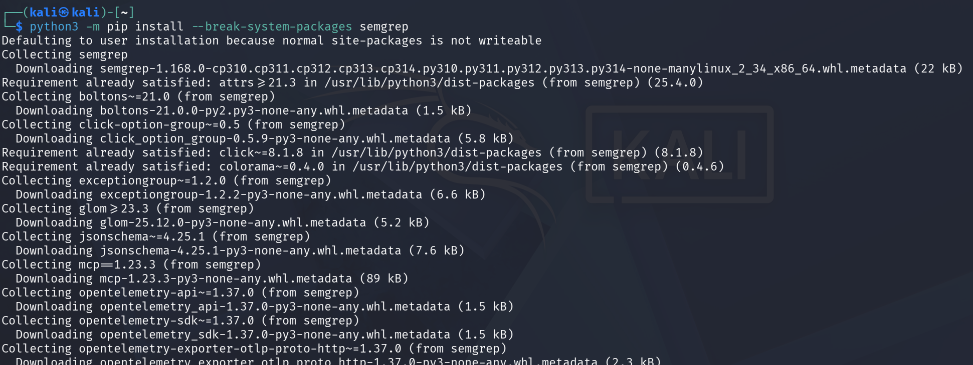
Installing Semgrep v1.168.0 via pip.
C. Running the scan
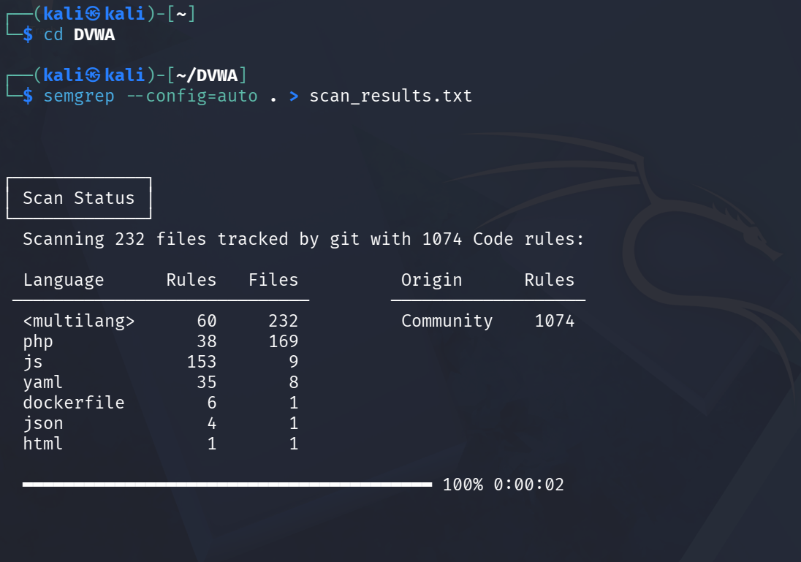
semgrep --config=auto scanning 232 files across the DVWA codebase.
D. Scan output
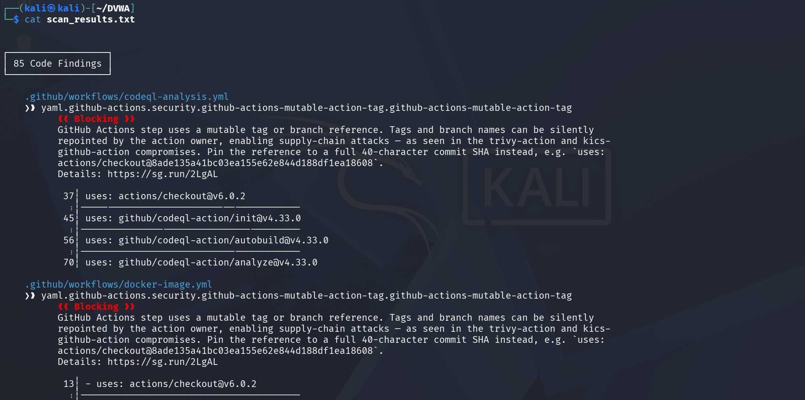
scan_results.txt — 85 blocking findings, including mutable GitHub Action tags.

