Intelligent Diabetes Risk Predictor
Software Requirements Specification

Version 1.0



Group Id: S26PROJECTA7FFD
Supervisor Name :Komal Khawer

Revision History
Date (dd/mm/yyyy) | Version | Description | Author
22/05/2026 | 1.0 | Introduction of the project | BC230206274

Contents
1. Scope of Project: 5
2. Functional and non Functional Requirements: 5
2.1. Functional Requirements 5
2.2. Non-Functional Requirements 7
3. Use Case Diagram(s): 8
3.1. Actors: 8
3.2. Use Cases: 9
4. Usage Scenarios: 10
4.1. Scenario 1: User Registration & Login 10
4.2. Scenario 2: Health Data Input 10
4.3. Scenario 3: Dataset Import 11
4.4. Scenario 4: Diabetes Risk Prediction 11
4.5. Scenario 5: Model Evaluation & Comparison 11
4.6. Scenario 6: View Dashboard & Visualization 12
4.7. Scenario 7: Generate & Export Report 12
4.8. Scenario 8: Personalized Recommendations 13
4.9. Scenario 9: Longitudinal Health Tracking 13
4.10. Scenario 10: Admin & Model Management 13
4.11. Scenario 11: Risk Factor Analysis & Explanation 14
5. Adopted Methodology 16
5.1. VU Process Model 16
5.2. Waterfall Component 16
5.3. Spiral Component 16
5.4. Rationale for Hybrid Approach 17
5.5. Process Model Diagram 17
6. Work Plan (Use MS Project to create Schedule/Work Plan) 17
6.1. Work Plan (Gantt Chart) 17
6.2. Milestone Summary 17

SRS Document

Scope of Project:

The Intelligent Diabetes Risk Predictor is a machine learning-based decision-support system designed to assist patients and healthcare providers in predicting the likelihood of diabetes using clinical and lifestyle data.

Functional and non Functional Requirements:

Functional Requirements

    - User Management & Authentication
- The system shall allow users (patients, healthcare providers, and administrators) to register, log in, and manage their accounts securely.
- The system shall enforce role-based access control.

    - Health Data Input Collection
- The system shall allow users to input health-related data required for diabetes prediction.
- The system shall also support dataset import by administrators for model training.

    - Data Analysis & Visualization
- The system shall perform Exploratory Data Analysis (EDA) on datasets.
- The system shall display summary statistics, trends and patterns, and visual insights using graphs.

    - Data Preprocessing
- The system shall preprocess data by cleaning and transforming data.
- The system shall split data into training (70%) and testing (30%) datasets.

    - Machine Learning Prediction Engine
- The system shall train machine learning models includingNeural Networks, Support Vector Machine (SVM), Decision Tree, and Logistic Regression.
- The system shall use trained models to predict whether a patient has diabetes.

    - Model Evaluation & Performance Analysis
- The system shall evaluate models using Accuracy, Precision, Recall, and F1-score.
- The system shall generate a confusion matrix for performance analysis.

    - Model Comparison & Selection
- The system shall compare multiple models and identify the best-performing model based on accuracy and evaluation metrics.

    - Model Persistence
- The system shall save trained models for future use without retraining.

    - Risk Factor Analysis & Explanation
- The system shall identify key features contributing to predictions and provide interpretable explanations.

    - Personalized Recommendations
- The system shall provide recommendations based on prediction results (e.g., lifestyle changes, medical consultation).

    - Longitudinal Tracking & Progress Monitoring
- The system shall store user health records over time.
- The system shall allow users and healthcare providers to track changes in health status and prediction results.

    - Visualization & Dashboard
- The system shall provide dashboards to display prediction results, risk levels, model performance, and trends over time.

    - Report Generation & Export
- The system shall generate reports containing user data, prediction results and analysis, and model evaluation metrics.
- Reports shall be downloadable in PDF/CSV format.

    - User Education & Resources
- The system shall provide educational content related to diabetesrisk factors, prevention strategies, and healthy lifestyle guidelines.

  - Clinical Decision Support
- The system shall assist healthcare providers by presenting ML-based insights and risk analysis.
- The system shall support clinical decision-making but shall not replace professional judgment.

  - Feedback & Model Improvement
- The system shall collect user and clinician feedback.
- The system shall support continuous model improvement through retraining.

  - Admin & Model Management
- The system shall allow administrators to manage datasets, train/update models, and monitor system performance.

Non-Functional Requirements

    - Performance & Real-Time Requirements
- The system shall generate predictions within an acceptable response time (< 3 seconds).
- The system shall efficiently handle multiple concurrent users without performance degradation.

    - Security & Compliance
- The system shall ensure secure storage and transmission of user data using encryption.
- The system shall maintain data privacy and comply with relevant data protection standards.

    - Usability
- The system shall provide an intuitive, user-friendly interface accessible to non-technical users.
- The system shall be accessible via standard web browsers without requiring additional installations.
    - Reliability
- The system shall maintain high availability and minimize downtime.
- The system shall handle data input errors gracefully with informative feedback.

    - Maintainability
- The system code shall be modular and well-documented to facilitate future updates.
- The system shall support model retraining and updates without full system redeploy.

    - Scalability
- The system shall be designed to scale to accommodate a growing number of users and datasets.

Use Case Diagram(s):
The following use case diagram illustrates the interactions between system actors (Patient, Healthcare Provider, Administrator) and the system's functional modules.

Actors:
    - Patient — inputs health data, views predictions, receives recommendations, tracks history.
    - Healthcare Provider — inputs patient data, views clinical insights, accesses reports.
    - Administrator — manages datasets, trains models, monitors system performance.

Use Cases:
    - UC-01: User Registration & Login
    - UC-02: Health Data Input
    - UC-03: Dataset Import
    - UC-04: Diabetes Risk Prediction
    - UC-05: Model Evaluation & Comparison
    - UC-06: View Dashboard & Visualization
    - UC-07: Generate & Export Report
    - UC-08: Personalized Recommendations
    - UC-09: Longitudinal Health Tracking
    - UC-10: Admin & Model Management
    - UC-11 Risk Factor Analysis
    - UC-12 Feedback and model improvement
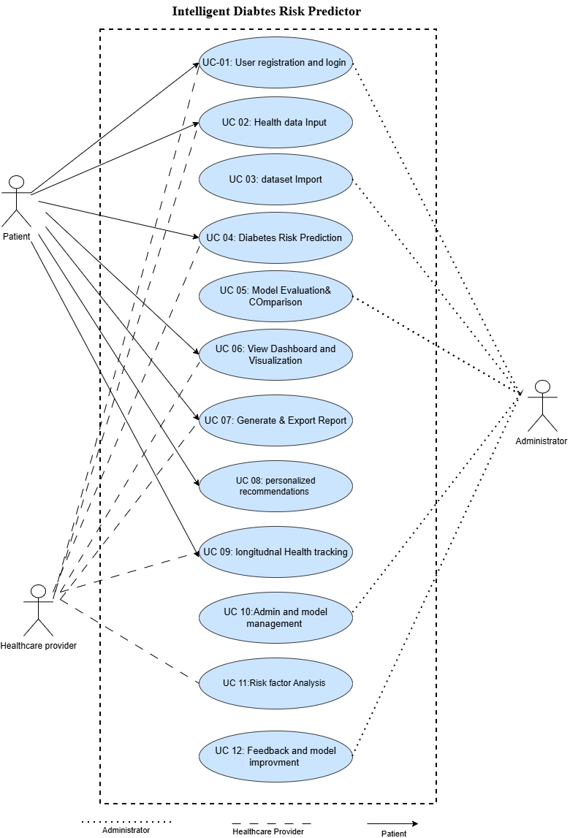

Usage Scenarios:

The following tables describe usage scenarios for each use case identified in the Use Case Diagram.

Scenario 1: User Registration & Login
Use Case Title | User Registration & Login
Use Case ID | UC-01
Actor | Patient, Healthcare Provider, Admin
Description | The system allows users to register, log in, and manage their accounts securely with role-based access control.
Pre-Conditions | User has access to the system interface.
Actions | 1. User navigates to registration/login page. 2. Enters credentials. 3. System validates and grants access.
Post-Conditions | User is authenticated and redirected to dashboard.
Alternative Paths | Invalid credentials: system displays error and prompts retry.
Exceptions | Account lockout after repeated failed attempts.
Author | Student (Admin)

Scenario 2: Health Data Input
Use Case Title | Health Data Input
Use Case ID | UC-02
Actor | Patient, Healthcare Provider
Description | User inputs health-related clinical and lifestyle data required for diabetes risk prediction.
Pre-Conditions | User is logged in.
Actions | 1. User opens data input form. 2. Enters health parameters. 3. Submits for prediction.
Post-Conditions | Data is stored and forwarded to prediction engine.
Alternative Paths | Invalid data: system highlights field errors.
Exceptions | Network failure during submission.
Author | Student (Admin)

Scenario 3: Dataset Import
Use Case Title | Dataset Import
Use Case ID | UC-03
Actor | Administrator
Description | Admin imports external datasets (e.g., Kaggle diabetes dataset) for model training.
Pre-Conditions | Admin is logged in with admin privileges.
Actions | 1. Admin navigates to dataset management. 2. Uploads dataset file. 3. System validates and stores.
Post-Conditions | Dataset is available for training.
Alternative Paths | Invalid file format: system rejects and notifies admin.
Exceptions | File size exceeds limit.
Author | Student (Admin)

Scenario 4: Diabetes Risk Prediction
Use Case Title | Diabetes Risk Prediction
Use Case ID | UC-04
Actor | Patient, Healthcare Provider
Description | System uses trained ML models (Neural Network, SVM, Decision Tree, Logistic Regression) to predict diabetes risk.
Pre-Conditions | Health data has been submitted; model is trained.
Actions | 1. System receives health data. 2. Runs prediction using best model. 3. Returns result with risk level.
Post-Conditions | Prediction result displayed to user.
Alternative Paths | Insufficient data: system prompts user to complete form.
Exceptions | Model unavailable; system notifies admin.
Author | Student (Admin)

Scenario 5: Model Evaluation & Comparison
Use Case Title | Model Evaluation & Comparison
Use Case ID | UC-05
Actor | Administrator
Description | Admin evaluates models using accuracy, precision, recall, F1-score, and confusion matrix to select the best.
Pre-Conditions | Models have been trained.
Actions | 1. Admin accesses model evaluation module. 2. Views metrics per model. 3. Selects best-performing model.
Post-Conditions | Best model is saved for production use.
Alternative Paths | No trained models available: system prompts to train first.
Exceptions | Evaluation fails due to data mismatch.
Author | Student (Admin)

Scenario 6: View Dashboard & Visualization
Use Case Title | View Dashboard & Visualization
Use Case ID | UC-06
Actor | Patient, Healthcare Provider
Description | System provides a visual dashboard showing prediction results, risk levels, model performance, and trends.
Pre-Conditions | User is logged in; predictions exist.
Actions | 1. User opens dashboard. 2. Views charts, graphs, and risk summaries.
Post-Conditions | User views updated health trends.
Alternative Paths | No data available: dashboard shows empty state message.
Exceptions | Rendering failure on unsupported browser.
Author | Student (Admin)

Scenario 7: Generate & Export Report
Use Case Title | Generate & Export Report
Use Case ID | UC-07
Actor | Patient, Healthcare Provider
Description | User generates downloadable reports (PDF/CSV) containing user data, prediction results, and model metrics.
Pre-Conditions | Prediction data exists for the user.
Actions | 1. User requests report. 2. System compiles data. 3. Downloads PDF/CSV.
Post-Conditions | Report is downloaded successfully.
Alternative Paths | No data to report: system notifies user.
Exceptions | Export fails due to server error.
Author | Student (Admin)

Scenario 8: Personalized Recommendations
Use Case Title | Personalized Recommendations
Use Case ID | UC-08
Actor | Patient
Description | System provides lifestyle and medical recommendations based on prediction results.
Pre-Conditions | Prediction result is available.
Actions | 1. System analyzes prediction. 2. Generates recommendations (diet, exercise, consultation).
Post-Conditions | Recommendations displayed to patient.
Alternative Paths | No prediction available: recommendations cannot be generated.
Exceptions | Recommendation engine error.
Author | Student (Admin)

Scenario 9: Longitudinal Health Tracking
Use Case Title | Longitudinal Health Tracking
Use Case ID | UC-09
Actor | Patient, Healthcare Provider
Description | System stores health records over time and allows tracking of changes in health status and prediction results.
Pre-Conditions | Multiple health records exist for the user.
Actions | 1. User accesses tracking module. 2. Views historical records and trend graphs.
Post-Conditions | Health trends are displayed over time.
Alternative Paths | Single record only: system shows no trend yet.
Exceptions | Data storage failure.
Author | Student (Admin)

Scenario 10: Admin & Model Management
Use Case Title | Admin & Model Management
Use Case ID | UC-10
Actor | Administrator
Description | Admin manages datasets, trains/updates ML models, and monitors overall system performance.
Pre-Conditions | Admin is authenticated.
Actions | 1. Admin logs in. 2. Manages datasets. 3. Trains or updates models. 4. Monitors performance metrics.
Post-Conditions | System is updated with latest models and data.
Alternative Paths | Training fails: system logs error and notifies admin.
Exceptions | Server resource exhaustion during training.
Author | Student (Admin)

Scenario 11: Risk Factor Analysis & Explanation
Use Case Title | Risk Factor Analysis & Explanation
Use Case ID | UC-11
Actor | Patient, Healthcare Provider
Description | The system identifies and displays the key clinical and lifestyle features contributing to a patient's diabetes risk prediction, along with interpretable explanations to enhance transparency and support informed decision-making.
Pre-Conditions | A prediction result has been generated for the user. The best-performing ML model is loaded and supports feature importance output
Actions | 1. User requests risk factor analysis after viewing prediction result. 2. System extracts feature importance scores from the trained model. 3. System ranks contributing factors (e.g. glucose level, BMI, age, insulin). 4. System displays a visual explanation such as a bar chart of top risk factors. 5. User reviews which factors contributed most or least to the prediction result.
Post-Conditions | Key risk factors are displayed to the user with relative importance scores. Healthcare provider may use this analysis to guide clinical discussion and further diagnostic steps.
Alternative Paths | Model does not support explainability: system displays a general message indicating that a detailed explanation is unavailable for the currently selected model.
Exceptions | Feature extraction fails due to model mismatch or corrupted model file; system logs the error and notifies the administrator for resolution.
Author | Student (Admin)

Scenario 12: Feedback & Model Improvement

Use Case Title | Feedback & Model Improvement
Use Case ID | UC-12
Actor | Administrator
Description | The system collects feedback from users and clinicians regarding prediction accuracy and usability, and uses this feedback to support continuous retraining and iterative improvement of machine learning models.
Pre-Conditions | Administrator is authenticated with admin privileges. At least one complete prediction cycle has been completed and feedback has been submitted by users or clinicians through the feedback module.
Actions | 1. System collects structured feedback from patients and healthcare providers after each prediction session. 2. Administrator reviews aggregated feedback through the admin panel. 3. Administrator identifies patterns indicating model underperformance or user dissatisfaction. 4. Administrator triggers model retraining using updated, corrected, or augmented data. 5. System retrains the model and evaluates new performance metrics (accuracy, F1-score, etc.). 6. Administrator reviews the evaluation results and approves the improved model for deployment. 7. Updated model is deployed to production and version history is updated.
Post-Conditions | An updated and improved ML model is deployed to production. All submitted feedback is stored and linked to the corresponding model version in the version history log.
Alternative Paths | Insufficient feedback collected: system prompts administrator to wait for additional user submissions before initiating a retraining cycle to ensure meaningful improvement.
Exceptions | Retraining process fails due to data quality issues, schema mismatch, or server resource exhaustion; system logs the detailed error and sends an alert notification to the administrator.

Adopted Methodology

VU Process Model
This project adopts the VU Process Model, which is a hybrid methodology combining the Waterfall Model and the Spiral Model.

Waterfall Component
The Waterfall component provides a structured, sequential framework for the following phases:
- Requirements Analysis — Gathering and documenting all functional and non-functional requirements.
- System Design — Designing system architecture, database schema, and ML pipeline.
- Implementation — Developing the system in Python using the Anaconda framework.
- Testing — Unit testing, integration testing, and model evaluation.
- Deployment — Final system deployment and user training.
- Maintenance — Post-deployment monitoring and model retraining.

Spiral Component
The Spiral component introduces iterative risk management across four quadrants per cycle:
- Planning — Define objectives and constraints for each iteration.
- Risk Analysis — Identify and mitigate technical and data-related risks.
- Engineering — Develop and test the increment (e.g., one ML model at a time).
- Evaluation — Review with stakeholders and plan the next spiral.

Rationale for Hybrid Approach
The combination is ideal for this project because:
- ML model development is inherently iterative — models are trained, evaluated, and refined across multiple cycles (Spiral).
        - Doc a sequential, controlled process (Waterfall).
- Risk management is essential when working with healthcare data and predictive algorithms.

Process Model Diagram
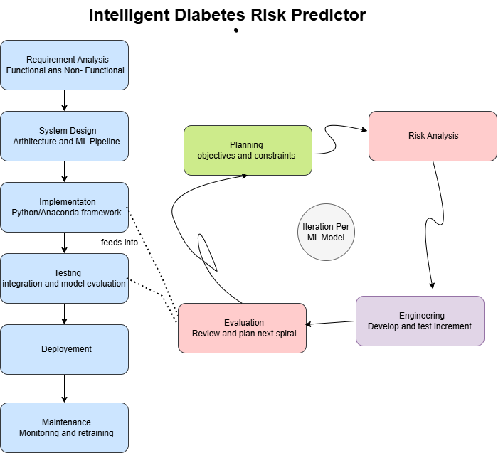

Work Plan (Use MS Project to create Schedule/Work Plan)

Work Plan (Gantt chart)
The following Gantt chart outlines the project schedule. The full chart has been created using MS Project.
