Evaluation

# Design

For the design aspect I stuck to my initial designs, I kept the programme as simple as I can and as direct as I can because it will make the usability a lot easier. However, there are a few aspects that I have changed, my initial programme had 2 windows, the first window was for user input and then display what was inputted back to the user, the second window was meant to be for the test. Because I wanted to keep my design simple and as user friendly as possible, I decide to minimise the clutter and keep it all on one window, this worked out a lot better for me as I can code it all under one section which saved me a lot of time and effort, it allowed me to focus on getting the functions right rather than putting all my attention on the design and losing sight of the outcome which was functionality. Instead of using two windows to display the data, I decided to display the user information and calculations in the form of a message box. When once the user inputs all the data and of the subject into the correct fields then performs the test, once they hit the continue button a message box will not pop up with feedback on what was entered into the fields and the calculations it has performed. I found this a lot simple and straight forward as the user will just stick to one window and have all the info and data in one place rather than jumping back and forth from each window.

The picture below is from my first design; I have kept to this design but enhanced it further as I wanted everything to be under one window as I find it more efficient.

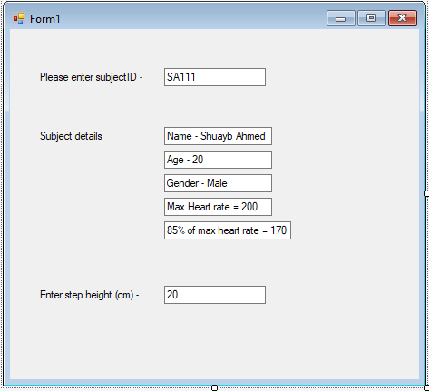

Below is another picture from my first design, this was meant to be the second window that I would be using for my programme however, it was a bit complex to have two separate windows and it did not make for a good viewing as the user will have to jump back and forth from both windows in order to view their information which is why I decided to simplify it and instead keep everything in one window.

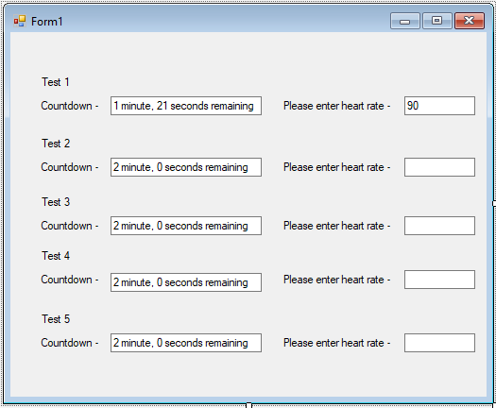

Below are screen shots of what my programme currently looks like. Instead of having 2 form windows, I have decided to stick to one as it makes things a lot efficient and easier to view. As you can see once the information has been inputted by the user and they click the continue button, the message box will pop up with the feedback.

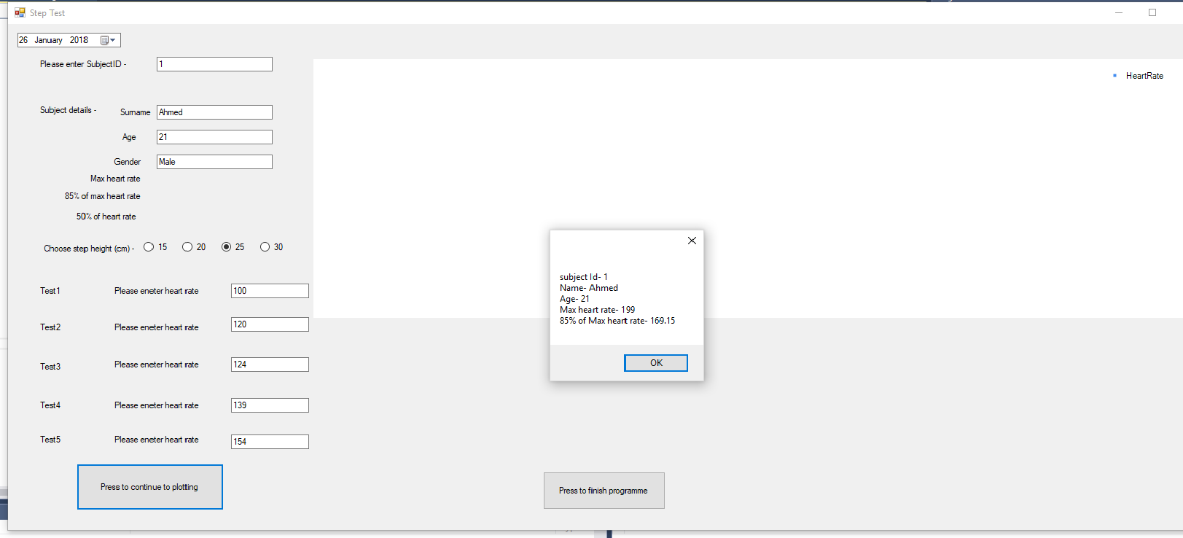

Once the user hits ok on the message box it will then display the graph with the point plotted in the correct positions (as shown below). The user can exit out of the programme whenever they like to by simply hitting the ‘Press to finish programme’ button.

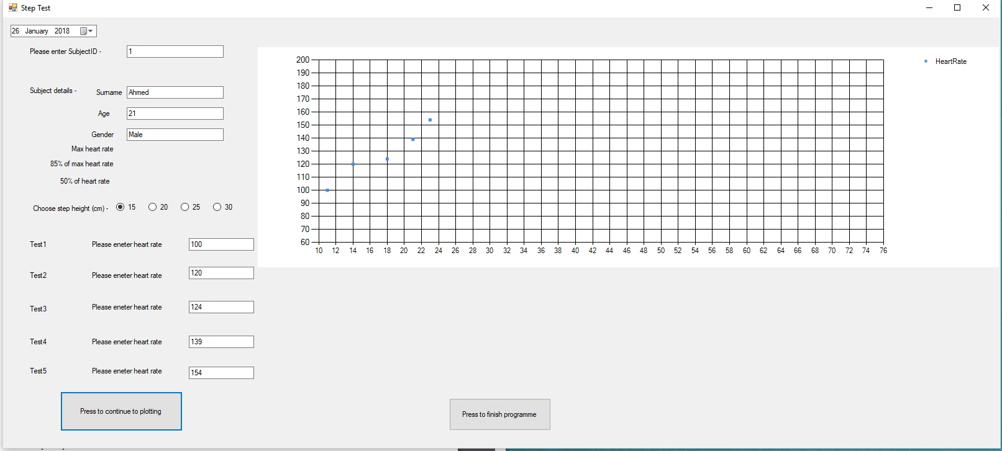

# Usability

I kept the programme as simple as I can make it so that it is easy to use, everything is in order from top to bottom. The user simply starts from the top and works their way down to the bottom, so there is no confusion or mistakes that may occur while using the programme. All the boxed and buttons are placed in order so the user just has to work their way through the programme and they will get the result that they are looking for. As the programme is not finished there are a few bits missing such as the line of best fit and database implementation, once I am able to find out how to fix the issues, I will allow the user to open up the database in order to view the information and data that was saved after the tests were performed so that the user can use it for future reference, in order to do that I will simply create a separate button on the form or something similar in that manner that will open up the data base directly.

# Testing

To test my programme firstly, I tested it myself. I used various different types of data in order to see that the programme is giving the right results and can handle the information and data that was inputted. Once I was satisfied with my own testing, I then got my classmates to test it as well. I allowed them to use my programme and enter their own data to see if it would still output the correct results, up until now it has displayed all the results correctly and all the functions have been working without any faults. I still have to finish the programme as I have not managed to find out how to do the line of best fit and implement the database so I will still need to do further testing once I find out how to complete the programme.

# Functionality

Currently my programmes functions as I planned only to the point when it gets to plotting the graph, further than that I have not managed to achieve as of yet. The programme allows me to enter the details that I want into the form without any issues, it is able to do all the calculations that I need the programme to do and it displays them in the correct manners. As for the test, the user can enter the figures and without any issues it manages to drop the results that are void such as if it reaches max heart rate, 85%of max heart rate and 50% of max heart rate, it then displays all the results on the graph correctly. The feature of selecting the step height also works without flaws, the user can simply select the step height for the test before the test is performed and once the test is done, depending on which step height was selected, the programme will plot the points on the graph in the appropriate places. Overall, I think the programme functions very well for what I have managed to do so far but it is still unfinished as I am not sure how to complete the coding to find the line of best fit and implement the database as of yet.

# Conclusion

Overall I ran into a lot of obstacles but I did manage to overcome some of them with a lot of help from researching on the internet and watching tutorials, I had done a lot of self-learning in order to achieve what I have done so far. I am happy with what I have managed to achieve but with the right help I feel like I could have done better, as of yet I have still not managed to finish off the rest of the graph such as the line of best fit because I am unsure of how to do the coding and I cannot find and learn a suitable solution at this moment in time. I have managed to create a database but I am also struggling to code it correctly in order to implement it into my programme so that once the user inputs the data it will save straight to the database. For what I have done so far I think it has been successful, it functions exactly the way I was expecting it to and it performs all the calculations correctly. I have managed to do the coding correctly after various attempts as I trying different methods, the first methods I used were complexed as I was trying to do more than I was capable of. I found out that keeping it simple gave me the best results, I simply minimised the clutter and stuck to having the programme functionality all under one button as this was a lot easier to do and the programme had no issues at all while it was in use. When I tried to code the programme the first time I ran into a lot of issues such as non-functionality and not receiving the results that I wanted due to the fact the coding I was trying to do was complexed and I tried to make the programme perform tasks that were complicated to do, I then decided to scrap everything that I did and start from scratch and decided it’s best to stick to my first principle that was keeping it all simple. This worked out very well for me as I was able to get all my coding working successfully and the programme was functioning without issues and it was giving the results that I wanted to see. Due to this reason, I could not complete the programme on time, I have also been struggling to finish off the coding for the chart and database as I have not learnt how to do so, I hope I can carry on learning and teach myself or get the help I need in order to complete my programme and have it fully functioning.