IoT-Enabled Smart Healthcare System for Monitoring

Patient Health and AI-Powered Anomaly Detection

Umme Rumana  
PG, School of Information Science  
*Presidency University*

*Bangalore, India*rumanaumme735@gmail.com

Laxmi S Dyapanagoudra  
PG, School of Information Science  
*Presidency University*

*Bangalore, India*  
ldyapanagoudra@gmail.com

Ms. Neha Arora

Assistant Professor  
School of Information Science  
Bangalore, India

Presidency University  
neha.arora@presidencyuniversity.in

Aakif Khan  
PG, School of Information Science

*Presidency University*

*Bangalore, India*  
aakifkhan499@gmail.com

Hassain Miyan  
PG, School of Information Science

*Presidency University*

*Bangalore, India*  
Hassain.miyan7@gmail.com

***Keywords - Smart Healthcare System, IoT sensors, Real time monitoring, AI Health Analysis, health Risk Predication, Patient-centric, cloud integration, wearable Sensors,  Abnormality or anomaly detection.***

1. INTRODUCTION

The IoT-Enabled Smart Healthcare System for Monitoring Patient Health ands

AI-Powered Anomaly Detection is an innovative solution aimed at modernizing healthcare monitoring through the integration of IoT devices and AI technologies. There is a growing need in current healthcare for real-time patient monitoring systems that can provide actionable insights, especially in the areas of remote patient care, chronic disease management, and elder care [1]. It satisfies all of these by continually tracking crucial health parameters, analyzing it in an intelligent manner, and bringing out the critical intervention. There are basically various IoT based wearable devices which are connected in this system like a smart ring, smartwatches, health patches, and sensors [2]. All of these can equip sensors for checking vital health parameters, like heart rate, blood pressure, SpO2, body temperature, glucose level, and signals in ECG. Real-time transmission to a central cloud-based platform with data acquired by the sensor module takes place using wireless communication protocols, like Bluetooth, Wi-Fi, and cellular networks [3]. Data can then be efficiently stored, scaled up, and accessed so healthcare providers can easily get into retrieving and analyzing the information concerning patients' health from their various health checkup clinics or resource-poor conditions.

The anomaly detection algorithm differs with its AI powers. The massive amount of real-time health data is processed by such algorithms to identify deviations or irregular patterns that may signal potential health risks [3]. In this regard, the system can detect early signs of arrhythmia based on irregular heart rhythms, hypoxia through drops in oxygen saturation levels, or infections indicated by abnormal spikes in body temperature.

*Abstract -* **This is the concept of a smart health-care system combined with smart connected sensors with IoT and AI as an enabling mechanism for revolutionizing the way the health status of a patient is to be managed. Having multiple physiological parameters being monitored with this system by having a network of IoT sensors will comprise such things as heart rate, blood pressure, ECG, body temperature, and steps. The data, being collected through these diverse sensors, is processed in real-time-this means that data constantly flows from the individual nodes to the central hub with no pause. The sophisticated AI processing techniques then applied at the central hub scrutinize all the information sent to enable a more critical analysis on the information that was gathered. The role played by AI in the process is that it continues scanning the data for aberrations, any patterns or the presence of health disorders with the most advanced applications of Artificial Intelligence technology. These highly sophisticated algorithms possess the remarkable capability to analyze and identify various trends or tendencies that emerge from the comprehensive health patterns observed. Furthermore, they can play a crucial role in preventing the onset of severe health risks before they escalate into more serious issues. Since the system is targeted for the transfer of alerts to the patients' healthcare providers in addition to the patients, it calls for prompt action in a manner that will aim to provide better wellness to the said patients. This new smart system of healthcare also avails a better mechanism for patient-centered health care, courtesy to its repeated ability to provide suggestions according to a patient's status of health towards providing patients with alert information of their respective sicknesses at the right and appropriate time. Besides the improvement of general health of patients, the system itself adds to the improvement and efficiency of various healthcare processing while simultaneously reducing and eliminating financial burdens associated with the need for additional inpatient services or otherwise complex laboratory tests which are required in most cases. Even more, the incredible ability of such a project to monitor the exact condition of patients in its real-time, combined with its ability to make relevant predictions about their health statuses, means that it has got the potential to revolutionize the healthcare field with an improved quality of treating patients, all while costs associated with the healthcare system decline effectively.**

**AI-Powered Anomaly Detection**

AI techniques have been increasingly used in healthcare monitoring systems to detect anomalies in patient health data. Machine learning (ML) and deep learning (DL) models are used for the analysis of large datasets and detection of irregular patterns that can indicate possible health issues [9]. For instance, CNNs are found effective in analyzing medical images and ECG signals, whereas RNNs and LSTM networks are used for time-series health data analysis.

Studies have demonstrated that AI-based anomaly detection systems are able to detect conditions such as arrhythmias, hypoxemia, and hypertension early on [2]. Predictive models based on historical health data enable timely alerts for medical interventions, which reduce the chances of emergencies. Systems such as Philips HealthSuite and IBM Watson Health apply AI algorithms to provide actionable insights and personalized healthcare recommendations.

***Integration of IoT and AI***

The integration of IoT and AI has given a new dimension to healthcare monitoring systems. The combination of real-time data collection from IoT devices with AI-driven predictive analytics allows the system to be proactive in its approach to healthcare management [10]. Research efforts have focused on developing end-to-end frameworks that incorporate IoT sensors, cloud platforms, and AI algorithms to provide continuous health monitoring and early diagnosis. For example, Intel Health Application Platform already showed a possibility in utilizing IoT and AI, through the real-time tracking of several patients and an alarm of potential health anomaly [11]. This method explores federated learning or distributed training on AI models to various devices under a network of distributed IoT and offers ways to preserve data integrity as well as security

Despite the progress, there are still several challenges in the implementation of IoT-enabled healthcare systems [1]. These include ensuring interoperability between devices, addressing concerns about data privacy, optimizing AI models for resource-constrained IoT devices, and the lack of standardization in communication protocols, which hinders scalability.

1. PROPOSED FRAMEWORK

The main source of data collection in an IoT-enabled smart healthcare system will be from wearable devices and in-room IoT sensors, monitoring real-time health parameters such as heart rate, blood pressure, temperature, and SpO2 (blood oxygen levels) at continuous intervals. These will ensure accuracy and on-time reading, thereby serving as the base for further analysis. This collected health data is then passed to the Edge Processing Node using low-latency so that it can proceed without causing any inefficiency in this process.

This system has several major benefits. Second, it enables continual health tracking and monitoring so that patients get the best care without regular visits to the hospital. Especially useful for patients after surgery, those with chronic diseases, and aged people who need to log and monitor their health regularly. Secondly, predictive analytics allows for early diagnosis which leads to timely interventions and hence improves patient outcomes. Third, by minimizing hospital admissions and enhancing medical staff utilization, the system aids healthcare resource allocation.

In addition to this, this system plays a vital role in tackling healthcare challenges in rural & under-served areas. It is solving a long-standing gap between providers and patients, providing remote monitoring, bridging the gap between those individuals and accessible medical care.

1. RELATED WORK

The convergence of the Internet of Things (IoT) and Artificial Intelligence (AI) in healthcare has transformed patient-monitoring systems into real-time health insights and predictive analytics leading to better medical care [1]. Several projects and studies have been put forward to explore the potential IoT and AI can offer for healthcare monitoring as well as anomaly detection purposes, thus forming a background for developing advanced and scalable healthcare solutions.

**IoT in Healthcare Monitoring**

IoT has been used widely in the health sector for remote patient monitoring and real-time data acquisition. Wearable devices like fitness bands, smartwatches, and biosensors are provided with sensors that measure physiological parameters like heart rate, blood pressure, body temperature, and oxygen saturation [1]. For instance, the MAX30102 pulse oximeter and AD8232 ECG module are very commonly used to monitor vital signs and identify anomalies in cardiovascular activity. These IoT-enabled devices collect data from patients continuously and forward them to a centralized platform so that healthcare professionals may monitor their health remotely.

Recent studies have shown that IoT-based systems can improve patient outcomes, especially in chronic disease management and elderly care. The integration of edge computing with IoT devices has further enhanced data processing capabilities, allowing for localized data analysis before transmission to the cloud. This approach reduces latency and ensures real-time response to critical health events.

**Cloud Integration in Healthcare Systems**

Cloud computing is one of the prime components in the IoT health system as it provides the scalability and secure data storage [7]. Health care applications mostly generate huge amounts of data, and the management of these data occurs through cloud platforms like AWS IoT Core, Microsoft Azure IoT, and Google Cloud IoT. These allow real-time visualization of data, accessibility from remote places, and integration with advanced analytics tools. Moreover, research emphasizes that healthcare needs hybrid cloud architectures [8]. A hybrid system can be developed that has both public and private clouds.

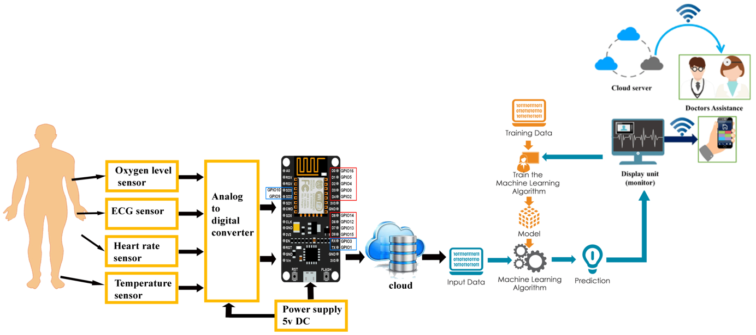

Fig. 1. Proposed Model

This phase hence provides a foundation for data processing, thus allowing patients' health to be under continual watch. It prepares the system for the subsequent phases, where collected information is processed and analyzed to derive actionable insights by ensuring a reliable and secure flow of data.

1. ***Edge Integration***

During Edge Integration, data from wearable IoT sensors and in-room devices such as heart rate, blood pressure, and SpO2 is sent to edge nodes for pre-processing. It begins with initializing edge devices that filter and pre-process raw data. This includes noise reduction, redundancy elimination, and extracting insights, ensuring the data is clean and ready for analysis. Edge computing allows local processing, thus cutting latency and cloud load. It leads to real-time computations at the edge, which accelerates the detection of critical health events and allows smooth data flow to the cloud for analysis.

1. ***Anomaly Detection***

RNN algorithm has been used for diagnosing the abnormalities in the vital psychological signal dataset that was collected from the patients. The RNN algorithm is a computational model, which takes ideas from the biological neural networks where the input values are computed to generate output values. In a non-linear parallel processing style, it gains knowledge from its prior experience and failures.

Once the pre-processed data has reached the Cloud Server, it is further processed, stored, and subjected to AI-based anomaly detection. Machine learning algorithms detect health patterns or critical deviations like arrhythmias or sudden drops in SpO2, which trigger alerts. These alerts are transmitted to healthcare providers, patients, or emergency services via SMS, app notifications, or automated calls, enabling timely interventions. Moreover, with the historical trend analysis as well as the visual dashboards in place, the cloud system provides educated decision-making to doctors and patients. Smooth data flow from IoT devices to actionable insights allows for immediate health monitoring, while supporting adaptive responses and, through this process, enhancing patient care and the ability to proactively manage one's health.

1. ***Data Transmission***

Data transmission: Acquired from wearable IoTs devices and in-room sensors real-time health information concerning the patient. Such critical parameters are monitored, among which include heart rate, blood pressure, temperature, and oxygen saturation (SpO2). The process will be initiated by initializing and calibrating the sensors to ensure accurate data is collected. From that point, the collected data is transmitted through standard IoT communication protocols like MQTT, CoAP, or HTTP. These are lightweight, low-resource protocols that promote the efficient transfer of data and allow seamless communication with IoT devices and edge nodes or cloud servers. The mechanism for transmitting the data thus guarantees minimal loss of information and reliability in low resource environments.

# Experiment and Results

The IoT-Enabled Smart Healthcare System for Monitoring Patient Health and AI-Powered Anomaly Detection was evaluated using specialized simulation tools. System simulation effectively analyzes AI healthcare models that reflect real medical scenarios. This research uses machine learning frameworks such as Microsoft's ML.NET and open-source tools to create and implement deep learning algorithms. These algorithms can efficiently process the patient's health data for anomaly detection. The integration of AI in IoT systems leads to models that are more accurate than ever and further enhance healthcare monitoring, increase outcomes, and enables real-time anomaly detection for a proactive intervention.

1. ***Experimental Parameter***

Performance indicators are integral in giving a clear appraisal of IoT-Enabled Smart Healthcare's ability to sense health information and identify unusual behaviour, hence measuring the healthcare scenarios it applies. Selecting good metrics thus enables one to pin-point what abnormalities are shown in data regarding the patient population and strengthen disease prediction. Because healthcare data are considered highly sensitive, these exact models enhance the ability of tracking accuracy and aid timely interventions. This chapter deals with the models involved along with their contribution towards effective output.

1. Accuracy: Algorithm accuracy refers to the sum of correct predictions in all categories. It is among the most elementary measures of a classification model's performance. In short, accuracy is a good way of explaining how well an algorithm has correctly predicted in general. In binary models, the measure could also be defined in terms of true positives and false negatives in the following way:

$Accuracy=\frac{TP+TN}{(TP+FP+FN+TN)}$ (1)

1. Precision: Algorithm accuracy is the ratio of correct predictions in all categories of a classification scheme. This is one of the most important measures of how well a classification model performs. In other words, accuracy is the number of correct predictions divided by the total number of predictions. For a binary classification, accuracy can be represented by true positives and true negatives, as illustrated below:

$Precision=\frac{TP}{TP+FP}$ (2)

The basic part of the algorithm is the neuron. The neuron processes the input, and an output is given that will be compared to the threshold value. In the processing and analysis internal structures are used that use mechanisms of back propagation and feed forward to produce almost accurate results. Both types of reinforcement types are used, namely the supervised and unsupervised type where there is no target. The unsupervised algorithm decides the learning pattern of biological neurons. The unsupervised replicates the structure of training in biological neurons. The most common applications of RNN in medicine are a classifier for Blood-Brain Barrier (BBB) permeability, medication delivery, and treatments of cancer. The next figure is a diagram of the basic structure of the RNN algorithm.

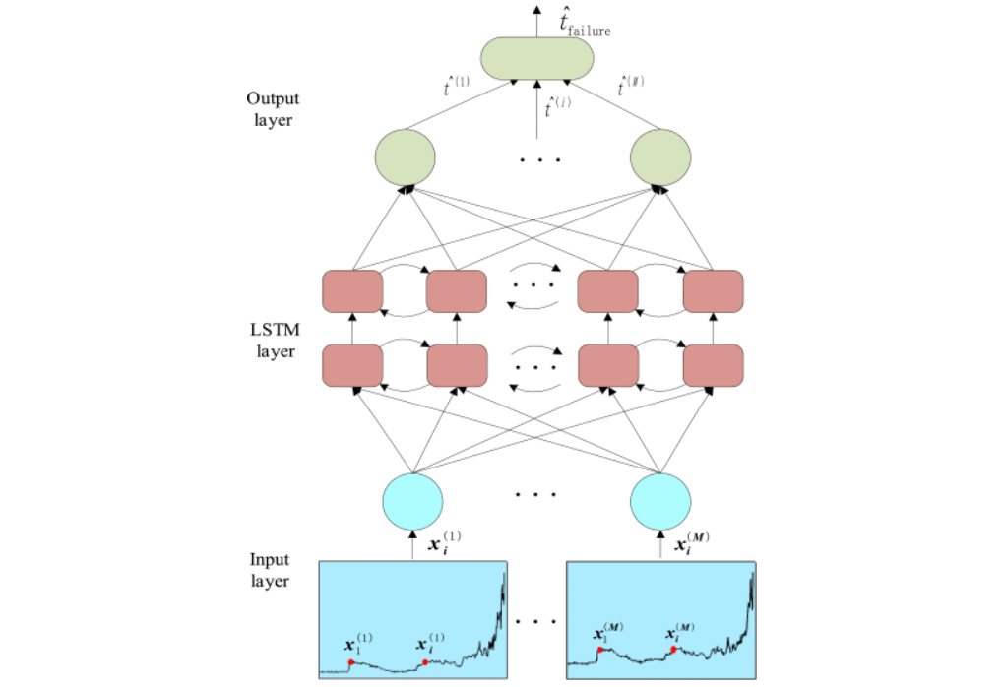

1. RNN Algorithm
2. ***Algorithm***

**Step 1:** The input dataset (e.g., time-series health data) is normalized to ensure uniformity and optimal processing.

**Step 2:** Input data is fed into the Recurrent Neural Network (RNN) with sequential training initialized for temporal dependencies.

**Step 3:** Network constraints (such as weights, biases, and learning rates) are defined and formulated.

**Step 4:** Hidden states and neuron outputs are calculated based on the current input and the previously stored hidden states.

**Step 5:** The output layer processes the updated hidden states to predict results (e.g., anomaly detection values).

**Step 6:** The error rate (loss) between predicted output and actual output is calculated, and the weights are updated using backpropagation through time (BPTT).

**Step 7:** Steps 3 through 6 are repeated iteratively until the network converges, achieving optimal predictions and minimal error.

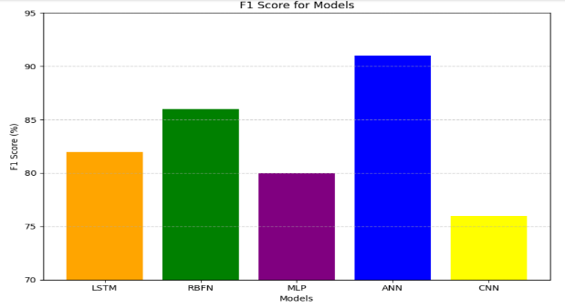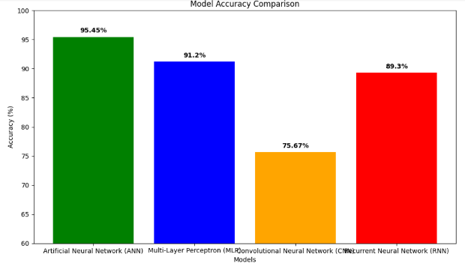

1. Data Trans between EMR
2. ***Prediction accuracy***

The model was tested against different architectures of neural networks, focusing on accuracy in predicting diseases relating to stroke. Accuracy revealed the ANN outscored other models with an accuracy level of 95.45%, which has thus justified its application to the area of stroke prediction. The CNN achieved 75.67%, the MLP 91.20%, and the RNN 89.30%. This shows that the ANN model is suitable for early stroke detection.

1. Accuracy of Deep Learning algorithms

The following figure 5 and figure 6 show the Recall score, and F1 Score based on the select learning models. From the simulation, ANN models outperform all the existing models based on the parameter selection.

1. F1 Score
2. Recall: Recall is the measure that gives percentage of stroke patients the algorithm is able to correctly detect. The patient whom model has picked out to be having strokes is also TP, as well as true positives (they have strokes are TP and FN). Because this person had a stroke, although their condition has been falsely predicted by model. FN is indicated by:

$Sensitivity=\frac{TP}{TP+FN}$ (3)

1. F1 Score: It is not necessary to have both Precision and Recall when developing a prototype to solve a classification problem. So, it would be perfect if it could get a single score that represented both Precision (P) and Recall (R). One way to do this is to take the average of all of them. With P standing for precision and R for recall, the formula is (P + R) / 2. It is estimated as follows:

$F1 Score=\frac{2*Precision*Recall}{Precision+Recall}$ (4)

# Results and Discussion

It gives a data transmission IoT healthcare framework for early detection of stroke. The model can be used in emergencies with aid to the patients and to medical experts, helps for early diagnosis of symptoms by predicting stroke risk factors through health monitoring and continuous monitoring via data transmission and IoT sensors. The study demonstrated that data transmission can efficiently capture vital health signals much better than traditional methods. In addition, the signal acquisition has a low error rate, which is promising for critical healthcare applications.

1. ***The rate of errors during signal acquisition.***

In a smart healthcare system with IoT, wearable devices and sensors monitor vital health parameters like heart rate (HR), blood pressure (BP), temperature, and blood oxygen levels (SpO2) in real time. The data is then forwarded to an Edge Processing Node for filtering and preprocessing, eliminating noise and redundancy. This ensures that signal acquisition is accurate with minimum errors. The refined data is sent to the Cloud Server for processing and anomaly detection. AI is able to detect issues like arrhythmias or drops in SpO2, and alert healthcare providers for timely intervention and better patient outcomes.

The parameters include significant metrics like heart rate, blood pressure, body temperature, and levels of blood oxygen (SpO2). These vital signs, which play an important role in assessing an individual's health, are monitored continuously over time and transmitted in real-time to the designated processing unit where they undergo further detailed analysis.

It is possible to predict critical risk factors of stroke patients using deep learning algorithms, such as ANN, CNN, and RNN, even in emergency conditions.

The results of the investigation prove that the proposed model is superior to the existing one. In other words, ANN models achieved 93.21% accuracy, which means they work well with producing accurate predictions. Moreover, a training dataset size between 75% and 80% is enough to provide reliable results without any underfitting or overfitting risk and ensures the high performance of models. This system can detect symptoms of health disorders way before the rest due to inclusion of the latest Data Transmission technology accompanied by deep learning. This would not only give the system a high level of accuracy and precision in its predictions of diseases but also enables intervention promptly and before time. That is why it is extremely helpful in healthcare systems and more so when patients are handled promptly with issues related to stroke disorders.

##### *References*

1. G Prasad, P Gujjar, HNN Kumar, MA Kumar… - Cyber Trafficking, Threat Behavior, and Malicious …, 2023
2. Imoize, Agbotiname Lucky, et al., eds. *Handbook of Security and Privacy of AI-Enabled Healthcare Systems and Internet of Medical Things*. CRC Press, 2023.
3. Kalusivalingam, Aravind Kumar, et al. "Enhancing Patient Care Through IoT-Enabled Remote Monitoring and AI-Driven Virtual Health Assistants: Implementing Machine Learning Algorithms and Natural Language Processing." *International Journal of AI and ML* 2.3 (2021).
4. Tiwari, Meena, and Akhilesh A. Waoo. "Transforming Healthcare: The Synergistic Fusion of AI and IoT for Intelligent, Personalized Well-Being." *Revolutionizing Healthcare: AI Integration with IoT for Enhanced Patient Outcomes*. Cham: Springer Nature Switzerland, 2024. 109-149.
5. Bhambri, Pankaj, and Alex Khang. "Managing and Monitoring Patient's Healthcare Using AI and IoT Technologies." In *Driving Smart Medical Diagnosis Through AI-Powered Technologies and Applications*, pp. 1-23. IGI Global, 2024.
6. Recall Score
7. ***Choosing the Appropriate Training Dataset***

Figure 6 presents the results for dataset sizes between 45 and 90. The analysis indicates that an optimum training size between 70% and 80% gives the best performance while ANN has the highest accuracy when the training size increases. Other models, CNN, RBFN, and LSTM, have a relatively low accuracy but settle at around the same value. The training size of 50% may lead to underfitting, and a training size of 90% will likely result in overfitting. Therefore, a training range of 70% to 80% is optimal to ensure consistent accuracy, recall, precision, and F1 score, thus allowing proper disease prediction and generalization.

1. Training Dataset Selection

# Conclusion

Among all the crucial and life-threatening health disorders globally, stroke disease has remained at the top of concern and emphasizes the need for early detection along with timely diagnosis to reduce the risk factors and improve patient outcomes. The paper introduces a Data Transmission-based IoT-enabled healthcare system that has been developed for continuous monitoring, real-time data acquisition, and analysis of physiological signals for the effective prediction of stroke-related disorders. The system efficiently utilizes Internet of Things (IoT) sensors that are tailored for collecting and gathering all essential health parameters that are essential in monitoring well-being.

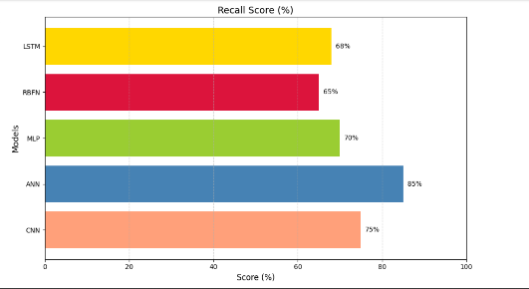

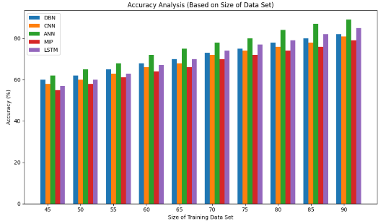

1. SEDDIKI, M., BOUHEDDA, M., TOBBAL, A., REBOUH, S., & ANIBA, Y. (2024). AI-Driven IoT Healthcare System for Real-Time ECG Analysis and Comprehensive Patient Monitoring. *Science, Engineering and Technology*, *4*(2), 61-81.
2. Bajpayi, P., Sharma, S., & Gaur, M. S. (2024, March). AI Driven IoT Healthcare Devices Security Vulnerability Management. In *2024 2nd International Conference on Disruptive Technologies (ICDT)* (pp. 366-373). IEEE.
3. Kumar A, Jain R, Gupta M, Islam SM, editors. 6G-enabled IoT and AI for smart healthcare: Challenges, impact, and analysis. CRC Press; 2023 Jun 21.
4. Awad, Ali Ismail, et al. "AI-powered biometrics for Internet of Things security: A review and future vision." *Journal of Information Security and Applications* 82 (2024): 103748.
5. David, Jameson. "Revolutionizing Biomedical Engineering: AI-Driven Medical Devices in Cloud-Based Healthcare Systems." (2024).
6. Rangasamy, Sangeetha, et al. "Revolutionizing Healthcare with IoT: Connecting the Dots for Better Patient Outcomes." *AI and IoT Technology and Applications for Smart Healthcare Systems*. Auerbach Publications, 2024. 204-223.
7. Daniel, Thomas. "Cloud Computing and Data Security Strategies in AI-Driven Healthcare Devices." (2024).