INDEX

Sr. No. | Practical Description | Pg. No. | Date | Sign
1 | Introduction to TensorFlow
a | • Create tensors with different shapes and data types.  • Perform basic operations like addition, subtraction, multiplication, and division on tensors.  • Reshape, slice, and index tensors to extract specific elements or sections.  • Performing matrix multiplication and finding eigenvectors and eigenvalues using TensorFlow
b | Program to solve the XOR problem.
2 | Linear Regression
a | • Implement a simple linear regression model using TensorFlow's low-level API (or tf. keras).  • Train the model on a toy dataset (e.g., housing prices vs. square footage).  • Visualize the loss function and the learned linear relationship.  • Make predictions on new data points.
3 | Convolutional Neural Networks (Classification)
a | Implementing deep neural network for performing binary classification task
b | Using a deep feed-forward network with two hidden layers for performing multiclass classification and predicting the class.
4 | Write a program to implement deep learning Techniques for image segmentation.
5 | Write a program to predict a caption for a sample image using LSTM.
6 | Applying the Autoencoder algorithms for encoding real-world data
7 | Write a program for character recognition using RNN and compare it with CNN.
8 | Write a program to develop Autoencoders using MNIST Handwritten Digits
9 | Demonstrate recurrent neural network that learns to perform sequence analysis for stock price.(google stock price)
10 | Applying Generative Adversarial Networks for image generation and unsupervised tasks.

Practical No.1 A
Introduction to TensorFlow

I] Create tensors with different shapes and data types
import tensorflow as tf
# Scalar
scalar = tf.constant(5)

# Vector (1D)
vector = tf.constant([1, 2, 3], dtype=tf.int32)

# Matrix (2D)
matrix = tf.constant([[1.0, 2.0],
[3.0, 4.0]], dtype=tf.float32)

# 3D Tensor
tensor_3d = tf.constant([
[[1, 2], [3, 4]],
[[5, 6], [7, 8]]
], dtype=tf.int64)

print("Scalar:", scalar)
print("Vector:", vector)
print("Matrix:\n", matrix)
print("3D Tensor:\n", tensor_3d)

Output:
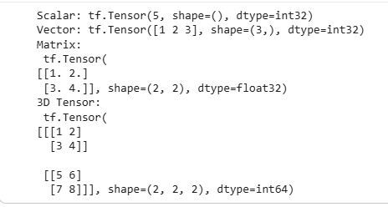

II] Basic tensor operations
a = tf.constant([10, 20, 30], dtype=tf.float32)
b = tf.constant([2, 4, 6], dtype=tf.float32)

addition = tf.add(a, b)
subtraction = tf.subtract(a, b)
multiplication = tf.multiply(a, b)
division = tf.divide(a, b)

print("Addition:", addition)
print("Subtraction:", subtraction)
print("Multiplication:", multiplication)
print("Division:", division)
Output:
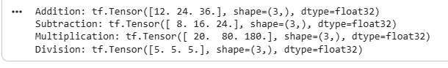

III] Reshape tensors
tensor = tf.constant([1, 2, 3, 4, 5, 6])
reshaped_tensor = tf.reshape(tensor, (2, 3))
print("Reshaped Tensor:\n", reshaped_tensor)
Output:
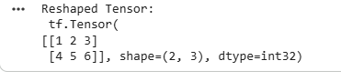

IV] Slicing and indexing tensors
matrix = tf.constant([
[10, 20, 30],
[40, 50, 60],
[70, 80, 90]
])

# Indexing
element = matrix[1, 2] # Row 1, Column 2
print("Single element:", element)

# Row slicing
row = matrix[1]
print("Row:", row)

# Column slicing
column = matrix[:, 0]
print("Column:", column)

# Sub-matrix slicing
sub_matrix = matrix[0:2, 1:3]
print("Sub-matrix:\n", sub_matrix)
Output:
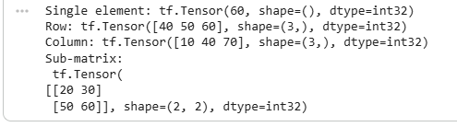

V] Matrix multiplication
A = tf.constant([[1, 2],
[3, 4]], dtype=tf.float32)

B = tf.constant([[5, 6],
[7, 8]], dtype=tf.float32)

matmul_result = tf.matmul(A, B)
print("Matrix Multiplication Result:\n", matmul_result)
Output:

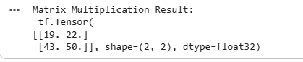

VI] Eigenvalues and eigenvectors (TensorFlow)
Eigen operations require square matrices and use tf.linalg.eig
# Square matrix
M = tf.constant([ [4.0, -2.0],
[1.0, 1.0] ])

# Compute eigenvalues and eigenvectors
eigenvalues, eigenvectors = tf.linalg.eig(M)

print("Eigenvalues:\n", eigenvalues)
print("Eigenvectors:\n", eigenvectors)

Output:
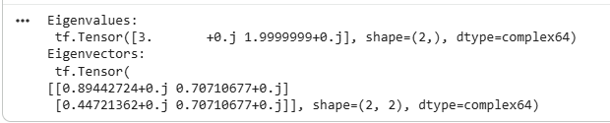

TensorFlow Concepts Used
- tf.constant() – tensor creation
- dtype – data type control
- Arithmetic ops: add, subtract, multiply, divide
- tf.reshape() – reshape tensors
- Indexing & slicing – NumPy-style
- tf.matmul() – matrix multiplication
- tf.linalg.eig() – eigenvalues & eigenvectors
What are Eigenvalues and Eigenvectors?
Eigenvalues and eigenvectors are fundamental concepts in linear algebra that describe the behavior of linear transformations represented by matrices.
Let A be a square matrix. A non-zero vector v is called an eigenvector of matrix A if it satisfies the equation:
$$\text{A}\text{v}\text{=}\text{λ}\text{v}$$
where:
- A is a square matrix
- v is the eigenvector
- λ (lambda) is the eigenvalue corresponding to v
Explanation
- An eigenvector is a vector whose direction remains unchanged when a matrix transformation is applied.
- The eigenvalue represents the factor by which the eigenvector is scaled.
- Eigenvalues indicate whether the transformation stretches, shrinks, flips, or leaves the vector unchanged
🔹 Simple Example
Let:
$$\text{A}\text{=}\left[\begin{matrix}\text{2} & \text{0} \\ \text{0} & \text{3}\end{matrix}\right]$$
If:
$$\text{v}\text{=}\left[\begin{aligned}\text{1} \\ \text{0}\end{aligned}\right]$$
Then:
$$\text{A}\text{v}\text{=}\left[\begin{aligned}\text{2} \\ \text{0}\end{aligned}\right]\text{=2}\text{v}$$
- Direction unchanged
- Scaled by 2
So:
- Eigenvector → $\left[\text{1} , \text{0}\right]$
- Eigenvalue → 2

Practical No.1 B

Aim: Program to solve the XOR problem.
CODE:
# Import required libraries
import numpy as np
from tensorflow.keras.models import Sequential
from tensorflow.keras.layers import Dense
# XOR input and output data
X = np.array([[0, 0],
[0, 1],
[1, 0],
[1, 1]])
y = np.array([[0],
[1],
[1],
[0]])
# Create the neural network model
model = Sequential()
# Hidden layer with 2 neurons and ReLU activation
model.add(Dense(2, input_dim=2, activation='relu'))
# Output layer with sigmoid activation
model.add(Dense(1, activation='sigmoid'))
# Compile the model
model.compile(loss='binary_crossentropy',
optimizer='adam',
metrics=['accuracy'])
# Train the model
model.fit(X, y, epochs=1000, verbose=0)
# Test the model
predictions = model.predict(X)
# Display results
print("Input Output")
for i in range(len(X)):
print(X[i], "=", round(predictions[i][0]))

Output:
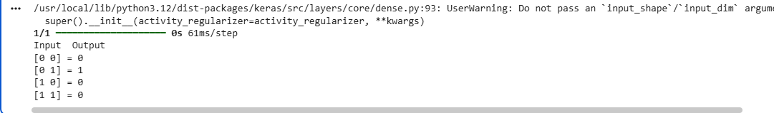

Practical No.2

AIM: Linear Regression
- Implement a simple linear regression model using TensorFlow's low level API
(or tf. keras).
- Train the model on a toy dataset (e.g., housing prices vs. square footage). • Visualize the loss function and the learned linear relationship.
- Make predictions on new data points.

Code File

# linear_regression_tf.py
import tensorflow as tf
import numpy as np
import matplotlib.pyplot as plt

# -----------------------------
# 1. Create Toy Dataset
# -----------------------------
# House size (sq ft)
square_feet = np.array([500, 800, 1000, 1200, 1500, 1800, 2000], dtype=float)

# House price (in $1000s)
prices = np.array([150, 200, 250, 300, 350, 400, 450], dtype=float)

# Normalize data for stable training
square_feet_norm = square_feet / 2000
prices_norm = prices / 500

# -----------------------------
# 2. Build Linear Regression Model
# -----------------------------
model = tf.keras.Sequential([
tf.keras.layers.Dense(units=1, input_shape=[1]) # y = wx + b
])

model.compile(
optimizer=tf.keras.optimizers.SGD(learning_rate=0.1),
loss='mse'
)

# -----------------------------
# 3. Train Model
# -----------------------------
history = model.fit(square_feet_norm, prices_norm,
epochs=200,
verbose=0)

# -----------------------------
# 4. Plot Training Loss
# -----------------------------
plt.figure(figsize=(10,4))

plt.subplot(1,2,1)
plt.plot(history.history['loss'])
plt.title("Training Loss")
plt.xlabel("Epoch")
plt.ylabel("MSE Loss")

# -----------------------------
# 5. Plot Regression Line
# -----------------------------
predictions = model.predict(square_feet_norm)

plt.subplot(1,2,2)
plt.scatter(square_feet, prices, color='blue', label='Actual Data')
plt.plot(square_feet, predictions * 500,
color='red', label='Regression Line')

plt.xlabel("Square Feet")
plt.ylabel("Price ($1000s)")
plt.legend()

plt.tight_layout()
plt.show()

# -----------------------------
# 6. Show Learned Parameters
# -----------------------------
weight, bias = model.layers[0].get_weights()
print("\nLearned Weight (normalized):", weight[0][0])
print("Learned Bias (normalized):", bias[0])

# -----------------------------
# 7. Make Prediction on New Data
# -----------------------------
new_sqft = np.array([1600], dtype=float)
new_sqft_norm = new_sqft / 2000

predicted_price_norm = model.predict(new_sqft_norm)
predicted_price = predicted_price_norm[0][0] * 500
print(f"\nPredicted price for 1600 sq ft house: ${predicted_price:.2f}k")

Output:
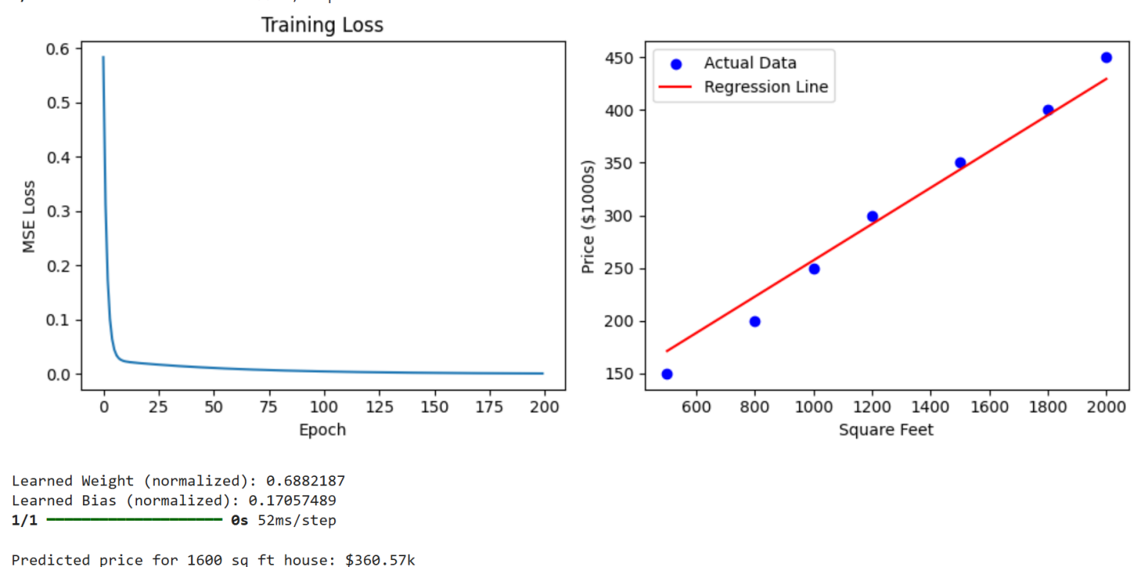

Practical No.3 A

AIM: Implementing deep neural network for performing binary classification task

Code File
# cnn_binary_inbuilt_dataset.py

import tensorflow as tf
from tensorflow.keras import layers, models
import matplotlib.pyplot as plt
import numpy as np
# ===============================
# 1. LOAD INBUILT DATASET
# ===============================
(x_train, y_train), (x_test, y_test) = tf.keras.datasets.cifar10.load_data()

# CIFAR-10 classes:
# 3 = cat, 5 = dog → binary classification

# ===============================
# 2. FILTER ONLY CAT & DOG
# ===============================
train_filter = np.where((y_train == 3) | (y_train == 5))[0]
test_filter = np.where((y_test == 3) | (y_test == 5))[0]

x_train, y_train = x_train[train_filter], y_train[train_filter]
x_test, y_test = x_test[test_filter], y_test[test_filter]

# Convert labels: cat=0, dog=1
y_train = (y_train == 5).astype(int)
y_test = (y_test == 5).astype(int)

# ===============================
# 3. NORMALIZE DATA
# ===============================
x_train = x_train / 255.0
x_test = x_test / 255.0

# ===============================
# 4. BUILD CNN MODEL
# ===============================
model = models.Sequential([

layers.Conv2D(32, (3,3), activation='relu', input_shape=(32,32,3)),
layers.MaxPooling2D(2,2),

layers.Conv2D(64, (3,3), activation='relu'),
layers.MaxPooling2D(2,2),

layers.Conv2D(128, (3,3), activation='relu'),
layers.MaxPooling2D(2,2),

layers.Flatten(),

layers.Dense(128, activation='relu'),
layers.Dropout(0.5),

layers.Dense(1, activation='sigmoid') # Binary output
])

# ===============================
# 5. COMPILE MODEL
# ===============================
model.compile(
optimizer='adam',
loss='binary_crossentropy',
metrics=['accuracy']
)

model.summary()

# ===============================
# 6. TRAIN MODEL
# ===============================
history = model.fit(
x_train, y_train,
epochs=10,
validation_data=(x_test, y_test)
)

# ===============================
# 7. EVALUATE MODEL
# ===============================
loss, accuracy = model.evaluate(x_test, y_test)
print("\nTest Accuracy:", accuracy)

# ===============================
# 8. PLOT RESULTS
# ===============================
plt.plot(history.history['accuracy'], label='Train Accuracy')
plt.plot(history.history['val_accuracy'], label='Validation Accuracy')
plt.xlabel("Epochs")
plt.ylabel("Accuracy")
plt.legend()
plt.title("Training vs Validation Accuracy")
plt.show()

Output:
TRAIN MODEL
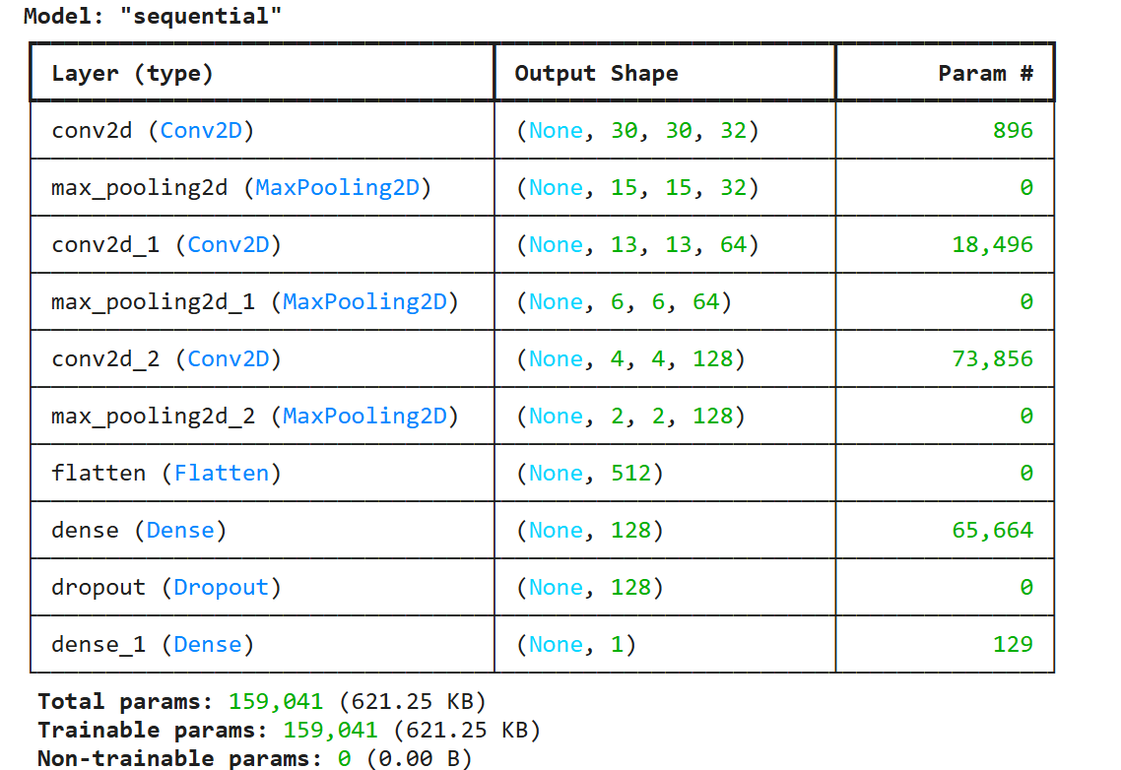
EVALUATE MODEL
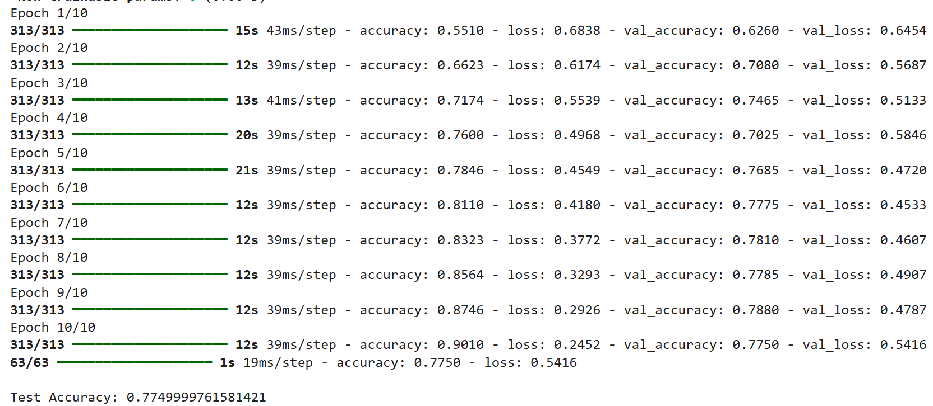
PLOT RESULTS
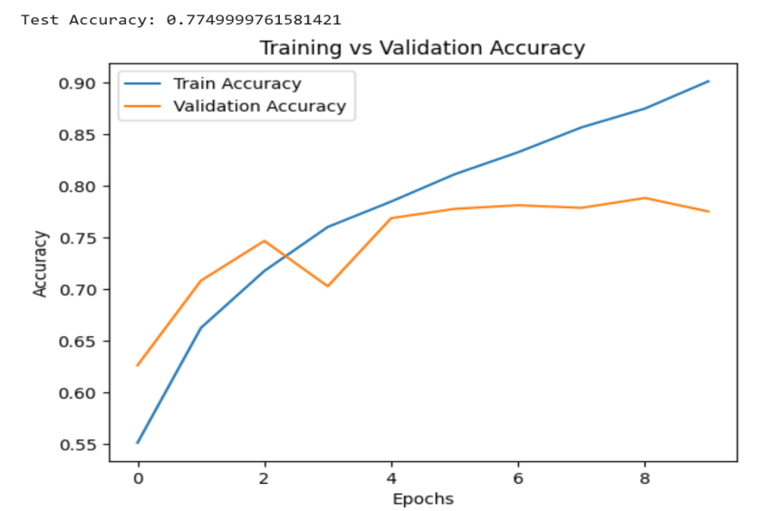

Practical No.3 B

AIM: Using a deep feed-forward network with two hidden layers for performing multiclass classification and predicting the class.

Code File
# Deep Feed-Forward Neural Network (2 Hidden Layers) for Multiclass Classification
import tensorflow as tf
from tensorflow.keras import layers, models
import matplotlib.pyplot as plt
import numpy as np
# 1. Load inbuilt dataset (MNIST)
(x_train, y_train), (x_test, y_test) = tf.keras.datasets.mnist.load_data()
# 2. Preprocess data
x_train = x_train / 255.0
x_test = x_test / 255.0
# Flatten images (28x28 → 784)
x_train = x_train.reshape(-1, 784)
x_test = x_test.reshape(-1, 784)
# 3. Build model (2 hidden layers)
model = models.Sequential([
layers.Dense(128, activation='relu', input_shape=(784,)),
layers.Dense(64, activation='relu'),
layers.Dense(10, activation='softmax') # 10 classes (0–9)
])

# 4. Compile model
model.compile(
optimizer='adam',
loss='sparse_categorical_crossentropy',
metrics=['accuracy']
)
# 5. Train model
history = model.fit(
x_train, y_train,
epochs=5,
batch_size=32,
validation_split=0.1
)
# 6. Evaluate model
test_loss, test_acc = model.evaluate(x_test, y_test)
print("\nTest Accuracy:", test_acc)
# 7. Predict classes
predictions = model.predict(x_test)
predicted_classes = np.argmax(predictions, axis=1)
# 8. Show some predictions
plt.figure(figsize=(10,5))
for i in range(10):
plt.subplot(2,5,i+1)
plt.imshow(x_test[i].reshape(28,28), cmap='gray')
plt.title(f"Pred: {predicted_classes[i]}")
plt.axis('off')
plt.show()
Output:
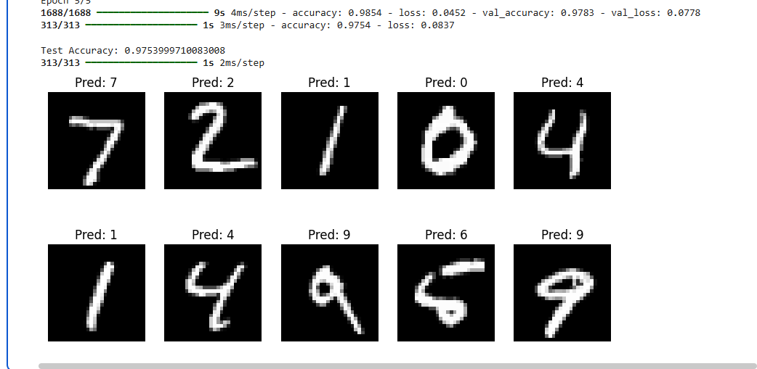

Practical No.4

AIM: Write a program to implement deep learning Techniques for image segmentation.
Code File
import tensorflow as tf
import numpy as np
import matplotlib.pyplot as plt

# Load built-in dataset
(x_train, _), (x_test, _) = tf.keras.datasets.mnist.load_data()
# Normalize and reshape
x_train = x_train / 255.0
x_test = x_test / 255.0
x_train = x_train[..., None]
x_test = x_test[..., None]
# Create masks (digit = 1, background = 0)
y_train = (x_train > 0).astype(float)
y_test = (x_test > 0).astype(float)
# Simple CNN model
model = tf.keras.Sequential([
tf.keras.layers.Conv2D(16, 3, activation='relu', padding='same', input_shape=(28,28,1)),
tf.keras.layers.Conv2D(1, 1, activation='sigmoid')
])
# Compile
model.compile(optimizer='adam', loss='binary_crossentropy', metrics=['accuracy'])
# Train
model.fit(x_train, y_train, epochs=3, batch_size=32)
# Predict
pred = model.predict(x_test[:1])
# Show result
plt.subplot(1,3,1); plt.title("Image"); plt.imshow(x_test[0].squeeze(), cmap='gray')
plt.subplot(1,3,2); plt.title("Mask"); plt.imshow(y_test[0].squeeze(), cmap='gray')
plt.subplot(1,3,3); plt.title("Pred"); plt.imshow(pred[0].squeeze(), cmap='gray')
plt.show()
Output:
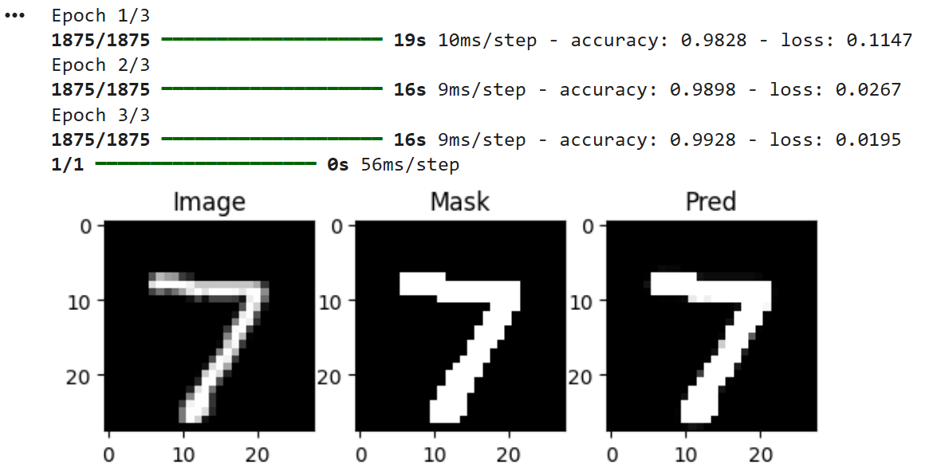

Practical No.5

AIM: Write a program to predict a caption for a sample image using LSTM.
Code File
import tensorflow as tf
import numpy as np
from tensorflow.keras.preprocessing.sequence import pad_sequences
import matplotlib.pyplot as plt
# Load image
img_path = tf.keras.utils.get_file(
'img.jpg',
'https://tensorflow.org/images/surf.jpg'
)
img = tf.keras.preprocessing.image.load_img(img_path, target_size=(224,224))
img = tf.keras.preprocessing.image.img_to_array(img)/255.0
img = np.expand_dims(img, axis=0)
# CNN feature extraction
cnn = tf.keras.applications.MobileNetV2(weights='imagenet', include_top=False, pooling='avg')
feature = cnn.predict(img)
# ✅ Better caption
captions = ["start person surfing on wave end"]
tokenizer = tf.keras.preprocessing.text.Tokenizer()
tokenizer.fit_on_texts(captions)

vocab_size = len(tokenizer.word_index) + 1
max_len = 6
# Prepare data
seq = tokenizer.texts_to_sequences(captions)[0]
X1, X2, y = [], [], []
for i in range(1, len(seq)):
in_seq = seq[:i]
out_seq = seq[i]
in_seq = pad_sequences([in_seq], maxlen=max_len)[0]
X1.append(feature[0])
X2.append(in_seq)
y.append(out_seq)
X1, X2, y = np.array(X1), np.array(X2), np.array(y)
# Model
img_input = tf.keras.Input(shape=(1280,))
img_dense = tf.keras.layers.Dense(50, activation='relu')(img_input)
seq_input = tf.keras.Input(shape=(max_len,))
seq_embed = tf.keras.layers.Embedding(vocab_size, 20)(seq_input)
seq_lstm = tf.keras.layers.LSTM(50)(seq_embed)
decoder = tf.keras.layers.add([img_dense, seq_lstm])
output = tf.keras.layers.Dense(vocab_size, activation='softmax')(decoder)

model = tf.keras.Model([img_input, seq_input], output)
model.compile(loss='sparse_categorical_crossentropy', optimizer='adam')
# Train
model.fit([X1, X2], y, epochs=100, verbose=0)
# Predict
index_word = {v:k for k,v in tokenizer.word_index.items()}
text = "start"
for i in range(max_len):
seq = tokenizer.texts_to_sequences([text])[0]
seq = pad_sequences([seq], maxlen=max_len)
pred = model.predict([feature, seq], verbose=0)
word = index_word[np.argmax(pred)]
text += " " + word
if word == "end":
break
# Show
plt.imshow(img[0])
plt.title(text)
plt.axis('off')
plt.show()
Output:
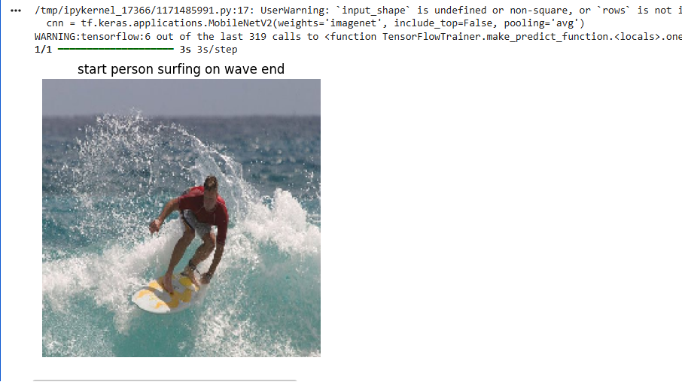

Practical No.6

AIM: Applying the Autoencoder algorithms for encoding real-world data
Code File
# autoencoder_mnist.py

import tensorflow as tf
import matplotlib.pyplot as plt

# ===============================
# 1. LOAD BUILT-IN DATASET
# ===============================
(x_train, _), (x_test, _) = tf.keras.datasets.mnist.load_data()

# Normalize and reshape
x_train = x_train / 255.0
x_test = x_test / 255.0

x_train = x_train.reshape(-1, 28, 28, 1)
x_test = x_test.reshape(-1, 28, 28, 1)

# ===============================
# 2. BUILD AUTOENCODER MODEL
# ===============================
input_img = tf.keras.Input(shape=(28,28,1))

# Encoder
x = tf.keras.layers.Conv2D(16, 3, activation='relu', padding='same')(input_img)
x = tf.keras.layers.MaxPooling2D(2, padding='same')(x)
x = tf.keras.layers.Conv2D(8, 3, activation='relu', padding='same')(x)
encoded = tf.keras.layers.MaxPooling2D(2, padding='same')(x)

# Decoder
x = tf.keras.layers.Conv2D(8, 3, activation='relu', padding='same')(encoded)
x = tf.keras.layers.UpSampling2D(2)(x)
x = tf.keras.layers.Conv2D(16, 3, activation='relu', padding='same')(x)
x = tf.keras.layers.UpSampling2D(2)(x)
decoded = tf.keras.layers.Conv2D(1, 3, activation='sigmoid', padding='same')(x)

# Model
autoencoder = tf.keras.Model(input_img, decoded)

# ===============================
# 3. COMPILE
# ===============================
autoencoder.compile(optimizer='adam', loss='binary_crossentropy')
# ===============================
# 4. TRAIN
# ===============================
autoencoder.fit(x_train, x_train, epochs=5, batch_size=32, validation_data=(x_test, x_test))

# ===============================
# 5. ENCODE & RECONSTRUCT
# ===============================
decoded_imgs = autoencoder.predict(x_test[:3])

# ===============================
# 6. VISUALIZE RESULTS
# ===============================
for i in range(3):
plt.figure(figsize=(6,2))

# Original
plt.subplot(1,2,1)
plt.title("Original")
plt.imshow(x_test[i].reshape(28,28), cmap='gray')

# Reconstructed
plt.subplot(1,2,2)
plt.title("Reconstructed")
plt.imshow(decoded_imgs[i].reshape(28,28), cmap='gray')

plt.show()
Output:
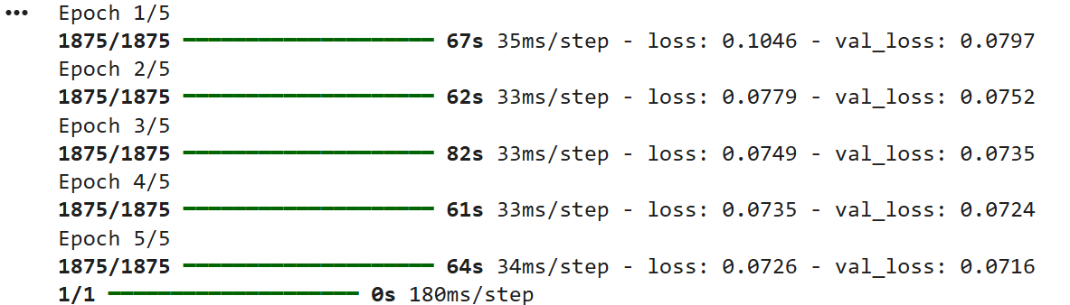
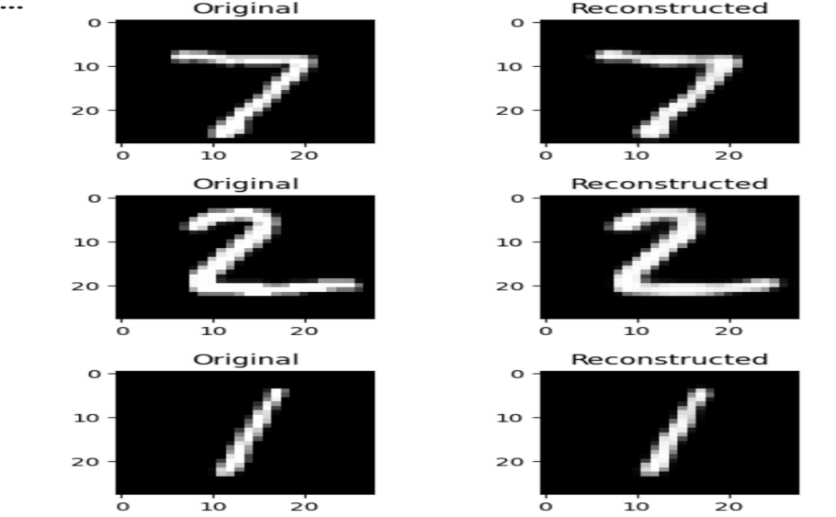
Practical No.7

AIM: Write a program for the character recognition using RNN and compare it with CNN.
Code File
import tensorflow as tf
from tensorflow.keras import layers, models
# Load dataset (MNIST digits as characters)
(x_train, y_train), (x_test, y_test) = tf.keras.datasets.mnist.load_data()
x_train, x_test = x_train/255.0, x_test/255.0

# -------------------- RNN MODEL --------------------
rnn_model = models.Sequential([
layers.SimpleRNN(128, input_shape=(28, 28)),
layers.Dense(10, activation='softmax')
])
rnn_model.compile(optimizer='adam',
loss='sparse_categorical_crossentropy',
metrics=['accuracy'])
print("Training RNN...")
rnn_model.fit(x_train, y_train, epochs=3, verbose=1)
rnn_loss, rnn_acc = rnn_model.evaluate(x_test, y_test, verbose=0)

# -------------------- CNN MODEL --------------------
x_train_cnn = x_train[..., tf.newaxis]
x_test_cnn = x_test[..., tf.newaxis]
cnn_model = models.Sequential([
layers.Conv2D(32, (3,3), activation='relu', input_shape=(28,28,1)),
layers.MaxPooling2D(2,2),
layers.Flatten(),
layers.Dense(128, activation='relu'),
layers.Dense(10, activation='softmax')
])

cnn_model.compile(optimizer='adam',
loss='sparse_categorical_crossentropy',
metrics=['accuracy'])
print("\nTraining CNN...")
cnn_model.fit(x_train_cnn, y_train, epochs=3, verbose=1)

cnn_loss, cnn_acc = cnn_model.evaluate(x_test_cnn, y_test, verbose=0)

# -------------------- COMPARISON --------------------
print("\n--- Comparison ---")
print(f"RNN Accuracy: {rnn_acc:.4f}")
print(f"CNN Accuracy: {cnn_acc:.4f}")
if cnn_acc > rnn_acc:
print("CNN performs better for character recognition.")
else:
print("RNN performs better.")
Output:

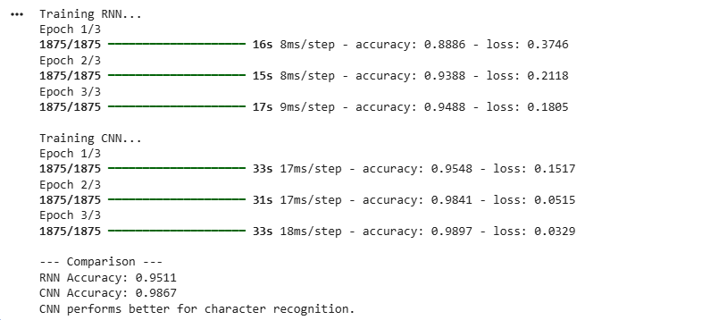

Practical No.8

AIM: Write a program to develop Autoencoders using MNIST Handwritten Digits
Code File
# Step 1: Import Libraries
import numpy as np
import matplotlib.pyplot as plt

from tensorflow.keras.datasets import mnist
from tensorflow.keras.models import Model
from tensorflow.keras.layers import Input, Dense

# Step 2: Load and Preprocess Data
(x_train, _), (x_test, _) = mnist.load_data()

# Normalize
x_train = x_train / 255.0
x_test = x_test / 255.0

# Flatten (28x28 → 784)
x_train = x_train.reshape(-1, 784)
x_test = x_test.reshape(-1, 784)

print("Training shape:", x_train.shape)
print("Testing shape:", x_test.shape)

# Step 3: Build Autoencoder
input_dim = 784
encoding_dim = 32

input_layer = Input(shape=(input_dim,))

# Encoder
encoded = Dense(128, activation='relu')(input_layer)
encoded = Dense(64, activation='relu')(encoded)
encoded = Dense(encoding_dim, activation='relu')(encoded)

# Decoder
decoded = Dense(64, activation='relu')(encoded)
decoded = Dense(128, activation='relu')(decoded)
decoded = Dense(input_dim, activation='sigmoid')(decoded)

# Model
autoencoder = Model(input_layer, decoded)

# Step 4: Compile
autoencoder.compile(optimizer='adam', loss='binary_crossentropy')

# Step 5: Train
autoencoder.fit(
x_train, x_train,
epochs=20,
batch_size=256,
shuffle=True,
validation_data=(x_test, x_test)
)

# Step 6: Predict (Reconstruction)
decoded_imgs = autoencoder.predict(x_test)

# Step 7: Visualization
n = 10
plt.figure(figsize=(20, 4))

for i in range(n):
# Original Image
ax = plt.subplot(2, n, i + 1)
plt.imshow(x_test[i].reshape(28, 28), cmap='gray')
plt.title("Original")
plt.axis('off')

# Reconstructed Image
ax = plt.subplot(2, n, i + 1 + n)
plt.imshow(decoded_imgs[i].reshape(28, 28), cmap='gray')
plt.title("Reconstructed")
plt.axis('off')

plt.show()
Output:
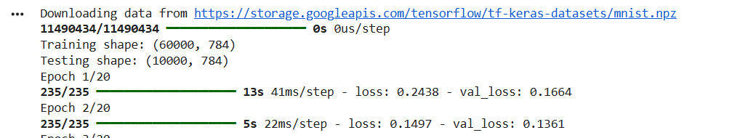

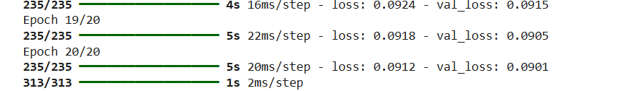

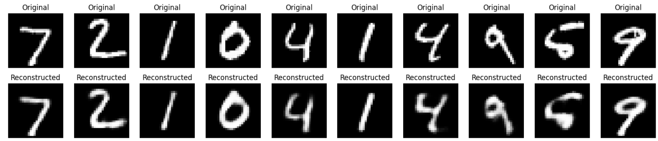
Practical No.9

AIM: Demonstrate recurrent neural network that learns to perform sequence analysis for stock price.(
Code File
# RNN (LSTM) for Stock Price Sequence Prediction
import numpy as np
import matplotlib.pyplot as plt
from keras.models import Sequential
from keras.layers import LSTM, Dense, Dropout
from sklearn.preprocessing import MinMaxScaler
# 1 Generate synthetic stock data
np.random.seed(0)
time_steps = 300
x = np.linspace(0,50,time_steps)
data = np.sin(x) + np.random.normal(scale=0.2,size=time_steps)
data = data.reshape(-1,1)
# 2 Scaling
scaler = MinMaxScaler(feature_range=(0,1))
scaled_data = scaler.fit_transform(data)
# 3 Create sequences
X=[]
y=[]

sequence_length = 60
for i in range(sequence_length,len(scaled_data)):
X.append(scaled_data[i-sequence_length:i,0])
y.append(scaled_data[i,0])
X = np.array(X)
y = np.array(y)
# Reshape for LSTM [samples,time steps,features]
X = np.reshape(X,(X.shape[0],X.shape[1],1))
# 4 Build LSTM model
model = Sequential()
model.add(LSTM(units=50,
return_sequences=True,
input_shape=(X.shape[1],1)))
model.add(Dropout(0.2))
model.add(LSTM(units=50,
return_sequences=True))
model.add(Dropout(0.2))
model.add(LSTM(units=50))
model.add(Dropout(0.2))
model.add(Dense(units=1))
# 5 Compile and train
model.compile(optimizer='adam',
loss='mean_squared_error')
model.fit(X,y,
epochs=20,
batch_size=32,
verbose=1)
# 6 Prediction
predicted = model.predict(X)
predicted = scaler.inverse_transform(predicted)
actual = scaler.inverse_transform(y.reshape(-1,1))
# 7 Plot results
plt.figure(figsize=(12,6))
plt.plot(actual,
color='red',
label='Actual (Synthetic Stock Price)')
plt.plot(predicted,
color='blue',
label='Predicted Price')

plt.title('LSTM Stock Price Prediction (Synthetic Data)')
plt.xlabel('Time')
plt.ylabel('Price')
plt.legend()
plt.grid()
plt.show()
Output:

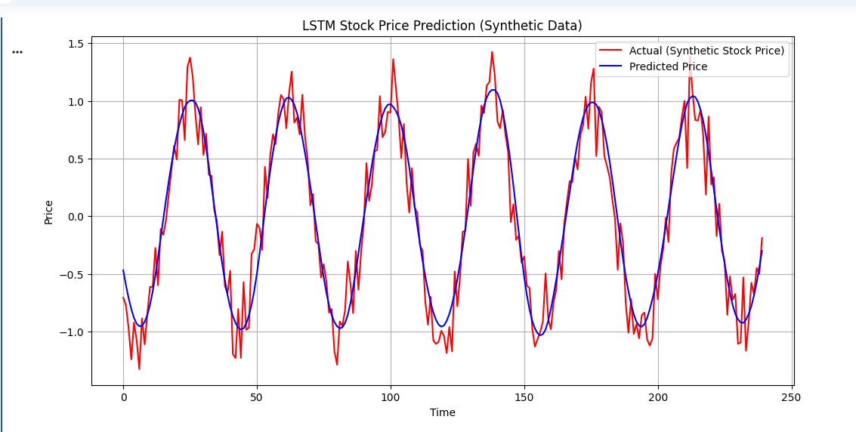

Practical No.10

AIM: Applying Generative Adversarail Newtorks for image generation and unsupervised tasks.
Code File
import tensorflow as tf
from tensorflow.keras import layers
import numpy as np
import matplotlib.pyplot as plt
# -------------------- Load Data --------------------
(x_train, _), _ = tf.keras.datasets.mnist.load_data()
x_train = (x_train.astype('float32') - 127.5) / 127.5 # Normalize [-1,1]
x_train = x_train.reshape(-1, 28, 28, 1)
BATCH_SIZE = 128
dataset = tf.data.Dataset.from_tensor_slices(x_train).shuffle(60000).batch(BATCH_SIZE)
# -------------------- Generator --------------------
def build_generator():
model = tf.keras.Sequential([
layers.Dense(256, activation='relu', input_dim=100),
layers.BatchNormalization(),
layers.Dense(512, activation='relu'),
layers.BatchNormalization(),
layers.Dense(784, activation='tanh'),
layers.Reshape((28, 28, 1))
])
return model
# -------------------- Discriminator --------------------
def build_discriminator():
model = tf.keras.Sequential([
layers.Flatten(input_shape=(28,28,1)),
layers.Dense(512, activation='relu'),
layers.Dense(256, activation='relu'),
layers.Dense(1, activation='sigmoid')
])
return model
generator = build_generator()
discriminator = build_discriminator()

# Compile discriminator
discriminator.compile(optimizer='adam',
loss='binary_crossentropy',
metrics=['accuracy'])
# -------------------- GAN Model --------------------
discriminator.trainable = False
noise_input = tf.keras.Input(shape=(100,))
generated_img = generator(noise_input)
validity = discriminator(generated_img)
gan = tf.keras.Model(noise_input, validity)
gan.compile(optimizer='adam', loss='binary_crossentropy')
# -------------------- Training --------------------
EPOCHS = 5
noise_dim = 100
for epoch in range(EPOCHS):
for real_imgs in dataset:
batch_size = real_imgs.shape[0]
# Train Discriminator
noise = np.random.normal(0,1,(batch_size, noise_dim))
fake_imgs = generator.predict(noise, verbose=0)
d_loss_real = discriminator.train_on_batch(real_imgs, np.ones((batch_size,1)))
d_loss_fake = discriminator.train_on_batch(fake_imgs, np.zeros((batch_size,1)))
# Train Generator
noise = np.random.normal(0,1,(batch_size, noise_dim))
g_loss = gan.train_on_batch(noise, np.ones((batch_size,1)))
print(f"Epoch {epoch+1} | D Loss: {d_loss_real[0]:.4f} | G Loss: {g_loss:.4f}")
# -------------------- Generate Images --------------------
noise = np.random.normal(0,1,(5,100))
generated_images = generator.predict(noise)
plt.figure(figsize=(5,1))
for i in range(5):
plt.subplot(1,5,i+1)
plt.imshow(generated_images[i,:,:,0], cmap='gray')
plt.axis('off')
plt.suptitle("Generated Images")
plt.show()

Output:

