INDEX

Sr No | Practical | Date | Pg. No. | Sign
1 | Develop a secure messaging application where users can exchange messages securely using RSA encryption.  Implement a mechanism for generating RSA key pairs and encrypting/decrypting messages.
2 | Allow users to create multiple transactions and display them in an organised format.
3 | Create a Python class named Transaction with attributes for sender, receiver, and amount. Implement a method within the class to transfer money from the sender's account to the receiver's account.
4 | Implement a function to add new blocks to the miner and dump the blockchain.
5 | Write a python program to demonstrate mining.
6 | Write a Solidity program that demonstrates various types of functions including regular functions, view functions, pure functions, and the fallback function.
7 | Write a Solidity program that demonstrates function overloading, mathematical functions, and cryptographic functions.
8 | Write a Solidity program that demonstrates various features including contracts, inheritance, constructors, abstract contracts, interfaces.
9 | Write a Solidity program that demonstrates use of libraries, assembly, events, and error handling.

Practical 1
Aim :- Develop a secure messaging application where users can exchange messages securely using RSA encryption. Implement a mechanism for generating RSA key pairs and encrypting/decrypting messages.
Code :
# Install cryptography if not already installed
!pip install cryptography

from cryptography.hazmat.primitives.asymmetric import rsa, padding from cryptography.hazmat.primitives import serialization, hashes import base64

# Function to generate RSA key pairs def generate_rsa_key_pair():
private_key = rsa.generate_private_key(public_exponent=65537, key_size=2048) public_key = private_key.public_key()
return private_key, public_key

# Function to serialize keys
def serialize_keys(private_key, public_key): priv_pem = private_key.private_bytes(
encoding=serialization.Encoding.PEM, format=serialization.PrivateFormat.PKCS8, encryption_algorithm=serialization.NoEncryption()
)
pub_pem = public_key.public_bytes( encoding=serialization.Encoding.PEM, format=serialization.PublicFormat.SubjectPublicKeyInfo
)
return priv_pem, pub_pem

# Encrypt a message using public key
def encrypt_message(public_key, message): encrypted = public_key.encrypt(
message.encode(), padding.OAEP(
mgf=padding.MGF1(algorithm=hashes.SHA256()), algorithm=hashes.SHA256(),
label=None
)
)
return base64.b64encode(encrypted).decode() # Decrypt a message using private key
def decrypt_message(private_key, encrypted_message): decrypted = private_key.decrypt(
base64.b64decode(encrypted_message), padding.OAEP(

mgf=padding.MGF1(algorithm=hashes.SHA256()), algorithm=hashes.SHA256(),
label=None
)
)
return decrypted.decode()

# Simulating two users: Alice and Bob print("Generating RSA key pairs for Alice and Bob...") alice_private, alice_public = generate_rsa_key_pair() bob_private, bob_public = generate_rsa_key_pair()

# Alice sends a message to Bob
message_from_alice = "Hi Bob, this is Alice. The message is secure!" print("\nOriginal message from Alice:", message_from_alice)

encrypted_message = encrypt_message(bob_public, message_from_alice) print("Encrypted message (sent to Bob):", encrypted_message)

# Bob decrypts the message
decrypted_message = decrypt_message(bob_private, encrypted_message) print("Decrypted message by Bob:", decrypted_message)

Output:
Requirement already satisfied: cryptography in /usr/local/lib/python3.11/dist-packages (43.0.3)
Requirement already satisfied: cffi>=1.12 in /usr/local/lib/python3.11/dist-packages (from cryptography) (1.17.1)
Requirement already satisfied: pycparser in /usr/local/lib/python3.11/dist-packages (from cffi>=1.12->cryptography) (2.22)
Generating RSA key pairs for Alice and Bob...
Original message from Alice: Hi Bob, this is Alice. The message is secure! Encrypted message (sent to Bob):
KGlFiU+Y9e1x0C0prVI1CLMr0hHQZqYygLv/EcXM2Sp8vSBeG7bgcK0u4/+UgpT+UmK vdOaH+NC/pIemG4yPINiaYx3G+Uh9GTTHJDpDWvCxdqjEDvdYTJVQE2uKxgvLLPNc OhenKxogCriQqG81biZnofxXpbq225k9UFlIVvKTcdAb52PSTsPTOy6vWso+HrkhmnIAH gbd0E/FJVh68KuiIQdZ8mmu1U7E9qqOOGot6qPsQZAdL0sHyc3Kl9kgLSLerZ3lwn3KcU Fekb5hbXyqOCI3jgxP7L8a1zuDvusWxhThy1/+T194y9+Mj7m2haX3iOONXTfXx1B3Dbv B8Q==
Decrypted message by Bob: Hi Bob, this is Alice. The message is secure!

Practical 2
Aim:- Allow users to create multiple transactions and display them in an organised format.
Code:
!pip install pandas import pandas as pd transactions = []
def create_transaction(sender, receiver, amount, description=""): transaction = {
"Sender": sender, "Receiver": receiver, "Amount": amount, "Description": description
}
transactions.append(transaction)
print("✅ Transaction recorded successfully!")

def display_transactions(): if transactions:
df = pd.DataFrame(transactions) print("\n📄 All Transactions:") display(df)
else:
print("⚠️ No transactions found.")

# Example usage
create_transaction("Alice", "Bob", 150, "Payment for services") create_transaction("Bob", "Charlie", 75, "Dinner split") create_transaction("Charlie", "Alice", 25, "Coffee refund")

# Display all transactions display_transactions()

Output:
Requirement already satisfied: pandas in /usr/local/lib/python3.11/dist-packages (2.2.2) Requirement already satisfied: numpy>=1.23.2 in /usr/local/lib/python3.11/dist-packages (from pandas) (2.0.2)
Requirement already satisfied: python-dateutil>=2.8.2 in /usr/local/lib/python3.11/dist-packages (from pandas) (2.9.0.post0)
Requirement already satisfied: pytz>=2020.1 in /usr/local/lib/python3.11/dist-packages (from pandas) (2025.2)

Requirement already satisfied: tzdata>=2022.7 in /usr/local/lib/python3.11/dist-packages (from pandas) (2025.2)
Requirement already satisfied: six>=1.5 in /usr/local/lib/python3.11/dist-packages (from python-dateutil>=2.8.2->pandas) (1.17.0)
⬛✓⬛ Transaction recorded successfully!
✓⬛⬛ Transaction recorded successfully!
✓⬛ Transaction recorded successfully!

´f All Transactions:

Sender | Receiver | Amount | Description
0 Alice | Bob | 150 | Payment for services
1 Bob | Charlie | 75 | Dinner split
2 Charlie | Alice | 25 | Coffee refund

Practical 3
Aim:- Create a Python class named Transaction with attributes for sender, receiver, and amount. Implement a method within the class to transfer money from the sender's account to the receiver's account.
Code:
# Simulate user accounts with balances accounts = {
"Alice": 500,
"Bob": 300,
"Charlie": 200
}

# Transaction class definition class Transaction:
def init (self, sender, receiver, amount): self.sender = sender
self.receiver = receiver self.amount = amount

def transfer(self):
# Check if users exist
if self.sender not in accounts or self.receiver not in accounts: print("❌ Either sender or receiver account doesn't exist.") return

# Check for sufficient funds
if accounts[self.sender] < self.amount:
print(f"❌ Insufficient funds in {self.sender}'s account.") return

# Perform transfer accounts[self.sender] -= self.amount accounts[self.receiver] += self.amount
print(f"✅ {self.amount} transferred from {self.sender} to {self.receiver}.")

# Example usage
print("💰 Initial account balances:", accounts)

# Create transactions
t1 = Transaction("Alice", "Bob", 100) t1.transfer()

t2 = Transaction("Bob", "Charlie", 50) t2.transfer()

t3 = Transaction("Charlie", "Alice", 300) # This should fail due to insufficient funds


t3.transfer()

print("\n Final account balances:", accounts)

Output:
💰 Initial account balances: {'Alice': 500, 'Bob': 300, 'Charlie': 200}
✅ 100 transferred from Alice to Bob.
✅ 50 transferred from Bob to Charlie.
❌ Insufficient funds in Charlie's account.

 Final account balances: {'Alice': 400, 'Bob': 350, 'Charlie': 250}

Practical 4
Aim:- Implement a function to add new blocks to the miner and dump the blockchain. Code:
import hashlib import time import json

# Block class class Block:
def init (self, index, previous_hash, timestamp, data, nonce=0): self.index = index
self.previous_hash = previous_hash self.timestamp = timestamp self.data = data
self.nonce = nonce
self.hash = self.calculate_hash()

def calculate_hash(self): block_string =
f"{self.index}{self.previous_hash}{self.timestamp}{json.dumps(self.data)}{self.nonce}" return hashlib.sha256(block_string.encode()).hexdigest()

# Blockchain class class Blockchain:
def init (self):
self.chain = [self.create_genesis_block()]
self.difficulty = 4 # Number of leading zeros in the hash

def create_genesis_block(self):
return Block(0, "0", time.time(), "Genesis Block")

def get_latest_block(self): return self.chain[-1]

def mine_block(self, data): previous_block = self.get_latest_block() index = previous_block.index + 1 timestamp = time.time()
nonce = 0

print(f"⛏️ Mining block #{index}...")

new_block = Block(index, previous_block.hash, timestamp, data, nonce) while not new_block.hash.startswith('0' * self.difficulty):
new_block.nonce += 1
new_block.hash = new_block.calculate_hash()

self.chain.append(new_block)
print(f"✅ Block #{index} mined: {new_block.hash}")

def dump_chain(self):
print("\n📦 Blockchain Dump:") for block in self.chain:
print({
'Index': block.index,
'Previous Hash': block.previous_hash,
'Timestamp': time.strftime('%Y-%m-%d %H:%M:%S', time.localtime(block.timestamp)),
'Data': block.data, 'Nonce': block.nonce, 'Hash': block.hash
})

# Create the blockchain my_blockchain = Blockchain()

# Add (mine) blocks
my_blockchain.mine_block({"sender": "Alice", "receiver": "Bob", "amount": 50}) my_blockchain.mine_block({"sender": "Bob", "receiver": "Charlie", "amount": 25}) my_blockchain.mine_block({"sender": "Charlie", "receiver": "Alice", "amount": 10})

# Dump the entire blockchain my_blockchain.dump_chain()

Outpput:
⛏️ Mining block #1...
✅ Block #1 mined: 0000037cc25274fa244cc6e1af1fdd6afa8aa6fd901d5c3889e9372b88e1c9ac
⛏️ Mining block #2...
✅ Block #2 mined: 00002bae30c62e2b6c2194ad790c0988af3a787656194d1023ee8bb20bc4eb68
⛏️ Mining block #3...
✅ Block #3 mined: 00007bd9b89e93898220a22f0b1674089558dccaed8b0e4ea54c8217175fb424
📦 Blockchain Dump:
{'Index': 0, 'Previous Hash': '0', 'Timestamp': '2025-05-07 03:01:35', 'Data': 'Genesis Block',
'Nonce': 0, 'Hash': '5b0087d56d98b0a8caf97c28ee28ff434bc984c9708842361d5a0725a0b15fac'}
{'Index': 1, 'Previous Hash': '5b0087d56d98b0a8caf97c28ee28ff434bc984c9708842361d5a0725a0b15fac', 'Timestamp': '2025-05-07 03:01:35', 'Data': {'sender': 'Alice', 'receiver': 'Bob', 'amount': 50}, 'Nonce': 11545, 'Hash': '0000037cc25274fa244cc6e1af1fdd6afa8aa6fd901d5c3889e9372b88e1c9ac'}
{'Index': 2, 'Previous Hash': '0000037cc25274fa244cc6e1af1fdd6afa8aa6fd901d5c3889e9372b88e1c9ac', 'Timestamp':

'2025-05-07 03:01:36', 'Data': {'sender': 'Bob', 'receiver': 'Charlie', 'amount': 25}, 'Nonce': 37227, 'Hash':
'00002bae30c62e2b6c2194ad790c0988af3a787656194d1023ee8bb20bc4eb68'}
{'Index': 3, 'Previous Hash': '00002bae30c62e2b6c2194ad790c0988af3a787656194d1023ee8bb20bc4eb68', 'Timestamp': '2025-05-07 03:01:36', 'Data': {'sender': 'Charlie', 'receiver': 'Alice', 'amount': 10}, 'Nonce': 100290, 'Hash': '00007bd9b89e93898220a22f0b1674089558dccaed8b0e4ea54c8217175fb424'}

Practical 5 Aim:- Write a python program to demonstrate mining. Code:
import hashlib import time

# Define the mining function
def mine_block(block_data, difficulty): prefix_str = '0' * difficulty
nonce = 0
start_time = time.time()

print("⛏️ Starting mining...") while True:
text = f"{block_data}{nonce}"
hash_result = hashlib.sha256(text.encode()).hexdigest() if hash_result.startswith(prefix_str):
end_time = time.time()
print(f"✅ Block mined successfully!") print(f"🔢 Nonce: {nonce}") print(f"🔐 Hash: {hash_result}")
print(f"⏱️ Time taken: {end_time - start_time:.2f} seconds") break
nonce += 1

# Example usage
block_data = "Alice pays Bob 10 BTC" difficulty = 4 # Increase for higher difficulty

mine_block(block_data, difficulty)

Output:
⛏️ Starting mining...
✅ Block mined successfully!
🔢 Nonce: 2040
🔐 Hash: 000077330197cd1a3f60c19a7990fa2b8ee23911e7d378d6e37d7d5d11d10b21
⏱️ Time taken: 0.01 seconds

Practical 6
Aim:- Write a Solidity program that demonstrates various types of functions including regular functions, view functions, pure functions, and the fallback function.
Code:
// SPDX-License-Identifier: MIT pragma solidity ^0.8.0;
contract FunctionTypesDemo { uint public count;
string public message; constructor() {
count = 0;
message = "Hello, Ethereum!";
}
// Regular function: modifies the contract state function incrementCount() public {
count += 1;
}
// View function: reads state but does not modify it function getCount() public view returns (uint) {
return count;
}
// Pure function: does not read or modify state function add(uint a, uint b) public pure returns (uint) {
return a + b;
}
// Fallback function: called when no other function matches or when plain ether is sent fallback() external payable {
message = "Fallback function called";

}
// Receive function: explicitly handles plain Ether transfers receive() external payable {
message = "Receive function called";
}
}
Output

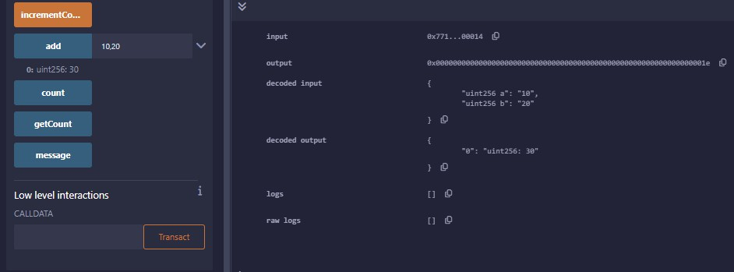
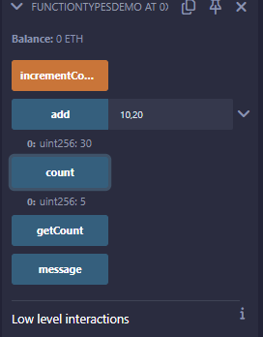
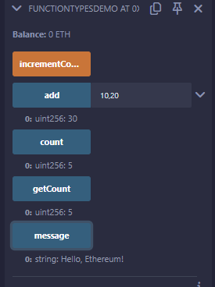

Practical 7
Aim: Write a Solidity program that demonstrates function overloading, mathematical functions, and cryptographic functions.
Code:
// SPDX-License-Identifier: MIT pragma solidity ^0.8.0;
contract AdvancedFunctionDemo {
// State variable uint public result;
// --- Function Overloading ---
// Overload 1: adds two numbers
function calculate(uint a, uint b) public pure returns (uint) { return a + b;
}
// Overload 2: adds three numbers
function calculate(uint a, uint b, uint c) public pure returns (uint) { return a + b + c;
}
// --- Mathematical Operations ---
function multiply(uint a, uint b) public pure returns (uint) { return a * b;
}
function divide(uint a, uint b) public pure returns (uint) { require(b != 0, "Division by zero");
return a / b;
}
function power(uint base, uint exponent) public pure returns (uint) { return base ** exponent;
}
// --- Cryptographic Hash Functions ---
function getKeccak256(string memory input) public pure returns (bytes32) {

return keccak256(abi.encodePacked(input));
}
function getSha256(string memory input) public pure returns (bytes32) { return sha256(abi.encodePacked(input));
}
function getRipemd160(string memory input) public pure returns (bytes20) { return ripemd160(abi.encodePacked(input));
}
// --- ecrecover Example (Signature Verification) ---
// This recovers the signer address from a message and its signature
function recoverSigner(bytes32 messageHash, uint8 v, bytes32 r, bytes32 s) public pure returns (address) {
return ecrecover(messageHash, v, r, s);
}
// Utility function to hash a message in Ethereum style (with prefix)
function getEthSignedMessageHash(string memory message) public pure returns (bytes32)
{
bytes32 msgHash = keccak256(abi.encodePacked(message));
return keccak256(abi.encodePacked("\x19Ethereum Signed Message:\n32", msgHash));
}
}

Output:
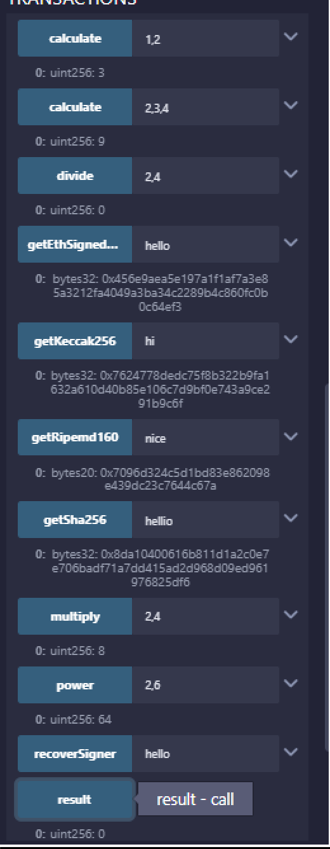

Practical 8
Aim: Write a Solidity program that demonstrates various features including contracts, inheritance, constructors, abstract contracts, interfaces.
Code:
// SPDX-License-Identifier: MIT pragma solidity ^0.8.0;
//
// Interface: Defines external interaction
//
interface IVehicle {
function startEngine() external pure returns (string memory);
}
//
// Abstract Contract: Provides base logic
//
abstract contract Machine { string public manufacturer;
constructor(string memory _manufacturer) { manufacturer = _manufacturer;
}
function getManufacturer() public view returns (string memory) { return manufacturer;
}
// Abstract method to be implemented in derived contracts function operate() public view virtual returns (string memory);
}
//
// Base Contract: Implements abstract and interface
//
contract Car is Machine, IVehicle { string public model;

constructor(string memory _manufacturer, string memory _model) Machine(_manufacturer)
{
model = _model;
}
// Implementing abstract method
function operate() public view override returns (string memory) { return string(abi.encodePacked("Driving ", model));
}
// Implementing interface method
function startEngine() public pure override returns (string memory) { return "Engine started";
}
function getCarInfo() public view returns (string memory, string memory) { return (manufacturer, model);
}
}

//
// Derived Contract: Inherits from Car
//
contract ElectricCar is Car { uint public batteryLevel; constructor(
string memory _manufacturer, string memory _model,
uint _batteryLevel
) Car(_manufacturer, _model) { batteryLevel = _batteryLevel;
}

function recharge() public { batteryLevel = 100;
}
function getElectricCarInfo() public
view
returns (string memory, string memory, uint)
{
return (manufacturer, model, batteryLevel);
}
}
Output :
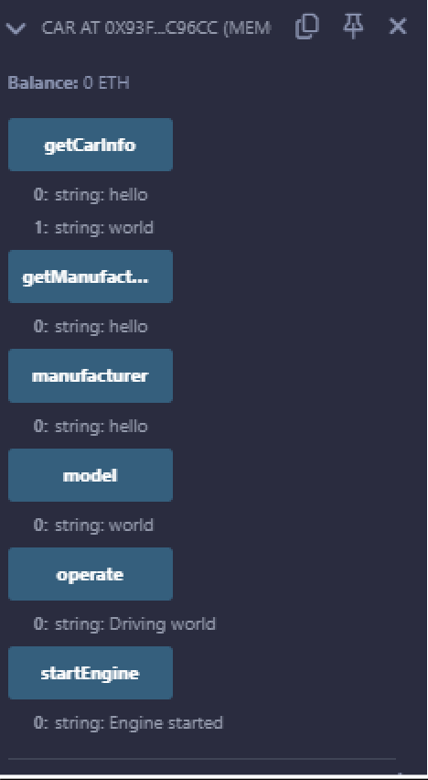

Practical 9
Aim: Write a Solidity program that demonstrates use of libraries, assembly, events, and error handling.
Code:
// SPDX-License-Identifier: MIT pragma solidity ^0.8.0;

//
// Library: Utility functions
//
library MathLib {
function square(uint x) internal pure returns (uint) { return x * x;
}
function cube(uint x) internal pure returns (uint) { return x * x * x;
}
}

//
// Main Contract
//
contract AdvancedFeatures { using MathLib for uint;

uint public result;

//
// Events
//
event Computed(string operation, uint value);

event ErrorHandled(string reason);
//
// Custom Error
//
error DivisionByZero();
error UnderflowError(uint a, uint b);

//
// Function using a Library
//
function computeSquare(uint x) public { result = x.square();
emit Computed("square", result);
}
function computeCube(uint x) public { result = x.cube();
emit Computed("cube", result);
}
//
// Function with Inline Assembly
//
function multiplyAssembly(uint a, uint b) public returns (uint product) { assembly {
product := mul(a, b)
}
result = product;
emit Computed("assemblyMultiply", result);
}
//
// Function with Error Handling

//
function safeDivide(uint a, uint b) public returns (uint) { if (b == 0) {
emit ErrorHandled("Division by zero attempted"); revert DivisionByZero();
}
result = a / b;
emit Computed("safeDivide", result); return result;
}
function safeSubtract(uint a, uint b) public returns (uint) { if (b > a) {
emit ErrorHandled("Underflow detected"); revert UnderflowError(a, b);
}
result = a - b;
emit Computed("safeSubtract", result); return result;
}
}
Output :
