**Optimizing Route Selection for Tuk-Tuk Travelers between Sri Lanka’s Cultural UNESCO World Heritage Sites**

Rumesh Dilshan Priyadarshana 1 and Sandun Dassanayake1

1 Department of Decision Science, University of Moratuwa, Sri Lanka

**Abstract.**

Tourists who often visit Sri Lanka to experience cultural‐heritage typically explore the island through ad-hoc tuk-tuk excursions that lead to longer travel distances, fuel consumption, and visitor fatigue. This study employs travelling salesperson problems (TSP) to optimize the tuk-tuk travel plan linking six UNESCO-listed sites and the Bandaranaike International Airport. To this end, the geographic coordinates were extracted from OpenStreetMap, and road-network distances were computed with the Open-Source Routing Machine. An exact integer-linear-programming formulation, solved with the evolutionary solver in Microsoft Excel, yielded a 792 km optimal loop approximately 17 % shorter than the benchmark loop recommended by commercial tour operators. Beyond immediate fuel and CO₂ savings, the proposed method offers a reproducible template for data-poor destinations: all code and GIS layers are openly released to facilitate replication and rapid customization by local stakeholders. The study shows that modest data collection coupled with off-the-shelf optimization can deliver tangible sustainability gains in emerging-economy tourism networks while enhancing traveler experience.

**Keywords:** Cultural Heritage Tourism, Tuk-tuk Accessibility, Travel Salesman Problem (TSP), Decision Support System, Route Optimization.

# Introduction

Sri Lanka is a popular tourist destination that contains six UNESCO-listed cultural world heritage sites that serve as major attractions. The tourism industry of this island nation contributed to 4.9% of the country’s GDP in 2023 [1]. The country attracts international tourists who travel focusing on experiencing places, artifacts, and activities that authentically represent the stories and people of the past[2-3]. These tourists who belong to cultural tourism typically face persistent accessibility challenges, especially when relying on affordable transportation mediums like tuk-tuks (i.e., three-wheel drives). Tuk-tuks have emerged as a primary mode of transport for tourists in Sri Lanka due to their affordability, flexibility, and ability to navigate narrow roads [4]. Unlike formal transport systems, tuk-tuk provides door-to-door services and offer personalized itineraries, making them ideal for tourists exploring multiple heritage sites. A primary issue is inefficient route planning, as most drivers rely on experience-based navigation rather than data-driven optimization, resulting in unnecessary long travel times and increased fuel costs [5].

Sri Lanka’s national road network comprises expressways, A-class, and B-class roads (Figure 01) [6]. Tuk-tuks are restricted on expressways and face difficulties on B-class roads due to lack of the capacity to support efficient long-distance travel due to narrow widths, poor surface conditions, and frequent interruption.

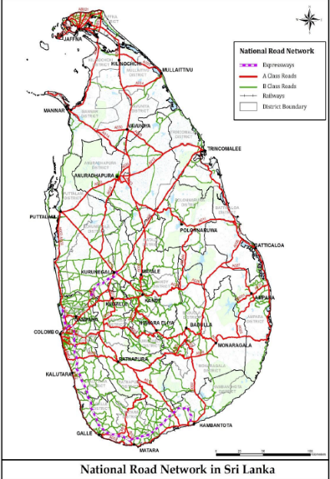

**Fig. 1.** National Road Network in Sri Lanka

Most tuk-tuks lack basic accessibility features to support differently abled or elderly travelers, which reduces inclusivity in heritage tourism experiences [7]. Furthermore, there remains a significant gap in designed to support trip planning across multiple heritage destinations. A decision support system (DSS), which is an interactive software-based tool that assists decision makers in identifying problems, evaluating data and models, and formulating optimal solutions, can address this gap by optimizing multi destination heritage trips via tuk-tuks [8].

**Table 1** Road Classification and Tuk-tuk Viability

|  |  |  |  |
| --- | --- | --- | --- |
| **Road type** | **Function** | **Key issues** | **Tuk-tuk suitability** |
| Expressways | High-speed intercity links | Legal prohibition and minimum speed requirements | Inaccessible |
| A-class | Primary inter-district | Moderate congestion | Optimal focus |
| B-class | Rural/local connectors | Narrow widths, poor conditions | Last mile only |

To maximize the potential of this A-class network, various route optimization techniques were evaluated. Dijkstra’s algorithm, though historically significant and widely used for calculating the shortest path to a single destination [9], lacks flexibility in managing multi-stop itineraries, which are essential in heritage tourism circuits. Genetic algorithms, as demonstrated in Malaysian heritage tourism applications, have shown success in evolving adaptive routes that respond to fluctuating traffic patterns. However, their computational demands pose challenges for real-time tuk-tuk navigation, which requires lightweight, efficient solutions. Ant colony optimization techniques, effectively utilized in managing cultural site traffic in urban space [10], depend on high-density node data for optimal performance. Given the limitation inherent in these approaches, the TSP emerges as the most suitable solution. The TSP, a well-established optimization model, offers an effective framework for determining the most efficient routes that connect all cultural heritage sites while minimizing overall travel distance [11]. By implementing a TSP-based route optimization system specifically reductions in both travel time and fuel consumption, improved tourists’ experiences through minimized detours, and the promotion of sustainable tourism practices via lower carbon emissions.

The study aims to develop a decision-support system that utilizes the TSP algorithm to generate and recommend the most efficient tuk-tuk travel routes between UNESCO cultural heritage sites in Sri Lanka with the goal of reducing total travel distance compared to current manually planned routes.

# Literature Review

* 1. **Tourism and Its Classification**

Tourism is a multifaceted global phenomenon that encompasses a wide range of activities related to travel for leisure, business, education, health, culture, and more. The United Nations World Tourism Organization defines tourism as the activities of people travelling to and staying in places outside their usual environment for not more than one consecutive year for leisure, business, or other purposes [12]. The tourism industry is generally classified into several types, including leisure tourism, business tourism, ecotourism, medical tourism, religious tourism, and cultural tourism, each of which offers unique motivations and experiences for travelers. Meanwhile, cultural tourism has gained increasing recognition for its role in promoting sustainable development, preserving heritage, and fostering cross-cultural understanding.

* 1. **Cultural Heritage Tourism**

Cultural heritage tourism has emerged as a significant sector within the tourism industry. Tourists are becoming more interested in learning about a destination's local history, culture, and heritage, resulting in a significant increase in cultural and heritage tourism trends [13]. Cultural Tourism can be defined as: “visits by people outside the host community motivated as a whole or partly by their interests in historical, artistic, scientific, or lifestyle offerings, of a community, region group or an institution” [14]. According to the Sri Lanka Tourism Development Authority (SLTDA), Annual Statistical Report 2023, the purpose of the visit Sri Lanka for cultural and religious factors was identified as 0.2% by the international tourists.

* 1. **UNESCO Cultural World Heritage Sites in Sri Lanka**

The United Nations Educational, Scientific and Cultural Organization (UNESCO) defines a World Heritage site as a landmark of outstanding universal value recognized for its cultural, historical, or scientific, or natural importance and legally protected under international treaties [15]. The designation process considers criteria such as representing a masterpiece of human creative genius, bearing testimony to cultural traditions, or containing exceptional natural beaty [16].

According to the Convention, Cultural heritage defines architectural works, monumental sculptures, archaeological structures, inscriptions, cave dwellings, and combinations of features of outstanding universal value in history, art, or science. It also includes groups of buildings, sites, and works of man and nature, including archaeological sites, of outstanding universal value [15].

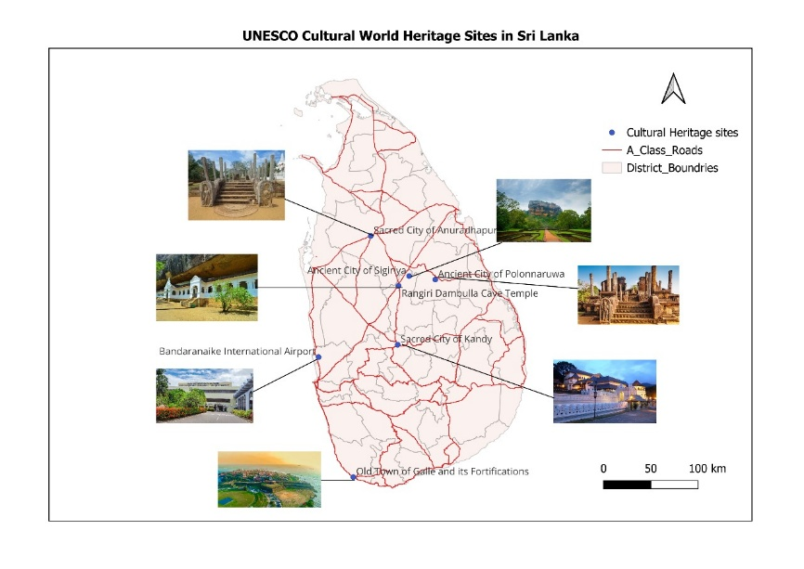

**Fig. 2**. UNESCO Cultural World Heritage Sites in Sri Lanka

Sri Lanka’s Six Cultural World Heritage Sites (Fig. 2.) each embody profound historical, religious, and architectural value. These include the Ancient City of Anuradhapura which serve as a major Buddhist pilgrimage site; Ancient City of Polonnaruwa from 11th to 13th centuries; Sacred City of Kandy (16th-19th century), which home to the Temple of the Tooth Relic; Old Town of Galle and its Fortifications (16th century); Golden Temple of Dambulla (1st century BCE).

Sigiriya Rock Fortress (5th century).

Despite their significance, poor transport connection between these sites remains a major challenge accessibility [17].

* 1. **Accessibility In Tourism**

A Digital Revolution in Pieria, Greece highlights the critical role of accessibility in shaping the tourism experience for travelers [18]. Several authors have written review articles on accessibility measures, often focusing on specific perspectives, such as wheelchair accessibility [7], public transport accessibility [5], but tuk-tuk-specific route optimization remains under-researched. However, in this context, “Accessibility” refers to the ease with which people can reach desired destinations using available transportation networks, considering factors such as time, cost, and convenience [19].

* 1. **Sri Lanka’s Road Infrastructure and Heritage Accessibility**

Sri Lanka’s Road hierarchy presents distinct advantages and limitations for tuk-tuk travel. Expressways, though efficient, exclude tuk-tuks by design, relegating heritage tourists to slower, circuitous routes. B-Class roads, while critical for last-mile connectivity to sites like Sigiriya or Dambulla, are often unsuitable for optimized long-distance travel due to uneven surfaces, congestion, and lack of signage [6]. A-Class roads, however, strike a unique balance: they are legally accessible to tuk-tuks, connect all major cultural hubs, and offer better maintenance and capacity than B-Class routes. For instance, the A1 (Colombo-Kandy) and A6 (Puttalam-Trincomalee) corridors from vital links between UNESCO sites but suffer from suboptimal routing information for tuk-tuk drivers. Prioritizing a-Class roads in TSP optimization thus address the most practical network for heritage tourism, leveraging infrastructure that is both legally permissible and operationally feasible for three-wheelers. Remote sensing and GIS in change detection.

* 1. **Remote Sensing and GIS in Change Detection**

Tuk-tuk, also known as rickshaw, trishaw, or moto taxi, is a popular mode of transportation in Asia, particularly in Sri Lanka, particularly for short-distance travel, owing to their unique advantages in local context [4]. However, there are several challenges hinder their full potential as an ideal transport solution. The absence of a standardized fare system leads to price variations based on negotiation, while the lack of optimized routing systems results in drivers frequently taking inefficient paths that increase travel time and costs.

Most tuk-tuk drivers rely on experience rather than optimized navigation, leading to longer travel times and higher costs. Perhaps most significantly, the majority of tuk-tuks lack basic accessibility features, rendering them largely unsuitable for wheelchair users and other travelers with mobility challenges, thereby limiting their inclusivity as a transportation option. These limitations present both challenges and opportunities for improving Sri Lanka's transportation infrastructure to better serve both local commuters and international tourists.

* 1. **The Travel Salesman Problem (TSP) in Route Optimization**

TSP is a fundamental optimization challenge, focusing on determining the most efficient route to visit predefined UNESCO Cultural Heritage sites, exactly once before returning to the starting point [11]. TSP-based solutions have been successfully implemented in tourism logistics and transportation planning, reducing fuel consumption and operational costs. When applied to Sri Lanka's tuk-tuk-based heritage tourism, TSP optimization offers transformative benefits, such as minimizing travel distances between sites, reducing direct costs for drivers and tourists, and enhancing the overall tourist experience by eliminating circuitous routes and unnecessary detours. However, the implementation of TSP solutions for tuk-tuk routes presents unique considerations, such as varying road quality, seasonal traffic patterns, and physical limitations of tuk-tuks. Recent advances in mobile computing and GPS technology make this an ideal time to implement such systems, allowing drivers and tourists to access optimized routes through smartphone applications in real-time. This application of TSP principles could serve as a model for similar heritage tourism destinations in developing countries, demonstrating how algorithmic optimization can enhance accessibility and promote sustainable tourism practices.

# Methodology

This study adopts a data-driven, optimization-oriented research methodology focused exclusively on secondary data sources to assess and enhance tuk-tuk accessibility among Sri Lanka’s six UNESCO cultural world heritage sites. The selected sites include the Ancient City of Anuradhapura (4th century BCE), Ancient City of Polonnaruwa (11th-13th century), Sacred City of Kandy (16th-19th century), Old Town of Galle and its Fortifications (16th century), Golden Temple of Dambulla (1st century BCE), Sigiriya Rock Fortress (5th century).

The study utilizes the publicly available geospatial dataset, which contains detailed attributes of Sri Lanka’s national road network. The dataset was processed in QGIS to extract and filter road segments by type. Roads tagged as “trunk” were classified as A-class roads, while “primary” roads were categorized as B-class roads [6]. The methodology prioritizes A-class roads as the core network for routes optimization. This decision is supported by literature highlighting the compatibility of A-class roads with tuk-tuk travel, particularly for tourism routes connecting heritage sites [6-7].

* 1. **Node Identification and Distance Matrix Construction**

A distance matrix was conducted by calculating the real-world road distance (in kilometers) between each of the six heritage sites using the filtered A-class road network using precise measurements obtained through Google Maps API.

**Table 2** Distance Matrix from Katunayake Airport to UNESCO World Heritage Sites (KM)

|  |  |  |  |  |  |  |  |
| --- | --- | --- | --- | --- | --- | --- | --- |
|  | 0  Katunayake Airport | 1  Sacred City of Anuradhapura | 2  Sacred City of Polonnaruwa | 3  Golden Temple of Dambulla | 4  Ancient City of Sigiriya | 5  Southern City of Galle | 6  Sacred City of Kandy |
| 0  Katunayake Airport | 0 | 169 | 195 | 128 | 145 | 148 | 105 |
| 1  Sacred City of Anuradhapura | 169 | 0 | 101 | 65 | 72 | 309 | 138 |
| 2  Sacred City of Polonnaruwa | 195 | 101 | 0 | 67 | 52 | 330 | 140 |
| 3  Golden Temple of Dambulla | 128 | 65 | 67 | 0 | 19 | 262 | 73 |
| 4  Ancient City of Sigiriya | 145 | 72 | 52 | 19 | 0 | 279 | 92 |
| 5  Southern City of Galle | 148 | 309 | 330 | 262 | 279 | 0 | 230 |
| 6  Sacred City of Kandy | 105 | 138 | 140 | 73 | 92 | 230 | 0 |

* 1. **Problem Formulation**

Let $V=\{v_{0}, v_{1},v_{2},…,v_{6}\}$ be the set of the nodes and $C_{ij}$ be the distance between node $i$ and node $j$. The binary decision variable $X_{ij}$ is defined as:

$$\begin{aligned}X_{ij }=\left\{\begin{aligned}1, if the tour travels directly from node i to node j \\ 0, otherwise\end{aligned}\right.\#\left(1\right)\end{aligned}$$

Objective:

$$\begin{aligned}min\sum_{i = 0}^{6}{\sum_{{j = 0 \atop j ≠ i}}^{6}{C_{ij}X_{ij}}}\#\left(2\right)\end{aligned}$$

Subjects to the constraints:

Each node must be entered once:

$$\begin{aligned}\sum_{{i = 0 \atop i ≠ j}}^{6}{X_{ij }= 1 ∀j ∈ V}\#\left(3\right)\end{aligned}$$

Each node must be exited once:

$$\begin{aligned}\sum_{{j = 0 \atop j ≠ i}}^{6}{X_{ij }= 1 ∀i ∈ V}\#\left(4\right)\end{aligned}$$

Subtour elimination:

Let $u_{i}$ denote the visit order of node $I$ with bounds $1 ≤ u_{i} ≤ 6$ and $u_{0 }= 0$:

$$\begin{aligned}u_{i }-u_{j}+7X_{ij}≤6∀_{i}≠j,i,j∈1,…,6\#\left(5\right)\end{aligned}$$

Binary variable condition

$$\begin{aligned}X_{ij}∈0,1∀_{i}≠j,i,j∈V\#\left(6\right)\end{aligned}$$

This model guarantees a single optimal closed-loop route that meets all problem constraints and is suitable for tuk-tuk travel.

* 1. **TSP Algorithm Implementation**

To solve the traveling salesman problem, which was formulated to optimize tuk-tuk tourist routes between cultural heritage sites in Sri Lanka, this study used the Evolutionary Solver in Microsoft Excel. This solver applies to a metaheuristic evolutionary algorithm approach with the following parameters: a population size of 100, mutation rate of 0.075, convergence tolerance of 0.0001, and a maximum runtime of 5 minutes. These settings ensure a balance between exploration and convergence speed. Although an exact integer linear programming solver such as CBC can solve a 7-node problem within milliseconds, the Excel Solver was chosen for its accessibility and transparency for non-specialist users. To ensure reproducibility, all associated materials include the spreadsheet implementation, distance matrix, and route output are publicly available in a GitHub repository <https://github.com/RumeshDilshan/Research>. This enables other researchers and practitioners to replicate, audit, or extend the findings with ease.

# Results and Discussion

The analysis employed a TSP model to determine the most efficient travel route for tuk-tuk travelers starting and ending at Katunayake Airport while visiting Sri Lanka’s six UNESCO cultural world heritage sites.

Using the TSP optimization, and optimal route was identified that minimizes the cumulative distance while ensuring each heritage site is visited exactly once. The optimized tour was as follows (Fig.3.):

Katunayake Airport (Node 0) → Southern City of Galle (Node 5) → Sacred City of Kandy (Node 6) → Golden Temple of Dambulla (Node 3) → Ancient City of Sigiriya (Node 4) → Sacred City of Polonnaruwa (Node 2) → Sacred City of Anuradhapura (Node 1) → back to Katunayake Airport (Node 0)

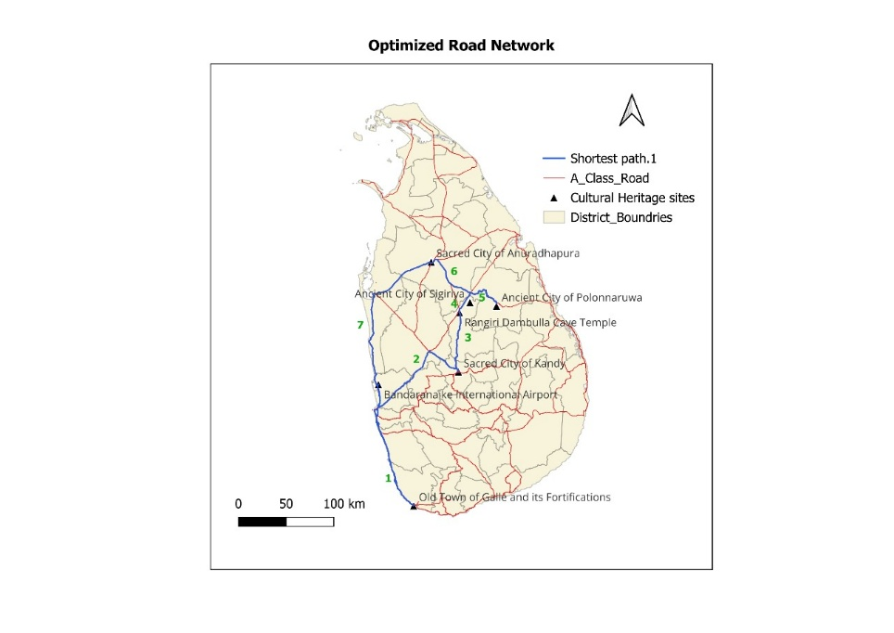

**Fig. 3.** Optimized route network

**Table 3** Optimized Route Network Calculation using TSP.

|  |  |  |
| --- | --- | --- |
| **From** | **To** | **Distance** |
| 0 | 5 | 148 |
| 5 | 6 | 230 |
| 6 | 3 | 73 |
| 3 | 4 | 19 |
| 4 | 2 | 52 |
| 2 | 1 | 101 |
| 1 | 0 | 169 |
| **Total in Km** | | 792 |

This route yields a total distance of 792km, as illustrated in Table 3. The route adheres strictly to A-class road segments, aligning with the legal and logistical constraints for tuk-tuk navigation. Without such optimization, travelers might inadvertently add hundreds of kilometers to their journey due to overlapping or inefficient paths. The result thus offers direct utility for tuk-tuk operators, independent travelers, and digital route planning services in Sri Lanka’s cultural tourism sector.

From a strategic tourism development perspective, the findings reveal critical insights into regional connectivity. Despite the geographic spread, Sri Lanka’s A-class road network offers sufficient linkage to form a coherent and optimized travel loop. However, practical considerations such as road maintenance, elevation changes, and seasonal accessibility remain external factors that could slightly affect real-world execution.

So, the optimization successfully minimized travel distance and offered a replicable, accessible and practical itinerary for tuk-tuk tourism circuits in Sri Lanka. The result can further inform mobile travel applications, eco-tourism planning tools, and infrastructure development priorities around cultural heritage accessibility.

Given that tuk-tuks typically travel at an average speed of 35km/h on A-class roads, the total driving time for the optimized 792km route amounts to approximately 23 hours of net driving. This duration excludes breaks and assumes dry weather. It is important to acknowledge that the South-West and North-West monsoon seasons may introduce route-specific delays due to road flooding or poor visibility conditions, potentially affecting the travel itinerary and requiring dynamic rerouting. These practical disruptions underscore the need for further improvements in adaptive trip-planning tools for heritage tourists.

# Limitations and Further Research

This study presents a promising first step in tuk-tuk route optimization for Sri Lanka’s cultural tourism sector. However, several limitations must be acknowledged. Firstly, the model addresses a relatively small-scale instance (7 nodes) which, while computationally manageable, may not reflect the complexity of longer, multi-day regional tours. Secondly, the reliance on secondary data sources including GIS shapefiles and estimated travel distances limits the model’s responsiveness to real-world fluctuations such as traffic congestion, road maintenance schedules, or localized disruptions. Thirdly, no primary traveler survey was conducted to validate tourist preferences regarding comfort, cost sensitivity, or amenity preferences.

Further research should aim to address these gaps by integrating real-time traffic data, weather patterns, and GIS-based tuk-tuk mobility datasets to increase route reliability. Additionally, multi-objective optimization models that balance time, cost, and rider comfort could further enhance decision-making for both tourists and tour operators. Incorporating travel preference surveys and feedback loops into the DSS could also make route suggestions more dynamic and user centric.

# Conclusion

The study aimed to address the problem of accessibility for tuk-tuk tourists visiting six UNESCO cultural World Heritage sites in Sri Lanka. By combining geospatial data, distance analysis, and the formulation of the travel salesperson problem, a practical, optimized route was developed using the evolutionary solver in Microsoft Excel. The route closely followed A-class roads that were legally accessible, better maintained, and logistically suitable for tuk-tuk travel. The optimized tour connected all six heritage sites in a single loop, minimizing the total travel distance to 792 km. This optimization process significantly reduced travel overhead, fuel costs, and environmental impact while improving the travel experience for both domestic and international tourists. These findings provide a replicable framework for implementing decision support systems that can benefit local tourism authorities, tourism service providers, and tuk-tuk operators in route planning. The study emphasizes the importance of utilizing existing infrastructure, especially A-class roads, to promote cultural tourism.

# References

1. Annual report of the Monetary Board to the Hon. Minister of Finance for the year 2022. Colombo: Central Bank of Sri Lanka, 2022.
2. “Annual_Statistical_Report_2023.pdf.” Accessed: Apr. 06, 2025. [Online]. Available: https://www.sltda.gov.lk/storage/common_media/Annual_Statistical_Report_2023.pdf
3. A. Gordon, “Heritage Tourism,” in The Oxford Handbook of Tourism History, E. G. E. Zuelow and K. J. James, Eds., Oxford University Press, 2025, p. 0. doi: 10.1093/oxfordhb/9780190889555.013.31.
4. C. Ushantha, “Analyzing the Service Quality of TukTuk (Three Wheelers) Transportation as the Mode of Tourists’ Transportation in Sri Lanka: A Case Study of Ahungalla Destination,” Mar. 2020.
5. M. Malagalage and N. Amarasingha, “ACCESSIBILITY ISSUES TO PUBLIC TRANSPORT IN SRI LANKA,” 2023.
6. “Natinal Road Master Plan 2021-2030 Main Report.”
7. N. Welage, P. Y. L. Karen, and A. Pathmeswaran, “Wheelchair Accessibility of Public Building in Colombo Metropolitan Area in Sri Lanka,” JSSNISD, vol. 2, no. 1, pp. 87–104, Dec. 2024, doi: 10.4038/jssnisd.v2i1.6.
8. A. Abdul-kareem, Z. Fayed, S. Rady, S. Amin, and B. Nema, “Advances in Decision Support Systems’ design aspects: architecture, applications, and methods,” IJICIS, vol. 23, no. 2, pp. 74–104, Jun. 2023, doi: 10.21608/ijicis.2023.160460.1216.
9. “dijkstra-routing-1959.pdf.” Accessed: Jun. 11, 2025. [Online]. Available: https://www.cs.yale.edu/homes/lans/readings/routing/dijkstra-routing-1959.pdf
10. S. Ç. Öztürk and E. Ö. Aktuğlu Aktan, “A Cultural Route Recommendation Based on Optimization Techniques in Urban Spaces,” IJSDP, vol. 19, no. 9, pp. 3417–3430, Sep. 2024, doi: 10.18280/ijsdp.190912.
11. D. Applegate, R. Bixby, V. Chvátal, and W. Cook, “The Traveling Salesman Problem: A Computational Study,” The Traveling Salesman Problem: A Computational Study, Jan. 2006.
12. “Glossary of tourism terms | UNWTO.” Accessed: Jun. 11, 2025. [Online]. Available: https://www.unwto.org/glossary-tourism-terms
13. W. Suryani, “Cultural and Heritage Tourism Trends for Sustainable Tourism,” 2024, pp. 1–15. doi: 10.4018/979-8-3693-5903-7.ch001.
14. S. W. S. Samarasinghe and T. U. Hewage, “TOURIST MOTIVATIONS AND CULTURAL HERITAGE FOR SRI LANKA”.
15. “CONVENTION CONCERNING THE PROTECTION OF THE WORLD CULTURAL AND NATURAL HERITAGE”.
16. А. П.О., Operational Guidelines for the Implementation of the World Heritage Convention. Российский научно-исследовательский институт культурного и природного наследия имени Д. С. Лихачёва, 2023. doi: 10.34685/HI.2022.25.22.001.
17. A. Nichols, J. Ryan, and C.-W. Palmqvist, “The importance of recurring public transport delays for accessibility and mode choice,” Journal of Transport Geography, vol. 115, p. 103796, Feb. 2024, doi: 10.1016/j.jtrangeo.2024.103796.
18. C. Achillas et al., “Empowering Tourism Accessibility: A Digital Revolution in Pieria, Greece,” Applied Sciences, vol. 14, p. 11136, Nov. 2024, doi: 10.3390/app142311136.
19. K. T. Geurs and B. van Wee, “Accessibility evaluation of land-use and transport strategies: review and research directions,” Journal of Transport Geography, vol. 12, no. 2, pp. 127–140, Jun. 2004, doi: 10.1016/j.jtrangeo.2003.10.005.