**Analysis Document Pre-Draft**

**Team 1.A / Mastering Bilkent**

**Introduction**:

To be written

**Overview**:

Mastering Bilkent is an educational desktop application that allows academic staffs and students to share different kinds of information and documentation related to particular courses. Students are not always in their best moods to fully focus on the lectures, or they might miss some lectures due to some inadvertent inconveniences. Same conditions go for instructors and lecturers too. Nevertheless they have followed the lectures completely, students might need some extra work to fully comprehend, and lecturers might want to upload some extra documentation related to course for students who prefer to enroll. Mastering Bilkent aims to bring innovative solutions and opportunities up for users.

**Functional / Non functional Requirements:**

To be written

**Scenarios**

**Scenario 1)**

-Instructor1 decides to open a new course. He does so by entering the course name and setting the course to the public mode. Then he starts to fill up his course page.

-Instructor2 decides to open a new course. He also enters the course name but sets the course to private mode, and sets a class key. Then he sends this key to the students that he wanted to see, excluding Student1. He too starts to fill the course page as he desired.

-Student1 looks for courses to register. He sees the courses opened by Instructor1 and Instructor2. He can see the course contents opened by Instructor1 but cannot see the contents of the course opened by Instructor2.

-He registers to the course opened by Instructor1 without any problems. However, when he also attempts to register to the course opened by Instructor2, he realizes that he can’t register since he doesn’t have the class key.

**Scenario 2)**

-Instructor uploads a quiz to his course by setting it to the assignment mode, and entering the questions and due date. The course page sends notification to all students who are registered to that course.

-Students take the quiz. After that, their results are sent to the instructor.

-After due date, the assignment quiz automatically turns into an exercise quiz. So after, due date the students can still take the quiz, but their results will not be sent to the instructor and they will not be graded.

-If instructor wishes she/he can delete the quiz at any point.

**Scenario 3)**

-For some reason, Instructor1 decides to be inactive for Course1, opened by him. He informs Developer1 about the situation.

-Developer1, so as not to leave students in Course1 in such an incomplete condition, asks Instructor2 if he is able to continue Course1.

-Instructor2 responds positively. So Developer1 assigns Instructor2 executive to Course1.

-Developer1 gets angry with Instructor1 because he is not convinced by Instructor1’s excuse for quitting his course, and this was not Instructor1’s first irresponsibility. So he disables Instructor1’s account.

**Use Case Model**:

**Dynamic Models:** 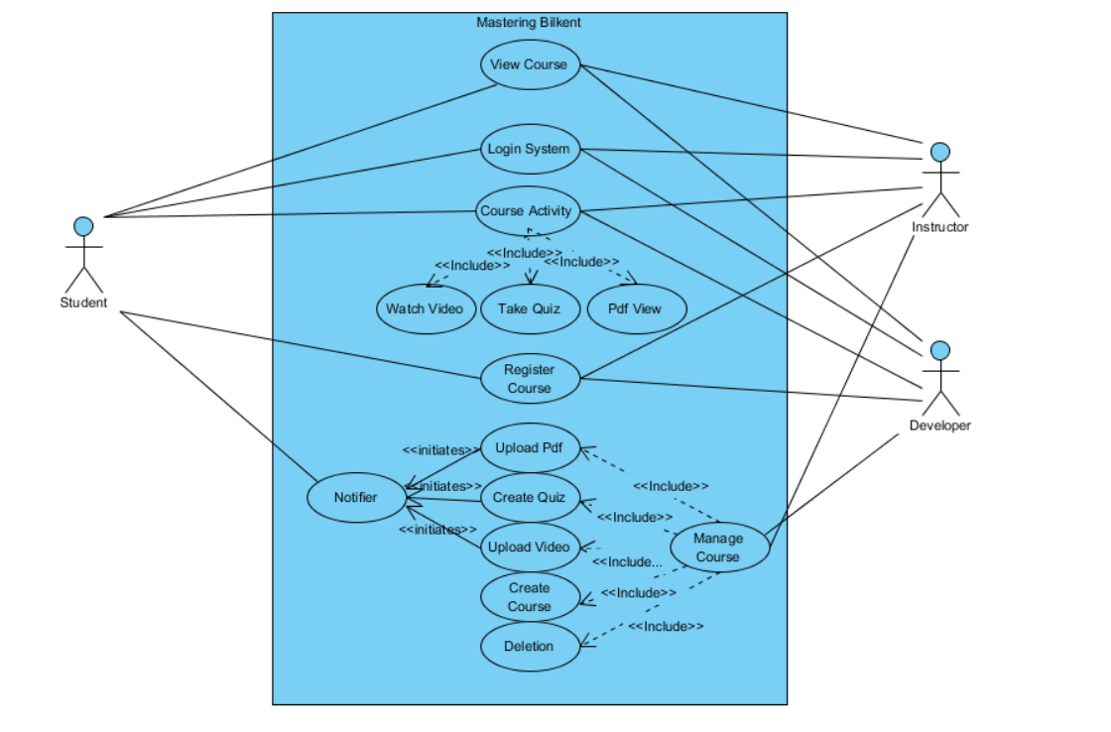

Not fully prepared yet

**Object and Class Model:**

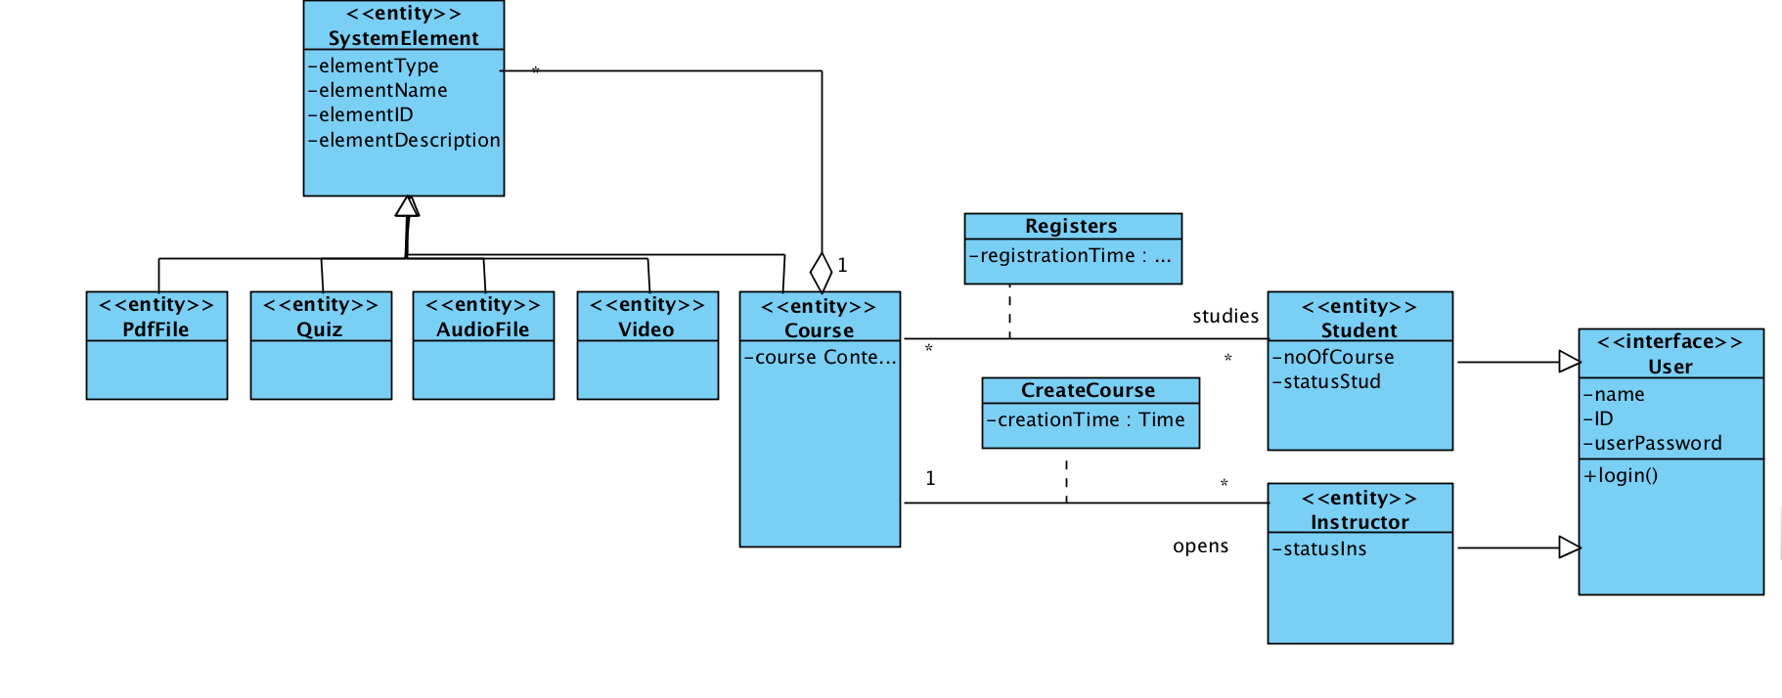

We couldn’t make an agreement on how to determine Instructor and Student Roles and their direct relationship with other system elements(quiz, audio etc). We would be grateful if you have any suggestions.

**User Interface:**

**Login Page:** 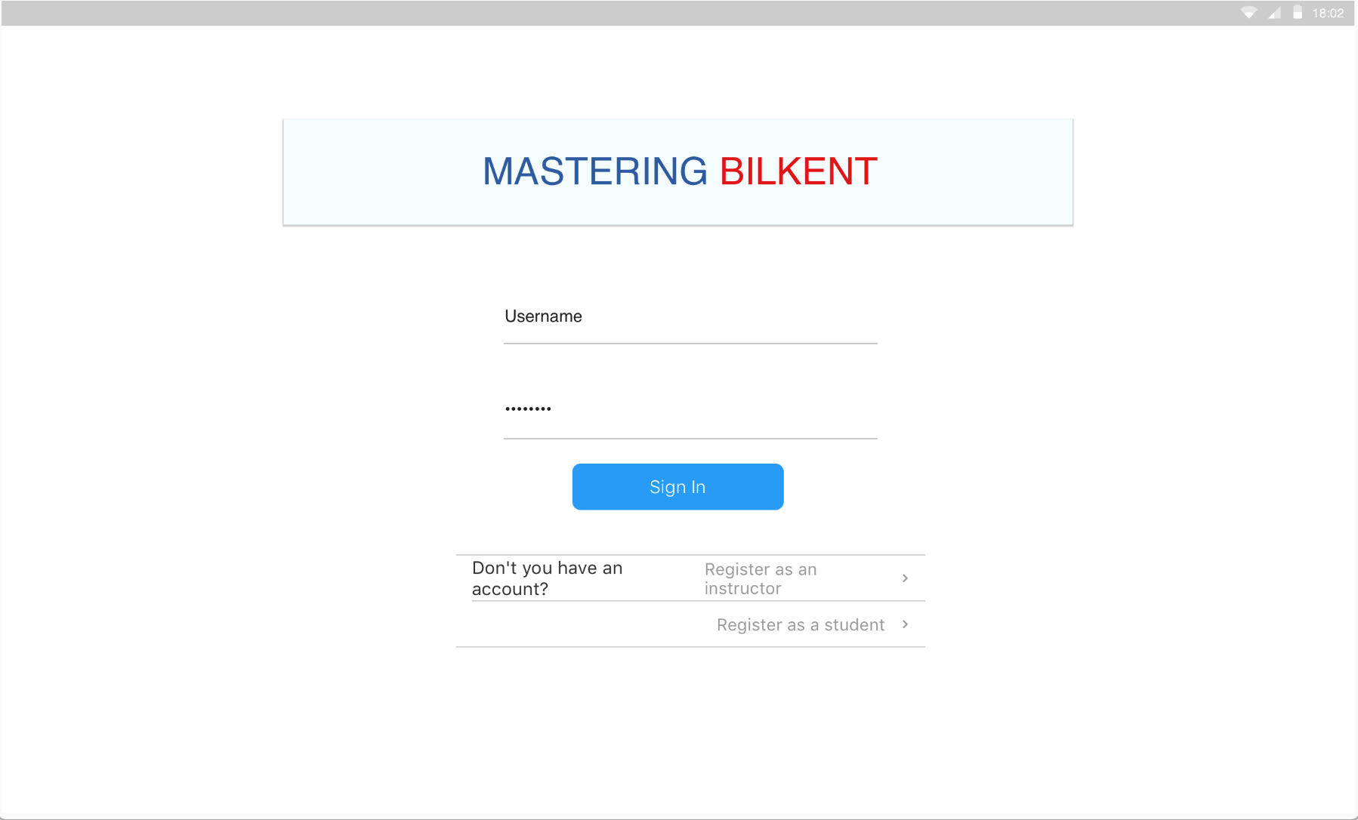

**Register as an instructor:** 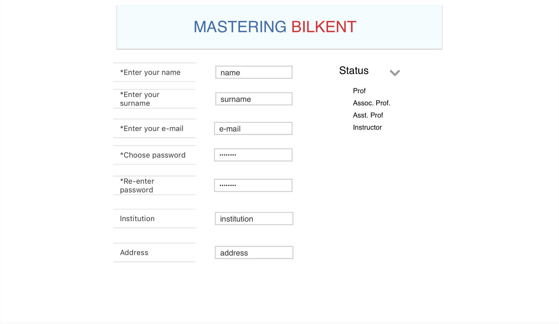

**Register as a student:**

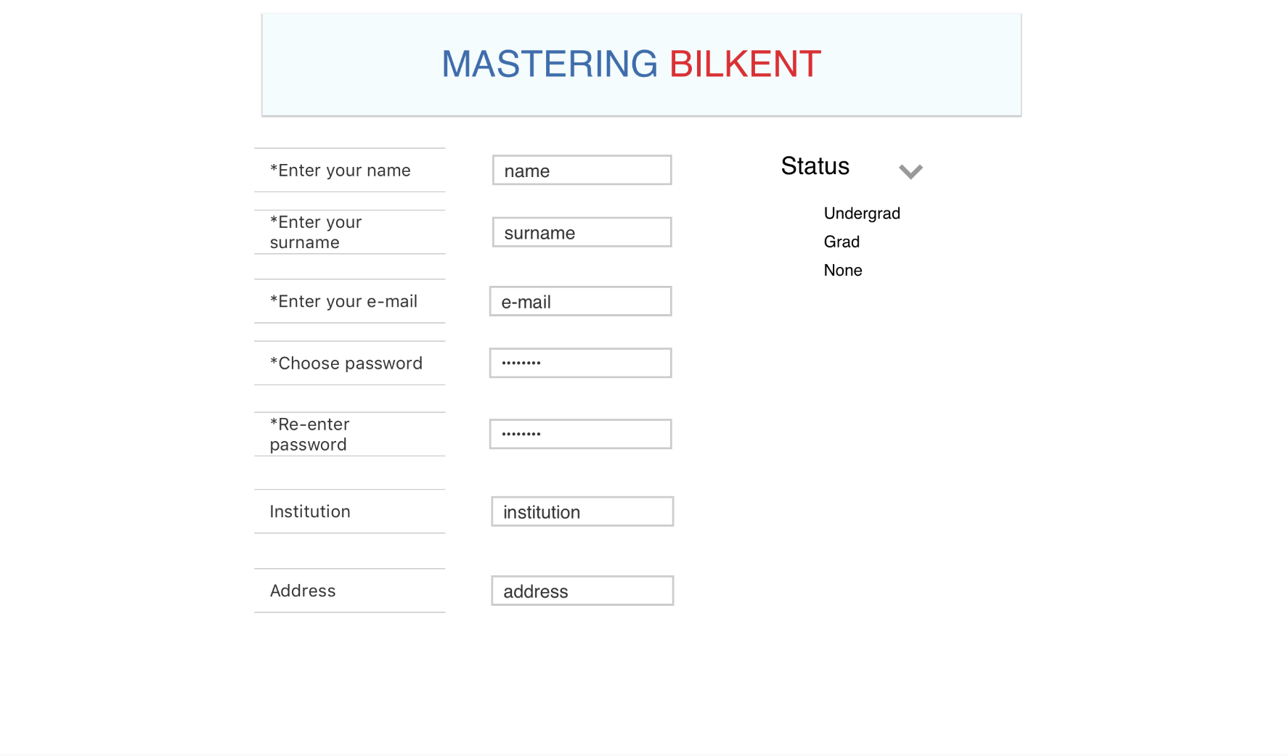

**Student Home Page:**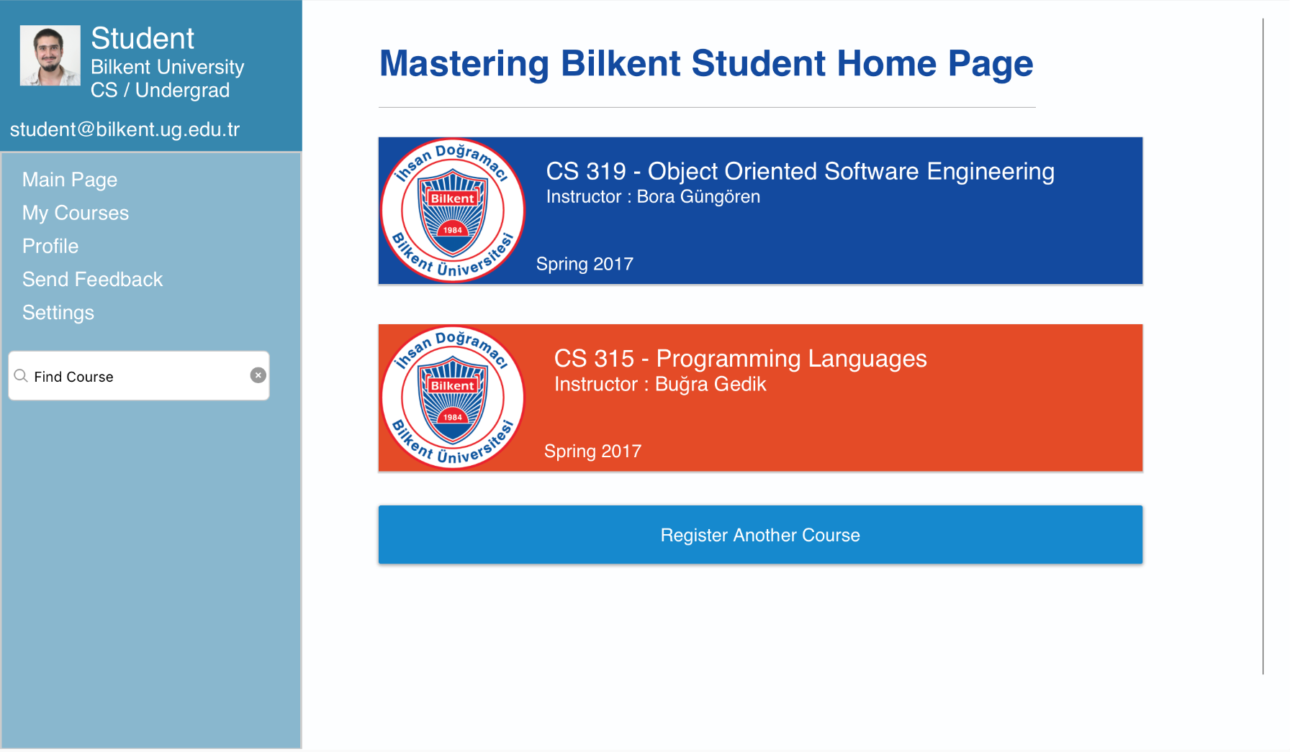

**Instructor Home Page:**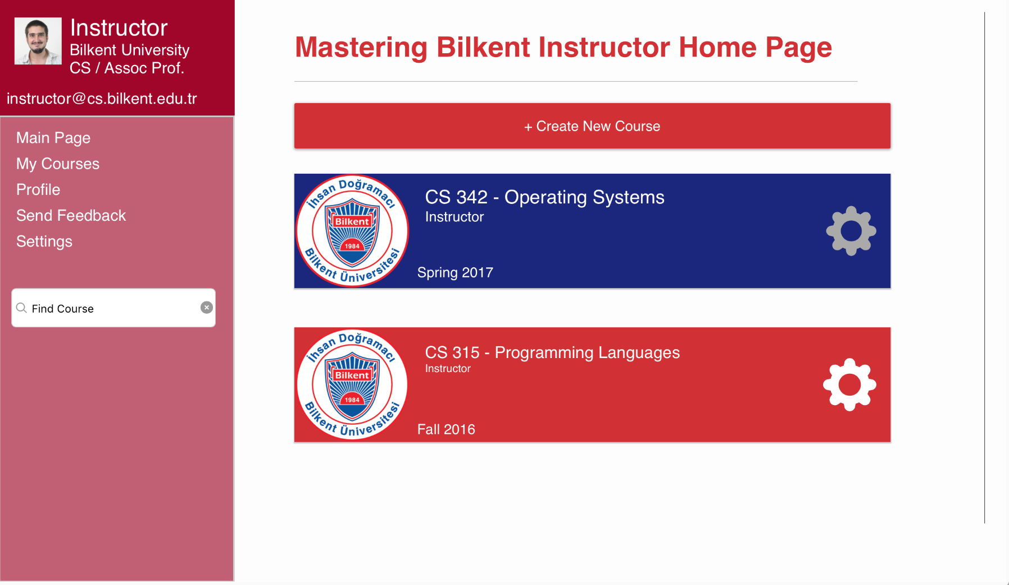

**Course View/Student Mode:**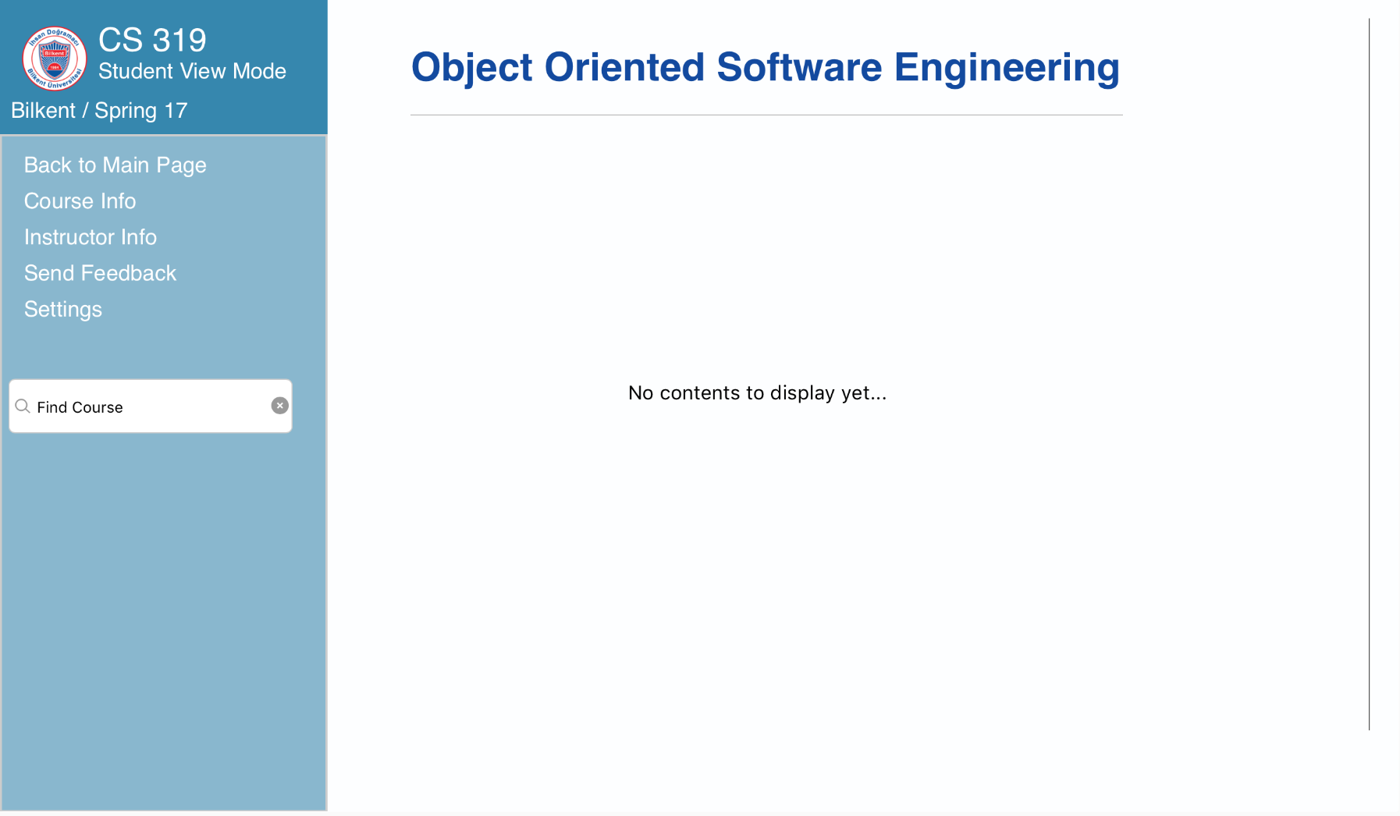

**Glossary & References:**

To be written.