**Part 1: Visualizing the scalar and the vector field**

Visualizing the scalar field

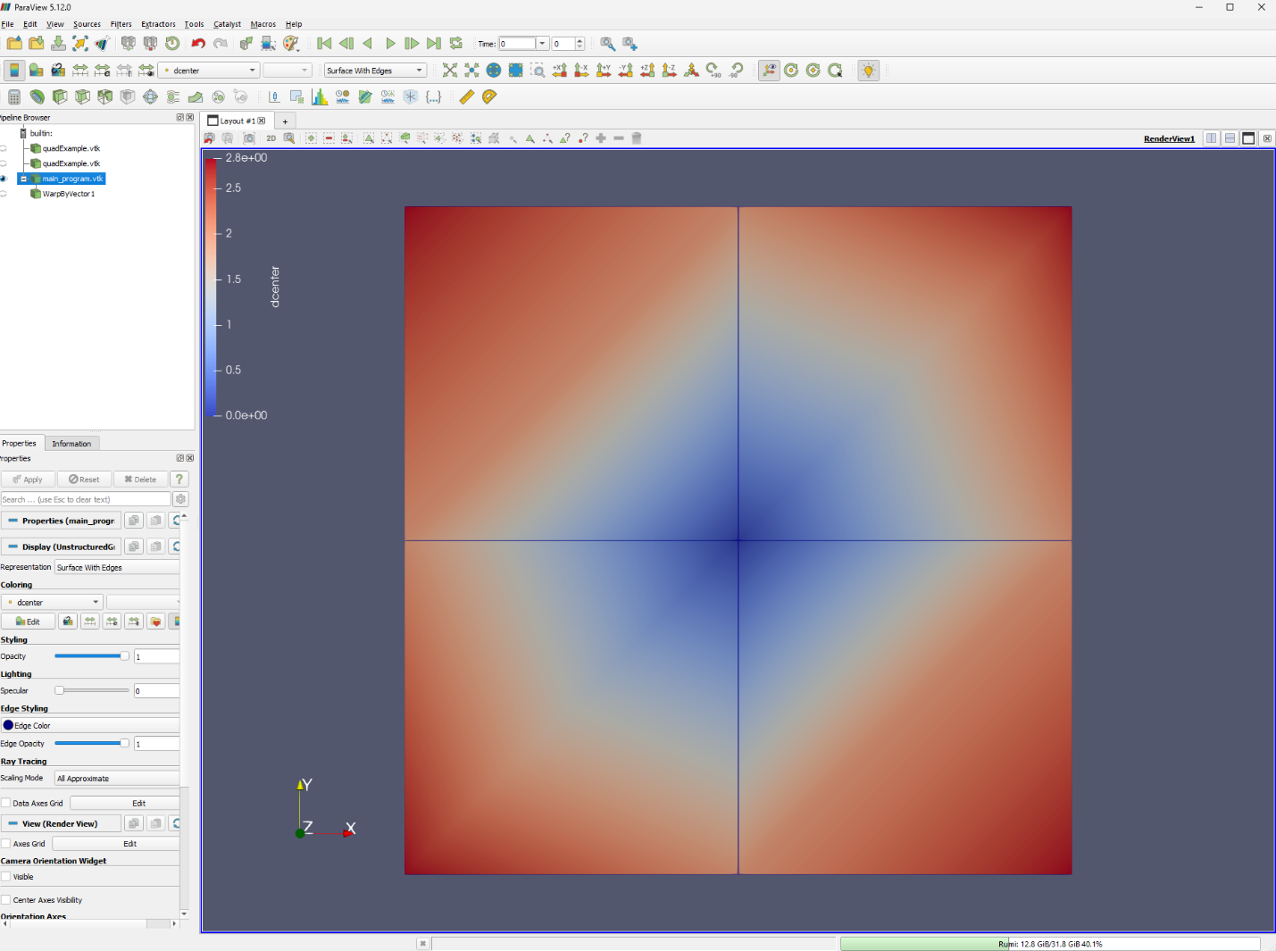

Visualizing the vector field

