**Tugas Pertemuan Ke – 2**

**Bab 1 :** FRAGMENT

|  |  |
| --- | --- |
| **Nama** | Latief Khanan Alqrubhi |
| **Nim** | 1818065 |
| **Kelas** | B |
| **Pemberi Tugas** | Bayu Rezky Ramadhan(1918004) |

1. **Nama projek yang ditugaskan (**Membuat 4 fragment didalam 1 Activity**)**
2. **Langkah – langkah pengerjaan**

1.Membuat Fragment

a. Buat class java pada package dengan cara klik package utama kita > New > Fragment > Fragment Blank.

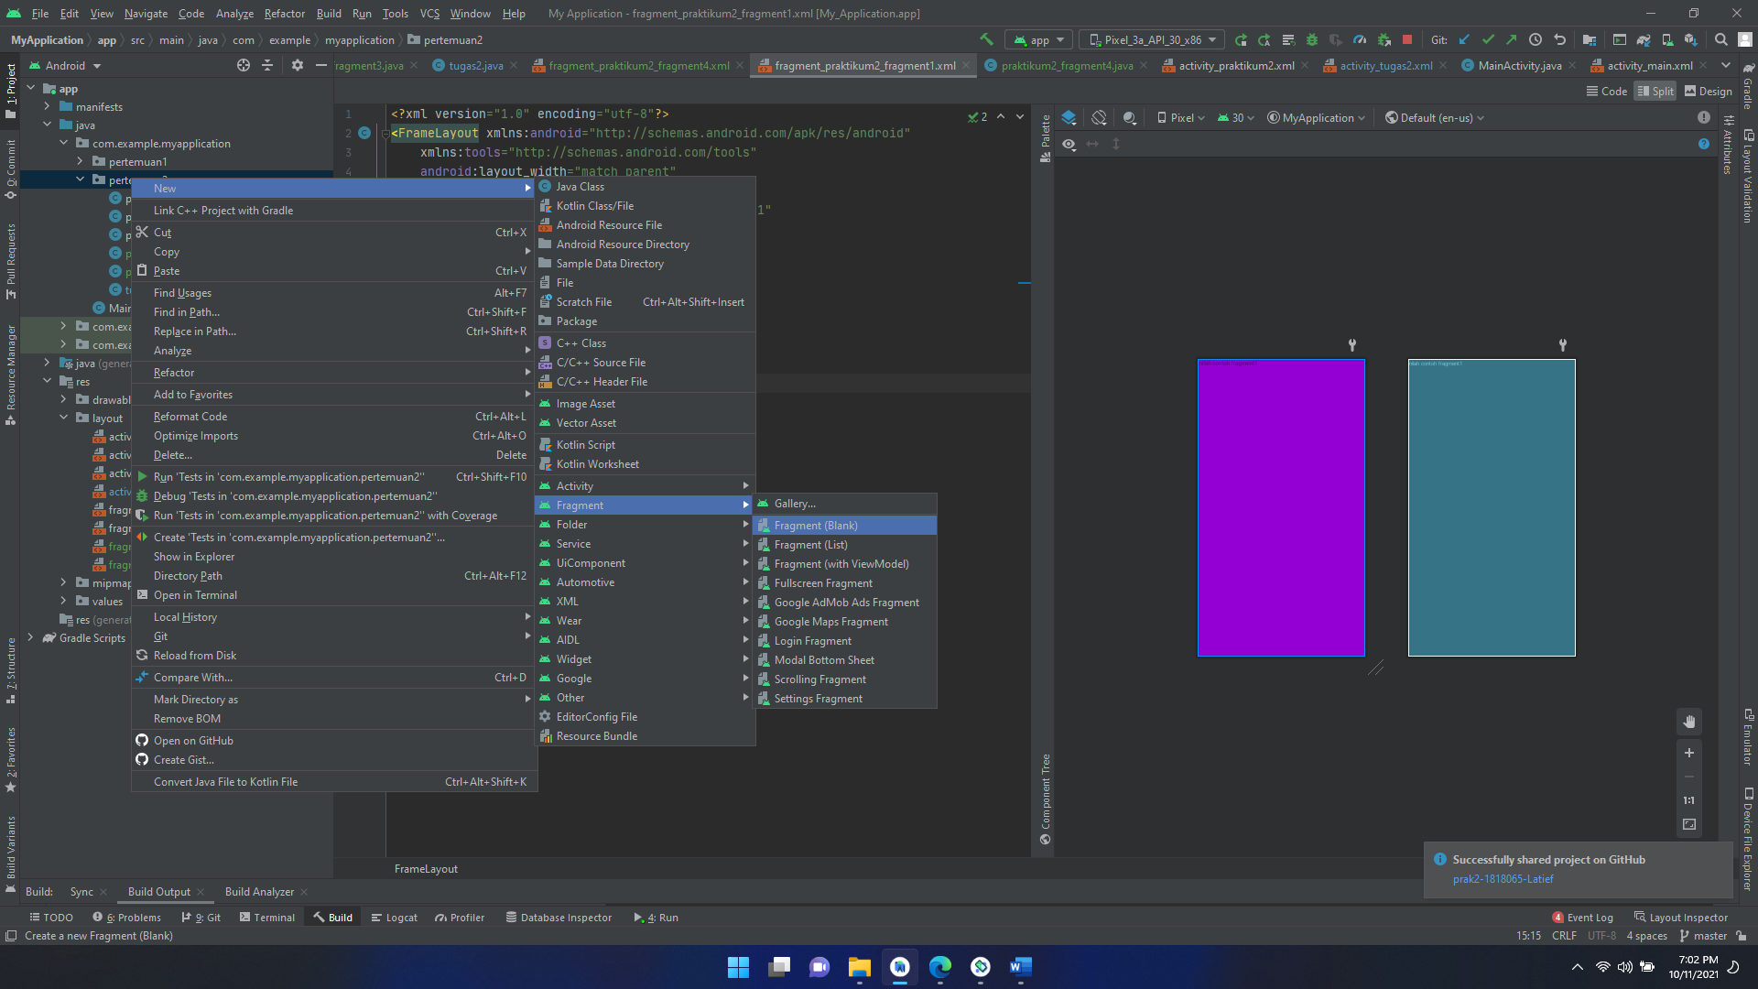

Gambar 1 : Membuat Java class dari fragment

b.Isikan nama fragment

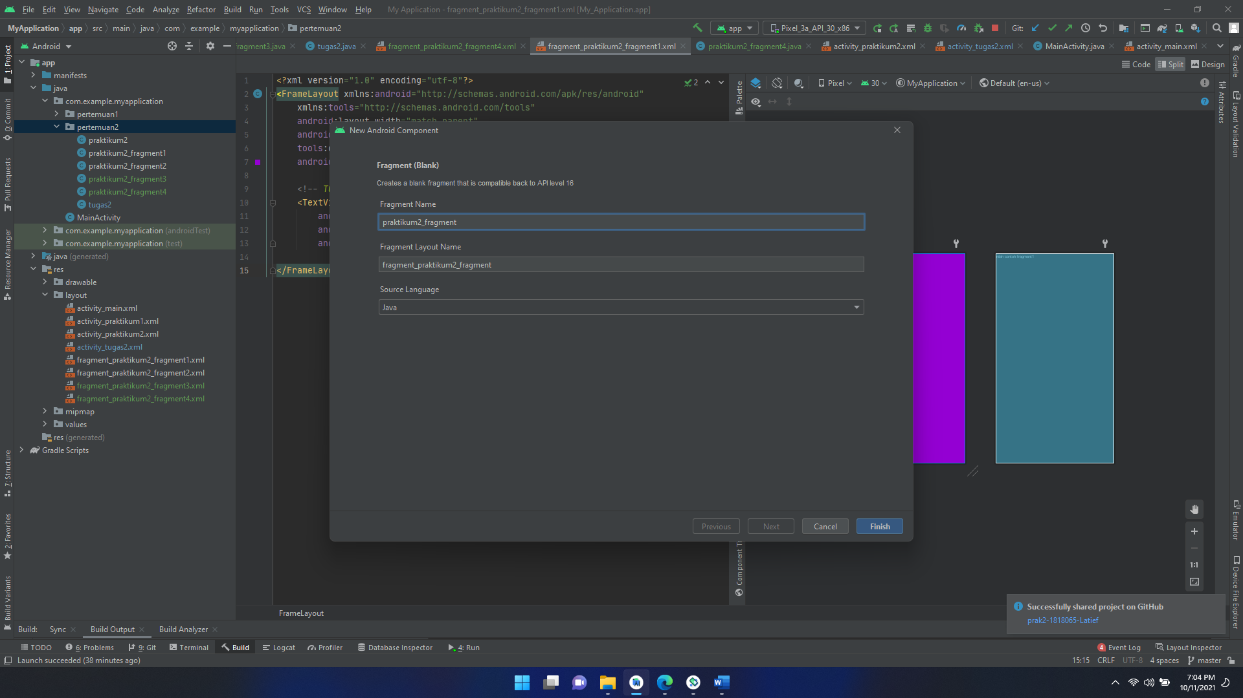

Gambar 2 : Membuat Fragment

c.Kemudian ulangi langkah diatas untuk membuat fragment 2-4

|  |  |  |
| --- | --- | --- |
| No. | Nama Komponen | Keterangan |
| 1. | Frame Layout Fragment1 | layout_width="match_parent" layout_height="match_parent" background="@color/DarkVio" |
| 2. | Frame Layout Fragment2 | layout_width="match_parent" layout_height="match_parent" background="@color/Crimson" |
| 3. | Frame Layout Fragment3 | ayout_width="match_parent" layout_height="match_parent" background="@color/Blue" |
| 4. | Frame Layout Fragment4 | layout_width="match_parent" layout_height="match_parent" background="@color/black" |
| 5. | TextView Fragment1 | text="@string/hello_blank_fragment1" |
| 6. | TextView Fragment2 | text="@string/hello_blank_fragment2" |
| 7. | TextView Fragment3 | text="@string/hello_blank_fragment3" |
| 8. | TextView Fragment4 | text="@string/hello_blank_fragment4" |

Source Code praktikum2_fragment1.java

|  |
| --- |
| public class praktikum2_fragment1 extends Fragment {  @Override  public void onCreate(Bundle savedInstanceState) {  super.onCreate(savedInstanceState);  }  @Override  public View onCreateView(LayoutInflater inflater, ViewGroup container,  Bundle savedInstanceState) {  // Inflate the layout for this fragment  return inflater.inflate(R.layout.fragment_praktikum2_fragment1, container, false);  }  } |

Hapus beberapa fungsi dan sisakan seperti diatas dan ulangi kembali langkah tersebut sampai langkah 4

Source Code praktikum2_fragment1.xml

<?xmlversion="1.0"encoding="utf-8"?>  
<FrameLayout xmlns:android="http://schemas.android.com/apk/res/android"  
 xmlns:tools="http://schemas.android.com/tools"  
 android:layout_width="match_parent"  
 android:layout_height="match_parent"  
 tools:context=".pertemuan2.praktikum2_fragment1"  
 android:background="@color/DarkVio">  
 <!--*TODO:Updateblankfragmentlayout*-->  
 <TextView  
 android:layout_width="match_parent"  
 android:layout_height="match_parent"  
 android:text="@string/hello_blank_fragment1"/>  
</FrameLayout>

Source Code praktikum2_fragment2.xml

<?xmlversion="1.0"encoding="utf-8"?>  
<FrameLayout xmlns:android="http://schemas.android.com/apk/res/android"  
 xmlns:tools="http://schemas.android.com/tools"  
 android:layout_width="match_parent"  
 android:layout_height="match_parent"  
 tools:context=".pertemuan2.praktikum2_fragment2"  
 android:background="@color/Crimson">  
 <!--*TODO:Updateblankfragmentlayout*-->  
 <TextView  
 android:layout_width="match_parent"  
 android:layout_height="match_parent"  
 android:text="@string/hello_blank_fragment2"/>  
</FrameLayout>

Source Code praktikum2_fragment3.xml

<?xmlversion="1.0"encoding="utf-8"?>  
<FrameLayout xmlns:android="http://schemas.android.com/apk/res/android"  
 xmlns:tools="http://schemas.android.com/tools"  
 android:layout_width="match_parent"  
 android:layout_height="match_parent"  
 tools:context=".pertemuan2.praktikum2_fragment3"  
 android:background="@color/Blue">  
 <!--*TODO:Updateblankfragmentlayout*-->  
 <TextView  
 android:layout_width="match_parent"  
 android:layout_height="match_parent"  
 android:text="@string/hello_blank_fragment3"/>  
</FrameLayout>

Source Code praktikum2_fragment4.xml

<?xmlversion="1.0"encoding="utf-8"?>  
<FrameLayout xmlns:android="http://schemas.android.com/apk/res/android"  
 xmlns:tools="http://schemas.android.com/tools"  
 android:layout_width="match_parent"  
 android:layout_height="match_parent"  
 tools:context=".pertemuan2.praktikum2_fragment4"  
 android:background="@color/black">  
 <!--*TODO:Updateblankfragmentlayout*-->  
 <TextView  
 android:layout_width="match_parent"  
 android:layout_height="match_parent"  
 android:text="@string/hello_blank_fragment4"/>  
</FrameLayout>

2.Menyatukan Fragment

a.Buat class Empty activity

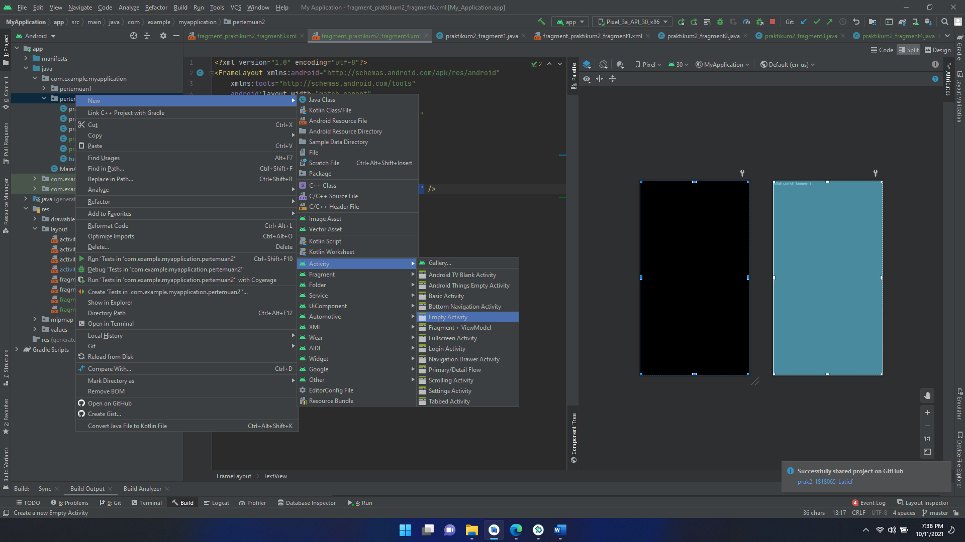

Gambar 3 : MembuatActivtiy

b. Namai activty sesuai kebutuhan

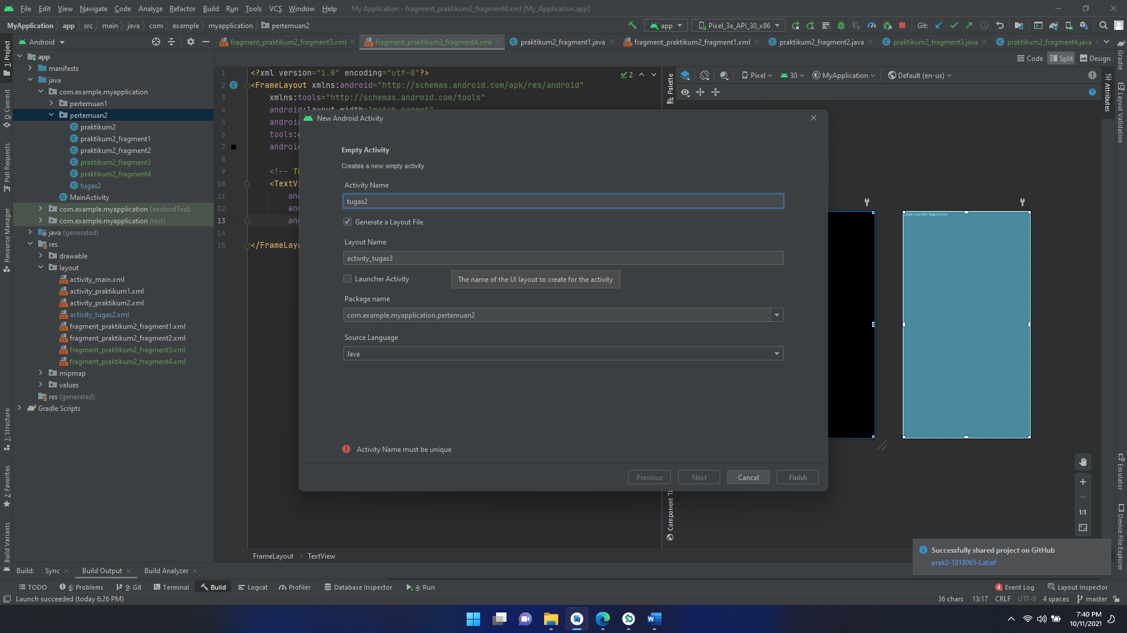

Gambar 4 : Memberi Nama Activty

|  |  |  |
| --- | --- | --- |
| No. | Nama Komponen | Keterangan |
| 1. | Linear Layout | layout_width="match_parent"  layout_height="match_parent" |
| 2. | Linear Layout Fragment1 | id="@+id/fragment1"  layout_width="30dp"  layout_height="85dp"  layout_weight="1"  background="@color/DarkVio" |
| 3. | Linear Layout Fragment1 | id="@+id/fragment1"  layout_width="85dp"  layout_height="85dp"  layout_weight="1"  background="@color/Crimson" |
| 4. | Linear Layout Fragment1 | id="@+id/fragment1"  layout_width="95dp"  layout_height="250dp"  layout_weight="1"  background="@color/Blue"" |
| 5. | Linear Layout Fragment1 | id="@+id/fragment1"  layout_width="0px"  layout_height="match_parent"  layout_weight="1"  background="@color/black" |

Source Code tugas2.xml

|  |
| --- |
| <?xml version="1.0" encoding="utf-8"?>  <LinearLayout  xmlns:android="http://schemas.android.com/apk/res/android"  xmlns:app="http://schemas.android.com/apk/res-auto"  xmlns:tools="http://schemas.android.com/tools"  android:layout_width="match_parent"  android:layout_height="match_parent"  tools:context=".pertemuan2.tugas2">  <LinearLayout  android:layout_width="match_parent"  android:layout_height="match_parent"  android:orientation="vertical">  <LinearLayout  android:layout_width="match_parent"  android:layout_height="wrap_content"  android:orientation="horizontal">  <fragment  android:id="@+id/fragment1"  android:name="com.example.myapplication.pertemuan2.praktikum2_fragment1"  android:layout_width="30dp"  android:layout_height="85dp"  android:layout_weight="1"  android:background="@color/Crimson" />  <fragment  android:id="@+id/fragment2"  android:name="com.example.myapplication.pertemuan2.praktikum2_fragment2"  android:layout_width="85dp"  android:layout_height="85dp"  android:layout_weight="1"  android:background="@color/DarkVio"/>  </LinearLayout>  <LinearLayout  android:layout_width="match_parent"  android:layout_height="240dp"  android:orientation="horizontal">  <fragment  android:id="@+id/fragment3"  android:name="com.example.myapplication.pertemuan2.praktikum2_fragment3"  android:layout_width="95dp"  android:layout_height="250dp"  android:layout_weight="1"  android:background="@color/Blue"/>  <fragment  android:id="@+id/fragment4"  android:name="com.example.myapplication.pertemuan2.praktikum2_fragment4"  android:layout_width="0px"  android:layout_height="match_parent"  android:layout_weight="1"  android:background="@color/black"/>  </LinearLayout>  </LinearLayout>  </LinearLayout> |

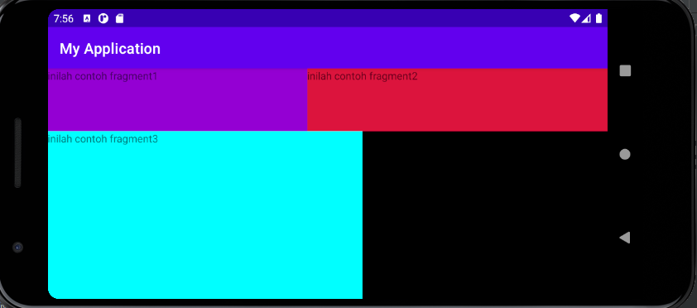

Gambar 5 : Running Aplikasi

Analisa:

Pada script diatas menggunakan linear layout untuk menampilkan 4 fragment yang telah dibuat.Pada script layout_width dan layout_heigth digunakan untuk merubah ukuran fragment,match_parent digunakan agar fragment ukuranya bisa memenuhi layar dan kita bisa juga mengatur ukuranya dengan cara manual yaitu dengan mengubah menjadi satuan dp.Pada background @color digunakan untuk merubah warna dari fragment tersebut.

1. **Link repository github**

https://github.com/Ruminkak/Tugas2-1818065-Latief-.git