CE154 Assignment 1

Info:

The website was made in vs code using a live server so if you’re not using that the navigation bar at the bottom will be present but not usable, so you can just open the pages separately as they’re all there as html files and are runnable on the latest version of firefox

Similar Websites:  
<https://www.artsy.net/>

<https://artuk.org/>

<https://www.saatchiart.com/>

Sections of Content

Header: This is usually at the top of the page and contains the website's logo, navigation menu, and sometimes contact information or other important links.

Navigation Menu: A set of links that allows users to easily navigate to different pages or sections of the website.

Homepage: The main landing page of the website, often featuring an overview of the site's content or highlights of recent updates.

About Us: This section provides information about the website or the organization behind it, including its mission, history, team, and contact details.

Products/Services: If the website represents a business, this section showcases the products or services offered, along with detailed descriptions, images, and pricing information.

Blog/News: A section where articles, blog posts, news updates, or other forms of content are published regularly.

Contact: This section typically includes a contact form, email addresses, phone numbers, or other means for visitors to get in touch with the website owner or organization.

FAQ: Frequently Asked Questions, where common queries and their answers are provided to help users find information quickly.

Testimonials/Reviews: This section may feature testimonials from satisfied customers or reviews of products/services to build trust and credibility.

Gallery/Portfolio: A collection of images, videos, or other media showcasing the work, projects, or achievements of the website owner or organization.

Footer: Similar to the header, but located at the bottom of the page, containing additional navigation links, copyright information, legal disclaimers, and sometimes social media links.

Search Bar: A tool that allows users to search for specific content within the website.

User Personas/Stories

***Persona Number #1***

**Name**: Muhammad

**Age**: 18

**Reason for Interest**: Big fan of the series “Naruto” which the artist of choice created. He would be interested in the website as it displays art from one of their favourite series and allows him to purchase art that he likes

***Persona Number #2***

**Name:** Tom

**Age:** 19

**Reason for Interest:** Interested in the genre of art that the artist of choice utilizes. He would be interested in the website as it allows him to find new pieces of art that he finds interesting as it follows a genre he is interested in

***Persona Number #4***

**Name:** Sarah

**Age:** 17

**Reason for Interest:** Is interested in all types of art in general, using this website she is able to explore an artist that she may enjoy and would allow her to purchase said artists work.

Wireframe Model for Basket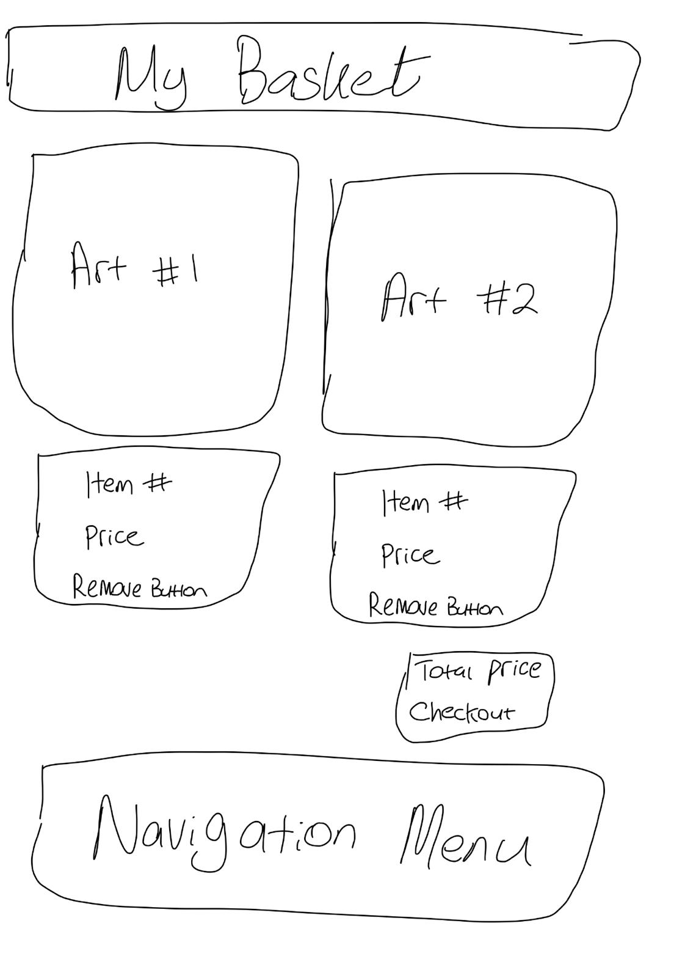

Wireframe model for Art Details Page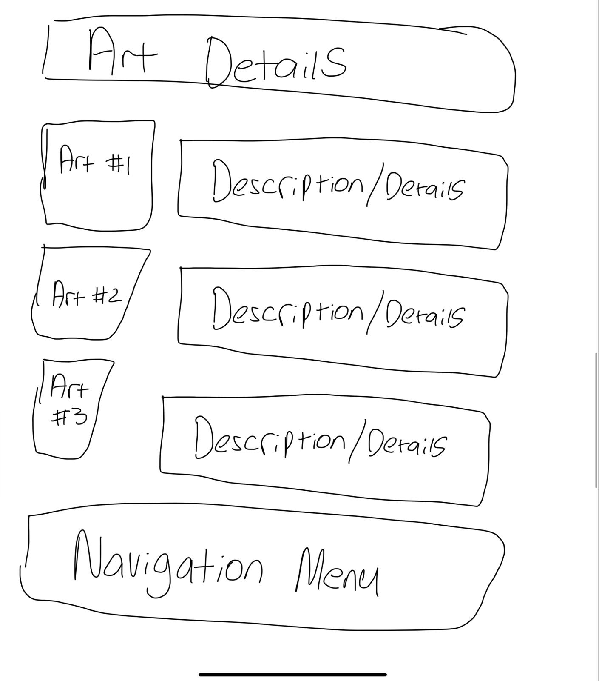

## 

Wireframe Model for Art Listings Page

Wireframe Model for About Me Page

Wireframe Model for Home Page

Design Research

<https://www.artsy.net/>

^ I liked the way the art was being displayed and tried my best to recreate it to the best of my ability

<https://www.saatchiart.com/>

^ I liked the design of the website and how it presented itself, I didn’t go with how this website looked for my own one but did take inspiration and implement similar techniques but with different colours

Justification of Design

Home:  
My home page design is nice and simple, it has the navigation wheel at the bottom to go to the other pages. There also is a link on the artists name for an easy link to the about me page

About Me:  
The about me page has the same navigation menu at the bottom as the other pages, it has a picture of the artist to show the users as well as pictures to show different pieces of him

Art Listings:

This page shows all the pieces of art that are on sale, it has them in a line with all of them sharing the same size as well as a border I designed using CSS. It has the name of the piece, a small description of what the art is/where it came from and also includes the price of the art. It also contains the same navigation menu as the other pages

Art Details:

This page displays the previously shown pieces of art but without the previous added on comments such as name and price. Instead this page would further describe the meaning behind each piece as well as any extra information that the potential buyer may find interesting. It also contains the same navigation menu as the other pages

Basket:

This is the area where you finalize your purchase of the artworks. It separates each piece individually with a large picture to make sure the user knows what they are purchasing. It displays the item numbers as well as their individual prices, in the bottom right there is the checkout button as well as the final price of all items together. This is currently hard coded in so you cant add or remove items for now.

Design Inspiration

<https://www.artsy.net/>

Reason:

I like the way they display the art so I see it as soon as I open the website and I like the user interface

<https://www.shademaster.com.au/>

Its very appealing to look at with the background being nice on the eyes, and the UI is very clean and straight forward

Art Genre

Kishimoto’s art genre can be best described as Shonen Manga, his term refers to the genre of manga and anime targeted primarily towards young male audiences, typically characterized by action-packed storylines, coming-of-age themes, and vibrant, energetic artwork.

Questionnaire

what do they like about the design?

what’s missing that they would like to see?

what else would they suggest, e.g., particular colours, layout, etc.?

Answers from friend #1:

Black outlines and picture design.

I would love to see captions under the pictures.

I would suggest a more colourful layout.

Answers from friend #2:

website design is homogenous and consistent.

I would like to see some scrolling action, and some more art on the home page.

make the background like Masashi’s? like Naruto’s colour scheme etc. new fonts maybe

Self Appraisal

I believe I was able to create a functioning website, though not fully as not javascript was implemented. The website may not be the flashiest or the best looking but I do think it is very clean and smooth, I managed to get what I wanted done in a clean and efficient manner

I would have preferred to add things such as drop down menus, functioning buttons and some nicer colours with effects such as translucency but was not able to this time around

Iterative Evaluation Evidence

After going through the feedback I attempted to add a little more colour to the website, this was done through adding a banner to the top of the webpages, colour to the home part of the navigation menu and swapping some of the black and white images with coloured ones. I attempted to add captions to the “About the Artist” page but was unable to, but managed to do it in the “Art Listings” page

Skill Tree

Before: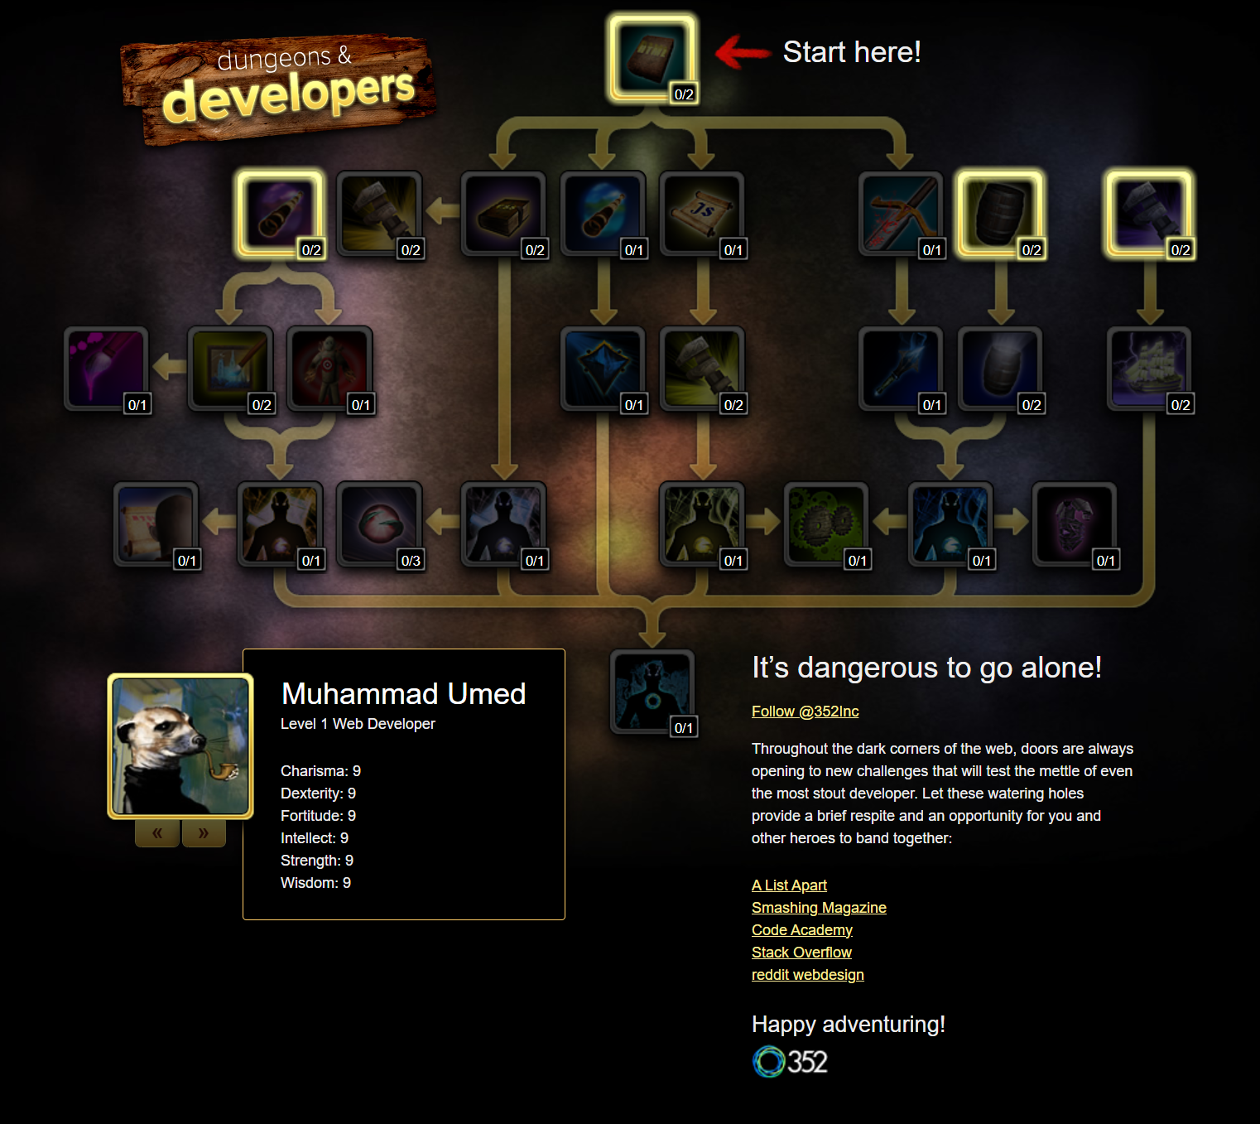After: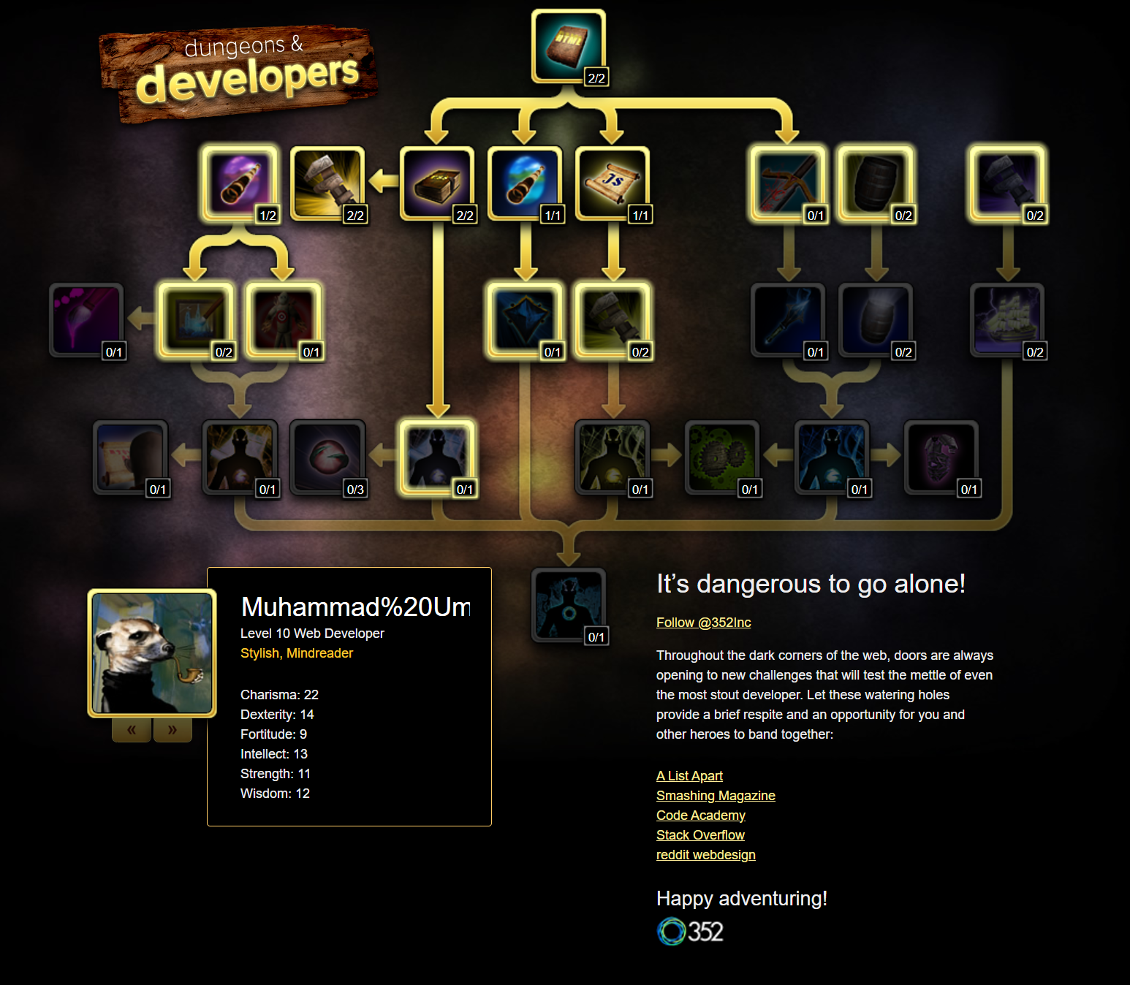

HTML Code Evaluation

After placing my code through the code evaluation, I did receive small errors such as some parts of my code having no meaning and some uses of the wrong type of slash, I went through all of it and managed to fix it, though the errors were not major and the website would have functioned without any changes being made

CSS Code Evaluation

There were no errors found in the CSS part of my code, this was due to me doing everything correctly and already checking through my CSS before I checked it through the CSS code evaluator