Predicting the Throne: Hero Draft-Based Win Prediction in Dota 2 Using Decision Tree and Random Forest Models
Codilla, Rhumer Y.
University of Mindanao, Matina, Davao City, Philippines
Rhumer Y. Codilla

1. INTRODUCTION

1.1 Description
In Dota 2, the hero draft is one of the first major strategic decisions made before a match begins. Each team selects five heroes while also banning heroes that may be unfavorable to its intended strategy. These choices shape the available abilities, team composition, and possible strategies for both sides, making the draft a meaningful source of information for pre-match analysis. Draft-based outcome forecasting already has a real-world audience. Valve's own Battle Pass includes a feature that rewards players for correctly predicting match winners during major tournaments, though this study does not treat that feature as evidence of predictive validity, only as context for why draft-based forecasting is a subject of genuine interest. A draft alone does not determine the final result, since match outcomes are also affected by factors such as player execution, decision-making, and in-game adaptation.
This project applies supervised machine learning to examine whether information contained in a completed professional Dota 2 draft can be used to predict the winning team, Radiant or Dire. Draft-based prediction of Dota 2 outcomes has also been examined in earlier work [1]. Rather than relying only on individual hero identities, the study incorporates three types of draft-based information: hero picks, hero bans, and engineered role-composition features representing the number of Disabler, Initiator, and Pusher heroes selected by each team. This allows the analysis to consider both the specific heroes chosen and broader characteristics of each team's draft.
Decision Tree and Random Forest classifiers were selected because they provide two complementary approaches to analyzing categorical and composition-based draft features. The Decision Tree serves as an interpretable baseline, allowing its decision structure to be examined and understood in relation to draft features. Random Forest extends this approach by combining multiple decision trees, helping reduce the tendency of a single tree to rely heavily on rare or coincidental hero combinations. Comparing these two models allows the study to examine both an interpretable single-tree approach and an ensemble approach when predicting match outcomes from draft information.
The study uses professional Captains Mode match data from the 2023 subset of the Dota 2 Pro League Matches dataset [2]. The final dataset contains 29,643 matches with complete five-hero drafts for both Radiant and Dire. The models use hero picks, up to seven recorded bans per side, and engineered role-composition features to predict the binary outcome represented by radiant_win. The project focuses on determining how much predictive information can be obtained from pre-game draft data alone, checking how stable model performance is under five-fold cross-validation, and identifying which categories of draft features account for the largest share of importance within the trained Random Forest.

1.2 OBJECTIVES
1.2.1 General Objective
To develop and compare Decision Tree and Random Forest classifiers in predicting Dota 2 match winners based on hero draft composition, using professional Captains Mode match data.
1.2.2 Specific Objectives
The project aims to:
- Retrieve and preprocess professional Dota 2 match data, extracting hero picks, bans, and match outcomes as the labeled dataset.
- Incorporate hero role data to engineer team-level composition features alongside raw hero picks.
- Train a Decision Tree Classifier as an interpretable baseline for predicting match winner from draft composition.
- Train a Random Forest Classifier and compare its performance against the Decision Tree baseline and a naive majority-class baseline, using accuracy, balanced accuracy, precision, recall, F1-score, and macro-F1.
- Apply five-fold stratified cross-validation to assess the stability of model performance on the training data.
- Identify which categories of draft features (hero picks, hero bans, and role composition) account for the largest share of the trained Random Forest's feature importance, and which individual features rank highest.

2. METHODOLOGY

2.1 Methodology / Approach
This project follows the CRISP-DM (Cross-Industry Standard Process for Data Mining) framework. Business Understanding defines the core problem, predicting Dota 2 match winners from a completed hero draft. Data Understanding involves examining professional match records and their associated pick and ban sequences, including a direct audit of ban counts per match. Data Preparation transforms these records into a usable feature set, isolating picks from bans, encoding hero and ban identities, and extracting match outcome as the target label. Modeling trains a Decision Tree and a Random Forest classifier, which are compared against a naive majority-class baseline. Evaluation uses a held-out test set and five-fold cross-validation on the training data. Deployment, in this context, refers to the proposed use of the trained model as a decision-support reference rather than a production system.

2.2 Dataset
Dataset name and source: "Dota 2 Pro League Matches 2016-2026" by bwandowando, retrieved from Kaggle [2]. This study uses the 2023 subset, in which every record has game_mode = 2 (Captains Mode) and a complete five-hero draft for both sides.
Number of records: 29,643 matches.
Features/input variables: hero picks for both teams (one-hot encoded), hero bans for both teams (up to seven per side, one-hot encoded), and six engineered role-composition counts (Disabler, Initiator, and Pusher per side).
Target variable: radiant_win (binary). Type of problem: binary classification.
Feature | Type | Description
match_id | Integer | Unique match identifier.
radiant/dire_hero_1-5 | Categorical | Hero picks, one-hot encoded.
radiant/dire_ban_1-7 | Categorical | Hero bans, up to seven per side, one-hot encoded.
role counts (6 cols) | Numerical | Disabler, Initiator, and Pusher counts per team.
game_mode | Categorical | Captains Mode (2) for all records.
radiant_win | Target | True if Radiant won, else False.
Table 1. Dataset features for hero draft-based win prediction.
A ban-count audit was run before finalizing the feature set, since the number of bans recorded per team can differ between matches. Most matches recorded seven bans per side (29,511 of 29,643 for Radiant and 29,508 for Dire), and the maximum recorded for either side was seven. Capping the ban columns at five, an earlier design choice, would have discarded recorded bans in most matches, so the feature set retains up to seven bans per side. Table 2 and Figure 1 show the distribution. The per-side counts total 29,621 rather than 29,643 because the audit was computed from ban events, so matches with no recorded ban events do not appear in it.
Bans recorded | Matches (Radiant) | Matches (Dire)
7 | 29,511 | 29,508
6 | 49 | 57
5 | 4 | 4
4 | 4 | 1
3 | 4 | 5
2 | 22 | 23
1 | 20 | 18
0 | 7 | 5
Table 2. Ban count distribution audit (Radiant and Dire sides).
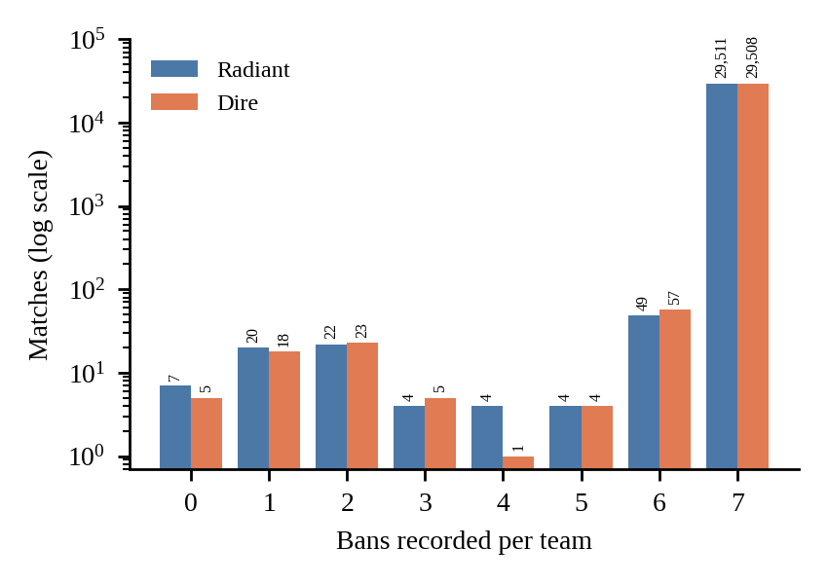
Figure 1. Ban count distribution by team (log scale).
Table 3 shows a sample of the extracted match records used for modeling. Hero values are the dataset's numeric hero identifiers, listed in draft pick order for each team.
match_id | Radiant picks | Dire picks | Radiant win
6947055162 | 104, 101, 56, 20, 48 | 31, 54, 14, 121, 97 | False
6947109699 | 31, 42, 121, 97, 14 | 71, 56, 87, 6, 112 | True
6947166291 | 86, 28, 70, 85, 56 | 11, 8, 96, 104, 1 | False
6947173900 | 86, 76, 120, 6, 3 | 11, 64, 22, 81, 101 | False
6947237459 | 83, 63, 97, 11, 1 | 5, 16, 9, 32, 35 | True
Table 3. Sample match draft records.

2.3 Data Preprocessing
A data quality audit was run on the final extracted dataset before modeling. It confirmed that every record is a Captains Mode match, with zero missing values in the target variable, zero duplicate match_id entries, and zero matches with missing hero picks. A separate consistency check found zero instances of a team picking the same hero twice, zero instances of the same hero being picked by both teams, zero instances of a picked hero appearing in the same team's first five ban positions, and zero duplicate heroes within each team's first five bans.
The ban columns contain missing values for matches with fewer than seven recorded bans, ranging from 27 missing values (dire_ban_1) to 135 (dire_ban_7) per column. These were kept as their own one-hot category instead of being dropped or imputed. The reason these matches record fewer bans was not investigated.
Hero and ban identities are categorical, not ordinal, and were one-hot encoded by position, so each pick slot and each ban slot has its own set of columns. The final feature matrix has 2,996 columns. Role-composition counts were computed from the roles field of the dataset's hero constants file, counting the heroes on each team labeled Disabler, Initiator, or Pusher. Feature scaling was not applied, since both models are tree-based and insensitive to feature scale. Post-draft columns such as chat logs, cosmetics, and in-game gold or experience advantage were excluded, since they would leak information unavailable at prediction time. Figure 2 shows that the target classes are near-balanced.
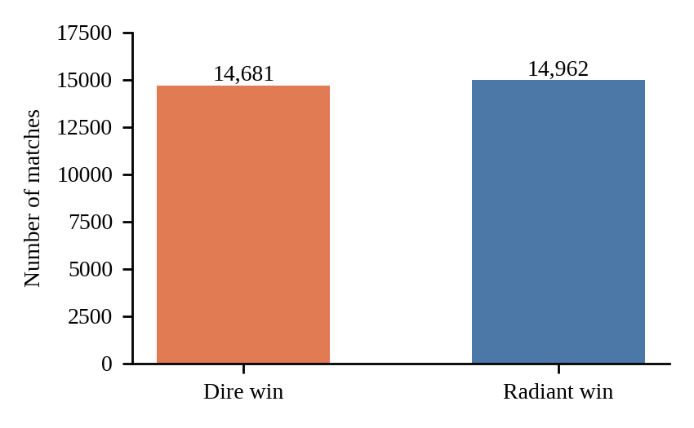
Figure 2. Class distribution of radiant_win (14,962 Radiant wins vs. 14,681 Dire wins).

2.4 Machine Learning Models
Decision Tree Classifier. This algorithm builds a tree of sequential decision rules, splitting the dataset at each node to separate the classes [4]. It was used as an interpretable baseline, since a prediction can be traced to the feature values along its path. The model used max_depth = 10 and random_state = 42.
Random Forest Classifier. This algorithm builds many decision trees on random subsets of the data and features and combines their outputs [3]. It was chosen because aggregating many trees can reduce the sensitivity of a single tree to rare or coincidental patterns. The model used n_estimators = 200 and random_state = 42. No other hyperparameter tuning was performed for either model.

2.5 Model Evaluation
The dataset was split 80/20 with a stratified train-test split (random_state = 42), giving 23,714 training matches and 5,929 held-out test matches. Both models were trained on the training set, and the test set was reserved for final evaluation.
Accuracy, precision, recall, F1-score, balanced accuracy, and macro-F1 were used. Precision, recall, and F1-score are reported for the Radiant-win class. Balanced accuracy averages recall across the two outcome classes, and macro-F1 averages the F1-score of the two classes, so both expose class-specific prediction bias that accuracy and single-class F1 can conceal. A naive majority-class baseline, which always predicts the more frequent outcome in the test set, was computed for reference.

2.6 Cross-Validation
To check how stable performance is across different subsets of the data, five-fold stratified cross-validation (shuffled, random_state = 42) was applied to the training partition only, using accuracy as the score. Each fold preserves the class distribution. Each model was trained on four folds and validated on the remaining fold until every fold had served as the validation set, and the mean validation accuracy was calculated across the five folds. The held-out test set was not used during cross-validation.

2.7 Methodology Workflow
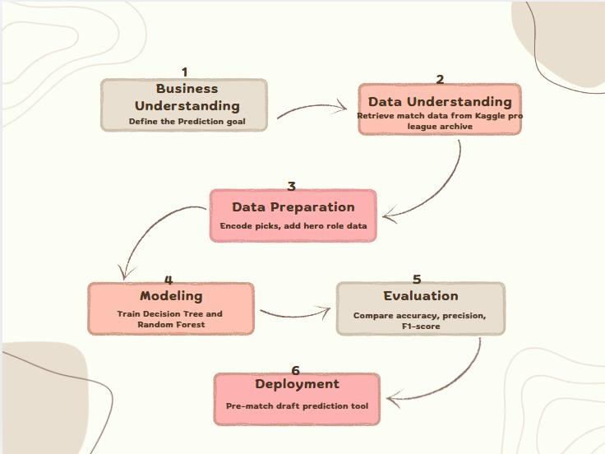
Figure 3. Methodology workflow for hero draft-based win prediction.
Figure 3 outlines the overall process from raw professional match data through to model evaluation, following the CRISP-DM framework: Business Understanding, Data Understanding, Data Preparation, Modeling, Evaluation, and Deployment. In this study, the Evaluation stage consisted of held-out test evaluation, comparison with the naive baseline, and five-fold cross-validation. Deployment refers to the proposed decision-support use of the model rather than a production system.

3. RESULTS

3.1 Final Evaluation Metrics
The Decision Tree and Random Forest classifiers were evaluated on the held-out test set of 5,929 matches, using the final feature set of hero picks, up to seven bans per side, and role-composition counts. The naive majority-class baseline reached 50.48% accuracy on this test set. Table 4 and Figure 4 summarize the results.
Metric | Decision Tree | Random Forest
Accuracy | 51.27% | 53.38%
Balanced accuracy | 50.88% | 53.40%
Precision | 50.96% | 54.03%
Recall | 92.32% | 51.32%
F1-score | 65.67% | 52.64%
Macro-F1 | 40.88% | 53.37%
Table 4. Model performance on the held-out test set.
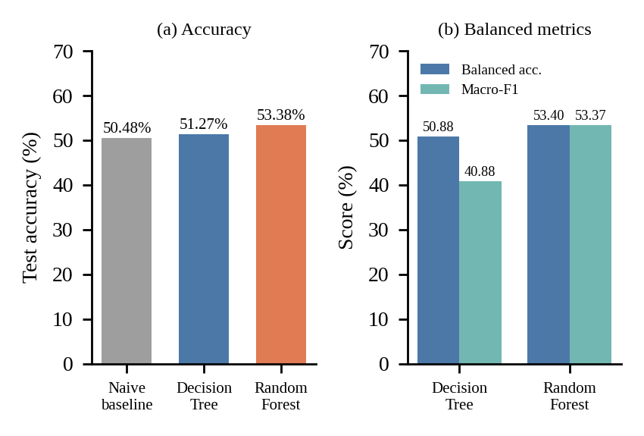
Figure 4. (a) Test accuracy compared with the naive majority-class baseline. (b) Balanced accuracy and macro-F1.
The Decision Tree improved on the naive baseline by 0.79 percentage points and the Random Forest by 2.90 points. The Decision Tree's single-class F1-score of 65.67% looks moderate, but its macro-F1 of 40.88% and balanced accuracy of 50.88% show that this came from predicting Radiant wins very often rather than from distinguishing the two outcomes. The Random Forest's accuracy, balanced accuracy, and macro-F1 agree closely with one another.
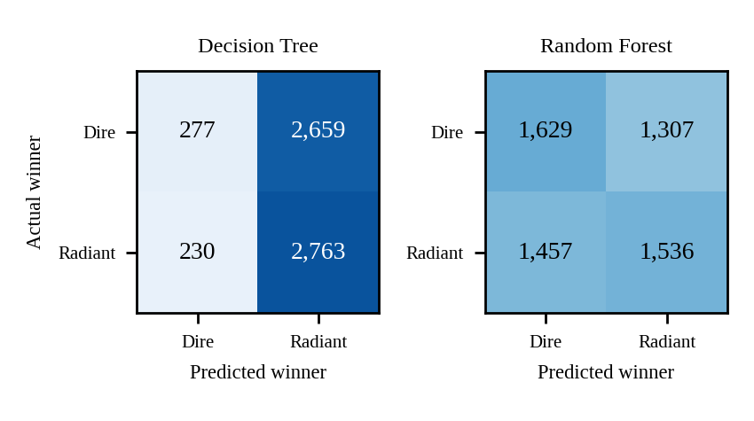
Figure 5. Decision Tree and Random Forest confusion matrices on the test set.
Figure 5 shows this difference directly. The Decision Tree predicted a Radiant win for 5,422 of the 5,929 test matches (91.4%). It correctly identified 2,763 of 2,993 actual Radiant wins but only 277 of 2,936 actual Dire wins (9.4%), with 2,659 Dire wins misclassified as Radiant wins. The Random Forest was more evenly distributed, correctly identifying 1,629 Dire wins (55.5%) and 1,536 Radiant wins (51.3%), with 1,307 false positives and 1,457 false negatives.

3.2 Five-Fold Cross-Validation
Five-fold stratified cross-validation on the training data produced the fold accuracies in Table 5 and Figure 6.
Fold | Decision Tree | Random Forest
1 | 51.19% | 53.36%
2 | 50.37% | 53.87%
3 | 52.52% | 54.10%
4 | 50.77% | 53.00%
5 | 51.62% | 53.71%
Mean | 51.29% | 53.61%
Table 5. Five-fold stratified cross-validation accuracy.
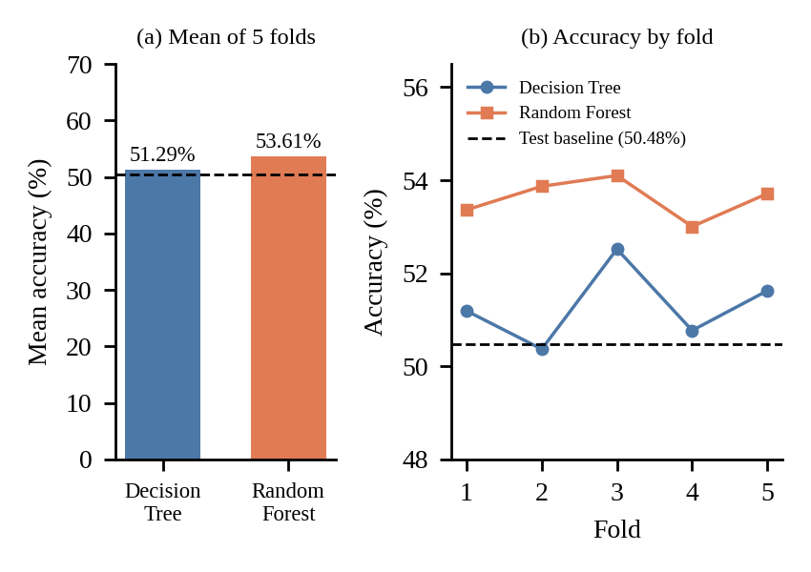
Figure 6. (a) Mean five-fold cross-validation accuracy. (b) Accuracy for each fold. The dashed line is the 50.48% test-set baseline.
The Decision Tree's fold accuracies ranged from 50.37% to 52.52% and the Random Forest's from 53.00% to 54.10%. The Random Forest scored higher than the Decision Tree in every fold. The mean validation accuracies (51.29% and 53.61%) are close to the corresponding test accuracies (51.27% and 53.38%), so performance did not depend strongly on one particular split. The Decision Tree's fold 2 score of 50.37% was below the 50.48% test-set baseline.

3.3 Feature Importance
Feature importance was taken from the trained Random Forest (impurity-based importance). Figure 7 shows the 15 highest-ranked individual features. The six role-composition counts occupied the highest positions among the individual features in the Top-15 ranking, each with an importance between 0.0042 and 0.0052, followed by individual pick and ban columns, the highest of which (radiant_hero_1_86) scored 0.0013.
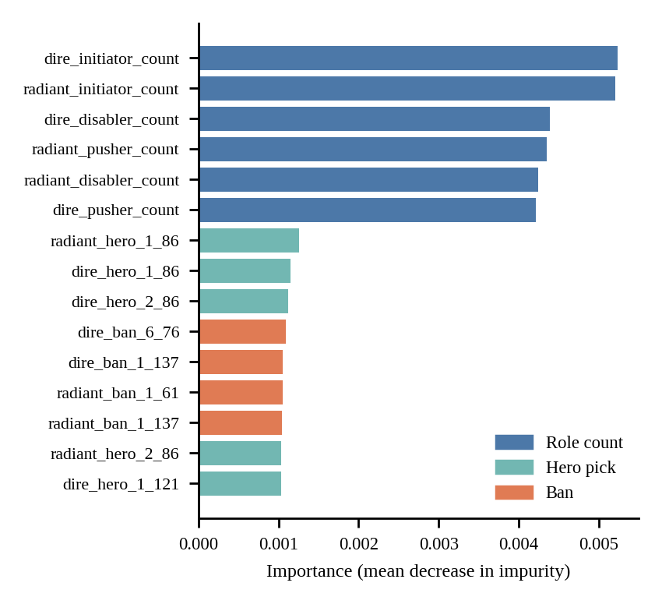
Figure 7. Top 15 individual feature importances from the Random Forest (final model with bans).
Table 6 sums importance by category. Hero bans account for 56.22% of total importance, hero picks for 41.02%, and role composition for 2.76%. These sums depend on how many columns each category has, since one-hot encoding splits picks and bans across many sparse columns while role composition uses six. The final feature matrix has 1,246 columns before bans are added and 2,996 with them, which gives 1,240 pick columns, 1,750 ban columns, and 6 role columns. Averaged per column, role features contributed about 0.0046 each, compared with about 0.00033 for pick columns and 0.00032 for ban columns.
Category | Columns | Summed importance | Mean per column
Hero picks | 1,240 | 41.02% | 0.00033
Hero bans | 1,750 | 56.22% | 0.00032
Role composition | 6 | 2.76% | 0.0046
Table 6. Feature importance by category. Column counts and per-column means are derived from the feature matrix shapes and the summed importances.
Two statements follow from these figures. First, almost all of the importance the trained forest assigned came from pick and ban columns, which together account for 97.24% of the total. Second, the highest-ranked pick or ban column (0.0013) scored less than a third of the lowest-ranked role-composition count (0.0042). Both views describe the structure of this trained model and are not causal effects.

4. DISCUSSION
A completed professional Dota 2 draft, including picks and bans, carried a modest but measurable signal in this experiment. The Random Forest reached 53.38% accuracy on the held-out test set and 53.61% mean accuracy across five validation folds, against 51.27% and 51.29% for the Decision Tree and a 50.48% naive baseline. The Random Forest's margin over the baseline is small, and the Decision Tree's margin is smaller still. No statistical significance test was run, so these differences should be read as modest and not as proof of a reliable predictor. An earlier run in the same notebook that used picks and role counts only, on the same split, gave 51.48% for the Decision Tree and 51.36% for the Random Forest, so the Random Forest's gain appeared after ban features were added. A controlled ablation was not run, so this cannot be attributed to bans alone.
The two models behaved differently under class-balanced metrics. The Decision Tree predicted Radiant wins for 91.4% of test matches, which produced its high recall (92.32%) and F1-score (65.67%) but a macro-F1 of 40.88% and a balanced accuracy of 50.88%. Its high recall should therefore not be read as better prediction. The Random Forest produced similar accuracy, balanced accuracy, and macro-F1, and it scored above the Decision Tree in all five validation folds.
The feature importance results have two sides. In summed terms, picks and bans hold nearly all of the importance (97.24%), with bans at 56.22%, picks at 41.02%, and role composition at 2.76%. Per column, however, the six role-composition counts were the most important individual features by a wide margin. Because the summed figures scale with the number of columns in each category, the results do not show that bans are inherently more informative than picks, or that role composition is uninformative. They show that the trained forest spread most of its importance across many individual hero and ban columns, while each of the six dense role counts received far more importance per column. Importance values describe the trained model and are not evidence that a particular hero or ban causes a win.
Taken together, the results support a cautious reading. A draft-based model can identify some pre-match patterns, but it cannot reliably determine the winner from draft information alone. Match outcomes also depend on factors outside the feature set, including player execution, decision-making, coordination, and in-game adaptation.

5. LIMITATIONS
(1) The model predicts from draft information only and cannot capture in-game execution, player skill, or mid-game adaptation.
(2) Hero picks are encoded in fixed positional columns following draft order, so identical rosters picked in a different order are treated as different feature patterns.
(3) The analysis uses a single year (2023) of a multi-year archive, and hero balance changes across patches were not modeled.
(4) Neither model was tuned. Hyperparameters were set once (max_depth = 10 for the Decision Tree, 200 trees for the Random Forest).
(5) Results come from one stratified split with a fixed random seed plus cross-validation on the training data. No statistical significance test was performed.
(6) Feature importance is impurity-based and was computed on the trained forest. Summed category importance depends on the number of columns per category, and permutation importance was not run.
(7) The consistency check for picks and bans covered each team's first five ban positions, and the reason some matches record fewer than seven bans was not investigated.
(8) The study evaluates completed drafts and does not identify or recommend an optimal lineup.

6. CONCLUSION
This project developed and compared Decision Tree and Random Forest classifiers for predicting Dota 2 match winners from completed professional Captains Mode drafts, using hero picks, hero bans, and engineered role-composition features. On the held-out test set, the Decision Tree reached 51.27% accuracy and the Random Forest 53.38%, against a 50.48% naive baseline. Five-fold stratified cross-validation gave mean accuracies of 51.29% and 53.61%, and the Random Forest scored higher in all five folds.
Balanced accuracy and macro-F1 showed that the Decision Tree's high recall came from predicting Radiant wins for about 91% of test matches, while the Random Forest's predictions were spread more evenly across both outcomes.
The trained Random Forest assigned 56.22% of its total feature importance to ban columns, 41.02% to pick columns, and 2.76% to the six role-composition counts. Per column, the role-composition counts ranked highest, so the summed figures mainly reflect the number of columns in each category.
Overall, professional Dota 2 drafts contained real but limited predictive information in this experiment. The model can serve as a lightweight analytical reference for examining draft patterns, but the reported accuracy does not support treating draft data alone as a reliable determinant of match outcome. Future work could add temporal validation across patches, ablation studies that isolate picks, bans, and role features, permutation-based importance, side-neutral or order-independent representations of the draft, and player- or team-level historical performance.

REFERENCES
[1] I. Semenov and B. Romov, "Performance of Machine Learning Algorithms in Predicting Game Outcome from Drafts in Dota 2," Communications in Computer and Information Science, vol. 573, pp. 26-37, 2016. doi: 10.1007/978-3-319-52920-2_3.
[2] B. Wandowando, "Dota 2 Pro League Matches 2016-2026," Kaggle. Available: kaggle.com/datasets/bwandowando/dota-2-pro-league-matches-2023
[3] L. Breiman, "Random Forests," Machine Learning, vol. 45, no. 1, pp. 5-32, 2001. doi: 10.1023/A:1010933404324.
[4] J. R. Quinlan, "Induction of Decision Trees," Machine Learning, vol. 1, no. 1, pp. 81-106, 1986. doi: 10.1007/BF00116251.

