PROJECT REPORT Feature Engineering, Model Optimization & Performance Comparison
Using Multiple Regression Models

Artificial Intelligence & Machine Learning Internship
Task – 2

Submitted By
Rumy Hota
B.E. – Computer Science Engineering

Submitted To
Maincrafts Technology

Technologies Used
Python | Pandas | NumPy | Scikit-learn | Matplotlib | Jupyter Notebook

2026

1. Objective
The objective of this project is to improve the performance of machine learning models through feature scaling and model optimization. The project focuses on training and comparing multiple regression algorithms using the California Housing dataset. It demonstrates the complete machine learning workflow, including data preprocessing, feature scaling, model training, prediction, evaluation, and performance comparison.

2. Introduction
Machine Learning is a branch of Artificial Intelligence that enables computers to learn patterns from data and make predictions without being explicitly programmed. In regression problems, selecting an appropriate model and preprocessing the dataset are essential for achieving better prediction accuracy.
In this project, the California Housing dataset provided by Scikit-learn is used to predict median house prices. Three regression algorithms—Linear Regression, Ridge Regression, and Decision Tree Regressor—are trained and evaluated. Feature Scaling using StandardScaler is applied to improve the performance of models that are sensitive to feature magnitude.

3. Methodology
The following machine learning workflow was followed:
- Imported the required Python libraries.
- Loaded the California Housing dataset.
- Separated the input features (X) and target variable (y).
- Split the dataset into training and testing sets using an 80:20 ratio.
- Applied Feature Scaling using StandardScaler.
- Trained multiple regression models:
  - Linear Regression
  - Ridge Regression
  - Decision Tree Regressor
- Generated predictions using the test dataset.
- Evaluated model performance using RMSE and R² Score.
- Compared the performance of all models using a performance comparison table and visualization.
4. Model Evaluation
The trained regression models were evaluated using the following performance metrics:
- Root Mean Squared Error (RMSE): Measures the average prediction error in the same units as the target variable. Lower RMSE indicates better model performance.
- R² Score (Coefficient of Determination): Represents how well the model explains the variance in the target variable. A value closer to 1 indicates better predictive performance.
5. Performance
Evaluation Results
Model | MSE | RMSE | R² Score
Linear Regression | 0.556 | 0.746 | 0.576
Ridge Regression | 0.556 | 0.746 | 0.576
Decision Tree Regressor | 0.525 | 0.724 | 0.600

Figure 1: Performance Comparison of Regression Models
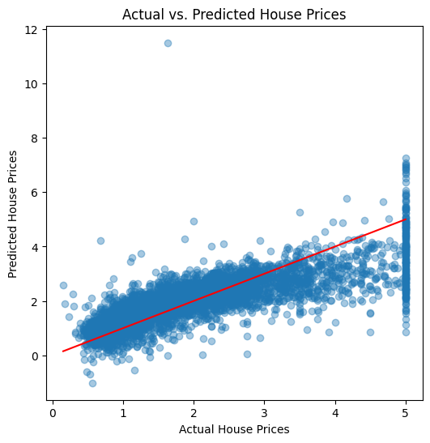
Graph Analysis
The scatter plot compares the actual house prices with the values predicted by the Linear Regression model. Most of the data points are clustered around the reference line, indicating that the model is able to capture the overall relationship between the input features and the target variable effectively.
However, a few data points are located farther from the reference line, which represents prediction errors for certain observations. These deviations suggest that the model does not perfectly capture all variations in the dataset.
The model achieved an R² Score of 0.576, which means it explains approximately 57.6% of the variance in house prices. This indicates a moderate level of predictive performance.
Overall, the Linear Regression model provides a reasonable baseline for house price prediction, but there is still room for improvement using more complex models or feature engineering techniques.
6. Conclusion
This project demonstrated the implementation of multiple regression models for house price prediction using the California Housing dataset. The models used were Linear Regression, Ridge Regression, and Decision Tree Regressor.
After evaluating the models using MSE, RMSE, and R² Score, it was observed that the Decision Tree Regressor performed the best with the highest R² Score (0.600) and the lowest error values. Linear Regression and Ridge Regression showed identical performance and acted as baseline models.
The results indicate that the dataset contains non-linear relationships that are better captured by tree-based models compared to linear models. However, there is still scope for improving accuracy through hyperparameter tuning and advanced algorithms.
Overall, this project provided a clear understanding of regression techniques, model evaluation, and performance comparison, strengthening practical skills in machine learning using Python and Scikit-learn.

