Breaking Democracy

User Documentation

**Getting Started**

To get started with Breaking Democracy simply go to <https://catiel.github.io/Breaking-Democracy/> on your favorite web browser. Desktop is preferred to mobile though!

**How To Play**

Introduction Video

When you first start the game, you will see the introduction video pictured below. This video will give you the story of the game and how to play it. For certain internet browsers the video does not start playing automatically, if this is the case for you simply press the play button in the bottom left corner.

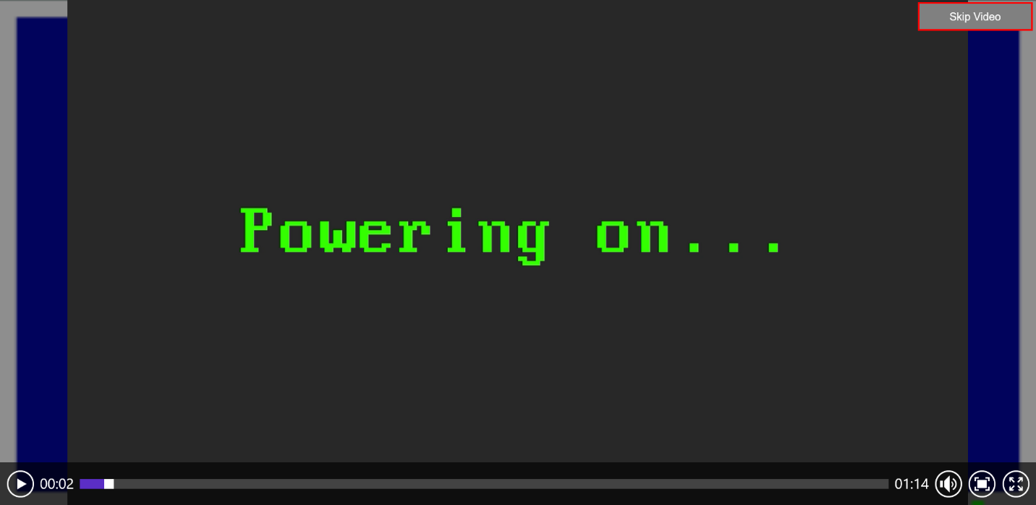

If you don’t have the time to watch the video, are a returning player, or you simply prefer to read the instructions you can click the “Skip Video” button in the corner shown below.

Start Screen

Once the video is over you will automatically be sent to the email screen shown below.

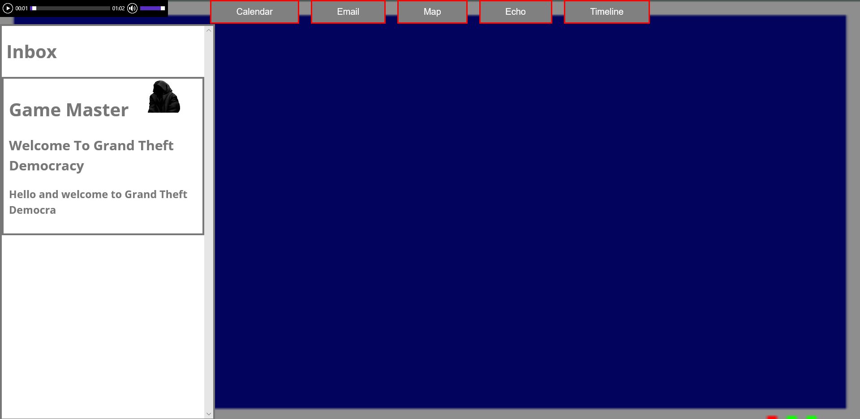

Once on the email screen you are free to click on any of the five tabs at the top, or you can read the game’s instructions from the first email seen above. You can also see the audio player in the top left corner which controls the background song.

Email Screen

Clicking on the Email tab will open the email screen pictured below. This is where you will receive gameplay instructions, updates on how you are doing in the game, and some fun in game information!

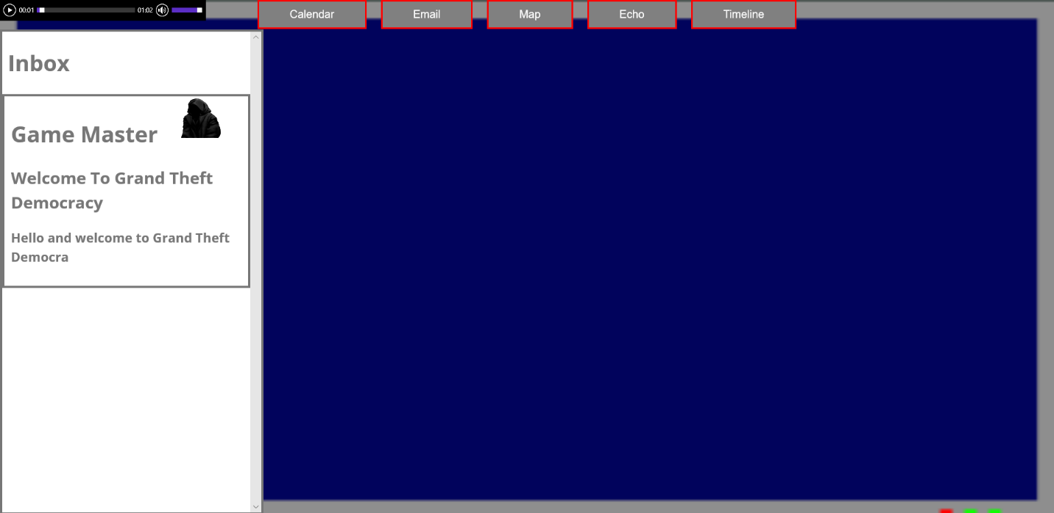

To access all of this information simply click on any of the emails that are shown in your Inbox on the left. When you click one of the emails it will open that email in the blank area next to the Inbox so that you can read all of its contents as seen below.

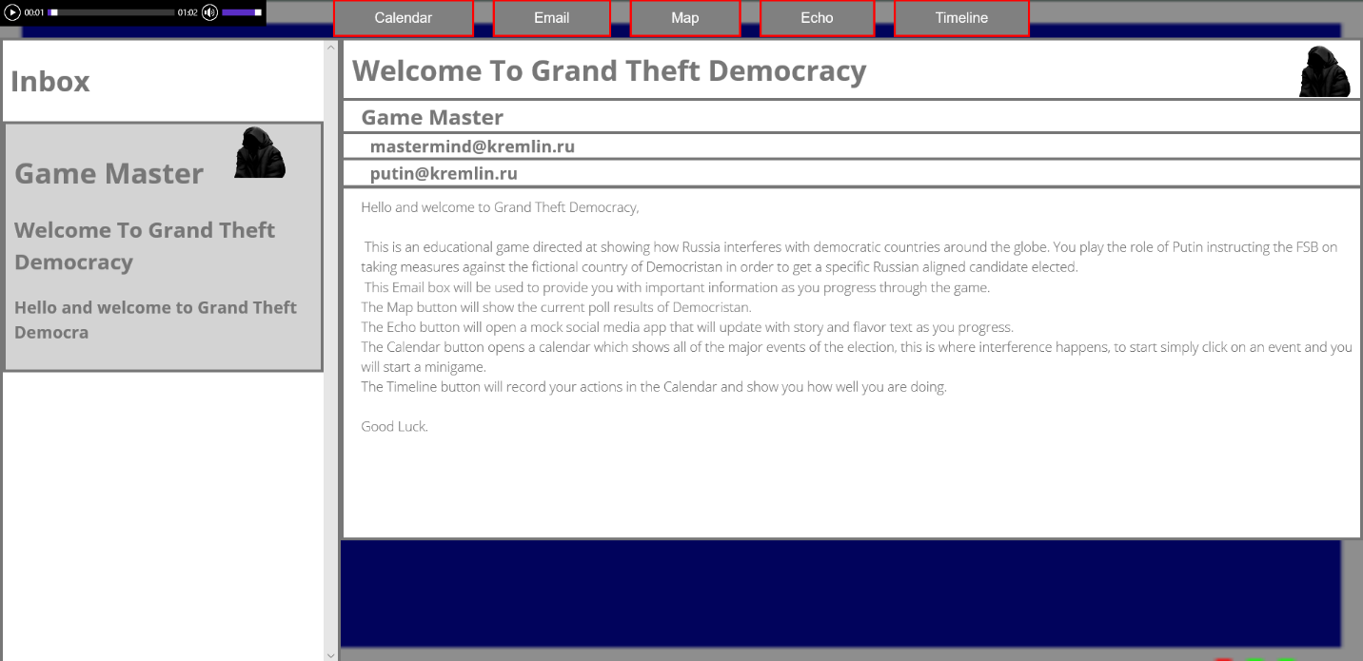

As you complete turns in the game more and more emails will be sent to you. To see all of the emails in your Inbox you can scroll up or down by either using your trackpad, mouse wheel, or by using the side bar controls pictured below.

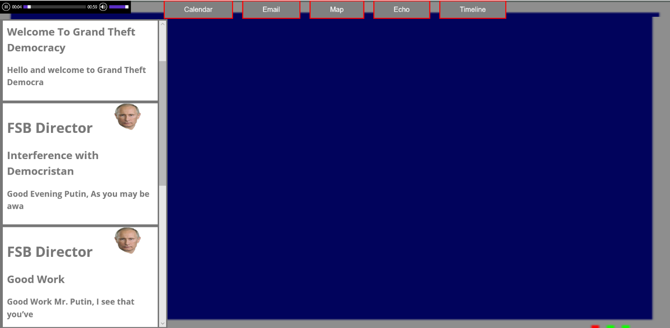

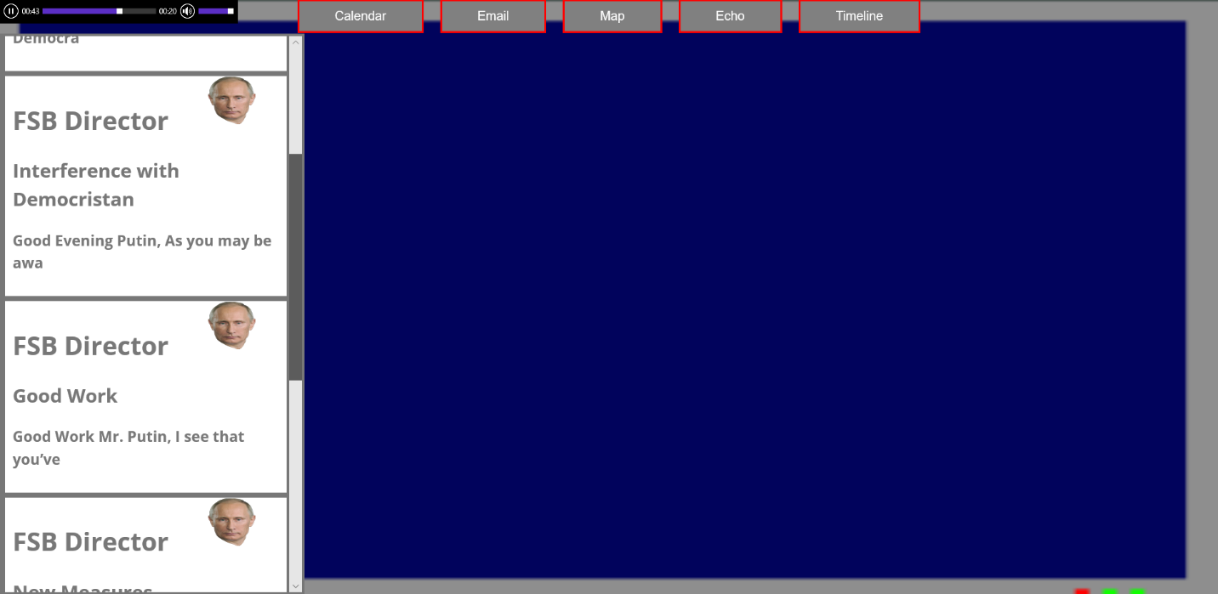

Calendar Screen

On the Calendar page shown below you are able to click on any of the events within a two-week window shown by the lighter colored days.

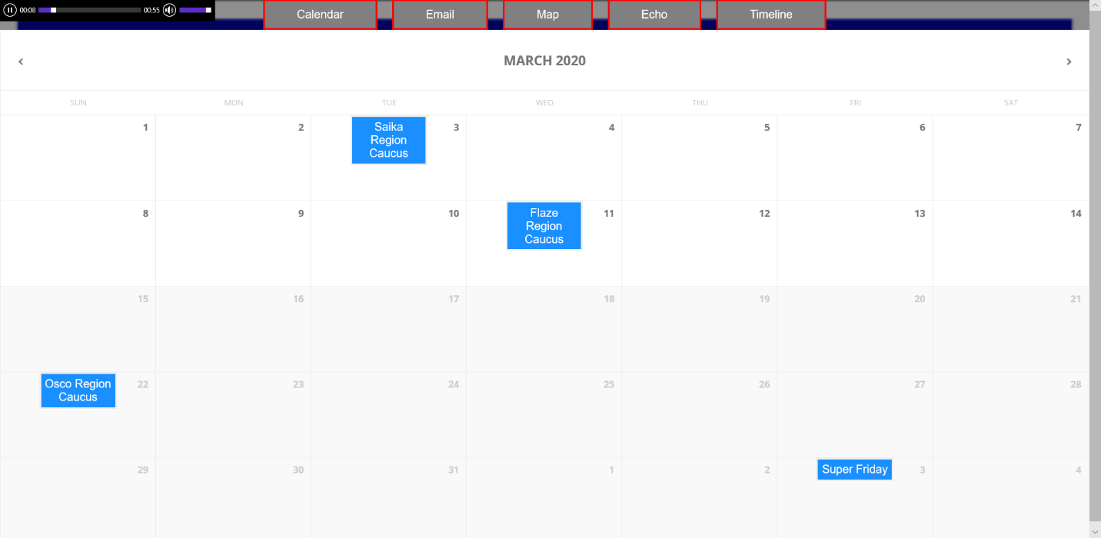

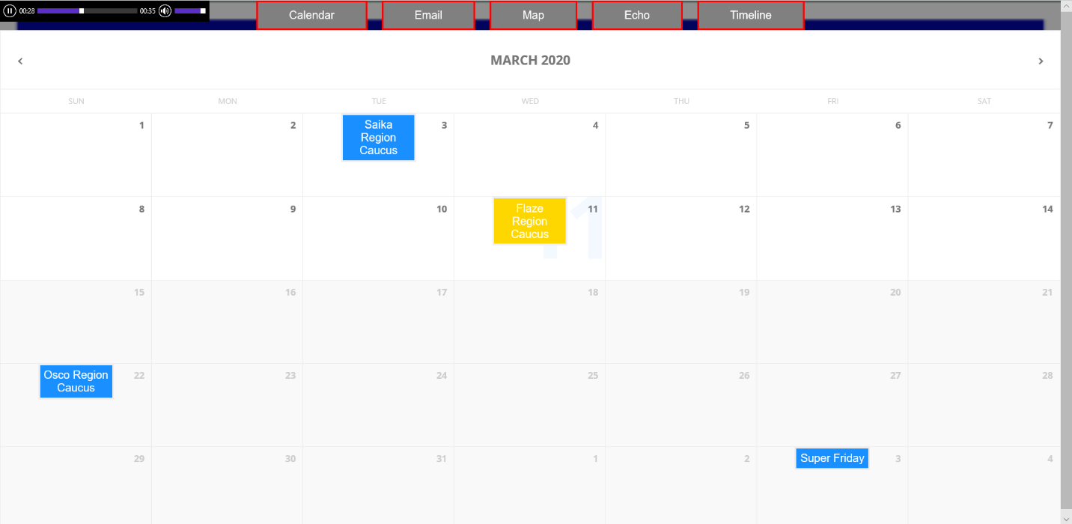

When you click on an event a window will pop up telling you what is happening with that event. You are also given two options on what you would like to do for that event.

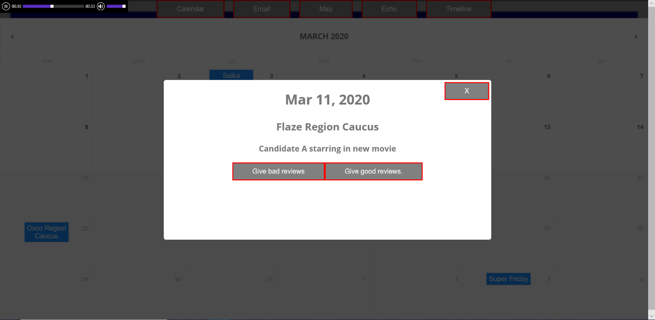

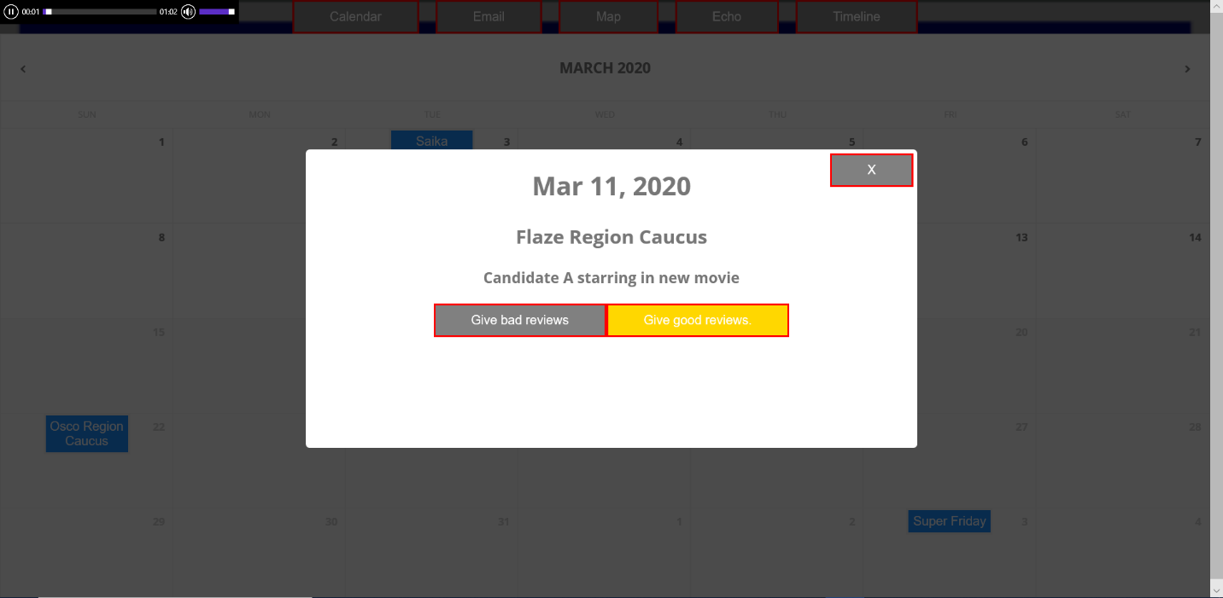

When you click on one of the options for the event a minigame will open up for you to play as shown in the picture below. How well you do in the minigame determines how well you do for the whole event. There are two different minigames so the controls for each minigame will be different.

Shown below is the first game called Reactoids. In this game you have to maneuver your ship to avoid the asteroids while shooting at them to break them apart and earn points! To maneuver you can use ‘W’ or the up arrow to move in the direction your ship is pointing, use ‘A’ or left arrow to turn left, use ‘D’ or right arrow to turn right, and lastly to shoot press space bar.

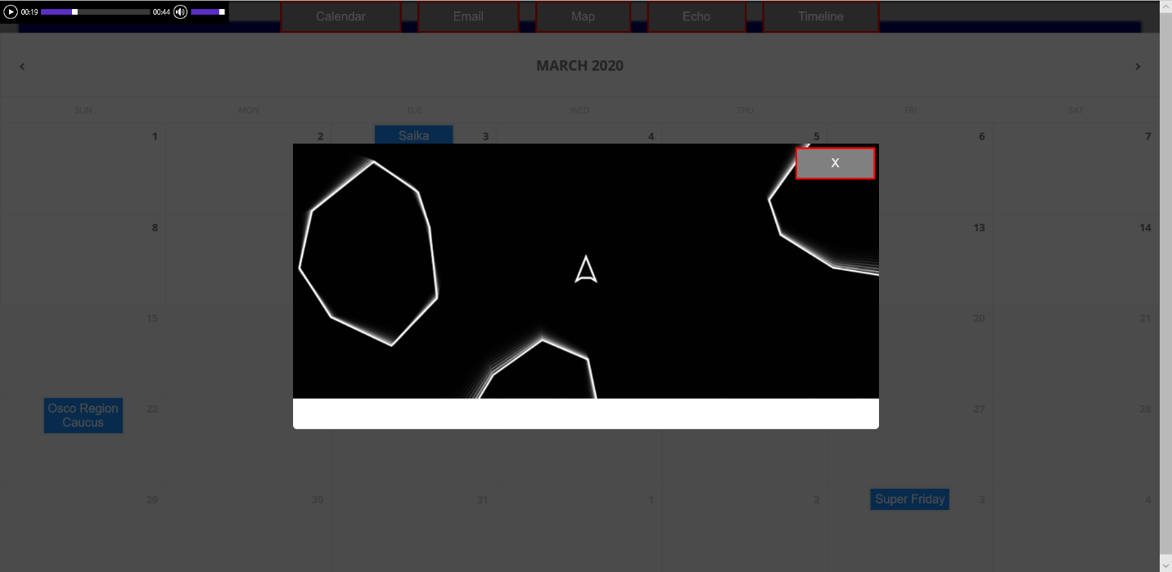

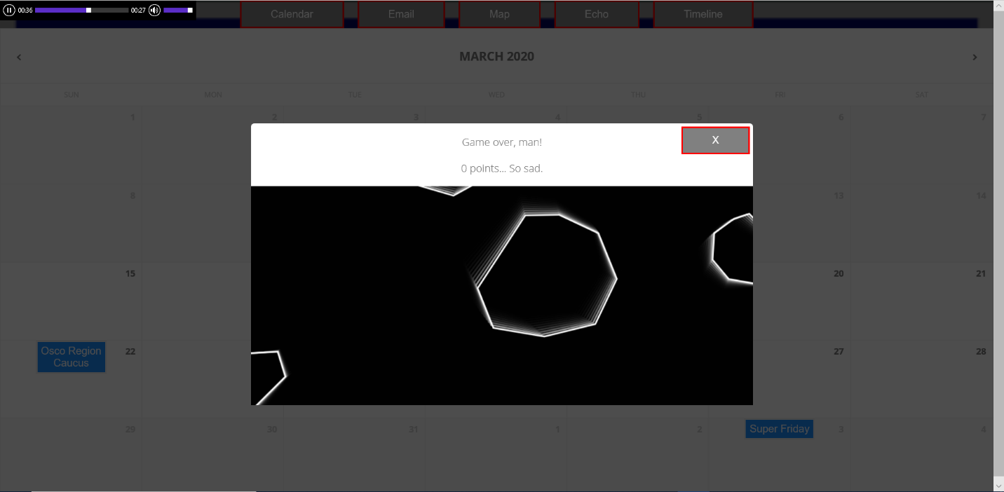

Once you have completed the minigame you can click the exit button in the top right corner of the popup window as shown below.

The second game is called TypeType! It is a simple game that asks you a question and you can try to answer it in the textbox provided.

When you are ready to submit your answer, you can either hit enter or you can click the submit button next to the text box. If your answer is wrong you will be shown the correct answer as shown below.

Finally, just like Reactoids you are able to exit the minigame by clicking the exit button in the top right corner.

Once the popup window is closed you will see that the event that you clicked on has disappeared as shown below. This means that you have successfully completed the event. To advance in the game complete all of the events in the two-week window to advance to the next two-week window.

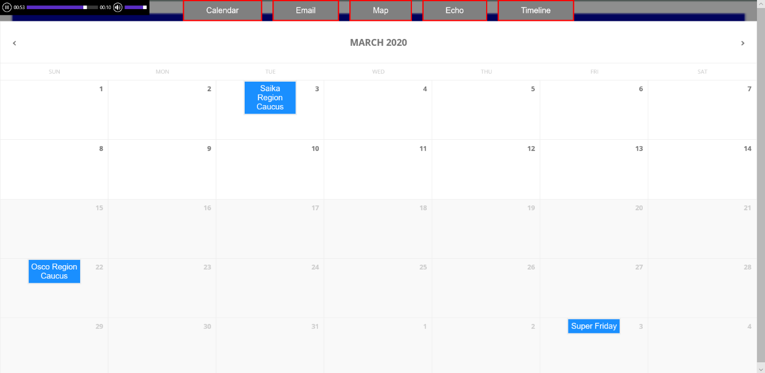

Timeline Screen

If you click on the Timeline tab before completing any events you will be shown the empty timeline shown below.

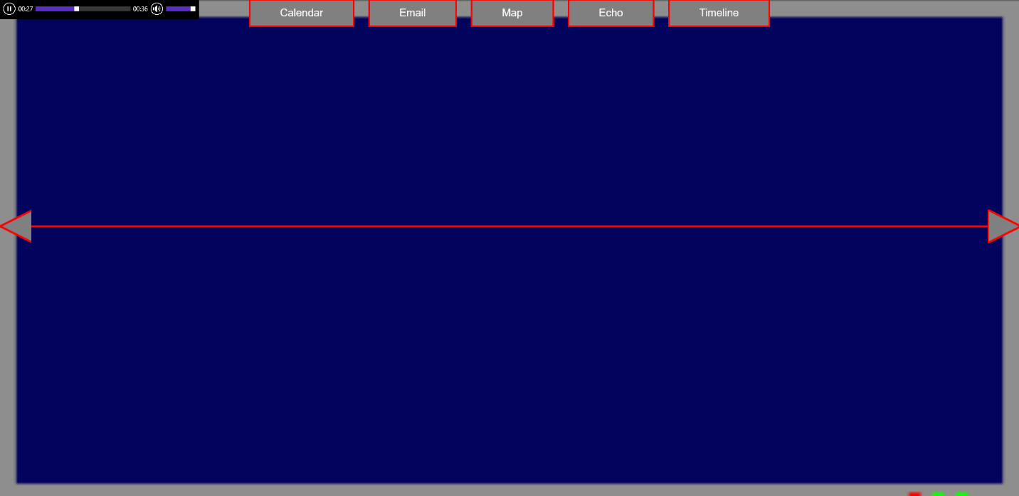

After you complete events in the Calendar Screen the Timeline screen will have a bubble for each event that you completed as shown below. Each bubble has the percentage change that resulted from the specific event and it is colored to reflect that change with red being a bad change, gray being no change, and green being a good change. You can also hover over each event bubble to see which event that bubble is related to as shown below.

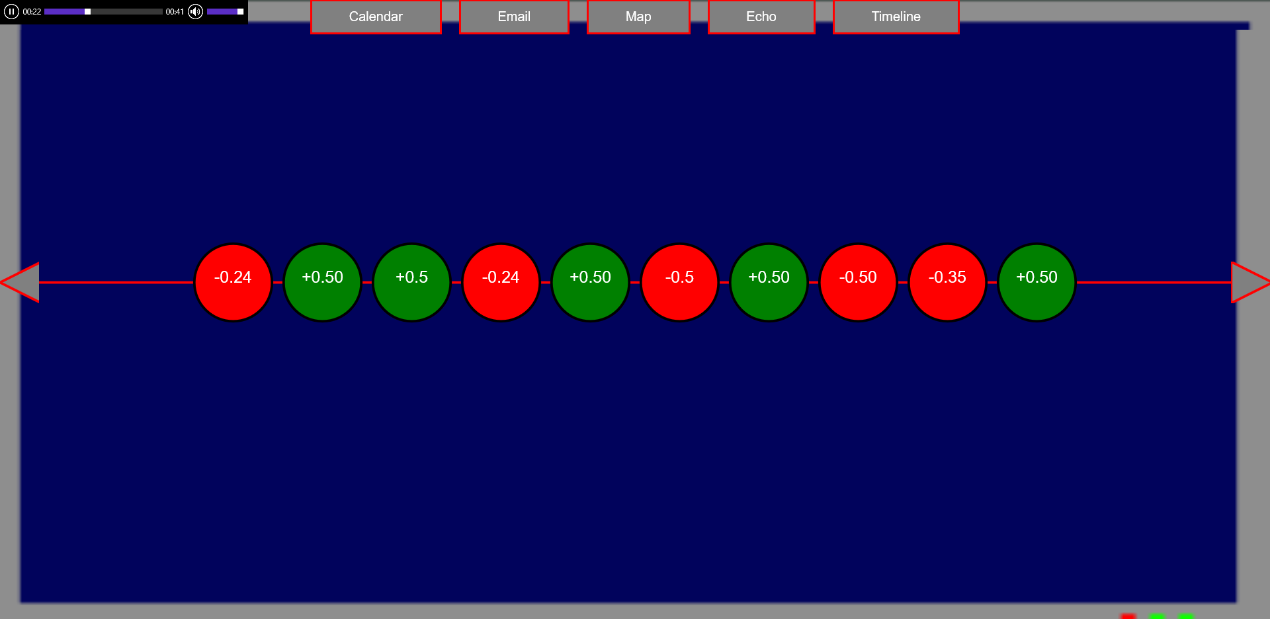

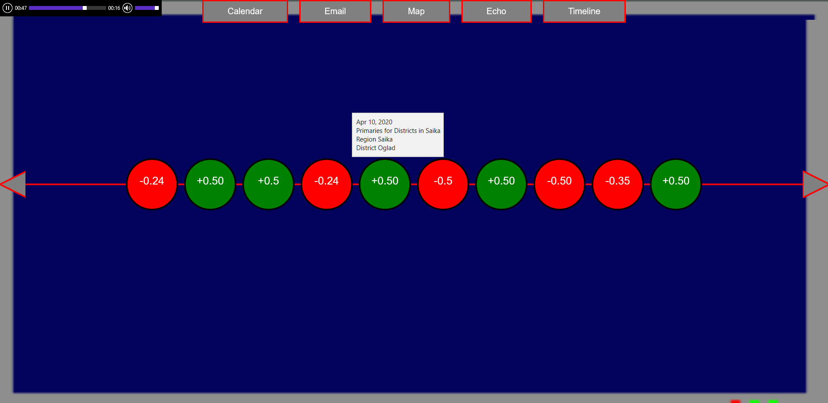

As you complete events you might notice that new event bubbles stop showing up. These new bubbles are accessible by clicking on the arrows on either end of the timeline to show you these new bubbles as seen below.

Map Screen

At any time, other than while you are playing an event, you can click on the Map tab to go to the Map screen shown below. On this screen you will see the map of Democristan. Each region of the map is colored like a polling map with more red color representing a red party dominated region, more blue color representing a blue party dominated region, and more purple color representing a swing region.

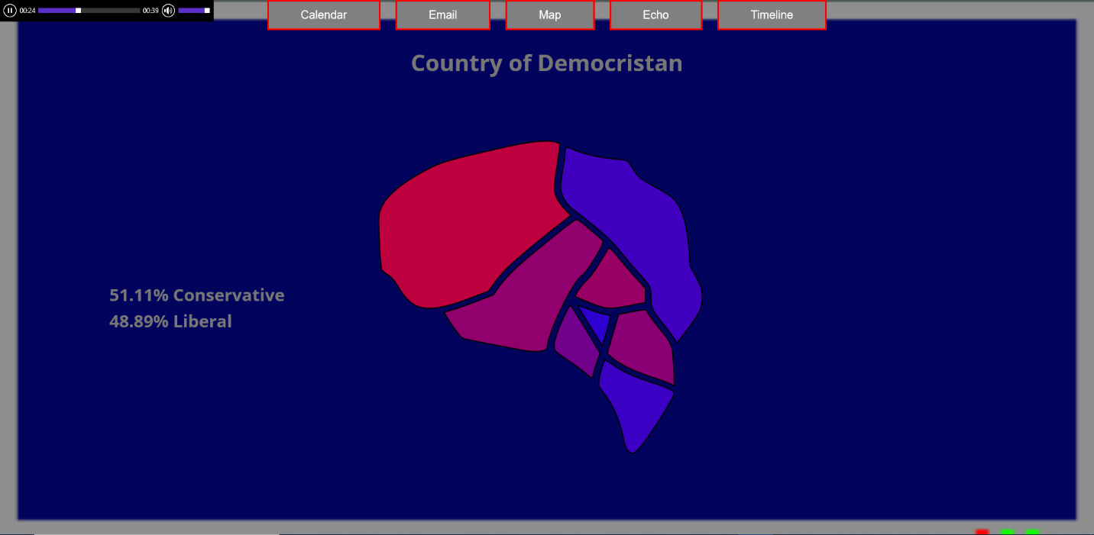

Below the tabs you can see the name of the country or of the regions your mouse is over. You are able to click on any of the individual regions to bring up a regional map of the specific region you clicked on as shown below. Each region is colored like a polling map just like the country map.

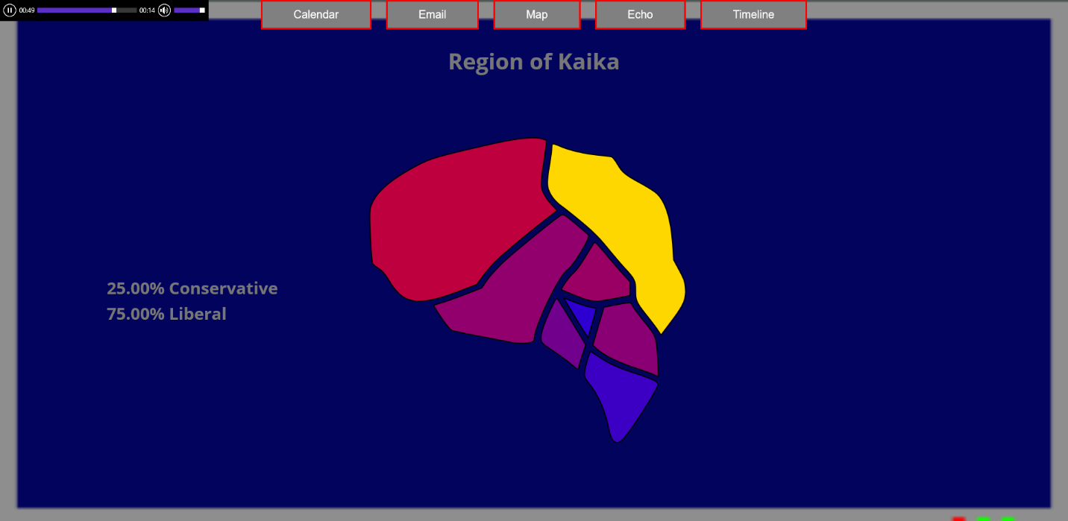

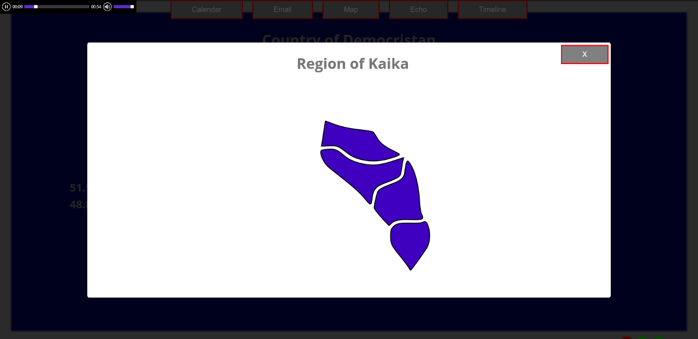

Also like the country map you can see the name of the region you are looking at or the district that your mouse is on. To exit out of the regional map popup you can click on the exit button in the top right corner of the popup as shown below.

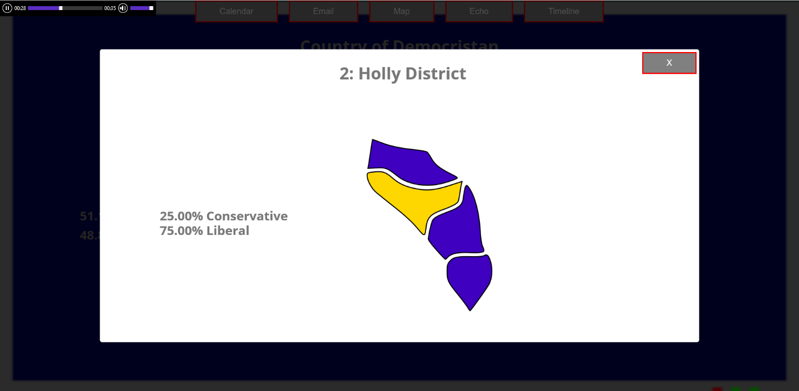

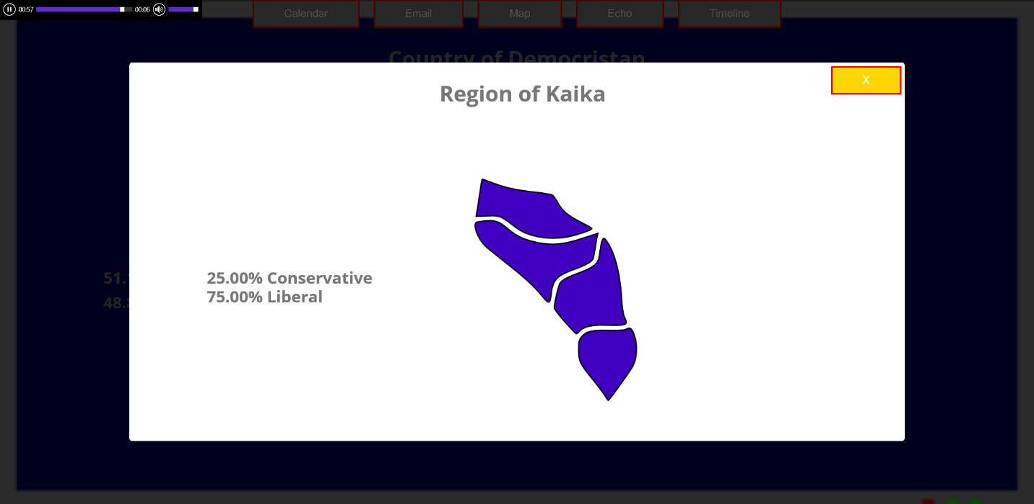

As you complete events the Map screen’s colors will update to show your progress in the game. This can be difficult to see on the country map at first, but it is much easier to see in the regional maps as shown below.

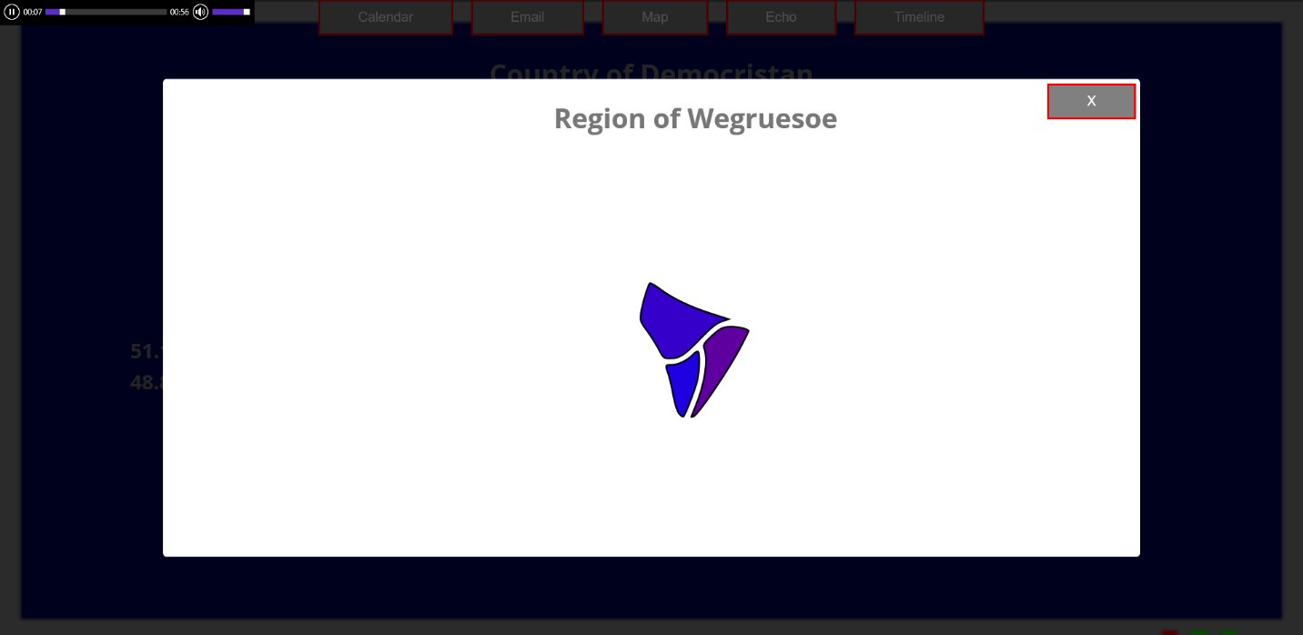

Region map pre-event completion.

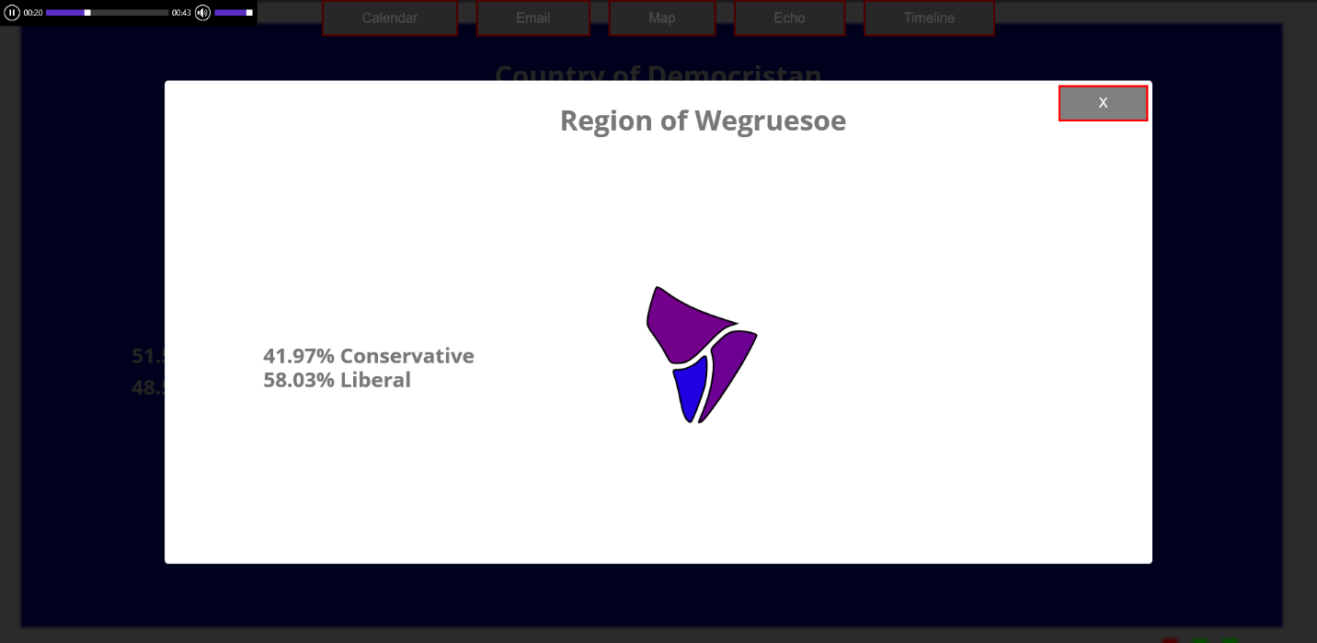

Region map post-event completion.

Echo Screen

Also, at any time, except during an event minigame, you can click on the Echo tab to go to the echo screen shown below. On this screen you will see the in game social media site where you can read more in game content to have a deeper playthrough of the game.

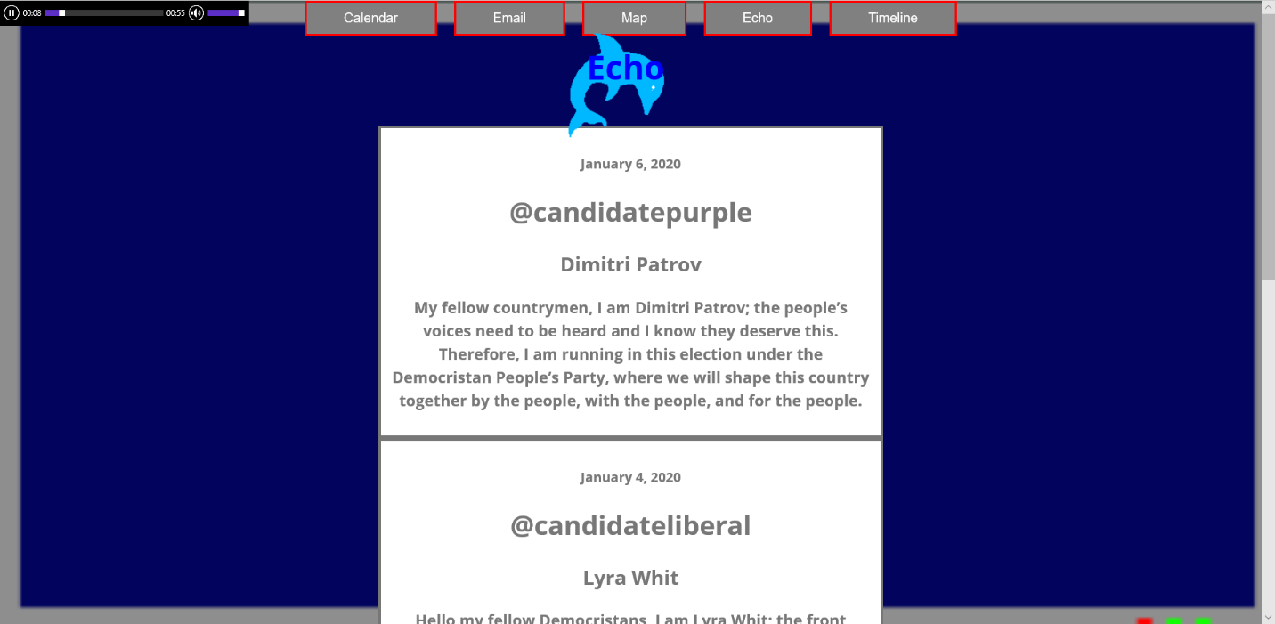

As you play the game new echos will appear on this screen for you to read! You can scroll up and down on the Echo screen to see and read more echos by either using your mouse wheel, trackpad, or using the control bar on the right side of the screen as shown below.

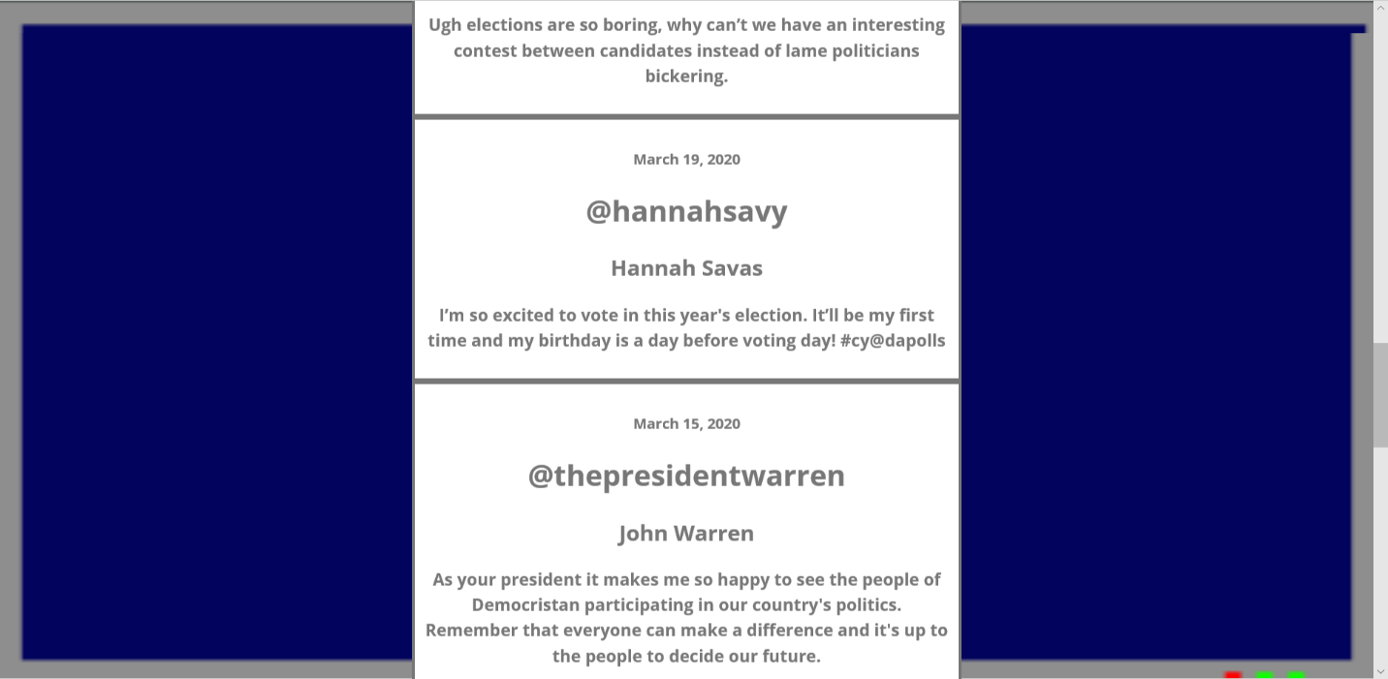

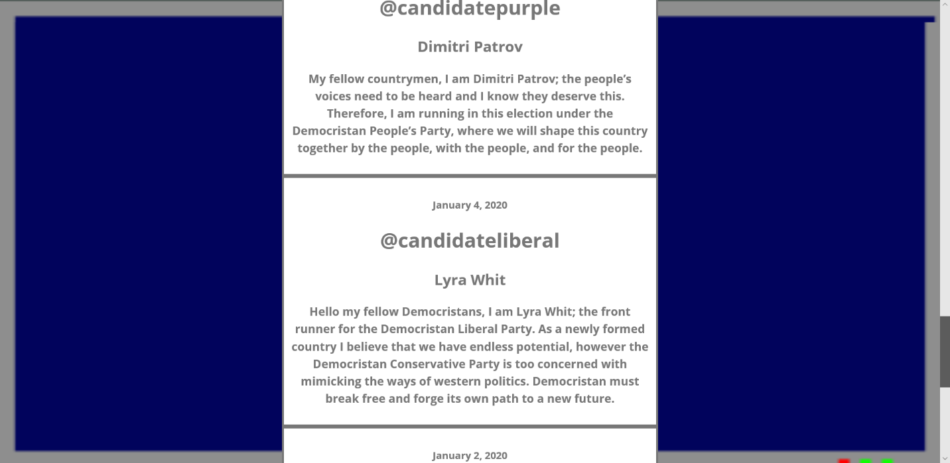

Ending Video

Once you complete all of the events in the calendar you will be shown one of two videos depending on how well you did!

If you want to play again and try to get the best ending you can simply click the “Play Again?” button in the top right corner of the screen as shown below.

