**1 Getting started**

* 1. **Downloading GRL**

GRL can be downloaded at https://github.com/GRL. It can be installed as a regular R package.

* 1. **Installing GRL**

GRL links to R packages Rcpp, RcppEigen and RcppArmadillo, and also imports R packages BEDMatrix and data.table. These dependencies should be installed before installing GRL. In addition, GRL requires PLINK2.0 Software (<http://www.cog-genomics.org/plink/2.0/>) with name “plink2.0” under your run directory. Here is an example for installing GRL and all its dependencies in an R session(assuming none of the R packages other than the default has been installed):

install.packages(c("BEDMatrix ", " data.table ", "Rcpp", " RcppEigen ", " RcppArmadillo "), repos = "https://cran.r-project.org/")

system(“R CMD install GRL_1.0.tgz”)

**2 Input**

GRL requires the phenotype and genotype files in an PLINK BED data frame which also called PLINK 1 binary file and the structure of these files is described in http://www.cog-genomics.org/plink/1.9/formats#bed. How to prepare these data are describe below.

**2.1 Phenotype**

Phenotype should place in the sixth column of “.fam” file. The missing phenotype value for quantitative traits is -9.

**2.2 Genotypes**

GRL can only take genotype files in “.bed” and “.bim” format.

**3 Running GRL**

If GRL has been successfully installed, you can load it in an R session using:

library(GRL)

and then loading "BEDMatrix "and " data.table "

library(BEDMatrix)

library(data.table)

We provide three functions in GRL: **Data** function for basic data management including extract phenotypic values, sampling markers, calculate allele frequencies and calculating GRM, saved in an external file, used for GBLUP method or the transformed GRM for large scale dataset; **Grammar** function for estimating heritability(optional), estimating breading values, association tests using Grammar method and **Grl** function for adjust statistics using lambda, joint analysis based on the results of Grammar-Lambda, and outputting association result file then drawing Q-Q and Manhattan plot .

**3.1 Data function**

**Usage**

Data (filename, nsmar, msampling)

Arguments

filename An object class of character: the filename before the suffix of plink files. The three plink file must have a same filename, for example, “filename.bed”, “filename.bim” and “filename.bam”.

nsmar An optional numeric for the number of sampling markers. If this is unset, the “nsmar” default is 5,000.

msampling logicals. If FLASE, entire markers will be used to calculate GRM. If this is unset or for large scale dataset, the “msampling” default is TURE.

Here we provide two simple examples of data management for GRL using Data.

**3.2 Grammar function**

**Usage**

Grammar (Data, Estimateh2, AssoTst)

Arguments

Data An object class of list from the 1st step.

Estimateh2 logicals. If TURE, heritability will be estimated and the estimate would be used for estimating breeding value. If this is unset or for large scale dataset, a moderate heritability is set by default at 0.5.

AssoTst You can choose correlation analysis software “GCTA” or “PLINK2.0” as prefer, “PLINK2.0” by default.

**3.3 GRL**

**Usage**

Grl(Grammar, Test, QQ,Manh)

Arguments

Grammar An object class of list from the 2st step.

Test An optional for association test, a test at once or joint analysis. You can choose “Separate” for a test at once and “Joint” for further joint analysis based on the result of “Separate”.

QQ logicals. If TURE, Q-Q plot would be drawn.

Manh logicals. If TURE, Q-Q plot would be drawn.

**4 Output**

**4.1 Grammar result**

The Grammar function generates a plink association text output file called “Grammar.PHENO1.glm.linear”. Here we show the header and the first five rows of the example output:

#CHROM POS ID REF ALT A1 TEST OBS_CT BETA SE T_STAT P ERRCODE

1 8500 S1_8500 G A A ADD 2648 0.0755563 0.188783 0.400227 0.689021 .

1 10390 S1_10390 G A A ADD 2648 -0.00784112 0.238845 -0.0328293 0.973813 .

1 10590 S1_10590 T A A ADD 2648 -0.202364 0.249746 -0.810281 0.417852 .

1 128159 S1_128159 C T T ADD 2648 0.15431 0.215808 0.715033 0.474652 .

1 128373 S1_128373 C T T ADD 2648 0.033819 0.124565 0.271498 0.78603 .

…

**4.2 Grammar-Lambda result**

In addition to the above file, a QTN candidate file, named “QTNs”, with Bonferroni as the threshold is also output. The header and the first five rows are:

#CHROM POS ID REF ALT A1 TEST OBS_CT BETA V2

1 222963574 S1_222963574 G A A ADD 2648 -0.462216 7.65251920613318

2 6597140 S2_6597140 T C C ADD 2648 1.16828 17.6731608197186

2 6597170 S2_6597170 G T T ADD 2648 1.91808 43.6572192493634

3 165856383 S3_165856383 T C C ADD 2648 0.489627 7.28229257925678

3 165858424 S3_165858424 G A A ADD 2648 -0.642925 11.2704149095184

…

If joint analysis, a file, named “jointQTNs”, will display candidate QTNs resulting from joint analysis, which is the same format as “QTNs”.

**4.3 Q-Q plot**

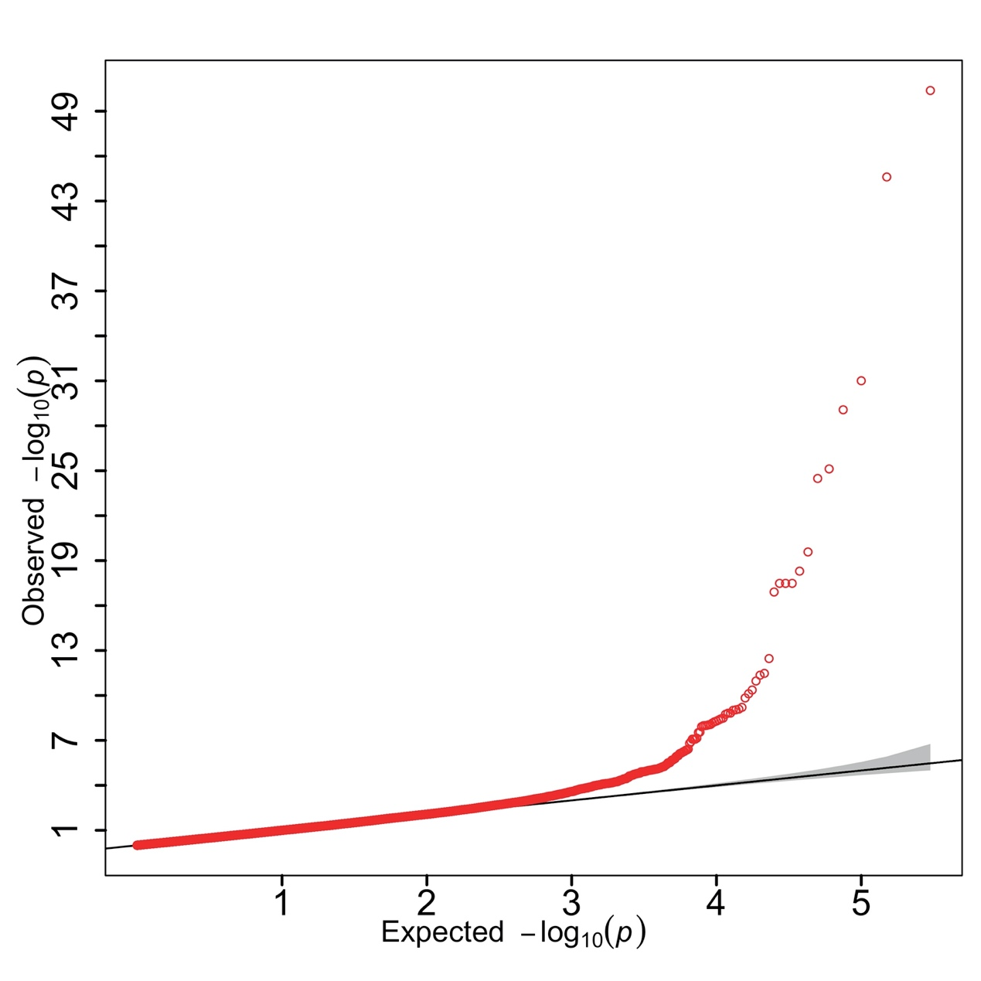

**4.3 Manhattan plot**

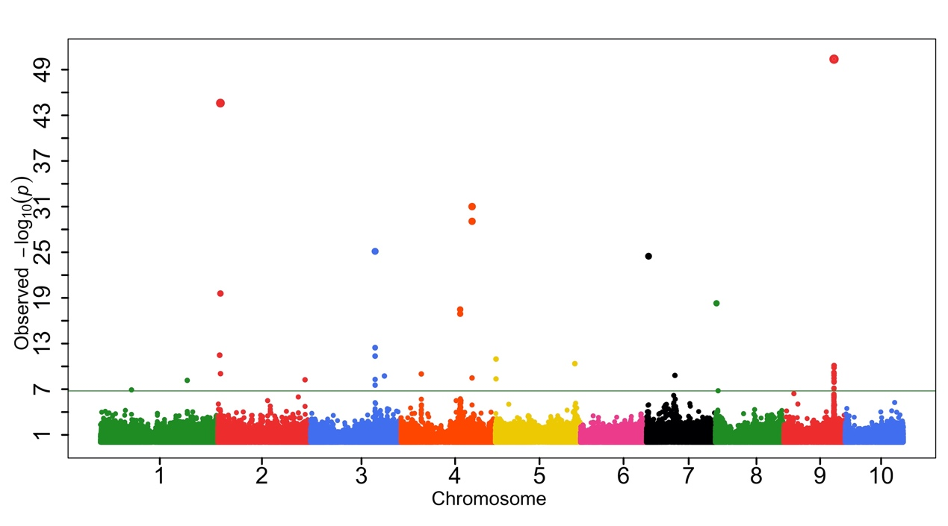

**5 Example**

library(GRL)

library(BEDMatrix)

library(data.table)

pathdata<-"/Users/songyuxin/Desktop/CFWmice_binary"

setwd(pathdata)

plinkfilename = "maize"

gdata <- Data(plinkfilename)

grammar <- Grammar(gdata)

Grl(grammar, Test = "Separate" , QQ = F, Manh = F)

############if you want joint analysis use following code#########

gdata <- Data(plinkfilename)

grammar <- Grammar(gdata)

Grl(grammar, Test = "Joint" , QQ = F, Manh = F)