Software Engineering Group Project

Design Specification

|  |  |
| --- | --- |
| Author: | Runar Reve [rur7] |
| Config Ref: | SE.GP09.DESIGNSPEC |
| Date: | 02th April 2019 |
| Version: | 1.0 |
| Status: | Release |

Department of Computer Science

Aberystwyth University

Aberystwyth

Ceredigion

SY23 3DB

Copyright © Aberystwyth University 2019

CONTENTS

CONTENTS 2

1. Introduction 3

1.1 Purpose of this Document 3

1.2 Scope 3

1.3 Objectives 3

2. decomposition description 3

2.1 Programs in system 3

2.2 Significant Classes 4

2.3 Mapping from requirement to classes 4

3. Dependency description 5

3.1 Component Diagrams 5

3.2 Table Diagram 6

4. interface description 6

4.1 PubTour interface specification 6

4.2 Town interface specification 6

4.3 Pub interface specification 7

4.4 DbCommunicator interface specification 7

5. detailed design 10

5.1 Sequence diagrams 10

5.2 Significant algorithms 11

5.3 Significant data structures 12

REFERENCES 13

DOCUMENT HISTORY 14

# Introduction

## Purpose of this Document

The purpose of this document is to describe and define the programs in our system, how those programs will be implemented and interact with each other. It is following the standards from the general Documentation Standards [1] and describing the system requirements for a pub tour system [2].

## Scope

The document describes the programs in our system and breaks each program down in detail, specifying the names and purpose of the significant classes in each program, and how all of the components will work together.

## Objectives

The objective of this document is to define how the system will be built, specify the names and purpose of significant classes and functions, the outcome of which should be a clear and concise design for our system that can be followed by all members of the team.

# decomposition description

## Programs in system

The Pub Tour system is built up of two programs and a database server:

* The desktop program
* The android program
* The database server

### The desktop program

The desktop program provides administration over the data the android application will use. It can create a new pub list for a town and load in an existing pub list. It can also add pubs, delete pubs, and edit existing pubs in a list. Linking pictures of each pub to the details of the pubs is also present. Then when something is done it will export it into a database where the android program will be able to receive and use this information.

### The android program

The android program collects the latest list of pubs in a selected town. The program can display all the pubs as a list and every pub can be selected to display further details about itself. It will display between one and five photos, the GPS location of the pub, opening and closing times, and a short description of the pub. It can also filter out pubs depending on some specific criteria (allows dogs, loud music, Welsh, etc), these criteria will also be displayed in further details.

The program will also have a random pub tour feature where it will create a random list of pubs, this list can be filtered or unfiltered, and then guide the user from pub to pub through the list. There is also a more planed pub tour where times are assigned to each pub and the program will tell the user where they should be at a specific time.

### The database server

The database server will take care of storing all the pubs and towns that will be in the system. It can only be modified by the desktop program and viewed by both the desktop and the android program. It will be using PostgreSQL.

## Significant Classes

### Significant classes in the desktop program

*PubEngin -* This will be the main stage for the program and will set up the desktop program and link all the classes together.

*DbCommunicator -* This class will communicate with the database and send commands to receive, add, and edit the data and pubs in it.

*Pub -* A class to represent a pub, will be able to convert its attributes to be understood as SQL

*Town -* A class to represent a town, will be able to convert its attributes to be understood as SQL

### Significant classes in the android program

*PubEngin -* This will be the main stage for the program and will set everything up, link all the classes together, and create variant of lists (e.g. Filtered lists, Random list, and planned lists).

*DbReceiver -* This class will retrieve the pubs and towns from the database server.

*PubTour -* This class will manipulate pub lists in different ways: randomise and filtering

### Significant tables in the database server

*Pubs -* This will store all the different pubs.

*Towns -* This will store all the different towns that will be allowed for pubs to be in.

## Mapping from requirement to classes

### Mapping requirement for the desktop system

|  |  |
| --- | --- |
| *Requirement* | *Classes providing requirement* |
| FRD1 | PubEngin, |
| FRD2 | PubEngin, Pub |
| FRD3 | PubEngin, DbCommunicator |
| FRD4 | PubEngin, DbCommunicator |
| FRD5 | PubEngin, DbCommunicator, Pub |
| FRD6 | PubEngin, DbCommunicator, Pub |
| FRD7 | PubEngin, DbCommunicator |
| FRD8 | PubEngin, DbCommunicator, Pub |

### Mapping requirement for the mobile system

|  |  |
| --- | --- |
| *Requirement* | *Classes providing requirement* |
| FRD1 | PubEngine, DbReceiever, Town, Pub |
| FRD2 | PubTour, Pub |
| FRD3 | PubTour, Pub |
| FRD4 | PubTour, Pub |
| FRD5 | PubTour, Pub |
| FRD6 | N/A |

# Dependency description

## Component Diagrams

### Component Diagram for Desktop Program

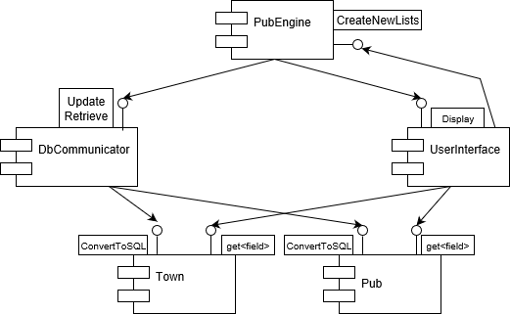

### Component Diagram for Android Program

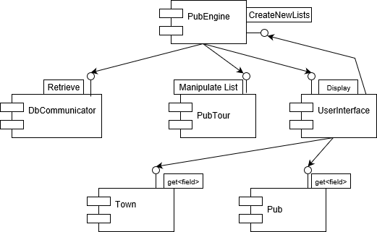

## Table Diagram

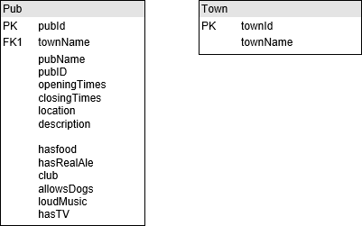

# interface description

## PubTour interface specification

package uk.ac.aber.cs221.group09;

import uk.ac.aber.cs221.group09.object.Pub;

import java.util.ArrayList;

/**

* uk.ac.aber.cs221.group09.PubTourInterface - A interface to modify the data for in ways the user wants.

* <p>

* Some classes to sort to filter pubs, "filterPubs", that you give it following

* an example pub that has the attributes the user wants.

* There is a randomize pub where it will extract the amount of pubs you want randomly and

* put them in another list

*

* @author (Runar Reve, rur7)

* @version 0.1 (Draft)

*/

public interface PubTourInterface {

/**

* Will filter out pubs to a new ArrayList that only has wanted attributes

* @param MainList the Main list that is going to be filtered

* @param samplePub example pub that has the wanted attributes, null where N/A

* @return a new ArrayList with pubs with wanted attributes

*/

ArrayList<Pub> filterPubs(ArrayList<Pub> mainList, Pub samplePub);

/**

* Create a random pub tour

* @param mainPubList is the list that is going to be extracting pubs out from

* @param amountOfPubs the amount of pubs wanted in the list

* @return a new ArrayList with pubs that is going to be in the tour

*/

ArrayList<Pub> randomPubs(ArrayList<Pub> mainPubList, int amountOfPubs);

}

## Town interface specification

package uk.ac.aber.cs221.group09.object;

import uk.ac.aber.cs221.group09.database.DbCommunicator;

/**

* uk.ac.aber.cs221.group09.object.TownInterface - An interface for a town class.

* <p>

* Will be used to create town objects and manipulate the data of it.

* Use the getters and setters to retrieve or edit the towns data.

* townToDatabase is used to convert the object into a string that can be used to communicate with a database

*

* @author (Runar Reve, rur7)

* @version 0.1 (Draft)

* @see Town

* @see DbCommunicator

*/

public interface TownInterface {

/**

* Converts the information of a town into something the database can read

* @param town the town that is being converted

* @return string that can be used in a SQL command

*/

String townToDatabase(Town town);

//Getters and setters for all variables

}

## Pub interface specification

package uk.ac.aber.cs221.group09.object;

import uk.ac.aber.cs221.group09.database.DbCommunicator;

/**

* uk.ac.aber.cs221.group09.object.PubInterface - An interface for a pub class.

* <p>

* Will be used to create a pub object and manipulate the data of it.

* Use the getters and setters to retrieve or edit the pubs data.

* pubToDatabase is used to convert the object into a string that can be used to communicate with a database

*

* @author (Runar Reve, rur7)

* @version 0.1 (Draft)

* @see Pub

* @see DbCommunicator

*/

public interface PubInterface {

/**

* Converts the information of the pub into something the database can read

* @param pub the pub that being converted

* @return string that can be used in a SQL command

*/

String pubToDatabase(Pub pub);

//Getters and setters for all variables

}

## DbCommunicator interface specification

### Receiver Side

package uk.ac.aber.cs221.group09.database;

import uk.ac.aber.cs221.group09.object.Pub;

import uk.ac.aber.cs221.group09.object.Town;

import java.sql.SQLException;

import java.sql.Statement;

import java.util.ArrayList;

/**

* uk.ac.aber.cs221.group09.database.DbReceiverInterface - A interface for how to receive

* towns and pubs from the database.

* <p>

* Both town and pubs have their separate methods for retrieving data from the database.

* In every method it has to take in a Statement that is the connection with the database.

*

* For updating the database see DbUpdateInterface

*

* @author (Runar Rve, rur7)

* @version 0.1 (draft)

* @see (DbUpdaterInterface)

*/

public interface DbReceiverInterface {

//-----PUB-----

/**

* Will retrieve specific pubs depending on the filters that is given to it

* @param town name of town that is being retrieved

* @param statement the connection with the database

* @return an ArrayList of pubs following the filters

* @throws SQLException if an SQL error occurs

*/

ArrayList<Pub> retrievePubs(Statement statement, String town)

throws SQLException;

//-----TOWN-----

/**

* Retrieves all the Towns in the database

* @param statement the connection with the database

* @return an ArrayList of all the towns in the database

* @throws SQLException if an SQL error occurs

*/

ArrayList<Town> retrieveTowns(Statement statement)

throws SQLException;

}

### Update Side

package uk.ac.aber.cs221.group09.database;

import uk.ac.aber.cs221.group09.object.Pub;

import uk.ac.aber.cs221.group09.object.Town;

import java.sql.SQLException;

import java.sql.Statement;

/**

* uk.ac.aber.cs221.group09.database.DbUpdaterInterface - A interface for how to update the database.

* <p>

* Both town and pubs have their separate methods for updating the database.

* In every method it has to take in a Statement that is the connection with the database.

*

* For receiving data from the database see DBReceiverInterface

*

* @author (Runar Rve, rur7)

* @version 0.1 (draft)

* @see (DbReceiverInterface)

*/

public interface DbUpdaterInterface {

//-----PUB-----

/**

* Adds a new pub to the database

* @param statement the connection with the database

* @param newPub the new pub that is going to be added

* @throws SQLException if an SQL error occurs

*/

void addPub(Statement statement, Pub newPub)

throws SQLException;

/**

* Updates an existing pub in the database

* @param statement the connection with the database

* @param updatedPub the new information that is updating the old

* @return true if it was successfully updated the pub

* @throws SQLException if an SQL error occurs

*/

boolean updatePub(Statement statement, Pub updatedPub)

throws SQLException;

/**

* Remove an existing pub from the database

* @param statement the connection with the database

* @param pub the pub that is being removed

* @return true if pub successfully removed the pub

* @throws SQLException if an SQL error occurs

*/

boolean removePub(Statement statement, Pub pub)

throws SQLException;

/**

* Search for if the pub is already in database

* @param statement the connection with the database

* @param pub the pub that is going to be searched for

* @return true if it's in the Database

* @throws SQLException if an SQL error occurs

*/

boolean searchPub(Statement statement, Pub pub)

throws SQLException;

//-----TOWN-----

/**

* Adds a new town in the database

* @param statement the connection with the database

* @param newTown the new town that is being pushed

* @throws SQLException if an SQL error occurs

*/

void addTown(Statement statement, Town newTown)

throws SQLException;

/**

* Update an existing town in the database

* @param statement the connection with the database

* @param updateTown the new information of the town

* @return true if it successfully updated the pub

* @throws SQLException if an SQL error occurs

*/

boolean updateTown(Statement statement, Town updateTown)

throws SQLException;

/**

* Remove an existing town from the database

* @param statement the connection with the database

* @param town the town that is being removed

* @return true if town was successfully removed

* @throws SQLException if an SQL error occurs

*/

boolean removeTown(Statement statement, Town town)

throws SQLException;

/**

* Search for if the town is already in database

* @param town the town that is going to be searched for

* @return true if it's in the Database

* @throws SQLException if an SQL error occurs

*/

boolean searchTown(Town town)

throws SQLException;

}

# detailed design

## Sequence diagrams

### Desktop program

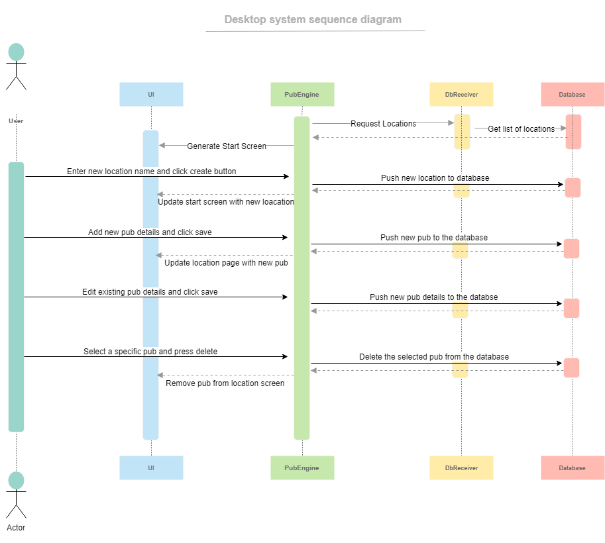

### Android Program

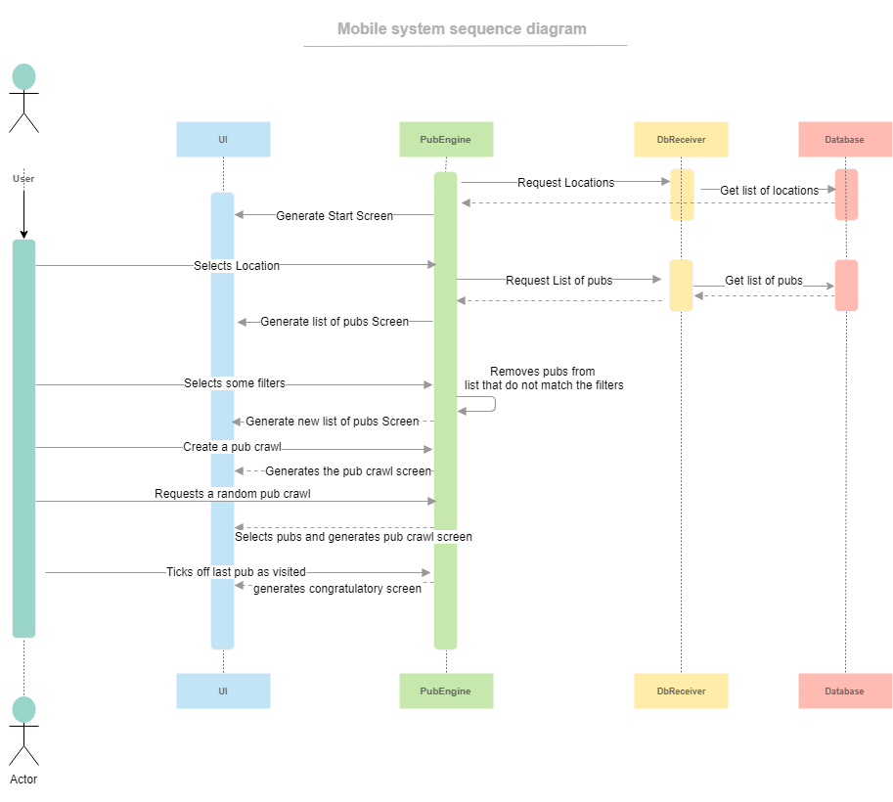

## Significant algorithms

### Filtering pubs

For filtering pubs, we will have a set number of characteristics that are available for the user to choose from. Once the specific characteristics that the user wants have been selected, the app will take them and send them to the database and apply them as a filter to get the relevant pubs. This filtered list will then be relayed back to the app in the form of a list.

### Communicating with database

For communicating with the database, there will be established a new connection with the database every time the program is going to retrieve/update the database. This might reduce the speed of the retrieving/updating but will ensure a more robust connection.

### Creating Lists

When creating a new list from the database it will extract every pub into a flexible arraylist and pass that onwards to the PubEngine program as a master list of pubs from a specific town. When the user wants to manipulate this to another pub list it will extract all the wanted pubs, either filtering, randomising, or choosing the pubs to go into a new arraylist that will be used, but still saving the original list.

## Significant data structures

### Desktop UML diagram

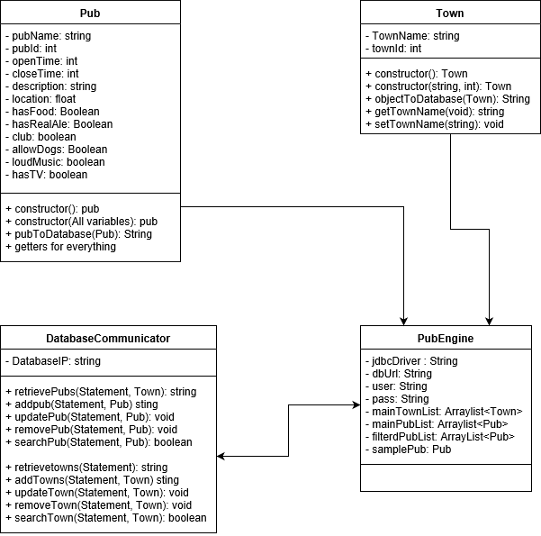

### Android program UML diagram

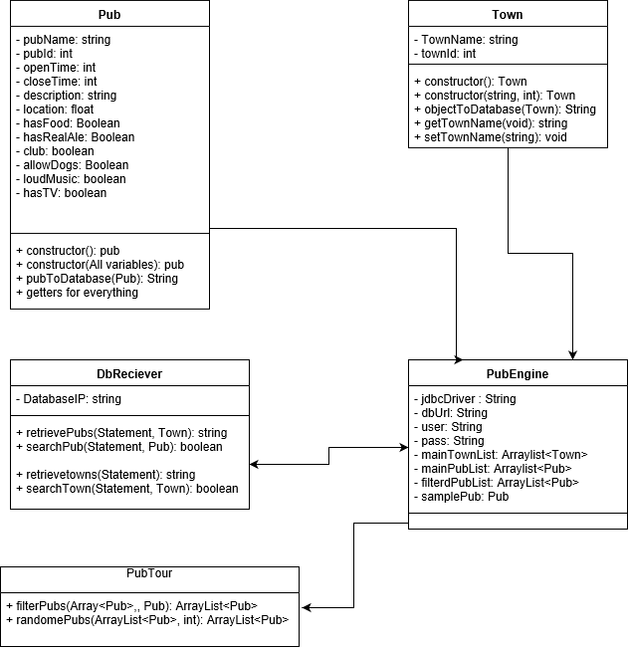

REFERENCES

[1] Software Engineering Group Projects: General Documentation Standards. C. J. Price.

SE.QA.02. 2.1 Release

[2] Software Engineering Group Projects: Pub Tour Requirements Specification. C. J. Price.

SE.QA.CSRS. 1.1 Release

[3] Software Engineering Group Projects: General Documentation Standards. C. J. Price, N. W. Hardy, B.P. SE.QA.03. 1.8 Release

[4] Software Engineering Group Projects: Design Specification Standards. C. J. Price.

SE.QA.05. 2.1 Release

[5] Software Engineering Group Projects: Design Specification. C. J. Price.

1.01 Draft

[6] Software Engineering Group Projects: Java Coding Standard. C. J. Price, A. McManus.

SE.QA.09. 2.0 Release

DOCUMENT HISTORY

| *Version* | *CCF No.* | *Date* | *Changes made to document* | *Changed by* |
| --- | --- | --- | --- | --- |
| 1.0 | N/A | 02/04/19 | Original released document | RUR7 |