Version 1.0
For Web Services on Devices
Date: November 9, 2006

© 2012 Microsoft Corporation. All rights reserved. By using these materials, you agree to the attached license agreement.

Microsoft Corporation Non-Confidential Technical Documentation License Agreement (Non-Standard)
READ THIS! THIS IS A LEGAL AGREEMENT BETWEEN MICROSOFT CORPORATION ("MICROSOFT") AND THE RECIPIENT OF THESE MATERIALS, WHETHER AN INDIVIDUAL OR AN ENTITY ("YOU"). IF YOU HAVE ACCESSED THIS AGREEMENT IN THE PROCESS OF DOWNLOADING MATERIALS ("MATERIALS") FROM A MICROSOFT WEB SITE, BY CLICKING "I ACCEPT", DOWNLOADING, USING THE MATERIALS, YOU AGREE TO THESE TERMS. IF THIS AGREEMENT IS ATTACHED TO MATERIALS, BY ACCESSING OR USING THE ATTACHED MATERIALS, YOU AGREE TO THESE TERMS.
For good and valuable consideration, the receipt and sufficiency of which are acknowledged, You and Microsoft agree as follows:
1. You may review these Materials only as a reference to assist You in planning and designing Your product, service or technology ("Product") to interface with a Microsoft Product as described in these Materials. All other rights are retained by Microsoft; this agreement does not give You rights under any Microsoft patents. You may not (i) duplicate any part of these Materials, (ii) remove this agreement or any notices from these Materials, or (iii) give any part of these Materials, or assign or otherwise provide Your rights under this agreement, to anyone else.
2. The information contained in these Materials is also available through the Microsoft Windows Driver Kit (WDK). You will receive additional intellectual property rights by agreeing to the terms of the WDK.
3. All Materials are provided entirely "AS IS." To the extent permitted by law, MICROSOFT MAKES NO WARRANTY OF ANY KIND, DISCLAIMS ALL EXPRESS, IMPLIED AND STATUTORY WARRANTIES, AND ASSUMES NO LIABILITY TO YOU FOR ANY DAMAGES OF ANY TYPE IN CONNECTION WITH THESE MATERIALS OR ANY INTELLECTUAL PROPERTY IN THEM.
4. If You are an entity and (a) merge into another entity or (b) a controlling ownership interest in You changes, Your right to use these Materials automatically terminates and You must destroy them.
5. This agreement is governed by the laws of the State of Washington. Any dispute involving it must be brought in the federal or state superior courts located in King County, Washington, and You waive any defenses allowing the dispute to be litigated elsewhere. If there is litigation, the losing party must pay the other party’s reasonable attorneys’ fees, costs and other expenses. If any part of this agreement is unenforceable, it will be considered modified to the extent necessary to make it enforceable, and the remainder shall continue in effect. This agreement is the entire agreement between You and Microsoft concerning these Materials; it may be changed only by a written document signed by both You and Microsoft.

Contents
1. Overview and Scope 11
2. Device Service Modeling Definitions 12
2.1. Device Service-Class 12
2.2. Terminology 12
2.2.1. Conformance Terminology 12
2.2.2. Other terminology 12
2.2.3. Notation: use of quotation marks 12
2.3. References 12
2.4. Purpose 13
3. Scanning Functional Model 13
3.1. Theory of Operation 14
3.1.1. Summary 14
3.1.2. Function Descriptions 14
3.1.2.1. Job Setup 14
3.1.2.2. Job Execution 15
3.1.2.3. Data Transfer 15
3.2. Job Concurrency 16
3.3. Usage Scenarios 17
3.3.1. Scan to Workstation, Device Initiated 17
3.3.2. Scan to Workstation, Client Initiated 17
3.4. Service Summary 17
3.4.1. Jobs 17
3.4.2. Operations 17
3.4.3. Events 18
3.4.4. Security 18
3.4.5. Localization 18
4. Service Schema 18
4.1. The Scanner’s Elements 19
4.2. The ScannerDescription Elements 20
4.2.1. ScannerName 20
4.2.2. ScannerInfo 20
4.2.3. ScannerLocation 20
4.3. The ScannerConfiguration Elements 21
4.3.1. DeviceSettings 23
4.3.1.1. FormatsSupported 23
4.3.1.1.1. FormatValue 23
4.3.1.2. CompressionQualityFactorSupported 23
4.3.1.2.1. MinValue 23
4.3.1.2.2. MaxValue 23
4.3.1.3. ContentTypesSupported 23
4.3.1.3.1. ContentTypeValue 24
4.3.1.4. DocumentSizeAutoDetectSupported 24
4.3.1.5. AutoExposureSupported 24
4.3.1.6. BrightnessSupported 24
4.3.1.7. ContrastSupported 24
4.3.1.8. ScalingRangeSupported 24
4.3.1.8.1. ScalingWidth 24
4.3.1.8.1.1. MinValue 24
4.3.1.8.1.2. MaxValue 24
4.3.1.8.2. ScalingHeight 24
4.3.1.8.2.1. MinValue 24
4.3.1.8.2.2. MaxValue 25
4.3.1.9. RotationsSupported 25
4.3.1.9.1. RotationValue 25
4.3.2. Platen 25
4.3.2.1. PlatenOpticalResolution 25
4.3.2.1.1. Width 25
4.3.2.1.2. Height 25
4.3.2.2. PlatenResolutions 25
4.3.2.2.1. Widths 25
4.3.2.2.1.1. Width 25
4.3.2.2.2. Heights 26
4.3.2.2.2.1. Height 26
4.3.2.3. PlatenColor 26
4.3.2.3.1. ColorEntry 26
4.3.2.4. PlatenMinimumSize 27
4.3.2.4.1. Width 27
4.3.2.4.2. Height 27
4.3.2.5. PlatenMaximumSize 27
4.3.2.5.1. Width 27
4.3.2.5.2. Height 27
4.3.3. ADF 27
4.3.3.1. ADFSupportsDuplex 27
4.3.3.2. ADFFront 27
4.3.3.2.1. ADFOpticalResolution 27
4.3.3.2.2. ADFResolutions 27
4.3.3.2.3. ADFColor 27
4.3.3.2.4. ADFMinimumSize 28
4.3.3.2.5. ADFMaximumSize 28
4.3.3.3. ADFBack 28
4.3.3.3.1. ADFOpticalResolution 28
4.3.3.3.2. ADFResolutions 28
4.3.3.3.3. ADFColor 28
4.3.3.3.4. ADFMinimumSize 28
4.3.3.3.5. ADFMaximumSize 28
4.3.4. Film 28
4.3.4.1. FilmScanModesSupported 28
4.3.4.1.1. FilmScanModeValue 28
4.3.4.2. FilmOpticalResolution 29
4.3.4.3. FilmResolutions 29
4.3.4.4. FilmColor 29
4.3.4.5. FilmMinimumSize 29
4.3.4.6. FilmMaximumSize 29
4.4. The ScannerStatus Elements 30
4.4.1. ScannerCurrentTime 30
4.4.2. ScannerState 30
4.4.3. ScannerStateReasons 31
4.4.3.1. ScannerStateReason 31
4.4.4. ActiveConditions 32
4.4.4.1. DeviceCondition 32
4.4.4.1.1. Id 32
4.4.4.1.2. Time 32
4.4.4.1.3. Name 32
4.4.4.1.4. Component 33
4.4.4.1.5. Severity 33
4.4.5. ConditionHistory 33
4.4.5.1. ConditionHistoryEntry 33
4.4.5.1.1. Id 33
4.4.5.1.2. Time 33
4.4.5.1.3. Name 33
4.4.5.1.4. Component 33
4.4.5.1.5. Severity 33
4.4.5.1.6. ClearTime 33
4.5. The Job’s Elements 34
4.5.1. JobStatus 36
4.5.1.1. JobId 36
4.5.1.2. JobState 36
4.5.1.3. JobStateReasons 37
4.5.1.3.1. JobStateReason 37
4.5.1.4. JobCreatedTime 38
4.5.1.5. JobCompletedTime 38
4.5.1.6. ScansCompleted 38
4.5.2. ScanTicket 38
4.5.2.1. JobDescription 38
4.5.2.1.1. JobName 38
4.5.2.1.2. JobOriginatingUserName 38
4.5.2.1.3. JobInformation 38
4.5.2.2. DocumentParameters 39
4.5.2.2.1. Format 39
4.5.2.2.2. CompressionQualityFactor 39
4.5.2.2.3. ImagesToTransfer 39
4.5.2.2.4. InputSource 39
4.5.2.2.5. FilmScanMode 39
4.5.2.2.6. ContentType 39
4.5.2.2.7. InputSize 39
4.5.2.2.7.1. DocumentSizeAutoDetect 39
4.5.2.2.7.2. InputMediaSize 40
4.5.2.2.7.2.1. Width 40
4.5.2.2.7.2.2. Height 40
4.5.2.2.8. Exposure 40
4.5.2.2.8.1. AutoExposure 40
4.5.2.2.8.2. ExposureSettings 40
4.5.2.2.8.2.1. Contrast 40
4.5.2.2.8.2.2. Brightness 40
4.5.2.2.8.2.3. Sharpness 40
4.5.2.2.9. Scaling 41
4.5.2.2.9.1. ScalingWidth 41
4.5.2.2.9.2. ScalingHeight 41
4.5.2.2.10. Rotation 41
4.5.2.2.11. MediaSides 41
4.5.2.2.11.1. MediaFront 41
4.5.2.2.11.1.1. ScanRegion 41
4.5.2.2.11.1.1.1. ScanRegionXOffset 42
4.5.2.2.11.1.1.2. ScanRegionYOffset 42
4.5.2.2.11.1.1.3. ScanRegionWidth 42
4.5.2.2.11.1.1.4. ScanRegionHeight 42
4.5.2.2.11.1.2. ColorProcessing 42
4.5.2.2.11.1.3. Resolution 43
4.5.2.2.11.1.3.1. Width 43
4.5.2.2.11.1.3.2. Height 43
4.5.2.2.11.2. MediaBack 43
4.6. The Document’s Elements 43
4.6.1. Documents 45
4.6.1.1. DocumentFinalParameters 45
4.6.1.1.1. Override 45
4.6.1.1.2. UsedDefault 45
4.6.1.2. Document 45
4.6.1.2.1. DocumentDescription 45
4.6.1.2.1.1. DocumentName 45
4.7. Job Table 45
4.8. ScanTicket 46
4.8.1. Example ScanTicket 49
4.9. Default Values and Allowed Values for Job Submission 49
4.9.1. DefaultScanTicket 49
4.9.2. Example DefaultScanTicket 49
5. Eventing 50
5.1. Event Model 50
5.2. ScanAvailableEvent 50
5.2.1. Subscribe Extensions 50
5.2.1.1. ScanDestinations 51
5.2.1.1.1. ScanDestination 51
5.2.1.1.1.1. ClientDisplayName 51
5.2.1.1.1.2. ClientContext 51
5.2.2. Example ScanAvailableEvent Subscribe 51
5.2.3. SubscribeResponse Extensions 52
5.2.3.1. DestinationResponses 52
5.2.3.1.1. DestinationResponse 52
5.2.3.1.1.1. ClientContext 52
5.2.3.1.1.2. DestinationToken 52
5.2.4. Example ScanAvailableEvent SubscribeResponse 52
5.2.5. Event Elements 53
5.2.5.1. ClientContext 53
5.2.5.2. ScanIdentifier 53
5.2.5.3. InputSource 53
5.2.6. Example ScanAvailableEvent 53
5.3. ScannerElementsChangeEvent 54
5.3.1. ElementChanges 54
5.3.2. Example ScannerElementsChangeEvent 54
5.4. ScannerStatusSummaryEvent 57
5.4.1. StatusSummary 57
5.4.1.1. ScannerState 57
5.4.1.2. ScannerStateReasons 57
5.4.1.2.1. ScannerStateReason 57
5.4.2. Example ScannerStatusSummaryEvent 57
5.5. ScannerStatusConditionEvent 58
5.5.1. DeviceCondition 58
5.5.2. Example ScannerStatusConditionEvent 58
5.6. ScannerStatusConditionClearedEvent 59
5.6.1. DeviceConditonCleared 59
5.6.1.1. ConditonId 59
5.6.1.2. ConditionClearTime 59
5.6.2. Example ScannerStatusConditionClearedEvent 59
5.7. JobStatusEvent 60
5.7.1. JobStatus 60
5.7.2. Example JobStatusEvent 60
5.8. JobEndStateEvent 61
5.8.1. JobEndState 61
5.8.1.1. JobId 61
5.8.1.2. JobCompletedState 61
5.8.1.2.1. JobCompletedStateReasons 61
5.8.1.2.1.1. JobStateReason 61
5.8.1.3. JobName 61
5.8.1.4. JobOriginatingUser 61
5.8.1.5. ScansCompleted 61
5.8.1.6. JobCompletedTime 62
5.8.2. Example JobEndStateEvent 62
6. Operations 62
6.1. Operation Error Reporting 62
6.1.1. Common Operation Faults 63
6.1.1.1. wsa:ActionNotSupported 64
6.1.1.2. InvalidArgs 64
6.1.1.3. OperationFailed 64
6.1.1.4. ServerErrorTemporaryError 64
6.1.1.5. ServerErrorInternalError 65
6.2. CreateScanJob 65
6.2.1. Request Elements 66
6.2.1.1. ScanIdentifier 66
6.2.1.2. DestinationToken 66
6.2.1.3. ScanTicket 66
6.2.2. Response Elements 66
6.2.2.1. JobId 67
6.2.2.2. JobToken 67
6.2.2.3. ImageInformation 67
6.2.2.3.1. MediaFrontImageInfo 67
6.2.2.3.1.1. PixelsPerLine 67
6.2.2.3.1.2. NumberOfLines 67
6.2.2.3.1.3. BytesPerLine 67
6.2.2.3.2. MediaBackImageInfo 67
6.2.2.4. DocumentFinalParameters 67
6.2.3. Example Request – Device Initiated 67
6.2.4. Example Response 68
6.2.5. Example Request – Client Initiated 69
6.2.6. Errors 69
6.2.6.1. ServerErrorNotAcceptingJobs 70
6.2.6.2. ClientErrorFormatNotSupported 70
6.2.6.3. ClientErrorInvalidScanIdentifier 70
6.2.6.4. ClientErrorInvalidDestinationToken 70
6.2.6.5. ClientErrorConflictingRequiredParameters 71
6.3. RetrieveImage 71
6.3.1. Request Elements 71
6.3.1.1. JobId 72
6.3.1.2. JobToken 72
6.3.1.3. DocumentDescription 72
6.3.2. Response Elements 72
6.3.2.1. ScanData 72
6.3.3. Example Request 72
6.3.4. Example Response 72
6.3.5. Errors 73
6.3.5.1. ClientErrorJobIdNotFound 73
6.3.5.2. ClientErrorNoImagesAvailable 73
6.3.5.3. ClientErrorInvalidJobToken 73
6.3.5.4. ClientErrorJobCancelled 74
6.4. CancelJob 74
6.4.1. Request Elements 74
6.4.1.1. JobId 74
6.4.2. Request 74
6.4.3. Response 74
6.4.4. Errors 75
6.4.4.1. ClientErrorJobIdNotFound 75
6.4.5. Effect on State 75
6.5. ValidateScanTicket 75
6.5.1. Request Elements 75
6.5.1.1. ScanTicket 76
6.5.2. Response Elements 76
6.5.2.1. ValidationInfo 76
6.5.2.1.1. ValidTicket 76
6.5.2.1.2. ImageInformation 76
6.5.2.1.3. ValidScanTicket 76
6.5.3. Example Request – Valid Ticket 76
6.5.4. Example Response – Valid Ticket 77
6.5.5. Example Request – Invalid Ticket 77
6.5.6. Example Response – Invalid Ticket 78
6.5.7. Errors 79
6.5.7.1. ClientErrorConflictingRequiredParameters 79
6.6. GetScannerElements 79
6.6.1. Request Elements 79
6.6.1.1. RequestedElements 79
6.6.1.2. Name 79
6.6.2. Response Elements 80
6.6.2.1. ScannerElements 80
6.6.2.2. ElementData 80
6.6.2.3. Name 80
6.6.2.4. Valid 80
6.6.3. Request - ScannerDescription 80
6.6.4. Response – ScannerDescription 81
6.6.5. Request - ScannerStatus 81
6.6.6. Response – ScannerStatus 81
6.6.7. Request – ScannerConfiguration and Invalid entry 82
6.6.8. Response – ScannerConfiguration and Invalid entry 82
6.6.9. Errors 85
6.7. GetJobElements 85
6.7.1. Request Elements 85
6.7.1.1. JobId 85
6.7.1.2. RequestedElements 85
6.7.1.3. Name 85
6.7.2. Response Elements 86
6.7.2.1. JobElements 86
6.7.2.2. ElementData 86
6.7.2.3. Name 86
6.7.2.4. Valid 86
6.7.3. Request 86
6.7.4. Response 87
6.7.5. Errors 87
6.7.5.1. ClientErrorJobIdNotFound 87
6.8. GetActiveJobs 87
6.8.1. Response Elements 88
6.8.1.1. ActiveJobs 88
6.8.1.1.1. JobSummary 88
6.8.1.1.1.1. JobId 88
6.8.1.1.1.2. JobName 88
6.8.1.1.1.3. JobOriginatingUserName 88
6.8.1.1.1.4. JobState 88
6.8.1.1.1.5. JobStateReasons 88
6.8.1.1.1.5.1. JobStateReason 88
6.8.1.1.1.6. ScansCompleted 88
6.8.2. Example Request 88
6.8.3. Example Response – No Active Jobs 89
6.8.4. Example Response – Two Active Jobs 89
6.8.5. Errors 90
6.9. GetJobHistory 90
6.9.1. Response Elements 90
6.9.1.1. JobHistory 90
6.9.1.2. JobSummary 90
6.9.2. Example Request 90
6.9.3. Example Response – No Job History 91
6.9.4. Example Response – 2 Completed Jobs 91
6.9.5. Errors 91
6.10. Non-Standard Operations Implemented by a WSD Vendor 91
Appendix A. WSDL Service Description 92
Appendix B. Windows Vista™ Support Requirements 97
1. PnP-X installation support 97
1.1. PnP-X Namespace 97
1.2. PnP-X CompatibleId definition and value 97
1.3. Sample Device Metadata response 97
2. Network Explorer category support 97
2.1. PnP-X Namespace 98
2.2. PnP-X Category definition and value 98
2.3. Sample Device Metadata response 98
3. Scan Device discoverability 98
3.1. Local subnet Discovery support 98
3.1.1. WSD Scan Namespace 99
3.1.2. WSD Scan Device porttype 99
3.1.3. Device Hello example 99
3.1.4. Device ProbeMatches example 99
3.2. Directed Discovery support 99
3.2.1. Directed Discovery URL 100
3.2.2. Secure Directed Discovery URL 100
4. WSD Scan WIA Driver required capabilities 100
4.1. InputSource values supported 100
4.2. ColorEntry values required 100
4.3. Document file formats required 100
4.4. Duplex scanning support 101

List of Tables
Table 1 – Color Processing Elements 25
Table 2 - Operations 61
List of Figures
Figure 1 – Scan Workflow 13
Figure 2 – Client Job Setup 14
Figure 3 – Response Mode Data Transfer 15
Figure 4 – Job Concurrency Example 16
Figure 5 – Scanner Model 18
Figure 6 - ScannerDescription Elements 19
Figure 7 – ScannerConfiguration Elements – Part 1 20
Figure 8 – ScannerConfiguration Elements – Part 2 21
Figure 9 - ScannerStatus Elements 29
Figure 10 - Scanner State Diagram 30
Figure 11 - Job Elements (Part 1) 33
Figure 12 - Job Elements (Part 2) 34
Figure 14 – Documents & Document Elements 43
Figure 15 - JobTable Elements 45
Figure 16 – ScanTicket Elements 47
Figure 17 - ScanDestinations Elements 50
Figure 18 - DestinationResponses Elements 51
Figure 19 – ScanAvailableEvent Elements 52
Figure 20 - ScannerElementsChangeEvent Elements 53
Figure 21 - ScannerStatusSummaryEvent Elements 56
Figure 22 - ScannerStatusConditon Event 57
Figure 23 - ScannerStatusConditonCleared Event 58
Figure 24 - JobStatus Event 59
Figure 25 - JobEndState Event 60
Figure 26 - CreateScanJobRequest Elements 65
Figure 27 - CreateScanJobResponse Elements 65
Figure 28 - RetrieveImageRequest Elements 71
Figure 29 - RetrieveImageResponse Elements 71
Figure 30 - ValidateScanTicketRequest Elements 75
Figure 31 - ValidationInfo elements 75
Figure 32 - GetScannerElementsRequest Elements 79
Figure 33 - GetScannerElementsResponse Elements 79
Figure 34 - GetJobElementsRequest Elements 85
Figure 35 - GetJobElementsResponse Elements 85
Figure 36 - GetActiveJobsResponse Elements 87
Figure 37 - GetJobHistoryResponse Elements 89

Overview and Scope
This service definition is compliant with the Devices Profile for Web Services [DEVICE].
This service-type enables the following functions:
- Scanning
This service template does not address:
- Printing
- Copying
- Faxing
- Inbound
- Outbound
- Multi-function Devices

Device Service Modeling Definitions

Device Service-Class
This Web Service for Devices (WSD) type maps to the WSDL “porttype” element. This combines operations, events and properties into a functional unit. A device service-class that is compliant with this template is identified with the following target namespace: “http://schemas.microsoft.com/windows/2006/08/wdp/scan”.

Terminology
This section defines terms that are used throughout this specification. These terms are always capitalized in order to indicate that they have the meaning defined in this section.

Conformance Terminology
The following terms have special meaning relating to conformance and so are always indicated in all capital letters:
- MUST - This word, or the term "REQUIRED", mean that the definition is an absolute requirement of the specification.
- MUST NOT - This phrase means that the definition is an absolute prohibition of the specification.
- SHOULD - This word, or the adjective "RECOMMENDED", mean that there may exist valid reasons in particular circumstances to ignore a particular item, but the full implications must be understood and carefully weighed before choosing a different course.
- SHOULD NOT - This phrase, or the phrase "NOT RECOMMENDED" mean that there may exist valid reasons in particular circumstances when the particular behavior is acceptable or even useful, but the full implications should be understood and the case carefully weighed before implementing any behavior described with this label.
- MAY - This word, or the adjective "OPTIONAL", mean that an item is truly optional. One vendor may choose to include the item because a particular marketplace requires it or because the vendor feels that it enhances the product while another vendor may omit the same item. An implementation which does not include a particular option MUST be prepared to interoperate with another implementation which does include the option, though perhaps with reduced functionality. An implementation which does include a particular option MUST be prepared to interoperate with another implementation which does not include the option

Other terminology
This document uses the terminology defined in the Devices Profile for Web Services [DEVICE], such as: operation, device description, and argument. This sub-section defines the following additional terms that are capitalized in order to indicate their specific meaning as defined in this section.
- Control Point (CP) - the entity that initiates requests to the Scanner on behalf of the end user.
- Scan Service (or Scanner) - the [DEVICE] entity that accepts operations from a CP (clients), returns responses including image data, and sends events.

Notation: use of quotation marks
Throughout this document, single quotes (‘) are used around literal string and integer values in running text, but not in Tables. The single quotes are not part of the values. Double quotes (“) are used around words in running text to indicate special English meanings. Element names, arguments names, and operation names are not quoted.

References
This section lists the references that this document refers to and the tag inside square brackets that is used for each such reference:
[DEVICE] – J. Schlimmer, et al, “Devices Profile for Web Services”, February 2006.
(See http://specs.xmlsoap.org/ws/2006/02/devprof/devicesprofile.pdf/.)
[MTOM] - N. Mendelsohn, et al, "SOAP Message Transmission Optimization Mechanism," January 2005.
(See http://www.w3.org/TR/2005/REC-soap12-mtom-20050125/.)
[ADDRESS] - D. Box, et al, "Web Services Addressing (WS-Addressing)," August 2004.
(See http://www.w3.org/Submission/2004/SUBM-ws-addressing-20040810/.)
[DISCOVERY] - J. Beatty, et al, "Web Services Dynamic Discovery (WS-Discovery)," April 2005.
(See http://schemas.xmlsoap.org/ws/2005/04/discovery.)
[WSDL] - E. Christensen, et al, "Web Services Description Language (WSDL) 1.1," March 2001.
(See http://www.w3.org/TR/2001/NOTE-wsdl-20010315.)
[WSDL Binding for SOAP 1.2] - K. Ballinger, et al, "WSDL Binding for SOAP 1.2," April 2002.
(See http://groups.yahoo.com/group/soapbuilders/files/soap12WSDL.htm.)
[EVENTING] - L. Cabrera, et al, "Web Services Eventing (WS-Eventing)," August 2004. (See http://msdn.microsoft.com/ws/2004/08/ws-eventing/.)
[PNPX] – C. Brodeur, “PnP-X: Plug and Play Extensions for Windows”, July 2006.
(See http://www.microsoft.com/whdc/Rally/pnpx-spec.mspx.)
[HTTP] - R. Fielding, et al, "Hypertext Transfer Protocol -- HTTP/1.1," June 1999. (See http://www.ietf.org/rfc/rfc2616.txt.)
[URI] - T. Berners-Lee, et al, "Uniform Resource Identifiers (URI): Generic Syntax," January 2005.
(See ftp://ftp.rfc-editor.org/in-notes/rfc3986.txt.)

Purpose
The purpose of this document is to describe the operational model for network connected scanning devices. The Devices Profile for Web Services [DEVICE] defines a peer-to-peer network connectivity model allowing intelligent applications to discover and make use of network resident devices. This document describes how Scanners would operate in this environment. This document focuses on the device control model that will be supported by scanning devices.
The scanning model described in this document focuses on walk-up scanning, where scanning is initiated by users at a device. Devices that support this model are typically connected directly to a network and reside in a central location. Scanning in this model is focused primarily on capturing a document and delivering it to a destination client or an application.
This document describes how to accomplish walk-up scanning in small (home or workgroup) environments. Scanning in the home is primarily driven from the PC although the user experience is very much a walk-up model. Although the scanning model, as described, focuses on walk-up scanning it should be noted it is not limited to walk-up. The model provides a framework in which all network scanning can be modeled.
This document outlines the functional components of Scanning services and describes their interactions with CLIENTs.

Scanning Functional Model
Operation of a device is modeled as a conversation between a Control Point (CP) and a Service exposed by a device. The operation of scanning can be described as a combination of distinct functions. The design of the Scanner Functional Model exposes these functions as distinct services and allows for different Control Points to control each function. In many instances, a single CLIENT will be responsible for the complete set of interactions with the scanner device – but by logically separating the CLIENTs we provide a foundation to support the many different Scanner usage patterns.
The scanning process consists of three logical functions:
- Job Setup
- Job Execution
- Data Transfer

Job
Setup

Data Transfer

Job
Execution
Figure 1 – Scan Workflow
The Scanner Model defines a Scan Ticket as the means by which Job Elements are communicated down the line of functions. At Job Setup the Scan Ticket is created based on user selections. At Job Execution a specific scan ticket is submitted to the Scan Service by a CLIENT. During Job Execution the Scan Ticket is used by the device to determine the appropriate settings to use during the scan. After the Job Execution has completed, the Scan Ticket may be used to generate a log containing the actual scanning parameters used during execution as well as additional information.

Theory of Operation

Summary
Scanning breaks into three logical sets of interactions:
- Job Setup: The creation of a scan ticket based on user scanning preferences.
- Job Execution: The physical scan and generation of data. A scan ticket generated in the Job Setup function is used to define the parameters of the Job Execution. Job Execution ends when the original document has been scanned and all of the scanned data is transferred to an external destination or internal storage.
- Data Transfer: The movement of data from the scanner’s buffer to a destination. Data transfer is contained within the job execution function but may be asynchronous to the physical scan. A scanner will always push data to a destination as the response to an operation.
Each of the above sets of operations represents a series of interactions between a service component provided by a scanner and a CLIENT.

Function Descriptions
This section describes the primary interactions that occur during each logical phase of the Scanning process.

Job Setup
The Job Setup function is provided by a CLIENT. The CLIENT providing Job Setup interacts with a Scan Service to determine the capabilities of the device. The CLIENT provides an interface to allow users to choose scanning options such as color mode, resolution, etc. based on the capabilities of the device. The CLIENT then creates a scan ticket that specifies scanning parameters chosen by the user. The scan ticket will be used during Job Execution (See Section 3.1.2.2).
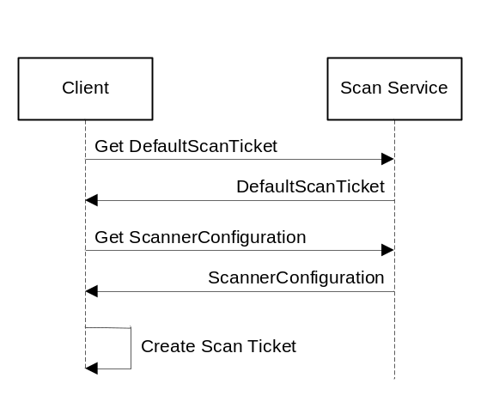
Figure 2 – Client Job Setup

Job Execution
Two different methods of Job Execution are supported:
- Device Initiated: A device can initiate execution as the result of a user interacting directly with the device.
- CLIENT Initiated: A CLIENT can initiate Job Execution by sending a request to the scan device.

If a CLIENT is initiating the execution of a job, it may subscribe for events of interest beforehand. If a device will initiate the execution, a client must register the intended destination of the scanned document.

Data Transfer
- Response Mode: The CLIENT starts a scan based on a ScanAvailableEvent notification from the device. The CLIENT sends down a CreateScanJob operation with the requested scan parameters (ScanTicket) and the device processes the scan. The data from the scan is sent back to the CLIENT as a part of the response to the RetrieveImage operation(s).
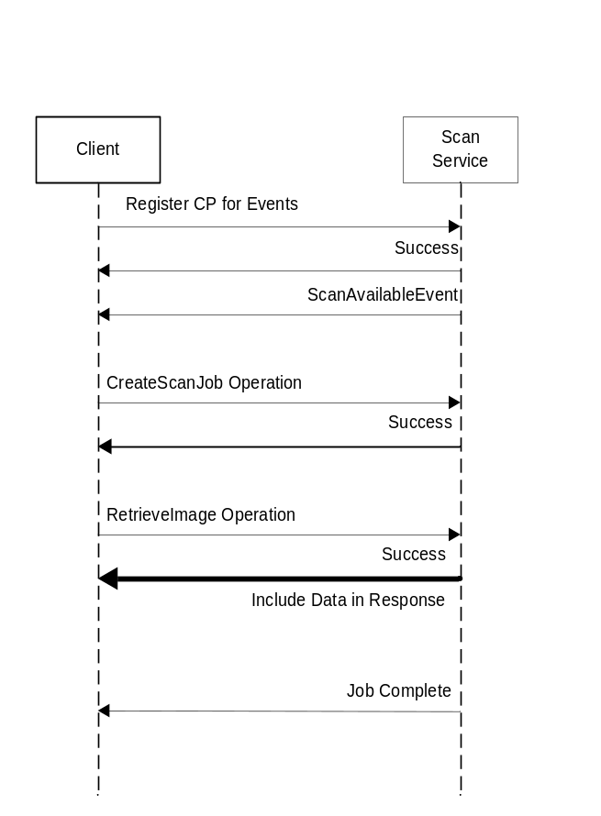
Figure 3 – Response Mode Data Transfer
The Data Transfer phase ends when all of the data has been successfully transferred or an unrecoverable error occurs.

Job Concurrency
It is possible that multiple jobs may exist at the same time. A scan for one job may be complete with data still transferring while another job is activated. The number of jobs transferring data is limited to the capacity of device resources.
The following diagram illustrates the number of allowable concurrent jobs during the Job Functions. Shown in the diagram are jobs X, Y and Z. Jobs X and Y must have completed scanning but may still be transferring data when job Z is activated. In order for another job to be activated, job Z must reach the completion of the physical scan. The Buffered Data Transfer portion of the diagram illustrates that multiple data transfers can be occurring at the same time.
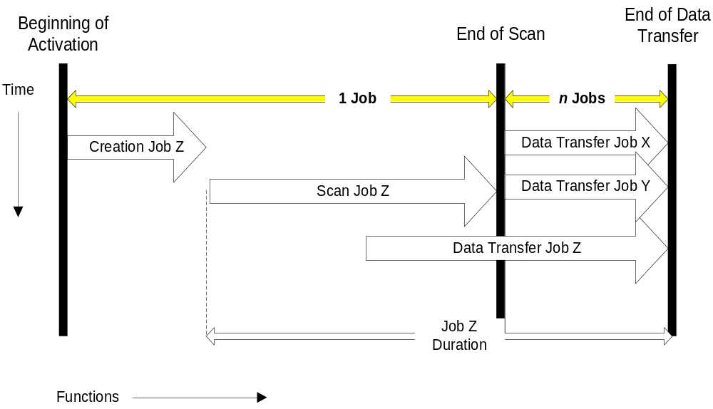
Figure 4 – Job Concurrency Example

Usage Scenarios

Scan to Workstation, Device Initiated
- Device Notification of waiting scan (event)
- CLIENT Initiated Execution, Response-based Data Transfer – Figure 3
A user wants to scan a document to his workstation. The user places their media on the platen/in the ADF. The user scrolls through the destinations on the scanner front panel. When the correct destination is found the user presses the SCAN button on the device. The scanner sends a ScanAvailableEvent to the specified destination (only). The CLIENT submits a CreateScanJob operation to the scanner using settings preconfigured by the user and then retrieves the data as part of the response to one or more RetrieveImage operations.

Scan to Workstation, Client Initiated
- CLIENT Job Setup – Figure 2
- CLIENT Initiated Execution, Response-based Data Transfer – Figure 3
A user wants to scan a document to his workstation. The UI displayed on or near the scanner is hosted by a CLIENT external to the scanner. The user selects scan settings using the UI. The user places the document on the platen/in the feeder and presses the Start button on the UI. The external CLIENT submits a CreateScanJob operation to the scanner and then retrieves the data as part of the response to one or more RetrieveImage operations.

Service Summary

Jobs
The Scan service’s main task is to accept scan jobs from clients, queue them up (if the scanner is capable of handling more than one job at a time), scan them, and transfer the output data. A job is identified by an integer, the JobId, which is allocated by the device. The JobId is returned by the CreateScanJob operation.
The set of jobs the scanner has in its queue can be found by using the GetActiveJobs command.

Operations
The following operations are defined and MUST be supported by conforming ScannerService implementations:
- CreateScanJob – This operation is used to submit a job to the scanner. A scan ticket defining the scanning parameters is supplied with the request. An allocated JobId and the image information are returned in the response.
- RetrieveImage – This operation is used to retrieve the image data associated with a previously submitted scan job. The JobId and JobToken are supplied with the request. The image data are returned in the response.
- CancelJob – This can be used to cancel a job using the JobId.
- ValidateScanTicket – This can be used to verify the settings in a ScanTicket for a future scan operation.
- GetScannerElements – This operation can be used to query for scanner elements.
- GetJobElements – This operation can be used to query for job elements for a particular job.
- GetActiveJobs – This operation can be used to obtain a list of all the currently active Jobs on the scanner and a subset of each job’s elements.
- GetJobHistory – This operation can be used to obtain a list of some of the recently completed Jobs on the scanner and a subset of each job’s elements.

Events
Events are defined to inform a CP that a user has asked to scan, to tell about any configurations changes in the scanner and to tell the status of active and finished jobs. The basic event model is based on Web Service Eventing [EVENT]. When using events to allow CPs to synchronize access to scanned data with the device output a unique destination for each client is registered with the scan device. Then when the user requests to scan data to that destination an Event is generated to just the client associated with the requested destination.

Security
The Devices Profile for Web Services [DEVICE] defines how compliant clients and devices interact in a secure manner. This specification assumes all clients and scan devices comply with this security model.

Localization
A WSD Scanner is assumed to be operating within the locale of the user. No other localization mechanism is defined for the Scan Service. The CP (client) is expected to localize the well-known string values to the locale of its user. The CP (client) is expected to convert the enum integer values to human readable string values in the locale of the user.

Service Schema
A scanner contains zero or more Jobs. A Job contains processing instructions and one or more output Documents.
The Scanner, Job, and Document elements are grouped together into logical elements. These element groups collect similar elements together. ScannerDescription elements for Scanners contain descriptive information that is static per device or administratively set by a CP. “Description” elements for Jobs and Documents contain descriptive information that is administratively set or supplied by a CP during job submission. The ScannerConfiguration elements contain information that describes the current physical configuration of the scanner and its options and also all the allowed values for the various DocumentParameters elements. The Scanner and Job “Status” elements contain information primarily controlled by automata. These can be indirectly affected by a CP through operations such as CancelJob. The DocumentParameters elements specify features that are applied to the Documents in the Job (e.g. Rotation). Finally the DefaultScanTicket element provides the default values for all the elements used in Job creation. Figure 5 below illustrates the relationships between these elements. The member elements of Scanners, Jobs, and Documents are detailed in the following sections.
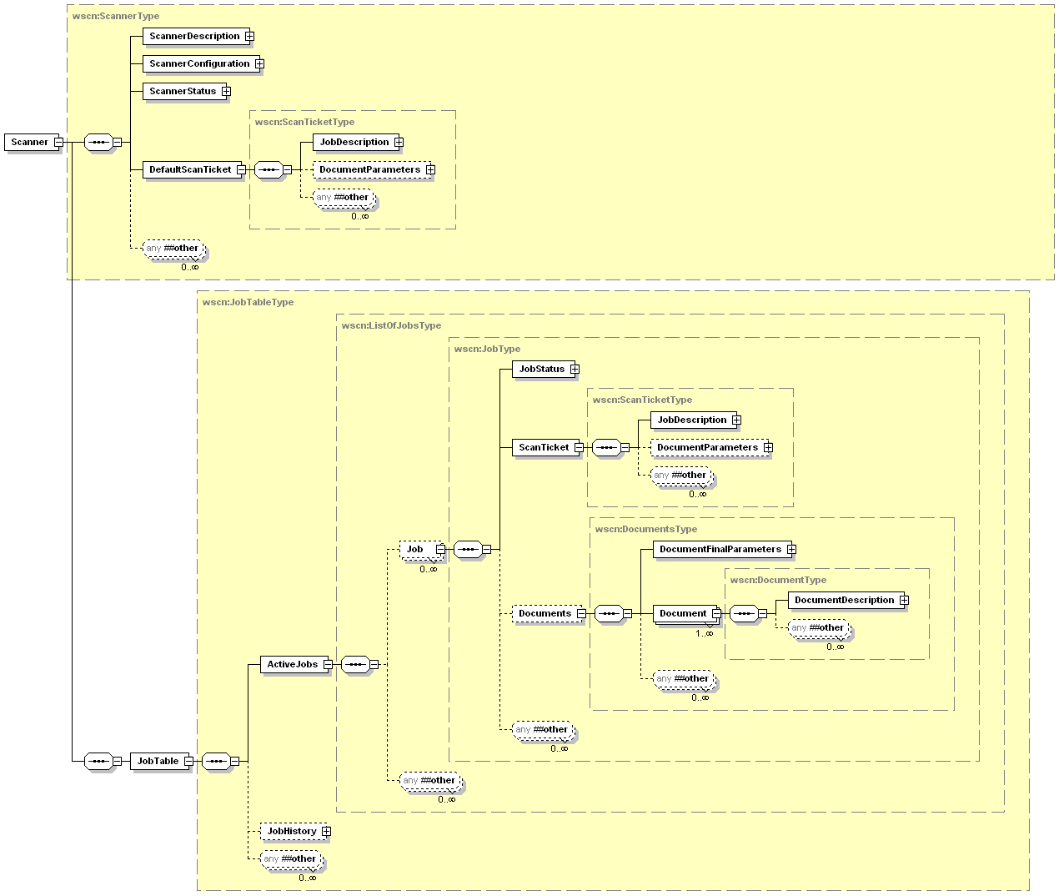
Figure 5 – Scanner Model

The Scanner’s Elements
This section defines the elements that comprise the WSD Scanner Service.
Figure 6 shows the ScannerDescription elements for the Scanner. Figure 7 and Figure 8 show the ScannerConfiguration elements for the Scanner. Figure 9 shows the ScannerStatus elements for the Scanner. Figure 16 shows the ScanTicket elements which define the DefaultScanTicket for the scanner.

The ScannerDescription Elements
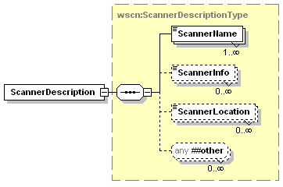
Figure 6 - ScannerDescription Elements
All of the Scanner elements contained within the ScannerDescription element are described in detail in the following sections.

ScannerName
This element indicates the administratively assigned user-friendly name of the scanner. How the value for this element is configured is implementation-specific, e.g., local console, Presentation Service (web access). If the Device Service has only one hosted service, then the Device’s <friendlyName> and ScannerName are recommended to have the same value. However, if the Device contains several hosted services, the ScannerName identifies the scanner. A scan device can return multiple version of this element to allow support for multiple localized languages by using the xml:lang attribute.
Allowed Values: any character string

ScannerInfo
This element is the descriptive information about this Scanner (example: “Out of courtesy for others, please scan only small (1-5 page) jobs at this scanner"). How the value for this element is configured is implementation-specific, e.g., local console, Presentation Service (web access). A scan device can return multiple version of this element to allow support for multiple localized languages by using the xml:lang attribute.
Allowed Values: any character string

ScannerLocation
This element indicates the administratively assigned location of the device (for example, “Building 1”). How the value for this element is configured is implementation-specific, e.g., local console, Presentation Service (web access). A scan device can return multiple version of this element to allow support for multiple localized languages by using the xml:lang attribute.
Allowed Values: any character string

The ScannerConfiguration Elements
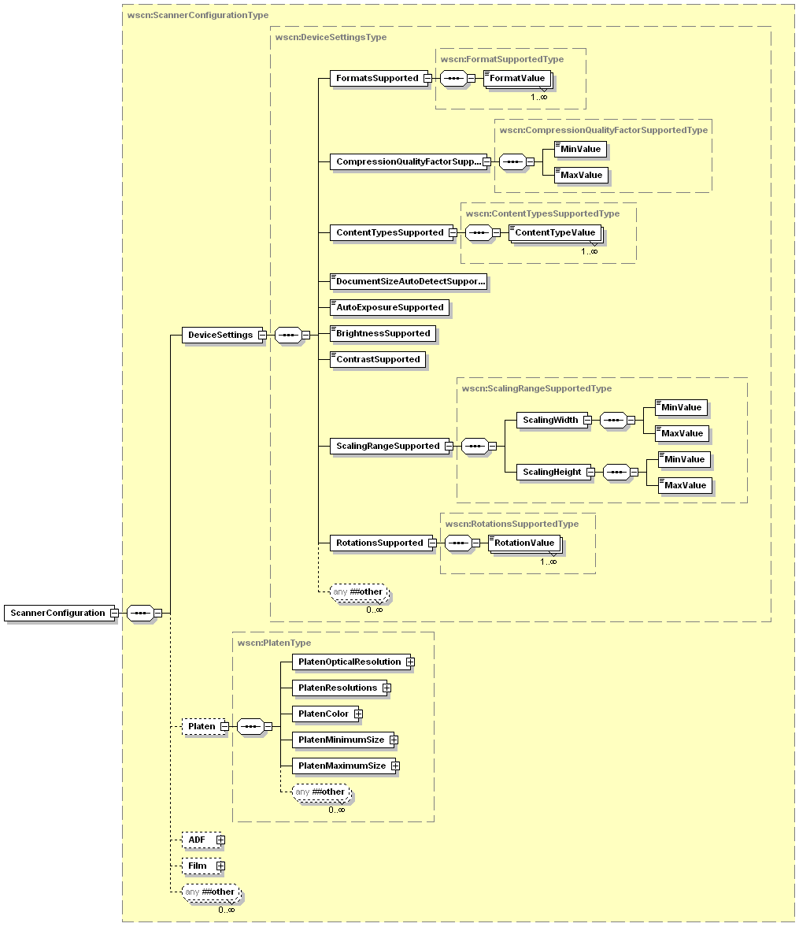
Figure 7 – ScannerConfiguration Elements – Part 1
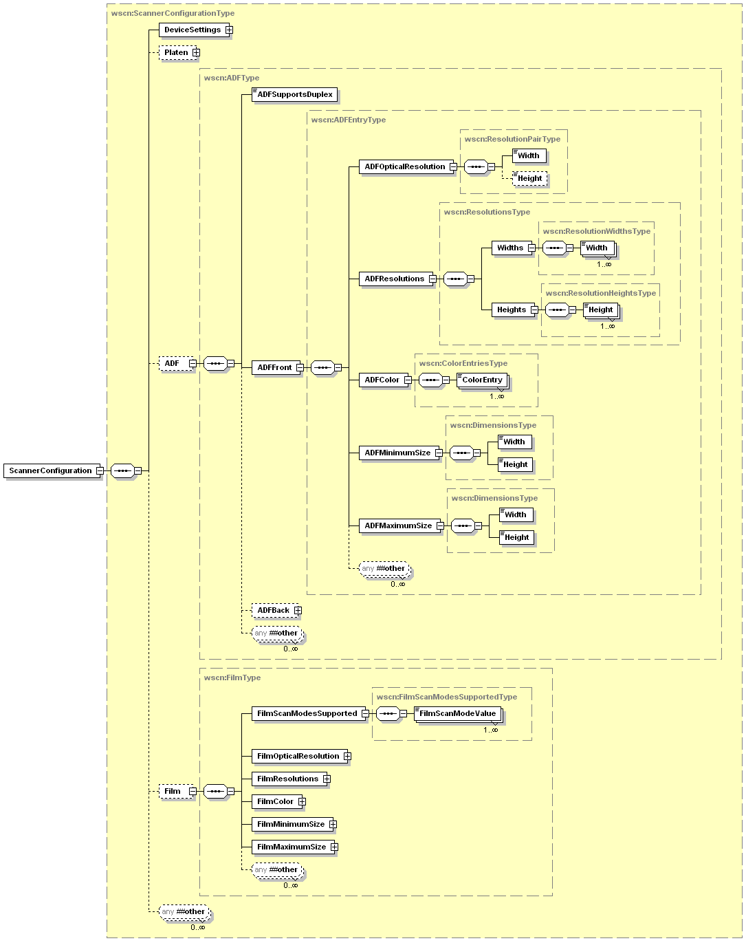
Figure 8 – ScannerConfiguration Elements – Part 2
All of the Scanner elements contained within the ScannerConfiguration element are described in detail in the following sections.

DeviceSettings
This section describes the basic capabilities of the device as a whole. This section contains the supported values for many of the imaging options settable in the ScanTicket for a scan operation. A CP can use the values returned in this section to create valid ScanTicket elements.

FormatsSupported
This element is a collection of keywords that describe the Document file formats supported by the scanner. Each file format describes a combination of file type and compression type.

FormatValue
This element indicates a single supported file format/compression type value.
Values:
dib – Windows Device Independent Bitmap
exif – Exchangeable Image File Format Version 2.x
jbig – ISO/IEC 11544:1993 Standard - Coded representation of picture and audio information -- Progressive bi-level image compression
jfif – JPEG File Interchange Format 1.x
jpeg2k – JPEG 2000 standards based file format and compression
pdf-a – PDF/A format: Standard based on ISO/CD 19005-1
png – Portable Networks Graphics (PNG) format. This format only supports PNG compression type
tiff-single-uncompressed – single page TIFF file with no compression type
tiff-single-g4 – single page TIFF file with g4 compression type
tiff-single-g3mh – single page TIFF file with g3mh compression type
tiff-single-jpeg-tn2 – single page TIFF file with jpeg compression type as described in Technical Note 2.
tiff-multi-uncompressed – multiple page TIFF file with no compression type
tiff-multi-g4 – multiple page TIFF file with g4 compression type
tiff-multi-g3mh – multiple page TIFF file with g3mh compression type
tiff-multi-jpeg-tn2 – multiple page TIFF file with jpeg compression type as described in Technical Note 2.
xps – XML Paper Specification
Vendors MAY extend the allowed values for this element
Vendors MAY subset the allowed values for this element

CompressionQualityFactorSupported
This element is an integer value used by any lossy compression type to determine the amount of acceptable image loss. The higher the requested fidelity the larger the resulting file size. A value of 100 means the device should use the least amount of compression it supports to produce the highest image quality. Currently JPEG compression is the only supported lossy compression type.

MinValue
This element indicates the minimum CompressionQualityFactor value supported by the scan device.
Values: 0 – 100

MaxValue
This element indicates the maximum CompressionQualityFactor value supported by the scan device.
Values: 0 – 100

ContentTypesSupported
This element is a collection of keywords that describe the different document content types supported by the scanner. Each ContentType describes the main characteristics of the original document.

ContentTypeValue
This element indicates a single supported ContentType value
Values:
Auto: The device will automatically detect the original type
Text: The original is mainly composed of distinct text that contrasts strongly with the background.
Photo: The original is mainly composed of photographic images, where shades change gradually and edges are not distinct.
Halftone: The original is mainly composed of halftoned images.
Mixed: A multipage document with characteristics of more than one specific ContentType.
Vendors MAY extend the allowed values for this element
Vendors MAY subset the allowed values for this element

DocumentSizeAutoDetectSupported
This element specifies whether the device can detect the size of the original media.
Values: 0, 1, true, false

AutoExposureSupported
This element specifies whether the device supports automatic adjustment of the various Exposure settings.
Values: 0, 1, true, false

BrightnessSupported
This element specifies whether the device supports user control of the scan brightness setting.
Values: 0, 1, true, false

ContrastSupported
This element specifies whether the device supports user control of the scan contrast setting.
Values: 0, 1, true, false

ScalingRangeSupported
This section describes the range of values this scan device supports for scaling the output document. A value of 100 specifies that no adjustments are made to the scanned image.

ScalingWidth
This element contains the minimum and maximum allowable values for scaling the width of the output document.

MinValue
This element indicates the minimum ScalingWidth value supported by the scan device.
Values: 1 – 1000

MaxValue
This element indicates the maximum ScalingWidth value supported by the scan device.
Values: 1 – 1000

ScalingHeight
This element contains the minimum and maximum allowable values for scaling the height of the output document.

MinValue
This element indicates the minimum ScalingHeight value supported by the scan device.
Values: 1 – 1000

MaxValue
This element indicates the maximum ScalingHeight value supported by the scan device.
Values: 1 – 1000

RotationsSupported
This element is a collection of keywords that describe the values supported by the scanner for rotation of each image of a scanned document. All requested Rotation values are applied to the scan data after acquisition and will be applied in the clockwise direction.

RotationValue
This element indicates a single supported Rotation value that tells the scanner the amount to rotate each image of a scanned document.
Values:
0
90
180
270
All WSD Scanners MUST support the 0 element value.
Vendors MAY subset the allowed values for this element
Vendors MAY extend the allowed values for this element

Platen
This element describes the capabilities of the flatbed scanning platen available on the scanner.

PlatenOpticalResolution
This element describes the maximum optical resolution at which the Platen is capable of scanning.
Resolution is specified in pixels per inch.

Width
This element indicates the maximum optical resolution the platen supports in the fast scan direction for this WidthxHeight pair.
Values: 1 – 2147483647

Height
This element indicates the maximum optical resolution the platen supports in the slow scan direction for this WidthxHeight pair.
Values: 1 – 2147483647

PlatenResolutions
This element is a collection that describes the resolutions at which the Platen is capable of scanning. Width and Height values are independent and most devices will support them being paired in any combination for a ScanTicket
Resolutions are specified in pixels per inch.

Widths
This element describes a list of Width(s) that the scanner is capable of scanning images.

Width
This element indicates a resolution the Platen supports in the fast scan direction.
Values: 1 – 2147483647

Heights
This element describes a list of Height(s) that the scanner is capable of scanning images.

Height
This element indicates a resolution the Platen supports in the slow scan direction.
Values: 1 – 2147483647

PlatenColor
This element is a collection of keywords that describe the ColorProcessing capabilities of the platen. The PlatenColor section contains the information needed to determine what type of color processing/acquisition the flatbed platen supports. The amount of information needed to describe each pixel depends on the specific ColorEntry keyword. Black and White images require only 1 bit per pixel whereas Grayscale and color images require significantly more information, the exact amount of information is driven by the color space and the technical capabilities of the scan device.
Another important aspect of the retuned scan data is the Photemetric Interpretation of the aquired data. All image data returned is required to be black on white, where black is represented by 0 and white is represented by 1.

ColorEntry
This element describes a single color processing mode supported by the Platen. Each keyword describes the data type/encoding, bit depth, and bits per channel. The table below illustrates how the keywords map to the color processing properties.
ColorEntry Keyword | Pixel Bit Depth | Bits Per Channel
BlackandWhite1 | 1 | 1
Grayscale4 | 4 | {4}
Grayscale8 | 8 | {8}
Grayscale16 | 16 | {16}
RGB24 | 24 | {8,8,8}
RGB48 | 48 | {16,16,16}
RGBa32 | 32 | {8,8,8,8}
RGBa64 | 64 | {16,16,16,16}
Table 1 – Color Processing Elements
Values:
BlackAndWhite1 – Black and White images, 1 bit per pixel and a single channel
Grayscale4 – Grayscale images, 4 bits per pixel and a single channel
Grayscale8 – Grayscale images, 8 bits per pixel and a single channel
Grayscale16 – Grayscale images, 16 bits per pixel and a single channel
RGB24 – RBG encoded color images, 24 bits per pixel divided between 3 channels of 8 bits each
RGB48 – RBG encoded color images, 48 bits per pixel divided between 3 channels of 16 bits each
RGBa32 – RBG encoded color images with an alpha channel, 32 bits per pixel divided between 4 channels of 8 bits each
RGBa64 – RBG encoded color images with an alpha channel, 64 bits per pixel divided between 4 channels of 16 bits each
Vendors MAY extend the allowed values for this element
Vendors MAY subset the allowed values for this element

PlatenMinimumSize
This element specifies the smallest size original that can be scanned on the Platen. All media dimensions are measured in 1/1000^{ths} of an inch.

Width
This element indicates the minimum size of media the Platen supports in the fast scan direction.
Values: 1 – 2147483647

Height
This element indicates the minimum size of media the Platen supports in the slow scan direction.
Values: 1 – 2147483647

PlatenMaximumSize
This element specifies the largest size original that can be scanned on the Platen. This element is made up of a pair of elements that describe the maximum media size. All media dimensions are measured in 1/1000^{ths} of an inch.

Width
This element indicates the maximum size of media the Platen supports in the fast scan direction.
Values: 1 – 2147483647

Height
This element indicates the maximum size of media the Platen supports in the slow scan direction.
Values: 1 – 2147483647

ADF
This element describes the capabilities of the Automatic Document Feeder (ADF) attached to the scanner.

ADFSupportsDuplex
This element specifies whether the attached ADF supports scanning both sides of the media.
Allowed Values: 0, 1, true, false

ADFFront
This section describes the capabilities of the front side of the Automatic Document Feeder attached to the scanner.

ADFOpticalResolution
This element describes the maximum optical resolution at which the ADF Front side is capable of scanning. See Section 4.3.2.1 for a detailed description of this data element.

ADFResolutions
This element is a collection that describes the resolutions at which the ADF Front side is capable of scanning. See Section 4.3.2.2 for a detailed description of this data element.

ADFColor
This element is a collection of keywords that describe the ColorProcessing capabilities of the ADF Front side. See Section 4.3.2.2 for a detailed description of this data element.

ADFMinimumSize
This element specifies the smallest size original that can be scanned with the ADF Front side. See Section 4.3.2.4 for a detailed description of this data element.

ADFMaximumSize
This element specifies the largest size original that can be scanned with the ADF Front side. See Section 4.3.2.5 for a detailed description of this data element.

ADFBack
This optional element describes the capabilities of the back side of a duplex Automatic Document Feeder attached to the scanner. If the scanner has a simplex ADF installed this element will not be present in the ScannerConfiguration.

ADFOpticalResolution
This element describes the maximum optical resolution at which the ADF Back side is capable of scanning. See Section 4.3.2.1 for a detailed description of this data element.

ADFResolutions
This element is a collection that describes the resolutions at which the ADF Back side is capable of scanning. See Section 4.3.2.2 for a detailed description of this data element.

ADFColor
This element is a collection of keywords that describe the ColorProcessing capabilities of the ADF Back side. See Section 4.3.2.2 for a detailed description of this data element.

ADFMinimumSize
This element specifies the smallest size original that can be scanned with the ADF Back side. See Section 4.3.2.4 for a detailed description of this data element.

ADFMaximumSize
This element specifies the largest size original that can be scanned with the ADF Back side. See Section 4.3.2.5 for a detailed description of this data element.

Film
This element describes the capabilities of the Film scanning option attached to the scanner.

FilmScanModesSupported
This element is a collection of keywords that describe the values supported for film exposure types by the Film scanning option.

FilmScanModeValue
This element indicates a single supported FilmScanMode value that specifies the exposure type of the film to be scanned.
Values:
NotApplicable – Only valid in a DefaultScanTicket. The default scan source is no longer the Film option, thus the FilmScanMode is no longer an applicable value for the DefaultScanTicket
ColorSlideFilm – Film images are in the normal color space captured
ColorNegativeFilm – Film images are negatives of the normal color space captured.
BlackandWhiteNegativeFilm – Film images are black and white negatives of the images captured
Vendors MAY extend the allowed values for this element
Vendors MAY subset the allowed values for this element

FilmOpticalResolution
This element describes the maximum optical resolution at which the Film scanning option is capable of scanning. See Section 4.3.2.1 for a detailed description of this data element.

FilmResolutions
This element is a collection that describes the resolutions at which the Film scanning option is capable of scanning. See Section 4.3.2.2 for a detailed description of this data element.

FilmColor
This element is a collection of keywords that describe the ColorProcessing capabilities of the Film scanning option. See Section 4.3.2.2 for a detailed description of this data element.

FilmMinimumSize
This element specifies the smallest size original that can be scanned with the Film scanning option. See Section 4.3.2.4 for a detailed description of this data element.

FilmMaximumSize
This element specifies the largest size original that can be scanned with the Film scanning option. See Section 4.3.2.5 for a detailed description of this data element.

The ScannerStatus Elements
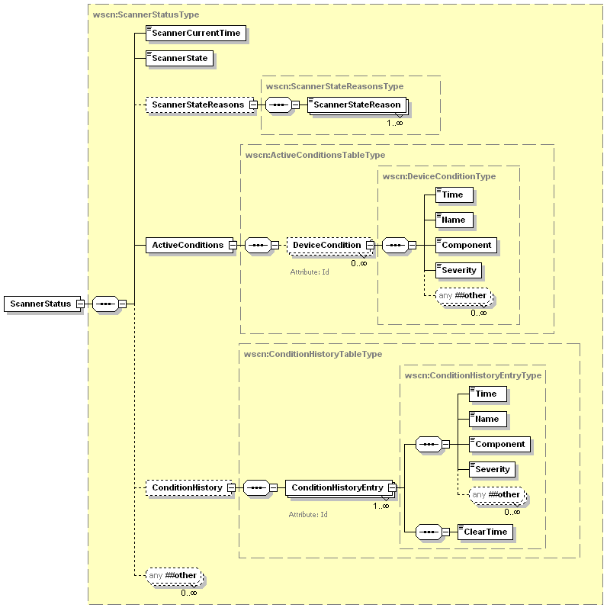
Figure 9 - ScannerStatus Elements
All of the Scanner elements contained within the ScannerStatus element are described in detail in the following sections.

ScannerCurrentTime
This element indicates the current date and time according the scanner’s internal clock. This is not required to be a realtime clock, it can start at zero (0001-01-01T00:00:00Z) and count up when the device is powered on. All times are based on the time at startup so duration and relative time can be calculated by reading the ScannerCurrentTime and comparing it to the previous time value.
Values: Any valid dateTime value

ScannerState
This element identifies the current state of scanning portion of the device.
Values:
Idle - Scanner is available and can start processing a new job.
Processing – The scanner is currently processing jobs.
Stopped - No jobs can be processed and intervention is needed.
Vendors MAY extend the allowed values for this element
Vendors MAY subset the allowed values for this element

Service
Available
Continue Processing Requested
User Intervention Required
Processing
Requested
Processing
Completed
Idle
Processing
Stopped
User Intervention Required
Calibration
Calibration/Startup Complete
Calibration or Service Mode Requested
Device Startup
Figure 10 - Scanner State Diagram

ScannerStateReasons
This element is a collection that describes all of the additional information about why the Scanner is in its current state.

ScannerStateReason
This element indicates a single additional piece of information about why the scanner is in its current state
Note: some of these reasons describe state of the scanner that cannot be entered on the basis of the currently defined WSD operations set. For example the scanner can be Paused; there is no PauseScanner operation. The reason these states are presented is because some other protocol (or console action) can have caused the scanner to enter that state.
Values:
AttentionRequired - User intervention is required before the device can continue.
Calibrating – The scan device is calibrating its internal components in preparation to acquire images
CoverOpen - One or more covers on the device are open.
InputTrayEmpty – The ADF input has no media
InterlockOpen
InternalStorageFull
LampError – The scanner lamp is failing and image acquisition can not proceed
LampWarming – The scanner lamp is warming in preparation to acquire images
MediaJam – Media is jammed in one of the input options causing image acquisition to fail
MultipleFeedError – The ADF option picked more than one piece of media
None - Indicates that there are no current state reasons
Paused - Someone has paused the scanner and the ScannerState is Stopped. In this state, a scanner will not produce Scanned output.
Vendors MUST support the values that represent conditions that are detectable in their implementation. Therefore, vendors MAY subset allowed values if specific ScannerStateReasons are undetectable in their implementation.
Vendors MAY extend allowed values. However, scanner vendors need to understand the implications of extending this list on a CP. The CP usually localizes the ScannerStateReasons value (as with other string variable values) to the human language of the user. However, such a scanner vendor extension value will not be recognized by the CP. As a Fallback presentation, the CP MAY display the value received as is, which should be in English and therefore, might not be understandable by the user. Alternatively, the vendor might use the general ScannerStateReasons value: AttentionRequired and then explain the problem on the scanner console which the user would see when they are at the scanner.

ActiveConditions
This element is a collection of detailed descriptions that describe in detail all of the currently active conditions/errors on the device. These conditions could vary in severity from Informational to Critical.

DeviceCondition
This is an element that describes the details about one of the currently active conditions.

Id
This attribute specifies the unique Id of the current DeviceCondition entry or ConditionHistoryEntry entry. This Id will be used by the CP to determine if an error condition is new, or has gone away. This Id is an integer value and MUST not be re-used over a reasonable duration of time to allow CPs to keep track of individual DeviceCondition(s).
REQUIRED attribute.
Values: 1 – 2147483647

Time
This element specifies the time a condition occurred. This time is according to the internal clock of the scanner.

Values: Any valid dateTime value

Name
This element specifies the name of the current DeviceConditon entry. This name describes the type of the current error condition. There are different error names for each component.
Values:
Calibrating
CoverOpen
InputTrayEmpty
InterlockOpen
InternalStorageFull
MediaJam
LampError
LampWarming
MultipleFeedError
Vendors MAY extend the allowed values for this element.
Vendors MAY subset the allowed values for this element

Component
This element specifies the component that is described by the current DeviceCondition entry.
Values:
ADF
Film
MediaPath
Platen
Vendors MAY extend the allowed values for this element.
Vendors MAY subset the allowed values for this element

Severity
This element specifies the level of severity of the current DeviceCondition entry. The scanner determines the severity level assigned to error condition.

Values:
Informational – This condition is purely for user information and has no noticeable affect on the image acquisition process
Warning – This condition is not affecting processing currently, but if not attended to it could become Critical
Critical – The device can not continue processing until this condition is resolved
Vendors MAY extend the allowed values for this element.
Vendors MAY subset the allowed values for this element

ConditionHistory
This element is a collection of detailed descriptions that describe a set of the most recent conditions/errors on the device. These conditions could vary in severity from Informational to Critical.

ConditionHistoryEntry
This is an element that describes the details about one of the past conditions.

Id
This data element is described in Section 4.4.4.1.1

Time
This data element is described in Section 4.4.4.1.2

Name
This data element is described in Section 4.4.4.1.3

Component
This data element is described in Section. 4.4.4.1.4

Severity
This data element is described in Section 4.4.4.1.5

ClearTime
This element specifies the time a condition was cleared. This time is according to the internal clock of the scanner.

Values: Any valid dateTime value

The Job’s Elements
This section defines the elements of the WSD Scan Job object. Figure 11 shows all the elements for the Job and their grouping. Jobs may contain one or more Documents. As indicated in the figure below the processing instructions for both the Job and the Document are done at the Job level. The Document object is covered in detail in section 4.6.

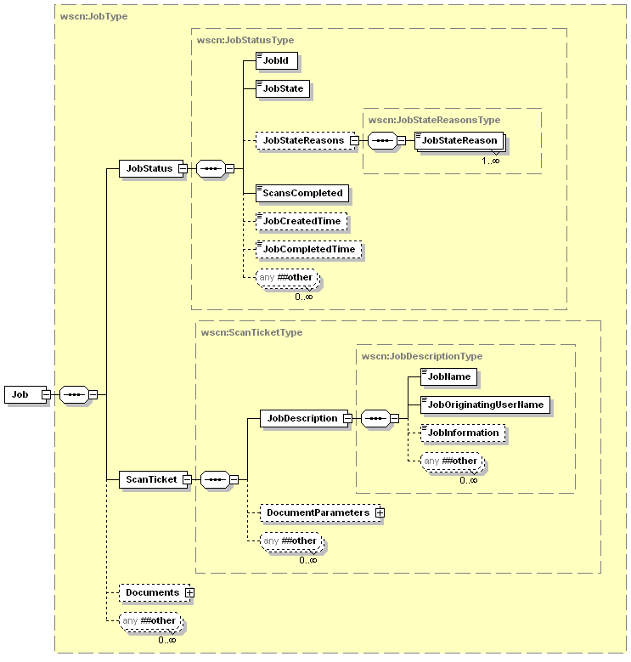
Figure 11 - Job Elements (Part 1)
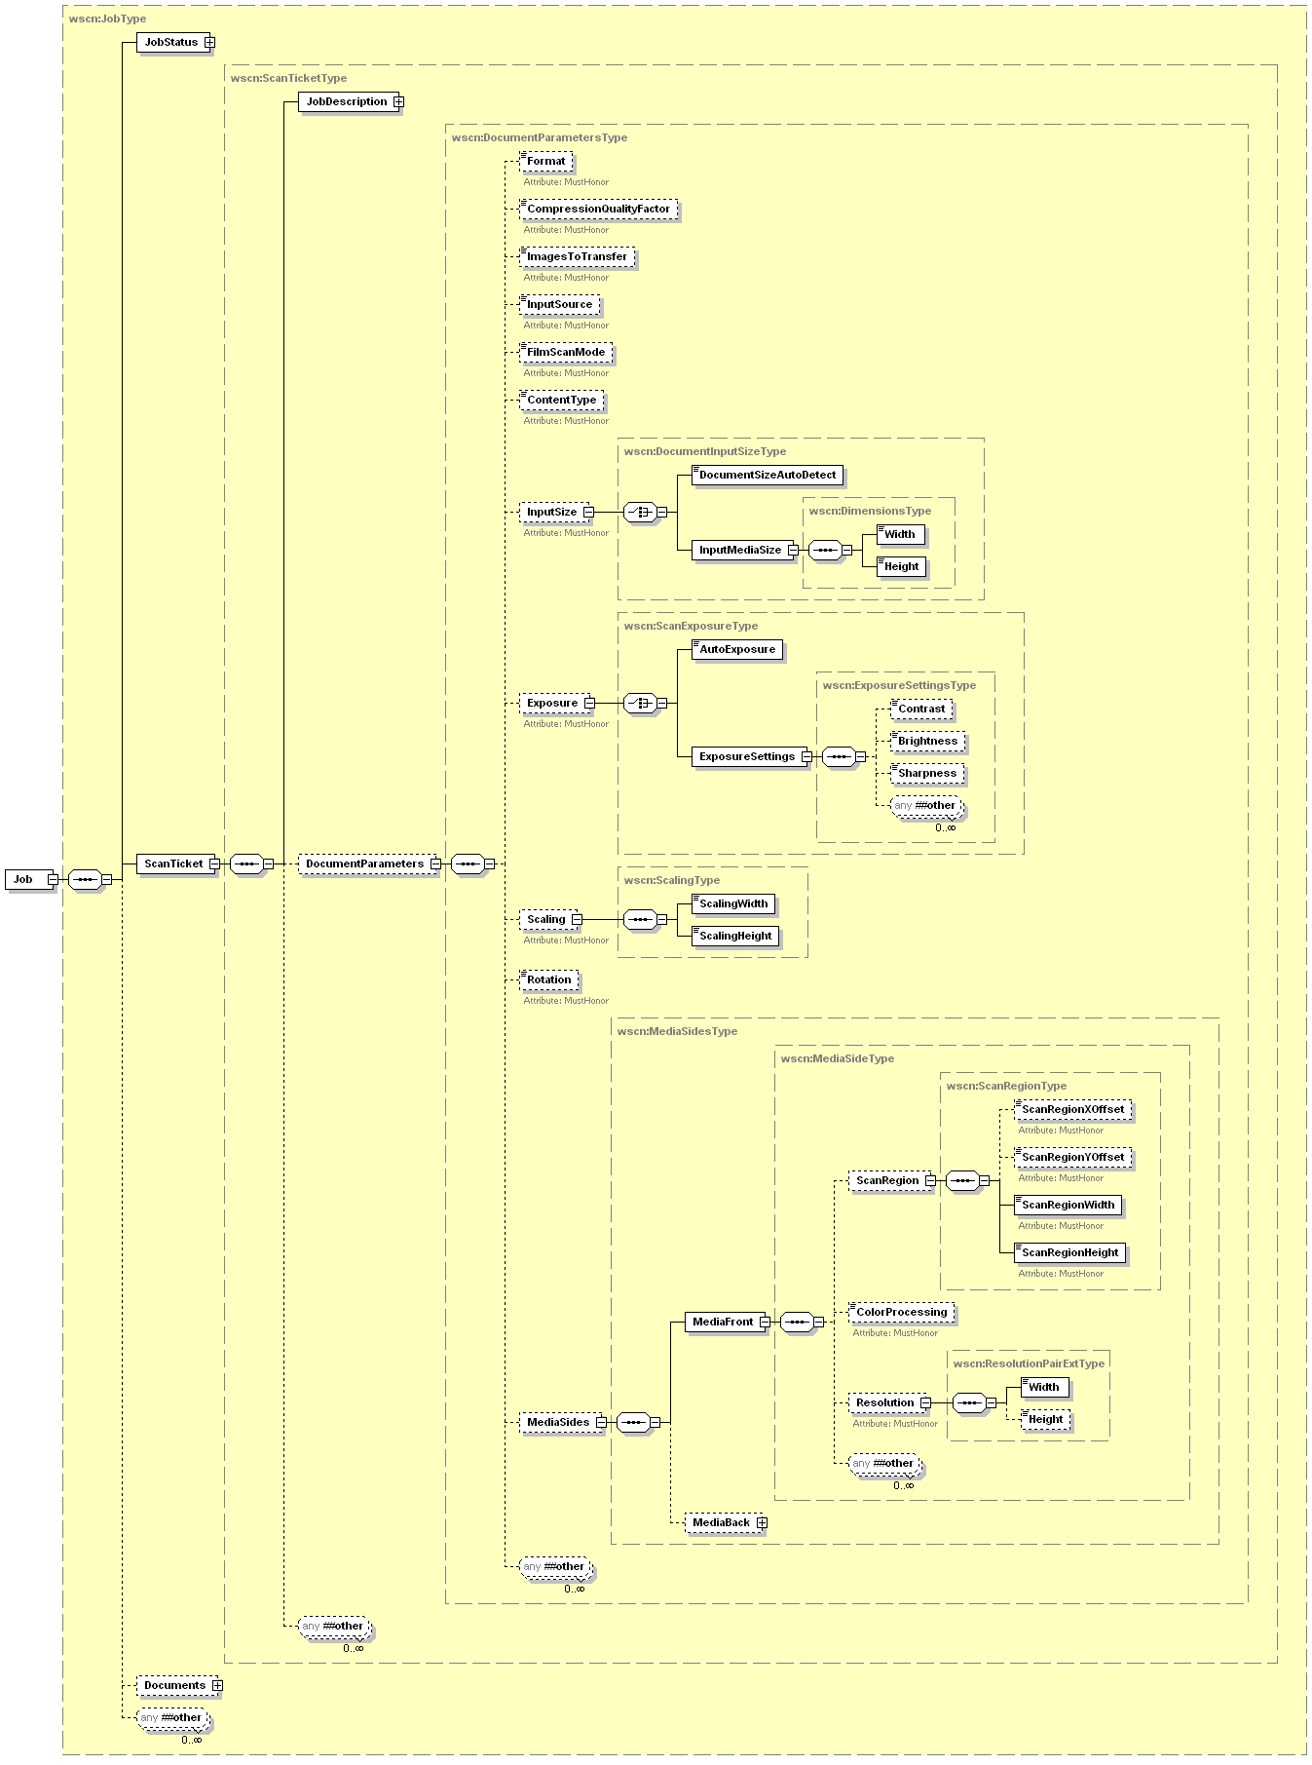
Figure 12 - Job Elements (Part 2)
All of the Scanner elements contained within a scan job are described in detail in the following sections.
The DocumentParameters elements of a Job are populated from corresponding elements explicitly supplied in a Job creation request by a CP. If the CP does not supply a parameter or processing element it indicates that the CP wants the scanner to use its default value. How the scanner’s default and allowed values for processing elements are set is implementation-specific, e.g., local console, Presentation Service (web access).
The JobDescription elements are populated from corresponding elements supplied in a Job creation request. These values may be changed by the scanner if more reliable information can be obtained. The JobStatus elements are maintained by automata. The values may be indirectly affected by a CP operation (e.g. CancelJob).

JobStatus
This section describes all of the elements that make up the JobStatus type in the scan job.

JobId
This element uniquely identifies a Job within a scanner. This number is not globally unique.
Values: 1 – 2147483647

JobState
This element specifies the current state of the Job. When contained in the JobEndStateEvent or a JobHistory entry it represents the completion state of the Job.
Values:
Aborted – The Job was aborted by the system.
Canceled – The Job was canceled either by a CP using the CancelJob operation or by means outside the scope of WSD
Completed – The Job is finished processing and all of the image data has been sent to the client.
Creating – The Job is being initialized.
Pending – The Job has been initialized and is waiting to be processed.
Pending-Held – The Job is waiting to be processed but is unavailable for scheduling. This state can only be reached by methods outside the scope of WSD.
Processing – The Job data is being digitized, transformed, or transferred.
Started – The scan device has begun processing the Job. This is a transient state, and will usually be seen only within a JobStatusEvent.
Terminating – The Job was canceled either by a CP using the CancelJob operation or aborted by means outside the scope of WSD.
Vendors MAY extend the allowed values for this element.
Vendors MAY subset the allowed values for this element.

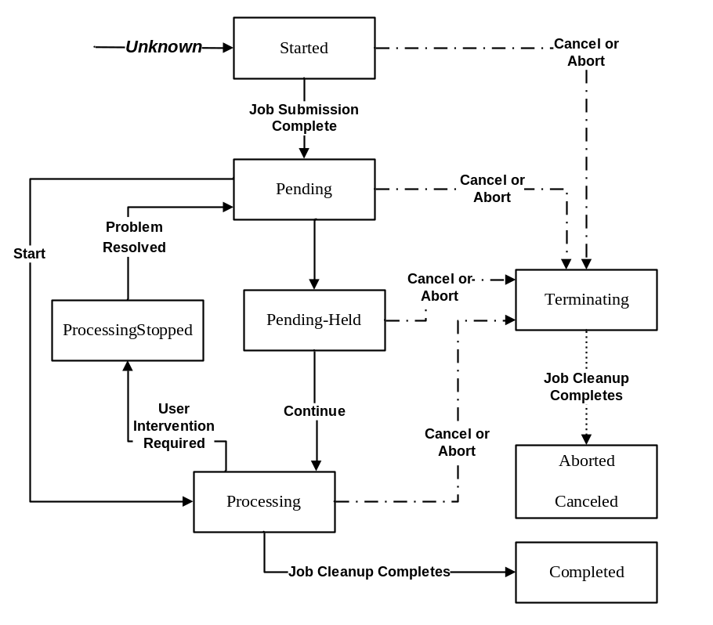
Figure 13 - Job States

JobStateReasons
This element is a collection that describes all of the additional information about why the Job is in its current state.

JobStateReason
This element is a single piece of additional information about why the Job is in its current state
Values:
InvalidScanTicket – The Job was rejected because the ScanTicket could not be processed.
DocumentFormatError – The requested Document format is not supported by the scan service
ImageTransferError – The data transfer of an image in the job failed. If this occurs the job is aborted.
JobCanceledAtDevice – The current scan job was canceled at the device front panel
JobCompletedSuccessfully – The Job is complete without any warnings or errors
JobCompletedWithErrors – The Job completed with at least one error.
JobCompletedWithWarnings – The Job completed with at least one warning. The Job data is expected to be successfully transferred. The warning may indicate that alterations to the job ticket occurred in order to process the Job.
JobScanning – The scanner is digitizing the Job data.
JobScanningAndTransferring – The scanner is digitizing the Job data and data is being transferred to the client.
JobTimedOut – The Job completed after no RetrieveImage operations followed the CreateScanJob operation in a timely fashion.
JobTransferring – The Job data is being transferred to the client.
None – The Job has no additional information on the Job State.
ScannerStopped – The scan device is stopped due to an active condition and the job can not continue until the condition is corrected
Vendors MUST support the values that represent conditions that are detectable in their implementation. Therefore, vendors MAY subset allowed values if specific JobStateReasons are undetectable in their implementation.
Vendors MAY extend allowed values. However, scanner vendors need to understand the implications of extending this list on a CP. The CP usually localizes the JobStateReason value (as with other string variable values) to the human language of the user. However, such a scanner vendor extension value will not be recognized by the CP. As a Fallback presentation, the CP MAY display the value received as is, which should be in English and therefore, might not be understandable by the user.

JobCreatedTime
This element contains the local time when the job was created. Job creation is the point in time where the job is submitted to the system.
Values: Any valid dateTime value

JobCompletedTime
This element specifies the scanner time at completion of the scan job. Completion is when all processing has completed, either because of successful completion of scanning and document transfer or because a fatal error was encountered.
Values: Any valid dateTime value

ScansCompleted
This element specifies the number of images scanned. A sheet of media may be scanned multiple times. In duplex scanning each side of the sheet is scanned, generating two scans in the ScansCompleted count.
(Note: This information may not be known until the scanner has completed processing the Job. The scanner MUST update this element when more exact information is available)
Values: 0 – 2147483647

ScanTicket
This section of the schema defines all the information that pertains to the description and processing parameters of the currently identified Job. This is the ScanTicket definition that was supplied with the CreateScanJob operation which started the Job.

JobDescription
This section describes all of the elements that make up the JobDescription type in the scan job.

JobName
This element is the user-friendly name of the job supplied by the CP. It is RECOMMENDED that the CP supply a value to help a user easily distinguish between the jobs that he/she has submitted.
Values: any character string

JobOriginatingUserName
This element is the name of the user that submitted the job. Either supplied by the CP or by the security infrastructure, if any. It is RECOMMENDED that the CP supply a value to help a user easily distinguish between the jobs that he/she has submitted and jobs that others have submitted.
Values: any character string

JobInformation
This element describes the intended use of the job. This value is useful if the job ticket used to create this job will be reused.
Values: any character string

DocumentParameters
This section describes all of the elements that make up the DocumentParameters type in the scan job. These parameters apply to all documents within the current scan job.

Format
This element specifies the document format in which the image data should be rendered. See section 4.3.1.1.1 for a list of values.
Vendors MAY extend the allowed values for this element.
Vendors MAY subset the allowed values for this element.

CompressionQualityFactor
This element specifies an integer value used by lossy compression types to determine the amount of acceptable image loss. See section 4.3.1.2 for a list of values. If the requested compression type is lossless then this element can be ignored if it is specified and the service should use a value of 100.
Values: 0 – 100
Vendors MAY subset the allowed values for this element

ImagesToTransfer
This element tells the scan device how many images to scan for the current job. This is useful if the document feeder could contain more pages of media than the current job. A value of 0 means scan as many pages as are currently available for the selected InputSource. If the InputSource is the Platen or Film then a value of 0 means a single image acquisition. If the InputSource is the ADF or ADFDuplex then a value of 0 means acquire images from the feeder until it is empty.
When acquiring images from ADFDuplex each side of the media represents a single image. To get both sides of the media the ImagesToTransfer value needs to be an even value of at least 2, sending an odd value, such as 1, would only acquire the front of the last sheet of media and the device should discard any data aquired from the back side of the media.
Values: 0 – 2147483647

InputSource
This element specifies the source of the original document:
Values:
ADF: Document being scanned is being delivered by a document feeding device scanning only the front side.
ADFDuplex: Document being scanned is being delivered by a document feeding device scanning both sides.
Film: Document is to be scanned using the Film scanning option.
Platen: Document is to be scanned from the platen
Vendors MAY extend the allowed values for this element.
Vendors MAY subset the allowed values for this element.

FilmScanMode
This element specifies the exposure type of the film to be scanned. This element is only valid if the InputSource element is set to a value of Film. See section 4.3.4.1.1 for a list of values for this element.

ContentType
This element specifies the main characteristics of the original document. See section 4.3.1.3.1 for a list of values for this element.

InputSize
This section describes the scan-able media size and how to detect it. This section is defined as a choice entry, which means only one of the sub-elements is valid at once. A CP can either ask for auto-size detection or specify a size.

DocumentSizeAutoDetect
This element indicates the scanner will do its best to determine the size of the original scan media. When/how this occurs is completely device dependent. If this element is specified along with a ScanRegion element, the Scan Region will be ignored if it falls outside of the media size detected by the device.
Values: 0, 1, true, false

InputMediaSize
This element describes the size of the media to be scanned for the current job. This element is made up of a pair of elements that describe the Width and Height of the media.

Width
This element indicates the width of the original media in the fast scan direction.
Values: 1 – 2147483647

Height
This element indicates the height of the original media in the slow scan direction.
Values: 1 – 2147483647

Exposure
This section indicates whether the scan service should automatically employ image processing techniques to reduce the background of the document to a white image or adjust the image processing by the values supplied. This section is defined as a choice entry, which means only one of the sub-elements is valid at once. A CP can either ask for auto-exposure adjustments or specify specific image processing adjustment values.

AutoExposure
This element indicates whether the scan service should automatically employ image processing techniques to reduce the background of the document to a white image. When set to 1 or true automatic background reduction will be performed on the original document.
Values: 0, 1, true, false

ExposureSettings
This element contains individual adjustment values which the scan service should apply to the image data after acquisition.

Contrast
This element indicates the relative amount to enhance or reduce the contrast of the scanned image. A value of 0 means to make no adjustments to the scanned contrast.
Values: -1000 – 1000
All WSD scanners MUST support the all values between and including -1000 and 1000, internally mapping as needed these values to the actual brightness/contrast values supported by the device.
Vendors MAY subset the allowed values for this element.

Brightness
This element indicates the relative amount to enhance or reduce the brightness of the scanned image. A value of 0 means to make no adjustments to the scanned brightness.
Values: -1000 – 1000
All WSD scanners MUST support the all values between and including -1000 and 1000, internally mapping as needed these values to the actual brightness/contrast values supported by the device.
Vendors MAY subset the allowed values for this element.

Sharpness
This element indicates the relative amount to enhance or reduce the sharpness of the scanned image. A value of 0 means to make no adjustments to the scanned sharpness.
Values: -100 – 100
All WSD scanners MUST support at least the 0 value.
Vendors MAY subset the allowed values for this element.

Scaling
This section specifies the scaling for both the slow and fast scan directions.
Both values must be specified. Isomorphic scaling is accomplished by supplying the same values for both width and height.

ScalingWidth
This element indicates the scaling factor to apply in the fast scan direction. A value of 100 specifies that no adjustments are made to the scanned image. Scaling is expressed in 1 percent increments.
Values: 1 – 1000
All WSD scanners MUST support at least the 100 value.
Vendors MAY subset the allowed values for this element.

ScalingHeight
This element indicates the scaling factor to apply in the slow scan direction. A value of 100 specifies that no adjustments are made to the scanned image. Scaling is expressed in 1 percent increments.
Values: 1 – 1000
All WSD scanners MUST support at least the 100 value.
Vendors MAY subset the allowed values for this element.

Rotation
This element indicates the amount to rotate each image of a scanned document. See section 4.3.1.9.1 for a list of values for this element. All devices must support a value of 0 (no rotation) for this element.

MediaSides
This element contains the parameters which are unique to each physical side of the media to be scanned. Many duplex capable scanners allow setting different scan regions, color processing and resolutions for each physical side of the media to be scanned. This element contains separate data for the Front side and Back side of the physical media. Every scan job can have parameters for the media front, however parameters for the media back are only valid if the InputSource specified equals ADFDuplex. If InputSource is ADFDuplex and the MediaBack element is missing, any parameters specified in MediaFront will be applied to the back side scanning as well.

MediaFront
This element contains all of the parameters specific to scanning the Front side of the physical media.

ScanRegion
This element specifies the area within the input document boundaries to scan. All ScanRegion values are in 1/1000ths of an inch.
If ScanRegion is not specified, the device should use 0 as the offsets and the width and height of the InputMediaSize, if given. If ScanRegion is not specified and InputMediaSize is not specified or cannot be determined by the device, the implementation is up to the hardware vendor.
The step size for all ScanRegion values in 1/1000th of an inch. If the requested scan region would fall completely outside of the supported acquisition area of the scanner the scan operation should be rejected. The scanner can also adjust the scan region requested if it can’t fulfill the exact dimensions. Any changes to the scan region should be reported in the DocumentFinalParameters elements in the scan job.
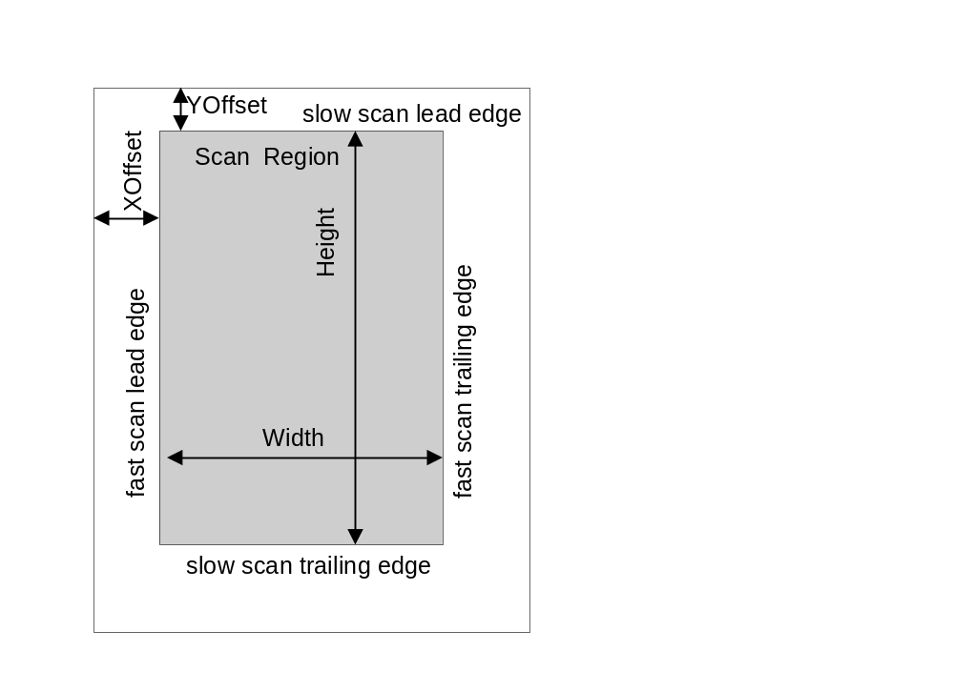
ScanRegionWidth corresponds to the fast scan direction and ScanRegionHeight corresponds to the slow scan direction.
ScanRegionXOffset + ScanRegionWidth must be equal to or less than InputSize width.
ScanRegionYOffset + ScanRegionLength must be equal to or less than InputSize length

ScanRegionXOffset
This element indicates how far from the fast scan lead edge to begin the scanning for this document. This value must be less than the InputSize width.
Values: 0 – InputSize width

ScanRegionYOffset
This element indicates how far from the slow scan lead edge to begin the scanning for this document. This value must be less than the InputSize height.
Values: 0 – InputSize height

ScanRegionWidth
This element indicates how far from the fast scan lead edge plus the ScanRegionXOffset to end the scanning for this document. This value plus ScanRegionXOffset must be less than the InputSize width.
Values: 1 – InputSize width

ScanRegionHeight
This element indicates how far from the slow scan lead edge plus the ScanRegionYOffset to end the scanning for this document. This value plus ScanRegionYOffset must be less than the InputSize height.
Values: 1 – InputSize height

ColorProcessing
This element contains the information needed to determine how color should be handled for the scanned image(s). See section 4.3.2.3.1 for a detailed description of this data element.

Resolution
This element specifies the resolution at which to capture the image. This element contains a single WidthxHeight pair that describes the desired capture resolution. If the Height element is missing, it is assumed this resolution pair (WidthxHeight) is a square resolution (i.e. 300x300) based on the Width.
Resolution is specified in pixels per inch.

Width
This element indicates the resolution to capture the image in the fast scan direction for this WidthxHeight pair.

Height
This element indicates the resolution to capture the image in the slow scan direction for this WidthxHeight pair.

MediaBack
This optional element contains all of the parameters specific to scanning the Back side of the physical media. These parameters are only valid when the scanner supports duplex scanning and the current scan job specifies ADFDuplex as the input source. See Section 4.5.2.2.11.1 for a detailed description of this data element.
If the current scan job specifies ADFDuplex as the input source and this element is not present, all parameters in the MediaFront element will be applied to the backside of the duplex scan as well.

The Document’s Elements
This section defines the elements of the WSD Document Object. Figure 14 shows all the elements for the Document and their grouping. Jobs contain one or more Documents.
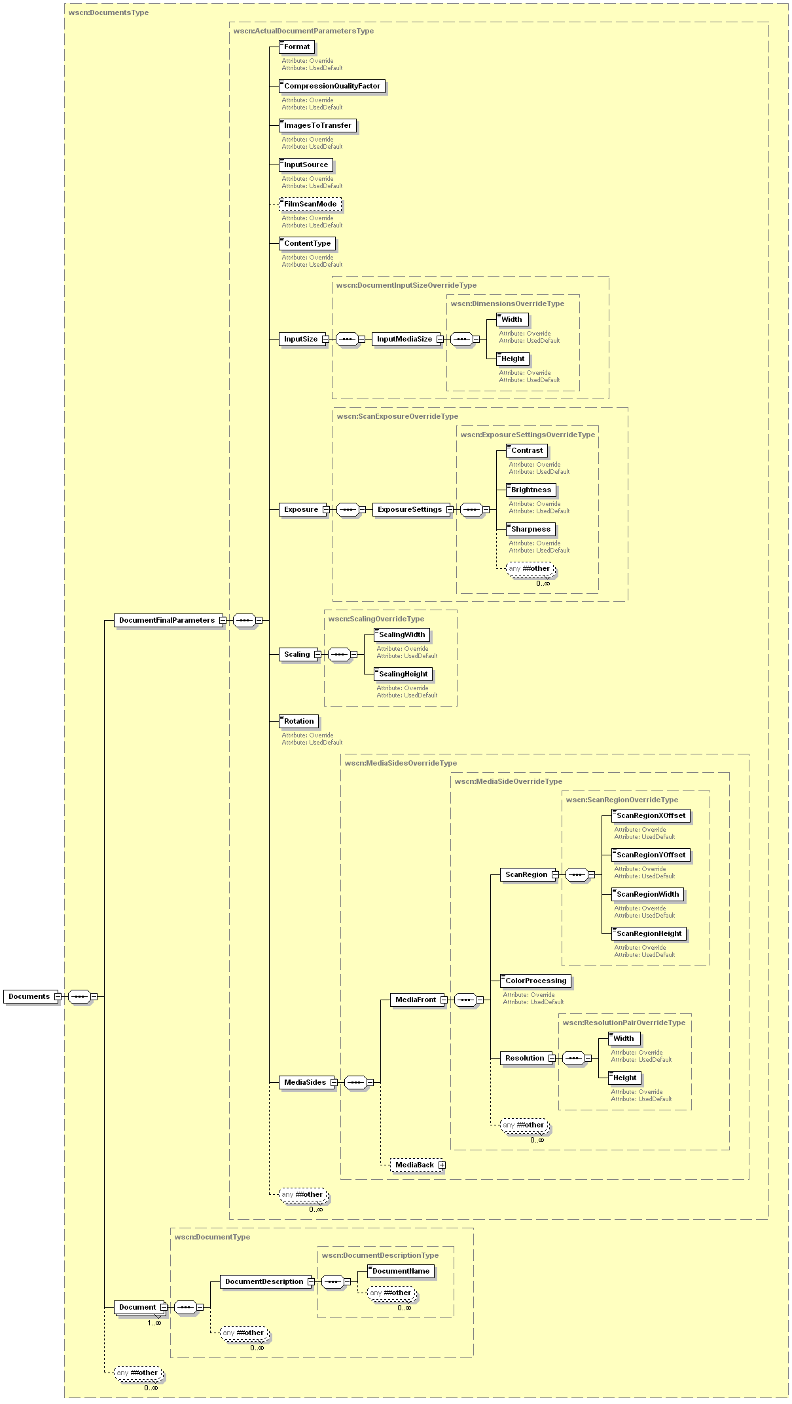
Figure 14 – Documents & Document Elements
All of the Scanner elements contained within a scan document are described in detail in the following sections.
The DocumentDescription elements are populated from corresponding elements supplied in a Job creation request. These values may be changed by the scanner if more reliable information can be obtained.

Documents
This element contains the actual scan characteristics used during image acquisition and also a collection of all the Document elements contained in the scan job.

DocumentFinalParameters
This section of the schema contains the actual DocumentParameters used by the scan device for image acquisition. These values may differ from the values requested in the job ScanTicket for any number of reasons. Each parameter is represented in this section, and must be filled in once the values are known. Each data element in this section also has two possible attributes associated with it. These attributes can be used by the client to determine whether the data value used by the scan device was the value sent in the ScanTicket, the scan device default value, or an override of the value requested by the ScanTicket.

Override
This attribute specifies that the current element was overridden by the scan device when the image data was aquired. The value of the element this attribute is associated with is the actual value used by the scan device during image acquisition.
OPTIONAL attribute.
Values: 0, 1, true, false

UsedDefault
This attribute specifies that the current element was not specified in the ScanTicket and the scan device used the default value when the image data was aquired. The value of the element this attribute is associated with is the actual value used by the scan device during image acquisition.
OPTIONAL attribute.
Values: 0, 1, true, false

Document
This is an element that describes the details about one of the documents scanned during the current scan job.

DocumentDescription
This section of the schema defines all the description attributes that pertain to the basic creation information of the currently identified Document.

DocumentName
This element specifies the name of the document supplied by the CP. The CP MUST supply a value to be used to store the document on the client.
Allowed Values: any character string

Job Table
This section describes how the Scanner keeps track of all the current and finished jobs submitted to the Scanner service. Figure 15 below shows how the JobTable fits into the Scanner service. The JobTable has two lists of jobs. The first list (ActiveJobs) holds all the jobs which have not yet completed processing. The state of active jobs could be scanning, pending, or stopped. The key is they are not completed yet. The second optional list (JobHistory) contains a subset of the most recent jobs that have finished processing. These jobs could have scanned, been aborted, or failed for other reasons. The maximum number of jobs in this list is dependent upon the device.
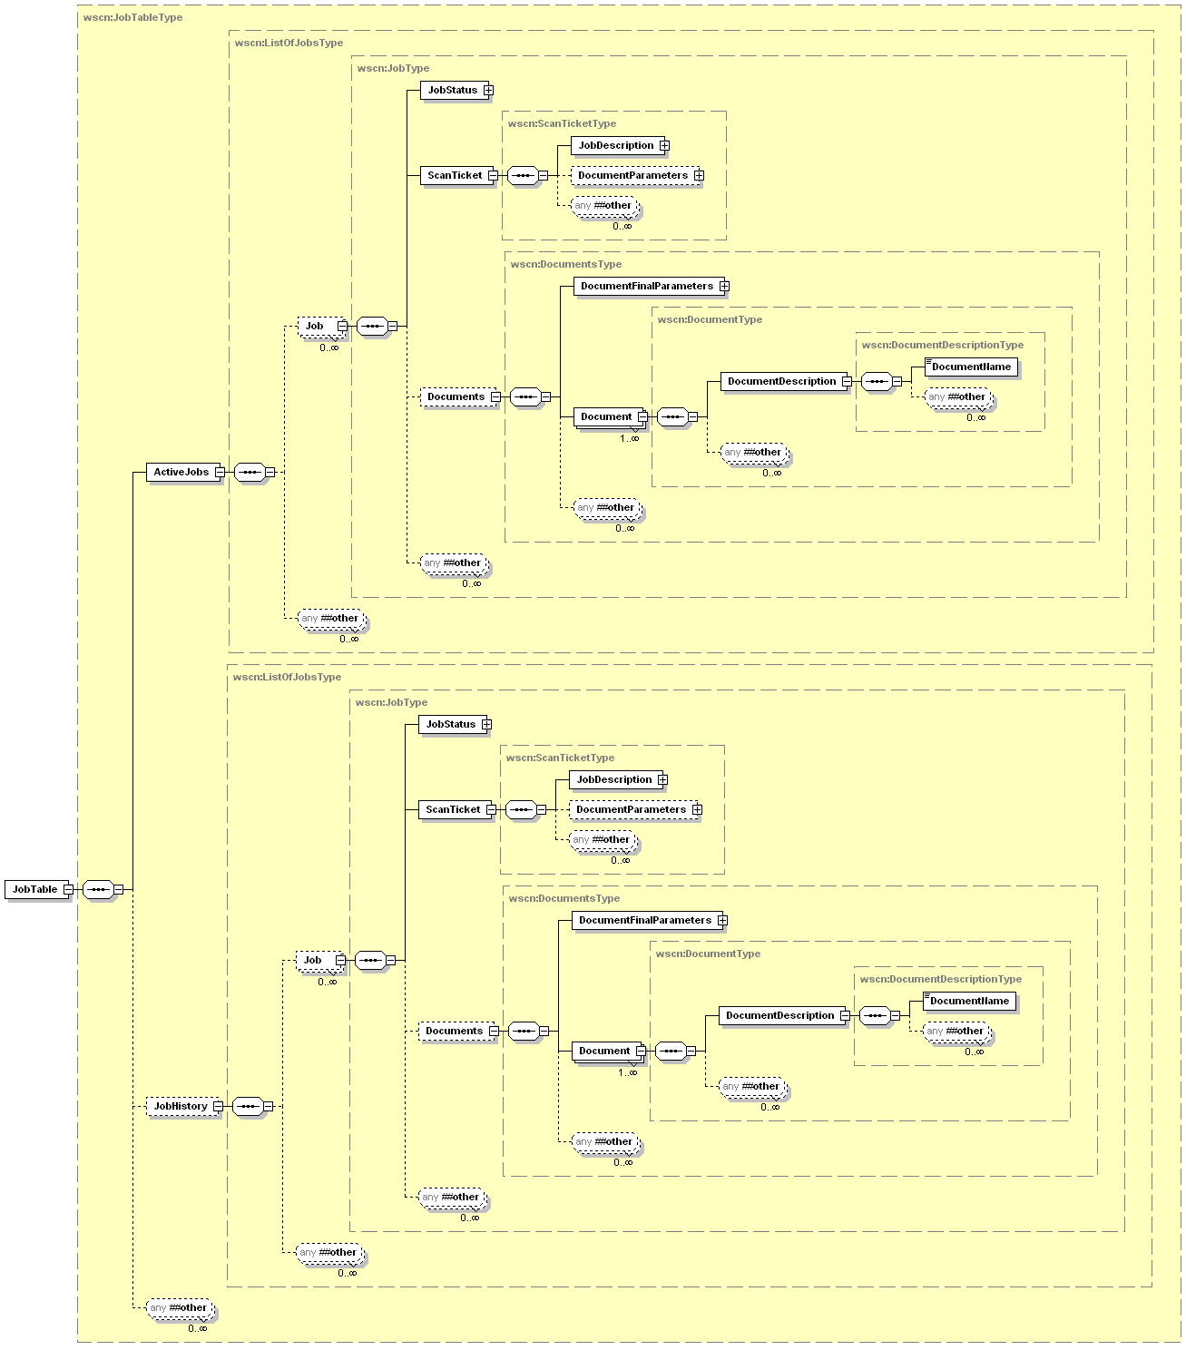
Figure 15 - JobTable Elements

ScanTicket
The ScanTicket is an instance document conforming to a proper subset of the scan job schema supported by the scanner. The ScanTicket contains the values that the CP has selected for the scanner settings for the current job. The ScanTicket is composed of these subsections:
JobDescription – This section of the ScanTicket contains general job information.
DocumentParameters– This section specifies the image processing functions and their values that will be applied against the job/document.
Figure 16 below illustrates the member elements of the ScanTicket element. Note that the member elements directly map to an instance of a Job and they are exactly what are required to be sent in a Job Creation operation.
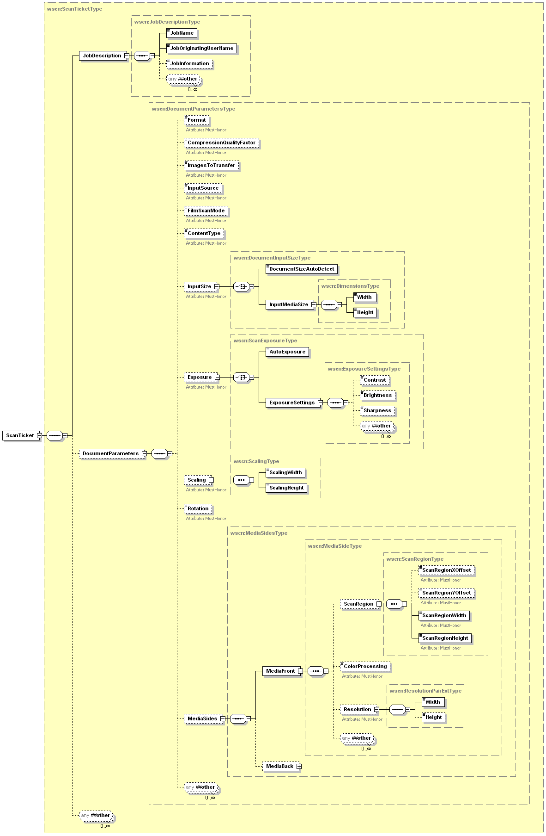
Figure 16 – ScanTicket Elements

Example ScanTicket
<wscn:ScanTicket>
<wscn:JobDescription>
<wscn:JobName>ScanJob for Den PC</wscn:JobName>
<wscn:JobOriginatingUserName>Dad</wscn:JobOriginatingUserName>
<wscn:JobInformation>Job created at Front Panel</wscn:JobInformation>
</wscn:JobDescription>
<wscn:DocumentParameters>
<wscn:Format>jfif</wscn:Format>
<wscn:CompressionQualityFactor>35</wscn:CompressionQualityFactor>
<wscn:ImagesToTransfer>1</wscn:ImagesToTransfer>
<wscn:InputSource>Platen</wscn:InputSource>
<wscn:InputSize>
<wscn:DocumentSizeAutoDetect>true</wscn:DocumentSizeAutoDetect>
</wscn:InputSize>
<wscn:Exposure>
<wscn:AutoExposure>true</wscn:AutoExposure>
</wscn:Exposure>
<wscn:MediaSides>
<wscn:MediaFront>
<wscn:ScanRegion>
<wscn:ScanRegionXOffset>250</wscn:ScanRegionXOffset>
<wscn:ScanRegionYOffset>250</wscn:ScanRegionYOffset>
<wscn:ScanRegionWidth>4000</wscn:ScanRegionWidth>
<wscn:ScanRegionHeight>6000</wscn:ScanRegionHeight>
</wscn:ScanRegion>
<wscn:ColorProcessing>RGB24</wscn:ColorProcessing>
<wscn:Resolution>
<wscn:Width>1200</wscn:Width>
</wscn:Resolution>
</wscn:MediaFront>
</wscn:MediaSides>
</wscn:DocumentParameters>
</wscn:ScanTicket>

Default Values and Allowed Values for Job Submission
The CP that submits a Scan Job may need to know the possible values and default values for the DocumentParameters elements that are included in a Job Creation operation. The Scanner has a ScannerConfiguration element and a DefaultScanTicket element to allow CPs to retrieve this information. The DefaultScanTicket element describes the current set of default values the scan service will apply when a job is created without specifying specific job creation elements. The ScannerConfiguration element contains information that will allow the CP to determine all of the allowed values for the Job and Document elements which can be specified to affect the image creation/acquisition process.

DefaultScanTicket
The DefaultScanTicket element is an instance of a ScanTicket element filled in with all the current default values for Job and Document creation. A CP can request the DefaultScanTicket and then use it as part of a CreateScanJob operation without error. The DefaultScanTicket will contain values for all ScanTicket options the device supports.

Example DefaultScanTicket
<wscn:DefaultScanTicket>
<wscn:JobDescription>
<wscn:JobName>Scan Job</wscn:JobName>
<wscn:JobOriginatingUserName></wscn:JobOriginatingUserName>
<wscn:JobInformation>User Selected Scan Job</wscn:JobInformation>
</wscn:JobDescription>
<wscn:DocumentParameters>
<wscn:Format>tiff-multi-uncompressed</wscn:Format>
<wscn:CompressionQualityFactor>100</wscn:CompressionQualityFactor>
<wscn:ImagesToTransfer>0</wscn:ImagesToTransfer>
<wscn:InputSource>Platen</wscn:InputSource>
<wscn:FilmScanMode>NotApplicable</wscn:FilmScanMode>
<wscn:ContentType>Auto</wscn:ContentType>
<wscn:InputSize>
<wscn:InputMediaSize>
<wscn:Width>8500</wscn:Width>
<wscn:Height>11000</wscn:Height>
</wscn:InputMediaSize>
</wscn:InputSize>
<wscn:Exposure>
<wscn:AutoExposure>true</wscn:AutoExposure>
</wscn:Exposure>
<wscn:Scaling>
<wscn:ScalingWidth>100</wscn:ScalingWidth>
<wscn:ScalingHeight>100</wscn:ScalingHeight>
</wscn:Scaling>
<wscn:Rotation>0</wscn:Rotation>
<wscn:MediaSides>
<wscn:MediaFront>
<wscn:ScanRegion>
<wscn:ScanRegionXOffset>0</wscn:ScanRegionXOffset>
<wscn:ScanRegionYOffset>0</wscn:ScanRegionYOffset>
<wscn:ScanRegionWidth>8500</wscn:ScanRegionWidth>
<wscn:ScanRegionHeight>11000</wscn:ScanRegionHeight>
</wscn:ScanRegion>
<wscn:ColorProcessing>RGB24</wscn:ColorProcessing>
<wscn:Resolution>
<wscn:Width>600</wscn:Width>
<wscn:Height>600</wscn:Height>
</wscn:Resolution>
</wscn:MediaFront>
</wscn:MediaSides>
</wscn:DocumentParameters>
</wscn:DefaultScanTicket>

Eventing
The scanner service will implement eventing as defined by the WS-Eventing [EVENT] specification. The scanner service will be an extension of the WS-Eventing porttype. This will add the operations defined in that spec to the scan service for use in creating and managing Event subscriptions.

Event Model
The eventing model for the scan service serves three main purposes: First is to inform the CP when the Configuration changes on the scan device. This could include changes in the ADF capabilities or changes in storage available, etc. Second is to inform the CP when there is a change in condition of the scan device. Examples: the scanner becomes idle or a document jam occurs. The ScannerState, ScannerStateReasons and DeviceConditon elements provide this information. Third is for job tracking; events inform a CP when a job is submitted, completed or removed from the job queue. The JobStatus and JobEndStateEvent elements provide this information. JobEndStateEvent indicates the final status of each job. It lets control points know whether it completed successfully or was canceled or aborted. ScansCompleted in the JobStatus is an example of information that updates an interested CP on the number of images scanned for the current job.

ScanAvailableEvent
This event is defined to inform the CP that a scan device for which the CP is subscribed is ready to scan a job. To keep from notifying every CP when a user presses the scan button, the Subscribe request will contain one or more destinations described by extensions that the scanner will use to filter down to a single CP per ScanAvailableEvent notification. These elements are defined in the scanner service namespace, and then added to the Subscribe request body.

Subscribe Extensions
Each of these extended elements is required to be sent in the Subscribe element of the [EVENT] Subscribe operation. It is important to note that only one ScanDestinations extension element should be included in the Subscribe element. Any subsequent ScanDestinations elements will be ignored. This also implies that only one DestinationResponses extension element will be returned in the SubscribeResponse element. An example subscribe follows the element definitions.
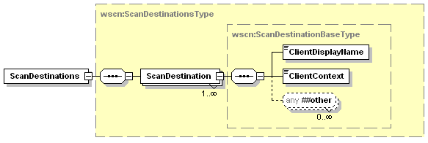
Figure 17 - ScanDestinations Elements

ScanDestinations
This element is a collection of all the Scan destinations the client wishes to register with the scan device. In most cases there will be a single scan destination, but this allows the client the flexibility to register multiple unique destinations at once.

ScanDestination
This element is a single scan destination on the CP. The elements that make up this destination registration will be used by the scan device to create appropriate ScanAvailableEvent(s) and are described fully below.

ClientDisplayName
This element specifies a string the scanner should display in its user-interface to allow the user to select the requesting client as a scan destination. When the user picks this display name and presses the scan button, the scanner will send a ScanAvailableEvent to the endpoint contained in this subscription.
Allowed Values: any character string

ClientContext
This element specifies a client specific string the scanner will send in the ScanAvailableEvent. This string will allow the client to associate the ScanAvailableEvent with the correct scanner device/service.
Allowed Values: any character string

Example ScanAvailableEvent Subscribe
<soap:Envelope
xmlns:soap="http://www.w3.org/2003/05/soap-envelope"
xmlns:wsa="http://schemas.xmlsoap.org/ws/2004/08/addressing"
xmlns:wse="http://schemas.xmlsoap.org/ws/2004/08/eventing"
xmlns:wscn="http://schemas.microsoft.com/windows/2006/01/wdp/scan”>
<soap:Header>
<wsa:To>AddressofScannerService</wsa:To>
<wsa:Action>
http://schemas.xmlsoap.org/ws/2004/08/eventing/Subscribe
</wsa:Action>
<wsa:MessageID>uuid:UniqueMsgId</wsa:MessageID>
</soap:Header>
<soap:Body>
<wse:Subscribe>
<wse:Delivery>
<wse:NotifyTo>
<wsa:Address>
http://www.example.com/MyEventSink/OnScanAvailableForMe
</wsa:Address>
</wse:NotifyTo>
</wse:Delivery>
<wse:Expires>P0Y0M0DT30H0M0S</wse:Expires>
<wse:Filter Dialect="http://schemas.xmlsoap.org/ws/2006/02/devprof/Action">
http://schemas.microsoft.com/windows/2006/08/wdp/scan/ScanAvailableEvent
</wse:Filter>
<wscn:ScanDestinations>
<wscn:ScanDestination>
<wscn:ClientDisplayString>Den Computer</wscn:ClientDisplayString>
<wscn:ClientContext>App1ScanID2345</wscn:ClientContext>
</wscn:ScanDestination>
</wscn:ScanDestinations>
</wse:Subscribe>
</soap:Body
</soap:Envelope>

SubscribeResponse Extensions
There is also an extended element in the SubscribeResponse body. This element helps tie the subscription back to the device that accepted it.
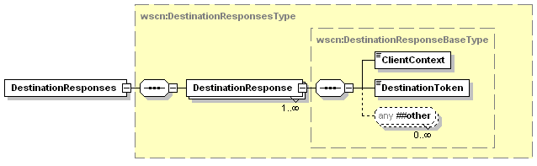
Figure 18 - DestinationResponses Elements

DestinationResponses
This element is a collection of all the responses to the scan destination requests. There will be one DestinationResponse element for each ScanDestination element in the Subscribe request.

DestinationResponse
This element is the response information for a single ScanDestination registration. The element contains the ClientContext from the ScanDestination to identify the response and a DestinationToken element for use in all CreateScanJob operations from this destination.

ClientContext
This element is a copy of the data sent in a ScanDestination element in the Subscribe operation. There is a one-to-one match of ClientContext(s) between a ScanDestination element and a DestinationResponse element. See Section 5.2.1.1.1.2 for a detailed description of this data element.

DestinationToken
This element specifies a device specific string the scanner will assign to this client destination. When the client sends the CreateScanJob operation after a ScanAvailableEvent it will include this token. This string will allow the device to double check the correct client is requesting the scan.
Allowed Values: any character string

Example ScanAvailableEvent SubscribeResponse
<soap:Envelope
xmlns:soap="http://www.w3.org/2003/05/soap-envelope"
xmlns:wsa="http://schemas.xmlsoap.org/ws/2004/08/addressing"
xmlns:wse="http://schemas.xmlsoap.org/ws/2004/08/eventing"
xmlns:wscn="http://schemas.microsoft.com/windows/2006/01/wdp/scan”
soap:encodingStyle='http://www.w3.org/2002/12/soap-encoding' >
<soap:Header>
<wsa:To>http://schemas.xmlsoap.org/ws/2004/08/addressing/role/anonymous</wsa:To>
<wsa:Action>
http://schemas.xmlsoap.org/ws/2004/08/eventing/SubscribeResponse
</wsa:Action>
<wsa:MessageID>uuid:UniqueMsgId</wsa:MessageID>
<wsa:RelatesTo>uuid:MsgIdOfTheSubscribe</wsa:RelatesTo>
</soap:Header>
<soap:Body>
<wse:SubscribeResponse>
<wse:SubscriptionManager>
<!-- Elements removed for clarity -->
</wse:SubscriptionManager>
<wse:Expires>P0Y0M0DT30H0M0S</wse:Expires>
<wscn:DestinationResponses>
<wscn:DestinationResponse>
<wscn:ClientContext>App1ScanID2345</wscn:ClientContext>
<wscn:DestinationToken>Client3478</wscn:DestinationToken>
</wscn:DestinationResponse>
</wscn:DestinationResponses>
</wse:SubscribeResponse>
</soap:Body
</soap:Envelope>

Event Elements
The body of the ScanAvailableEvent consists of information that will allow the CP to determine which scanner to send the CreateScanJob operation.
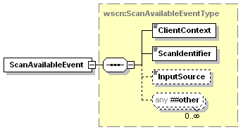
Figure 19 – ScanAvailableEvent Elements

ClientContext
This element contains a client specific string the scanner received as part of the ScanAvalibleEvent subscription request.. See section 5.2.1.1.1.2 for more details about this element.

ScanIdentifier
This element specifies a device specific string the scanner sends in the ScanAvailableEvent. This identifier will be sent as part of the resulting CreateScanJob operation from the client. It allows the scanner to make sure the correct client is requesting the scan after a user has selected the destination. This value should be unique per instance of the ScanAvailableEvent.
Allowed Values: any character string

InputSource
This optional element contains the InputSource the user has placed the original images in on the scan device. The scan client should use this value for the InputSource element of the ScanTicket in the successive CreateScanJob operation. See section 4.5.2.2.4 for more details about this element.

Example ScanAvailableEvent
<soap:Envelope
xmlns:soap="http://www.w3.org/2003/05/soap-envelope"
xmlns:wsa="http://schemas.xmlsoap.org/ws/2004/08/addressing"
xmlns:wse="http://schemas.xmlsoap.org/ws/2004/08/eventing"
xmlns:wscn="http://schemas.microsoft.com/windows/2006/01/wdp/scan”>
<soap:Header>
<wsa:To>AddressofEventSink</wsa:To>
<wsa:Action>
http://schemas.microsoft.com/windows/2006/08/wdp/scan/ScanAvailableEvent
</wsa:Action>
<wsa:MessageID>uuid:UniqueMsgId</wsa:MessageID>
</soap:Header>
<soap:Body>
<wscn:ScanAvailableEvent>
<wscn:ClientContext>App1ScanID2345</wscn:ClientContext>
<wscn:ScanIdentifier>AnyUniqueIdentifierSuchAsAGUID</wscn:ScanIdentifier>
<wscn:InputSource>ADF</wscn:InputSource>
</wscn:ScanAvailableEvent>
</soap:Body
</soap:Envelope>

ScannerElementsChangeEvent
This event is defined to inform the CP that something has changed in the ScannerDescription element, the ScannerConfiguration element, the DefaultScanTicket element, or an IHV extension in the Scanner. The body of the ScannerElementsChangeEvent consists of the complete XML for the updated element. If an optional element is missing from returned XML the implication is that that element is no longer supported by the scanner service. This could be caused by a removal of a film scan option or a duplex scanning mode. The CP is then responsible for comparing the incoming element against previous data to determine which values have changed.
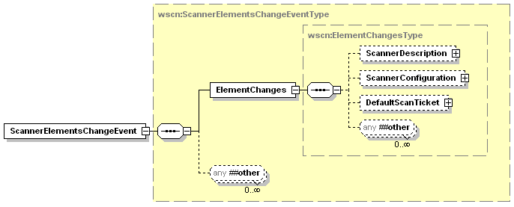
Figure 20 - ScannerElementsChangeEvent Elements

ElementChanges
The information returned in this data element should be entire element in the Scanner schema which contains changed values. This could be because an ADF was installed, a value changed in the DefaultScanTicket or DeviceSettings, or an IHV extension has changed value. In each case the complete ScannerDescription, ScannerConfiguration, DefaultScanTicket or IHV extension would be returned in this element.

Example ScannerElementsChangeEvent
In this example the device is reporting updated device configuration due to the installation of a Film scanning option.
<soap:Envelope
xmlns:soap="http://www.w3.org/2003/05/soap-envelope"
xmlns:wsa="http://schemas.xmlsoap.org/ws/2004/08/addressing"
xmlns:wse="http://schemas.xmlsoap.org/ws/2004/08/eventing"
xmlns:wscn="http://schemas.microsoft.com/windows/2006/01/wdp/scan”>
<soap:Header>
<wsa:To>AddressofEventSink</wsa:To>
<wsa:Action>
http://schemas.microsoft.com/windows/2006/08/wdp/scan/ScannerElementsChangeEvent
</wsa:Action>
<wsa:MessageID>uuid:UniqueMsgId</wsa:MessageID>
</soap:Header>
<soap:Body>
<wscn:ScannerElementsChangeEvent>
<wscn:ElementChanges>
<wscn:ScannerConfiguration>
<wscn:DeviceSettings>
<wscn:FormatsSupported>
<wscn:FormatValue>dib</wscn:FormatValue>
<wscn:FormatValue>exif</wscn:FormatValue>
<wscn:FormatValue>jpeg2k</wscn:FormatValue>
<wscn:FormatValue>pdf-a</wscn:FormatValue>
<wscn:FormatValue>png</wscn:FormatValue>
<wscn:FormatValue>tiff-single-uncompressed</wscn:FormatValue>
<wscn:FormatValue>tiff-single-g4</wscn:FormatValue>
<wscn:FormatValue>tiff-multi-uncompressed</wscn:FormatValue>
<wscn:FormatValue>tiff-multi-g4</wscn:FormatValue>
<wscn:FormatValue>xps</wscn:FormatValue>
</wscn:FormatsSupported>
<wscn:CompressionQualityFactorSupported>
<wscn:MinValue>15</wscn:MinValue>
<wscn:MaxValue>100</wscn:MaxValue>
</wscn:CompressionQualityFactorSupported>
<wscn:ContentTypesSupported>
<wscn:ContentTypeValue>Auto</wscn:ContentTypeValue>
<wscn:ContentTypeValue>Text</wscn:ContentTypeValue>
<wscn:ContentTypeValue>Photo</wscn:ContentTypeValue>
<wscn:ContentTypeValue>Halftone </wscn:ContentTypeValue>
<wscn:ContentTypeValue>Mixed</wscn:ContentTypeValue>
</wscn:ContentTypesSupported>
<wscn:DocumentSizeAutoDetectSupported>
true
</wscn:DocumentSizeAutoDetectSupported>
<wscn:AutoExposureSupported>true</wscn:AutoExposureSupported>
<wscn:BrightnessSupported>true</wscn:BrightnessSupported>
<wscn:ContrastSupported>true</wscn:ContrastSupported>
<wscn:ScalingRangeSupported>
<wscn:ScalingWidth>
<wscn:MinValue>50</wscn:MinValue>
<wscn:MaxValue>500</wscn:MaxValue>
</wscn:ScalingWidth>
<wscn:ScalingHeight>
<wscn:MinValue>50</wscn:MinValue>
<wscn:MaxValue>500</wscn:MaxValue>
</wscn:ScalingHeight>
</wscn:ScalingRangeSupported>
<wscn:RotationsSupported>
<wscn:RotationValue>0</wscn:RotationValue>
<wscn:RotationValue>90</wscn:RotationValue>
<wscn:RotationValue>180</wscn:RotationValue>
<wscn:RotationValue>270</wscn:RotationValue>
</wscn:RotationsSupported>
</wscn:DeviceSettings>
<wscn:Platen>
<wscn:PlatenOpticalResolution>
<wscn:Width>1200</wscn:Width>
<wscn:Height>1200</wscn:Height>
</wscn:PlatenOpticalResolution>
<wscn:PlatenResolutions>
<wscn:Widths>
<wscn:Width>150</wscn:Width>
<wscn:Width>204</wscn:Width>
<wscn:Width>300</wscn:Width>
<wscn:Width>600</wscn:Width>
<wscn:Width>1200</wscn:Width>
</wscn:Widths>
<wscn:Heights>
<wscn:Height>96</wscn:Height>
<wscn:Height>150</wscn:Height>
<wscn:Height>204</wscn:Height>
<wscn:Height>300</wscn:Height>
<wscn:Height>600</wscn:Height>
<wscn:Height>900</wscn:Height>
<wscn:Height>1200</wscn:Height>
</wscn:Heights>
</wscn:PlatenResolutions>
<wscn:PlatenColor>
<wscn:ColorEntry>BlackAndWhite1</wscn:ColorEntry>
<wscn:ColorEntry>Grayscale4</wscn:ColorEntry>
<wscn:ColorEntry>Grayscale8</wscn:ColorEntry>
<wscn:ColorEntry>RGB24</wscn:ColorEntry>
<wscn:ColorEntry>RGB48</wscn:ColorEntry>
<wscn:ColorEntry>RGBa32</wscn:ColorEntry>
<wscn:ColorEntry>RGBa64</wscn:ColorEntry>
</wscn:PlatenColor>
<wscn:PlatenMinimumSize>
<wscn:Width>250</wscn:Width>
<wscn:Height>250</wscn:Height>
</wscn:PlatenMinimumSize>
<wscn:PlatenMaximumSize>
<wscn:Width>11000</wscn:Width>
<wscn:Height>14000</wscn:Height>
</wscn:PlatenMaximumSize>
</wscn:Platen>
<wscn:ADF>
<wscn:ADFSupportsDuplex>false</wscn:ADFSupportsDuplex>
<wscn:ADFFront>
<wscn:ADFOpticalResolution>
<wscn:Width>600</wscn:Width>
<wscn:Height>600</wscn:Height>
</wscn:ADFOpticalResolution>
<wscn:ADFResolutions>
<wscn:Widths>
<wscn:Width>150</wscn:Width>
<wscn:Width>204</wscn:Width>
<wscn:Width>300</wscn:Width>
<wscn:Width>600</wscn:Width>
</wscn:Widths>
<wscn:Heights>
<wscn:Height>96</wscn:Height>
<wscn:Height>150</wscn:Height>
<wscn:Height>204</wscn:Height>
<wscn:Height>300</wscn:Height>
<wscn:Height>600</wscn:Height>
</wscn:Heights>
</wscn:ADFResolutions>
<wscn:ADFColor>
<wscn:ColorEntry>BlackAndWhite1</wscn:ColorEntry>
<wscn:ColorEntry>Grayscale4</wscn:ColorEntry>
<wscn:ColorEntry>RGB24</wscn:ColorEntry>
</wscn:ADFColor>
<wscn:ADFMinimumSize>
<wscn:Width>4000</wscn:Width>
<wscn:Height>6000</wscn:Height>
</wscn:ADFMinimumSize>
<wscn:ADFMaximumSize>
<wscn:Width>8500</wscn:Width>
<wscn:Height>11000</wscn:Height>
</wscn:ADFMaximumSize>
</wscn:ADFFront>
</wscn:ADF>
<wscn:Film>
<wscn:FilmScanModesSupported>
<wscn:FilmScanModeValue>
ColorSlideFilm
</wscn:FilmScanModeValue>
<wscn:FilmScanModeValue>
ColorNegativeFilm
</wscn:FilmScanModeValue>
<wscn:FilmScanModeValue>
BlackandWhiteNegativeFilm
</wscn:FilmScanModeValue>
</wscn:FilmScanModesSupported>
<wscn:FilmOpticalResolution>
<wscn:Width>600</wscn:Width>
<wscn:Height>600</wscn:Height>
</wscn:FilmOpticalResolution>
<wscn:FilmResolutions>
<wscn:Widths>
<wscn:Width>150</wscn:Width>
<wscn:Width>300</wscn:Width>
<wscn:Width>600</wscn:Width>
</wscn:Widths>
<wscn:Heights>
<wscn:Height>150</wscn:Height>
<wscn:Height>300</wscn:Height>
<wscn:Height>600</wscn:Height>
</wscn:Heights>
</wscn:FilmResolutions>
<wscn:FilmColor>
<wscn:ColorEntry>BlackAndWhite1</wscn:ColorEntry>
<wscn:ColorEntry>Grayscale4</wscn:ColorEntry>
<wscn:ColorEntry>RGB24</wscn:ColorEntry>
<wscn:ColorEntry>RGBa32</wscn:ColorEntry>
</wscn:FilmColor>
<wscn:FilmMinimumSize>
<wscn:Width>1378</wscn:Width>
<wscn:Height>1378</wscn:Height>
</wscn:FilmMinimumSize>
<wscn:FilmMaximumSize>
<wscn:Width>2756</wscn:Width>
<wscn:Height>10000</wscn:Height>
</wscn:FilmMaximumSize>
</wscn:Film>
</wscn:ScannerConfiguration>
</wscn:ElementChanges>
</wscn:ScannerElementsChangeEvent>
</soap:Body
</soap:Envelope>

ScannerStatusSummaryEvent
This event is defined to inform the CP that the device status has changed. The body of the ScannerStatusSummaryEvent consists of the StatusSummary element.
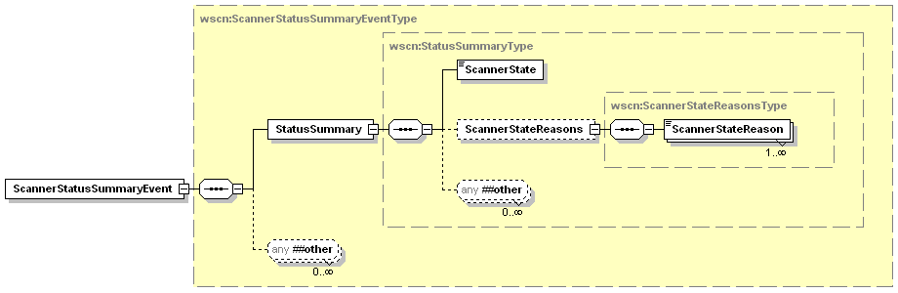
Figure 21 - ScannerStatusSummaryEvent Elements

StatusSummary
This data element contains the current summary of the scanner status.

ScannerState
This data element is described in Section 4.4.2

ScannerStateReasons
This data element is described in Section 4.4.3

ScannerStateReason
This data element is described in Section 4.4.3.1.

Example ScannerStatusSummaryEvent
In this example the device is stopped because of a jam in the media feed path.
<soap:Envelope
xmlns:soap="http://www.w3.org/2003/05/soap-envelope"
xmlns:wsa="http://schemas.xmlsoap.org/ws/2004/08/addressing"
xmlns:wse="http://schemas.xmlsoap.org/ws/2004/08/eventing"
xmlns:wscn="http://schemas.microsoft.com/windows/2006/01/wdp/scan”>
<soap:Header>
<wsa:To>AddressofEventSink</wsa:To>
<wsa:Action>
http://schemas.microsoft.com/windows/2006/08/wdp/scan/ScannerStatusSummaryEvent
</wsa:Action>
<wsa:MessageID>uuid:UniqueMsgId</wsa:MessageID>
</soap:Header>
<soap:Body>
<wscn:ScannerStatusSummaryEvent>
<wscn:StatusSummary>
<wscn:ScannerState>Stopped</wscn:ScannerState>
<wscn:ScannerStateReasons>
<wscn:ScannerStateReason>MediaJam</wscn:ScannerStateReason>
</wscn:ScannerStateReasons>
</wscn:StatusSummary>
</wscn:ScannerStatusSummaryEvent>
</soap:Body
</soap:Envelope>

ScannerStatusConditionEvent
This event is defined to inform the CP detailed information about a status change in the device. The body of the ScannerStatusConditionEvent event consists of the DeviceConditon element for the status change. This element contains the following data:
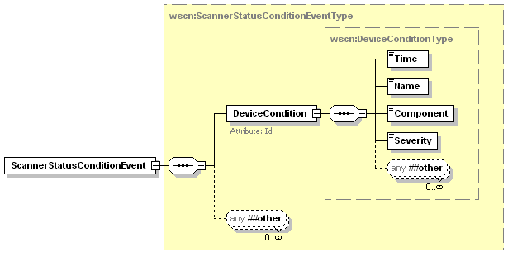
Figure 22 - ScannerStatusConditon Event

DeviceCondition
This is an element that describes the details about one of the currently active conditions. This data element is described in Section 4.4.4.1.

Example ScannerStatusConditionEvent
In this example the device is notifying the CP of a scan Lamp failure.
<soap:Envelope
xmlns:soap="http://www.w3.org/2003/05/soap-envelope"
xmlns:wsa="http://schemas.xmlsoap.org/ws/2004/08/addressing"
xmlns:wse="http://schemas.xmlsoap.org/ws/2004/08/eventing"
xmlns:wscn="http://schemas.microsoft.com/windows/2006/01/wdp/scan”>
<soap:Header>
<wsa:To>AddressofEventSink</wsa:To>
<wsa:Action>
http://schemas.microsoft.com/windows/2006/08/wdp/scan/ScannerStatusConditionEvent
</wsa:Action>
<wsa:MessageID>uuid:UniqueMsgId</wsa:MessageID>
</soap:Header>
<soap:Body>
<wscn:ScannerStatusConditionEvent>
<wscn:DeviceCondition Id=”1543”>
<wscn:Time>2006-01-21T17:22:27.5242689Z</wscn:Time>
<wscn:Name>LampError</wscn:Name>
<wscn:Component>Platen</wscn:Component>
<wscn:Severity>Critical</wscn:Severity>
</wscn:DeviceCondition>
</wscn:ScannerStatusConditionEvent>
</soap:Body
</soap:Envelope>

ScannerStatusConditionClearedEvent
This event is defined to inform the CP that a previously reported DeviceCondition has been cleared. The body of the ScannerStatusConditionClearedEvent message consists of the DeviceConditonId element for the condition that has been cleared, and an element representing the time the condition was cleared. This event contains the following data:
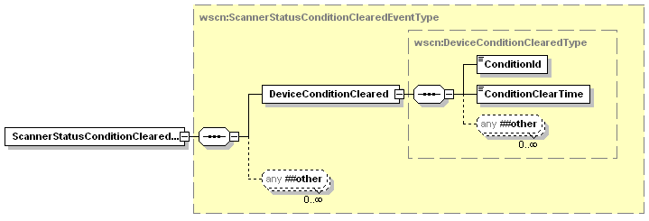
Figure 23 - ScannerStatusConditionCleared Event

DeviceConditonCleared
This data element contains the Id of the condition that cleared and the time the condition was cleared.

ConditonId
This data element is equivalent to the Id attribute of a DeviceCondition entry. See Section 4.4.4.1.1 for an explanation of the format.

ConditionClearTime
This data element is a dateTime element that describes when the condition was cleared. See Section 4.4.5.1.6 for an explanation of the format.

Example ScannerStatusConditionClearedEvent
In this example the device is notifying the CP that the previous condition identified by Id 1543 has cleared.
<soap:Envelope
xmlns:soap="http://www.w3.org/2003/05/soap-envelope"
xmlns:wsa="http://schemas.xmlsoap.org/ws/2004/08/addressing"
xmlns:wse="http://schemas.xmlsoap.org/ws/2004/08/eventing"
xmlns:wscn="http://schemas.microsoft.com/windows/2006/01/wdp/scan”>
<soap:Header>
<wsa:To>AddressofEventSink</wsa:To>
<wsa:Action>
http://schemas.microsoft.com/windows/2006/08/wdp/scan/ScannerStatusConditionClearedEvent
</wsa:Action>
<wsa:MessageID>uuid:UniqueMsgId</wsa:MessageID>
</soap:Header>
<soap:Body>
<wscn:ScannerStatusConditionClearedEvent>
<wscn:DeviceConditionCleared>
<wscn:ConditionId>1543</wscn:ConditionId>
<wscn:ConditionClearTime>2006-01-21T17:22:35.8345Z</wscn:ConditionClearTime>
</wscn:DeviceConditionCleared>
</wscn:ScannerStatusConditionClearedEvent>
</soap:Body
</soap:Envelope>

JobStatusEvent
This event is defined to inform the CP that a job’s status has changed. The first JobStatusEvent message sent will usually have the JobId and a JobState of Started. The body of the JobStatusEvent message consists of the following data elements:
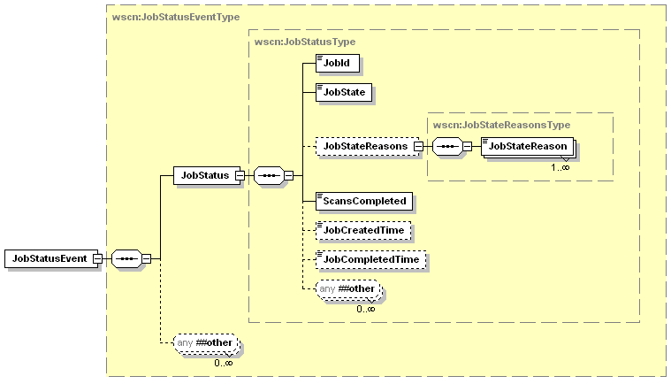
Figure 24 - JobStatus Event

JobStatus
This data element contains the current status of a Job. This data element is described in Section 4.5.1

Example JobStatusEvent
In this example the device is notifying the CP of the current state of Job 253.
<soap:Envelope
xmlns:soap="http://www.w3.org/2003/05/soap-envelope"
xmlns:wsa="http://schemas.xmlsoap.org/ws/2004/08/addressing"
xmlns:wse="http://schemas.xmlsoap.org/ws/2004/08/eventing"
xmlns:wscn="http://schemas.microsoft.com/windows/2006/01/wdp/scan”>
<soap:Header>
<wsa:To>AddressofEventSink</wsa:To>
<wsa:Action>
http://schemas.microsoft.com/windows/2006/08/wdp/scan/JobStatusEvent
</wsa:Action>
<wsa:MessageID>uuid:UniqueMsgId</wsa:MessageID>
</soap:Header>
<soap:Body>
<wscn:JobStatusEvent>
<wscn:JobStatus>
<wscn:JobId>253</wscn:JobId>
<wscn:JobState>Processing</wscn:JobState>
<wscn:JobStateReasons>
<wscn:JobStateReason>JobScanning</wscn:JobStateReason>
</wscn:JobStateReasons>
<wscn:ScansCompleted>4</wscn:ScansCompleted>
<wscn:JobCreatedTime>2006-01-24T11:34:35.8345Z</wscn:JobCreatedTime>
<wscn:JobStatus>
</wscn:JobStatusEvent>
</soap:Body
</soap:Envelope>

JobEndStateEvent
This event is defined to inform the CP that a Job has finished processing.
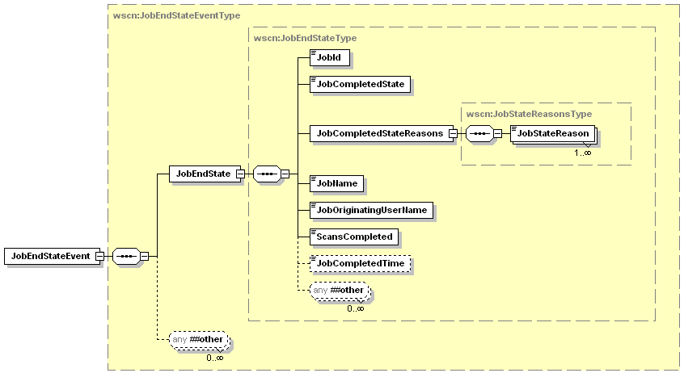
Figure 25 - JobEndState Event

JobEndState
This data element contains the final state of the Job status elements.

JobId
This data element is described in Section 4.5.1.1

JobCompletedState
This data element is the final JobState for the job and has the same semantics and values as the JobState element from JobStatus. The JobState element is described in Section 4.5.1.2

JobCompletedStateReasons
This element is a collection that describes all of the additional information about how/why the Job completed.

JobStateReason
This elements indicates additional information about how/why the Job completed and has the same semantics and values as the JobStateReason element from JobStatus. The JobStateReason element is described in Section 4.5.1.3.1

JobName
This data element is described in Section 4.5.2.1.1

JobOriginatingUser
This data element is described in Section 4.5.2.1.2

ScansCompleted
This data element is described in Section 4.5.1.6

JobCompletedTime
This data element is described in Section 4.5.1.5

Example JobEndStateEvent
In this example the device is notifying the CP of the final state/status of Job 253.
<soap:Envelope
xmlns:soap="http://www.w3.org/2003/05/soap-envelope"
xmlns:wsa="http://schemas.xmlsoap.org/ws/2004/08/addressing"
xmlns:wse="http://schemas.xmlsoap.org/ws/2004/08/eventing"
xmlns:wscn="http://schemas.microsoft.com/windows/2006/01/wdp/scan”>
<soap:Header>
<wsa:To>AddressofEventSink</wsa:To>
<wsa:Action>
http://schemas.microsoft.com/windows/2006/08/wdp/scan/JobEndStateEvent
</wsa:Action>
<wsa:MessageID>uuid:UniqueMsgId</wsa:MessageID>
</soap:Header>
<soap:Body>
<wscn:JobEndStateEvent>
<wscn:JobEndState>
<wscn:JobId>253</wscn:JobId>
<wscn:JobCompletedState>Completed</wscn:JobCompletedState>
<wscn:JobCompletedStateReasons>
<wscn:JobStateReason>JobCompletedWithWarnings</wscn:JobStateReason>
</wscn:JobCompletedStateReasons>
<wscn:JobName>Scan from Imaging App</wscn:JobName>
<wscn:JobOriginatingUserName>User</wscn:JobOriginatingUserName>
<wscn:ScansCompleted>7</wscn:ScansCompleted>
<wscn:JobCompletedTime>2006-01-24T11:37:05.673Z</</wscn:JobCompletedTime>
</wscn:JobEndState>
</wscn:JobEndStateEvent>
</soap:Body
</soap:Envelope>

Operations
Immediately following this table is detailed information about these operations, including short descriptions of the operations, the effects of the operations on state, and error codes defined by the operations.
Table 2 - Operations
Name | Req. or Opt. ¹
CreateScanJob | R
RetrieveImage | R
CancelJob | R
ValidateScanTicket | R
GetScannerElements | R
GetJobElements | R
GetActiveJobs | R
GetJobHistory | R
Non-standard operations implemented by a WSD vendor go here. | X
¹ R = REQUIRED, O = Optional, X = Non-standard.

Operation Error Reporting
Error codes are returned in the <soap:Fault> element. A vendor MAY subset or extend these error codes by supporting private error subcodes. All fault messages defined in this specification MUST be sent according to the rules described in [ADDRESS] section 4 and [DEVICE]. They are sent to the [fault endpoint], if present and valid. Otherwise they are sent to the [reply endpoint] if present. If neither is present faults may be sent to the [source endpoint].
Endpoints compliant with this specification MUST include required message information headers on all fault messages. Fault messages are correlated as replies using the [relationship] property as defined in WS-Addressing. The [action] property below designates fault messages:
http://schemas.xmlsoap.org/ws/2004/08/addressing/fault

The definitions of faults use the following properties:
[Code] | The fault code.
[Subcode] | The fault subcode.
[Reason] | The English language reason element.
[Detail] | The detail element. If absent, no detail element is defined for the fault.
The properties above bind to a SOAP 1.2 fault as follows:
<S:Envelope>
<S:Header>
<wsa:Action>http://schemas.xmlsoap.org/ws/2004/08/addressing/fault</wsa:Action>
<!-- Headers excluded for clarity -->
</S:Header>
<S:Body>
<S:Fault>
<S:Code>
<S:Value>[Code]</S:Value>
<S:Subcode>
<S:Value>[Subcode]</S:Value>
</S:Subcode>
</S:Code>
<S:Reason>
<S:Text xml:lang="en">[Reason]</S:Text>
</S:Reason>
<S:Detail> [Detail] </S:Detail>
</S:Fault>
</S:Body>
</S:Envelope>

Example SOAP Fault:
<soap:Envelope xmlns:soap="http://www.w3.org/2003/05/soapelope"
xmlns:xml=”http://www.w3.org/XML/1998/namespace”
xmlns:wsa="http://schemas.xmlsoap.org/ws/2004/08/addressing"
xmlns:wscn="http://schemas.microsoft.com/windows/2006/08/wdp/scan">
<soap:Header>
<wsa:Action>http://schemas.xmlsoap.org/ws/2004/08/addressing/fault</wsa:Action>
<!-- Headers excluded for brevity -->
</soap:Header>
<soap:Body>
<soap:Fault>
<soap:Code>
<soap:Value>soap:Receiver</soap:Value>
<soap:Subcode>
<soap:Value>wscn:OperationFailed</soap:Value>
</soap:Subcode>
</soap:Code>
<soap:Reason>
<soap:Text xml:lang="en">Service can not perform the requested Operation</soap:Text>
</soap:Reason>
</soap:Fault>
</soap:Body>
</soap:Envelope>

Common Operation Faults
The following table lists SOAP Faults common to all operations for this service type. If an operation results in multiple errors, the most specific fault SHOULD be returned.

wsa:ActionNotSupported
This fault is sent when a Client requests an operation that is not supported by the current service.
[Code] | soap:Sender
[Subcode] | wsa:ActionNotSupported
[Reason] | The [wsa:action] cannot be processed at the receiver
[Detail] | The invalid operation name

InvalidArgs
This fault is sent when a Client sends an invalid argument as part of an operation. The invalid argument could be any of the following: not enough in args, too many in args, no in arg by that name, one or more in args are of the wrong data type.
[Code] | soap:Sender
[Subcode] | wscn:InvalidArgs
[Reason] | At least one input argument is invalid
[Detail] | The invalid argument

OperationFailed
This fault may be returned if the current state of the service prevents invoking that action.
[Code] | soap:Receiver
[Subcode] | wscn:OperationFailed
[Reason] | Service can not perform the requested operation
[Detail] | None

ServerErrorTemporaryError
This fault is sent when the server experiences a temporary error that occurs while the Scanner processes the operation. The client MAY try the unmodified request again at some later point in time with an expectation that the temporary internal error condition MAY have been cleared. If there is a more specific error defined that applies to a temporary error, such as disk full, that code SHOULD be used.
[Code] | soap:Receiver
[Subcode] | wscn:ServerErrorTemporaryError
[Reason] | The service had an unexpected error
[Detail] | None

ServerErrorInternalError
This fault is sent when the Scanner encounters an unexpected condition that prevented it from fulfilling the request. This error differs from ServerErrorTemporaryError in that it implies a more permanent type of internal error and resending the operation will return the same fault.
[Code] | soap:Receiver
[Subcode] | wscn:ServerErrorInternalError
[Reason] | The service had an unexpected error
[Detail] | None

CreateScanJob
This operation is the main mechanism to prepare a scan device to scan the images available to it. This operation can be initiated in two different ways – either the User selects a destination and pushes the scan button at the device or the User starts an application on the client and acquires an image. Each method will send different arguments in the operation request.
If the scan is initiated from the device via a ScanAvailableEvent the operation contains the ScanIdentifier from the ScanAvailableEvent and also the DestinationToken returned during the Subscribe operation for the ScanAvailableEvent. The request also contains a scan ticket to control the processing of the scan. The values in the ScanTicket are the defaults set at the client before the User went to the device to initiate the scan.
If the scan is initiated from an application on the client the request contains a ScanTicket to control the processing of the scan. The ScanIdentifier and DestinationToken are omitted.
The allowed values returned in a GetScannerElements(ScannerConfiguration) (see section 4.3) indicate the values of the arguments that the Scan Service instance (scanner) supports (see section 4.9) for a Job creation operation. The scanner performs the following validation in the indicated order:
- If the Format is not supported, the Scanner MUST reject the request and return the ClientErrorDocumentFormatNotSupported error code.
- If the client (CP) supplies elements that are unsupported or their values are unsupported (except Format) the Scanner
  - MUST reject the Job if the MustHonor attribute with a value of 1 or true is in effect.
  - MUST ignore or substitute with supported values, respectively, if the MustHonor attribute with a value of 0 or false is in effect
  - The MustHonor attribute is in effect if the attribute is supplied at the element level. Note that if the MustHonor attribute is not explicitly specified in the element, the default is 0 or false.
- If a client (CP) supplies a conflicting combination of elements in the arguments (such as InputSource and Resolution), the Scanner MUST reject the Job if the MustHonor attribute with a value of 1 or true is in effect.
The scanner returns a unique JobId to identify the job for this service. The scanner generates the JobId in an implementation-defined manner. The scanner MUST return values in the range 1 to 2³¹⁻¹; 0 and negative values are invalid values to be returned as a result of a CreateScanJob operation. Furthermore, the scanner MUST NOT re-use values recently assigned, since CPs would confuse such jobs with older jobs. The scanner also returns a unique identifier to be used in subsequent RetrieveImage operations associated with this scan job. The device MUST respond to the CreateScanJob request as quickly as possible. The scan device should not wait for scanning to begin before sending the CreateScanJobResponse.
The client (CP) MUST retrieve the image data from the scan service using one or more RetrieveImage operations. Once the device has responded to the CreateScanJob request, the client has 60 seconds to send the RetrieveImage operation. If the device does not receive a RetrieveImage operation within this time, it should abort the job with a JobStateReason of JobTimedOut. If the job consists of multiple documents this timeout applies between each successive RetrieveImage operation also.

Request Elements
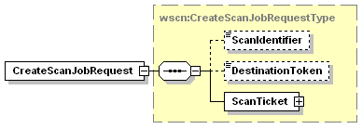
Figure 26 - CreateScanJobRequest Elements

ScanIdentifier
This optional element specifies a device specific string the scanner sent in the ScanAvailableEvent. This identifier will allow the scanner to make sure the correct client is requesting the scan after a user selected a destination. See section 5.2.5.2 for more details on this element.

DestinationToken
This optional element specifies a device specific string the scanner will assign to this client. This string was returned as a part of the SubscribeResponse element when the client subscribed to the ScanAvailableEvent for the current destination. See section 5.2.3.1 for more details on this element.

ScanTicket
This element contains all the settings the client wishes to affect the scan operation. The scan ticket may contain only the processing elements that the client wishes to override in the scanner, or it may contain every possible element supported in the scan service. See section 4.5.2 for more details on the definition of the ScanTicket.

Response Elements
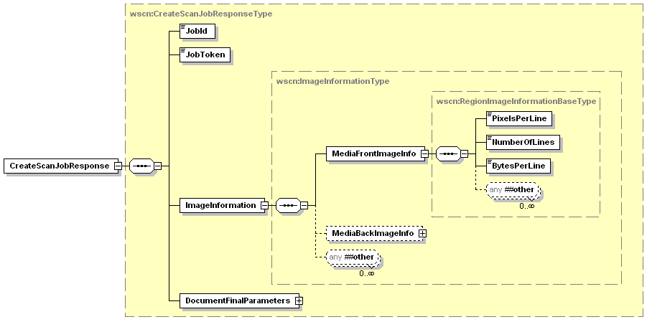
Figure 27 - CreateScanJobResponse Elements

JobId
This element is the device created identifier for the new scan job. This Id can be used in subsequent operations like CancelJob and GetJobElements to modify the job or retrieve job information. This data element is described in Section 4.5.1.1

JobToken
This element is the device created token for the new scan job. This element is paired with the JobId to uniquely represent the scan job. It will be passed to the device in the RetrieveImage command to allow the scan device to verify the requester actually created the scan job.

ImageInformation
This element contains information about the resulting image data from a scan made with the ScanTicket that is currently being validated. This data is valuable to scan applications for decoding the image within an image file.

MediaFrontImageInfo
This element contains the ImageInformation for a simplex scan, or the front side of an ADFDuplex scan.

PixelsPerLine
This element describes the exact width, in pixels, of the final image that would be scanned from this document side using the current ScanTicket settings that are being validated. This width should include rotation and any adjustment done by the scanner on the final images transferred to the client.
Values: 1 – 2147483647

NumberOfLines
This element describes the exact height, in pixels (or: number of lines) of the final output image that would be generated for the current ScanTicket, including rotation and any adjustment the scanner may perform on the scanned image before to transfer it to the client.
Values: 1 – 2147483647

BytesPerLine
This element indicates how many bytes each scan line will use in the resultant image file. This includes the data pixels and any padding the scanner will add to each scan line. This element is only valid if the requested Format is an uncompressed file format. If the file format indicates compression then this element should have a value of 0.
Values: 0 – 2147483647

MediaBackImageInfo
This element contains the ImageInformation for the back side of an ADFDuplex scan.

DocumentFinalParameters
This section of the schema contains the actual DocumentParameters which were used by the scan device for this scan job. This data element is described in Section 4.6.1.1

Example Request – Device Initiated
<?xml version="1.0" encoding="utf-8"?>
<soap:Envelope
xmlns:soap="http://www.w3.org/2003/05/soap-envelope"
xmlns:wsa="http://schemas.xmlsoap.org/ws/2004/08/addressing"
xmlns:wscn="http://schemas.microsoft.com/windows/2006/01/wdp/scan”>
<soap:Header>
<wsa:To>AddressofScannerService</wsa:To>
<wsa:Action>
http://schemas.microsoft.com/windows/2006/08/wdp/scan/CreateScanJob
</wsa:Action>
<wsa:MessageID>uuid:UniqueMsgId</wsa:MessageID>
</soap:Header>
<soap:Body>
<wscn:CreateScanJobRequest>
<wscn:ScanIdentifier>uuid:12e7a983-1034-5428-d298-0016f11097fa</wscn:ScanIdentifier>
<wscn:DestinationToken>Dest1234TokenString</wscn:DestinationToken>
<wscn:ScanTicket>
<wscn:JobDescription>
<wscn:JobName>Photo Scan</wscn:JobName>
<wscn:JobOriginatingUserName>RogerSmith</JobOriginatingUserName>
</wscn:JobDescription>
<wscn:DocumentParameters>
<wscn:Format>jfif</wscn:Format>
<wscn:CompressionQualityFactor>45</wscn:CompressionQualityFactor>
<wscn:InputSource>Platen</wscn:InputSource>
<wscn:ContentType>Auto</wscn:ContentType>
<wscn:InputSize>
<wscn:DocumentSizeAutoDetect>true</wscn:DocumentSizeAutoDetect>
</wscn:InputSize>
<wscn:Scaling wscn:MustHonor=”1”>
<wscn:ScalingWidth>125</wscn:ScalingWidth>
<wscn:ScalingHeight>125</wscn:ScalingHeight>
</wscn:Scaling>
<wscn:MediaSides>
<wscn:MediaFront>
<wscn:Resolution wscn:MustHonor=”1”>
<wscn:Width>300</wscn:Width>
<wscn:Height>300</wscn:Height>
</wscn:Resolution>
</wscn:MediaFront>
</wscn:MediaSides>
</wscn:DocumentParameters>
</wscn:ScanTicket>
</wscn:CreateScanJobRequest>
</soap:Body>
</soap:Envelope>

Example Response
<?xml version="1.0" encoding="utf-8"?>
<soap:Envelope
xmlns:soap="http://www.w3.org/2003/05/soap-envelope"
xmlns:wsa="http://schemas.xmlsoap.org/ws/2004/08/addressing"
xmlns:wscn="http://schemas.microsoft.com/windows/2006/01/wdp/scan”>
<soap:Header>
<wsa:To>http://schemas.xmlsoap.org/ws/2004/08/addressing/role/anonymous</wsa:To>
<wsa:Action>
http://schemas.microsoft.com/windows/2006/08/wdp/scan/CreateScanJobResponse
</wsa:Action>
<wsa:MessageID>uuid:UniqueMsgId</wsa:MessageID>
<wsa:RelatesTo>uuid:MsgIdOfTheCreateScanJobRequest</wsa:RelatesTo>
</soap:Header>
<soap:Body>
<wscn:CreateScanJobResponse>
<wscn:JobId>1</wscn:JobId>
<wscn:JobToken>Job9876TokenString</wscn:JobToken>
<wscn:ImageInformation>
<wscn:MediaFrontImageInfo>
<wscn:PixelsPerLine>900</wscn:PixelsPerLine>
<wscn:NumberOfLines>1500</wscn:NumberOfLines>
<wscn:BytesPerLine>113</wscn:BytesPerLine>
</wscn:MediaFrontImageInfo>
</wscn:ImageInformation>
<wscn:DocumentFinalParamters>
<wscn:Format>jfif</wscn:Format>
<wscn:CompressionQualityFactor>45</wscn:CompressionQualityFactor>
<wscn:ImagesToTransfer>0</wscn:ImagesToTransfer>
<wscn:InputSource>Platen</wscn:InputSource>
<wscn:ContentType>Auto</wscn:ContentType>
<wscn:InputSize>
<wscn:InputMediaSize>
<wscn:Width Override=”true”>8500</wscn:Width>
<wscn:Height Override=”true”>11000</wscn:Height>
</wscn:InputMediaSize>
</wscn:InputSize>
<wscn:Exposure>
<wscn:ExposureSettings>
<wscn:Contrast UsedDefault=”true”>0</wscn:Contrast>
<wscn:Brightness UsedDefault=”true”>0</wscn:Brightness>
<wscn:Sharpness UsedDefault=”true”>0</wscn:Sharpness>
</wscn:ExposureSettings>
</wscn:Exposure>
<wscn:Scaling>
<wscn:ScalingWidth>125</wscn:ScalingWidth>
<wscn:ScalingHeight>125</wscn:ScalingHeight>
</wscn:Scaling>
<wscn:Rotation UsedDefault=”true”>0</wscn:Rotation>
<wscn:MediaSides>
<wscn:MediaFront>
<wscn:ScanRegion>
<wscn:ScanRegionXOffset UsedDefault=”true”>0</wscn:ScanRegionXOffset>
<wscn:ScanRegionYOffset UsedDefault=”true”>0</wscn:ScanRegionYOffset>
<wscn:ScanRegionWidth UsedDefault=”true”>8500</wscn:ScanRegionWidth>
<wscn:ScanRegionHeight UsedDefault=”true”>11000</wscn:ScanRegionHeight>
</wscn:ScanRegion>
<wscn:ColorProcessing UsedDefault=”true”>RGB24</wscn:ColorProcessing>
<wscn:Resolution>
<wscn:Width>300</wscn:Width>
<wscn:Height>300</wscn:Height>
</wscn:Resolution>
</wscn:MediaFront>
</wscn:MediaSides>
</wscn:DocumentFinalParamters>
</wscn:CreateScanJobResponse>
</soap:Body>
</soap:Envelope>

Example Request – Client Initiated
<?xml version="1.0" encoding="utf-8"?>
<soap:Envelope
xmlns:soap="http://www.w3.org/2003/05/soap-envelope"
xmlns:wsa="http://schemas.xmlsoap.org/ws/2004/08/addressing"
xmlns:wscn="http://schemas.microsoft.com/windows/2006/01/wdp/scan”>
<soap:Header>
<wsa:To>AddressofScannerService</wsa:To>
<wsa:Action>
http://schemas.microsoft.com/windows/2006/08/wdp/scan/CreateScanJob
</wsa:Action>
<wsa:MessageID>uuid:UniqueMsgId</wsa:MessageID>
</soap:Header>
<soap:Body>
<wscn:CreateScanJobRequest>
<wscn:ScanTicket>
<wscn:JobDescription>
<wscn:JobName>Application Scan</wscn:JobName>
<wscn:JobOriginatingUserName>RogerSmith</JobOriginatingUserName>
</wscn:JobDescription>
<wscn:DocumentParameters>
<wscn:Format>xps</wscn:Format>
<wscn:ImagesToTransfer>0</wscn:ImagesToTransfer>
<wscn:InputSource>ADF</wscn:InputSource>
<wscn:ContentType>Auto</wscn:ContentType>
<wscn:InputSize>
<wscn:DocumentSizeAutoDetect>true</wscn:DocumentSizeAutoDetect>
</wscn:InputSize>
<wscn:MediaSides>
<wscn:MediaFront>
<wscn:ColorProcessing>RGB48</wscn:ColorProcessing>
<wscn:Resolution>
<wscn:Width>1200</wscn:Width>
</wscn:Resolution>
</wscn:MediaFront>
</wscn:MediaSides>
</wscn:DocumentParameters>
</wscn:ScanTicket>
</wscn:CreateScanJobRequest>
</soap:Body>
</soap:Envelope>

Errors
All the Codes described in section 6.1.1 - Common Operation Error Codes could be returned from this operation. The following errors could also be returned from this operation.

ServerErrorNotAcceptingJobs
This fault is sent when the server can’t accept a new scan job. This could occur because the scanner has been put into service mode, or there is a user intervention condition and all the memory buffers have been exhausted. The client MAY try the unmodified request again at some later point in time with an expectation that the server has become unblocked and the scanner is accepting jobs again.
[Code] | soap:Receiver
[Subcode] | wscn:ServerErrorNotAcceptingJobs
[Reason] | The service is temporarily blocked and can’t accept new job or document requests.
[Detail] | None

ClientErrorFormatNotSupported
This fault is sent when the supplied Format value is not supported by the Scanner object.
[Code] | soap:Sender
[Subcode] | wscn:ClientErrorFormatNotSupported
[Reason] | Format parameter value not supported
[Detail] | Optional: Return a list of supported formats.  The data in this element should be of type wscn:FormatSupportedType.

ClientErrorInvalidScanIdentifier
This fault is sent when the supplied ScanIdentifier value is not currently valid within the scan device.
[Code] | soap:Sender
[Subcode] | Wscn:ClientErrorInvalidScanIdentifier
[Reason] | ScanIdentifier parameter value not currently valid
[Detail] | None

ClientErrorInvalidDestinationToken
This fault is sent when the supplied DestinationToken value is not valid for this scan device.
[Code] | soap:Sender
[Subcode] | Wscn:ClientErrorInvalidDestinationToken
[Reason] | DestinationToken parameter value not currently valid
[Detail] | None

ClientErrorConflictingRequiredParameters
This fault is sent when the there is a conflict between 2 or more DocumentParameters elements which each have the MustHonor attribute set to true. Using all of the settings supplied with MustHonor attributes set to true will cause a conflict in the scanner mechanism. This conflict cannot be resolved so the ScanTicket is invalid.
[Code] | soap:Sender
[Subcode] | wscn: ClientErrorConflictingRequiredParameters
[Reason] | Multiple elements in the DocumentParameters element have MustHonor set to true but applying all settings causes a conflict in the scanner device.
[Detail] | None

RetrieveImage
This operation is used to actually retrieve the scan data from the device after a scan job has been created.
The scan data is returned as a binary attachment along with the RetrieveImageResponse packet. The response will be packaged as a MIME Multipart/Related content type and make use of the new SOAP Message Transmission Optimization Mechanism [MTOM] to efficiently send the binary image data. The example below indicates how to create a valid response.
The number of images returned in the resultant file depends on the combination of the ImagesToTransfer element of the ScanTicket and the image file Format element. If the file Format is a single image format then the returned file will always contain a single image, if the file Format is a multi-page format then the resultant file will contain as many images as the input source can scan up to the value of ImagesToTransfer. In the case of a single image file Format and an ImagesToTransfer value of 0 or >1, the client will send repeated RetrieveImage commands until either the devices replies with a ClientErrorNoImagesAvailable fault to one of the operations, or the ImagesToTransfer value is met.
The scan device sends the headers and XML part of the RetrieveImageResponse as soon as it can. This should be before the timeout of 60 seconds occurs and can be well before the scanner starts writing the binary ScanData as the data becomes available, without an imposed timeout restriction. This is the benefit of using Multipart/Related in the MTOM processing. The first part containing the XML for the RetrieveImageResponse, including the reference to the 2nd part (binary data block), can be sent back immediately and the http connection will remain open without timing out waiting for the completion of the data transfer. When the complete file is scanned and all ScanData for this file is written the current RetrieveImage operation ends.
If there is a communication failure during the transfer of the image data the device will abort the job with a JobStateReason of ImageTransferError.

Request Elements
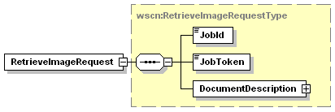
Figure 28 - RetrieveImageRequest Elements

JobId
This data element contains the JobId with which the current document is associated. This data element is described in Section 4.5.1.1

JobToken
This element is the device created token for the scan job. This data element is described in Section 6.2.2.2.

DocumentDescription
This data element contains the description attributes that pertain to the basic creation information of the currently identified Document. This data element is described in Section 4.6.1

Response Elements
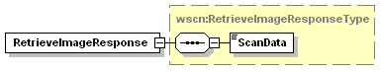
Figure 29 - RetrieveImageResponse Elements

ScanData
The data element is the binary data that represents the scanned image is part of the response as a binary attachment to the SOAP Envelope/Body.

Example Request
<?xml version="1.0" encoding="utf-8"?>
<soap:Envelope
xmlns:soap="http://www.w3.org/2003/05/soap-envelope"
xmlns:wsa="http://schemas.xmlsoap.org/ws/2004/08/addressing"
xmlns:wscn="http://schemas.microsoft.com/windows/2006/01/wdp/scan”>
<soap:Header>
<wsa:To>AddressofScannerService</wsa:To>
<wsa:Action>
http://schemas.microsoft.com/windows/2006/08/wdp/scan/RetrieveImage
</wsa:Action>
<wsa:MessageID>uuid:UniqueMsgId</wsa:MessageID>
</soap:Header>
<soap:Body>
<wscn:RetrieveImageRequest>
<wscn:JobId>1</wscn:JobId>
<wscn:JobToken>Job9876TokenString</wscn:JobToken>
<wscn:DocumentDescription>
<wscn:DocumentName>Scan001.jpg</DocumentName>
</wscn:DocumentDescription>
</wscn:RetrieveImageRequest>
</soap:Body>
</soap:Envelope>

Example Response
mime-version: 1.0
Content-Type: Multipart/Related;
boundary=4aa7d814-adc1-47a2-8e1c-07585b9892a4;
type=application/xop+xml;
start=”<14629f74-2047-436c-8046-5cac76d280fc@uuid>”;
startinfo=”application/soap+xml”

--4aa7d814-adc1-47a2-8e1c-07585b9892a4
Content-Type: application/xop+xml; type="application/soap+xml"
charset=UTF-8
Content-Transfer-Encoding: binary
Content-ID: <14629f74-2047-436c-8046-5cac76d280fc@uuid>

<?xml version="1.0" encoding="utf-8"?>
<soap:Envelope
xmlns:soap="http://www.w3.org/2003/05/soap-envelope"
xmlns:wsa="http://schemas.xmlsoap.org/ws/2004/08/addressing"
xmlns:xop="http://www.w3.org/2003/12/xop/include"
xmlns:wscn="http://schemas.microsoft.com/windows/2006/01/wdp/scan”>
<soap:Header>
<wsa:To>http://schemas.xmlsoap.org/ws/2004/08/addressing/role/anonymous</wsa:To>
<wsa:Action>
http://schemas.microsoft.com/windows/2006/08/wdp/scan/RetrieveImageResponse
</wsa:Action>
<wsa:MessageID>uuid:UniqueMsgId</wsa:MessageID>
<wsa:RelatesTo>uuid:MsgIdOfTheRetrieveImageRequest</wsa:RelatesTo>
</soap:Header>
<soap:Body>
<wscn:RetrieveImageResponse>
<wscn:ScanData>
<xop:Include href=”cid:1c696bd7-005a-48d9-9ee9-9adca11f8892@uuid” />
</wscn:ScanData>
</wscn:RetrieveImageResponse>
</soap:Body>
</soap:Envelope>

--4aa7d814-adc1-47a2-8e1c-07585b9892a4
Content-Type: image/jpeg;
Content-Transfer-Encoding: binary
Content-ID: <1c696bd7-005a-48d9-9ee9-9adca11f8892@uuid>

Binary Scan Data
--4aa7d814-adc1-47a2-8e1c-07585b9892a4--

Errors
All the Codes described in section 6.1.1 - Common Operation Error Codes could be returned from this operation. The following errors could also be returned from this operation.

ClientErrorJobIdNotFound
This fault is sent when the scanner can not find a job matching the JobId argument (including when the argument is not in the range: 1 to 2^³¹-1).
[Code] | soap:Sender
[Subcode] | wprt:ClientErrorJobIdNotFound
[Reason] | Specified JobId not found
[Detail] | Jobid:Incorrect JobId

ClientErrorNoImagesAvailable
This fault is sent when the scanner does not have any more images available for the client to retrieve.
[Code] | soap:Sender
[Subcode] | Wscn:ClientErrorNoImagesAvailable
[Reason] | The server has no images available to acquire.
[Detail] | None

ClientErrorInvalidJobToken
This fault is sent when the supplied JobToken value is not valid for this scan JobId.
[Code] | soap:Sender
[Subcode] | Wscn:ClientErrorInvalidJobToken
[Reason] | JobToken parameter value not valid with JobId parameter
[Detail] | None

ClientErrorJobCancelled
This fault is sent when the current scan job has been cancelled.
[Code] | soap:Sender
[Subcode] | wscn:ClientErrorJobCancelled
[Reason] | The current Scan job has been cancelled.
[Detail] | None

CancelJob
This operation allows a client to cancel a Scan job from the time the job is created up to the time it is completed, canceled or aborted.

Request Elements
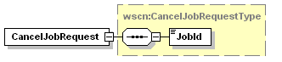

JobId
This data element contains the JobId which the client is trying to cancel. This data element is described in Section 4.5.1

Request
<?xml version="1.0" encoding="utf-8"?>
<soap:Envelope
xmlns:soap="http://www.w3.org/2003/05/soap-envelope"
xmlns:wsa="http://schemas.xmlsoap.org/ws/2004/08/addressing"
xmlns:wscn="http://schemas.microsoft.com/windows/2006/01/wdp/scan”>
<soap:Header>
<wsa:To>AddressofScannerService</wsa:To>
<wsa:Action>
http://schemas.microsoft.com/windows/2006/08/wdp/scan/CancelJob
</wsa:Action>
<wsa:MessageID>uuid:UniqueMsgId</wsa:MessageID>
</soap:Header>
<soap:Body>
<wscn:CancelJobRequest>
<wscn:JobId>1</ wscn::JobId>
</wscn:CancelJobRequest>
</soap:Body>
</soap:Envelope>

Response
<?xml version="1.0" encoding="utf-8"?>
<soap:Envelope
xmlns:soap="http://www.w3.org/2003/05/soap-envelope"
xmlns:wsa="http://schemas.xmlsoap.org/ws/2004/08/addressing"
xmlns:wscn="http://schemas.microsoft.com/windows/2006/01/wdp/scan”>
<soap:Header>
<wsa:To>http://schemas.xmlsoap.org/ws/2004/08/addressing/role/anonymous</wsa:To>
<wsa:Action>
http://schemas.microsoft.com/windows/2006/08/wdp/scan/CancelJobResponse
</wsa:Action>
<wsa:MessageID>uuid:UniqueMsgId</wsa:MessageID>
<wsa:RelatesTo>uuid:MsgIdOfTheCancelJobRequest</wsa:RelatesTo>
</soap:Header>
<soap:Body>
<wscn:CancelJobResponse/>
</soap:Body>
</soap:Envelope>

Errors
All the Codes described in section 6.1.1 - Common Operation Error Codes could be returned from this operation. The following error could also be returned from this operation.

ClientErrorJobIdNotFound
This fault is sent when the scanner can not find a job matching the JobId argument (including when the argument is not in the range: 1 to 2^³¹-1).
[Code] | soap:Sender
[Subcode] | wscn:ClientErrorJobIdNotFound
[Reason] | Specified JobId not found
[Detail] | Jobid:Incorrect JobId

Effect on State
The specified job moves to the Canceled state if the Job was Pending or Processing. It is an error to attempt to cancel a completed or canceled job or to try and cancel any Job the CP does not have rights to.

ValidateScanTicket
This operation will allow a client to ask the scan device if the settings for a future scan operation are valid. This can be used to validate changes/combinations of settings.

Request Elements
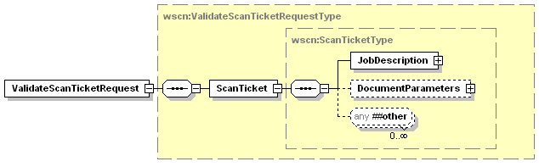
Figure 30 - ValidateScanTicketRequest Elements

ScanTicket
This element contains all the settings the client wishes to submit in a future scan operation. The scan ticket may contain only the processing elements that the client wishes to override in the scanner, or it may contain every possible element supported in the scan service. See section 4.8 for more details on the definition of the ScanTicket.

Response Elements
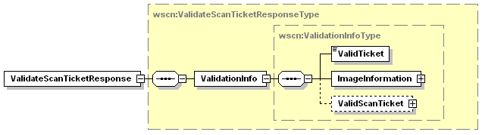
Figure 31 - ValidationInfo elements

ValidationInfo
This element defines whether the ScanTicket was valid and if not what data was changed to make the ticket valid.

ValidTicket
This element indicates whether the ScanTicket the device received contains all valid settings.
Values: 0, 1, true, false

ImageInformation
This element contains information about the resulting image data from a scan made with the ScanTicket that is currently being validated. This data is valuable to scan applications for decoding the image within an image file. This data element is described in Section 6.2.2.3.

ValidScanTicket
If the initial ScanTicket had some invalid settings and the scan device could fix the problems; this element will contain a new ScanTicket with any invalid options changed to valid data. See section 4.8 for more details on the definition of the ScanTicket.

Example Request – Valid Ticket
<?xml version="1.0" encoding="utf-8"?>
<soap:Envelope
xmlns:soap="http://www.w3.org/2003/05/soap-envelope"
xmlns:wsa="http://schemas.xmlsoap.org/ws/2004/08/addressing"
xmlns:wscn="http://schemas.microsoft.com/windows/2006/01/wdp/scan”>
<soap:Header>
<wsa:To>AddressofScannerService</wsa:To>
<wsa:Action>
http://schemas.microsoft.com/windows/2006/08/wdp/scan/ValidateScanTicket
</wsa:Action>
<wsa:MessageID>uuid:UniqueMsgId</wsa:MessageID>
</soap:Header>
<soap:Body>
<wscn:ValidateScanTicketRequest>
<wscn:ScanTicket>
<wscn:JobDescription>
<wscn:JobName>Photo Scan</wscn:JobName>
<wscn:JobOriginatingUserName>RogerSmith</JobOriginatingUserName>
</wscn:JobDescription>
<wscn:DocumentParameters>
<wscn:Format>dib</wscn:Format>
<wscn:InputSource>Platen</wscn:InputSource>
<wscn:ContentType>Auto</wscn:ContentType>
<wscn:InputSize>
<wscn:InputMediaSize>
<wscn:Width>3000</wscn:Width>
<wscn:Height>5000</wscn:Height>
</wscn:InputMediaSize>
</wscn:InputSize>
<wscn:Scaling>
<wscn:ScalingWidth>125</wscn:ScalingWidth>
<wscn:ScalingHeight>125</wscn:ScalingHeight>
</wscn:Scaling>
<wscn:MediaSides>
<wscn:MediaFront>
<wscn:ColorProcessing>GrayScale4</wscn:ColorProcessing>
<wscn:Resolution>
<wscn:Width>300</wscn:Width>
<wscn:Height>300</wscn:Height>
</wscn:Resolution>
<wscn:MediaFront>
<wscn:MediaSides>
</wscn:DocumentParameters>
</wscn:ScanTicket>
</wscn:ValidateScanTicketRequest>
</soap:Body>
</soap:Envelope>

Example Response – Valid Ticket
<?xml version="1.0" encoding="utf-8"?>
<soap:Envelope
xmlns:soap="http://www.w3.org/2003/05/soap-envelope"
xmlns:wsa="http://schemas.xmlsoap.org/ws/2004/08/addressing"
xmlns:wscn="http://schemas.microsoft.com/windows/2006/01/wdp/scan” >
<soap:Header>
<wsa:To>
http://schemas.xmlsoap.org/ws/2004/08/addressing/role/anonymous
</wsa:To>
<wsa:Action>
http://schemas.microsoft.com/windows/2006/08/wdp/scan/ValidateScanTicketResponse
</wsa:Action>
<wsa:MessageID>uuid:UniqueMsgId</wsa:MessageID>
<wsa:RelatesTo>uuid:MsgIdOfTheValidateScanTicketRequest</wsa:RelatesTo>
</soap:Header>
<soap:Body>
<wscn:ValidateScanTicketResponse>
<wscn:ValidationInfo>
<wscn:ValidTicket>true</wscn:ScanIdentifier>
<wscn:ImageInformation>
<wscn:MediaFrontImageInfo>
<wscn:PixelsPerLine>900</wscn:PixelsPerLine>
<wscn:NumberOfLines>1500</wscn:NumberOfLines>
<wscn:BytesPerLine>113</wscn:BytesPerLine>
</wscn:MediaFrontImageInfo>
</wscn:ImageInformation>
</wscn:ValidationInfo>
</wscn:ValidateScanTicketResponse>
</soap:Body>
</soap:Envelope>

Example Request – Invalid Ticket
<?xml version="1.0" encoding="utf-8"?>
<soap:Envelope
xmlns:soap="http://www.w3.org/2003/05/soap-envelope"
xmlns:wsa="http://schemas.xmlsoap.org/ws/2004/08/addressing"
xmlns:wscn="http://schemas.microsoft.com/windows/2006/01/wdp/scan”>
<soap:Header>
<wsa:To>AddressofScannerService</wsa:To>
<wsa:Action>
http://schemas.microsoft.com/windows/2006/08/wdp/scan/ValidateScanTicket
</wsa:Action>
<wsa:MessageID>uuid:UniqueMsgId</wsa:MessageID>
</soap:Header>
<soap:Body>
<wscn:ValidateScanTicketRequest>
<wscn:ScanTicket>
<wscn:JobDescription>
<wscn:JobName>Photo Scan</wscn:JobName>
<wscn:JobOriginatingUserName>RogerSmith</JobOriginatingUserName>
</wscn:JobDescription>
<wscn:DocumentParameters>
<wscn:Format>jfif</wscn:Format>
<wscn:InputSource>Platen</wscn:InputSource>
<wscn:ContentType>Auto</wscn:ContentType>
<wscn:InputSize>
<wscn:DocumentSizeAutoDetect>true</wscn:DocumentSizeAutoDetect>
</wscn:InputSize>
<wscn:Scaling>
<wscn:ScalingWidth>1250</wscn:ScalingWidth>
<wscn:ScalingHeight>1250</wscn:ScalingHeight>
</wscn:Scaling>
<wscn:MediaSides>
<wscn:MediaFront>
<wscn:Resolution>
<wscn:Width>350</wscn:Width>
<wscn:Height>350</wscn:Height>
</wscn:Resolution>
<wscn:MediaFront>
<wscn:MediaSides>
</wscn:DocumentParameters>
</wscn:ScanTicket>
</wscn:ValidateScanTicketRequest>
</soap:Body>
</soap:Envelope>

Example Response – Invalid Ticket
<?xml version="1.0" encoding="utf-8"?>
<soap:Envelope
xmlns:soap="http://www.w3.org/2003/05/soap-envelope"
xmlns:wsa="http://schemas.xmlsoap.org/ws/2004/08/addressing"
xmlns:wscn="http://schemas.microsoft.com/windows/2006/01/wdp/scan”>
<soap:Header>
<wsa:To>
http://schemas.xmlsoap.org/ws/2004/08/addressing/role/anonymous
</wsa:To>
<wsa:Action>
http://schemas.microsoft.com/windows/2006/08/wdp/scan/ValidateScanTicketResponse
</wsa:Action>
<wsa:MessageID>uuid:UniqueMsgId</wsa:MessageID>
<wsa:RelatesTo>uuid:MsgIdOfTheValidateScanTicketRequest</wsa:RelatesTo>
</soap:Header>
<soap:Body>
<wscn:ValidateScanTicketResponse>
<wscn:ValidationInfo>
<wscn:ValidTicket>false</wscn:ValidTicket>
<wscn:ImageInformation>
<wscn:MediaFrontImageInfo>
<wscn:PixelsPerLine>0</wscn:PixelsPerLine>
<wscn:NumberOfLines>0</wscn:NumberOfLines>
<wscn:BytesPerLine>0</wscn:BytesPerLine>
</wscn:MediaFrontImageInfo>
</wscn:ImageInformation>
<wscn:ValidScanTicket>
<wscn:JobDescription>
<wscn:JobName>Photo Scan</wscn:JobName>
<wscn:JobOriginatingUserName>RogerSmith</JobOriginatingUserName>
</wscn:JobDescription>
<wscn:DocumentParameters>
<wscn:Format>jfif</wscn:Format>
<wscn:InputSource>Platen</wscn:InputSource>
<wscn:ContentType>Auto</wscn:ContentType>
<wscn:InputSize>
<wscn:DocumentSizeAutoDetect>true</wscn:DocumentSizeAutoDetect>
</wscn:InputSize>
<wscn:Scaling>
<wscn:ScalingWidth>1000</wscn:ScalingWidth>
<wscn:ScalingHeight>1000</wscn:ScalingHeight>
</wscn:Scaling>
<wscn:MediaSides>
<wscn:MediaFront>
<wscn:Resolution>
<wscn:Width>300</wscn:Width>
<wscn:Height>300</wscn:Height>
</wscn:Resolution>
<wscn:MediaFront>
<wscn:MediaSides>
</wscn:DocumentParameters>
</wscn:ValidScanTicket>
</wscn:ValidationInfo>
</wscn:ValidateScanTicketResponse>
</soap:Body>
</soap:Envelope>

Errors
All the Codes described in section 6.1.1 - Common Operation Error Codes could be returned from this operation. The following error could also be returned from this operation.

ClientErrorConflictingRequiredParameters
This fault is sent when the there is a conflict between 2 or more DocumentParameters elements which each have the MustHonor attribute set to true and using all of the settings supplied with MustHonor attributes set to true will cause a conflict in the scanner mechanism. This conflict cannot be resolved so the ScanTicket is invalid.
[Code] | soap:Sender
[Subcode] | wscn: ClientErrorConflictingRequiredParameters
[Reason] | Multiple elements in the DocumentParameters element have MustHonor set to true but applying all settings causes a conflict in the scanner device.
[Detail] | None

GetScannerElements
The GetScannerElements operation allows a client (CP) to request information about the scanner. This info includes any part of scanner data accessible at the device root level. Examples of this are the configuration, status, default ScanTicket, or IHV extensions to the Scanner schema.
The GetScannerElements operation allows a client to discover standard and vendor extended elements.

Request Elements
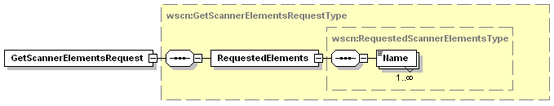
Figure 32 - GetScannerElementsRequest Elements

RequestedElements
This data element is a collection of elements that describes the data in which the CP is interested.

Name
This data element is a QName that represents a location within the Scanner schema. The keyword represents a top level section of the scanner schema such as the ScannerConfiguration or DefaultScanTicket.

Allowed Values:
wscn:ScannerDescription– Get all the descriptive information for the scan device.
wscn:ScannerConfiguration– Get all the configuration information for the scan device.
wscn:ScannerStatus – Entire status section including all ActiveConditons and the ConditionHistory
wscn:DefaultScanTicket – The current default values for Job creation and processing
xmlns:VendorSection– A Vendor defined extension to the Scanner Schema

Response Elements
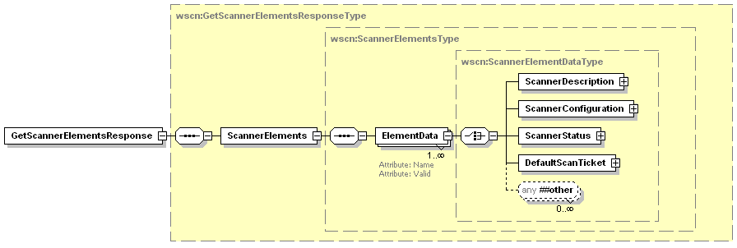
Figure 33 - GetScannerElementsResponse Elements

ScannerElements
This data element is a collection of all the responses generated by the scan device for the schema queries in the GetScannerElements request.

ElementData
This data element contains the data returned for one of the schema requests. There will be the same number of ElementData elements in the response as there were Name elements in the request.

Name
This attribute contains the schema QName used to create the data that is returned in the element.

REQUIRED Attribute

Valid
This attribute indicates whether the schema query value was for a valid or invalid schema keyword within the device schema. This attribute will be false if the requested schema keyword does not map to a valid schema section in the Scanner schema supported by the device.
REQUIRED Attribute

Request - ScannerDescription
<?xml version="1.0" encoding="utf-8"?>
<soap:Envelope
xmlns:soap="http://www.w3.org/2003/05/soap-envelope"
xmlns:wsa="http://schemas.xmlsoap.org/ws/2004/08/addressing"
xmlns:wscn="http://schemas.microsoft.com/windows/2006/01/wdp/scan”>
<soap:Header>
<wsa:To>AddressofScannerService</wsa:To>
<wsa:Action>
http://schemas.microsoft.com/windows/2006/08/wdp/scan/GetScannerElements
</wsa:Action>
<wsa:MessageID>uuid:UniqueMsgId</wsa:MessageID>
</soap:Header>
<soap:Body>
<wscn:GetScannerElementsRequest>
<wscn:RequestedElements>
<wscn:Name>wscn:ScannerDescription</wscn:Name>
</wscn:RequestedElements>
</wscn:GetScannerElementsRequest>
</soap:Body>
</soap:Envelope>

Response – ScannerDescription
<?xml version="1.0" encoding="utf-8"?>
<soap:Envelope
xmlns:soap="http://www.w3.org/2003/05/soap-envelope"
xmlns:wsa="http://schemas.xmlsoap.org/ws/2004/08/addressing"
xmlns:wscn="http://schemas.microsoft.com/windows/2006/01/wdp/scan”>
<soap:Header>
<wsa:To>http://schemas.xmlsoap.org/ws/2004/08/addressing/role/anonymous</wsa:To>
<wsa:Action>
http://schemas.microsoft.com/windows/2006/08/wdp/scan/GetScannerElementsResponse
</wsa:Action>
<wsa:MessageID>uuid:UniqueMsgId</wsa:MessageID>
<wsa:RelatesTo>uuid:MsgIdOfTheGetScannerElementsRequest</wsa:RelatesTo>
</soap:Header>
<soap:Body>
<wscn:GetScannerElementsResponse>
<wscn:ScannerElements>
<wscn:ElementData Name=”wscn:ScannerDescription” Valid=”true”>
<wscn:ScannerDescription>
<wscn:ScannerName xml:lang="en-AU, en-CA, en-GB, en-US">
Accounting Scanner in Copy Room 2
</wscn:ScannerName>
<wscn:ScannerInfo xml:lang="en-AU, en-CA, en-GB, en-US">
Scanner for use of Accounting only
</wscn:ScannerInfo>
<wscn:ScannerLocation xml:lang="en-AU, en-CA, en-GB, en-US">
LA Campus – Building 3
</wscn:ScannerLocation>
</wscn:ScannerDescription>
</wscn:ElementData>
</wscn:ScannerElements>
</wscn:GetScannerElementsResponse>
</soap:Body>
</soap:Envelope>

Request - ScannerStatus
<?xml version="1.0" encoding="utf-8"?>
<soap:Envelope
xmlns:soap="http://www.w3.org/2003/05/soap-envelope"
xmlns:wsa="http://schemas.xmlsoap.org/ws/2004/08/addressing"
xmlns:wscn="http://schemas.microsoft.com/windows/2006/01/wdp/scan”
soap:encodingStyle='http://www.w3.org/2002/12/soap-encoding'>
<soap:Header>
<wsa:To>AddressofScannerService</wsa:To>
<wsa:Action>
http://schemas.microsoft.com/windows/2006/08/wdp/scan/GetScannerElements </wsa:Action>
<wsa:MessageID>uuid:UniqueMsgId</wsa:MessageID>
</soap:Header>
<soap:Body>
<wscn:GetScannerElementsRequest>
<wscn:RequestedElements>
<wscn:Name>wscn:ScannerStatus</wscn:Name>
</wscn:RequestedElements>
</wscn:GetScannerElementsRequest>
</soap:Body>
</soap:Envelope>

Response – ScannerStatus
<?xml version="1.0" encoding="utf-8"?>
<soap:Envelope
xmlns:soap="http://www.w3.org/2003/05/soap-envelope"
xmlns:wsa="http://schemas.xmlsoap.org/ws/2004/08/addressing"
xmlns:wscn="http://schemas.microsoft.com/windows/2006/01/wdp/scan”>
<soap:Header>
<wsa:To>http://schemas.xmlsoap.org/ws/2004/08/addressing/role/anonymous</wsa:To>
<wsa:Action>
http://schemas.microsoft.com/windows/2006/08/wdp/scan/GetScannerElementsResponse
</wsa:Action>
<wsa:MessageID>uuid:UniqueMsgId</wsa:MessageID>
<wsa:RelatesTo>uuid:MsgIdOfTheGetScannerElementsRequest</wsa:RelatesTo>
</soap:Header>
<soap:Body>
<wscn:GetScannerElementsResponse>
<wscn:ScannerElements>
<wscn:ElementData Name=”wscn:ScannerStatus” Valid=”true”>
<wscn:ScannerStatus>
<wscn:ScannerCurrentTime>2006-01-26T11:17:00Z</wscn:ScannerCurrentTime>
<wscn:ScannerState>Stopped</wscn:ScannerState>
<wscn:ScannerStateReasons>
<wscn:ScannerStateReason>MediaJam</wscn:ScannerStateReason>
<wscn:ScannerStateReason>LampError</wscn:ScannerStateReason>
</wscn:ScannerStateReasons>
<wscn:ActiveConditions>
<wscn:DeviceCondition Id="1384">
<wscn:Time>2005-01-26T11:07:00Z</wscn:Time>
<wscn:Name>MediaJam</wscn:Name>
<wscn:Component>MediaPath</wscn:Component>
<wscn:Severity>Critical</wscn:Severity>
</wscn:DeviceCondition>
<wscn:DeviceCondition Id="534">
<wscn:Time>2005-01-26T11:09:12Z</wscn:Time>
<wscn:Name>LampError</wscn:Name>
<wscn:Component>Platen</wscn:Component>
<wscn:Severity>Warning</wscn:Severity>
</wscn:DeviceCondition>
</wscn:ActiveConditions>
</wscn:ScannerStatus>
</wscn:ElementData>
</wscn:ScannerElements>
</wscn:GetScannerElementsResponse>
</soap:Body>
</soap:Envelope>

Request – ScannerConfiguration and Invalid entry
<?xml version="1.0" encoding="utf-8"?>
<soap:Envelope
xmlns:soap="http://www.w3.org/2003/05/soap-envelope"
xmlns:wsa="http://schemas.xmlsoap.org/ws/2004/08/addressing"
xmlns:wscn="http://schemas.microsoft.com/windows/2006/08/wdp/scan"
xmlns:ihv=”http://www.example.com/extention”>
<soap:Header>
<wsa:To>AddressofScannerService</wsa:To>
<wsa:Action>
http://schemas.microsoft.com/windows/2006/08/wdp/scan/GetScannerElements
</wsa:Action>
<wsa:MessageID>uuid:UniqueMsgId</wsa:MessageID>
</soap:Header>
<soap:Body>
<wscn:GetScannerElementsRequest>
<wscn:RequestedElements>
<wscn:Name>wscn:ScannerConfiguration</wscn:Name>
<wscn:Name>ihv:InvalidRequestEntry</wscn:Name>
</wscn:RequestedElements>
</wscn:GetScannerElementsRequest>
</soap:Body>
</soap:Envelope>

Response – ScannerConfiguration and Invalid entry
<?xml version="1.0" encoding="utf-8"?>
<soap:Envelope
xmlns:soap="http://www.w3.org/2003/05/soap-envelope"
xmlns:wsa="http://schemas.xmlsoap.org/ws/2004/08/addressing"
xmlns:wscn="http://schemas.microsoft.com/windows/2006/08/wdp/scan"
xmlns:ihv=”http://www.example.com/extention”>
<soap:Header>
<wsa:To>http://schemas.xmlsoap.org/ws/2004/08/addressing/role/anonymous</wsa:To>
<wsa:Action>
http://schemas.microsoft.com/windows/2006/08/wdp/scan/GetScannerElementsResponse
</wsa:Action>
<wsa:MessageID>uuid:UniqueMsgId</wsa:MessageID>
<wsa:RelatesTo>uuid:MsgIdOfTheGetScannerElementsRequest</wsa:RelatesTo>
</soap:Header>
<soap:Body>
<wscn:GetScannerElementsResponse>
<wscn:ScannerElements>
<wscn:ElementData Name=”wscn:ScannerConfiguration” Valid=”true”>
<wscn:ScannerConfiguration>
<wscn:DeviceSettings>
<wscn:FormatsSupported>
<wscn:FormatValue>dib</wscn:FormatValue>
<wscn:FormatValue>exif</wscn:FormatValue>
<wscn:FormatValue>jpeg2k</wscn:FormatValue>
<wscn:FormatValue>pdf-a</wscn:FormatValue>
<wscn:FormatValue>png</wscn:FormatValue>
<wscn:FormatValue>tiff-single-uncompressed</wscn:FormatValue>
<wscn:FormatValue>tiff-single-g4</wscn:FormatValue>
<wscn:FormatValue>tiff-multi-uncompressed</wscn:FormatValue>
<wscn:FormatValue>tiff-multi-g4</wscn:FormatValue>
<wscn:FormatValue>xps</wscn:FormatValue>
</wscn:FormatsSupported>
<wscn:CompressionQualityFactorSupported>
<wscn:MinValue>15</wscn:MinValue>
<wscn:MaxValue>100</wscn:MaxValue>
</wscn:CompressionQualityFactorSupported>
<wscn:ContentTypesSupported>
<wscn:ContentTypeValue>Auto</wscn:ContentTypeValue>
<wscn:ContentTypeValue>Text</wscn:ContentTypeValue>
<wscn:ContentTypeValue>Photo</wscn:ContentTypeValue>
<wscn:ContentTypeValue>Halftone </wscn:ContentTypeValue>
<wscn:ContentTypeValue>Mixed</wscn:ContentTypeValue>
</wscn:ContentTypesSupported>
<wscn:DocumentSizeAutoDetectSupported>
true
</wscn:DocumentSizeAutoDetectSupported>
<wscn:AutoExposureSupported>true</wscn:AutoExposureSupported>
<wscn:BrightnessSupported>true</wscn:BrightnessSupported>
<wscn:ContrastSupported>true</wscn:ContrastSupported>
<wscn:ScalingRangeSupported>
<wscn:ScalingWidth>
<wscn:MinValue>50</wscn:MinValue>
<wscn:MaxValue>500</wscn:MaxValue>
</wscn:ScalingWidth>
<wscn:ScalingHeight>
<wscn:MinValue>50</wscn:MinValue>
<wscn:MaxValue>500</wscn:MaxValue>
</wscn:ScalingHeight>
</wscn:ScalingRangeSupported>
<wscn:RotationsSupported>
<wscn:RotationValue>0</wscn:RotationValue>
<wscn:RotationValue>90</wscn:RotationValue>
<wscn:RotationValue>180</wscn:RotationValue>
<wscn:RotationValue>270</wscn:RotationValue>
</wscn:RotationsSupported>
</wscn:DeviceSettings>
<wscn:Platen>
<wscn:PlatenOpticalResolution>
<wscn:Width>1200</wscn:Width>
<wscn:Height>1200</wscn:Height>
</wscn:PlatenOpticalResolution>
<wscn:PlatenResolutions>
<wscn:Widths>
<wscn:Width>150</wscn:Width>
<wscn:Width>204</wscn:Width>
<wscn:Width>300</wscn:Width>
<wscn:Width>600</wscn:Width>
<wscn:Width>1200</wscn:Width>
</wscn:Widths>
<wscn:Heights>
<wscn:Height>96</wscn:Height>
<wscn:Height>150</wscn:Height>
<wscn:Height>204</wscn:Height>
<wscn:Height>300</wscn:Height>
<wscn:Height>600</wscn:Height>
<wscn:Height>900</wscn:Height>
<wscn:Height>1200</wscn:Height>
</wscn:Heights>
</wscn:PlatenResolutions>
<wscn:PlatenColor>
<wscn:ColorEntry>BlackAndWhite1</wscn:ColorEntry>
<wscn:ColorEntry>Grayscale4</wscn:ColorEntry>
<wscn:ColorEntry>Grayscale8</wscn:ColorEntry>
<wscn:ColorEntry>RGB24</wscn:ColorEntry>
<wscn:ColorEntry>RGB48</wscn:ColorEntry>
<wscn:ColorEntry>RGBa32</wscn:ColorEntry>
<wscn:ColorEntry>RGBa64</wscn:ColorEntry>
</wscn:PlatenColor>
<wscn:PlatenMinimumSize>
<wscn:Width>250</wscn:Width>
<wscn:Height>250</wscn:Height>
</wscn:PlatenMinimumSize>
<wscn:PlatenMaximumSize>
<wscn:Width>11000</wscn:Width>
<wscn:Height>14000</wscn:Height>
</wscn:PlatenMaximumSize>
</wscn:Platen>
<wscn:ADF>
<wscn:ADFSupportsDuplex>false</wscn:ADFSupportsDuplex>
<wscn:ADFFront>
<wscn:ADFOpticalResolution>
<wscn:Width>600</wscn:Width>
<wscn:Height>600</wscn:Height>
</wscn:ADFOpticalResolution>
<wscn:ADFResolutions>
<wscn:Widths>
<wscn:Width>150</wscn:Width>
<wscn:Width>204</wscn:Width>
<wscn:Width>300</wscn:Width>
<wscn:Width>600</wscn:Width>
</wscn:Widths>
<wscn:Heights>
<wscn:Height>96</wscn:Height>
<wscn:Height>150</wscn:Height>
<wscn:Height>204</wscn:Height>
<wscn:Height>300</wscn:Height>
<wscn:Height>600</wscn:Height>
</wscn:Heights>
</wscn:ADFResolutions>
<wscn:ADFColor>
<wscn:ColorEntry>BlackAndWhite1</wscn:ColorEntry>
<wscn:ColorEntry>Grayscale4</wscn:ColorEntry>
<wscn:ColorEntry>RGB24</wscn:ColorEntry>
</wscn:ADFColor>
<wscn:ADFMinimumSize>
<wscn:Width>4000</wscn:Width>
<wscn:Height>6000</wscn:Height>
</wscn:ADFMinimumSize>
<wscn:ADFMaximumSize>
<wscn:Width>8500</wscn:Width>
<wscn:Height>11000</wscn:Height>
</wscn:ADFMaximumSize>
</wscn:ADFFront>
</wscn:ADF>
<wscn:Film>
<wscn:FilmScanModesSupported>
<wscn:FilmScanModeValue>
ColorSlideFilm
</wscn:FilmScanModeValue>
<wscn:FilmScanModeValue>
ColorNegativeFilm
</wscn:FilmScanModeValue>
<wscn:FilmScanModeValue>
BlackandWhiteNegativeFilm
</wscn:FilmScanModeValue>
</wscn:FilmScanModesSupported>
<wscn:FilmOpticalResolution>
<wscn:Width>600</wscn:Width>
<wscn:Height>600</wscn:Height>
</wscn:FilmOpticalResolution>
<wscn:FilmResolutions>
<wscn:Widths>
<wscn:Width>150</wscn:Width>
<wscn:Width>300</wscn:Width>
<wscn:Width>600</wscn:Width>
</wscn:Widths>
<wscn:Heights>
<wscn:Height>150</wscn:Height>
<wscn:Height>300</wscn:Height>
<wscn:Height>600</wscn:Height>
</wscn:Heights>
</wscn:FilmResolutions>
<wscn:FilmColor>
<wscn:ColorEntry>BlackAndWhite1</wscn:ColorEntry>
<wscn:ColorEntry>Grayscale4</wscn:ColorEntry>
<wscn:ColorEntry>RGB24</wscn:ColorEntry>
<wscn:ColorEntry>RGBa32</wscn:ColorEntry>
</wscn:FilmColor>
<wscn:FilmMinimumSize>
<wscn:Width>1378</wscn:Width>
<wscn:Height>1378</wscn:Height>
</wscn:FilmMinimumSize>
<wscn:FilmMaximumSize>
<wscn:Width>2756</wscn:Width>
<wscn:Height>10000</wscn:Height>
</wscn:FilmMaximumSize>
</wscn:Film>
</wscn:ScannerConfiguration>
</wscn:ElementData>
<wscn:ElementData Name=”ihv:InvalidRequestEntry” Valid=”false”/>
</wscn:ScannerElements>
</wscn:GetScannerElementsResponse>
</soap:Body>
</soap:Envelope>

Errors
All the Codes described in section 6.1.1 - Common Operation Error Codes could be returned from this operation.

GetJobElements
The GetJobElements operation allows a client (CP) to access job-related information of the specified job with a JobId from 1 to 2^{^31}-1. The information returned complies with the full scan job schema.
If the specified job is not found, the fault ClientErrorJobIdNotFound is returned. Any job not found either never existed or has been purged from the system and is no longer known to the Scan Service.
The GetJobElements operation allows a client to discover standard and vendor extended elements.

Request Elements
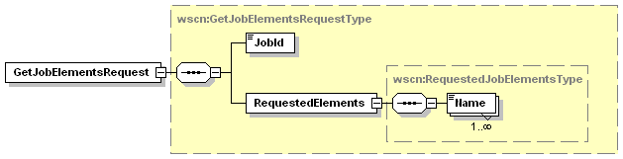
Figure 34 - GetJobElementsRequest Elements

JobId
This data element contains the JobId of the Job about which the client is request information. This data element is described in Section 4.5.1.1

RequestedElements
This data element is a collection of elements that describes the data in which the CP is interested.

Name
This data element is a QName that represents a location within the Job schema. The keyword represents a top level section of the Job schema such as the JobStatus or ScanTicket.

Allowed Values:
wscn:JobStatus – Get the current JobStatus element for the specified Job.
wscn:ScanTicket – Get the ScanTicket element for the specified Job
wscn:Documents - Get the Documents element for the specified Job
xmlns:VendorSection– A Vendor defined extension to the Job Schema

Response Elements
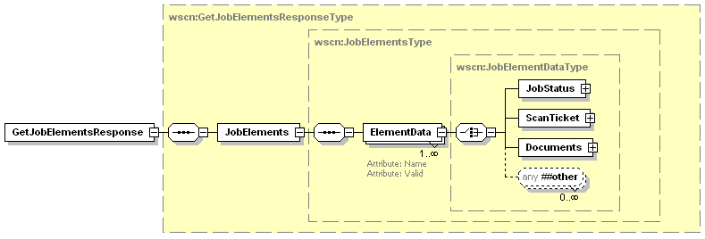
Figure 35 - GetJobElementsResponse Elements

JobElements
This data element is a collection of all the responses generated by the scan device for the schema queries in the GetJobElements request.

ElementData
This data element contains the data returned for one of the schema requests. There will be the same number of ElementData elements in the response as there were Name elements in the request.

Name
This attribute contains the schema QName used to create the data that is returned in the element.

Valid
This attribute indicates whether the schema query value was for a valid or invalid schema keyword within the device schema. This attribute will be false if the requested schema keyword does not map to a valid schema section in the Job schema supported by the device.

Request
<?xml version="1.0" encoding="utf-8"?>
<soap:Envelope
xmlns:soap="http://www.w3.org/2003/05/soap-envelope"
xmlns:wsa="http://schemas.xmlsoap.org/ws/2004/08/addressing"
xmlns:wscn="http://schemas.microsoft.com/windows/2006/01/wdp/scan”>
<soap:Header>
<wsa:To>AddressofScannerService</wsa:To>
<wsa:Action>
http://schemas.microsoft.com/windows/2006/08/wdp/scan/GetJobElements
</wsa:Action>
<wsa:MessageID>uuid:UniqueMsgId</wsa:MessageID>
</soap:Header>
<soap:Body>
<wscn:GetJobElements>
<wscn:JobId>1</wscn:JobId>
<wscn:RequestedElements>
<wscn:Name>wscn:JobStatus</wscn:Name>
</wscn:RequestedElements>
</wscn:GetJobElements>
</soap:Body>
</soap:Envelope>

Response
<?xml version="1.0" encoding="utf-8"?>
<soap:Envelope
xmlns:soap="http://www.w3.org/2003/05/soap-envelope"
xmlns:wsa="http://schemas.xmlsoap.org/ws/2004/08/addressing"
xmlns:wscn="http://schemas.microsoft.com/windows/2006/01/wdp/scan”>
<soap:Header>
<wsa:To>http://schemas.xmlsoap.org/ws/2004/08/addressing/role/anonymous</wsa:To>
<wsa:Action>
http://schemas.microsoft.com/windows/2006/08/wdp/scan/GetJobElementsResponse
</wsa:Action>
<wsa:MessageID>uuid:UniqueMsgId</wsa:MessageID>
<wsa:RelatesTo>uuid:MsgIdOfTheGetJobElementsRequest</wsa:RelatesTo>
</soap:Header>
<soap:Body>
<wscn:GetJobElementsResponse>
<wscn:JobElements>
<wscn:ElementData Name=”wscn:JobStatus” Valid=”true”>
<wscn:JobStatus>
<wscn:JobId>1</wscn:JobId>
<wscn:JobState>Completed</wscn:JobState>
<wscn:ScansCompleted>1</wscn:ScansCompleted>
</wscn:JobStatus>
</wscn:ElementData>
<wscn:JobElements>
</wscn:GetJobElementsResponse >
</soap:Body>
</soap:Envelope>

Errors
All the Codes described in section 6.1.1 - Common Operation Error Codes could be returned from this operation. The following error could also be returned from this operation.

ClientErrorJobIdNotFound
This fault is sent when the scanner can not find a job matching the JobId argument (including when the argument is not in the range: 1 to 2^³¹-1).
[Code] | soap:Sender
[Subcode] | wscn:ClientErrorJobIdNotFound
[Reason] | Specified JobId not found
[Detail] | Jobid:Incorrect JobId

GetActiveJobs
The GetActiveJobs operation allows a client (CP) to retrieve a list containing a summary of the currently active jobs. The list of Jobs returned contains information such as the JobId, JobOriginatingUserName and the JobName. To retrieve more detailed information on a Job use the GetJobElements operation (section 6.7)

Response Elements
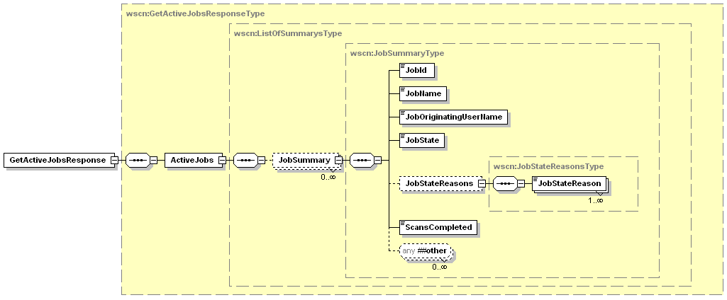
Figure 36 - GetActiveJobsResponse Elements

ActiveJobs
This data element is a collection of JobSummary elements that describe all the currently active jobs in the scan device.

JobSummary
This data element collects a subset of information about a Job currently active within the scan device. The individual elements are detailed in the following sections.

JobId
This data element is the JobId of the current job entry. This data element is described in Section 4.5.1.1

JobName
This data element is described in Section 4.5.2.1.1

JobOriginatingUserName
This data element is described in Section 4.5.2.1.2

JobState
This data element is described in Section 4.5.1.2

JobStateReasons
This data element is described in Section 4.5.1.3

JobStateReason
This data element is described in Section 4.5.1.3.1

ScansCompleted
This data element is described in Section 4.5.1.6

Example Request
<?xml version="1.0" encoding="utf-8"?>
<soap:Envelope
xmlns:soap="http://www.w3.org/2003/05/soap-envelope"
xmlns:wsa="http://schemas.xmlsoap.org/ws/2004/08/addressing"
xmlns:wscn="http://schemas.microsoft.com/windows/2006/01/wdp/scan”>
<soap:Header>
<wsa:To>AddressofScannerService</wsa:To>
<wsa:Action>
http://schemas.microsoft.com/windows/2006/08/wdp/scan/GetActiveJobs
</wsa:Action>
<wsa:MessageID>uuid:UniqueMsgId</wsa:MessageID>
</soap:Header>
<soap:Body>
<wscn:GetActiveJobsRequest/>
</soap:Body>
</soap:Envelope>

Example Response – No Active Jobs
<?xml version="1.0" encoding="utf-8"?>
<soap:Envelope
xmlns:soap="http://www.w3.org/2003/05/soap-envelope"
xmlns:wsa="http://schemas.xmlsoap.org/ws/2004/08/addressing"
xmlns:wscn="http://schemas.microsoft.com/windows/2006/01/wdp/scan”>
<soap:Header>
<wsa:To>http://schemas.xmlsoap.org/ws/2004/08/addressing/role/anonymous</wsa:To>
<wsa:Action>
http://schemas.microsoft.com/windows/2006/08/wdp/scan/GetActiveJobsResponse
</wsa:Action>
<wsa:MessageID>uuid:UniqueMsgId</wsa:MessageID>
<wsa:RelatesTo>uuid:MsgIdOfTheGetActiveJobsRequest</wsa:RelatesTo>
</soap:Header>
<soap:Body>
<wscn:GetActiveJobsResponse>
<wscn:ActiveJobs/>
</wscn:GetActiveJobsResponse>
</soap:Body>
</soap:Envelope>

Example Response – Two Active Jobs
<?xml version="1.0" encoding="utf-8"?>
<soap:Envelope
xmlns:soap="http://www.w3.org/2003/05/soap-envelope"
xmlns:wsa="http://schemas.xmlsoap.org/ws/2004/08/addressing"
xmlns:wscn="http://schemas.microsoft.com/windows/2006/01/wdp/scan”>
<soap:Header>
<wsa:To>http://schemas.xmlsoap.org/ws/2004/08/addressing/role/anonymous</wsa:To>
<wsa:Action>
http://schemas.microsoft.com/windows/2006/08/wdp/scan/GetActiveJobsResponse
</wsa:Action>
<wsa:MessageID>uuid:UniqueMsgId</wsa:MessageID>
<wsa:RelatesTo>uuid:MsgIdOfTheGetActiveJobsRequest</wsa:RelatesTo>
</soap:Header>
<soap:Body>
<wscn:GetActiveJobsResponse>
<wscn:ActiveJobs>
<wscn:JobSummary>
<wscn:JobId>1</wscn:JobId>
<wscn:JobName>SampleJob 1</wscn:JobName>
<wscn:JobOriginatingUserName>Joe.Smith</wscn:JobOriginatingUserName>
<wscn:JobState>Processing</wscn:JobState>
<wscn:JobStateReasons>
<wscn:JobStateReason>JobScanning</wscn:JobStateReason>
</wscn:JobStateReasons>
<wscn:ScansCompleted>2</wscn:ScansCompleted>
</wscn:JobSummary>
<wscn:JobSummary>
<wscn:JobId>2</wscn:JobId>
<wscn:JobName>Sample Job 2</wscn:JobName>
<wscn:JobOriginatingUserName>JaneSmith</wscn:JobOriginatingUserName>
<wscn:JobState>Pending</wscn:JobState>
<wscn:JobStateReasons>
<wscn:JobStateReason>None</wscn:JobStateReason>
</wscn:JobStateReasons>
<wscn:ScansCompleted>0</wscn:ScansCompleted>
</wscn:JobSummary>
</wscn:ActiveJobs>
</wscn:GetActiveJobsResponse>
</soap:Body>
</soap:Envelope>

Errors
All the Codes described in section 6.1.1 - Common Operation Error Codes could be returned from this operation.

GetJobHistory
The GetJobHistory operation allows a client (CP) to retrieve a list containing a summary of some of the recently previously completed jobs. The list of Jobs returned contains information such as JobId, JobOriginatingUserName and the JobName. To retrieve more detailed information on a Job use the GetJobElements operation (section 6.7)
How much Job history the device keeps is completely device specific. Each device can keep as much or as little history as it deems useful/practical.

Response Elements
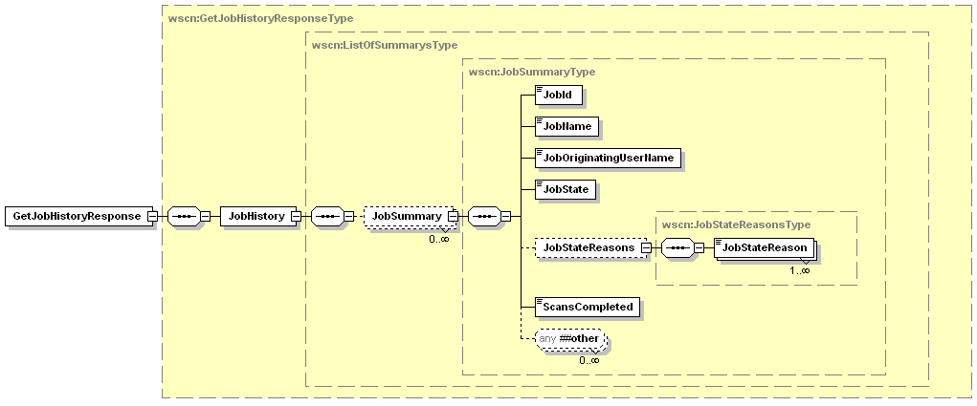
Figure 37 - GetJobHistoryResponse Elements

JobHistory
This data element is a collection of JobSummary elements that describes the most recently completed jobs in the scan device.

JobSummary
This data element collects a subset of information about a recently completed Job within the scan device. This data element is described in Section 6.8.1.1.1.

Example Request
<?xml version="1.0" encoding="utf-8"?>
<soap:Envelope
xmlns:soap="http://www.w3.org/2003/05/soap-envelope"
xmlns:wsa="http://schemas.xmlsoap.org/ws/2004/08/addressing"
xmlns:wscn="http://schemas.microsoft.com/windows/2006/01/wdp/scan”>
<soap:Header>
<wsa:To>AddressofScannerService</wsa:To>
<wsa:Action>
http://schemas.microsoft.com/windows/2006/08/wdp/scan/GetJobHistory
</wsa:Action>
<wsa:MessageID>uuid:UniqueMsgId</wsa:MessageID>
</soap:Header>
<soap:Body>
<wscn:GetJobHistoryRequest/>
</soap:Body>
</soap:Envelope>

Example Response – No Job History
<?xml version="1.0" encoding="utf-8"?>
<soap:Envelope
xmlns:soap="http://www.w3.org/2003/05/soap-envelope"
xmlns:wsa="http://schemas.xmlsoap.org/ws/2004/08/addressing"
xmlns:wscn="http://schemas.microsoft.com/windows/2006/01/wdp/scan”>
<soap:Header>
<wsa:To>http://schemas.xmlsoap.org/ws/2004/08/addressing/role/anonymous</wsa:To>
<wsa:Action>
http://schemas.microsoft.com/windows/2006/08/wdp/scan/GetJobHistoryResponse
</wsa:Action>
<wsa:MessageID>uuid:UniqueMsgId</wsa:MessageID>
<wsa:RelatesTo>uuid:MsgIdOfTheGetJobHistoryRequest</wsa:RelatesTo>
</soap:Header>
<soap:Body>
<wscn:GetJobHistoryResponse>
<wscn:JobHistory/>
</wscn:GetJobHistoryResponse>
</soap:Body>
</soap:Envelope>

Example Response – 2 Completed Jobs
<?xml version="1.0" encoding="utf-8"?>
<soap:Envelope
xmlns:soap="http://www.w3.org/2003/05/soap-envelope"
xmlns:wsa="http://schemas.xmlsoap.org/ws/2004/08/addressing"
xmlns:wscn="http://schemas.microsoft.com/windows/2006/01/wdp/scan”>
<soap:Header>
<wsa:To>http://schemas.xmlsoap.org/ws/2004/08/addressing/role/anonymous</wsa:To>
<wsa:Action>
http://schemas.microsoft.com/windows/2006/08/wdp/scan/GetJobHistoryResponse
</wsa:Action>
<wsa:MessageID>uuid:UniqueMsgId</wsa:MessageID>
<wsa:RelatesTo>uuid:MsgIdOfTheGetJobHistoryRequest</wsa:RelatesTo>
</soap:Header>
<soap:Body>
<wscn:GetJobHistoryResponse>
<wscn:JobHistory>
<wscn:JobSummary>
<wscn:JobId>1</wscn:JobId>
<wscn:JobName>SampleJob 1</wscn:JobName>
<wscn:JobOriginatingUserName>Joe.Smith</wscn:JobOriginatingUserName>
<wscn:JobState>Completed</wscn:JobState>
<wscn:JobStateReasons>
<wscn:JobStateReason>JobCompletedSuccessfully</wscn:JobStateReason>
</wscn:JobStateReasons>
<wscn:ScansCompleted>4</wscn:ScansCompleted>
</wscn:JobSummary>
<wscn:JobSummary>
<wscn:JobId>2</wscn:JobId>
<wscn:JobName>Sample Job 2</wscn:JobName>
<wscn:JobOriginatingUserName>JaneRogers</wscn:JobOriginatingUserName>
<wscn:JobState>Canceled</wscn:JobState>
<wscn:JobStateReasons>
<wscn:JobStateReason>JobCanceledAtDevice</wscn:JobStateReason>
</wscn:JobStateReasons>
<wscn:ScansCompleted>1</wscn:ScansCompleted>
</wscn:JobSummary>
</wscn:JobHistory>
</wscn:GetJobHistoryResponse>
</soap:Body>
</soap:Envelope>

Errors
All the Codes described in section 6.1.1 - Common Operation Error Codes could be returned from this operation.

Non-Standard Operations Implemented by a WSD Vendor
To facilitate certification, non-standard operations implemented by WSD vendors MUST be part of a new porttype that extends the porttype defined in this specification.
- WSDL Service Description
Scan Device WSDL
<wsdl:definitions xmlns:wsdl="http://schemas.xmlsoap.org/wsdl/"
xmlns:wsoap12="http://schemas.xmlsoap.org/wsdl/soap12/"
xmlns:wsdp="http://schemas.xmlsoap.org/ws/2006/02/devprof"
xmlns:wsp="http://schemas.xmlsoap.org/ws/2004/09/policy"
xmlns:wsu="http://docs.oasis-open.org/wss/2004/01/oasis-200401-wss-wssecurity-utility-1.0.xsd"
xmlns:wscn="http://schemas.microsoft.com/windows/2006/08/wdp/scan"
targetNamespace="http://schemas.microsoft.com/windows/2006/08/wdp/scan"
name="WSDScanDevice">

<wsp:Policy wsu:Id="DevicePolicy">
<wsdp:Profile />
</wsp:Policy>

<wsdl:portType name="ScanDeviceType" />

<wsdl:binding name="ScannerSoapBinding" type="wscn:ScanDeviceType" >
<wsoap12:binding style="document" transport="http://schemas.xmlsoap.org/soap/http" />
<wsp:PolicyReference URI="#DevicePolicy" wsdl:required="true" />
</wsdl:binding>

</wsdl:definitions>
Scanner Service WSDL
<definitions xmlns="http://schemas.xmlsoap.org/wsdl/"
xmlns:wsoap12="http://schemas.xmlsoap.org/wsdl/soap12/"
xmlns:http="http://schemas.xmlsoap.org/wsdl/http/"
xmlns:xs="http://www.w3.org/2001/XMLSchema"
xmlns:wsdp="http://schemas.xmlsoap.org/ws/2006/02/devprof"
xmlns:wsp="http://schemas.xmlsoap.org/ws/2004/09/policy"
xmlns:wsd="http://schemas.xmlsoap.org/ws/2005/04/discovery"
xmlns:wse="http://schemas.xmlsoap.org/ws/2004/08/eventing"
xmlns:wsa="http://schemas.xmlsoap.org/ws/2004/08/addressing"
xmlns:wscn="http://schemas.microsoft.com/windows/2006/08/wdp/scan"
xmlns:wsu="http://docs.oasis-open.org/wss/2004/01/oasis-200401-wss-wssecurity-utility-1.0.xsd"
targetNamespace="http://schemas.microsoft.com/windows/2006/08/wdp/scan"
name="WSDScannerService">

<xs:annotation>
<xs:documentation>
WSD Scanner Service Web Service Description (WSDL) file
Copyright 2005-2006 Microsoft Corporation. All rights reserved
</xs:documentation>
</xs:annotation>

<wsp:Policy wsu:Id="ServicePolicy">
<wsdp:Profile />
</wsp:Policy>

<types>
<xs:schema targetNamespace="http://schemas.microsoft.com/windows/2006/08/wdp/scan">
<xs:include schemaLocation="WDPScan.xsd"/>
</xs:schema>
</types>

<message name="CreateScanJobRequestMsg">
<part name="body" element="wscn:CreateScanJobRequest"/>
</message>
<message name="CreateScanJobResponseMsg">
<part name="body" element="wscn:CreateScanJobResponse"/>
</message>
<message name="RetrieveImageRequestMsg">
<part name="body" element="wscn:RetrieveImageRequest"/>
</message>
<message name="RetrieveImageResponseMsg">
<part name="body" element="wscn:RetrieveImageResponse"/>
</message>
<message name="CancelJobRequestMsg">
<part name="body" element="wscn:CancelJobRequest"/>
</message>
<message name="CancelJobResponseMsg">
<part name="body" element="wscn:CancelJobResponse"/>
</message>
<message name="ValidateScanTicketRequestMsg">
<part name="body" element="wscn:ValidateScanTicketRequest"/>
</message>
<message name="ValidateScanTicketResponseMsg">
<part name="body" element="wscn:ValidateScanTicketResponse"/>
</message>
<message name="GetScannerElementsRequestMsg">
<part name="body" element="wscn:GetScannerElementsRequest"/>
</message>
<message name="GetScannerElementsResponseMsg">
<part name="body" element="wscn:GetScannerElementsResponse"/>
</message>
<message name="GetJobElementsRequestMsg">
<part name="body" element="wscn:GetJobElementsRequest"/>
</message>
<message name="GetJobElementsResponseMsg">
<part name="body" element="wscn:GetJobElementsResponse"/>
</message>
<message name="GetActiveJobsRequestMsg">
<part name="body" element="wscn:GetActiveJobsRequest"/>
</message>
<message name="GetActiveJobsResponseMsg">
<part name="body" element="wscn:GetActiveJobsResponse"/>
</message>
<message name="GetJobHistoryRequestMsg">
<part name="body" element="wscn:GetJobHistoryRequest"/>
</message>
<message name="GetJobHistoryResponseMsg">
<part name="body" element="wscn:GetJobHistoryResponse"/>
</message>

<message name="ScanAvailableEventMsg">
<part name="body" element="wscn:ScanAvailableEvent"/>
</message>
<message name="ScannerElementsChangeEventMsg">
<part name="body" element="wscn:ScannerElementsChangeEvent"/>
</message>
<message name="ScannerStatusSummaryEventMsg">
<part name="body" element="wscn:ScannerStatusSummaryEvent"/>
</message>
<message name="ScannerStatusConditionEventMsg">
<part name="body" element="wscn:ScannerStatusConditionEvent"/>
</message>
<message name="ScannerStatusConditionClearedEventMsg">
<part name="body" element="wscn:ScannerStatusConditionClearedEvent"/>
</message>
<message name="JobStatusEventMsg">
<part name="body" element="wscn:JobStatusEvent"/>
</message>
<message name="JobEndStateEventMsg">
<part name="body" element="wscn:JobEndStateEvent"/>
</message>

<portType name="ScannerServiceType" wse:EventSource="true">
<operation name="CreateScanJob">
<input message="wscn:CreateScanJobRequestMsg"
wsa:Action="http://schemas.microsoft.com/windows/2006/08/wdp/scan/CreateScanJob" />
<output message="wscn:CreateScanJobResponseMsg"
wsa:Action="http://schemas.microsoft.com/windows/2006/08/wdp/scan/CreateScanJobResponse" />
</operation>
<operation name="RetrieveImage">
<input message="wscn:RetrieveImageRequestMsg"
wsa:Action="http://schemas.microsoft.com/windows/2006/08/wdp/scan/RetrieveImage" />
<output message="wscn:RetrieveImageResponseMsg"
wsa:Action="http://schemas.microsoft.com/windows/2006/08/wdp/scan/RetrieveImageResponse" />
</operation>
<operation name="CancelJob">
<input message="wscn:CancelJobRequestMsg"
wsa:Action="http://schemas.microsoft.com/windows/2006/08/wdp/scan/CancelJob" />
<output message="wscn:CancelJobResponseMsg"
wsa:Action="http://schemas.microsoft.com/windows/2006/08/wdp/scan/CancelJobResponse" />
</operation>
<operation name="ValidateScanTicket">
<input message="wscn:ValidateScanTicketRequestMsg"
wsa:Action="http://schemas.microsoft.com/windows/2006/08/wdp/scan/ValidateScanTicket" />
<output message="wscn:ValidateScanTicketResponseMsg"
wsa:Action="http://schemas.microsoft.com/windows/2006/08/wdp/scan/ValidateScanTicketResponse" />
</operation>
<operation name="GetScannerElements">
<input message="wscn:GetScannerElementsRequestMsg"
wsa:Action="http://schemas.microsoft.com/windows/2006/08/wdp/scan/GetScannerElements" />
<output message="wscn:GetScannerElementsResponseMsg"
wsa:Action="http://schemas.microsoft.com/windows/2006/08/wdp/scan/GetScannerElementsResponse" />
</operation>
<operation name="GetJobElements">
<input message="wscn:GetJobElementsRequestMsg"
wsa:Action="http://schemas.microsoft.com/windows/2006/08/wdp/scan/GetJobElements" />
<output message="wscn:GetJobElementsResponseMsg"
wsa:Action="http://schemas.microsoft.com/windows/2006/08/wdp/scan/GetJobElementsResponse" />
</operation>
<operation name="GetActiveJobs">
<input message="wscn:GetActiveJobsRequestMsg"
wsa:Action="http://schemas.microsoft.com/windows/2006/08/wdp/scan/GetActiveJobs" />
<output message="wscn:GetActiveJobsResponseMsg"
wsa:Action="http://schemas.microsoft.com/windows/2006/08/wdp/scan/GetActiveJobsResponse" />
</operation>
<operation name="GetJobHistory">
<input message="wscn:GetJobHistoryRequestMsg"
wsa:Action="http://schemas.microsoft.com/windows/2006/08/wdp/scan/GetJobHistory" />
<output message="wscn:GetJobHistoryResponseMsg"
wsa:Action="http://schemas.microsoft.com/windows/2006/08/wdp/scan/GetJobHistoryResponse" />
</operation>
<operation name="ScanAvailableEvent">
<output message="wscn:ScanAvailableEventMsg"
wsa:Action="http://schemas.microsoft.com/windows/2006/08/wdp/scan/ScanAvailableEvent" />
</operation>
<operation name="ScannerElementsChangeEvent">
<output message="wscn:ScannerElementsChangeEventMsg"
wsa:Action="http://schemas.microsoft.com/windows/2006/08/wdp/scan/ScannerElementsChangeEvent" />
</operation>
<operation name="ScannerStatusSummaryEvent">
<output message="wscn:ScannerStatusSummaryEventMsg"
wsa:Action="http://schemas.microsoft.com/windows/2006/08/wdp/scan/ScannerStatusSummaryEvent" />
</operation>
<operation name="ScannerStatusConditionEvent">
<output message="wscn:ScannerStatusConditionEventMsg"
wsa:Action="http://schemas.microsoft.com/windows/2006/08/wdp/scan/ScannerStatusConditionEvent" />
</operation>
<operation name="ScannerStatusConditionClearedEvent">
<output message="wscn:ScannerStatusConditionClearedEventMsg"
wsa:Action="http://schemas.microsoft.com/windows/2006/08/wdp/scan/ScannerStatusConditionClearedEvent" />
</operation>
<operation name="JobStatusEvent">
<output message="wscn:JobStatusEventMsg"
wsa:Action="http://schemas.microsoft.com/windows/2006/08/wdp/scan/JobStatusEvent" />
</operation>
<operation name="JobEndStateEvent">
<output message="wscn:JobEndStateEventMsg"
wsa:Action="http://schemas.microsoft.com/windows/2006/08/wdp/scan/JobEndStateEvent" />
</operation>
</portType>
<binding name="ScannerServiceBinding" type="wscn:ScannerServiceType">
<wsoap12:binding style="document" transport="http://schemas.xmlsoap.org/soap/http"/>
<wsp:PolicyReference URI="#ServicePolicy" />
<operation name="CreateScanJob">
<wsoap12:operation
soapAction="http://schemas.microsoft.com/windows/2006/08/wdp/scan/CreateScanJob"
soapActionRequired="true" />
<input>
<wsoap12:body use="literal" />
</input>
<output>
<wsoap12:body use="literal" />
</output>
</operation>
<operation name="RetrieveImage">
<wsoap12:operation
soapAction="http://schemas.microsoft.com/windows/2006/08/wdp/scan/RetrieveImage"
soapActionRequired="true" />
<input>
<wsoap12:body use="literal" />
</input>
<output>
<wsoap12:body use="literal" />
</output>
</operation>
<operation name="CancelJob">
<wsoap12:operation
soapAction="http://schemas.microsoft.com/windows/2006/08/wdp/scan/CancelJob"
soapActionRequired="true" />
<input>
<wsoap12:body use="literal" />
</input>
<output>
<wsoap12:body use="literal" />
</output>
</operation>
<operation name="ValidateScanTicket">
<wsoap12:operation
soapAction="http://schemas.microsoft.com/windows/2006/08/wdp/scan/ValidateScanTicket"
soapActionRequired="true" />
<input>
<wsoap12:body use="literal" />
</input>
<output>
<wsoap12:body use="literal" />
</output>
</operation>
<operation name="GetScannerElements">
<wsoap12:operation
soapAction="http://schemas.microsoft.com/windows/2006/08/wdp/scan/GetScannerElements"
soapActionRequired="true" />
<input>
<wsoap12:body use="literal" />
</input>
<output>
<wsoap12:body use="literal" />
</output>
</operation>
<operation name="GetJobElements">
<wsoap12:operation
soapAction="http://schemas.microsoft.com/windows/2006/08/wdp/scan/GetJobElements"
soapActionRequired="true" />
<input>
<wsoap12:body use="literal" />
</input>
<output>
<wsoap12:body use="literal" />
</output>
</operation>
<operation name="GetActiveJobs">
<wsoap12:operation
soapAction="http://schemas.microsoft.com/windows/2006/08/wdp/scan/GetActiveJobs"
soapActionRequired="true" />
<input>
<wsoap12:body use="literal" />
</input>
<output>
<wsoap12:body use="literal" />
</output>
</operation>
<operation name="GetJobHistory">
<wsoap12:operation
soapAction="http://schemas.microsoft.com/windows/2006/08/wdp/scan/GetJobHistory"
soapActionRequired="true" />
<input>
<wsoap12:body use="literal" />
</input>
<output>
<wsoap12:body use="literal" />
</output>
</operation>
<operation name="ScanAvailableEvent">
<wsoap12:operation
soapAction="http://schemas.microsoft.com/windows/2006/08/wdp/scan/ScanAvailableEvent"
soapActionRequired="true" />
<output>
<wsoap12:body use="literal" />
</output>
</operation>
<operation name="ScannerElementsChangeEvent">
<wsoap12:operation
soapAction="http://schemas.microsoft.com/windows/2006/08/wdp/scan/ScannerElementsChangeEvent"
soapActionRequired="true" />
<output>
<wsoap12:body use="literal" />
</output>
</operation>
<operation name="ScannerStatusSummaryEvent">
<wsoap12:operation
soapAction="http://schemas.microsoft.com/windows/2006/08/wdp/scan/ScannerStatusSummaryEvent"
soapActionRequired="true" />
<output>
<wsoap12:body use="literal" />
</output>
</operation>
<operation name="ScannerStatusConditionEvent">
<wsoap12:operation
soapAction="http://schemas.microsoft.com/windows/2006/08/wdp/scan/ScannerStatusConditionEvent"
soapActionRequired="true" />
<output>
<wsoap12:body use="literal" />
</output>
</operation>
<operation name="ScannerStatusConditionClearedEvent">
<wsoap12:operation
soapAction="http://schemas.microsoft.com/windows/2006/08/wdp/scan/ScannerStatusConditionClearedEvent"
soapActionRequired="true" />
<output>
<wsoap12:body use="literal" />
</output>
</operation>
<operation name="JobStatusEvent">
<wsoap12:operation
soapAction="http://schemas.microsoft.com/windows/2006/08/wdp/scan/JobStatusEvent"
soapActionRequired="true" />
<output>
<wsoap12:body use="literal" />
</output>
</operation>
<operation name="JobEndStateEvent">
<wsoap12:operation
soapAction="http://schemas.microsoft.com/windows/2006/08/wdp/scan/JobEndStateEvent"
soapActionRequired="true" />
<output>
<wsoap12:body use="literal" />
</output>
</operation>
</binding>
<service name="ScannerService">
<port name="ScannerPort" binding="wscn:ScannerServiceBinding">
<wsoap12:address location="http://localhost/ScannerService/"/>
</port>
</service>
</definitions>
- Windows Vista™ Support Requirements

PnP-X installation support
Installation of WSD Scan devices on Windows Vista™ takes advantage of a new feature called PNP-X. This enables networked devices to take part in the normal PnP experience just like locally connected devices. To enable this support a device that complies with [DEVICE] needs to add a specific XML element to their Relationship section of the Device Metadata. This element will allow the inbox WSD Scan device driver to be loaded and kick off the install process for the WSD Scan device and the correct scanner driver.
Within the extensiability area of the wsdp:Relationship/wsdp:Hosted element the metadata should include a CompatibleId element as defined in [PNPX].

PnP-X Namespace
The current required namespace for all PNP-X related elements is: http://schemas.microsoft.com/windows/pnpx/2005/10

PnP-X CompatibleId definition and value
The current definition of the CompatibleId element is:
<xs:element name="CompatibleId" type="tns:CompatibleIdType" >
<xs:annotation>
<xs:documentation xml:lang="en" >
Used as the Compatible ID for INF file matching for devices. The length
of this string must not exceed 196 wide characters (392 bytes). To specify
more than one CompatibleID, separate them with a space character. For example:
PNPX_SampleService_CPID_1 PNPX_SampleService_CPID_2 PNPX_SampleService1_CPID_3
</xs:documentation>
</xs:annotation>
</xs:element>
<xs:simpleType name="CompatibleIdType" >
<xs:list itemType="xs:string" />
</xs:simpleType>

The value of this field in a supported Metadata section is: http://schemas.microsoft.com/windows/2006/08/wdp/scan/ScannerServiceType

Sample Device Metadata response
<mex:MetadataSection Dialect="http://schemas.xmlsoap.org/ws/2006/02/devprof/relationship">
<wsdp:Relationship Type="http://schemas.xmlsoap.org/ws/2006/02/devprof/host">
<wsdp:Hosted>
<wsa:EndpointReference>
.
.
.
</wsa:EndpointReference>
<wsdp:Types xmlns:wscn="http://schemas.microsoft.com/windows/2006/08/wdp/scan">
wscn:ScannerServiceType
</wsdp:Types>
<wsdp:ServiceId>
.
</wsdp:ServiceId>
<pnpx:CompatibleId xmlns:pnpx="http://schemas.microsoft.com/windows/pnpx/2005/10">
http://schemas.microsoft.com/windows/2006/08/wdp/scan/ScannerServiceType
</pnpx:CompatibleId>
</wsdp:Hosted>
</wsdp:Relationship>
</mex:MetadataSection>

Network Explorer category support
Another new feature of Windows Vista™ is the Network Explorer. This is a folder that can be used to discover and install network connected devices such as WSD capable printers & scanners. To improve the usability of the Network Explorer every device that is discovered can have belong to one or more Category(s). The way to indicate what category(s) a device belongs to is by adding one or more DeviceCategory elements to the device wsdp:ThisModel metadata section. The primary category for the device is equal to the first DeviceCategory element found. Each successive DeviceCategory element will be considered a secondary category. For more information on the definition of the device categories see [PNPX].
Each device should include the DeviceCategory element(s) as defined in [PNPX] within the extensiability area of the wsdp:ThisModel metadata section

PnP-X Namespace
The current required namespace for all PNP-X related elements is: http://schemas.microsoft.com/windows/pnpx/2005/10

PnP-X Category definition and value
The current definition of the DeviceCategory element is:
<xs:element name="DeviceCategory" type="tns:DeviceCategoryType" >
<xs:annotation>
<xs:documentation>
Used to identify the category to which the device belongs. The device
categories are strings which are defined in the DeviceCategory section
of [PNPX]. To specify more than one device category, separate them with a
space character. For example: Scanners Storage
identifies a device with a primary category of Scanners and a secondary
category of Storage. Devices can also specify a device subcategory for
a more descriptive device category.
For example: Displays.Television MediaDevices.DVR
identifies a device which is a Television and a Digital Video recorder.
The primary device category for this device would be Displays.
</xs:documentation>
</xs:annotation>
</xs:element>
<xs:simpleType name="DeviceCategoryType" >
<xs:list itemType="xs:string" />
</xs:simpleType>

Sample Device Metadata response
<mex:MetadataSection Dialect="http://schemas.xmlsoap.org/ws/2006/02/devprof/ThisModel">
<wsdp:ThisModel>
<wsdp:Manufacturer xml:lang="en">..</wsdp:Manufacturer>
<wsdp:ManufacturerUrl>..</wsdp:ManufacturerUrl>
<wsdp:ModelName xml:lang="en">..</wsdp:ModelName>
<wsdp:ModelNumber>..</wsdp:ModelNumber>
<pnpx:DeviceCategory>Scanners</pnpx:DeviceCategory>
</wsdp:ThisModel>
</mex:MetadataSection>

Scan Device discoverability
A common user scenario is to search for a particular type of device on the network. Searching for local devices takes advantage of the Multicast capabilities of [DISCOVERY] while the discovery of a distant device used the Unicast, or directed, discovery capabilities. To advertise a service with devices that implement [DISCOVERY] a defined porttype must be exposed by the high level device for each hosted service that wishes to advertise. This porttype contains no operations but implies the device hosts at least one of the advertised service types.
Requirements to support each discovery method are explained in detail in the following sections.

Local subnet Discovery support
To advertise support for a particular service type a device includes a Scan Device porttype in the wsdisco:Types element of the wsdisco:Hello and wsdisco:ProbeMatches messages. The porttype is defined in the same namespace as the WSD Scanner Service.

WSD Scan Namespace
The current namespace for WSD Scan related elements is: http://schemas.microsoft.com/windows/2006/08/wdp/scan

WSD Scan Device porttype
The Device Type is defined as: “ScanDeviceType”.

Device Hello example
<?xml version="1.0" encoding="utf-8"?>
<soap:Envelope xmlns:soap="http://www.w3.org/2003/05/soap-envelope"
xmlns:wsa="http://schemas.xmlsoap.org/ws/2004/08/addressing"
xmlns:wsdisco="http://schemas.xmlsoap.org/ws/2005/04/discovery"
xmlns:wsdp=”http://schemas.xmlsoap.org/ws/2006/02/devprof”
xmlns:wscn="http://schemas.microsoft.com/windows/2006/08/wdp/scan">
<soap:Header>
<wsa:MessageID>urn:uuid:ac8523ee-6813-498c-8c1b-6272a22353f7</wsa:MessageID>
<wsa:Action>
http://schemas.xmlsoap.org/ws/2005/04/discovery/Hello
</wsa:Action>
<wsa:To>urn:schemas-xmlsoap-org:ws:2005:04:discovery</wsa:To>
<wsdisco:AppSequence InstanceId="3094203799" MessageNumber="1" />
</soap:Header>
<soap:Body>
<wsdisco:Hello>
<wsa:EndpointReference>
<wsa:Address>uuid:D10000D1-ca45-5fee-a376-112233445555</wsa:Address>
</wsa:EndpointReference>
<wsdisco:Types>wsdp:Device wscn:ScanDeviceType</wsdisco:Types>
<wsdisco:XAddrs>http://IPAddress:80/TestDevice</wsdisco:XAddrs>
<wsdisco:MetadataVersion>1</wsdisco:MetadataVersion>
</wsdisco:Hello>
</soap:Body>
</soap:Envelope>

Device ProbeMatches example
<?xml version="1.0" encoding="utf-8"?>
<soap:Envelope xmlns:soap="http://www.w3.org/2003/05/soap-envelope"
xmlns:wsa="http://schemas.xmlsoap.org/ws/2004/08/addressing"
xmlns:wsdisco="http://schemas.xmlsoap.org/ws/2005/04/discovery"
xmlns:wsdp=”http://schemas.xmlsoap.org/ws/2006/02/devprof”
xmlns:wscn="http://schemas.microsoft.com/windows/2006/08/wdp/scan">
<soap:Header>
<wsa:MessageID>urn:uuid:147823ee-83f7-498c-8c1b-6272a22353f7</wsa:MessageID>
<wsa:RelatesTo>urn:uuid:0a6dc791-2be6-4991-9af1-454778a1917a</wsa:RelatesTo>
<wsa:Action>
http://schemas.xmlsoap.org/ws/2005/04/discovery/ProbeMatches
</wsa:Action>
<wsa:To>http://schemas.xmlsoap.org/ws/2004/08/addressing/role/anonymous</wsa:To>
<wsdisco:AppSequence InstanceId="3094203799" MessageNumber="2" />
</soap:Header>
<soap:Body>
<wsdisco:ProbeMatches>
<wsdisco:ProbeMatch>
<wsa:EndpointReference>
<wsa:Address>uuid:D10000D1-ca45-5fee-a376-112233445555</wsa:Address>
</wsa:EndpointReference>
<wsdisco:Types>wsdp:Device wscn:ScanDeviceType</wsdisco:Types>
<wsdisco:XAddrs>http://IPAddress:80/TestDevice</wsdisco:XAddrs>
<wsdisco:MetadataVersion>1</wsdisco:MetadataVersion>
</wsdisco:ProbeMatch>
</wsdisco:ProbeMatches>
</soap:Body>
</soap:Envelope>

Directed Discovery support
A stable discovery URL is needed to enable a Windows Vista™ admin to easily discover a device in an enterprise environment. Having a defined URL allows the client to simply ask for the Hostname or IP Address of the device and then create the stable URL which a device will be listening at for a Probe message via HTTP. This also allows the device to listening at a single URL for discovery messages over HTTP.

Directed Discovery URL
http://IPAddressOrHostname:80/StableWSDiscoveryEndpoint/schemas-xmlsoap-org_ws_2005_04_discovery

Secure Directed Discovery URL
https://IPAddressOrHostname:443/StableWSDiscoveryEndpoint/schemas-xmlsoap-org_ws_2005_04_discovery

WSD Scan WIA Driver required capabilities
The WSD Scanner Service describes a number of input sources, file formats/compression technologies, and color capabilities. Each device and client can decide which of the described capabilities best meet the needs. However to be supported fully by the Windows Vista™ WSD Scan WIA Driver the following minimum requirements must be met.

InputSource values supported
Each device must support either the Platen or ADF input source.
Additionally, the device must go through a power-up cycle whenever an InputSource is added or removed.

ColorEntry values required
Each device must support at least one of the following ColorEntry values for their Platen or ADF input source.
- BlackAndWhite1
- Grayscale4
- Grayscale8
- RGB24

Document file formats required
Each device must support at least one of the following file formats:
- png
- exif – only for RGB24 data (**)
- tiff-single-g4 – only for BlackAndWhite1 data (**)
- tiff-single-uncompressed
- dib
All supported ColorEntry values must be transferable in this file format except where noted.
** - If this is the only required file format supported by the scanner all other color modes that may be supported by the scanner are ignored by the driver.

If the scanner does not support the dib format and a WIA application client (including the TWAIN Compatibility Layer) requests transferring images in the dib format the WSD Scan WIA Driver tries to scan in one of the following file formats, in order, if supported by the scanner. The driver then converts the images to the dib format before transferring them to the application:

1. png
2. exif (if the current color mode is RGB24)
3. tiff-single-g4 (if the current color mode is BlackAndWhite1)
4. tiff-single-uncompressed

The file formats xps and pdf-a are used as multi-page image file formats with no specified internal compression for image data. WSD scanners are allowed to choose the compression mode appropriate with the scanned images. The WSD Scan WIA Driver will treat only WIA_COMPRESSION_NONE as supported for these formats, meaning the application cannot change the default compression mode selected by the scanner.

Duplex scanning support
The WSD Scan WIA Driver will always set the same image acquisition parameters for both sides of a duplex scan using only the MediaFront element.

See the CreateScanJob operation defined in the Scan Service Specification

