Project #8 – Markov Chain Monte Carlo
EE 511: Spring 2017
Rundong Cao
USC ID: #43
Question1.
Introduction to Stratified Sampling and Importance Sampling
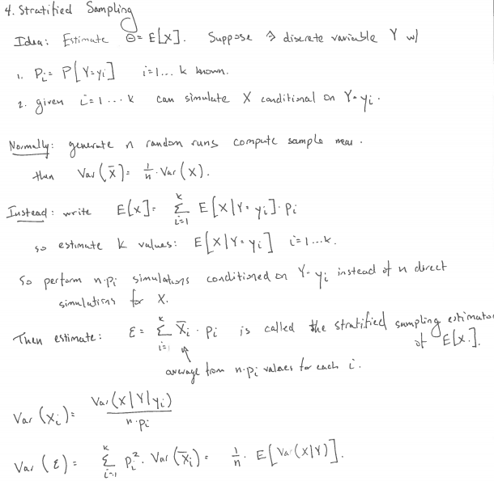

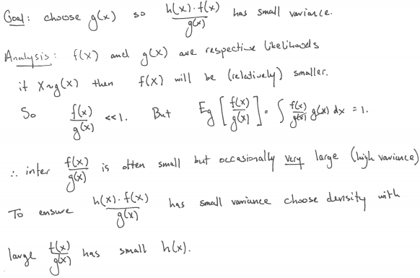
Method
- For Stratified Sampling, choose partition K to break the interval up into regions of equal probability. Use $U_{ij}=\frac{i-1}{n}+\frac{1}{n}U (i=1,…K; j=1,…K)$ to generate random samples for the integral function.
- For Importance Sampling, choose an easily sampled pdf g(x), such that X~G(X), use uniform sampling to get X and then calculate the integral result.
Core Matlab Code
%Q1(a)
g1 = @(x)exp(sum(5*abs(x-5)));
N = 1000; X1 = g1(rand(2,N)); % Simple MC
disp([mean(X1) std(X1)/sqrt(N)])

K = 10; Nij = N/K^2; % Stratified
for i = 1:K
for j = 1:K
XS1 = g1([i-1+rand(1,Nij);j-1+rand(1,Nij)]/K);
XSb1(i,j) = mean(XS1); SS1(i,j) = var(XS1);
end
end, SST1 = mean(mean(SS1/N));
disp([mean(mean(XSb1)) 2*sqrt(SST1) ])
%Importance
U = rand(2,N);
e = exp(1); X2 = log(1+(e-1)*U);
T1 = (e-1).^2*exp(sum(5*abs(X2-5))-sum(X2));
disp( [mean(T1) std(T1)/sqrt(N)])

%Q1(b)
g2 = @(x)4*cos(pi + sum(5*x));
N = 1000; X11 = g2(2*rand(2,N)-1); % Simple MC
disp([mean(X11) std(X11)/sqrt(N)])

K = 10; Nij = N/K^2; % Stratified
for i = 1:K
for j = 1:K
XS2 = g2(2*[i-1 + rand(1,Nij);j-1 + rand(1,Nij)]/K - 1);
XSb2(i,j) = mean(XS2); SS2(i,j) = var(XS2);
end
end, SST2 = mean(mean(SS2/N));
disp([mean(mean(XSb2)) 2*sqrt(SST2) ])
%Importance
U = rand(2,N);
e = exp(2); X12 = -1 + log(1+(e-1)*U);
T2 = ((e-1)/exp(1)).^2*cos(pi + sum(5*X12)).*exp(-sum(X12));
disp( [mean(T2) std(T2)/sqrt(N)])
Results
Generate three Monte Carlo integral estimates for Q(a) as follows:
 | Simple MC | Stratified | Importance
Estimates | 2.0426e+20 | 2.0748e+20 | 2.1467e+20
Variances | 0.1565e+20 | 0.0641e+20 | 0.2381e+20
The true integral result: 2.046e+20

Generate three Monte Carlo integral estimates for Q(b) as follows:
 | Simple MC | Stratified | Importance
Estimates | -0.1450 | -0.1428 | -0.1449
Variances | 0.0885 | 0.0666 | 0.1300
The true integral result: -0.1471
Findings
- For Q(a), Simple MC is 0.17% lower than the true value, Stratified result is 1.41% higher than the true value, Importance result is 4.92% higher than the true value. For Q(b), Simple MC is 1.43% higher than the true value, Stratified result is 2.92% higher than the true value, Importance result is 1.50% higher than the true value.
- Since Q(a) is an exponential function, the estimates and variances are expected to be very large as the results. Repeat the experiment, the results will change around the true value.

Question2
Introduction to Gibbs Sampler
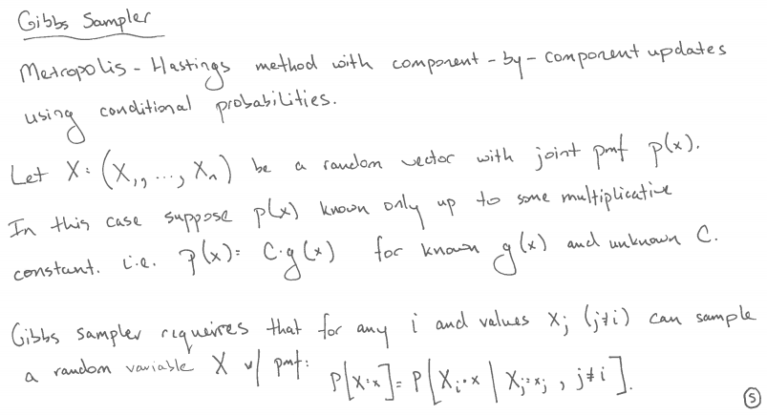
Method
- Pick a random coordinate $X_{1}$, already have values for $X_{2} and X_{3}$.
- Sample from the exponential distribution for $X_{1}$ given the condition for $X_{1}+{2X}_{2}+3X_{3}$.
- Repeat the process for a large number of iterations and estimate the expectation.
Core Matlab Code
N = 10000;
n = 3;
c = 15;
X = ones(1,n);
for m = 1:N %Gibbs Sample
i = ceil(n*rand);
S = sum(X) - X(i);
X(i) = max(c-S,0) - log(rand)/i;
H(m) = S + i*X(i);
end
gibs = [mean(H) std(H)/sqrt(N)];
%MC
N = 10000000;
XR = -diag(1./(1:n))*log(rand(n,N));
S = sum(XR);
H = S.*(S>15)/mean(S>15);
MC = ([mean(H) std(H)/sqrt(N)]);

%Q(b)
N2 = 10000;
n2 = 3;
c2 = 1;
X2 = ones(1,n2);
for m2 = 1:N2 %Gibbs Sample
i2 = ceil(n2*rand);
S2 = sum(X2) - X2(i2);
X2(i2) = min(c2-S2,0) - log(rand)/i2;
H2(m2) = S2 + i2*X2(i2);
end
gibs2 = [mean(H2) std(H2)/sqrt(N2)];
%MC
N2 = 10000000;
XR2 = -diag(1./(1:n2))*log(rand(n2,N2));
S2 = sum(XR2);
H2 = S2.*(S2<1)/mean(S2<1);
MC2 = ([mean(H2) std(H2)/sqrt(N2)]);
Results
For Q(a), obtain the expectation estimates as follows:
For Q(b), obtain the expectation estimates as follows:
Findings
- For Q(a), Gibbs sampler estimates’ result is 16.7233, the variance is 0.0181. Compared to Monte Carlo results, Gibbs expectation value is 3.75% higher than the MC result.
- For Q(b), Gibbs sampler estimates’ result is 0.9812, the variance is 0.0155. While the Monte Carlo estimate is 0.6675 with variance 3.89e-04.

Question3
Introduction to Simulated Annealing
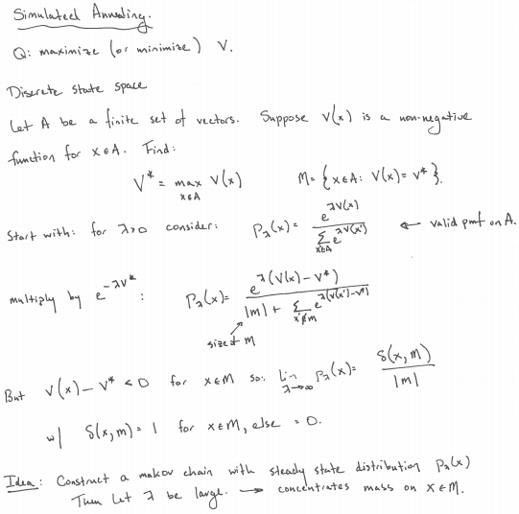
Method
- Choose initial $\left(x_{1},x_{2}\right)=\left(0,0\right) and set T_{0}=100$
- $x_{1}^{*}\left(t+1\right)=x_{1}\left(t\right)+N\left(0,100\right); x_{2}^{*}\left(t+1\right)=x_{2}\left(t\right)+N\left(0,100\right)$
- Compute $α=exp⁡(\frac{f\left(x_{1}^{*}\left(t+1\right),x_{2}^{*}\left(t+1\right)\right)-f(x_{1}\left(t\right),x_{2}(t))}{T})$
- Set $\left(x_{1}\left(t+1\right),x_{2}\left(t+1\right)\right)=\left(x_{1}^{*}\left(t+1\right),x_{2}^{*}\left(t+1\right)\right) if f\left(x_{1}^{*}\left(t+1\right),x_{2}^{*}\left(t+1\right)\right)≤f\left(x_{1}\left(t\right),x_{2}\left(t\right)\right) or if Unit\left(0,1\right)<α;$
$$Else \left(x_{1}\left(t+1\right),x_{2}\left(t+1\right)\right)= \left(x_{1}\left(t\right),x_{2}\left(t\right)\right)$$
- Use different cooling schedules to update $T_{t}=T(t)$
- Goto Step2 until estimate of min not change much or iterations count to N.
Core Matlab Code
d = 2;
fx = @(x1,x2)418.9829*d - (x1.*sin(sqrt(abs(x1))) + x2.*sin(sqrt(abs(x2))));
X = [0,0];%Starting Point
N = 1000;
T0 = 100;
T = T0;
count = 0;
for t = 1:N
X_new = X + 100*randn(1,2);
if ((X_new(1) < -500)||(X_new(2) < -500)||(X_new(1) > 500)||(X_new(2) > 500))
continue;
end
delta = fx(X_new(1),X_new(2))-fx(X(1),X(2));
alpha = exp(-delta/T);
if (delta < 0)
X = X_new;
count = count + 1;
Path(count,:) = X;
else
if (rand < alpha)
X = X_new;
count = count + 1;
Path(count,:) = X;
end
end
T = T0/log(t+1);%log
%T = T0*exp(-0.01*sqrt(t)).^t;%exp
%T = T0 - (T0/N)*t;%poly
end
min_result = fx(X(1),X(2));
accept_rate = count/N;
Results
Generate global minimum histograms using logarithmic, exponential, and logarithmic cooling schedules with N = {50, 200, 1000, 10000} as follows:
For the simulation that achieves the best estimate of the global minimum overlay the 2-D sample path on a contour plot of the surface as follows:
Comments
- The exponential, polynomial and logarithmic cooling schedules have different cooling rate, which will affect the performance of the algorithm convergence. Besides, the jumping function and $T_{0}$ also matter a lot.
- As N increases from 50 to 10000, the min values for those histograms will gather in some specific intervals, which shows the global minimum and local minimum.
- The path shown in the contour plot is a path to the global minimum, whose value is 0.19, coordinates are [420.18, 421.92]. The theoretical global minimum for Schwefel function is [420.97, 420.97] with value 0. So the performance of this estimate is pretty good.

Question4
Introduction to TSP problem
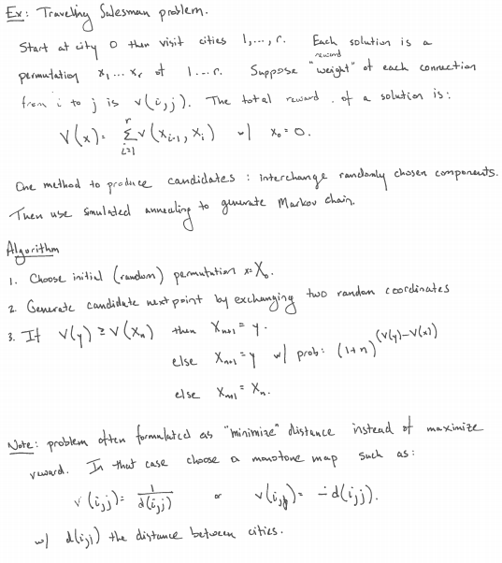
Method
- Initialize the path $p^{(0)}$ and calculate its cost $l(p^{(0)})$
- Iteratively find the next path $p^{(t+1)}$ from $p^{(t)}$ via:
- Generate a candidate path $p^{'}$ by swapping two cities in $p^{(t)}$ randomly.
- If $l\left(p^{'}\right)≤l\left(p^{\left(t\right)}\right), then p^{\left(t+1\right)}=p^{'}$
$$Else p^{(t+1)}=\left\{\begin{aligned}p^{'} with probability q \\ { p}^{(t)} with probability 1-q\end{aligned}\right.$$
$$Choose q={(t+1)}^{\frac{l\left(p^{\left(t\right)}\right)-l(p^{'})}{c}}$$

Core Matlab Code
name = importdata('E:\USC_class\EE511\pro8\uscap_name.txt');
city = importdata('E:\USC_class\EE511\pro8\uscap_xy.txt');
n = size(city,1);
flag = 0;
for i = 1:n
if(strcmp(name(i),'Juneau, Alaska')||strcmp(name(i),'Honolulu, Hawaii'))
city(i+flag,:) = [];
flag = flag - 1;
end
end
n = size(city,1);

distance = pdist2(city, city);
% Parameters
num_iter = 1000; % number of iterations
c = 200;
% Initial path p
p = 1:n;
% Initial length of p
len = 0;
for a1 = 1:n-1
len = len + distance(p(a1),p(a1+1));
end
len = len + distance(p(n),p(1));

% Save the paths and lengths
pathHistory = zeros(num_iter,n);
lenHistory = zeros(1,n);

% Plotting intial path
figure(1)
plot(city(:,1), city(:,2), 'ro');
%xlim([0 5]);
%ylim([1 6]);
hold on
line(city([p(:); p(1)],1), city([p(:); p(1)],2));
title('Initial path');
hold off

count = 0;

while(count<num_iter)
count = count + 1;
% Create path p2 by randomly swap two cities
swap_index = randsample(n,2);
p2 = p;
temp = p2(swap_index(1));
p2(swap_index(1)) = p2(swap_index(2));
p2(swap_index(2)) = temp;
% Cost of p2
len2 = 0;
for a1 = 1:n-1
len2 = len2 + distance(p2(a1),p2(a1+1));
end
len2 = len2 + distance(p2(n),p2(1));

q = (1+count)^((len - len2)/c);

if len2 - len <= 0
p = p2;
len = len2;
else
if rand <= q
p = p2;
len = len2;
end
end
pathHistory(count,:) = p;
lenHistory(count) = len;
end

figure(2)
plot(1:num_iter, lenHistory, 'linewidth',2);
title('Length of path in each iteration')

figure(3)
plot(city(:,1), city(:,2), 'ro');
%xlim([0 5]);
%ylim([1 6]);
hold on
line(city([p(:); p(1)],1), city([p(:); p(1)],2));
title('Final path of TSP using simulated annealing');
hold off
Results
Comments
- As the number of iterations increases from 100 to 10000, the length of path gradually converges to the shortest path, whose distance value is around $1.72×{10}^{4}$ in this estimate. The parameter c will affect the convergence rate.
- The final graphical path looks good, which shows the global minimum path.

