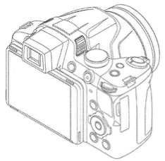

**u**

**v**

**n**

eye point

center point

A camera’s “tilt up” motion

new center point

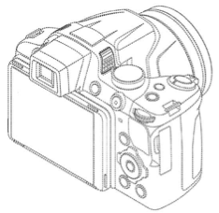

**u**

**v**

**n**

eye point

center point

A camera’s “trunk right” motion

new center point

new eye point