Reference line

y

x

Reference line  
(x-axis)

Reference line  
(x-axis)

Reference line  
(y-axis)

Head

(xh,yh)

Tail

(xt,yt)

dy = yh-yt

dx = xh-xt

Reference line  
(x-axis)

Reference line  
(y-axis)

<2,5>

<5,-1>

(6,7)

(1,-1)

a

b

**c**

**d**

Reference line  
(x-axis)

Reference line  
(y-axis)

Reference line  
(x-axis)

Reference line  
(y-axis)

(2,3)

<3,1>

z

Reference line  
(x-axis)

Reference line  
(y-axis)

(2,3)

<2,3>

<2,3>

(3,4)

Reference line  
(x-axis)

Reference line  
(y-axis)

Reference line  
(z-axis)  
(right-handed)

Reference line  
(z-axis)  
(left-handed)

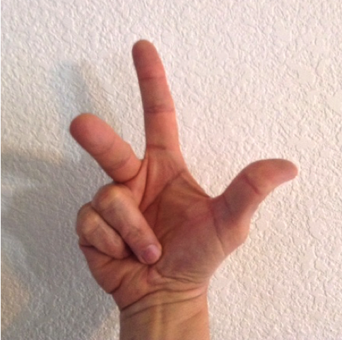

Reference line  
(x-axis)

Reference line  
(y-axis)

Reference line  
(z-axis)  
(right-handed)

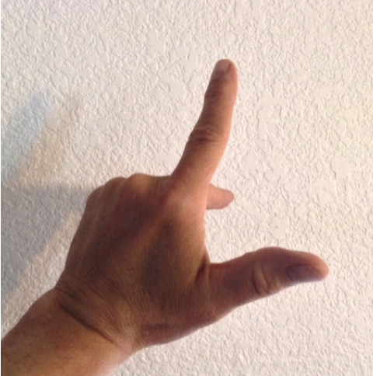

Reference line  
(x-axis)

Reference line  
(y-axis)

Reference line  
(z-axis)  
(left-handed)

Reference line  
(x-axis)

Reference line  
(y-axis)

Reference line  
(z-axis)  
(right-handed)

4

2

6

(2,4,6)