Global Origin

Local origin

Local origin

Local origin

10 units

10 units

Angle (theta)

r

Reference line

r

Reference line

r

x

Reference line  
(x-axis)

x

Reference line

y

Reference line  
(x-axis)

Reference line  
(y-axis)

Reference line  
(y-axis)

Reference line  
(y-axis)

4

-2

Reference line  
(x-axis)

Reference line  
(prime meridian)

Reference

line  
(Equator)

Longitude

Latitude

Altitude

Reference line  
(x-axis)

Reference line  
(y-axis)

Reference line  
(z-axis)  
(right-handed)

Reference line  
(z-axis)  
(left-handed)

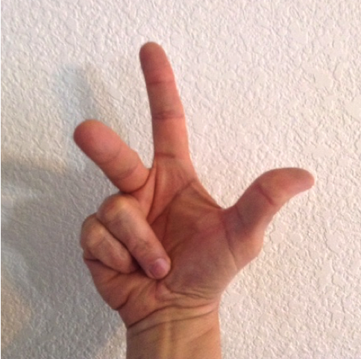

Reference line  
(x-axis)

Reference line  
(y-axis)

Reference line  
(z-axis)  
(right-handed)

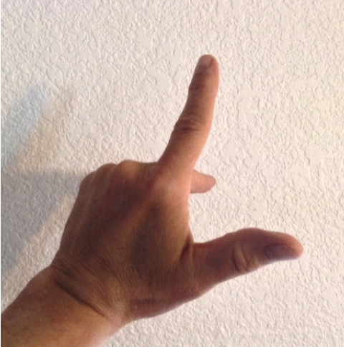

Reference line  
(x-axis)

Reference line  
(y-axis)

Reference line  
(z-axis)  
(left-handed)

Reference line  
(x-axis)

Reference line  
(y-axis)

Reference line  
(z-axis)  
(right-handed)

4

2

6

(2,4,6)

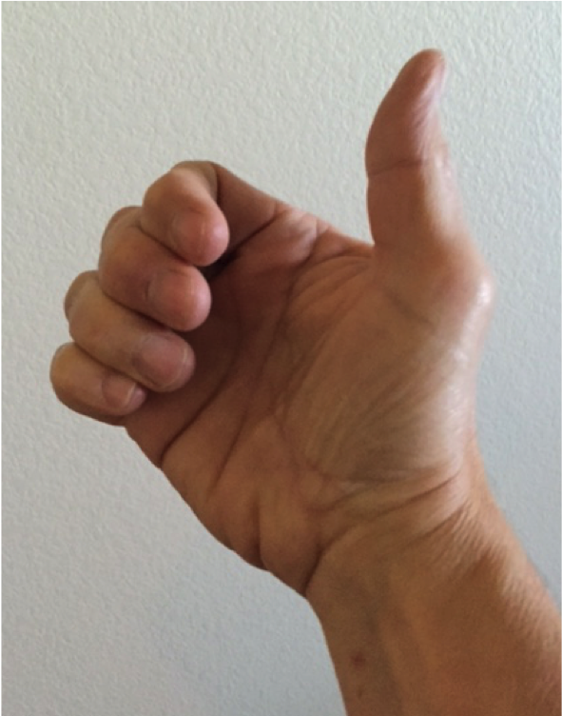

Lighting diagrams

Surface

Light Source

Light Ray

Reflected Rays

Surface

Light Source

Light Ray

Reflected Rays

Surface

Light Source

Light Ray

Reflected Rays

Light Source

Light Ray

Surface normal

Reflected light ray

Surface

Ray to camera

Camera

Rendering Diagrams

RAM

JavaScript

Program

Variables

GPU

Shader

Program

VOB_1

VOB_2

VOB_3

Render Buffer

(Output image)

1. Copy uniform values to the shader program.
2. Attach a vertex object buffer to the shader program for the attribute values.
3. Execute the shader program on the data: gl.drawArrays()
4. Outputs colors to the rendered image.

1.

2.

3. gl.drawArrays()

4.