X

Y

Z

(-1,-1,-1)

(+1,+1,+1)

This is an example web page with a canvas

element.

The +Y

axis

goes

down!

+X

+Y

A WebGL image's coordinate system:

+X

+Y

World viewing window:

+X

+Y

right

left

top

bottom

(x_world, y_world)

A canvas window:

+X

+Y

(x_mouse, y_mouse)

gl.viewport(x, y, width, height)

+X

+Y

yOffset

xOffset

width

height

Reference line  
(x-axis)

Reference line  
(y-axis)

Head

(xh,yh)

Tail

(xt,yt)

dy = yh-yt

dx = xh-xt

Reference line  
(x-axis)

Reference line  
(y-axis)

<2,5>

<5,-1>

(6,7)

(1,-1)

a

b

**c**

**d**

Reference line  
(x-axis)

Reference line  
(y-axis)

Reference line  
(x-axis)

Reference line  
(y-axis)

(2,3)

<3,1>

z

Reference line  
(x-axis)

Reference line  
(y-axis)

(2,3)

<2,3>

<2,3>

(3,4)

Reference line  
(x-axis)

Reference line  
(y-axis)

Reference line  
(z-axis)  
(right-handed)

Reference line  
(z-axis)  
(left-handed)

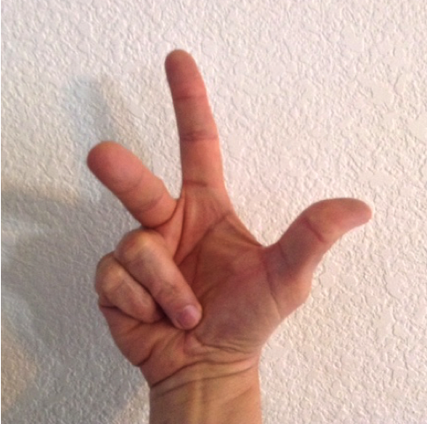

Reference line  
(x-axis)

Reference line  
(y-axis)

Reference line  
(z-axis)  
(right-handed)

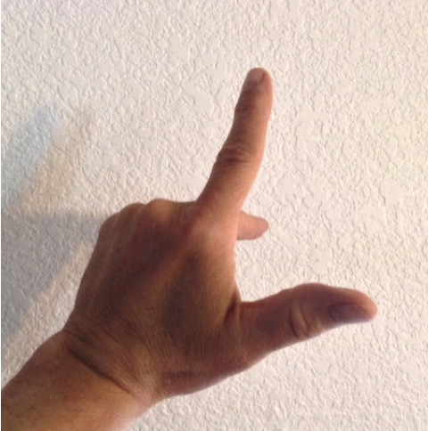

Reference line  
(x-axis)

Reference line  
(y-axis)

Reference line  
(z-axis)  
(left-handed)

Reference line  
(x-axis)

Reference line  
(y-axis)

Reference line  
(z-axis)  
(right-handed)

4

2

6

(2,4,6)