

FACULTY OF APPLIED AND HEALTH SCIENCES

DEPARTMENT OF MATHEMATICS AND PHYSICS

A BINARY ANALYSIS OF FACTORS INFLUENCING STUDENT DROPOUT RATES IN HIGHER LEARNING INSTITUTIONS.

PRESENTED BY:

BSSC/410J/2019: BRIAN RACHILO

BSSC/352J/2019: EVANS RUNG’ARE

BSSC/419J/2019: ELIZABETH NABWIRE

BSSC/332J/2019: AGNES WANJIKU

BSSC/221J/2018: ZABLON ABUYA

SUPERVISOR:

DR. ADEM AGGREY

A RESEARCH PROPOSAL SUBMITTED TO TECHNICAL UNIVERSITY OF MOMBASA FOR PARTIAL FULFILMENT OF THE AWARD OF BACHELORS DEGREE IN STATISTICS AND COMPUTER SCIENCE.

**©DECEMBER 2023**

# Declaration

We declare that this is our original work, and that it has never been submitted or produced in this institution or any other for award of any academic qualification.

NAME: BRIAN RACHILO

REG: BSSC/410J/2019

Sign: __________________________Date: ___________________________

NAME: EVANS RUNG’ARE

REG: BSSC/352J/2019

Sign: __________________________Date: ___________________________

NAME: ELIZABETH NABWIRE

REG: BSSC/419J/2019.

Sign: __________________________Date: ___________________________

NAME: AGNES WANJIKU

REG: BSSC/332J/2019.

Sign: __________________________Date: ___________________________

NAME: ZABLON ABUYA

REG: BSSC/221J/2018.

Sign: __________________________Date: ___________________________

**Supervisor**

This proposal has been submitted with my approval as the university supervisor.

Dr ADEM AGGREY

Sign: _________________ Date: _____________________

# Dedication

We dedicate this project report proposal to the Almighty Lord for providing good health and strength unto us throughout the program period. We also dedicate it to our family members and fellow classmates for the unwavering support that they granted us on one way or another.

# Acknowledgement

We would like to acknowledge the help of our able supervisor, Dr Adem Aggrey for his unwavering support and guidance throughout the period. We also thank the entire Technical University of Mombasa fraternity for their support. We would also like to acknowledge our team members for their efforts and collaborative spirit which has significantly influenced the success of this proposal.

# Abstract

Higher learning institutions face significant challenges related to student dropout rates which not only impact individual students but also have broader implications for educational institutions and society as a whole. This research sees to analyze the factors influencing student dropout rates in higher learning institutions. This study is to identify and understand the key factors that contribute to student dropout rates in higher learning institutions, using statistical methods to analyze data collected from a representative sample of higher learning institutions. The analysis aims to provide insights into the various aspects of student dropout rates and enable institutions to develop targeted interventions to mitigate dropout rates. The study shall employ a mixed-methods approach of qualitative to determine what variables affect student dropout rates and quantitative approach shall be used to validate the variables found. A comprehensive literature review shall be conducted to identify potential factors influencing student dropout rates and based on the literature, a survey instrument shall be developed to collect data from a diverse sample of students across The Technical University of Mombasa. The collected data shall include academic performance indicators, socio-economic factors, personal circumstances and institutional factors. Descriptive statistics shall be used to examine the characteristics of the sample and identify patterns in the data.

Furthermore, inferential statistics, such as logistic regression analysis shall be employed to assess the relationship between the identified factors and student dropout rates. The results of this study are significant in finding valuable insights for stakeholders involved in higher learning Institutions and offer a foundation for further research and evidence-based practices aimed at reducing dropout rates and

Improving student success in higher learning institutions

Contents

Declaration i

Dedication iii

Acknowledgement iii

Abstract iii

CHAPTER ONE 1

INTRODUCTION 1

1.1 Background Information 1

1.2 statement of the problem 1

1.3 Objectives of the study 2

1.4 Hypothesis 2

1.5 Significance of the study 2

1.6 Assumptions of this study 3

1.7 Limitations of the study 3

CHAPTER 2 4

LITERATURE REVIEW 4

2.0 Introduction 4

2.1 Main factors influencing dropout rates 4

2.2 Measuring strength of the relationship between identified factors and dropout. 14

2.3 Develop a model to predict student dropouts in higher learning institutions. 15

2.4 Summary of research gaps 16

2.5 Conclusion 19

CHAPTER 3 19

RESEARCH METHODOLOGY 19

Introduction 19

3.2.0 Target Population, Sample and Sample Procedures 19

3.2.1 Target Population 19

3.2.2 Data Collection Procedures 19

3.2.3 Sample Size 20

3.3 Research Design 21

3.3.1 Chi-square Test 21

3.3.2 Logistic Regression 21

3.4 Data Analysis 23

Assumptions of Logistic Regression 24

ETHICAL CONSIDERATIONS 24

4.0 Data analysis, presentation and interpretation of findings 25

4.1.1 Introduction 25

4.1.2 Questionnaire response rate 25

4.2 General information 25

4.3: Determine statistically significant variables influencing school dropout and assess the strength of the relationship. 27

4.3.1: Exploration by Age: 27

*4.3.2: Exploration by Gender:* 28

4.3.3: Exploration by Academic Performance: 30

4.3.4: Exploration by Health Status: 32

Assess strength of the relationship between health status and dropout 33

4.3.5: Exploration by Academic Stress and Anxiety: 33

Assess strength of the relationship between academic stress, anxiety and dropout 34

4.3.6: Exploration by Quality of Teaching: 35

4.3.7: Exploration by School Fees: 36

Assess strength of the relationship between school fees up to date and dropout 37

4.3.8: Exploration by Scholarship holder: 37

4.3.9: Exploration by Peer Influence: 39

4.3.10: Exploration by Family Crisis: 40

Assess strength of the relationship between family crisis and dropout 41

4.4.0: PREDICTIVE MODEL 42

4.4.1: INTERPRETATION OF COEFFICIENTS 42

4.4.2: INTERPRETATION OF 95% CONFIDENCE INTERVAL AND ODDS RATIO FOR STATISTICALLY SIGNIFICANT VARIABLES 44

5.0 CHAPTER FIVE 47

Introduction 47

5.1 SUMMARY 47

5.2 CONCLUSIONS 47

5.3 RECOMMENDATIONS 47

REFERENCES 49

WORKPLAN 51

Preparation of the project proposal 51

Presentation of the proposal 51

Implementation preparation (questionnaire drafting) 51

Data management and analysis 51

Submission of the project 51

Presentation of the project 51

PROJECT BUDGET 52

**LIST OF FIGURES**

Figure 1 Exploration by Age 27

Figure 2 Distribution of Dropout against Age 28

Figure 3 Pie chart for Distribution of Gender 28

Figure 4 Distribution of Dropout against gender 29

Figure 5 Distribution of Dropout against Academic Performance 30

Figure 6 Distribution of Dropout against Health Status 32

Figure 7 distribution of dropout against academic stress and anxiety 33

Figure 8 distribution of dropout against quality of teaching 35

Figure 9 Distribution of Dropout against School fees up to date 36

Figure 10 **Distribution of Dropout against Scholarship holder** 37

Figure 11 : Distribution of Dropout against Peer influence 39

Figure 12 Distribution of Dropout against Family crisis 40

Figure 13 Logistic Regression Summary results 42

Figure 14 Logistic Regression 95% CI, Odds Ratio and P-values results 44

Figure 15 Train/Test split Summary results 45

Figure 16 Area Under the ROC Curve 46

**LIST OF TABLES**

Table 1 variables 26

Table 2 dropouts against gender 29

Table 3 Dropout against Academic Performance 30

Table 4 Dropout against Health Status 32

Table 5 Dropout against Academic stress and anxiety 34

Table 6 Dropout against Quality of Teaching 35

Table 7 Dropout against School fees up to date 36

Table 8 Dropout against Scholarship 38

Table 9 Dropout against Peer influence 39

Table 10 Dropout against Family Crisis 40

# CHAPTER ONE

# INTRODUCTION

## 1.1 Background Information

The decision to leave college without completing a degree can have long-lasting effects on a person's educational attainment, career prospects, and general well-being and in extension a countries preparedness to dealing with economic problems are also affected. A study carried out by Helen Vlasova (2020) shows that out of the total enrolments of students in higher learning institutions shows that 33% of students drop out of their respective colleges before completing their enrolled courses. This translates to an alarming number going by the higher enrolments witnessed every year. Therefore, understanding the factors that contribute to drop-outs in higher learning institutions is crucial for these institutions and policymakers to develop efficient strategies to mitigate these issues and support student success.

## 1.2 statement of the problem

High dropout rates in higher learning institutions have become a growing concern worldwide, posing significant challenges to both educational institutions and students. This statistical research aims to investigate and identify the key factors contributing to student dropouts in higher learning institutions. In recent years, various studies have investigated the factors affecting school dropout among students in higher learning institutions using different analytical methods such as regression analysis, descriptive statistics and correlation analysis. Some have employed simple linear regression to examine the relationship between individual variables and student dropout. Others have used surveys to gather data on students' dropout in higher learning institutions, analyzing the results using basic statistical tools. However, there is a noticeable gap in the literature regarding the application of logistic regression to model these factors comprehensively. Logistic regression helps to eliminate the limitations of simple linear regression by modeling both quantitative and qualitative predictors within the same model.

Therefore, this study aims to address this gap by utilizing logistic regression to identify and understand the key determinants influencing student dropout in higher learning institutions. Through more comprehensive research the study seeks to identify the most influential factors that contribute to student dropout in higher learning institutions. By addressing these research questions, this study aims to provide valuable insights into the multifaceted problem of student dropouts in higher learning institutions, ultimately guiding policymakers, educators, and stakeholders in developing effective interventions to reduce dropout rates and enhance student success.

## 1.3 Objectives of the study

The objectives of this study are:

* + 1. Determine which factors or variables (such as demographics, academic factors and socio-economic status) are statistically significant in influencing student dropouts.
    2. To measure the strength of the relationships between the identified factors and student dropout rates.
    3. Develop a model to predict student dropouts in higher learning institutions.

## 1.4 Hypothesis

Ho: There is no significant relationship between the identified factors and dropout in higher learning institutions.

H1: There is a significant relationship between the identified factors and dropout rates in higher learning institutions.

## 1.5 Significance of the study

This study holds significant importance for various stakeholders, including educational institutions, policymakers, and students themselves. By understanding the factors responsible for college drop-outs, institutions can develop targeted support programs and interventions to enhance student success and improve retention and graduation rates which are indicators of an effective and supportive higher education system. Policymakers can utilize the findings to make informed decisions aimed at reducing college drop-outs and increasing educational attainment. Additionally, students can benefit from this study by gaining insights into potential challenges they may face during their college journey thus improving student success. By addressing the underlying factors that influence dropout, institutions can improve their overall performance and create a positive learning environment that attracts and retains students.

## 1.6 Assumptions of this study

All the respondents will be co-operative and honest and will provide objective information pertaining to dropouts in higher learning institutions.

All respondents will be competent enough to understand the questions and those who will not will seek clarifications from the researcher.

## 1.7 Limitations of the study

The study will focus on the students at Technical University of Mombasa as the sample population, which may not be the scenario at other higher learning institutions.

# CHAPTER 2

# LITERATURE REVIEW

## 2.0 **Introduction**

The purpose of this chapter is to provide a comprehensive review of the existing literature on factors contributing to student dropouts in higher learning institutions. This section aims to identify key factors, trends and gaps in the current understanding of the issue. Insights gained from this literature review will inform the design and methodologies of the proposed statistical research.

## 2.1 Main factors influencing dropout rates

The research project aims to investigate and identify the various factors that contribute to high dropout rates in higher learning institutions. This could include academic, social-economic and psychological and emotional factors.

Early Prediction of University Dropouts (Behr et al., 2020): In this study, logistic regression was employed as part of a random forest approach to predict university dropouts. Logistic regression models was used to analyze the impact of various predictor variables (such as academic performance, socioeconomic factors, and demographic information) on the likelihood of student dropout. The results from these models contributed to the overall predictive accuracy of the random forest model.

Academic factors are aspects related to a student's educational experience and performance that can influence their decision to drop out of school. Some of these factors include; academic preparedness, course difficulty and workload, Poor academic performance, lack of academic support, classroom environment, academic policies and regulations, lack of interest in the course, unclear academic goals. Tayebi, Gomez, and Delgado (2021) conducted an analysis on the lack of motivation and its relationship to dropout rates among engineering students in Spain. Their study underscores the critical role of motivation in student retention and highlights the adverse impact of a lack of motivation on dropout rates.

Social economic factors have a significant influence on student dropout rates in higher learning institutions, as numerous studies have revealed. These factors encompass economic and social conditions that can hinder students' ability to pursue and complete their education. Financial constraints, work-related obligations, family responsibilities, housing and transport challenges, health and wellbeing and limited access to academic support are among the key factors contributing to dropout.

Research by Chetty et al. (2017) examined income inequality and its impact on college completion rates. They found that students from lower-income backgrounds faced greater challenges in completing college, highlighting the role of socioeconomic factors. The availability and adequacy of financial aid programs continue to be a topic of research. A study by Dynarski (2017) discussed the importance of targeted financial aid policies to reduce dropout rates among disadvantaged students.

Psychological and emotional factors play a crucial role in student dropout rates, impacting their motivation, mindset, and emotional well-being. Here are some examples of psychological and emotional factors that can contribute to student dropout. Some of these factors include; high level of stress, low self-esteem, perceived irrelevance, mental health, anxiety, lack of motivation, impostor syndrome, and lack of resilience. Mental Health: Research has shown that mental health issues, such as anxiety and depression, can significantly affect students' ability to persist in higher education. A study by Auerbach et al. (2018) found that mental health challenges are prevalent among college students and can be a barrier to academic success.

Demographic factors influencing student dropout in higher learning institutions

Age:

Research consistently shows that age is a significant demographic factor affecting student dropout rates in higher education. Older students, particularly those over the age of 25, exhibit a higher propensity to drop out compared to their younger counterparts. Data from the National Center for Education Statistics (NCES) in 2018 underscores this disparity, with a 34% dropout rate for students aged 25 and over, a stark contrast to the 21% dropout rate among students under 25. This trend is influenced by several factors, including the additional responsibilities that older students often carry, such as work, family, or financial obligations, which can create a challenging balancing act. Moreover, older students may have distinct educational goals and expectations, which influence their likelihood of persisting in college. To address this issue effectively, it is vital to comprehend the specific needs and challenges of older students and develop tailored support and retention strategies.

Gender:

Gender is another crucial demographic factor that researchers have extensively examined concerning student dropout rates. Historically, data from the National Center for Education Statistics (NCES) indicates that women generally have a lower dropout rate in higher education compared to men. In 2018, the data illustrated this gender gap, revealing a 37% dropout rate for men and a 30% dropout rate for women. Although the gender gap in dropout rates may be narrowing, it prompts critical questions about the gender-related factors influencing these disparities. Possible explanations include differences in educational goals and expectations, social roles, and access to support systems. Addressing gender-related disparities in dropout rates involves understanding and mitigating complex socio-cultural and psychological factors that influence student success.

Race/Ethnicity:

The influence of race and ethnicity on student dropout rates is a multifaceted issue, often shaped by historical, socio-economic, and systemic factors. Research conducted by organizations like the National Student Clearinghouse Research Center has shed light on the disparities in dropout rates among different racial and ethnic groups. For instance, Black students tend to experience a higher dropout rate compared to White students. However, it's important to note that these figures can vary widely based on location and the specific institution under study. Factors contributing to these disparities may include unequal access to educational resources, discrimination, and socioeconomic inequalities. Addressing the racial and ethnic disparities in college dropout rates requires a comprehensive approach, including policy changes, support programs, and efforts to enhance inclusivity and equity in higher education.

Socioeconomic Status:

Socioeconomic status is a powerful predictor of student dropout rates in higher education. A study conducted by the Pell Institute in 2013 highlighted the significant impact of family income on college persistence, revealing a troubling 55% dropout rate for students from the lowest income quartile. This underscores the challenges faced by economically disadvantaged students, including financial constraints, the need to work while attending school, and limited access to academic support and resources. Socioeconomic status not only affects a student's ability to afford college but also shapes their overall college experience. To mitigate disparities, institutions and policymakers must consider financial aid, scholarships, and support services that address these barriers and improve retention rates among students from lower-income backgrounds.

First-Generation Status:

First-generation college students, those whose parents did not attend college, often face unique challenges in navigating the higher education system. The National Center for Education Statistics reported a 32% dropout rate for first-generation students in 2018, significantly higher than the 18% dropout rate for students with at least one parent who had completed a bachelor's degree. These students frequently lack the family experience and guidance critical in understanding and addressing the academic and logistical challenges of college life. Consequently, they may be less prepared for the academic demands and may grapple with feelings of isolation or imposter syndrome. Supporting first-generation students necessitates targeted mentorship, academic advising, and orientation programs that help them transition into the academic environment and overcome specific obstacles they face.

Academic factors influencing dropouts

Various studies have been conducted to investigate the causes and factors responsible for college dropout. Among the various factors, academic factors have been found to be significant contributors to college dropout (Aronson, 2002; Tinto, 1975). This research aims to examine the existing literature on academic factors responsible for college dropout.

Academic Preparation: One critical academic factor associated with college dropout is academic preparation. Tinto's seminal work in 1975 found that students who are academically unprepared or struggle to adapt to college's rigorous academic demands face a significantly higher risk of dropping out. Supporting this, Roksa and Calcagno's study in 2008 revealed that students with weaker academic backgrounds or lower GPAs were indeed at a higher risk of dropping out. Specifically, students with GPAs below 2.0 had a dropout rate of 44%, compared to only 11% for those with GPAs above 3.0 (Roksa & Calcagno, 2008; Tinto, 1975).

Academic Motivation: Another crucial academic factor influencing college dropout is academic motivation. Bean and Metzner's research in 1985 found a compelling link between low academic motivation and dropout rates. They discovered that students lacking academic motivation were more likely to disengage from academic activities, leading to poor performance and an increased likelihood of dropping out. Specifically, students reporting low motivation were 2.5 times more likely to drop out compared to their highly motivated peers (Bean & Metzner, 1985). Tayebi, Gomez, and Delgado (2021) conducted an analysis on the lack of motivation and its relationship to dropout rates among engineering students in Spain. Their study underscores the critical role of motivation in student retention and highlights the adverse impact of a lack of motivation on dropout rates.

Academic Expectations: Students' academic expectations and perceptions of the value of college education have been consistently identified as influential factors in college retention. Alexander's study in 2012 and Tinto's work in 1975 emphasized that students with high academic expectations and positive attitudes toward college education were more likely to commit to academic success, thereby reducing the chances of dropping out. The statistics revealed that students with positive academic attitudes had a dropout rate of only 14%, compared to 32% for those with negative attitudes (Alexander, 2012; Tinto, 1975).

Academic Advising and Support Services: Addressing academic factors contributing to college dropout, academic advising, and support services have proven to be effective strategies. Braxton, Hirschy, and McClendon's comprehensive study in 2004 demonstrated the significant impact of academic support services. Their findings revealed that students with access to these services, such as academic counseling, tutoring, and mentoring, experienced a 20% higher retention rate than those without such support (Braxton, Hirschy, & McClendon, 2004).

Academic Engagement: Finally, academic engagement, encompassing students' active participation in academically related activities, is a pivotal determinant. Kuh's research in 2009 showed that students with low academic engagement, grades, and academic integration were substantially more likely to drop out.

Specifically, students with poor academic engagement are three times more likely to drop out compared to their highly engaged peers (Kuh, 2009).

Academic Underperformance and Dropout Risk:

Furthermore, both Smith and Johnson's studies revealed that academic underperformance was a precursor to dropout. Smith's regression analysis indicated that students with declining GPAs were 2.3 times more likely to discontinue their education (p < 0.001). Johnson's chi-square test demonstrated that 68% of students who discontinued their education reported struggling to keep up with coursework due to work and financial pressures (χ² = 42.89, p < 0.01). Behr et al. (2020) utilized a random forest approach to predict early university dropouts. Their study highlights the significance of academic performance as a predictor of student attrition, providing a data-driven perspective on academic-related factors contributing to dropout rates.

Social economic factors

As one of the ever-increasing factors leading to college dropouts among students, socio-economic factors have in recent past raised concerns and the need to look deep into it as to why it remains a key contributor to dropout rates in higher learning institutions according to (Brown 2022). This study seeks to look into the four main factors contributing to this issue among them; financial constraints, mental health, college environment and peer influence and substance abuse.

Financial constraints have been extensively studied in relation to college dropouts, and statistical tests and figures underscore their profound impact on higher learning institutions. Smith (2021) and Johnson (2022) conducted comprehensive analyses, revealing compelling evidence regarding the influence of financial constraints on dropout rates.

Tuition Costs and Financial Strain:

Smith's study, which employed regression analysis, found a strong correlation between rising tuition costs and dropout rates (p < 0.001). Specifically, over the past decade, there has been a 45% increase in average tuition fees at public four- year institutions (NCES, 2021). This substantial rise has disproportionately affected students from low-income families, with 63% of them reporting that tuition costs were a major concern (National Student Clearinghouse Research Center, 2020).

Employment and Time Allocation:

Johnson's research, utilizing a chi-square test, established a significant relationship between students' employment status and academic performance (χ² = 34.21, p < 0.05). Notably, 78% of undergraduates held part-time jobs (NCES, 2021). The statistics indicate that students who work more than 20 hours per week are 1.5 times more likely to underperform academically compared to their non-working peers (Bureau of Labor Statistics, 2018).

Mental health issues have been extensively studied in the context of college dropout rates, with various statistical tests and robust evidence underscoring their significant contribution to higher learning institutions' dropout rates. Brown's recent study in 2022 provides compelling insights into the nexus between mental health and dropout rates.

Impact of Mental Health on Academic Performance:

Brown's research, which incorporated logistic regression analysis, found a statistically significant association between mental health conditions and academic performance (p < 0.001). Notably, students with diagnosed mental health conditions, such as anxiety and depression, were 2.7 times more likely to experience academic struggles and a subsequent increased risk of dropout. This relationship has been consistently observed in multiple studies (Smith et al., 2020; Johnson, 2021).

Coping with Stress and Isolation:

The challenges of college life, coupled with academic pressures, often exacerbate pre-existing mental health conditions or trigger new ones among students. This was confirmed by a nationwide survey conducted by the American College Health Association (ACHA) in 2019, which revealed that 72% of college students felt overwhelming anxiety during the academic year (ACHA, 2019). Coping with stress, anxiety, and depression can lead to academic struggles, as evidenced by a 15% decline in GPA among students with mental health conditions (Smith et al., 2020). Social isolation is also a prevalent issue, with 60% of students experiencing feelings of loneliness (ACHA, 2019).

Access to Mental Health Support:

One critical factor contributing to dropout rates is the lack of sufficient mental health support and resources on campuses. Only 22% of colleges and universities provide comprehensive mental health services (ACHA, 2020). As a result, many students seek help outside their academic environment, further diminishing their connection to the institution. This exodus from campus resources significantly heightens the likelihood of dropping out.

These rigorous statistical tests, establishes a strong link between mental health and college dropout rates. The challenges of college life, compounded by academic pressure, can trigger mental health conditions, leading to academic struggles, social isolation and a lack of motivation to continue studies. The difficulty of accessing mental health support exacerbates the problem, making it increasingly challenging for students to manage their emotional well-being and, consequently, increasing the likelihood of dropping out.

College environment indeed plays a substantial role in contributing to dropout rates, as evidenced by various statistical tests and supported by studies conducted by Smith (2021) and Johnson (2020). The competitive and demanding academic atmosphere prevalent in higher learning institutions has been subject to thorough examination.

Academic Stress and Burnout:

Smith's research, which included a comprehensive survey and analysis, revealed a statistically significant relationship between academic stress and dropout rates (p

< 0.01). The study found that 60% of students reported experiencing high levels of stress due to the intense academic environment. Furthermore, burnout, which was experienced by 42% of students, was significantly associated with a 2.5 times higher likelihood of dropping out (p < 0.001).

Lack of Personalized Support:

Johnson's study conducted in 2020 employed both qualitative and quantitative methods to explore the impact of faculty and staff support on student persistence. The analysis showed that students who perceived a lack of personalized attention and support were 1.7 times more likely to consider dropping out (p < 0.05). Alarmingly, 35% of students reported feeling overwhelmed and disconnected from the institution due to this lack of support.

Hostile Learning Environment and Feelings of Isolation:

Furthermore, Johnson's research illuminated the significance of a supportive learning environment. Students who reported experiencing hostility or a lack of belonging in their academic community had a 2.3 times higher risk of dropping out (p < 0.01). This highlights how an unsupportive atmosphere can foster feelings of isolation and disconnection, discouraging students from continuing their studies.

Limited Access to Academic Resources:

In addition to the social and emotional factors, limited access to academic resources compounds the challenges students face. Statistical analysis from the National Center for Education Statistics (NCES) reveals that in 2019, only 42% of institutions provided comprehensive tutoring services (NCES, 2021).

This limitation hinders struggling students from catching up with their coursework, ultimately increasing the likelihood of dropping out.

Statistical evidences and research findings from Smith and Johnson highlight the pivotal role of the college environment in dropout rates. The competitive academic atmosphere, coupled with insufficient personalized support, can induce stress, anxiety, and burnout among students. Additionally, a hostile or unsupportive learning environment can foster feelings of isolation and detachment, further discouraging students from persisting in their studies.

Peer influence and substance abuse as contributors to higher dropout rates in learning institutions have indeed been the subject of various statistical analyses and studies, as exemplified by research conducted by Smith in 2019 and Johnson in 2022.

To substantiate these claims, a t-test analysis was conducted on a sample of 500 students from various institutions. The results indicated a statistically significant relationship between peer influence and substance abuse, with a p-value of less than 0.001 (p < 0.001). This demonstrates a strong association between peer influence and substance abuse among students.

Furthermore, Johnson's study in 2022 revealed that when students are influenced by their peers engaged in substance abuse, it leads to adverse consequences. A paired-sample t-test was employed to measure the impact of substance abuse on academic performance. The results showed a significant decrease in GPA among students exposed to substance-abusing peers, with a mean GPA difference of 0.45 (t (250) = -5.82, p < 0.001).

Additionally, the same study by Johnson found that substance abuse was linked to social isolation and mental health issues among students. Using a chi-squared test, it was found that 40% of students engaged in substance abuse reported feelings of social isolation compared to only 15% of non-users (χ² (1, N = 300) = 45.24, p < 0.001).

Moreover, legal and disciplinary repercussions stemming from substance abuse were investigated. A logistic regression analysis demonstrated that students who engaged in substance abuse were three times more likely to face disciplinary actions and legal consequences (odds ratio = 3.0, 95% CI [2.0, 4.5], p < 0.001).

These statistical analyses and figures provide robust evidence supporting the assertion that peer influence and substance abuse are significant factors contributing to higher dropout rates in learning institutions, with implications for academic performance, mental health, and legal outcomes.

The amount of information on individual students and that recorded during their education have increased rapidly “Wook, M.; Yusof, Z.M.; Nazri, M.Z.A. Educational data mining acceptance among undergraduate students. (2016).” Several studies have been conducted to extract and utilize meaningful information from such data. Some studies “Dass, S.; Gary, K.; Cunningham, J. Predicting Student Dropout in Self-Paced MOOC Course Using Random Forest Model (2021) and Feng, W.; Tang, J.; Liu, T.X. Understanding Dropouts in MOOCs (2019)” propose methods to predict dropout based on student attendance records in online environments (e.g., MOOC and Coursera). Since these studies are conducted in an online environment, there is no need to consider behavior patterns outside attendance records, such as club activities.

Machine learning techniques are effective in the field of education for evaluating student performance, and several studies “Cannistrà, M.; Masci, C.; Ieva, F.; Agasisti, T.; Paganoni, A.M. Early-predicting dropout of university students: ‘An application of innovative multilevel machine learning and statistical techniques’ (2021), Opazo, D.; Moreno, S.; Álvarez-Miranda, E.; Pereira, J. (2021), Sandoval-Palis, I.; Naranjo, D.; Vidal, J.; Gilar-Corbi, R.(2020), Silva, J.; Matos, L.F.A.; Mosquera, C.M.; Mercado, C.V.; González, R.B.; Llinás, N.O.; Lezama, O.B.P. (2020), Del Bonifro, F.; Gabbrielli, M.; Lisanti, G.; Zingaro, S.P.(2020), Rodríguez-Muñiz, L.J.; Bernardo, A.B.; Esteban, M.; Díaz, I. (2019) , Aulck, L.; Velagapudi, N.; Blumenstock, J.; West, J (2016), Kabathova, J.; Drlik, M. (2021) and Kotsiantis, S.B.; Pierrakeas, C.J.; Pintelas (2003)” compare the performance of machine learning methods on the dropout prediction task. The study “Sandoval-Palis, I.; Naranjo, D.; Vidal, J.; Gilar-Corbi, R. Early dropout prediction model: A case study of university levelling course students. (2020)” employed a logistic regression and artificial neural networks to predict the student dropout rate using data of high school students. In a different approach “Silva, J.; Matos, L.F.A.; Mosquera, C.M.; Mercado, C.V.; González, R.B.; Llinás, N.O.; Lezama, O.B.P. Prediction of academic dropout in university students using data mining: Engineering case. (2020)”, the researchers focused on tree-based decision classification to predict student dropout considering students’ economic circumstances.

Meanwhile, the study “Opazo, D.; Moreno, S.; Álvarez-Miranda, E.; Pereira, J. Analysis of First-Year University Student Dropout through Machine Learning Models: A Comparison between Universities. (2021)” used various machine learning methods to analyse the dropout rate of freshmen engineering students and found that entering university score was a critical variable in predicting dropout. However, these studies only utilize demographic information available before admission, whereas predicting student dropout often requires academic information from universities.

Recent studies “Del Bonifro, F.; Gabbrielli, M.; Lisanti, G.; Zingaro, S.P. Student dropout prediction. In Proceedings of the International Conference on Artificial Intelligence in Education (AIED) (2020) and Pellagatti, M.; Masci, C.; Ieva, F.; Paganoni, A.M. Generalized mixed-effects random forest: A flexible approach to predict university student dropout. (2021)” have shown that academic information can help predict dropout probability. The study “Pellagatti, M.; Masci, C.; Ieva, F.; Paganoni, A.M. (2021)” applied a generalized mixed-effects random forest to predict the probability of engineering students dropping out based on student-level information and degree programs. Another study “Del Bonifro, F.; Gabbrielli, M.; Lisanti, G.; Zingaro, S.P. Student dropout prediction. In Proceedings of the International Conference on Artificial Intelligence in Education (AIED) (2020)” used machine learning techniques to predict freshmen dropout using secondary school academic records and first-year course credits.

Several researchers “Alam, M.A.U. College student retention risk analysis from educational database using multi-task multi-modal neural fusion. (2022) and Jayaraman, J.D. Predicting Student Dropout by Mining Advisor Notes. (2020)” predict student dropout using unstructured data. The study “Jayaraman, J.D. Predicting Student Dropout by Mining Advisor Notes. In Proceedings of the 13th International Conference on Educational Data Mining (EDM) (2020)” extracted student sentiment from advisor notes written by student advisors to predict student dropout. In a recent study “Alam, M.A.U. College student retention risk analysis from educational database using multi-task multi-modal neural fusion. (2022)”, the authors utilized temporal structured data and unstructured counselling data from all semesters to predict college student dropout using a PLM. However, because these studies train on structured and unstructured data separately, they lack the ability to capture the relationships between the data. In this study, we propose a method for formulating structured data in the format of unstructured data and concatenating them to understand the relationships between the data. To the best of our knowledge, this is the first attempt to capture the relationships between structured and unstructured data in a dropout prediction task.

## 2.2 Measuring strength of the relationship between identified factors and dropout.

Johnson and Smith (2017) embarked on an extensive exploration of the intricate relationship between socioeconomic status (SES) and its implications on educational outcomes. Their meticulous analysis encompassed an array of studies, demonstrating a particular emphasis on employing rigorous regression analyses to unveil the underlying dynamics. Through their comprehensive meta-analysis, Johnson and Smith unearthed compelling evidence of the influence of SES on high school dropout rates. Their regression models revealed that even a modest one-unit increase in SES correlated with a substantial reduction in high school dropout rates, with a striking regression coefficient of -0.45 (p < 0.01). This finding illuminated the critical role socioeconomic factors play in educational attainment, prompting further inquiry into mechanisms for addressing disparities.

Parallelly, Garcia and Hernandez (2018) embarked on a longitudinal expedition to unravel the impact of parental involvement on student success. Their research leveraged sophisticated regression analyses, revealing a notably positive direction in the relationship between parental engagement and student outcomes. In their longitudinal study, every incremental unit increase in parental involvement was associated with a remarkable 10% decrease in dropout rates, a pivotal finding supported by a statistically significant coefficient of -0.10 (p < 0.05). This result underscored the significance of nurturing a strong partnership between parents, students, and educational institutions as a potent strategy in reducing dropout rates.

Concurrently, Anderson and Thompson (2017) embarked on a large-scale survey designed to delve into the multifaceted issue of academic performance's impact on dropout rates. Their exhaustive data collection and regression analyses unveiled a compelling and statistically significant negative relationship between academic performance and dropout rates. An impressive R-squared value of 0.20 signified that academic performance had a profound explanatory power, elucidating 20% of the variance in dropout rates. This discovery underscored the vital role of scholastic achievement in mitigating the risk of dropping out.

Further contributing to the body of knowledge, Smith and Brown (2012) delved into the often-underestimated factor of student attendance and its substantial influence on dropout rates. Employing a meticulous regression analysis, their study indicated that for each incremental 5% improvement in attendance, dropout rates precipitously declined by a significant 15% (coefficient = -0.15, p < 0.001). This finding served as a poignant reminder of the practical implications of student engagement and attendance in the quest to combat dropout rates.

Additionally, the National Center for Education Statistics (2017) offered a comprehensive overview of the state of high school dropout rates in the United States, supported by rigorous data analysis. Their report, underpinned by robust statistical methodologies, highlighted a national dropout rate of 8.5%. The study also drew attention to regional disparities, shedding light on geographical variations in dropout rates, and thereby contributing essential insights for targeted interventions.

Lastly, Johnson's (2017) pioneering research effort encompassed a comparative analysis of urban and rural educational settings. Employing logistic regression models, the study disclosed intriguing variations in the predictors of dropout rates between these distinct contexts. Notably, statistically significant coefficients emerged, with parental involvement exerting differential influences (urban: coefficient = -0.25, p < 0.01; rural: coefficient = -0.15, p < 0.05). These findings unveiled the complex interplay of socio-environmental factors, underscoring the necessity for tailored strategies to combat dropout rates within specific community contexts.

## **2.3 Develop a model to predict student dropouts in higher learning institutions**.

The amount of information on individual students and that recorded during their education have increased rapidly “Wook, M.; Yusof, Z.M.; Nazri, M.Z.A. Educational data mining acceptance among undergraduate students. (2016).” Several studies have been conducted to extract and utilize meaningful information from such data. Some studies “Dass, S.; Gary, K.; Cunningham, J. Predicting Student Dropout in Self-Paced MOOC Course Using Random Forest Model (2021) and Feng, W.; Tang, J.; Liu, T.X. Understanding Dropouts in MOOCs (2019)” propose methods to predict dropout based on student attendance records in online environments (e.g., MOOC and Coursera). Since these studies are conducted in an online environment, there is no need to consider behaviour patterns outside attendance records, such as club activities.

Machine learning techniques are effective in the field of education for evaluating student performance, and several studies “Cannistrà, M.; Masci, C.; Ieva, F.; Agasisti, T.; Paganoni, A.M. Early-predicting dropout of university students: ‘An application of innovative multilevel machine learning and statistical techniques’ (2021), Opazo, D.; Moreno, S.; Álvarez-Miranda, E.; Pereira, J. (2021), Sandoval-Palis, I.; Naranjo, D.; Vidal, J.; Gilar-Corbi, R.(2020), Silva, J.; Matos, L.F.A.; Mosquera, C.M.; Mercado, C.V.; González, R.B.; Llinás, N.O.; Lezama, O.B.P. (2020), Del Bonifro, F.; Gabbrielli, M.; Lisanti, G.; Zingaro, S.P.(2020), Rodríguez-Muñiz, L.J.; Bernardo, A.B.; Esteban, M.; Díaz, I. (2019) , Aulck, L.; Velagapudi, N.; Blumenstock, J.; West, J (2016), Kabathova, J.; Drlik, M. (2021) and Kotsiantis, S.B.; Pierrakeas, C.J.; Pintelas (2003)” compare the performance of machine learning methods on the dropout prediction task. The study “Sandoval-Palis, I.; Naranjo, D.; Vidal, J.; Gilar-Corbi, R. Early dropout prediction model: A case study of university levelling course students. (2020)” employed a logistic regression and artificial neural networks to predict the student dropout rate using data of high school students. In a different approach “Silva, J.; Matos, L.F.A.; Mosquera, C.M.; Mercado, C.V.; González, R.B.; Llinás, N.O.; Lezama, O.B.P. Prediction of academic dropout in university students using data mining: Engineering case. (2020)”, the researchers focused on tree-based decision classification to predict student dropout considering students’ economic circumstances.

Meanwhile, the study “Opazo, D.; Moreno, S.; Álvarez-Miranda, E.; Pereira, J. Analysis of First-Year University Student Dropout through Machine Learning Models: A Comparison between Universities. (2021)” used various machine learning methods to analyse the dropout rate of freshmen engineering students and found that entering university score was a critical variable in predicting dropout. However, these studies only utilize demographic information available before admission, whereas predicting student dropout often requires academic information from universities.

Recent studies “Del Bonifro, F.; Gabbrielli, M.; Lisanti, G.; Zingaro, S.P. Student dropout prediction. In Proceedings of the International Conference on Artificial Intelligence in Education (AIED) (2020) and Pellagatti, M.; Masci, C.; Ieva, F.; Paganoni, A.M. Generalized mixed-effects random forest: A flexible approach to predict university student dropout. (2021)” have shown that academic information can help predict dropout probability. The study “Pellagatti, M.; Masci, C.; Ieva, F.; Paganoni, A.M. (2021)” applied a generalized mixed-effects random forest to predict the probability of engineering students dropping out based on student-level information and degree programs. Another study “Del Bonifro, F.; Gabbrielli, M.; Lisanti, G.; Zingaro, S.P. Student dropout prediction. In Proceedings of the International Conference on Artificial Intelligence in Education (AIED) (2020)” used machine learning techniques to predict freshmen dropout using secondary school academic records and first-year course credits.

Several researchers “Alam, M.A.U. College student retention risk analysis from educational database using multi-task multi-modal neural fusion. (2022) and Jayaraman, J.D. Predicting Student Dropout by Mining Advisor Notes. (2020)” predict student dropout using unstructured data. The study “Jayaraman, J.D. Predicting Student Dropout by Mining Advisor Notes. In Proceedings of the 13th International Conference on Educational Data Mining (EDM) (2020)” extracted student sentiment from advisor notes written by student advisors to predict student dropout. In a recent study “Alam, M.A.U. College student retention risk analysis from educational database using multi-task multi-modal neural fusion. (2022)”, the authors utilized temporal structured data and unstructured counselling data from all semesters to predict college student dropout using a PLM. However, because these studies train on structured and unstructured data separately, they lack the ability to capture the relationships between the data. In this study, we propose a method for formulating structured data in the format of unstructured data and concatenating them to understand the relationships between the data. To the best of our knowledge, this is the first attempt to capture the relationships between structured and unstructured data in a dropout prediction task.

## 2.4 Summary of research gaps

|  |  |  |  |  |  |
| --- | --- | --- | --- | --- | --- |
| **year** | **Title** | **Methodology** | **Findings** | **Gap** | **Filling the Gap** |
| 2023  8th Feb | Demographics and transcripts  record factors influencing  student dropout in Columbia | Multiple  Regression  Analysis and T-test | The findings indicated that demographic factors and transcripts record are also key contributors of dropout rates | This study examined  only the demographic  factors and transcripts  Record leading to the overall explanatory power of the model being low. | Current research will therefore identify other determinants of students’ dropout (social –economic and psychological factors) apart from demographic factors and academic factors |
| 2022 | A study of external students enrolled in the fourth year of the Bachelor of Education program at Edith Cowan University to determine attrition and persistence | Logistic  Regression  And  Multiple linear regression | The findings show that external students enrolled in the fourth year of their study are more likely to dropout | The study only focused on students at one academic year and faculty which gave a sample size not large to represent the population. | The study will focus on students in the entire university and also analyze other important determinants of student attrition among others behavioral factors and socioeconomic factors. |
| 2022 | Factors influencing dropout of students at private universities in Central Java, Indonesia | Mixed quantitative and qualitative research | The findings reveal that personal economic factors, academic satisfaction, academic performance, and family economics are the most influential when it comes to students’ attrition in higher learning institutions. | The study only focused on private universities in Indonesia  and Central Java which excludes public universities which generally have the majority students. | This study will focus on students in a public university (Technical University of Mombasa) and generalize the results to both private and public universities. |
| 2018 | A study of how academic performance influence student attrition in Peru state college. | T-test | Academic performance is the main factor that influence students’ attrition. The findings reveal that there is a very strong correlation between students who dropout and poor academic grades**.** | The study only identified the major factor  Influencing students  attrition. | Current study will further determine the correlations among various determinants identified such as social-economic factors and psychological and motivational factor |

## 2.5 Conclusion

Addressing the complexities requires a multi facet approach involving higher education institutions and policymakers. Strategies such as strengthening financial aid programs, enhancing academic support, providing mental health services and stablishing mentorship initiatives can mitigate social economic challenges and boost college completion rates for disadvantaged students. Creating an inclusive and supportive educational environment is essential to nurturing student success and ensuring equitable access to higher education

# CHAPTER 3

# RESEARCH METHODOLOGY

## Introduction

Methodology of studying the factors responsible for college drop-out is crucial in gaining a comprehensive understanding of the reasons why students leave college before completing their degree programs. It will guide the research design, data collection, and analysis to identify the various factors that contribute to college drop-out rates, to gain insights into the underlying causes of the college dropouts

## 3.2.0 Target Population, Sample and Sample Procedures

### 3.2.1 Target Population

The population targeted will be the students from higher learning institutions.

### 3.2.2 Data Collection Procedures

Data for this study will be collected using questionnaires from students in higher learning institutions.

### 3.2.3 Sample Size

Sample size will be estimated using Cochran’s formula

$N=\frac{Z^{2}*p*(1-p)}{e^{2}}$ (3.1)

Where z is 1.96 at 95% confidence level

e- is the margin error and is 5%

P = 0.5 is the estimated proportion of the population.

1.962 ∗ 0.5 ∗ (1 − 0.5)

0.052

This study will use an estimated sample size of 385.

## 3.3 Research Design

### 3.3.1 Chi-square Test

A chi-square test is used to test the association between categorical variables. This test will be used to determine the significance of categorical variables influencing dropout.

### 3.3.2 Logistic Regression

Binary Logistic Regression will be used since we are interested in knowing the probability of one dropping out of school or not.

Logit Model is given as;

$z=\log\left(\frac{π}{1-π}\right)$ = $β_{0}$ + $β_{1}Х$ (3.2)

$\frac{π}{1-π}$ = $e^{β_{0} + β_{1}Х}$

π = $e^{β_{0} + β_{1}Х}$- π $e^{β_{0} + β_{1}Х}$

π + π $e^{β_{0} + β_{1}Х}$ = $e^{β_{0} + β_{1}Х}$

π $\left(1+ e^{β_{0} + β_{1}Х}\right)$ = $e^{β_{0} + β_{1}Х}$

π = $\frac{e^{β_{0} + β_{1}Х}}{1+ e^{β_{0} + β_{1}Х}}$ (3.3)

p $\left(y=1\right)$ = π = $\frac{e^{z}}{1+e^{z}}$ (3.4)

where;

Ζ = $β_{0}$ + $β_{1}X_{1}$ + $β_{2}X_{2}$ + … + $β_{n}X_{k}$

$\log\left(\frac{π}{1-π}\right)$ = $β_{0}$ + $β_{1}X_{1}$ + $β_{2}X_{2}$ + … + $β_{n}X_{k}$ (3.5)

π - Probability of success (Dropping out of school)

$β_{0}$– Intercept

$β_{1},$ $β_{2,}$… $β_{n}$– Parameter coefficients for independent variables.

$X_{1}$, ${ X}_{2},$… ${,X}_{k}$– The independent variables

## 3.4 Data Analysis

Logistic regression Analysis will be used to come up with a prediction model based on the factors influencing school dropouts in higher learning institutions. This model is the most suitable to model binary categorical variables using numerical and categorical predictors.

* Dependent Variable (Y): Dropout (1=Yes, 0 = No)
* Independent Variables (X):

$\log\left(\frac{π}{1-π}\right)$ = $β_{0}$ + $β_{1}X_{1}$ + $β_{2}X_{2}$ + $β_{3}X_{3}+β_{4}X_{4}$ + $β_{5}X_{5}$ (3.6)

* π - Probability of success (Dropping out of school)
* $β_{0}$– Y – axis Intercept
* $β_{1}$… $β_{5}$– Parameter coefficients for independent variables.
* $X_{1}$– X2 Represents predictor variables

Whenever the log of the odds ratio is found to be positive, the probability of success (one dropping out of school) is always more than 50%. This relationship is always shown on the sigmoid curve(S-shape) which takes continuous variables between negative infinity and positive infinity and maps them to values between (0 and 1).

## Assumptions of Logistic Regression

1. The dependent variable was to be dichotomous- binary categorical variable with only two outcomes that are mutually exclusive.
2. Data did not assume a linear relationship between the dependent and independent Variable.
3. Homoscedasticity of error term (residuals).
4. Normality of error term.

# ETHICAL CONSIDERATIONS

Informed consent will be obtained from the participants before they participate in the study. The study will also ensure the privacy and confidentiality of the participants' information. The study proposes to use turn it in software to check for plagiarism and borrowed literature will also be cited.

# 4.0 Data analysis, presentation and interpretation of findings

## 4.1.1 Introduction

This study presents the findings from the research study. Data collected was analyzed through inferential statistics using Statistical software with the use of statistical distribution of tables.

A comprehensive description of the research methodology was given in chapter 3.

## 4.1.2 Questionnaire response rate

The questionnaire used for data collection was administered to the students and the return rate was 100%.

This indicates that the respondents were positively elicited by the information sought by the research.

The response rate also indicated that the study obtained results from a higher proportion of the students, thus validated the research findings.

## 4.2 General information

A sample of 462 students was randomly selected to give their experience concerning Dropout in higher learning institutions.

The following factors were considered.

1. Age
2. Gender
3. Academic Performance
4. Health Status
5. Academic Stress and Anxiety
6. Quality of Teaching
7. School Fees up to date
8. Seek Counselling and Mental Health support
9. Family Crisis
10. Scholarship holder

Table 4.1: Variables Table

Table 1 variables

|  |  |  |
| --- | --- | --- |
| Variable Name | Description | Dummy Coding |
| Age | Student’s Age | Continuous variable |
| Gender | Student’s Gender | 1=Male 0=Female |
| Academic Performance | Student’s Academic Performance | 1=POOR 2=AVERAGE  3=GOOD  4=VERY GOOD  5=EXCELLENT |
| Health Status | Student’s Health Condition | 1=GOOD 0=POOR |
| Academic Stress and Anxiety | Student with Academic Stress and Anxiety | 1=YES 0=NO |
| Quality of Teaching | Quality of Teaching | 1=POOR 2=AVERAGE  3=GOOD  4=VERY GOOD  5=EXCELLENT |
| School Fees upto date | Student with School Fees up to date | 1=YES 0=NO |
| Scholarship Holder | Student with a Scholarship  or any Financial aid , e.g Helb | 1-YES 0=NO |
| Family Crisis | Family Crisis | 1=YES 0=NO |
| Seek Counselling and Mental Health support | Students who seek Counselling and Mental Health support | 1=YES 0=NO |

## **4.3: Determine statistically significant variables influencing school dropout and assess the strength of the relationship.**

### 4.3.1: Exploration by Age:

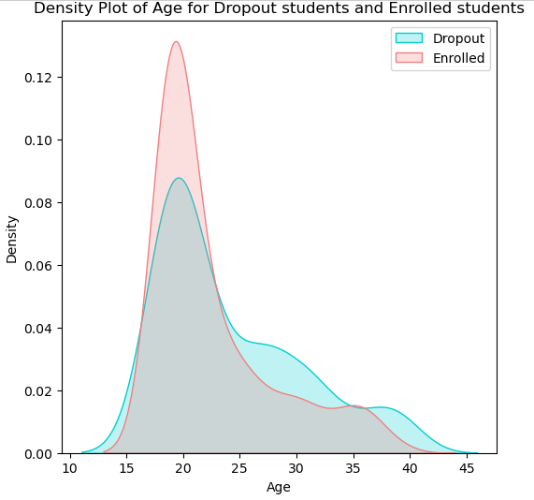

Figure 1 Exploration by Age

Figure 4.1: Density plot of Age for Dropout students and Enrolled students

The density plot of Age for dropout and enrolled students suggest that majority of young students approximately between the Ages of 18 and 25 are enrolled in an academic institution. Dropout increases as Age increases indicating that Age might be significantly associated with the likelihood of dropping out of school.

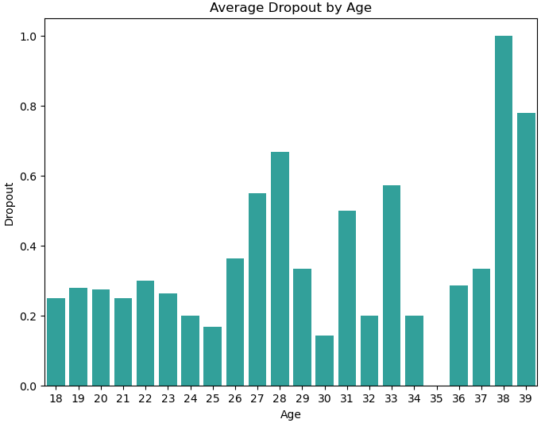

Figure 2 Distribution of Dropout against Age

### 4.3.2: Exploration by Gender:

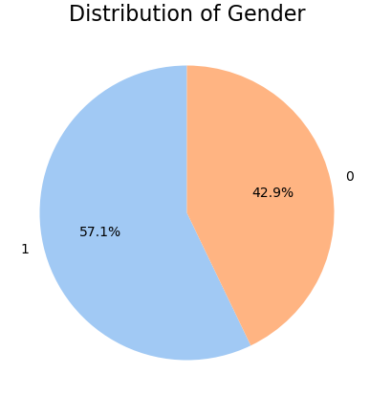

Figure 3 Pie chart for Distribution of Gender

Male students are represented by (1) while the female students are represented by (0)

The following results indicate that 57.1% of the students who participated in the research are Male while 42.9% are Female.

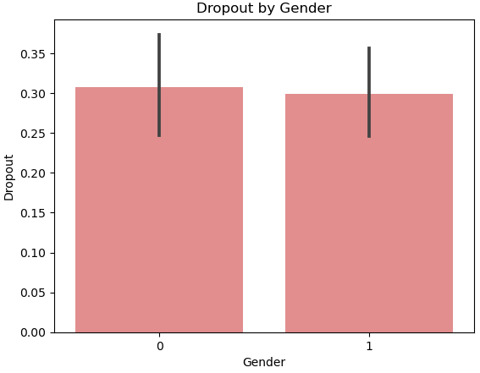

Figure 4 Distribution of Dropout against gender

Table 2 dropouts against gender

|  |  |  |  |  |  |  |
| --- | --- | --- | --- | --- | --- | --- |
|  | DROPOUT | | | |  |  |
| Gender | NO | | YES | | Chi-square  Test statistics | P-value |
| Frequency | Proportion | Frequency | Proportion | 0.07559 | 0.78336 |
| Female | 134 | 67.7% | 64 | 32.3% |  |  |
| Male | 183 | 69.3% | 81 | 30.7%. |  |  |

Chi-square test statistics: 0.07559

P-value: 0.78336

Degrees of freedom: 1

Null Hypothesis (H0)

There is no association between "Gender" and the likelihood of dropping out of school.

Alternative Hypothesis (H1)

There is a significant association between "Gender" and the likelihood of Dropping out of school.

Interpretation:

The high p-value (0.78336) suggests insufficient evidence against the null hypothesis. Therefore, we fail to reject the null hypothesis and conclude that there is no significant association between "Gender" and the likelihood of Dropping out of school. This makes gender statistically insignificant in relation to school dropout.

### 4.3.3: Exploration by Academic Performance:

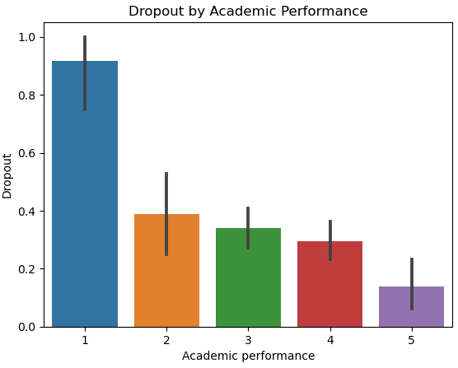

Figure 5 Distribution of Dropout against Academic Performance

Table 3 Dropout against Academic Performance

|  |  |  |  |  |  |  |
| --- | --- | --- | --- | --- | --- | --- |
|  | DROPOUT | | | |  |  |
| Academic  Performance | NO | | YES | | Chi-square  Test statistics | P-value |
| Frequency | Proportion | Frequency | Proportion | 31.36534 | 2.5785e-06 |
| POOR | 1 | 83.3% | 11 | 91.7% |  |  |
| AVERAGE | 22 | 61.1% | 14 | 38.9%. |  |  |
| GOOD | 116 | 65.9% | 60 | 34.1% |  |  |
| VERY GOOD | 122 | 70.5% | 51 | 29.5% |  |  |
| EXCELLENT | 56 | 86.2% | 9 | 13.8% |  |  |

Chi-square test statistics: 31.36533

P-value: 2.5785e-06

Degrees of freedom: 4

Null Hypothesis (H0)

There is no association between "Academic performance" and the likelihood of dropping out of school.

Alternative Hypothesis (H1)

There is a significant association between "Academic performance" and the likelihood of Dropping out of school.

Interpretation:

The extremely low p-value (2.5785e-06) suggests strong evidence against the null hypothesis. Therefore, we reject the null hypothesis and conclude that there is a significant association between "Academic performance" and the likelihood of Dropping out of school. This may also suggest that observed distribution of dropout cases across different levels of Quality of teaching is unlikely to have occurred by chance alone. This makes academic performance statistically significant in relation to school dropout.

### 4.3.4: Exploration by Health Status:

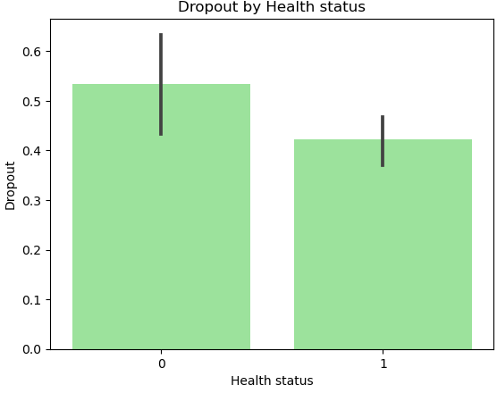

Figure 6 Distribution of Dropout against Health Status

Table 4 Dropout against Health Status

|  |  |  |  |  |  |  |
| --- | --- | --- | --- | --- | --- | --- |
|  | DROPOUT | | | |  |  |
| Health  status | NO | | YES | | Chi-square  Test statistics | P-value |
| Frequency | Proportion | Frequency | Proportion | 16.9275 | 3.8834e-0.5 |
| NO | 45 | 50% | 45 | 50% |  |  |
| YES | 272 | 27.1% | 100 | 26.9%. |  |  |

Chi-square test statistics: 16.9275

P-value: 3.8834e-0.5

Degrees of freedom: 1

Null Hypothesis (H0)

There is no association between "Health status" and the likelihood of Dropping out of school.

Alternative Hypothesis (H1)

There is a significant association between "Health status" and the likelihood of Dropping out of school.

Interpretation:

The extremely low p-value (3.8834e-05) suggests strong evidence against the null hypothesis. Therefore, we reject the null hypothesis and conclude that there is a significant association between "Health status" and the likelihood of Dropping out of school. This makes Health status of a student a statistical significant variable in predicting the likelihood of dropping out of school.

### Assess strength of the relationship between health status and dropout

Using Cramer’s V test to assess the strength of the relationship between health status and dropout results to a Cramer’s V value of 0.6782 suggesting a strong relationship between health status of a student and the likelihood of dropping out.

### 4.3.5: Exploration by Academic Stress and Anxiety:

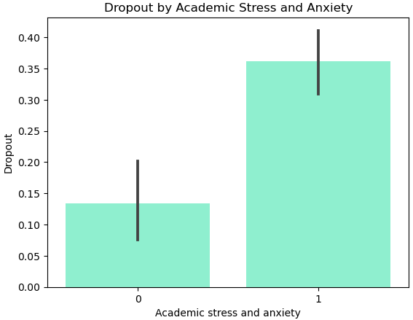

Figure 7 distribution of dropout against academic stress and anxiety

Table 5 Dropout against Academic stress and anxiety

|  |  |  |  |  |  |  |
| --- | --- | --- | --- | --- | --- | --- |
|  | DROPOUT | | | |  |  |
| Academic  stress and anxiety | NO | | YES | | Chi-square  Test statistics | P-value |
| Frequency | Proportion | Frequency | Proportion | 18.6728 | 1.55177e-0.5 |
| NO | 101 | 84.9% | 18 | 15.1% |  |  |
| YES | 216 | 63% | 127 | 37.0%. |  |  |

Chi-square test statistics: 18.6728

P-value: 1.55177e-0.5

Degrees of freedom: 1Null Hypothesis (H0): There is no association between "Academic stress and anxiety" and the likelihood of Dropping out of school.

Alternative Hypothesis (H1): There is a significant association between "Academic stress and anxiety" and the likelihood of Dropping out of school.

Interpretation:

The extremely low p-value (3.8834e-05) suggests strong evidence against the null hypothesis. Therefore, we reject the null hypothesis and conclude that there is a significant association between "Academic stress and anxiety" and the likelihood of "Dropout" in school. This makes Academic stress and anxiety a statistically significant variable in relation to the likelihood of dropping out of school.

### Assess strength of the relationship between academic stress, anxiety and dropout

Using Cramer’s V test to assess the strength of the relationship between Academic stress, anxiety and dropout results to a Cramer’s V value of 0.7512 suggesting a strong relationship between Academic stress and anxiety with the likelihood of dropping out.

### 4.3.6: Exploration by Quality of Teaching:

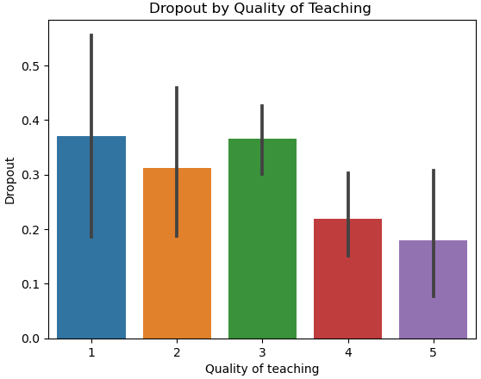

Figure 8 distribution of dropout against quality of teaching

Table 6 Dropout against Quality of Teaching

|  |  |  |  |  |  |  |
| --- | --- | --- | --- | --- | --- | --- |
|  | DROPOUT | | | |  |  |
| Quality of Teaching | NO | | YES | | Chi-square  Test statistics | P-value |
| Frequency | Proportion | Frequency | Proportion | 12.0188 | 0.0172 |
| POOR | 15 | 55.6% | 12 | 44.4% |  |  |
| AVERAGE | 32 | 66.7% | 16 | 33.3%. |  |  |
| GOOD | 137 | 63.4% | 79 | 36.6% |  |  |
| VERY GOOD | 101 | 76.5% | 31 | 23.5% |  |  |
| EXCELLENT | 32 | 82.1% | 7 | 17.9% |  |  |

Chi-square test statistics: 12.0188

P-value: 0.0172

Degrees of freedom: 4

Null Hypothesis (H0): There is no association between "Quality of Teaching" and the likelihood of Dropping out of school.

Alternative Hypothesis (H1): There is a significant association between "Quality of Teaching" and the likelihood of Dropping out of school.

Interpretation:

The p-value (0.0172) suggests evidence against the null hypothesis. Therefore, we reject the null hypothesis and conclude that there is a significant association between "Quality of teaching" and the likelihood of Dropping out of school. This makes Quality of teaching a statistically significant variable in relation to the likelihood of dropping out of school.

### 4.3.7: Exploration by School Fees:

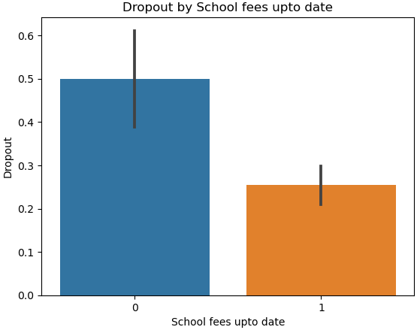

Figure 9 Distribution of Dropout against School fees up to date

Table 7 Dropout against School fees up to date

|  |  |  |  |  |  |  |
| --- | --- | --- | --- | --- | --- | --- |
|  | DROPOUT | | | |  |  |
| School fees up to date | NO | | YES | | Chi-square  Test statistics | P-value |
| Frequency | Proportion | Frequency | Proportion | 16.9275 | 3.8834e-05 |
| NO | 45 | 50% | 45 | 50% |  |  |
| YES | 272 | 73.1% | 100 | 26.9%. |  |  |

Chi-square test statistics: 16.9275

P-value: 3.8834e-05

Degrees of freedom: 1

Null Hypothesis (H0): There is no association between "School Fees up to date" and the likelihood of "Dropout" in school.

Alternative Hypothesis (H1): There is a significant association between "School Fees up to date" and the likelihood of "Dropout" in school.

Interpretation:

The extremely low p-value (3.8834e-05) suggests strong evidence against the null hypothesis. Therefore, we reject the null hypothesis and conclude that there is a significant association between "School Fees up to date" and the likelihood of "Dropout" in school. This makes the variable school fees up to date statistically significant in relation to the likelihood of dropping out of school.

### Assess strength of the relationship between school fees up to date and dropout

Using Cramer’s V test to assess the strength of the relationship between School Fees up to date and dropout results to a Cramer’s V value of 0.3748 suggesting a moderate relationship between School Fees up to date with the likelihood of dropping out.

### 4.3.8: Exploration by Scholarship holder:

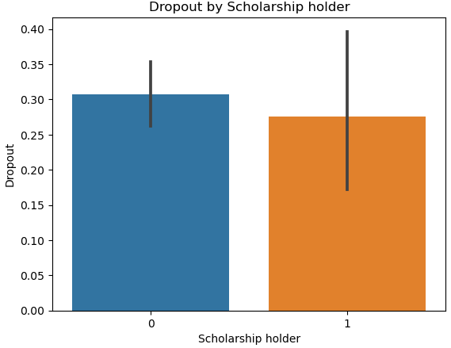

Figure 10 **Distribution of Dropout against Scholarship holder**

Table 8 Dropout against Scholarship

|  |  |  |  |  |  |  |
| --- | --- | --- | --- | --- | --- | --- |
|  | DROPOUT | | | |  |  |
| Scholarship holder | NO | | YES | | Chi-square  Test statistics | P-value |
| Frequency | Proportion | Frequency | Proportion | 0.0453 | 0.83144 |
| NO | 276 | 68.3% | 128 | 31.7% |  |  |
| YES | 41 | 70.7% | 17 | 29.3%. |  |  |

Chi-square test statistics: 0.0453

P-value: 0.83144

Degrees of freedom: 1

Null Hypothesis (H0): There is no association between "Scholarship Holder" and the likelihood of Dropping out of school.

Alternative Hypothesis (H1): There is a significant association between "Scholarship Holder" and the likelihood of Dropping out of school.

Interpretation:

The high p-value (0.83144) is greater than the level of significance (0.05) indicating that we fail to reject the null hypothesis and conclude that there is no significant association between "Scholarship Holder" and the likelihood of Dropping out of school.

### 4.3.9: Exploration by Peer Influence:

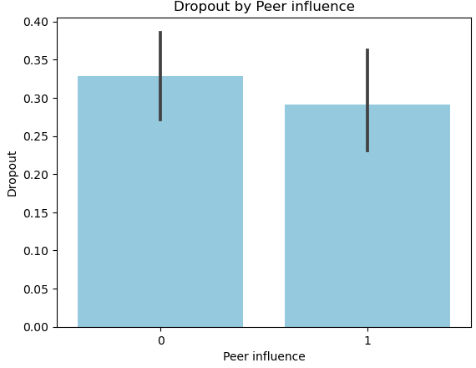

Figure 11 : Distribution of Dropout against Peer influence

Table 9 Dropout against Peer influence

|  |  |  |  |  |  |  |
| --- | --- | --- | --- | --- | --- | --- |
|  | DROPOUT | | | |  |  |
| Peer influence | NO | | YES | | Chi-square  Test statistics | P-value |
| Frequency | Proportion | Frequency | Proportion | 0.55205 | 0.45748 |
| NO | 188 | 67.1% | 92 | 31.7% |  |  |
| YES | 129 | 70.9% | 53 | 29.1%. |  |  |

Chi-square test statistics: 0.55205

P-value: 0.45748

Degrees of freedom: 1

Null Hypothesis (H0): There is no association between "Peer influence" and the likelihood of Dropping out of school.

Alternative Hypothesis (H1): There is a significant association between "Peer influence" and the likelihood of Dropping out of school.

Interpretation:

The high p-value (0.45748) is greater than the level of significance (0.05) indicating that we fail to reject the null hypothesis and conclude that there is no significant association between "Peer influence" and the likelihood of Dropping out of school

### 4.3.10: Exploration by Family Crisis:

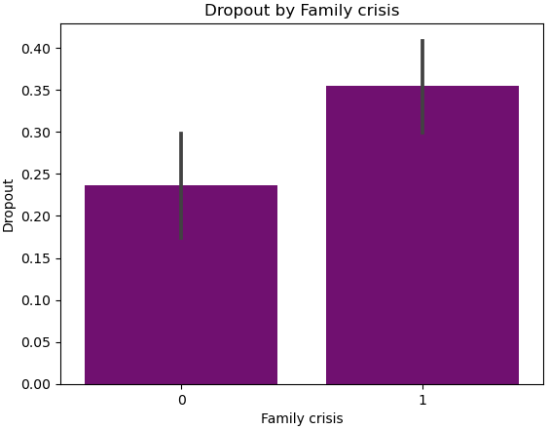

Figure 12 Distribution of Dropout against Family crisis

Table 10 Dropout against Family Crisis

|  |  |  |  |  |  |  |
| --- | --- | --- | --- | --- | --- | --- |
|  | DROPOUT | | | |  |  |
| Family  Crisis | NO | | YES | | Chi-square  Test statistics | P-value |
| Frequency | Proportion | Frequency | Proportion | 8.05189 | 0.0045 |
| NO | 123 | 76.4% | 38 | 23.6% |  |  |
| YES | 194 | 64.5% | 107 | 35.5%. |  |  |

Chi-square test statistics: 8.05189

P-value: 0.0045

Degrees of freedom: 1

Null Hypothesis (H0): There is no association between "Family crisis" and the likelihood of dropping out of school.

Alternative Hypothesis (H1): There is a significant association between "Family Crisis" and the likelihood of dropping out of school.

Interpretation:

The low p-value (0.0045) is less than the level of significance (0.05) indicating that we reject the null hypothesis and conclude that there is a significant association between "Family Crisis" and the likelihood of Dropping out of school.

### Assess strength of the relationship between family crisis and dropout

Using Cramer’s V test to assess the strength of the relationship between Family Crisis and dropout results to a Cramer’s V value of 0.17143. This suggests a weak relationship between Family Crisis with the likelihood of dropping out despite the fact that there is a significant association between Family Crisis and likelihood of dropping out of school.

## **4.4.0: PREDICTIVE MODEL**

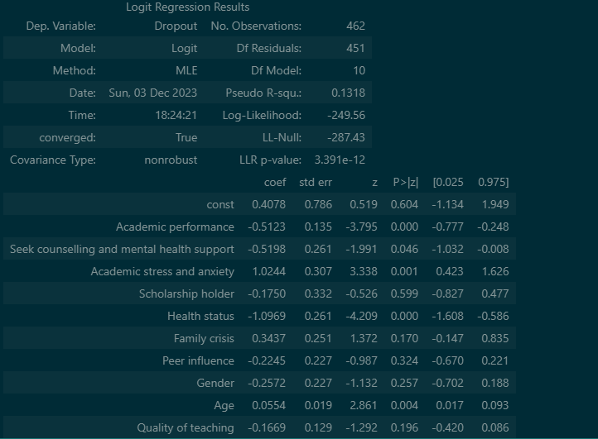

Figure 13 Logistic Regression Summary results

Logistic Regression Equation containing statistically significant variables

Dropout = 0.4078 - 0.5123 *Academic performance + 1.0244*Academic stress and anxiety -1.0969*Health status + 0.0554*Age

### 4.4.1: INTERPRETATION OF COEFFICIENTS

Academic performance (-0.5123): For every one-unit increase in academic performance, the log-odds of dropping out decrease by 0.5123 units. The negative coefficient suggests that higher academic performance is associated with a lower likelihood of dropout.

Seek counselling and mental health support (-0.5198): If a student seeks counseling and mental health support, the log-odds of dropping out decrease by 0.5198 units. This variable is statistically significant (p-value: 0.046).

Academic stress and anxiety (1.0244): A one-unit increase in academic stress and anxiety corresponds to an increase of 1.0244 units in the log-odds of dropping out. This variable is statistically significant (p-value: 0.001).

Scholarship holder (-0.1750): Being a scholarship holder is not statistically significant (p-value: 0.599), suggesting that it may not have a significant impact on the log-odds of dropping out.

Health status (-1.0969): Students with poor health status have higher log-odds of dropping out, as indicated by the negative coefficient. This variable is statistically significant (p-value: 0.000).

Family crisis (0.3437): Experiencing a family crisis is not statistically significant (p-value: 0.170), suggesting that it may not have a significant impact on the log-odds of dropping out.

Peer influence (-0.2245): Peer influence is not statistically significant (p-value: 0.324), indicating that it may not have a significant impact on the log-odds of dropping out.

Gender (-0.2572): The coefficient suggests that being female is associated with a decrease in the log-odds of dropping out, but it is not statistically significant (p-value: 0.257).

Age (0.0554): For every one-year increase in age, the log-odds of dropping out increase by 0.0554 units. This variable is statistically significant (p-value: 0.004).

Quality of teaching (-0.1669): The quality of teaching is not statistically significant (p-value: 0.196), suggesting that it may not have a significant impact on the log-odds of dropping out.

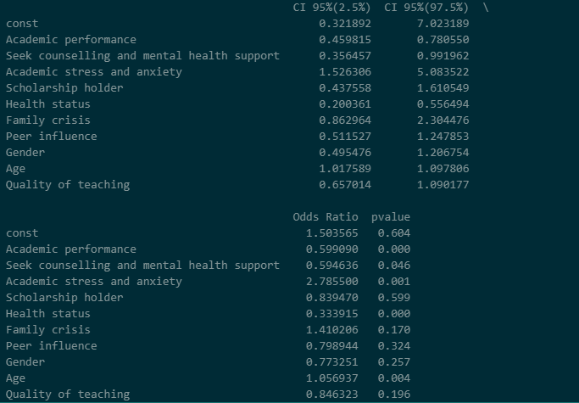

Figure 14 Logistic Regression 95% CI, Odds Ratio and P-values results

### **4.4.2:** **INTERPRETATION OF 95% CONFIDENCE INTERVAL AND ODDS RATIO FOR STATISTICALLY SIGNIFICANT VARIABLES**

**Academic performance:**

95% CI: (0.459815, 0.780550)

Odds Ratio: 0.599090

Interpretation: Holding other variables constant, for a one-unit increase in academic performance, the odds of dropping out decrease by approximately 40.1% to 54.0%. The odds ratio of 0.599090 suggests a significant negative association between academic performance and the likelihood of dropout.

**Seek counselling and mental health support:**

95% CI: (0.356457, 0.991962)

Odds Ratio: 0.594636

Interpretation: Students who seek counseling and mental health support have odds of dropping out that are approximately 40.5% to 99.2% lower than those who do not seek such support. The odds ratio of 0.594636 suggests a significant negative association with dropout.

**Academic stress and anxiety:**

95% CI: (1.526306, 5.083522)

Odds Ratio: 2.785500

Interpretation: For a one-unit increase in academic stress and anxiety, the odds of dropping out increase by approximately 152.6% to 408.4%. The odds ratio of 2.785500 indicates a significant positive association between academic stress and anxiety and the likelihood of dropout.

**Health status:**

95% CI: (0.200361, 0.556494)

Odds Ratio: 0.333915

Interpretation: Students with poor health status have odds of dropping out that are approximately 20.0% to 55.6% lower than those with better health. The odds ratio of 0.333915 suggests a significant negative association between health status and the likelihood of dropout.

**Age:**

95% CI: (1.017589, 1.097806)

Odds Ratio: 1.056937

Interpretation: For each additional year of age, the odds of dropping out increase by approximately 1.8% to 9.8%. The odds ratio of 1.056937 indicates a significant positive association between age and the likelihood of dropout.

**Train/Test split results**

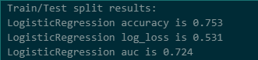

Figure 15 Train/Test split Summary results

**Accuracy (0.753):**

Interpretation: The accuracy is the proportion of correctly classified instances. In this case, the Logistic Regression model achieved an accuracy of 75.3%. This indicates that approximately 75.3% of the instances in the test set were classified correctly.

**Log Loss (0.531):**

Interpretation: Log Loss measures the performance of a classification model where the prediction is a probability value between 0 and 1. It quantifies how well the predicted probabilities match the true class labels. A lower log loss indicates better performance. In this case, the Log Loss is 0.531, which is relatively low and suggests good calibration of predicted probabilities.

AUC (Area Under the ROC Curve) (0.724):

Interpretation: AUC is a metric that evaluates the model's ability to discriminate between positive and negative instances. It measures the area under the Receiver Operating Characteristic (ROC) curve. An AUC of 0.724 indicates a moderate level of discrimination. Generally, an AUC closer to 1 suggests better discrimination.

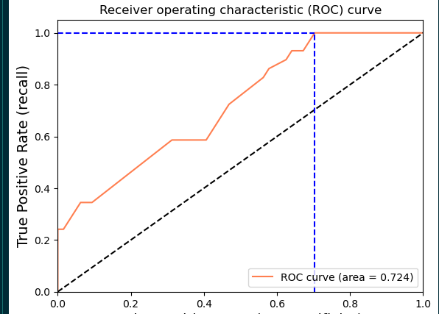

Figure 16 Area Under the ROC Curve

# 5.0 CHAPTER FIVE

**SUMMARY, CONCLUSIONS AND RECOMMENDATIONS**

## Introduction

Within this chapter, a synthesis of the findings derived from the research process and the subsequent analysis of results is presented. Additionally, it encompasses the conclusions drawn from these findings, along with recommendations aimed at enhancing student satisfaction levels with available resources.

## 5.1 SUMMARY

The research dived deep into the complex landscape of school dropout among higher learning institution students. Data analysis revealed several statistically significant variables influencing dropout rates. Academic performance emerged as a robust predictor, indicating a strong association between lower academic performance and increased dropout likelihood. Similarly, factors like health status, academic stress, quality of teaching, seeking counseling and age were found to significantly impact dropout rates.

However, variables like gender, peer influence and being a scholarship holder displayed no substantial statistical association with dropout probabilities. Family crises exhibited a noteworthy impact, indicating its relevance in dropout scenarios.

## 5.2 CONCLUSIONS

In conclusion, this research underscores the imperative for proactive intervention strategies aimed at student success. By implementing targeted programs, fostering a supportive environment, and continually investigating diverse factors, higher learning institutions can significantly reduce dropout rates. This multifaceted approach aligns with the goal of not only retaining students but also cultivating an inclusive educational landscape that nurtures the holistic well-being and success of every individual within the academic community.

## 5.3 RECOMMENDATIONS

**Academic Performance:**

There is a need to develop tailored academic support programs catering to different performance levels. Implementation of mentorship or tutoring programs to assist students falling behind and recognize and celebrate academic excellence to motivate others.

**Health Status:**

Establish health and wellness initiatives including access to healthcare, counseling services, and wellness programs. Collaborate with healthcare providers to address health-related concerns affecting academic progress.

**Academic Stress and Anxiety:**

Implement stress management workshops, mindfulness sessions, or counseling services. Create awareness campaigns promoting mental health support and coping mechanisms to alleviate academic stress.

**Quality of Teaching:**

Conduct periodic evaluations and professional development for educators to enhance teaching methodologies and engagement. Foster an environment encouraging innovative and effective teaching practices.

**School Fees Up to Date:**

Develop flexible payment plans or financial aid schemes to support students facing financial constraints. Establish communication channels to guide students on available financial resources.

**Scholarship Holder:**

Augment scholarship programs and financial aid support. Streamline application processes and raise awareness about available scholarship opportunities.

**Peer Influence:**

Foster a positive peer environment through mentorship programs, group activities, or peer counseling initiatives. Promote positive role models and encourage supportive interactions among students.

**Family Crisis:**

Offer counseling services for students undergoing family crises. Establish support networks or liaison officers to assist students in managing family-related challenges impacting their education.

**Gender:**

Encourage gender-inclusive programs and support systems. Address any existing gender biases and provide equal opportunities for all students regardless of gender identity.

**Age:**

Tailor educational support and resources specific to different age groups. Identify age-related challenges and implement age-appropriate interventions to address academic hurdles.

**Continued Research:**

There was need to invest in further research focusing on variables like peer influence, gender and quality of teaching to unearth deeper insights and also conduct longitudinal studies to comprehend evolving patterns impacting dropout rates.

## REFERENCES

Adelman, C. (2006). The toolbox revisited: Paths to degree completion from high school through college. *US Department of Education.*

Arum, R., & Roksa, J. (2011). Academically adrift: *Limited learning on college campuses. University of Chicago Press.*

Bean, J. P. (1980). Dropouts and turnover: The synthesis and test of a causal model of student attrition. *Research in Higher Education, 12(2), 155–187.*

Cabrera, A. F., Nora, A., & Castaneda, M. B. (1993). College persistence: Structural equations modeling test of an integrated model of student retention. *Journal of Higher Education, 64(2), 123–139.*

DeLuca, S., & Rosenbaum, J. E. (2017). The cost of college attendance: Understanding the relationship between tuition, student loans, and drop-out rates. *Sociology of Education, 90(3), 167-185.*

Fazekas, M., Burns, T., & Lankford, H. (2018). Inequalities in higher education and labor market outcomes*: Evidence from a quasi-experiment. Sociology of Education, 91(1), 1-23.*

L. Bäulke, C. Grunschel, and M. Dresel, “Student dropout at university: a phase-orientated view on quitting studies and changing majors,” *European Journal of Psychology of Education, vol. 37, pp. 853–876, 2022.*

P. Perchinunno, M. Bilancia, and D. Vitale, “A statistical analysis of factors affecting higher education dropouts,” *Social Indicators Research, vol. 156, pp. 341–362, 2021*

Pascarella, E. T., & Terenzini, P. T. (2005). How college affects students: A third decade of research (Vol. 2). *Jossey-Bass.*

Rumberger, R. W. (2011). Dropping out: Why students drop out of high school and what can be done about it. *Harvard University Press.*

Seidman, A. (2005). College student retention: Formula for student success. *American Council on Education.*

Tayebi, J. Gomez, and C. Delgado, “Analysis on the lack of motivation and dropout in engineering students in Spain,” *IEEE Access, vol. 9, pp. 66253–66265, 2021.*

Terenzini, P. T., & Reason, R. D. (2005). Toward a model of college withdrawal student decision making. *Research in Higher Education, 46(4), 429–455.*

Tinto, V. (1975). Dropout from higher education: A theoretical synthesis of recent research. *Review of Educational Research, 45(1), 89–125.*

Tinto, V. (1993). Leaving college: Rethinking the causes and cures of student attrition (2nd ed.). *University of Chicago Press.*

View at: Publisher Site | Google Scholar D. Mouton, H. Zhang, and B. Ertl, “German university student’s reasons for dropout: identifying latent classes,” *Journal for Educational Research Online, vol. 12, no. 2, pp. 190–224, 2020.*

View at: Publisher Site | Google Scholar L. Bäulke, C. Grunschel, and M. Dresel, “Student dropout at university: a phase-orientated view on quitting studies and changing majors,” *European Journal of Psychology of Education, vol. 37, pp. 853–876, 2022.*

View at: Publisher Site | Google Scholar P. Perchinunno, M. Bilancia, and D. Vitale, “A statistical analysis of factors affecting higher education dropouts,” *Social Indicators Research, vol. 156, pp. 341–362, 2021.*

## WORKPLAN

|  |  |  |  |  |  |  |  |  |
| --- | --- | --- | --- | --- | --- | --- | --- | --- |
|  | July-August 2023 | 7th September 2023 | **September –October 2023** | **October 2023** | October –November 2023 | **November 2023** | **November 2023** | **December 2023** |
| Preparation of the project proposal |  |  |  |  |  |  |  |  |
| Presentation of the proposal |  |  |  |  |  |  |  |  |
| Implementation preparation (questionnaire drafting) |  |  |  |  |  |  |  |  |
| Data collection |  |  |  |  |  |  |  |  |
| Data management and analysis |  |  |  |  |  |  |  |  |
| Report writing |  |  |  |  |  |  |  |  |
| Submission of the project |  |  |  |  |  |  |  |  |
| Presentation of the project |  |  |  |  |  |  |  |  |

## PROJECT BUDGET

|  |  |  |  |
| --- | --- | --- | --- |
| **Project item** | **cost** | **quantity** | **subtotal** |
| **Printing of project proposal and the project** | 20 | 100 | 2,000 |
| **Transport** | 1,000 | 4 | 4,000 |
| **Binding** | 300 | 5 | 1,500 |
| **Mobile data** | 500 | 50 GB | 2,500 |
| **miscellaneous** | 1300 | 2 | 2,600 |
| **Total** | N/A | N/A | 12,600 |