📘 Case Study on XML (eXtensible Markup Language)
1. Introduction
XML is a markup language designed to store and transport data. It is both human-readable and machine-readable, making it ideal for data interchange between systems. Unlike HTML, XML focuses on the structure and meaning of data rather than its presentation.

2. Structure of XML
An XML document is made up of:
- Elements: Defined by start and end tags (e.g., <name>John</name>)
- Attributes: Provide additional information (e.g., <book id="101">)
- Root Element: The top-level element that contains all others
- Well-formedness: Every tag must be properly nested and closed
Example:
XML
<person>
<name>John Doe</name>
<age>30</age>
</person>

3. Use Cases of XML
- Data exchange between applications (e.g., APIs, web services)
- Configuration files (e.g., .xml files in Java apps)
- Document storage (e.g., Office Open XML in Word/Excel)
- RSS feeds for content syndication
- SOAP-based web services

4. Advantages of XML
- Platform-independent and language-neutral
- Self-descriptive and hierarchical
- Supports complex data structures
- Widely supported across technologies
- Easy to transform using XSLT

5. Limitations of XML
- Verbose and can lead to large file sizes
- Parsing is slower compared to JSON
- Not ideal for real-time or bandwidth-sensitive applications
- Requires strict syntax adherence

6. Simple XML Example
XML
<book>
<title>XML Fundamentals</title>
<author>John Doe</author>
<year>2023</year>
</book>

7. Explanation of the Example
- The root element is <book>
- It contains three child elements: <title>, <author>, and <year>
- Each element holds text data
- The structure is hierarchical and clearly describes the data

Login.html (1st Page) 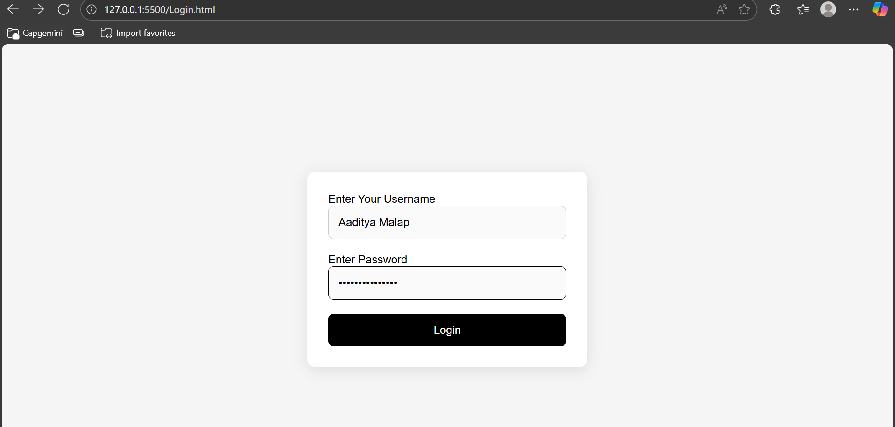
The login.html page is designed to allow users to enter their credentials and log in. It includes HTML form elements and CSS styling for a modern and responsive layout.

HTML Structure
- The form uses <form> with id 'loginForm' and includes two input fields: one for username and one for password.
- Each input field is wrapped in a <label> for accessibility.
- A <button> element is used to submit the form.
- A <p> element with id 'error' is used to display validation messages.

CSS Styling
- The page uses flexbox to center the form vertically and horizontally.
- The form has a white background, padding, rounded corners, and a subtle box shadow.
- Input fields and the button are styled with padding, border-radius, and hover effects.
- The error message is styled with red text and background, and is hidden by default unless there is an error.

JavaScript Logic
- On form submission, the script prevents default behavior and validates the password.
- Password must contain at least one uppercase letter, one lowercase letter, one number, and one special character.
- If validation fails, an error message is displayed in the #error element.
- If validation passes, the user credentials are stored in localStorage as XML and in sessionStorage as JSON.
- The user is redirected to welcome.html upon successful login.
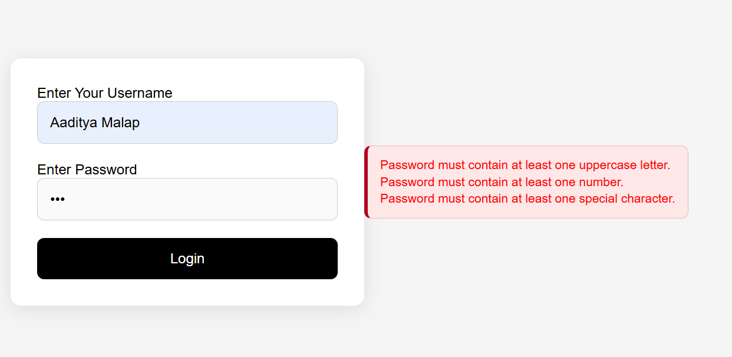

Welcome.html (2nd Page)
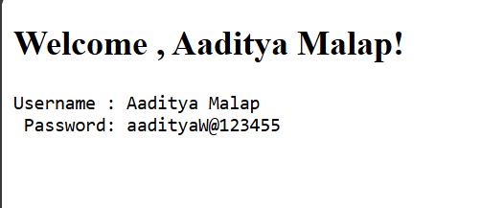
The welcome.html page is a simple page that displays the credentials of the user after a successful login.

HTML Structure
- The page retrieves the current user data from sessionStorage.
- It displays the username and password in a readable format.
- This page serves as a confirmation that the user has logged in successfully.

Data Handling
- User data is stored in localStorage as XML for persistence.
- The current session user is stored in sessionStorage and used to populate the welcome page.

CODE: Login.html
<!DOCTYPE html>
<html lang="en">
<head>
<meta charset="UTF-8">
<meta name="viewport" content="width=device-width, initial-scale=1.0">
<title>Login</title>
</head>
<body>
<form id="loginForm">
<label>Enter Your Username<input id="username" name="username" type="text" required/> </label>
<label>Enter Password<input id="password" name="password" type="password" required /> </label>
<button type="submit">Login </button>
</form>
<p id="error" style="color:red"></p>
<style>/* Reset & Base */
* {
box-sizing: border-box;
margin: 0;
padding: 0;
font-family: Arial, sans-serif;
}
body {
background: #f5f5f5;
display: flex;
justify-content: center;
align-items: center;
height: 100vh;
}
#error {
display: none;
font-size: 14px;
color: #b00020;
background: #fde7e7;
border: 1px solid #f5b5b5;
border-left: 4px solid #b00020;
padding: 12px 14px;
border-radius: 8px;
line-height: 1.35;
}
#error:not(:empty) {
display: block;
}
@supports selector(:has(*)) {
#loginForm:has(#password:invalid) #error {
display: block;
}
}
#loginForm {
background: #fff;
padding: 30px;
border-radius: 12px;
box-shadow: 0 4px 20px rgba(0, 0, 0, 0.1);
width: 100%;
max-width: 400px;
display: flex;
flex-direction: column;
gap: 20px;
}
#loginForm input[type="text"],
#loginForm input[type="password"] {
width: 100%;
padding: 14px;
border: 1px solid #ccc;
border-radius: 8px;
font-size: 16px;
background: #fafafa;
transition: border 0.3s ease;
}
#loginForm input:focus {
border-color: #000;
outline: none;
}
#loginForm button {
background: #000;
color: #fff;
border: none;
padding: 14px;
font-size: 16px;
border-radius: 8px;
cursor: pointer;
transition: background 0.3s ease;
}
#loginForm button:hover {
background: #333;
}
@media (max-width: 480px) {
#loginForm {
padding: 20px;
gap: 15px;
}
}
</style>
<script>
if(!localStorage.getItem("userXML")){
localStorage.setItem("userXML", "<users></users>");
}
document.getElementById("loginForm").addEventListener("submit", e => {
e.preventDefault();
const uname = document.getElementById("username").value.trim();
const pwd = document.getElementById("password").value;
const errorEl = document.getElementById("error");
const checkUpperCase = /[A-Z]/;
const checkLowerCase = /[a-z]/;
const checkNumber = /[0-9]/;
const checkSpecial = /[^a-zA-Z0-9]/;
function validatePassword(password) {
let errorMsg = "";
if (!checkUpperCase.test(password)) {
errorMsg += "Password must contain at least one uppercase letter.\n";
}
if (!checkLowerCase.test(password)) {
errorMsg += "Password must contain at least one lowercase letter.\n";
}
if (!checkNumber.test(password)) {
errorMsg += "Password must contain at least one number.\n";
}
if (!checkSpecial.test(password)) {
errorMsg += "Password must contain at least one special character.\n";
}
if (errorMsg) {
errorEl.innerText = errorMsg.trim();
return false;
} else {
errorEl.innerText = "Logged in Successfully";
return true;
}
}
if (!validatePassword(pwd)) {
return;
}
const xmlString = localStorage.getItem("userXML");
const parser = new DOMParser();
const xmlDoc = parser.parseFromString(xmlString, "application/xml");
const userEl = xmlDoc.createElement("user");
const usernameEl = xmlDoc.createElement("username");
usernameEl.textContent = uname;
const pwdEl = xmlDoc.createElement("password");
pwdEl.textContent = pwd;
userEl.append(usernameEl,pwdEl);
xmlDoc.documentElement.appendChild(userEl);
const serializer = new XMLSerializer();
localStorage.setItem("userXML", serializer.serializeToString(xmlDoc));
sessionStorage.setItem("currentUser", JSON.stringify({uname,pwd}));
window.location.href = "Welcome.html"
})
</script>
</body>
</html>

CODE: Welcome.html

<!DOCTYPE html>
<html lang="en">
<head>
<meta charset="UTF-8">
<meta name="viewport" content="width=device-width, initial-scale=1.0">
<title>Welcome</title>
</head>
<body>
<h2 id="msg"></h2>
<pre id="creds"></pre>

<script>

const user = JSON.parse(sessionStorage.getItem("currentUser") || "{}")

if(!user.uname){
document.getElementById("msg").textContent = "No session found.";
}else{
document.getElementById("msg").textContent = "Welcome , " + user.uname + "!";
document.getElementById("creds").textContent = `Username : ${user.uname} \n Password: ${user.pwd}`;
}
</script>
</body>
</html>

