我的导师是王照奎老师，汉语拼音Wang zhaokui.

首先，从FUNSON官网获得老师信息，如下图。

联系邮箱：[zkwang@suda.edu.cn](mailto:zkwang@suda.edu.cn)

联系电话：0512-65881374

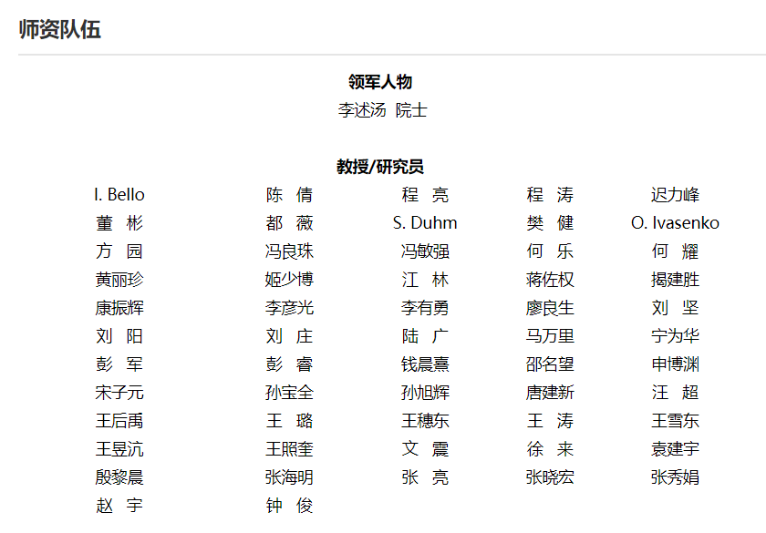

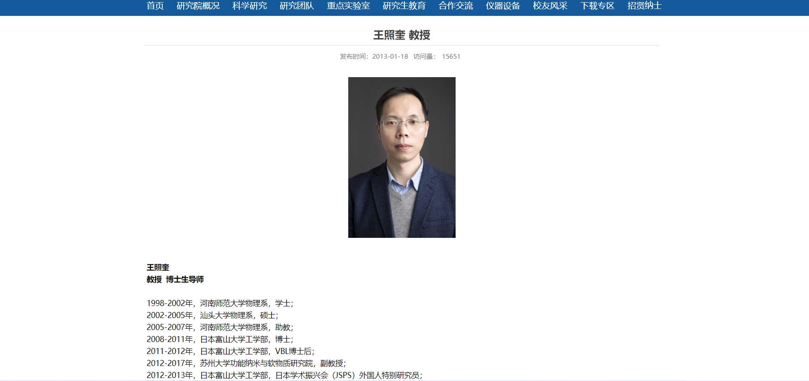

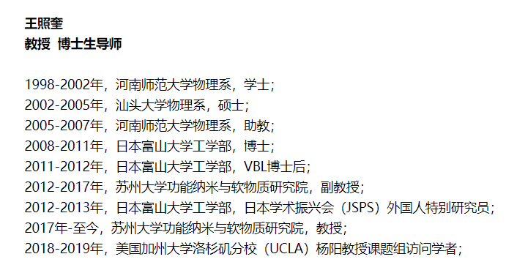

为了检索到老师硕士，博士期间的导师，我需要检索老师的硕士学位论文，以及博士阶段以第一作者发表的论文，以此来确定他的导师。

1. 硕士学位论文

由于老师的硕士就读于汕头大学，因此，从中国知网学位论文库检索即可。

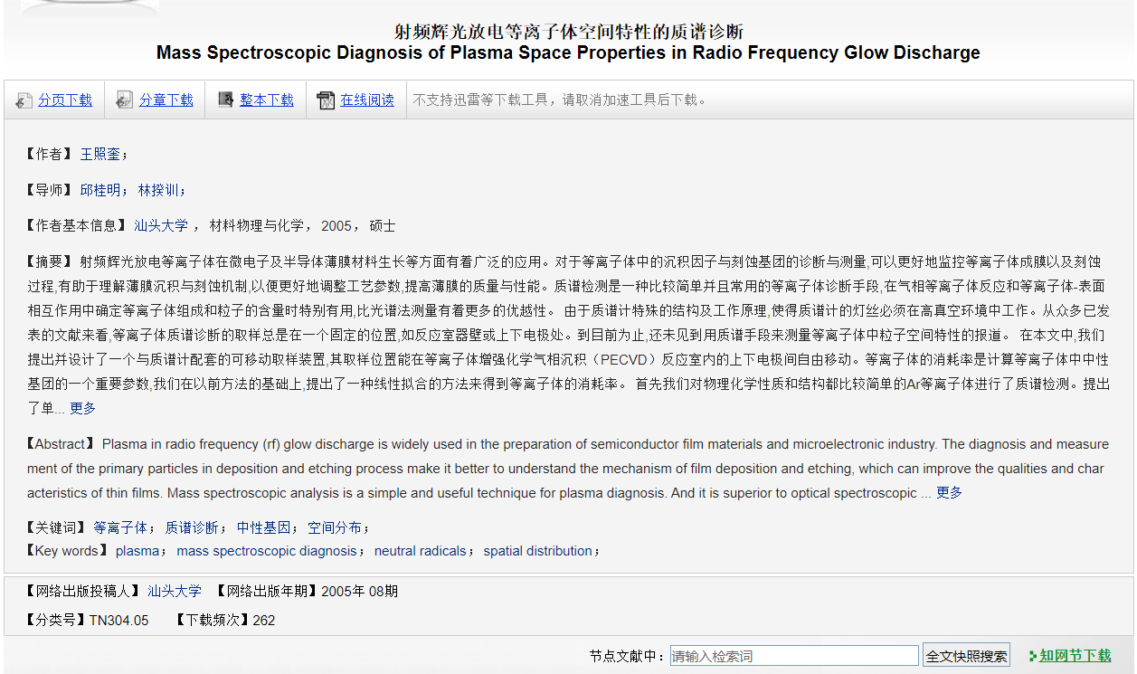

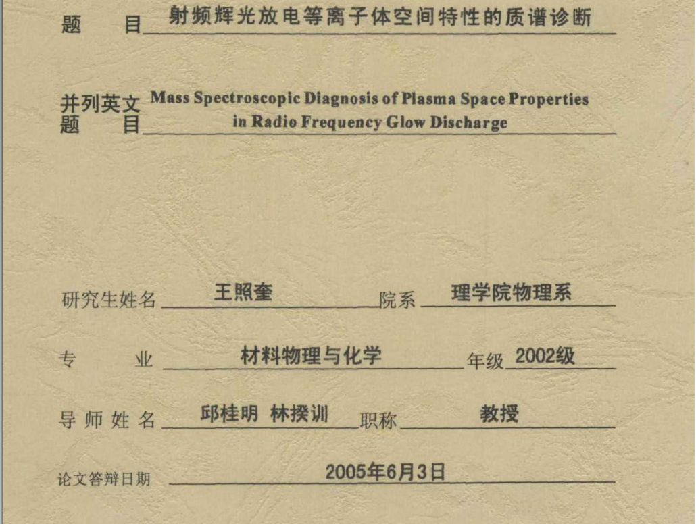

可知，王老师硕士阶段的导师有两位，分别是邱桂明与林揆训

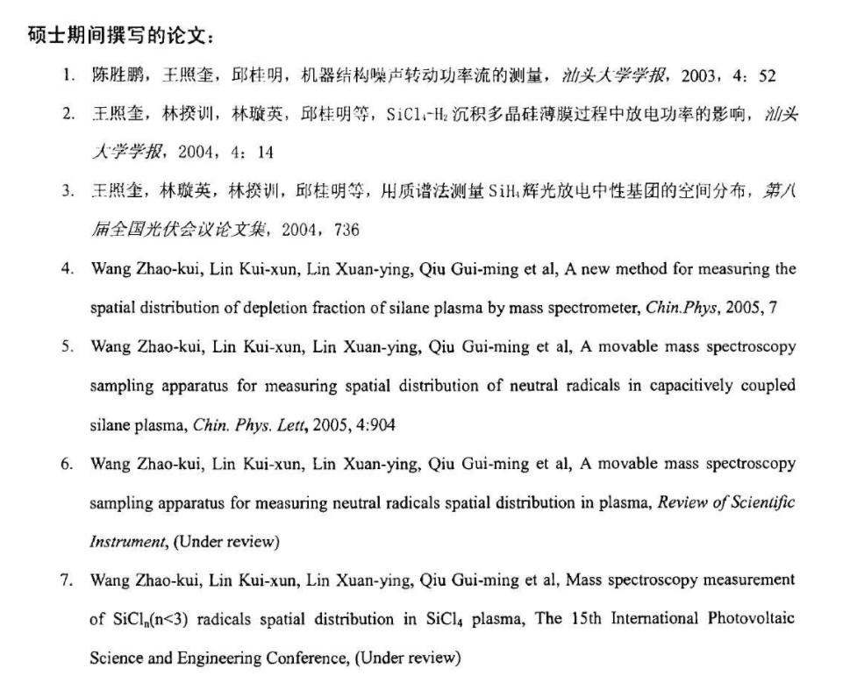

由此推测，邱桂明应该是王老师就读课题组的导师，因为所有发表的文章中均有该导师，且学位论文导师姓名排列第一位。致谢充分证明了这一点。

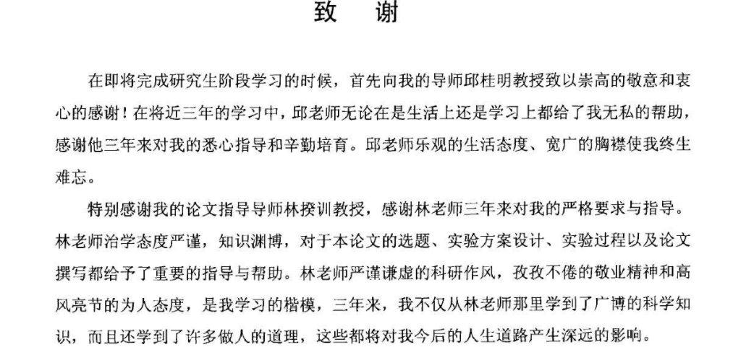

2. 博士阶段的导师

由于王老师是在日本富山大学读的博士研究生，所有学位论文库中并不能检索到他的博士学位论文。

故转而检索他博士期间发表的文章来判断。

检索时间锁定2008-2011年。

关键词为导师姓名与富山大学。





一共有十五条结果。

FN Clarivate Analytics Web of Science

VR 1.0

PT J

AU Wang, ZK

Lou, YH

Naka, S

Okada, H

AF Wang, Zhaokui

Lou, Yanhui

Naka, Shigeki

Okada, Hiroyuki

TI Competitive emission process in mixed single layer top-emission organic

light emitting device with reduced efficiency roll-off

SO APPLIED PHYSICS LETTERS

RI Naka, Shigeki/M-4647-2017; Wang, Zhao-Kui/ABD-5942-2021; Wang,

Zhaokui/E-7486-2011

OI Wang, Zhao-Kui/0000-0003-1707-499X; Naka, Shigeki/0000-0002-6248-515X

SN 0003-6951

EI 1077-3118

PD NOV 15

PY 2010

VL 97

IS 20

AR 203302

DI 10.1063/1.3516159

UT WOS:000284545200062

ER

PT J

AU Wang, ZK

Okada, H

Naka, S

AF Wang, Zhaokui

Okada, Hiroyuki

Naka, Shigeki

TI Evaluation of Reliability in Rubrene-Based Organic Light Emitting

Devices with a Mixed Single Layer

SO JAPANESE JOURNAL OF APPLIED PHYSICS

CT 5TH INTERNATIONAL CONFERENCE ON MOLECULAR ELECTRONICS AND BIOELECTRONICS

CY MAR 15-18, 2009

CL Miyazaki, JAPAN

RI Wang, Zhaokui/E-7486-2011; Naka, Shigeki/M-4647-2017

OI Naka, Shigeki/0000-0002-6248-515X

SN 0021-4922

EI 1347-4065

PY 2010

VL 49

IS 1

SI SI

AR 01AA02

DI 10.1143/JJAP.49.01AA02

UT WOS:000279288900002

ER

PT J

AU Wang, ZK

Naka, S

Okada, H

AF Wang, Zhaokui

Naka, Shigeki

Okada, Hiroyuki

TI Improved Performance of Top-Emission Organic Light Emitting Device With

a Mixed Single Layer

SO MOLECULAR CRYSTALS AND LIQUID CRYSTALS

CT KJF International Conference on Organic Materials for Electronics and

Photonics (ICOMEP)

CY AUG 23-26, 2009

CL Cheju Isl, SOUTH KOREA

RI Naka, Shigeki/M-4647-2017; Wang, Zhaokui/E-7486-2011

OI Naka, Shigeki/0000-0002-6248-515X

SN 1542-1406

PY 2010

VL 519

BP 1

EP 8

DI 10.1080/15421400903579655

UT WOS:000277664700002

ER

PT J

AU Wang, ZK

Naka, S

Okada, H

AF Wang, Zhaokui

Naka, Shigeki

Okada, Hiroyuki

TI Solution-Processed Small Molecular Organic Light-Emitting Devices with a

Mixed Single Layer

SO JAPANESE JOURNAL OF APPLIED PHYSICS

CT International Symposium on Organic and Inorganic Electronic Materials

and Related Nanotechnologies (EM-NANO 2010)

CY JUN 22-25, 2010

CL Toyama Int Conf Ctr, Toyama, JAPAN

HO Toyama Int Conf Ctr

RI Wang, Zhaokui/E-7486-2011; Naka, Shigeki/M-4647-2017

OI Naka, Shigeki/0000-0002-6248-515X

SN 0021-4922

EI 1347-4065

PD JAN

PY 2011

VL 50

IS 1

SI SI

AR 01BC06

DI 10.1143/JJAP.50.01BC06

PN 3

UT WOS:000287523900011

ER

PT J

AU Wang, ZK

Naka, S

Okada, H

AF Wang, Zhaokui

Naka, Shigeki

Okada, Hiroyuki

TI Improved performance of mixed single layer top-emission organic light

emitting devices using capping layer

SO SOLID-STATE ELECTRONICS

RI Wang, Zhaokui/E-7486-2011; Naka, Shigeki/M-4647-2017

OI Naka, Shigeki/0000-0002-6248-515X

SN 0038-1101

EI 1879-2405

PD FEB

PY 2011

VL 56

IS 1

BP 155

EP 158

DI 10.1016/j.sse.2010.11.007

UT WOS:000287272000027

ER

PT J

AU Wang, ZK

Lou, YH

Naka, S

Okada, H

AF Wang, Zhaokui

Lou, Yanhui

Naka, Shigeki

Okada, Hiroyuki

TI Bias and temperature dependent charge transport in solution-processed

small molecular mixed single layer organic light emitting devices

SO APPLIED PHYSICS LETTERS

RI Wang, Zhao-Kui/ABD-5942-2021; Naka, Shigeki/M-4647-2017; Wang,

Zhaokui/E-7486-2011

OI Wang, Zhao-Kui/0000-0003-1707-499X; Naka, Shigeki/0000-0002-6248-515X

SN 0003-6951

EI 1077-3118

PD FEB 7

PY 2011

VL 98

IS 6

AR 063302

DI 10.1063/1.3554391

UT WOS:000287242100053

ER

PT J

AU Wang, ZK

Naka, S

Okada, H

AF Wang, Zhaokui

Naka, Shigeki

Okada, Hiroyuki

TI Investigation of carrier injection mechanism in small molecular organic

light emitting device with a mixed single organic layer

SO APPLIED PHYSICS A-MATERIALS SCIENCE & PROCESSING

RI Wang, Zhaokui/E-7486-2011; Naka, Shigeki/M-4647-2017

OI Naka, Shigeki/0000-0002-6248-515X

SN 0947-8396

EI 1432-0630

PD MAR

PY 2011

VL 102

IS 3

BP 681

EP 687

DI 10.1007/s00339-010-6084-3

UT WOS:000287320600025

ER

PT J

AU Wang, ZK

Lou, YH

Naka, S

Okada, H

AF Wang, Zhaokui

Lou, Yanhui

Naka, Shigeki

Okada, Hiroyuki

TI High efficiency rubrene based inverted top-emission organic light

emitting devices with a mixed single layer

SO JOURNAL OF LUMINESCENCE

RI Wang, Zhaokui/E-7486-2011; Naka, Shigeki/M-4647-2017

OI Naka, Shigeki/0000-0002-6248-515X

SN 0022-2313

EI 1872-7883

PD JUL

PY 2010

VL 130

IS 7

BP 1198

EP 1202

DI 10.1016/j.jlumin.2010.02.021

UT WOS:000277674400015

ER

PT J

AU Lou, YH

Wang, ZK

Naka, S

Okada, H

AF Lou, Yanhui

Wang, Zhaokui

Naka, Shigeki

Okada, Hiroyuki

TI Enhanced short-circuit current density in poly(3-hexylthiophene) and

1-(3-methoxycarbonyl)-propyl-1-phenyl-(6,6)C61 based organic solar cells

by doping small molecular perylene

SO APPLIED PHYSICS LETTERS

RI Wang, Zhao-Kui/ABD-5942-2021; Naka, Shigeki/M-4647-2017

OI Wang, Zhao-Kui/0000-0003-1707-499X; Naka, Shigeki/0000-0002-6248-515X

SN 0003-6951

EI 1077-3118

PD JUL 18

PY 2011

VL 99

IS 3

AR 033305

DI 10.1063/1.3615711

UT WOS:000293679000064

ER

PT J

AU Wang, ZK

Naka, S

Okada, H

AF Wang, Zhaokui

Naka, Shigeki

Okada, Hiroyuki

TI Performance improvement of rubrene-based organic light emitting devices

with a mixed single layer

SO APPLIED PHYSICS A-MATERIALS SCIENCE & PROCESSING

RI Wang, Zhaokui/E-7486-2011; Naka, Shigeki/M-4647-2017

OI Naka, Shigeki/0000-0002-6248-515X

SN 0947-8396

PD SEP

PY 2010

VL 100

IS 4

BP 1103

EP 1108

DI 10.1007/s00339-010-5710-4

UT WOS:000281085200019

ER

PT J

AU Wang, ZK

Lou, YH

Naka, S

Okada, H

AF Wang, Zhaokui

Lou, Yanhui

Naka, Shigeki

Okada, Hiroyuki

TI Temperature dependence of carrier injection in small molecular organic

light emitting device with a mixed single layer

SO CHEMICAL PHYSICS LETTERS

RI Naka, Shigeki/M-4647-2017; Wang, Zhaokui/E-7486-2011

OI Naka, Shigeki/0000-0002-6248-515X

SN 0009-2614

EI 1873-4448

PD DEC 6

PY 2010

VL 501

IS 1-3

BP 75

EP 79

DI 10.1016/j.cplett.2010.10.056

UT WOS:000284688700016

ER

PT J

AU Wang, ZK

Lou, YH

Naka, S

Okada, H

AF Wang, Zhaokui

Lou, Yanhui

Naka, Shigeki

Okada, Hiroyuki

TI Highly simplified small molecular phosphorescent organic light emitting

devices with a solution-processed single layer

SO AIP ADVANCES

RI Naka, Shigeki/M-4647-2017

OI Naka, Shigeki/0000-0002-6248-515X

EI 2158-3226

PD SEP

PY 2011

VL 1

IS 3

AR 032130

DI 10.1063/1.3625549

UT WOS:000302139600030

ER

PT J

AU Wang, ZK

Lou, YH

Naka, S

Okada, H

AF Wang, Zhaokui

Lou, Yanhui

Naka, Shigeki

Okada, Hiroyuki

TI Direct Comparison of Solution- and Vacuum-Processed Small Molecular

Organic Light-Emitting Devices with a Mixed Single Layer

SO ACS APPLIED MATERIALS & INTERFACES

RI Wang, Zhaokui/E-7486-2011; Naka, Shigeki/M-4647-2017; Wang,

Zhao-Kui/ABD-5942-2021

OI Wang, Zhao-Kui/0000-0003-1707-499X; Naka, Shigeki/0000-0002-6248-515X

SN 1944-8244

PD JUL

PY 2011

VL 3

IS 7

BP 2496

EP 2503

DI 10.1021/am2003729

UT WOS:000293196800048

PM 21667985

ER

PT J

AU Lou, YH

Wang, ZK

Naka, S

Okada, H

AF Lou, Yanhui

Wang, Zhaokui

Naka, Shigeki

Okada, Hiroyuki

TI Influence of Perylene Doping on Performance of Organic Solar Cells Based

on P3HT:PCBM Blend

SO JOURNAL OF PHOTOPOLYMER SCIENCE AND TECHNOLOGY

RI Naka, Shigeki/M-4647-2017

OI Naka, Shigeki/0000-0002-6248-515X

SN 0914-9244

PY 2011

VL 24

IS 3

BP 325

EP 328

DI 10.2494/photopolymer.24.325

UT WOS:000293609200019

ER

PT J

AU Wang, ZK

Naka, S

Okada, H

AF Wang, Zhaokui

Naka, Shigeki

Okada, Hiroyuki

TI Influence of ITO patterning on reliability of organic light emitting

devices

SO THIN SOLID FILMS

RI Wang, Zhaokui/E-7486-2011; Naka, Shigeki/M-4647-2017

OI Naka, Shigeki/0000-0002-6248-515X

SN 0040-6090

PD NOV 30

PY 2009

VL 518

IS 2

SI SI

BP 497

EP 500

DI 10.1016/j.tsf.2009.07.029

UT WOS:000271776300019

ER

EF

所有检索结果均涉及Naka, Shigeki与Okada, Hiroyuki这二位导师，因此，其中必有一位是王照奎老师博士阶段课题组的导师。

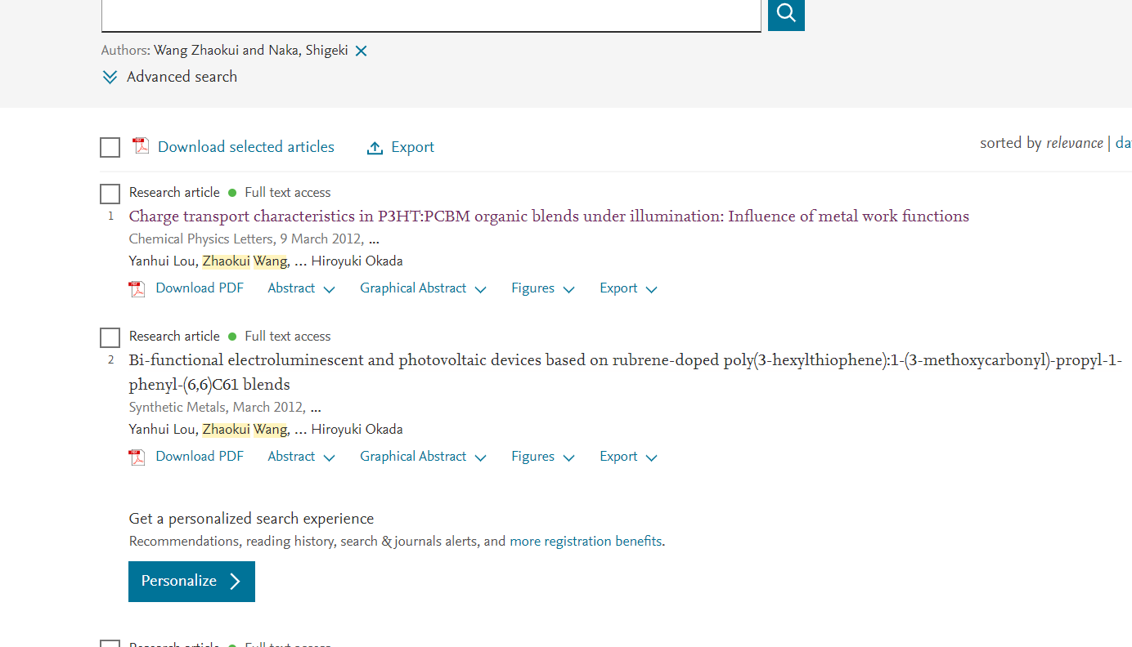

检索王老师与Naka, Shigeki的工作，都有Okada, Hiroyuki的参与。



而王老师与Okada, Hiroyuki的工作有时无Naka, Shigeki的参与。

推测，Okada, Hiroyuki是王老师博士期间的导师。

3. 另外，可以知道，王老师的博士后也在这一老师的课题组修读。

4. 从检索到的文献可以总结得出，王老师的硕士阶段的研究方向涉及等离子体的半导体方向的应用优化，半导体薄膜的制备工艺等；博士及博士后研究方向均为光电领域，从有机发光二极管到有机太阳能电池。

5. 目前王老师的研究方向涉及钙钛矿半导体光电器件与物理，开展基于钙钛矿的光伏与发光的工作。