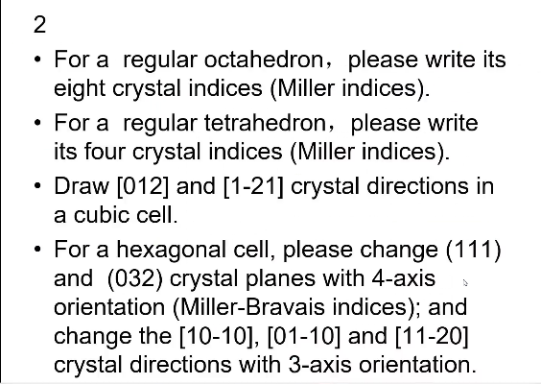

1. The regular regular octahedron.

**O**

**a**

**b**

**c**

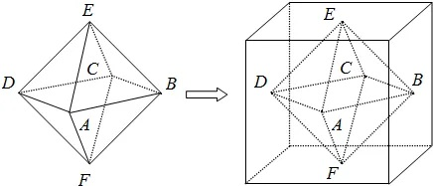

**Figure 1**. The regular octahedron within the cube.

Look at this octahedron: ABCDEF.

Because of the square ABCD, we select the center of it as original point, which could be seen in the **Figure 1**. The OA, OB, and OE are considered as a, b, and c axes, respectively.

Therefore, the eight crystal indices could be obtained.

For example, the ABE plane indices:

Firstly, the a, b and c axes intercepts of ABE are 1, 1 and 1, respectively. After taking reciprocal, the values won’t change due to the reciprocal of one is itself.

So, the indices of ABE are (111).

Similarly, the BCE, CDE, ADE, ABF, BCF, CDF, and ADF indices are ($\overline{1}$ 11), ($\overline{1}\overline{1}$ 1), (1 $\overline{1}$ 1), (11 $\overline{1}$), ($\overline{1}1\overline{1}$), ($\overline{1}\overline{1}\overline{1}$), and (1 $\overline{1}\overline{1}$), respectively.

2. The regular tetrahedron.

**c**

**A**

**B**

**C**

**D**

**O**

**b**

**a**

**Figure 2**. The regular tetrahedron within the cube.

Look at the **Figure 2**, we choose the center of cube as original point.

The axes between three centers of the cube face and the original point are a, b and c, respectively.

Therefore, we get the ABC, ABD, BCD and ACD crystal indices are ($\overline{1}$ 11), (11 $\overline{1}$), (1 $\overline{1}$ 1), ($\overline{1}\overline{1}\overline{1}$), respectively.

3. We get a cubic cell as **Figure 3**.

The [012] and [1 $\overline{2}$ 1] crystal directions are showed in **Figure 3**,which are described red and blue lines, respectively.

**c**

[012]

[1 $\overline{2}$ 1]

**b**

**a**

**Figure 3**. The cubic cell

4. We know the relationship between Miller indices [hkl] and hexagonal Miller-Bravais indices [uvtw] are follows:

$\left\{\begin{aligned}\frac{2h-k}{3}=u \\ \frac{2k-h}{3}=v \\ -\left(u+v\right)=t;l=w\end{aligned}\right.$ or $\left\{\begin{aligned}2u+v=h \\ 2v+u=k \\ l=w\end{aligned}\right.$

So, [10 $\overline{1}$ 0], [01 $\overline{1}$ 0], and [11 $\overline{2}$ 0] can be changed into [210], [120], and [110], respectively.

The transformation rules of crystal plane indices must be different, which is shown as follows:

$$\left(hkl\right)↔\left(hk \overline{h+k} l\right)$$

Therefore, the plane (111) and (032) can be transferred into (11 $\overline{2}$ 1) and (03 $\overline{3}$ 2), respectively.

**How can we confirm these above?**

Firstly, we should figure out the three axes’ indices and [hkl] belong to the hexagonal axes.

In three axes, there are a1, a2 and z axes while the four axes system has one more a3 axis than three axes system, where the a1, a2, a3, and z are all vectors.

We can look at the **Figure 4**, a3 = a1 + a2, the four axes indices are [uvtw].

**a2**

**O**

**a3**

**a1**

**Figure 4**. Four axes system.

[uvtw] = u a1 + v a2 + t a3 + w z

= (u-t)a1 + (v-t)a2 + w z = h a1 + k a2 + l z

Therefore, $\left\{\begin{aligned}u-t=h \\ v-t=k \\ w=l;t=-(u+v)\end{aligned}\right.$,

So we obtained $\left\{\begin{aligned}2u+v=h \\ 2v+u=k \\ w=l;t=-(u+v)\end{aligned}\right.$ or $\left\{\begin{aligned}\frac{2h-k}{3}=u \\ \frac{2k-h}{3}=v \\ -\left(u+v\right)=t;l=w\end{aligned}\right.$.

The relationship between (hkl) and (uvtw) is obvious, where the t is also equal to –(u+v).