Environment/Nature
To create a proper environment for the wildfire simulation, we are going to start with an model, which contains wind, fire and rain. The whole model is based on the repast framework. So we able to define methods in each class, which is called every time step. On top of that we can use the Grid and the ContinuousSpace provided by repast to place objects in space. Classes, their main attributes and methods and the interactions between wood, fire and rain are displayed in the diagram below.
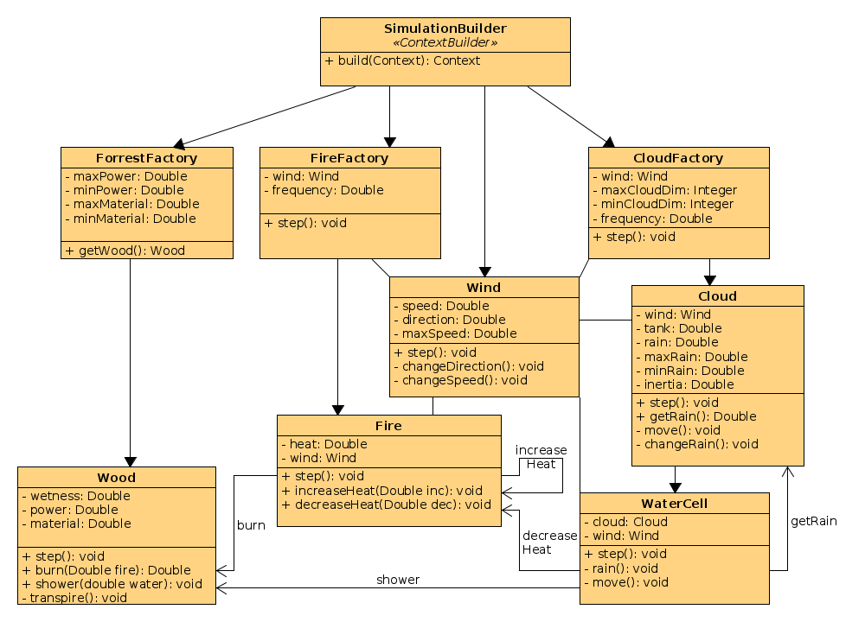

SimulationBuilder
The SimulationBuilder class is used by repast to initialize the simulation. Within the build-method all classes, which belong to the simulation, can be added to the simulation context.
Here the forest is placed in the grid and a FireFactory and a CloudFactory are added to the simulation.

Wood
The whole forest is made up of tiles of wood placed in the grid. Each piece of wood has three attributes, which describe physical conditions. The power attribute is an initial double-value which is used as life-points. This power-attribute might decrease by fire calling the burn method. If there is no power left, the piece of wood “dies” and disappears from the map.
Wetness is used to give a threshold for the fire. Before the fire can join this wood-cell, the wetness has to be zero. This attribute can be decreased by time (transpire) or fire in the neighbourhood and it can be increased by rain, or firefighters in order to build a wet line (indirect attack) , which slows spreading down.
The last attribute describes the woods physical behaviour. This includes, how much water/wetness can be stored in this wood-cell, how fast this water transpires and the maximum heat, this wood can burn.
The step function is called by the simulation in every iteration-step and calls the transpire-method, which decreases the current wetness with respect to the wood's material-value.
The burn-method is called by fire-”agents”. This reduces the wetness or power value for a given fire/heat- value. It returns the maximum heat, which is calculated by the remaining amount and quality of wood. If there is no material left, the wood “dies” and it will deregister from the simulation context.
The shower method is called by rain(WaterCells) or firefighters and it simple increases the woods wetness if its able to store some more water (depends on material and remaining power).

ForestFactory
This class is only used by the SimulationBuilder.build-method to create the forest. In its constructor you can define the range of wood's conditions (power and material). The getWood-method creates a piece of wood which attributes are randomly distributed in the given ranges.

Wind
There is only one global wind in the whole simulation. It is defined by its direction (0-360°) and a certain speed given the moved distance each iteration. The speed can be limited to a max-value. In each iteration the direction and the distance is changed by a random value using a gaussian distribution. Consequently turns about 360 degrees are less likely than little changes which seems to be more realistic.

Fire
Fire is also designed as a kind of agent. The only important attribute is the current heat. Heat can be increased by fire in its neighbourhood or decreased by firefighters or rain. In each timestep at first the influence on neighbour-cells are calculated. Each fire-cell increases the heat of fire within the 8 neighbour-cells with respect to its current heat, wind direction and wind speed. If there is a wood-cell, which is not occupied by a fire-agent, either its wetness will decrease or if there is no wetness left, it will spread a new fire to this cell.
In of each iteration it calls the burn-mehtod of the wood in its cell and adjusts its heat according the woods material. If there is no wood left, also the fire “dies” in this cell and deregisters from the simulation's context.

FireFactory
The FireFactory exists during the whole simulation and starts little fires in random cells. In its step-method a random tile is chosen and comparing a random value with a give frequency decides, if a fire is set in this cell.

Cloud
A cloud is used to simulate the rain. Each cloud has a tank, which defines the remaining water this cloud carries. A value “rain” describes the amount of water, which rains at each cell within a timestep. This value changes each iteration by gaussian distributed random value. Also its position changes during a timestep taking the current wind direction and speed and an inertia into concideration. If the cloud leaves the map or there is no water left in the tank, the cloud deregisters from the simulation context.

WaterCell
Each cloud consists of some WaterCells. Each of these cells has its own continuous location on the map. In each iteration a WaterCell moves with respect to wind and inertia and rains. This means it asks for water at its parent cloud and spends it to the current cell. If there is fire, it will decreases its heat. If there is no fire, the rain will increase the wood's wetness.
CloudFactory
The CloudFactory also exists during the whole simulation. According to the current wind and to a given frequency it will create clouds in at the map's borders with a random factor in position and size.

In the following three images you can see the spreading of the wildfire with an almost north west wind.
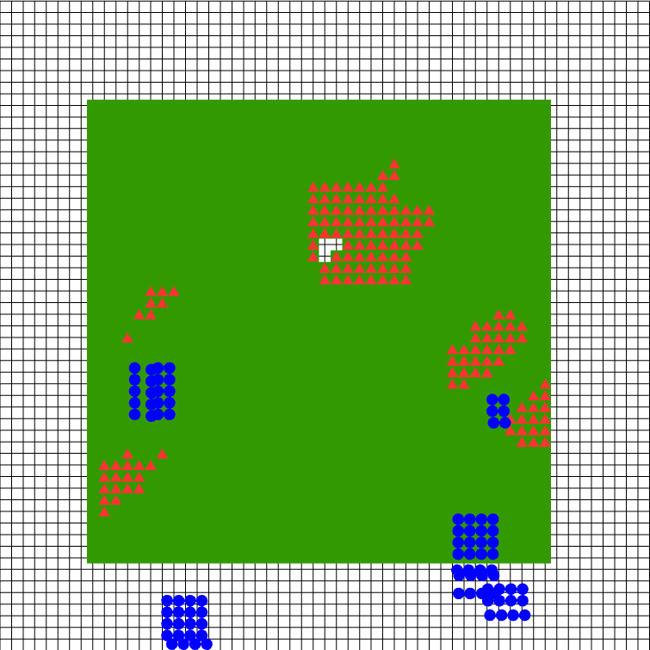
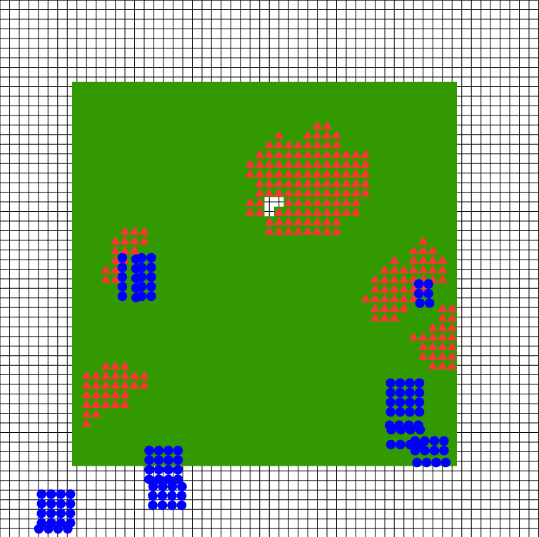
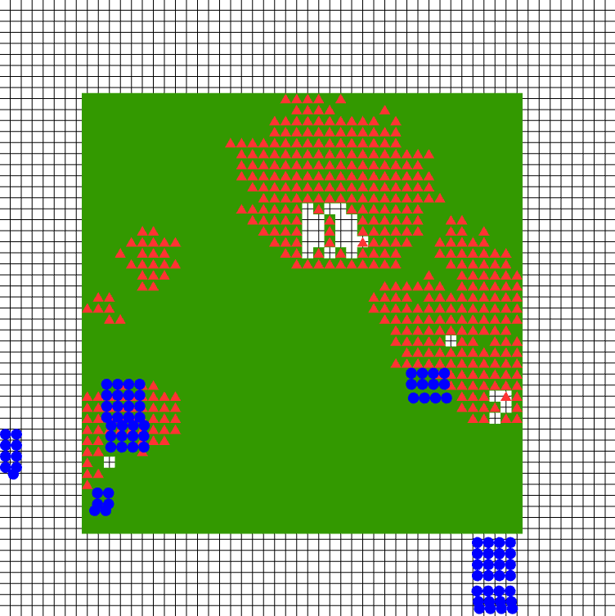
The green tiles represent the forest.
Blue circles represent watercells belonging to a cloud.
Red circles indicate a fire within the forest.
The white areas already burned down.

With a north west directed wind you can see that the fire only spreads in this direction. And clouds do also move to the north.

One cloud was able to extinguish some fire (left side) but its tank was already empty and it disappeared.

