Type of project (e.g. Bachelor thesis, Master AI thesis, Master OR thesis, Master AI internship project, Master OR internship project, Master AI semester project, Master OR semester project):
Master Semester Project AI
Year of project:
2015-2016
Key words (5 max):
Topic detection, natural language processing, NMF, LDA
Name(s) of student(s) who participated in the project:
Daniel Brüggemann, Yannik Hermey, Carsten Orth, Darius Schneider, Stefan Selzer
Name(s) of supervisor(s):
Dr. Gerasimos (Jerry) Spanakis, Prof. Dr. Jan Scholtes
Title of the project:
Topic detection and tracking system
Captions of images/figures. Enter your images (in low resolution if needed) here as well with appropriate captions:
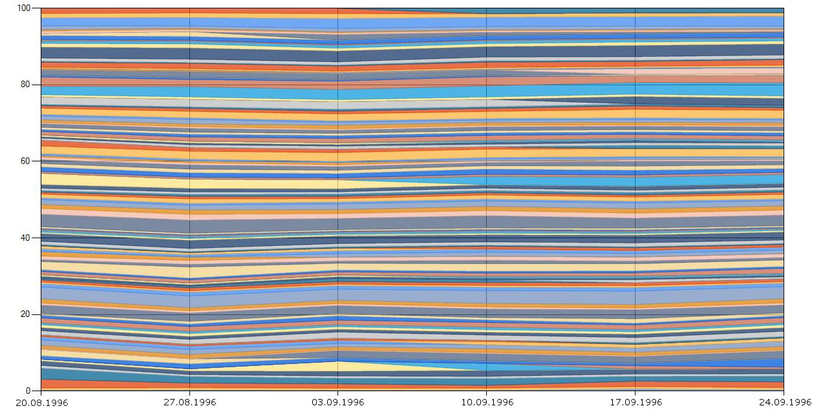
Fig. 1. Dynamic topic model with emerging topics on the documents of August and September 1996 from RCV1 Corpus.
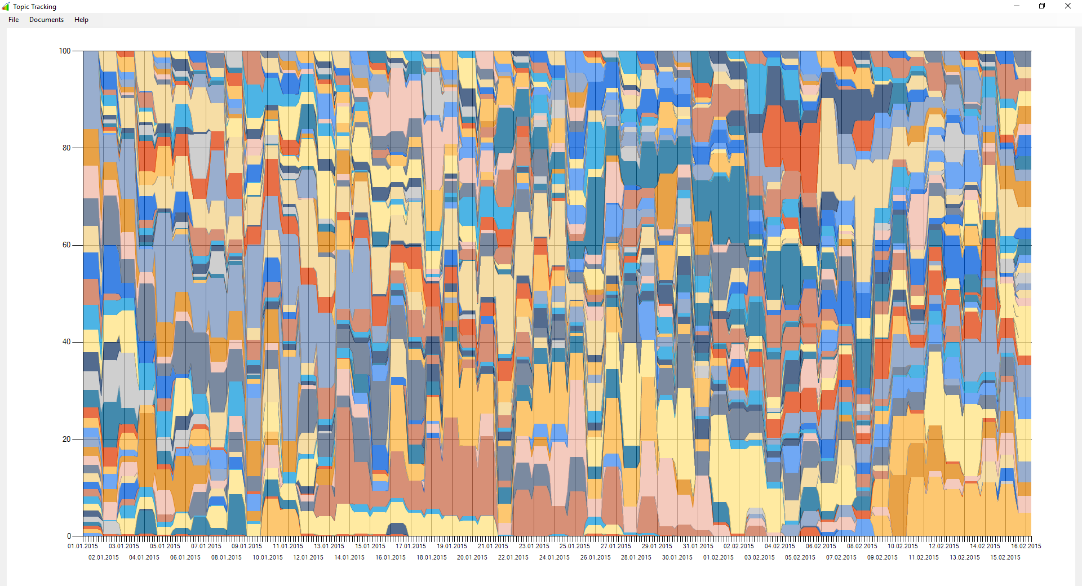
Fig. 2. NMF topics over time on the documents of Reuters archive 2015.
Problem statement and motivation. Please provide a general description of the problem that you worked on, a short description of why this is relevant, and a few sentences that state precisely what you aimed at:
Growth of internet came along with an increasingly complex amount of text data from emails, news sources, forums, etc. As a consequence, it is impossible for a single person to keep track of all relevant text data in most cases and moreover to detect changes in trends or topics. Every company (and every person) would be interested to harness this amount of free and cheap data in order to develop intelligent algorithms, which are able to react to emerging topics as fast as possible and at the same time track existing topics over long time spans. There are many techniques about topic extraction (like Nonnegative Matrix Factorization (NMF) or Latent Dirichlet Allocation (LDA) [Blei et al., 2003] ) but there are not many extensions to dynamic data handling. The goal of this project is to explore LDA (or other techniques) as a technique to detect topics as they appear and track them through time. Corpus can be the (fully annotated and immediately available) RCV1 Reuters corpus (810.000 documents) and/or the actual Reuters archive.
Research questions and/or hypothesis: explain the questions/hypothesis that you addressed during your project:
In the present project we aimed at answering the following research questions:
- How to detect, track and visualize topics in a large document collection, that dynamically change in the course of a certain time span.
Major outcomes of your project. Please provide up to seven major outcomes of your project. These should be formulated in a clear but compact way:
This report presents two approaches to detect evolving and dynamically changing topics in a large document collection, and visualizes them in the form of a topic river, allowing for easy and direct association between topics, terms and documents.
The LDA dynamic topic model was researched and applied to the news articles of the 6 weeks in August and September 1996 of the Reuters corpus RCV1. After applying careful preprocessing, it was possible to identify some of the main events happening at that time. The Kurdish civil war or the horrible crimes in Belgium were clearly reflected in the extracted topics. A matching with the RCV1 annotated topics can not be found, although the topics reveal a similar behavior in their evolvement. The dynamic topic model itself works with a fixed number of topics and does not present much evolvement of topics directly. To identify more details and find possible turning points of topic contents according to the differences among the word distributions of a topic at different time steps, a second step of comparing the word distributions inside each topic at each time step is added. The cosine similarity is used to compute these turning points, where a topic’s word distribution is regarded as having changed enough to declare a new topic. As the corresponding differences are very small for the given data, a proof of this concept was implemented using an artificially low difference to produce such an evolvement. The results should be more distinguishable and clearer when applied to the whole corpus. Similar to the topic emergence, topic aggregation is presented. Here the similarities between different topics at all time steps are compared to find points in time, where different topics are similar enough to be aggregated into a common one. Corresponding to the topic emergence, the clustering of 25LDA produces clearly separated distances between topics as it produces high similarity inside the topics. Therefore, concrete results impose doubts, if the topics really should become one, or if they clearly present different events. The question, how to combine the emerging topics with the aggregated ones still has to be answered. If a topic is emerging from itself and aggregating with other topics at the same time, as it was seen here, how can this be combined properly ? More open question would be, how to define the aggregated topic in terms of the word distributions with regard to the original ones and how to properly visualize aggregating topics on a 2D canvas, if topics merge multiple times with different topic rivers flowing in completely different parts of the stacked graph. Summarizing the LDA based approach, the dynamic topic model produces topics, that are on a more generalized level, at least when the same number of topics is chosen, similar to the annotated topics. A high frequency of topic evolvement can not be seen here.
For NMF over time, the NMF algorithm was applied on separate time steps of the data and then connected using a similarity metric, thus creating a topic river with evolving and emerging topics. By using extensive cleaning of the vocabulary during pre-processing, a fast data processing algorithm was developed that is able to process a year of data with around 3000 text files per day and 50 topics generated per month in circa 15 hours. The generated topics can easily be identified by their most relevant terms and associated with events happening in the corresponding time period. The highly significant financial topics that are not very specific to the respective time frame, as mentioned in Section 5.2.2, are a problem and could maybe be prevented by extending the stop word list with these general business terms. A closer examination of the documents making up these topics would therefore be advisable. So far, the NMF over time implementation was not evaluated by a quality metric, as explained in Section 5.2.2. As a first approach, the tags from the Corpus 96/97 documents that are most relevant for a topic (e.g. the tags of the ten best documents) could be compared against the best terms of the topic. To compensate for the more general tags that are assigned to the documents, a categorizing system like the WordNet ontology could be used to measure the distance between terms and tags horizontally (e.g. synonyms) and vertically (hierarchical distance), allowing a more granular measurement.
The visualization with a stacked graph over time already works well. What can be improved is the performance for large data sets in a way, that for cases when not everything can be displayed at once, approximations to the original series are built, that are less expensive to decrease load time. Other additions can be flexible visualizations with user-defined time spans to display or statistics for single topics (even if some tend to be very short-lived). Other improvements include more colors for the graph palette if there are too many topics to display at once, and, if needed, smoothing of the graph lines.
In this case, the Reuters Corpus was used as test data, but the developed systems are dynamic and reusable and can take an arbitrary corpus of text data to extract a topic river. To categorize these text files into a time frame correctly, the files have to be put in the corresponding format (see Section A for a manual on both the LDA and the NMF approach). Topics so far are mainly identified by their most relevant terms, which already gives a sufficient overview on the topic’s content. However, for a more comprehensive and sophisticated description of a topic, it is possible to create story lines or summaries by applying natural language processing techniques on the most relevant documents of a topic.
References: Provide possible references you are using in your text in the APA standard. Use e.g. Google Scholar to obtain references in the correct format:
[Blei and Lafferty, 2006] Blei, D. M. and Lafferty, J. D. (2006). Dynamic topic models. In Proceedings of the 23rd International Conference on Machine Learning, ICML ’06, pages 113–120, New York, NY, USA. ACM.
[Blei et al., 2003] Blei, D. M., Ng, A. Y., and Jordan, M. I. (2003). Latent dirichlet allocation. J. Mach. Learn. Res., 3:993–1022.
[Cao et al., 2007] Cao, B., Shen, D., Sun, J.-T., Wang, X., Yang, Q., and Chen, Z. (2007). Detect and track latent factors with online nonnegative matrix factorization. IJCAI, page 2689–2694.
[Fiscus and Doddington, 2002] Fiscus, J. G. and Doddington, G. R. (2002). Topic detection and tracking. chapter Topic Detection and Tracking Evaluation Overview, pages 17–31. Kluwer Academic Publishers, Norwell, MA, USA. [Lee and Seung, 1999] Lee, D. D. and Seung, H. S. (1999). Learning the parts of objects by non-negative matrix factorization. Nature, page 788–791.
[Lewis et al., 2004] Lewis, D. D., Yang, Y., Rose, T. G., and Li, F. (2004). Rcv1: A new benchmark collection for text categorization research. J. Mach. Learn. Res., 5:361–397.
[Manning et al., 2014] Manning, C. D., Surdeanu, M., Bauer, J., Finkel, J., Bethard, S. J., and McClosky, D. (2014). The Stanford CoreNLP natural language processing toolkit. In Association for Computational Linguistics (ACL) System Demonstrations, pages 55–60.
[Navarro, 2001] Navarro, G. (2001). A guided tour to approximate string matching. ACM Comput. Surv., 33(1):31–88.
[Porter, 1980] Porter, M. F. (1980). An algorithm for suffix stripping. Program, 14(3):130–137.
[Qian, 2016] Qian, M. (2016). Linear algebra and machine learning version 1.6.5.
https://sourceforge.net/projects/lamal/files/LAML/.
[Saha and Sindhwani, 2012] Saha, A. and Sindhwani, V. (2012). Learning evolving and emerging topics in social media: a dynamic nmf approach with temporal regularization. Proceedings of the fifth ACM international conference on Web search and data mining, page 693–702.
[Scholtes and van Cann, 2013] Scholtes, J. C. and van Cann, T. H. (2013). Improving machine learning input for automatic document classification with natural language processing.
[Smeets, 2015] Smeets, J. (2015). Applying text-mining in the archives of the stedelijk museum amsterdam. Technical report.
[Tannenbaum et al., 2015] Tannenbaum, M., Fischer, A., and Scholtes, J. C. (2015). Dynamic topic detection and tracking using non-negative matrix factorization.
[Wang et al., 2008] Wang, C., Blei, D. M., and Heckerman, D. (2008). Continuous time dynamic topic models. In McAllester, D. A. and Myllymäki, P., editors, UAI, pages 579–586. AUAI Press.
[Wang et al., 2011a] Wang, F., Li, P., and König, A. C. (2011a). Efficient document clustering via online nonnegative matrix factorizations. SDM, 11.
31[Wang et al., 2011b] Wang, F., Tan, C., Li, P., and König, A. C. (2011b). Efficient document clustering via online nonnegative matrix factorizations. Eleventh SIAM International Conference on Data Mining.
[Wang and McCallum, 2006] Wang, X. and McCallum, A. (2006). Topics over time: A non-markov continuous-time model of topical trends. In Proceedings of the 12th ACM SIGKDD International Conference on Knowledge Discovery and Data Mining, KDD ’06, pages 424–433, New York, NY, USA. ACM.
[Wei et al., 2007] Wei, X., Sun, J., and Wang, X. (2007). Dynamic mixture models for multiple time-series. In Veloso, M. M., editor, IJCAI, pages 2909–2914.

To be filled by supervisors (dear supervisors: delete what you do not want):
◻ I agree that this project is posted on the DKE student projects webpage. (Feel free to make any modifications to the text/material provided by your students.)
◻ I agree that the final project report is uploaded to the DKE student projects webpage.
◻ I agree that the final presentation is uploaded to the DKE student projects webpage.
◻ I agree that movies provided by the students are uploaded to the DKE Youtube channel and shown on the DKE student projects webpage.

