|  |
| --- |
| **Guidelines developmentnopCommercemulti Tenant** |
| **NopCommerceMulti Tenant** |
| Website: [http://nopplugin.com](http://nopplugin.com/) |
| **QuanNH** |
| **01/10/2021** |
|  |

* **Case Study**
* **Target**

Theguide document maintain to develop multi store system and manage website.

* **Objects**

Documents spend programmer nopCommerce on edition 4.4.

* **Function**
* **Admin area**
* **Copy files and folder**
* Presentation\Nop.Web\Areas\Admin\Views\StoreMapping\
* Presentation\Nop.Web\Areas\Admin\Models\Stores\StoreMappingModel.cs
* Presentation\Nop.Web\Areas\Admin\Models\Stores\StoreMappingListModel.cs
* Presentation\Nop.Web\Areas\Admin\Models\Stores\StoreMappingSearchModel.cs
* Presentation\Nop.Web\Areas\Admin\Controllers\StoreMappingController.cs
* **Change Libraries. Add #region name “Extensions by QuanNH” in files:**
* \Libraries\Nop.Services\Blogs\BlogService.cs
* \Libraries\Nop.Services\Catalog\BackInStockSubscriptionService.cs
* \Libraries\Nop.Services\Catalog\CategoryService.cs
* \Libraries\Nop.Services\Catalog\ProductService.cs
* \Libraries\Nop.Services\Catalog\ProductTagService.cs
* \Libraries\Nop.Services\Common\SearchTermService.cs
* \Libraries\Nop.Services\Customers\CustomerRegistrationService.cs
* \Libraries\Nop.Services\Customers\CustomerReportService.cs
* \Libraries\Nop.Services\Customers\CustomerService.cs
* \Libraries\Nop.Services\Directory\CountryService.cs
* \Libraries\Nop.Services\ExportImport\ExportManager.cs
* \Libraries\Nop.Services\ExportImport\ImportManager.cs
* \Libraries\Nop.Services\Gdpr\GdprService.cs
* \Libraries\Nop.Services\Messages\CampaignService.cs
* \Libraries\Nop.Services\Messages\NewsLetterSubscriptionService.cs
* \Libraries\Nop.Services\News\NewsService.cs
* \Libraries\Nop.Services\Orders\IOrderService.cs
* \Libraries\Nop.Services\Orders\OrderReportService.cs
* \Libraries\Nop.Services\Orders\OrderService.cs
* \Libraries\Nop.Services\Orders\ReturnRequestService.cs
* \Libraries\Nop.Services\Shipping\ShipmentService.cs
* \Libraries\Nop.Services\Stores\IStoreMappingService.cs
* \Libraries\Nop.Services\Stores\IStoreService.cs
* \Libraries\Nop.Services\Stores\StoreMappingService.cs
* \Libraries\Nop.Services\Stores\StoreService.cs
* \Presentation\Nop.Web.Framework\Factories\StoreMappingSupportedModelFactory.cs
* \Presentation\Nop.Web\Areas\Admin\Components\AclDisabledWarning.cs
* \Presentation\Nop.Web\Areas\Admin\Components\MultistoreDisabledWarning.cs
* \Presentation\Nop.Web\Areas\Admin\Controllers\BlogController.cs
* \Presentation\Nop.Web\Areas\Admin\Controllers\CampaignController.cs
* \Presentation\Nop.Web\Areas\Admin\Controllers\CategoryController.cs
* \Presentation\Nop.Web\Areas\Admin\Controllers\CheckoutAttributeController.cs
* \Presentation\Nop.Web\Areas\Admin\Controllers\CountryController.cs
* \Presentation\Nop.Web\Areas\Admin\Controllers\CurrencyController.cs
* \Presentation\Nop.Web\Areas\Admin\Controllers\CustomerController.cs
* \Presentation\Nop.Web\Areas\Admin\Controllers\LanguageController.cs
* \Presentation\Nop.Web\Areas\Admin\Controllers\ManufacturerController.cs
* \Presentation\Nop.Web\Areas\Admin\Controllers\MessageTemplateController.cs
* \Presentation\Nop.Web\Areas\Admin\Controllers\NewsController.cs
* \Presentation\Nop.Web\Areas\Admin\Controllers\OrderController.cs
* \Presentation\Nop.Web\Areas\Admin\Controllers\PollController.cs
* \Presentation\Nop.Web\Areas\Admin\Controllers\ProductController.cs
* \Presentation\Nop.Web\Areas\Admin\Controllers\ProductReviewController.cs
* \Presentation\Nop.Web\Areas\Admin\Controllers\StoreMappingController.cs
* \Presentation\Nop.Web\Areas\Admin\Controllers\TopicController.cs
* \Presentation\Nop.Web\Areas\Admin\Factories\ActivityLogModelFactory.cs
* \Presentation\Nop.Web\Areas\Admin\Factories\BaseAdminModelFactory.cs
* \Presentation\Nop.Web\Areas\Admin\Factories\BlogModelFactory.cs
* \Presentation\Nop.Web\Areas\Admin\Factories\CategoryModelFactory.cs
* \Presentation\Nop.Web\Areas\Admin\Factories\CheckoutAttributeModelFactory.cs
* \Presentation\Nop.Web\Areas\Admin\Factories\CountryModelFactory.cs
* \Presentation\Nop.Web\Areas\Admin\Factories\CurrencyModelFactory.cs
* \Presentation\Nop.Web\Areas\Admin\Factories\CustomerModelFactory.cs
* \Presentation\Nop.Web\Areas\Admin\Factories\LanguageModelFactory.cs
* \Presentation\Nop.Web\Areas\Admin\Factories\ManufacturerModelFactory.cs
* \Presentation\Nop.Web\Areas\Admin\Factories\MessageTemplateModelFactory.cs
* \Presentation\Nop.Web\Areas\Admin\Factories\NewsModelFactory.cs
* \Presentation\Nop.Web\Areas\Admin\Factories\PollModelFactory.cs
* \Presentation\Nop.Web\Areas\Admin\Factories\ProductModelFactory.cs
* \Presentation\Nop.Web\Areas\Admin\Factories\SettingModelFactory.cs
* \Presentation\Nop.Web\Areas\Admin\Factories\TopicModelFactory.cs
* \Presentation\Nop.Web\Areas\Admin\Infrastructure\Mapper\AdminMapperConfiguration.cs
* \Presentation\Nop.Web\Areas\Admin\Models\Blogs\BlogPostModel.cs
* \Presentation\Nop.Web\Areas\Admin\Models\Catalog\CategoryModel.cs
* \Presentation\Nop.Web\Areas\Admin\Models\Catalog\ManufacturerModel.cs
* \Presentation\Nop.Web\Areas\Admin\Models\Catalog\ProductModel.cs
* \Presentation\Nop.Web\Areas\Admin\Models\Directory\CountryModel.cs
* \Presentation\Nop.Web\Areas\Admin\Models\Directory\CurrencyModel.cs
* \Presentation\Nop.Web\Areas\Admin\Models\Localization\LanguageModel.cs
* \Presentation\Nop.Web\Areas\Admin\Models\Messages\MessageTemplateModel.cs
* \Presentation\Nop.Web\Areas\Admin\Models\News\NewsItemModel.cs
* \Presentation\Nop.Web\Areas\Admin\Models\Orders\CheckoutAttributeModel.cs
* \Presentation\Nop.Web\Areas\Admin\Models\Polls\PollModel.cs
* \Presentation\Nop.Web\Areas\Admin\Models\Stores\StoreMappingListModel.cs
* \Presentation\Nop.Web\Areas\Admin\Models\Stores\StoreMappingModel.cs
* \Presentation\Nop.Web\Areas\Admin\Models\Topics\TopicModel.cs
* \Presentation\Nop.Web\Controllers\BlogController.cs
* \Presentation\Nop.Web\Controllers\CatalogController.cs
* \Presentation\Nop.Web\Controllers\CustomerController.cs
* \Presentation\Nop.Web\Controllers\NewsController.cs
* \Presentation\Nop.Web\Controllers\ProductController.cs
* **Change file View in files (@(Model.LimitedToStores == true ? "style=display:none;" : ""))**
* Areas\Admin\Views\Blog\_CreateOrUpdate.Info.cshtml
* Areas\Admin\Views\Category\_CreateOrUpdate.Mappings.cshtml
* Areas\Admin\Views\CheckoutAttribute\_CreateOrUpdate.Info.cshtml
* Areas\Admin\Views\Country\_CreateOrUpdate.Info.cshtml
* Areas\Admin\Views\Currency\_CreateOrUpdate.cshtml
* Areas\Admin\Views\Language\_CreateOrUpdate.Info.cshtml
* Areas\Admin\Views\Manufacturer\_CreateOrUpdate.Mappings.cshtml
* Areas\Admin\Views\MessageTemplate\_CreateOrUpdate.cshtml
* Areas\Admin\Views\News\_CreateOrUpdate.Info.cshtml
* Areas\Admin\Views\Poll\_CreateOrUpdate.Info.cshtml
* Areas\Admin\Views\Product\_CreateOrUpdate.Info.cshtml
* Areas\Admin\Views\StoreMapping\Create.cshtml
* Areas\Admin\Views\StoreMapping\Edit.cshtml
* Areas\Admin\Views\StoreMapping\List.cshtml
* Areas\Admin\Views\StoreMapping\_CreateOrUpdate.cshtml
* Areas\Admin\Views\Topic\_CreateOrUpdate.Display.cshtml
* Areas\Admin \sitemap.config
* **Public store**
* **Insert Table StoreMapping**

Insert table StoreMapping1 row with:

* EntityId: Id is the administrator account in the Customer table
* EntityName: "Admin" is the administrator-defined value
* StoreId: As of 1 Id any stores

Import the English language pack follow attachments: language_pack.xml

* **Admin**

**Enable multiple stores**

Option to limit this product to a certain store. If you have multiple stores, choose one or several from the list. If you don't use this option just leave this field empty. In order to use this functionality you have to enable the following setting: Catalog settings > Checked Ignore "limit per store" rules.

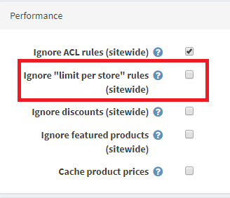

**Log in items to create authority group(Admin/CustomerRole/List)**

Create a new authority was named **Stores** or any name which can be separated this group have store administration authority.

Then, log in decentralization for this authority group at link address:

**Admin/Security/Permissions**. Choose some permissions assign to **Stores**.

Now, you create a new user account at link address: **Admin/Customer/List**

Choosing command **Registered** and **Stores** which have just create as image:

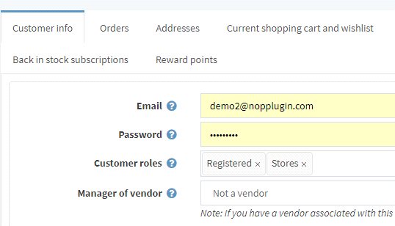

The end, you make mapping to user in each store at link address:

**/Admin/StoreMapping/List** you add a new records, including Entity name value has 2 values: **admin**, **stores**. You can fill value is **admin** if you are the highest admistrator , on which you only need to choose one any **store**. with authority is own store administrator, you choose account name and store adaptation.

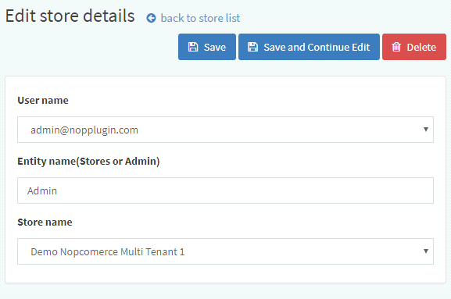

* **Description administrator function**

Account highest administrator was managed all of common setting, edit or delete product, customers, orders,….

Account administrator of each store:

* Manage own Category, own manufactures
* Manage own Products
* Manage own customers, own orders
* Manage registration receive news, own message
* Manage own Campaign
* Manage own Topic
* Manage own Poll
* Manage own Language
* Manage own News
* Manage own Blog
* Manage own Currency
* Manage own Country
* Manage own CheckoutAttribute
* Manage own PaymentMethod
* Manage own Plugins
* Vv..