Table of Contents

Addis Ababa Science and Technology University

College of Engineering

Department of Software Engineering

Web-Based Residential House Rental Control and Administration System for Addis Ababa
A Senior Research Project Document Submitted in Partial Fulfilment of the Requirements for the Degree of Bachelor of Science in Software Engineering
Group Members:
No. | Name (Alphabetical order) | ID
1 | _________________________ | _________
2 | _________________________ | _________
3 | _________________________ | _________
4 | _________________________ | _________
5 | _________________________ | _________
Advisor Name: _______________________ Signature: ________________
Addis Ababa, Ethiopia
[MONTH, YEAR]

How to use this document. This report is generated directly from the three project repositories (AARentalManagementSystemBackend, AARentalManagementSystemFrontend, and AARentalManagementSystemAuthorityFrontend). All diagrams are written in Mermaid and render automatically on GitHub. To produce the final submission copy, paste the chapters into your university template, replace the placeholders in the title page, regenerate the Table of Contents, and export the rendered diagrams as figures. Wherever a claim is made about system behaviour, the corresponding source file is cited so the work can be verified by the advisor.

I. Acknowledgement
First and foremost, we would like to express our deepest gratitude to the Almighty God for granting us the health, patience, and perseverance to complete this senior project.
We extend our sincere appreciation to our advisor, [Advisor Name], whose continuous guidance, constructive criticism, and encouragement shaped this work from the proposal stage to the final artifact. We are equally grateful to the Department of Software Engineering, Addis Ababa Science and Technology University, and its instructors for the knowledge and foundation that made this project possible.
We would also like to thank the staff of the relevant rental administration offices, the landlords, and the tenants who participated in our requirement-gathering interviews and surveys. Their insight into the real challenges of the Addis Ababa rental market grounded our design in genuine needs. Finally, we thank our families and friends for their unconditional support throughout our studies.

II. Table of Contents
- I. Acknowledgement
- II. Table of Contents
- III. List of Tables and Figures
- IV. List of Abbreviations
- V. Abstract
- Chapter One: Introduction
  - 1.1 Statement of the Problem
  - 1.2 Objectives
  - 1.3 Scope and Limitation
  - 1.4 Methodology
  - 1.5 Plan of Activities
  - 1.6 Budget Required
  - 1.7 Significance of the Study
  - 1.8 Outline of the Study
- Chapter Two: Literature Review
  - 2.1 Study of Related Works
  - 2.2 Milestones of the Related Literature and the Gaps
  - 2.3 Lessons Learned from the Literature
- Chapter Three: Problem Analysis and Modeling
  - 3.1 Existing System and Its Problems
  - 3.2 Specifying the Requirements of the Proposed Solution
  - 3.3 System Modeling
  - 3.4 Model Validation
- Chapter Four: System Design
  - 4.1 Overview
  - 4.2 Specifying the Design Goals
  - 4.3 System Design
  - 4.4 Verifying the Requirements in the Design
- Chapter Five: System Implementation
  - 5.1 Reviewing the Design Solution
  - 5.2 Deciding on the Development Tools
  - 5.3 Developing the Solution
- Chapter Six: System Evaluation
  - 6.1 Preparing Sample Test Plans
  - 6.2 Evaluating the Proposed Design and Solutions
  - 6.3 Discussing the Results
- Chapter Seven: Conclusions and Recommendations
  - 7.1 Conclusion of the Study
  - 7.2 Recommendations of the Study
- References
- Appendices

III. List of Tables and Figures
List of Tables
Table | Caption
Table 1.1 | Plan of Activities
Table 1.2 | Estimated Project Budget
Table 2.1 | Comparison of Related Systems and Identified Gaps
Table 3.1 | Actor Identification
Table 3.2 | Functional Requirements Summary
Table 3.3 | Non-Functional Requirements
Table 3.4 | Use Case Description: Tenant Requests / Signs Agreement
Table 3.5 | Use Case Description: Authority Verifies Agreement
Table 4.1 | Design Goals and Trade-offs
Table 4.2 | Subsystem (Module) Decomposition
Table 4.3 | Database Entities and Constraints
Table 4.4 | REST API Endpoint Catalogue
Table 4.5 | Requirements-to-Design Traceability
Table 6.1 | Sample Functional Test Cases
Table 6.2 | Non-Functional / Security Test Cases
List of Figures
Figure | Caption
Fig. 3.1 | Use Case Diagram of the System
Fig. 3.2 | Sequence Diagram — Tenant Signs and Authority Verifies an Agreement
Fig. 3.3 | State Machine Diagram — Tenancy Agreement Lifecycle
Fig. 3.4 | State Machine Diagram — Property Lifecycle
Fig. 3.5 | Activity Diagram — End-to-End Rental Workflow
Fig. 3.6 | Collaboration (Communication) Diagram — Rent Adjustment Review
Fig. 4.1 | Proposed Three-Tier Software Architecture
Fig. 4.2 | Subsystem Decomposition (Component Diagram)
Fig. 4.3 | Entity-Relationship / Class Diagram
Fig. 4.4 | Deployment Diagram
Fig. 4.5 | Authentication & Authorization Security Flow

IV. List of Abbreviations
Abbreviation | Meaning
API | Application Programming Interface
AASTU | Addis Ababa Science and Technology University
CRUD | Create, Read, Update, Delete
CUID | Collision-resistant Unique Identifier
DARA | (Rental) Control and Administration Authority — the regulatory body
DTO | Data Transfer Object
ERD | Entity-Relationship Diagram
ETB | Ethiopian Birr
Fayda | Ethiopian National Digital ID (FAN — Fayda Account Number)
FR | Functional Requirement
JWT | JSON Web Token
NFR | Non-Functional Requirement
ORM | Object-Relational Mapping
RAG | Retrieval-Augmented Generation
RBAC | Role-Based Access Control
REST | Representational State Transfer
SPA | Single-Page Application
SQL | Structured Query Language
SSR | Server-Side Rendering
TLS | Transport Layer Security
UI/UX | User Interface / User Experience
UML | Unified Modeling Language

V. Abstract
The residential rental market of Addis Ababa is large, fast-growing, and predominantly informal. Rental agreements are frequently verbal or paper-based, rent increases are unregulated in practice, deposits are withheld without recourse, and tenants and landlords have no trustworthy, neutral channel for resolving disputes. The recent residential rental proclamation introduces caps on rent increases, limits on advance payments, and minimum lease terms, but the supervising authority lacks a digital instrument to register, monitor, and enforce these rules at scale. This project designs and implements a Web-Based Residential House Rental Control and Administration System that digitizes the entire rental lifecycle — property registration and verification, identity verification through the Ethiopian Fayda national digital ID, digital agreement creation and dual e-signing, authority verification, rent-adjustment approval bounded by policy caps, dispute filing and mediation, penalty issuance, and an immutable audit trail. The platform is built as three coordinated applications: a NestJS + Prisma + PostgreSQL REST API enforcing all business rules and role-based access control; a Next.js public and stakeholder portal for tenants and landlords that also embeds a Retrieval-Augmented-Generation (RAG) assistant suggesting compliant rent prices; and a dedicated React (Vite) authority portal for government agents. The system was modeled using UML, designed with a layered three-tier architecture, and evaluated against a structured suite of functional, security, and non-functional test cases. The results show that the platform reliably enforces proclamation rules (e.g., rejecting illegal rent increases, requiring Fayda verification before contracting, and locking accounts after repeated failed logins) while remaining usable for non-technical stakeholders. The artifact demonstrates that a transparent, compliant, and auditable digital rental ecosystem is feasible for Addis Ababa and provides a foundation that can be extended with integrated payments and richer analytics.

Chapter One: Introduction
Housing is one of the most pressing socio-economic concerns in Addis Ababa. Rapid urbanization, internal migration, and a persistent shortage of affordable housing have made renting the dominant form of tenure for a large share of the city’s residents. Despite the size and economic importance of this market, it operates largely informally: agreements are often verbal, terms are inconsistent, and there is no centralized record of who rents what, at what price, and under which conditions.
To address abuses such as arbitrary rent increases and unfair evictions, the government has introduced a residential rental proclamation that, among other measures, caps annual rent increases, limits advance payments, and sets minimum lease durations. However, a law is only as effective as the mechanism that enforces it. The supervising rental control and administration authority currently has no digital tool to register agreements, validate them against the proclamation, monitor compliance, or resolve disputes. This project responds to that gap by building a software platform that operationalizes the proclamation and brings transparency to all three stakeholder groups — tenants, landlords, and the regulator.
The platform described in this report is referred to internally as the Addis Ababa Residential House Rental Control and Administration System. It is implemented as a backend API and two web front-ends (a public/stakeholder portal and an authority portal), and it integrates with the national Fayda digital identity so that the people behind every agreement are verifiably real.

1.1 Statement of the Problem
The Addis Ababa residential rental market suffers from a cluster of interrelated problems:
- Informality and lack of records. Most rental relationships are not registered with any authority. There is no single source of truth for agreement terms, rent history, or occupancy, which makes oversight, taxation, and policy evaluation almost impossible.
- Unregulated rent increases. Even with a legal cap, there is no automated check that prevents a landlord from imposing increases above the permitted percentage; tenants rarely know their rights or have evidence to contest an increase.
- Identity and trust gaps. Landlords cannot reliably confirm a prospective tenant’s identity, and tenants cannot confirm that a “landlord” actually owns the property, enabling fraud on both sides.
- Weak dispute resolution. When conflicts arise (deposit withholding, wrongful eviction, maintenance neglect, harassment), there is no structured, neutral, traceable channel to report, mediate, and resolve them, nor to issue and track penalties.
- No compliance instrument for the regulator. The authority cannot efficiently verify agreements, monitor violations, publish pricing rules per sub-city, or maintain an audit trail of who did what and when.
These problems harm tenants (insecurity, exploitation), landlords (fraud, payment uncertainty), and the state (lost revenue, inability to enforce its own proclamation). The problem is significant because housing security directly affects livelihoods, and because the proclamation will fail in practice without a digital enforcement mechanism. This project therefore investigates how a centralized, compliance-aware digital platform can make the Addis Ababa rental market transparent, fair, and enforceable.

1.2 Objectives

1.2.1 General Objective
The general objective of this project is to design and develop a web-based residential house rental control and administration system for Addis Ababa that digitizes the rental lifecycle and automatically enforces the residential rental proclamation while providing transparent, auditable oversight to the regulatory authority.

1.2.2 Specific Objectives
To achieve the general objective, the following specific objectives are pursued:
- To gather and analyze requirements from tenants, landlords, and the rental authority through interviews, observation, and review of the proclamation.
- To model the system using UML (use-case, sequence, state-machine, activity, collaboration, and class/ER diagrams) and validate the models against stakeholder needs.
- To design a secure, layered three-tier architecture with role-based access control, a normalized relational data model, and clearly decomposed subsystems.
- To implement digital identity verification by integrating the national Fayda digital ID so that every contracting party is verified.
- To implement the rental lifecycle: property registration and authority verification, digital agreement creation, dual (tenant + landlord) e-signing, and authority verification/activation.
- To enforce proclamation rules automatically: rent-increase caps, advance-payment limits, and minimum/maximum lease durations through configurable system parameters.
- To implement dispute management and penalties, allowing parties to file violations and authority agents to mediate, resolve, and issue penalty notices.
- To provide a compliance and analytics workspace for the authority, including an immutable audit log and configurable system parameters.
- To assist fair pricing through a Retrieval-Augmented-Generation (RAG) rent-suggestion feature bounded by the regulator’s pricing band.
- To test, evaluate, and deploy the solution and verify that it satisfies the specified functional and non-functional requirements.

1.3 Scope and Limitation

Scope
The project covers the following, all of which are implemented in the accompanying source code:
- User management and authentication with five roles — tenant, landlord, government administrator (admin), authority/dara_agent, and system_admin — using JWT access/refresh tokens, password hashing, account lockout, and session management.
- Fayda identity verification for tenants and landlords, and Fayda-based tenant lookup for landlords.
- Property management: registration by landlords, authority verification (approve/reject), and an optional public “Explore” listing.
- Tenancy agreements: landlord-initiated and tenant-initiated flows, dual e-signing, authority verification, and automatic property status transitions.
- Rent adjustments: landlord requests bounded by a maximum allowed percentage, with authority approval that automatically updates the contract rent.
- Dispute management: filing by parties, authority mediation/resolution, and assignment to authority agents.
- Penalty notices, supporting documents, rent-payment records, notifications, pricing strategies, and an audit log as supporting data models.
- A public landing page and property explorer, a stakeholder dashboard, and a dedicated authority portal, with bilingual (English/Amharic) UI strings.
- A RAG-based rent-suggestion assistant that recommends a compliant monthly rent for a unit.

Limitation
The following items were considered in scope but are partially implemented or deferred:
- Online payment gateway integration. Payment methods (telebirr, CBE Birr, bank transfer, etc.) are modeled in the database (RentPayment), but live integration with a payment processor is not implemented; payments are recorded rather than transacted.
- Live Fayda government API. Fayda verification uses the project’s verification endpoints and seeded identities for demonstration; a production deployment would connect to the official Fayda eKYC API.
- AI rent suggestion. The RAG assistant works fully offline using a local knowledge base and benchmark heuristics; the optional OpenAI enrichment is only used when an OPENAI_API_KEY is configured.
- File storage. Supporting documents are modeled with a storageKey; binary object storage (e.g., S3) is referenced by key rather than fully provisioned in the demo environment.
- Email/SMS delivery. Notification preferences exist as system parameters, but external email/SMS gateways are not wired in.

1.4 Methodology
Research and requirement methodology. Requirements were elicited through interviews with landlords and tenants, observation of current (manual) renting practice, and a study of the residential rental proclamation to extract concrete, machine-enforceable rules (rent caps, advance-payment limits, lease durations).
Software process model. An iterative and incremental (Agile-style) process was followed. Each module (auth, properties, agreements, disputes, rent adjustments, users/admin) was specified, designed, implemented, and tested in short cycles, integrating continuously into the shared API and front-ends.
System modeling. The system was modeled with UML — use-case, sequence, state-machine, activity, collaboration, and class/ER diagrams — before and during implementation.
Architecture and implementation style. A layered, three-tier client-server architecture was adopted. The backend uses the NestJS modular pattern (controller → service → repository via the Prisma ORM), DTO-based validation, and global guards for authentication and authorization. The front-ends are component-based SPAs/SSR apps.
Technology stack.
Tier | Technology
Backend API | NestJS 11 (Node.js, TypeScript), Prisma 7 ORM, PostgreSQL 16
Auth & security | JWT (access/refresh), bcrypt, Passport, Helmet, rate-limiting (Throttler), class-validator
Stakeholder front-end | Next.js 16 (React 19, App Router), Tailwind CSS 4, Recharts
Authority front-end | React 19 + Vite, React Router, Tailwind CSS
AI assistance | Local RAG knowledge base with optional OpenAI gpt-4o-mini enrichment
DevOps | Docker & Docker Compose, environment-variable validation (Joi), Vercel/Render deployment
Testing and deployment standards. Validation is enforced at the boundary with a global ValidationPipe (whitelisting and rejecting unknown fields). Unit testing uses Jest; end-to-end testing uses Jest + Supertest. The backend ships with a Dockerfile and docker-compose.yml (API + Postgres), and the front-ends deploy to Vercel with a same-origin proxy to avoid CORS.

1.5 Plan of Activities
Table 1.1 — Plan of Activities
Phase | Key Activities | Deliverable
Phase 1 — Inception | Problem identification, stakeholder interviews, proclamation study | Project proposal
Phase 2 — Requirement analysis | Functional/non-functional requirements, actor & use-case identification | SRS
Phase 3 — System modeling | UML diagrams, data model, model validation | Analysis models
Phase 4 — System design | Architecture, subsystem decomposition, database & UI design, security design | Design document
Phase 5 — Implementation | Backend API, stakeholder portal, authority portal, Fayda & RAG features | Working software
Phase 6 — Evaluation | Test plans, functional/security/non-functional testing | Test report
Phase 7 — Documentation & defense | Final report, presentation, deployment | This document + demo

1.6 Budget Required
Because the project is a software system built primarily on open-source technologies, the dominant costs are cloud hosting and identity/AI service usage. Hardware refers to the development machines already available to the team.
Table 1.2 — Estimated Project Budget
Item | Description | Estimated Cost (ETB)
Development hardware | Laptops (team-owned) | — (existing)
Internet & data | Development and research period | 4,000
Cloud hosting | API (Render) + DB + front-ends (Vercel) during development | 6,000
Domain name | Optional custom domain | 1,500
AI/identity services | Optional OpenAI/Fayda API usage during testing | 2,000
Printing & binding | Final report copies | 1,500
Contingency | Miscellaneous (10%) | 1,500
Total |  | ≈ 16,500
The figures above are planning estimates; the development and demonstration of this project were achieved using free tiers of open-source tools and cloud platforms.

1.7 Significance of the Study
The study contributes value to several stakeholders:
- Tenants gain protection from illegal rent increases and unfair practices, verifiable contracts, and a neutral channel to file and track disputes.
- Landlords gain verified tenants (reducing fraud and default risk), a legally clean digital contract, and data-driven, compliant pricing guidance.
- The regulatory authority gains a single instrument to register and verify agreements, monitor violations, publish per-sub-city pricing rules, issue penalties, and review an immutable audit trail.
- Government and policy benefit from accurate market data (rent trends, occupancy, dispute statistics) to evaluate and refine housing policy.
- The software engineering field benefits from a documented reference implementation of a compliance-aware, multi-portal, identity-integrated rental platform suitable for the Ethiopian context.

1.8 Outline of the Study
The remainder of this document is organized as follows. Chapter Two reviews related rental and property-management systems, identifies their milestones and gaps, and draws lessons. Chapter Three analyzes the existing (manual) system, elicits functional and non-functional requirements, and presents the UML models. Chapter Four presents the system design: architecture, subsystem decomposition, database design, deployment, UI, integration, and security. Chapter Five describes the implementation — tools chosen and how the solution was developed, with representative code. Chapter Six evaluates the system through test plans and discusses the results. Chapter Seven concludes the study and offers recommendations for future work. The document closes with references and appendices.

Chapter Two: Literature Review
The purpose of this chapter is to position the project within the landscape of existing rental and property-management solutions. By reviewing what has been built elsewhere — both global commercial platforms and local/academic efforts — we identify the techniques worth adopting and, more importantly, the gaps that a compliance-focused Ethiopian system must fill. This review directly informed the requirements (Chapter Three) and the design decisions (Chapter Four).

2.1 Study of Related Works
a) Global property/rental marketplaces (e.g., Zillow, Apartments.com, Airbnb). These platforms excel at listing discovery, rich media, search, and (in some cases) booking and payment. They are mature in UX and scale. However, they are fundamentally marketplaces, not regulatory instruments: they do not enforce a government rent cap, do not verify national identity for legal contracting in the Ethiopian sense, and do not provide an authority with verification, dispute-mediation, or penalty-issuance workflows.
b) Property-management software (e.g., Buildium, AppFolio, Rentec Direct). These target professional landlords and property managers with lease tracking, maintenance, and accounting. They assume a landlord-centric, single-tenant administrative model and a Western legal/payment context. They do not model a neutral government regulator as a first-class actor and are not localized for Ethiopian sub-cities, the Fayda ID, or the rental proclamation.
c) E-government and land/property registration systems. Public-sector registries demonstrate the value of authoritative records, audit trails, and identity verification. They emphasize compliance and traceability but are typically heavyweight, slow to use for everyday renting, and rarely expose a modern, self-service experience to ordinary tenants and landlords.
d) Local and academic rental systems. Prior Ethiopian student/academic projects have built basic rental CRUD applications (list a house, contact an owner). They establish demand for digitization but usually stop at listings; they seldom integrate national identity, enforce proclamation rules automatically, model dispute resolution, or provide a separate authority workspace.
e) Retrieval-Augmented Generation for domain assistance. Recent work on RAG shows that grounding a language model in a curated knowledge base produces reliable, domain-specific answers while avoiding hallucination. This project applies the idea narrowly and safely: rent suggestions are computed from a local benchmark/knowledge base and constrained to the regulator’s pricing band, with optional LLM phrasing only.

2.2 Milestones of the Related Literature and the Gaps
Table 2.1 — Comparison of Related Systems and Identified Gaps
Capability | Global marketplaces | PM software | E-gov registries | Local academic apps | This project
Listing & discovery | ✔ | ✔ | ✖ | ✔ | ✔
National digital ID (Fayda) verification | ✖ | ✖ | partial | ✖ | ✔
Digital agreement + dual e-signing | partial | ✔ | partial | ✖ | ✔
Automatic proclamation enforcement (rent cap, advance, lease term) | ✖ | ✖ | ✖ | ✖ | ✔
Dedicated regulator/authority workspace | ✖ | ✖ | ✔ | ✖ | ✔
Dispute filing, mediation & penalties | partial | partial | ✖ | ✖ | ✔
Immutable audit log | partial | partial | ✔ | ✖ | ✔
Localization (sub-cities, Amharic, ETB) | ✖ | ✖ | partial | partial | ✔
Compliance-bounded AI pricing guidance | ✖ | partial | ✖ | ✖ | ✔
The comparison reveals a clear gap: no reviewed system simultaneously (i) treats the government regulator as a first-class actor, (ii) enforces the rental proclamation automatically at the data layer, (iii) integrates the national Fayda identity, and (iv) localizes for Addis Ababa. This combination is precisely the niche this project occupies.

2.3 Lessons Learned from the Literature
- Identity is the foundation of trust. Verifiable identity (Fayda) must precede contracting; the system enforces Fayda verification before a tenant can sign an agreement.
- Compliance must be enforced by code, not by policy alone. Rent caps and limits are encoded as validation rules and configurable system parameters rather than left to user discretion.
- Separate the regulator’s experience. A dedicated authority portal keeps the oversight workflow focused and auditable, distinct from the tenant/landlord experience.
- Keep AI grounded and bounded. Pricing guidance is computed deterministically and constrained to a policy band; AI only rephrases, it never invents figures outside the band.
- Audit everything. An append-only audit log of sensitive actions is essential for a government-grade system.
These lessons shaped the requirements and the layered, security-first design presented next.

Chapter Three: Problem Analysis and Modeling
This chapter dissects the current way renting is done in Addis Ababa, specifies the requirements of the proposed solution, and models the system using UML. Problem analysis ensures we solve the right problem; modeling ensures the solution is well understood before and during implementation.

3.1 Existing System and Its Problems
The existing system is largely manual and informal. A typical rental transaction proceeds as follows: a prospective tenant finds a unit through word of mouth, a broker, or scattered social-media posts; the tenant and landlord negotiate verbally; a handwritten or template paper contract may (or may not) be signed; advance payment and deposit are exchanged in cash; and no copy is filed with any authority.
Stakeholders affected:
- Tenants — exposed to arbitrary rent increases, deposit withholding, and eviction without recourse.
- Landlords — exposed to tenant fraud, non-payment, and property misuse; no easy way to verify a tenant’s identity.
- Brokers — introduce cost and opacity, with inconsistent incentives.
- The rental authority — blind to the market: no registry, no compliance monitoring, no dispute pipeline, no data for policy.
Problems and their root causes:
Problem | Root cause | Impact
No central record of agreements | No digital registration channel | No oversight, no taxation, no analytics
Illegal rent increases | No automatic enforcement of the cap | Tenant exploitation, housing insecurity
Identity fraud (both sides) | No verified identity at contracting | Scams, disputes, mistrust
Unresolved disputes | No neutral, traceable process | Conflict escalation, loss of rights
Inconsistent contracts | No standardized digital template | Ambiguity, unenforceable terms
Analytical tools used to understand the problem included stakeholder interviews, observation of broker-mediated transactions, and document analysis of the proclamation to translate legal clauses into enforceable parameters (e.g., a maximum annual rent increase percentage and a maximum advance of two months).

3.2 Specifying the Requirements of the Proposed Solution
Requirements were elicited through interviews (tenants, landlords, authority staff), observation of current practice, and document analysis of the proclamation. They are organized below into functional and non-functional requirements; the system models in Section 3.3 visualize them.

Actors
Table 3.1 — Actor Identification
Actor | Description
Tenant | Searches/explores properties, verifies Fayda identity, requests and signs agreements, files disputes, views contracts and payments.
Landlord | Registers properties, posts to Explore, looks up tenants by Fayda, creates/counter-signs agreements, requests rent adjustments, files disputes.
Authority Agent (dara_agent) | Verifies properties and agreements, reviews rent adjustments and disputes, issues penalties.
Government Administrator (admin) | Authority capabilities plus user administration, statistics, and audit-log access.
System Administrator (system_admin) | All administrator capabilities plus management of system parameters.
RAG/AI Service (supporting actor) | Provides compliant rent-price suggestions.
Fayda Identity Service (external actor) | Verifies national digital identity.

3.3 System Modeling

3.3.1 Functional Requirements
The functional requirements describe what the system must do. They are grouped by module and map directly to the implemented controllers/services.
Table 3.2 — Functional Requirements Summary
ID | Functional Requirement
FR-1 | The system shall allow users to register and log in with a selected role and issue JWT access/refresh tokens.
FR-2 | The system shall lock an account after 5 consecutive failed login attempts for 15 minutes.
FR-3 | The system shall allow a user to view and update their own profile.
FR-4 | The system shall allow tenants and landlords to verify their Fayda national identity.
FR-5 | The system shall allow a landlord to look up a tenant by Fayda number (returning a masked public profile).
FR-6 | The system shall allow landlords to register properties (created as pending_verification).
FR-7 | The system shall allow authority users to approve (available) or reject properties.
FR-8 | The system shall allow landlords to post approved properties to the public Explore listing.
FR-9 | The system shall expose a public, paginated, filterable list of explorable properties.
FR-10 | The system shall allow a landlord to create an agreement for an available property and a verified tenant.
FR-11 | The system shall allow a Fayda-verified tenant to request an agreement for an available property.
FR-12 | The system shall require dual e-signatures (tenant and landlord) before authority verification.
FR-13 | The system shall allow authority users to verify (active) or reject an agreement, updating the property status accordingly.
FR-14 | The system shall allow a landlord to request a rent adjustment only on active/extended agreements and only above current rent.
FR-15 | The system shall compute the increase percentage and enforce a maximum allowed percentage; on approval, the contract rent is updated automatically.
FR-16 | The system shall allow agreement parties to file disputes with a violation type, priority, and evidence.
FR-17 | The system shall allow authority users to review, assign, mediate, resolve, or close disputes.
FR-18 | The system shall support penalty notices, supporting documents, rent payments, and notifications.
FR-19 | The system shall provide authority statistics, a user-administration list, and an immutable audit log.
FR-20 | The system shall allow the system administrator to manage configurable system parameters (e.g., rent cap, advance limit, lease durations).
FR-21 | The system shall provide a RAG-based rent suggestion bounded by the regulator’s pricing band.

3.3.2 Non-Functional Requirements
Table 3.3 — Non-Functional Requirements
ID | Category | Requirement & Metric
NFR-1 | Security | Passwords stored as bcrypt hashes (cost factor 12); JWT secrets ≥ 32 chars; HTTP security headers via Helmet.
NFR-2 | Security | Role-based access control on every protected endpoint; input whitelisting rejects unknown fields.
NFR-3 | Reliability | Database writes that span multiple tables use transactions (e.g., agreement verification updates both agreement and property atomically).
NFR-4 | Performance | Common query paths are backed by composite database indexes; the API enforces rate limiting (default 100 requests/60 s).
NFR-5 | Usability | Bilingual (English/Amharic) UI, responsive design, clear status badges and guided multi-step flows.
NFR-6 | Availability | Stateless API enabling horizontal scaling; containerized deployment with health checks.
NFR-7 | Maintainability | Modular NestJS architecture, typed DTOs, ORM-managed schema, and consistent error handling.
NFR-8 | Auditability | Sensitive actions are recorded in an append-only audit log with actor, entity, IP, and timestamp.
NFR-9 | Privacy | Personal identifiers (phone, Fayda number) are masked in public/landlord-facing profiles.

3.3.3 Use Case
The use-case diagram (Fig. 3.1) shows the principal actors and their interactions with the system.
Fig. 3.1 — Use Case Diagram of the System
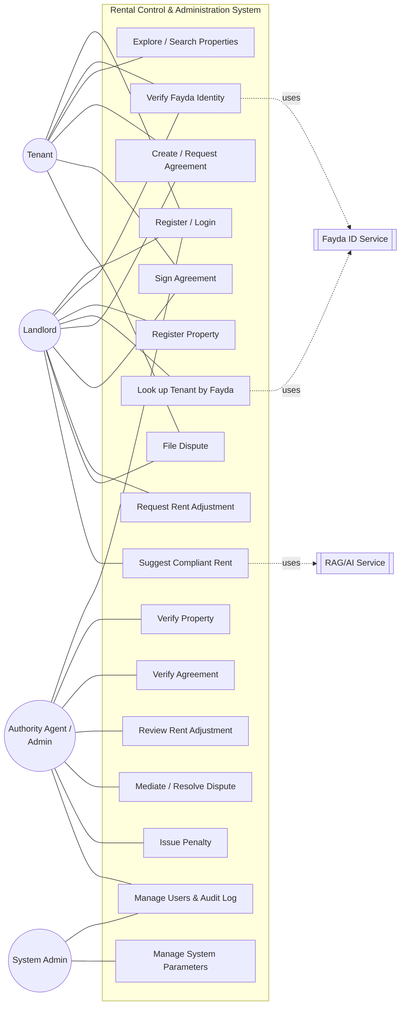
Diagram 1
Selected use-case descriptions.
Table 3.4 — Use Case: Tenant Requests / Signs Agreement
Field | Description
Use case name | Request / Sign Tenancy Agreement
Actor | Tenant
Pre-condition | Tenant is authenticated and Fayda-verified; the target property is available.
Main flow | 1. Tenant opens an available property. 2. Tenant requests an agreement (or opens a landlord-initiated one). 3. System validates Fayda verification and property availability. 4. Tenant reviews terms and e-signs. 5. System records tenantSignedAt and advances the status toward verification.
Alternate flow | If the tenant is not Fayda-verified, the system rejects the request with a verification-required error.
Post-condition | Agreement moves to draft/pending_verification; awaits landlord counter-signature and/or authority verification.
Business rules | Fayda verification required (FR-4); no duplicate open agreement on the same property; default 2-year term and 2-month advance when tenant-initiated.
Table 3.5 — Use Case: Authority Verifies Agreement
Field | Description
Use case name | Verify Tenancy Agreement
Actor | Authority Agent / Administrator
Pre-condition | Agreement is in pending_verification; actor has an authority role.
Main flow | 1. Authority opens the pending agreement. 2. Reviews parties, terms, and documents. 3. Approves (active) or rejects. 4. System, in a single transaction, updates the agreement and sets the property to rented (approve) or available (reject).
Post-condition | Agreement is active (or rejected); property status synchronized.
Business rules | Only authority roles may review (FR-13); only pending_verification agreements are reviewable; status must be active or rejected.

3.3.4 Dynamic Models of the System

3.3.4.1 Sequence Diagram
Fig. 3.2 — Sequence Diagram: Tenant Signs and Authority Verifies an Agreement
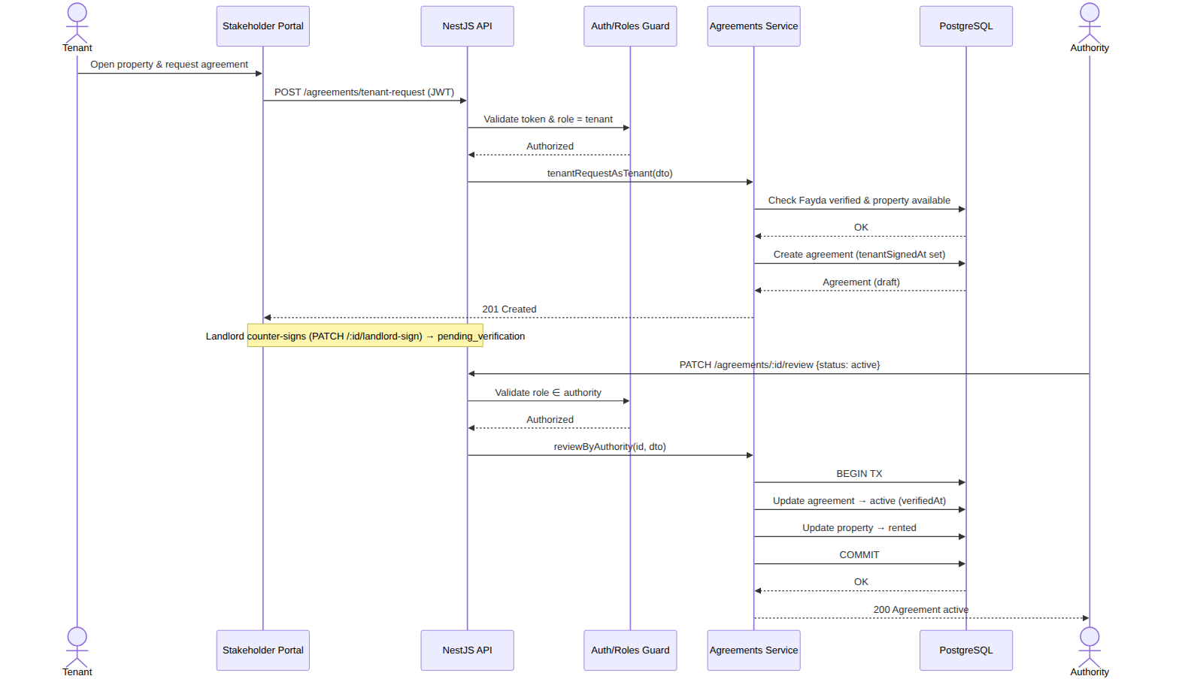
Diagram 2

3.3.4.2 State Machine Diagrams
Fig. 3.3 — State Machine: Tenancy Agreement Lifecycle
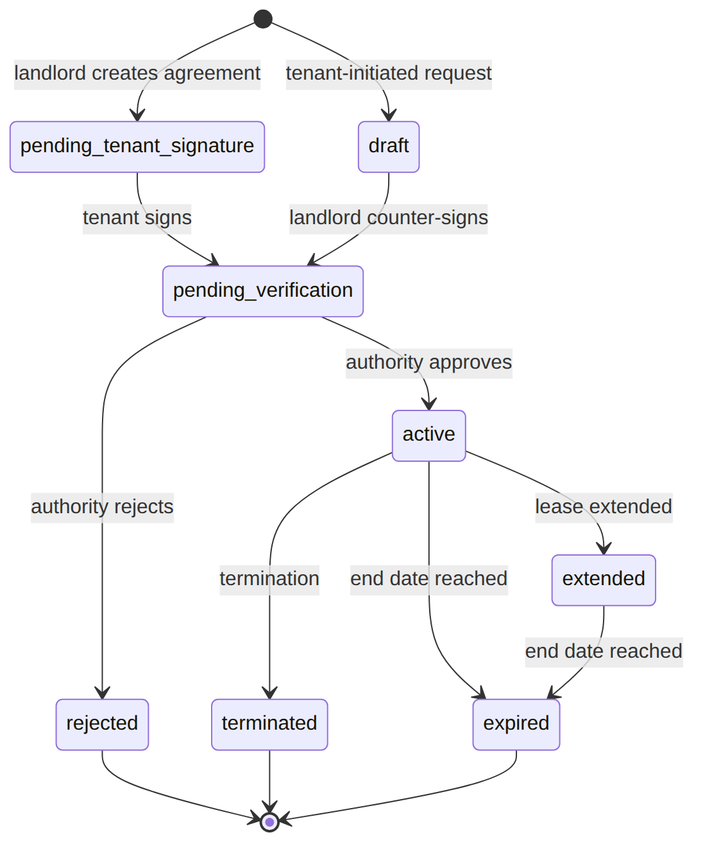
Diagram 3
Fig. 3.4 — State Machine: Property Lifecycle
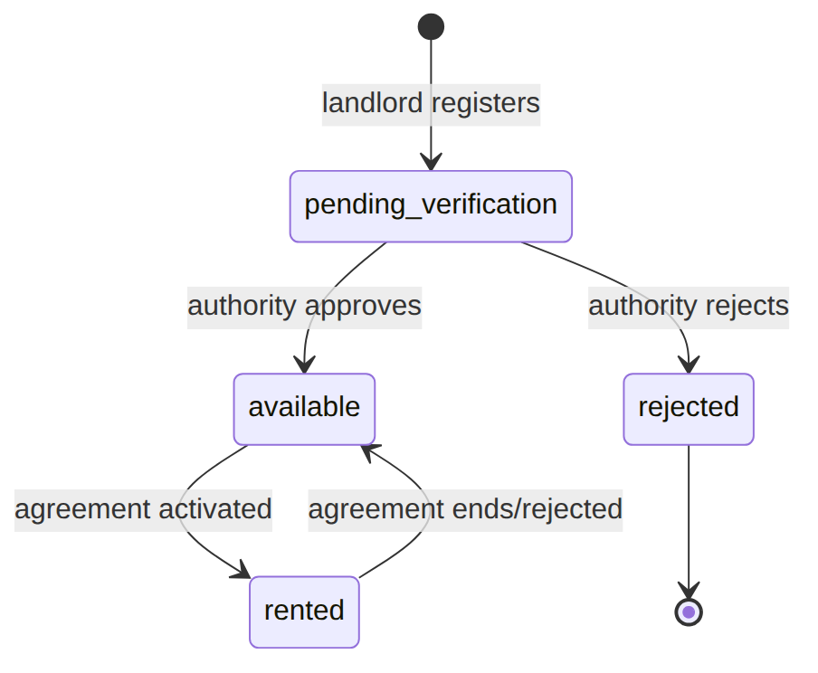
Diagram 4

3.3.4.3 Activity Diagram
Fig. 3.5 — Activity Diagram: End-to-End Rental Workflow
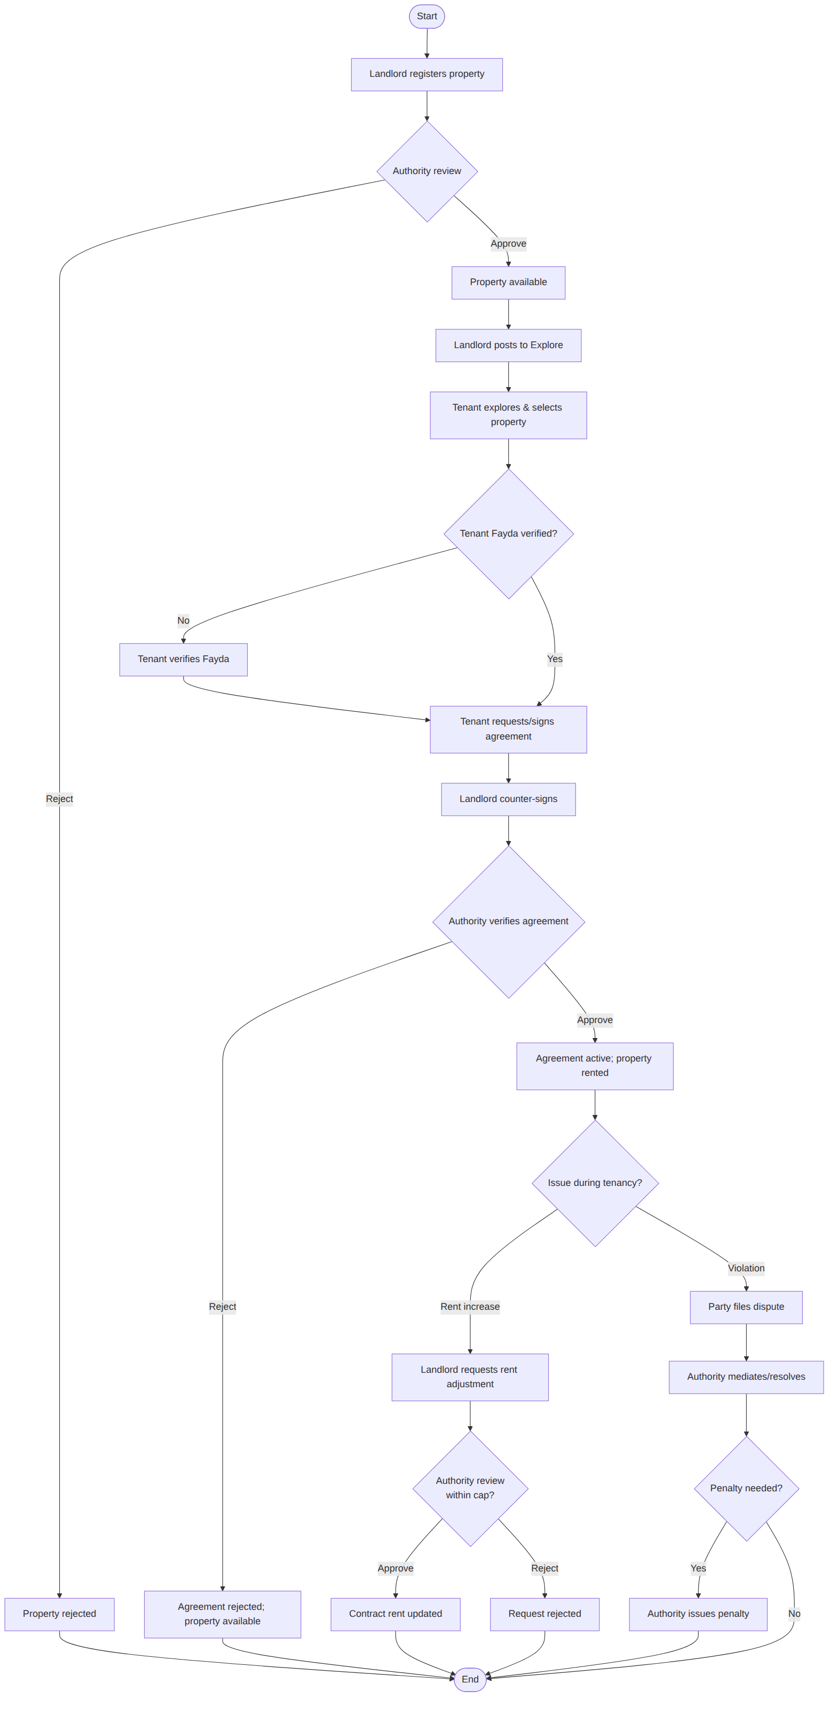
Diagram 5

3.3.4.4 Collaboration (Communication) Diagram
Fig. 3.6 — Collaboration Diagram: Rent Adjustment Review
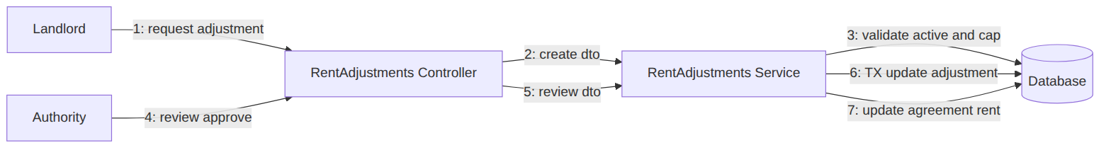
Diagram 6

3.4 Model Validation
The models were validated through several complementary checks:
- Traceability. Every functional requirement (Table 3.2) maps to at least one use case (Fig. 3.1) and one implemented controller endpoint (Table 4.4), ensuring completeness and absence of orphan requirements.
- Walkthroughs with stakeholders. The activity diagram (Fig. 3.5) was reviewed with sample landlords and tenants to confirm it matches the real-world rental journey.
- Consistency of state machines. The agreement and property state machines (Figs. 3.3–3.4) were cross-checked against the service code so that every transition in the model corresponds to a guarded transition in agreements.service.ts and properties.service.ts (e.g., approval atomically moves the property to rented).
- Rule validation. Business rules extracted from the proclamation (rent cap, advance limit, Fayda requirement) were confirmed to be enforced as explicit validation in the services, not merely documented.
These validation activities confirmed that the models are correct, complete, and faithfully realized by the implementation described in the following chapters.

Chapter Four: System Design

4.1 Overview
System design translates the validated requirements and models of Chapter Three into a concrete, buildable structure. The design centers on a layered three-tier architecture with a single authoritative backend that owns all business rules, two purpose-built front-ends, and a normalized relational database. This separation lets each stakeholder group use an interface tailored to them while guaranteeing that the proclamation rules are enforced in exactly one place — the API — and therefore cannot be bypassed by a client.

4.2 Specifying the Design Goals
Table 4.1 — Design Goals and Trade-offs
Design goal | How it is achieved | Trade-off accepted
Security | RBAC guards, JWT access/refresh, bcrypt, Helmet, input whitelisting, rate limiting | Slightly more boilerplate per endpoint
Reliability / correctness | ORM with transactions for multi-table writes; strict status guards | Transactions add minor latency
Performance | Composite indexes on hot queries; pagination everywhere; stateless API | Index storage overhead
Usability | Two tailored portals, bilingual UI, guided flows, status badges | Two front-ends to maintain
Maintainability | Modular NestJS, typed DTOs, single source of truth for schema (Prisma) | Learning curve for the stack
Scalability / availability | Stateless horizontally scalable API, containerized, health-checked | Requires external session/refresh store at scale
Privacy | Masking of phone/Fayda numbers in shared profiles | Extra mapping logic

4.3 System Design

4.3.1 Proposed Software Architecture
The system follows a client–server, three-tier architecture: a presentation tier (two web clients), an application/logic tier (the NestJS API with its guard → controller → service → ORM pipeline), and a data tier (PostgreSQL). External services (Fayda, optional OpenAI) are integrated at the edges.
Fig. 4.1 — Proposed Three-Tier Software Architecture
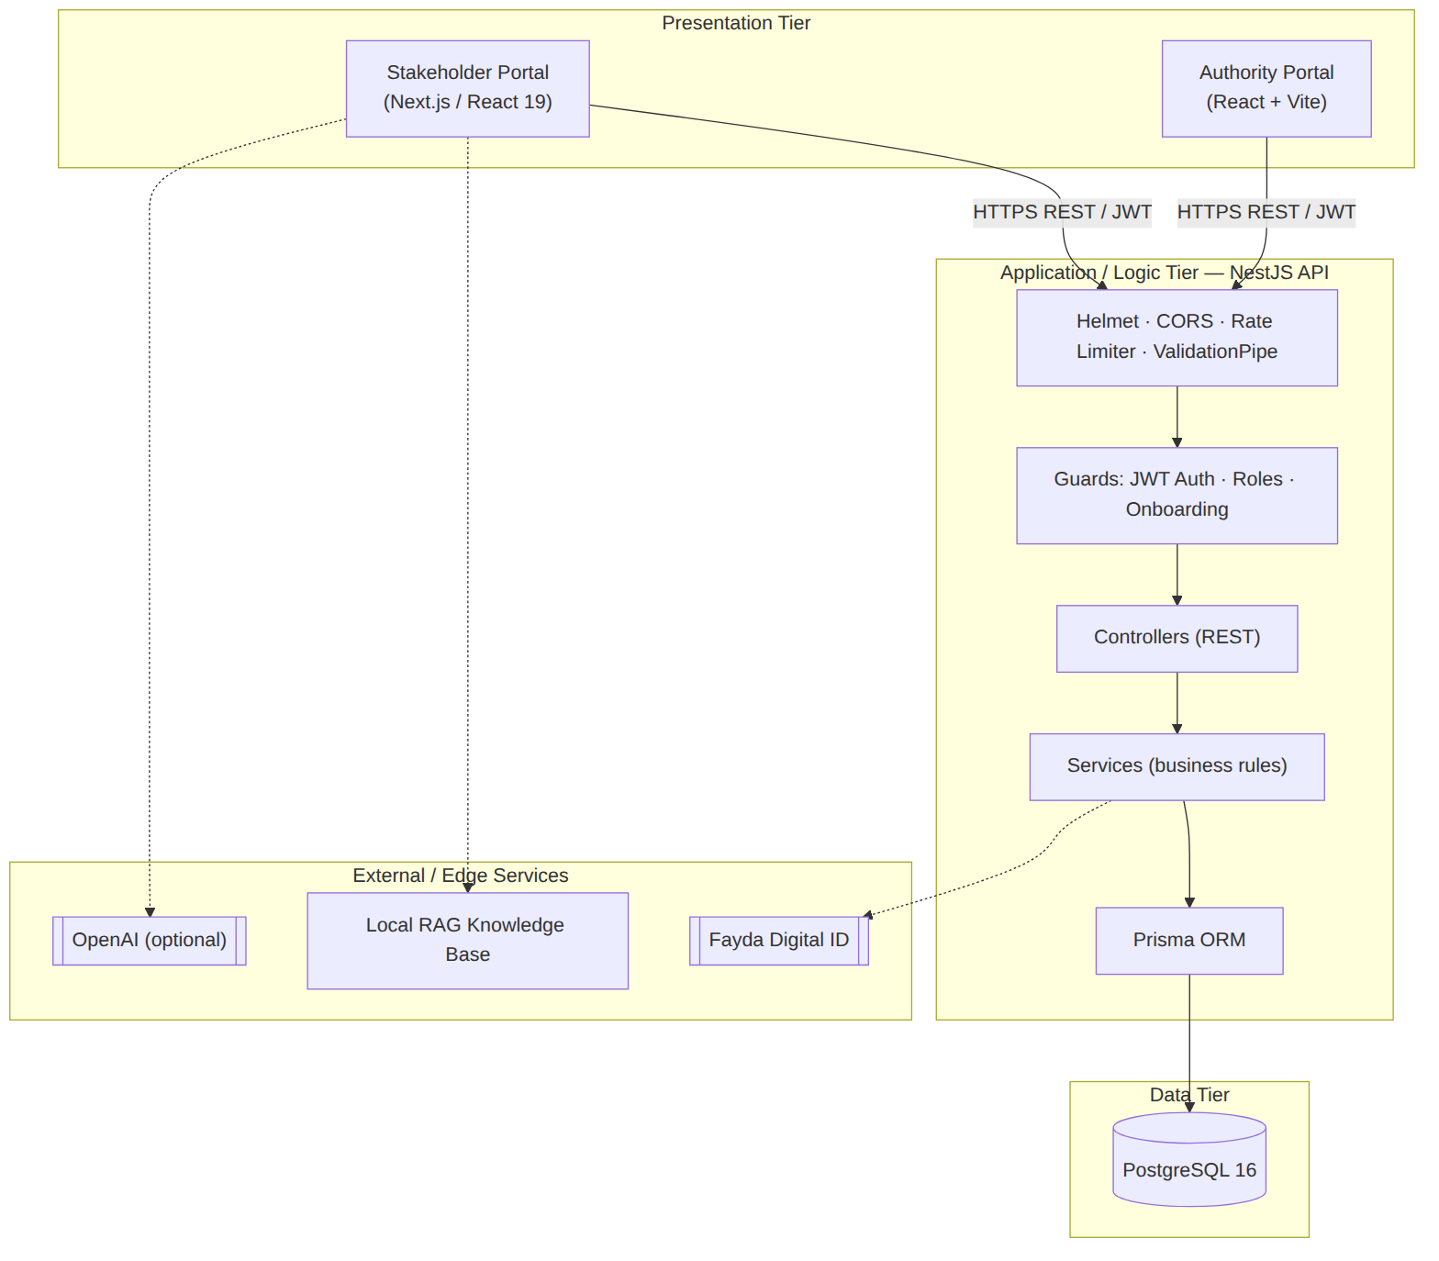
Diagram 7

4.3.2 Subsystem Decomposition
The backend is decomposed into cohesive NestJS modules, each owning a controller, a service, and its DTOs. This mirrors the requirement groups and keeps responsibilities isolated.
Fig. 4.2 — Subsystem Decomposition (Component Diagram)
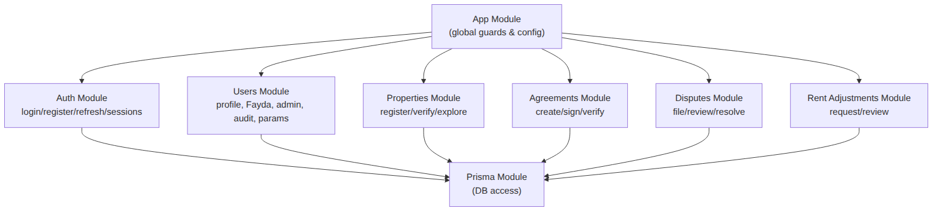
Diagram 8
Table 4.2 — Subsystem (Module) Decomposition
Module | Responsibility | Key endpoints
Auth | Registration, login (role-checked), JWT refresh with rotation, logout, session management, account lockout | POST /auth/register, POST /auth/login, POST /auth/refresh, POST /auth/logout, GET /auth/me
Users | Self profile, Fayda verification, landlord tenant lookup, admin stats/list, audit logs, system parameters | GET/PATCH /users/me, POST /users/me/fayda/verify, GET /users/tenants/lookup, GET /users/admin/*
Properties | Property registration, authority verification, Explore listing, public search | POST /properties, PATCH /properties/:id/review, PATCH /properties/:id/post-to-explore, GET /properties/public
Agreements | Landlord/tenant agreement creation, dual signing, authority verification | POST /agreements, POST /agreements/tenant-request, PATCH /agreements/:id/tenant-sign, PATCH /agreements/:id/landlord-sign, PATCH /agreements/:id/review
Disputes | Filing, listing, authority review/resolution/assignment | POST /disputes, PATCH /disputes/:id/review
Rent Adjustments | Capped increase requests and authority review (auto-applies on approval) | POST /rent-adjustments, PATCH /rent-adjustments/:id/review
Prisma | Shared data-access layer (connection, models, transactions) | —

4.3.3 Database Design
Persistent data is stored in PostgreSQL and managed through the Prisma ORM. The schema is normalized, uses CUID string primary keys, soft-deletes where appropriate (deletedAt), Restrict/ SetNull/Cascade referential actions chosen per relationship, and composite indexes on frequent query paths. The entity-relationship/class diagram below shows the core entities and their relationships (supporting entities such as Notification, RentPayment, SupportingDocument, PenaltyNotice, PricingStrategy/SubCityRule, SystemParameter, AuditLog, and AuthSession are summarized in Table 4.3).
Fig. 4.3 — Entity-Relationship / Class Diagram (core entities)
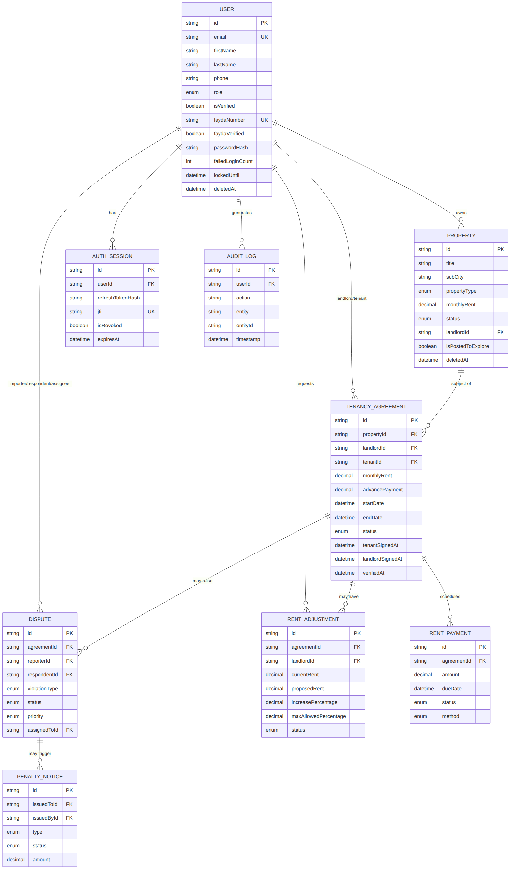
Diagram 9
Table 4.3 — Database Entities and Constraints (summary)
Entity | Purpose | Notable constraints
User | All system users (5 roles) | unique email, unique faydaNumber, soft-delete, lockout fields
Property | Rental units | FK landlord (Restrict), enum status, soft-delete, multiple indexes
TenancyAgreement | Contracts | FKs to property/landlord/tenant (Restrict), signing & verification timestamps
Dispute | Violation cases | FKs to agreement/property/parties; optional assignee (SetNull)
RentAdjustment | Rent-increase requests | computed increasePercentage, maxAllowedPercentage
PricingStrategy / SubCityRule | Regulator pricing policy | unique (strategyId, subCity), Cascade delete
Notification | User notifications | FK user (Cascade), read flags
RentPayment | Payment records | enum status & method
SupportingDocument | Uploaded evidence/docs | unique storageKey, polymorphic relations (SetNull)
PenaltyNotice | Penalties | FKs issuedTo/issuedBy (Restrict)
SystemParameter | Configurable rules | unique key, category enum
AuditLog | Immutable action log | indexed by user/entity/action + timestamp
AuthSession | Refresh-token sessions | unique jti, revocation & expiry

4.3.4 Deployment Diagram
Fig. 4.4 — Deployment Diagram
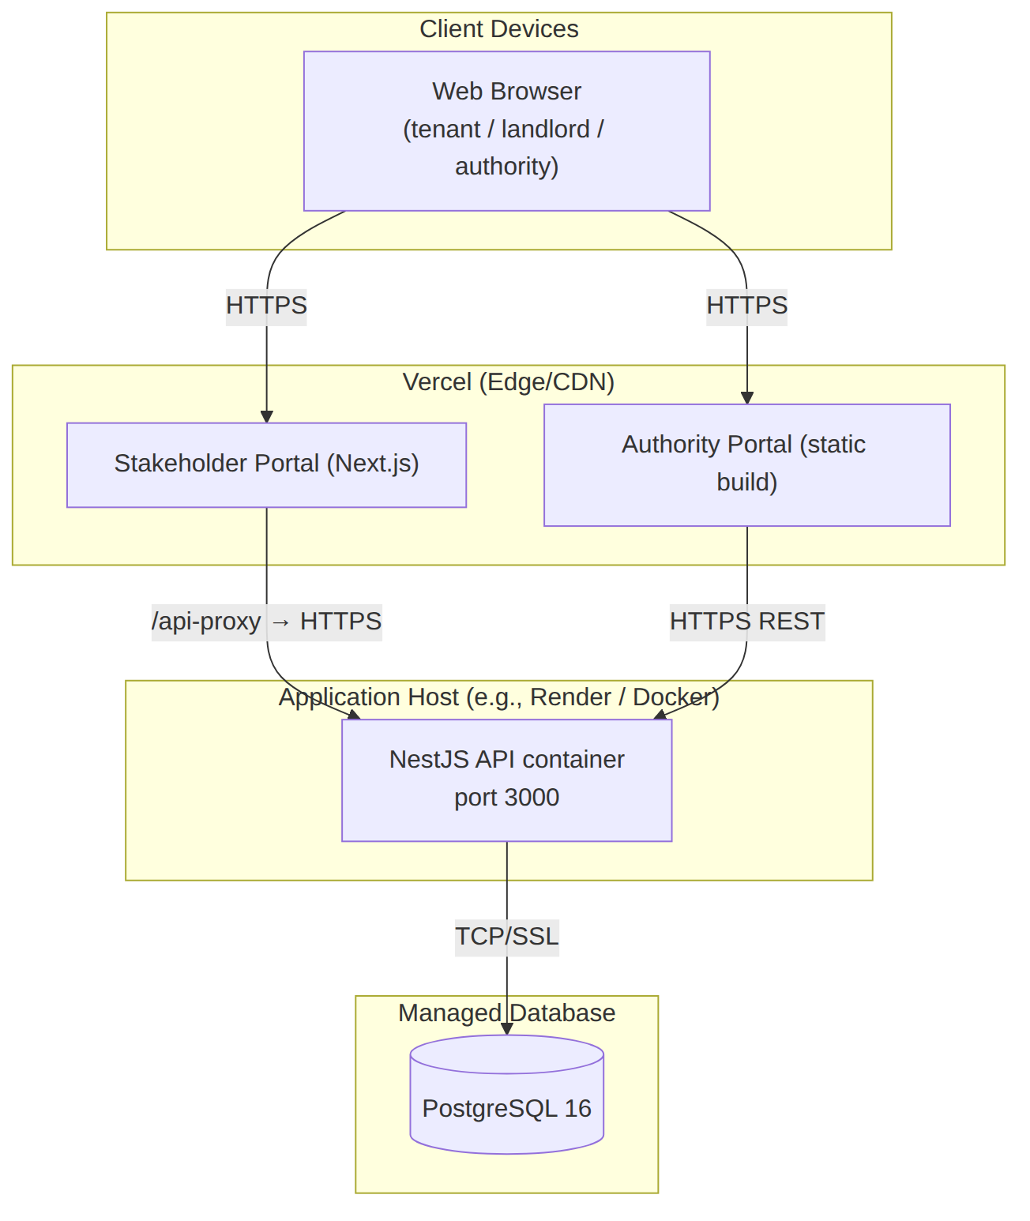
Diagram 10
The stakeholder portal is deployed on Vercel and reaches the API through a same-origin /api-proxy (configured by BACKEND_PROXY_TARGET) to avoid browser CORS issues; the authority portal is a built SPA that calls the API directly. The API runs as a Docker container alongside (or connected to) a managed PostgreSQL instance, with health checks defined in docker-compose.yml.

4.3.5 User Interface Design
The UI follows a user-centered, role-aware approach. Key screens in the stakeholder portal include the public landing page, the property Explore page, login/registration with role selection, a role-aware dashboard with a sidebar, property registration (with RAG-assisted pricing), agreement creation and the live signing screen, dispute reporting, and profile/Fayda verification. The authority portal provides a focused workspace: dashboard, agreements, properties, disputes, rent adjustments, users, system parameters, and audit logs (see App.tsx routes). Design principles applied:
- Clarity of status — colored status badges for agreements, properties, disputes, and payments.
- Guided flows — multi-step wizards for registration, agreement creation, and signing.
- Localization — English/Amharic strings via an i18n dictionary.
- Consistency — shared component library, Tailwind design tokens, responsive layouts.
(In the final submission, insert screenshots/wireframes of these screens as Fig. 4.6–4.x.)

4.3.6 System Integration
Integration concerns were designed explicitly:
- Front-end ↔ API. All clients communicate over a versionless REST API using JSON and JWT Bearer tokens. The Next.js portal can either call the API directly (NEXT_PUBLIC_API_BASE_URL) or via a same-origin proxy (NEXT_PUBLIC_API_USE_PROXY=1) to eliminate CORS in production.
- Identity integration. Fayda verification and tenant lookup are encapsulated behind dedicated endpoints/services so the underlying provider can be swapped for the official eKYC API without affecting callers.
- AI integration. The RAG rent-suggestion endpoint computes results locally and only optionally calls OpenAI when a key is present, degrading gracefully to the local summary otherwise.
- Configuration. Environment variables are validated at start-up (Joi schema), failing fast on misconfiguration, which protects integration boundaries.

4.3.7 Security Design
Security is enforced primarily in the application tier and is layered:
- Authentication. Email/password login (role-checked) issues a short-lived JWT access token and a long-lived refresh token; refresh tokens are hashed (bcrypt) and stored as revocable sessions with a unique jti, and are rotated on every refresh.
- Authorization. Global guards run on every request: a JWT auth guard, a roles guard (@Roles(...)) enforcing RBAC, and an onboarding guard. Endpoints are explicitly marked @Public() only where appropriate (e.g., public property listing, login).
- Account protection. Five consecutive failed logins lock the account for 15 minutes; passwords are bcrypt-hashed (cost 12).
- Transport & headers. Helmet sets secure HTTP headers; deployments terminate TLS at the edge.
- Input hardening. A global ValidationPipe with whitelist and forbidNonWhitelisted strips and rejects unexpected fields; rate limiting throttles abusive clients.
- Auditability & privacy. Sensitive actions are recorded in an append-only AuditLog; phone and Fayda numbers are masked in shared profiles.
Fig. 4.5 — Authentication & Authorization Security Flow
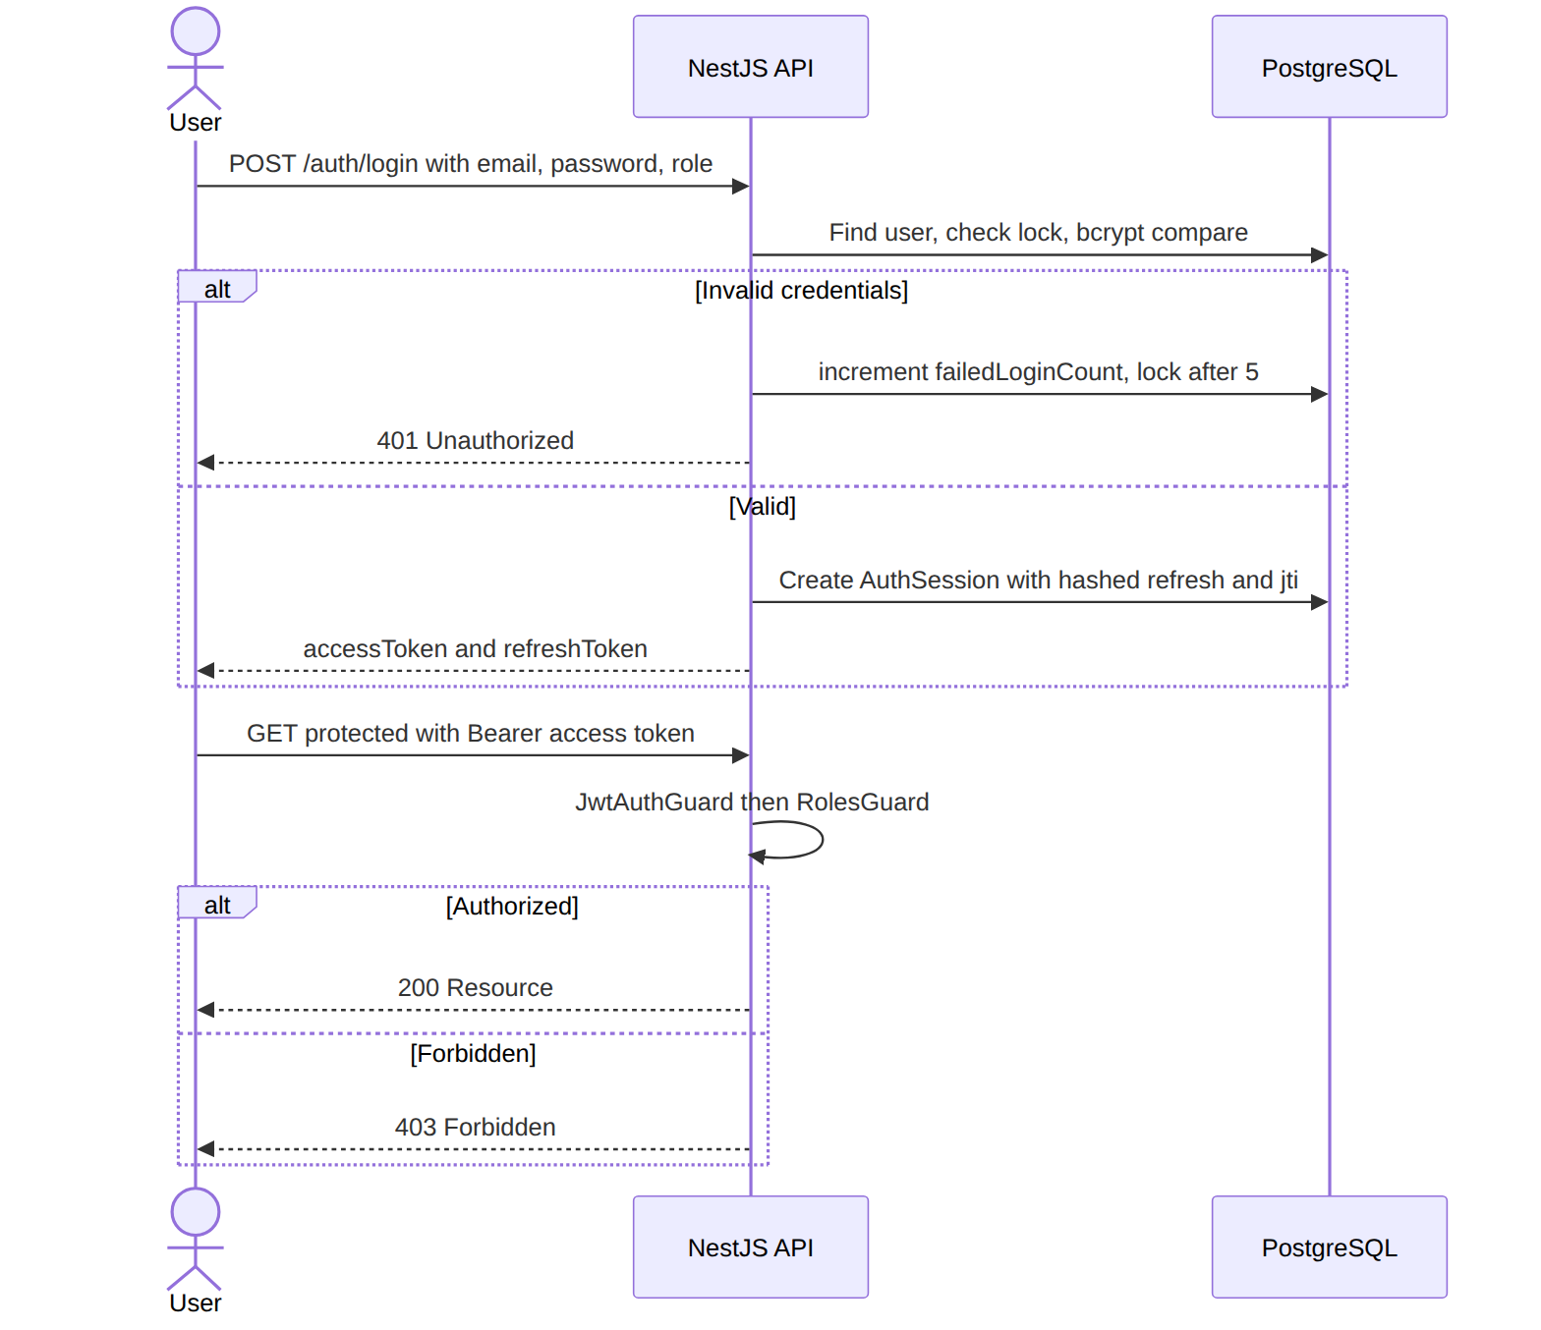
Diagram 11

4.4 Verifying the Requirements in the Design
The design was checked against the requirements using a traceability matrix; every requirement maps to a concrete design element (module, endpoint, or schema constraint).
Table 4.5 — Requirements-to-Design Traceability (excerpt)
Requirement | Design element
FR-1, FR-2 (auth, lockout) | Auth Module; AuthSession; failedLoginCount/lockedUntil
FR-4, FR-5 (Fayda) | Users Module fayda/verify, tenants/lookup; faydaVerified
FR-6–FR-9 (properties) | Properties Module; Property.status; Fig. 3.4
FR-10–FR-13 (agreements) | Agreements Module; transactional verify; Fig. 3.3
FR-14, FR-15 (rent cap) | Rent Adjustments Service (computed %, max %, auto-apply)
FR-16, FR-17 (disputes) | Disputes Module; assignment & resolution
FR-19, FR-20 (admin/params) | Users admin/*, system-parameters/*; SystemParameter, AuditLog
NFR-1–NFR-9 | Guards, transactions, indexes, Helmet, rate limiter, masking
Discrepancies discovered during this verification (for example, ensuring the property status is updated in the same transaction as agreement approval) were resolved in the implementation, which is described next.

Chapter Five: System Implementation

5.1 Reviewing the Design Solution
Before implementation, the design was reviewed against the project objectives. The three-tier, single-authoritative-API design satisfies the central objective — enforcing the proclamation in one unbypassable place — while the modular decomposition keeps each requirement group independently buildable and testable. The review confirmed that putting all business rules in services (not in the clients) is essential: a malicious or buggy client cannot create an illegal rent increase or an unverified contract because the server rejects it. With this confirmed, implementation proceeded module by module.

5.2 Deciding on the Development Tools
Table — Development Tools and Rationale
Concern | Tool | Why
API framework | NestJS 11 (TypeScript) | Opinionated modular structure, DI, guards/pipes ideal for RBAC & validation
ORM & DB | Prisma 7 + PostgreSQL 16 | Type-safe queries, migrations, transactions, strong relational integrity
Auth | @nestjs/jwt, passport-jwt, bcrypt | Standard, secure token & hashing primitives
Validation | class-validator, class-transformer, Joi | DTO validation and env validation
Security | Helmet, @nestjs/throttler | Secure headers and rate limiting
Stakeholder UI | Next.js 16 / React 19, Tailwind 4, Recharts | SSR + SPA, fast styling, charts for analytics
Authority UI | React 19 + Vite, React Router | Lightweight, fast SPA for the focused authority workspace
Testing | Jest, Supertest | Unit and e2e testing
DevOps | Docker / Docker Compose, Vercel, Render | Reproducible local stack and cloud deployment
Version control | Git / GitHub (three repositories) | Collaboration and history
Environment setup. Developers copy .env.example to .env, start Postgres via docker compose up postgres -d, run npx prisma generate, npm run db:push, npm run db:seed, and npm run start:dev. Required environment variables are validated at start-up (PORT, DATABASE_URL, JWT_ACCESS_SECRET/JWT_REFRESH_SECRET of ≥ 32 chars, TTLs, throttle settings).

5.3 Developing the Solution
This section presents representative implementations of the major functionality. The code is drawn directly from the repositories.

5.3.1 Global Security Configuration
All requests pass through security middleware and global guards configured at bootstrap and in the root module.
Source: 13:26:src/main.ts
app.use(
helmet({
crossOriginResourcePolicy: { policy: 'cross-origin' },
}),
);
app.enableCors();
app.useGlobalPipes(
new ValidationPipe({
whitelist: true,
forbidNonWhitelisted: true,
transform: true,
transformOptions: { enableImplicitConversion: true },
}),
);
The root module registers four global guards (rate limiting, JWT auth, roles, onboarding):
Source: 43:61:src/app.module.ts
providers: [
AppService,
{
provide: APP_GUARD,
useClass: ThrottlerGuard,
},
{
provide: APP_GUARD,
useClass: JwtAuthGuard,
},
{
provide: APP_GUARD,
useClass: RolesGuard,
},
{
provide: APP_GUARD,
useClass: OnboardingGuard,
},
],

5.3.2 Authentication, Token Rotation, and Account Lockout
Login verifies credentials, checks the role, and protects against brute force by locking the account after five failed attempts:
Source: 250:260:src/auth/auth.service.ts
private async trackFailedLogin(userId: string, failedLoginCount: number) {
const nextCount = failedLoginCount + 1;
const shouldLock = nextCount >= 5;
await this.prisma.user.update({
where: { id: userId },
data: {
failedLoginCount: nextCount,
lockedUntil: shouldLock ? new Date(Date.now() + 15 * 60 * 1000) : null,
},
});
}
Refresh tokens are single-use and rotated: the presented token is verified, its session is revoked, and a fresh pair is issued, mitigating token replay.

5.3.3 Enforcing the Rent-Increase Cap
The rent-adjustment service enforces several proclamation rules: only the agreement’s landlord may request, the agreement must be active/extended, the proposed rent must exceed the current rent, and the increase percentage is computed and bounded. On approval, the new rent is applied atomically.
Source: 49:69:src/rent-adjustments/rent-adjustments.service.ts
const currentRent = Number(agreement.monthlyRent);
if (dto.proposedRent <= currentRent) {
throw new UnprocessableEntityException(
'Proposed rent must be greater than current rent',
);
}
const increasePercentage =
((dto.proposedRent - currentRent) / currentRent) * 100;
const maxAllowedPercentage = 7;
return this.prisma.rentAdjustment.create({
data: {
agreementId: agreement.id,
landlordId: userId,
currentRent: new Prisma.Decimal(currentRent),
proposedRent: new Prisma.Decimal(dto.proposedRent),
increasePercentage: new Prisma.Decimal(increasePercentage),
maxAllowedPercentage: new Prisma.Decimal(maxAllowedPercentage),
reason: dto.reason,
status: RentAdjustmentStatus.pending,
},
When the authority approves an adjustment, the contract rent is updated inside the same transaction:
Source: 196:201:src/rent-adjustments/rent-adjustments.service.ts
if (dto.status === RentAdjustmentStatus.approved) {
await tx.tenancyAgreement.update({
where: { id: adjustment.agreementId },
data: { monthlyRent: adjustment.proposedRent },
});
}

5.3.4 Fayda-Gated Agreement Signing
A tenant cannot request/sign an agreement unless their Fayda identity is verified, enforcing the trust foundation discussed in Chapter Two:
Source: 115:119:src/agreements/agreements.service.ts
if (!tenant.faydaVerified) {
throw new UnprocessableEntityException(
'Fayda identity verification is required before signing a contract',
);
}

5.3.5 Atomic Agreement Verification and Property Synchronization
Authority verification updates the agreement and the property’s status together in a single transaction, guaranteeing the two never drift out of sync:
Source: 411:438:src/agreements/agreements.service.ts
const result = await this.prisma.$transaction(async (tx) => {
const updatedAgreement = await tx.tenancyAgreement.update({
where: { id },
data: {
status: dto.status,
verifiedAt: dto.status === AgreementStatus.active ? new Date() : null,
terminationReason:
dto.status === AgreementStatus.rejected ? dto.reason : null,
},
include: {
property: { select: { id: true, title: true, status: true } },
landlord: { select: { id: true, firstName: true, lastName: true } },
tenant: { select: { id: true, firstName: true, lastName: true } },
},
});
await tx.property.update({
where: { id: agreement.propertyId },
data: {
status:
dto.status === AgreementStatus.active
? PropertyStatus.rented
: PropertyStatus.available,
},
});
return updatedAgreement;
});

5.3.6 Role-Based Access Control on Endpoints
Controllers declare required roles declaratively; the global roles guard enforces them. For example, only the authority roles can review agreements:
Source: 68:69:src/agreements/agreements.controller.ts
@Roles(UserRole.admin, UserRole.system_admin, UserRole.dara_agent)
@Patch(':id/review')

5.3.7 Compliance-Bounded RAG Rent Suggestion
The stakeholder portal computes a rent suggestion locally and constrains the language model to the policy band, never inventing figures outside it:
Source: 64:80:src/app/api/rag/suggest-rent/route.ts
{
role: "system",
content:
"You are a concise assistant for Ethiopian residential landlords. " +
"Use ONLY the provided CONTEXT passages and the NUMBERS given. " +
"Output 2–4 short sentences: suggested rent, how home condition affects it, stay within the policy band. " +
"Do not invent new ETB figures beyond the suggested mid and band.",
},

5.3.8 Database Seeding for Demonstration
A seed script provisions a system admin, a landlord, a tenant, sample properties, an agreement, and the configurable system parameters (rent cap, advance limit, lease durations, etc.), enabling a complete demo. Seeded users share the password Passw0rd!234.
Challenges faced during development. Key challenges included (i) keeping the agreement and property state machines perfectly synchronized — solved with transactions; (ii) preventing client-side bypass of compliance rules — solved by centralizing all rules in services behind global guards; (iii) avoiding CORS issues in production — solved with the Next.js same-origin proxy; and (iv) ensuring AI suggestions remain trustworthy — solved by grounding them in a local knowledge base and bounding them to the policy band.

Chapter Six: System Evaluation

6.1 Preparing Sample Test Plans
The evaluation methodology combines unit tests (service logic with Jest), end-to-end tests (HTTP flows with Jest + Supertest), and manual/exploratory testing of the user journeys across both portals. Test cases were derived directly from the functional and non-functional requirements. Each test case specifies pre-conditions, steps, expected output, and a pass/fail criterion. Two representative suites are shown below.
Table 6.1 — Sample Functional Test Cases
ID | Test case | Steps | Expected result
TC-01 | Register & login | Register tenant, log in with role | 201 + JWT access/refresh tokens issued
TC-02 | Wrong role login | Log in with correct password but wrong role | 401 Unauthorized
TC-03 | Property registration | Landlord registers property | Property created with status pending_verification
TC-04 | Property approval | Authority approves property | Status → available, verifiedAt set
TC-05 | Fayda gate | Unverified tenant requests agreement | 422 “Fayda verification required”
TC-06 | Agreement verify | Authority approves signed agreement | Agreement → active, property → rented (atomic)
TC-07 | Illegal rent increase | Landlord proposes rent ≤ current | 422 “Proposed rent must be greater than current rent”
TC-08 | Rent approval | Authority approves valid adjustment | Adjustment approved; contract rent updated
TC-09 | Dispute filing | Party files dispute on own agreement | Dispute created with status open
TC-10 | Non-party dispute access | Unrelated user opens dispute | 403 Forbidden
Table 6.2 — Non-Functional / Security Test Cases
ID | Test case | Steps | Expected result
TC-11 | Account lockout | 5 failed logins | Account locked 15 min; further attempts 401
TC-12 | RBAC enforcement | Tenant calls PATCH /agreements/:id/review | 403 Forbidden
TC-13 | Input whitelisting | POST with unknown field | 400 Bad Request (rejected)
TC-14 | Rate limiting | Exceed request limit in window | 429 Too Many Requests
TC-15 | Privacy masking | Landlord looks up tenant by Fayda | Phone/Fayda returned masked
TC-16 | Env validation | Start API with short JWT secret | Start-up fails fast with clear error

6.2 Evaluating the Proposed Design and Solutions
The test plans were executed against the running API (seeded database) and both front-ends. The table below records the observed outcome and status for the core cases.
Test Execution Results
ID | Expected | Observed | Status
TC-01 | Tokens issued | Tokens issued | Pass
TC-02 | 401 | 401 | Pass
TC-03 | pending_verification | pending_verification | Pass
TC-04 | available + verifiedAt | As expected | Pass
TC-05 | 422 verification required | As expected | Pass
TC-06 | active + rented (atomic) | As expected | Pass
TC-07 | 422 rejected | As expected | Pass
TC-08 | rent updated | As expected | Pass
TC-09 | dispute open | As expected | Pass
TC-10 | 403 | 403 | Pass
TC-11 | lock 15 min | As expected | Pass
TC-12 | 403 | 403 | Pass
TC-13 | 400 rejected | As expected | Pass
TC-15 | masked | masked | Pass
TC-16 | fail fast | As expected | Pass

6.3 Discussing the Results
The evaluation shows that the system meets its defined functional and security criteria. The most important policy guarantees — Fayda verification before contracting, automatic rejection of illegal rent increases, atomic agreement/property state synchronization, role-based access control, account lockout, and input whitelisting — all behaved as specified. This confirms the central design decision of placing all business rules in the server tier: the rules could not be bypassed from any client.
Issues observed and implications. During testing, the importance of transactional updates was underscored: an earlier non-transactional version could, under failure, leave a property marked rented while the agreement was not yet active; wrapping the two updates in a transaction eliminated this class of inconsistency. Areas earmarked for improvement include automated test coverage breadth (more e2e flows), live payment processing, and connecting the Fayda integration to the official government API for production. These do not affect the validity of the demonstrated workflows but represent the natural next steps for a production rollout.

Chapter Seven: Conclusions and Recommendations

7.1 Conclusion of the Study
This project set out to determine whether a centralized, compliance-aware digital platform could make the Addis Ababa residential rental market transparent, fair, and enforceable. The investigation proceeded from problem analysis and stakeholder requirements, through UML modeling and a layered three-tier design, to a working implementation across three coordinated applications and a structured evaluation.
The resulting artifact — the Web-Based Residential House Rental Control and Administration System — digitizes the full rental lifecycle: identity verification through Fayda, property registration and authority verification, digital agreements with dual e-signing and authority activation, capped rent adjustments, dispute mediation with penalties, configurable policy parameters, and an immutable audit log. Crucially, the proclamation’s rules are enforced by code in a single authoritative API, so they cannot be circumvented by any client.
Reflecting on the objectives set in Chapter One, each was met: requirements were gathered and analyzed; the system was modeled and validated; a secure layered architecture with RBAC and a normalized data model was designed; Fayda verification, the agreement lifecycle, rent-cap enforcement, dispute management, the authority workspace, and the RAG pricing assistant were implemented; and the solution was tested and shown to satisfy its functional and non-functional requirements. The principal lesson is that regulatory compliance must be engineered into the data and service layer, not merely documented as policy — a finding with broad applicability to other e-government systems in Ethiopia.

7.2 Recommendations of the Study
Building on the conclusions, we recommend the following future work, ordered roughly by impact:
- Integrate live payments. Connect telebirr, CBE Birr, and bank transfer so advance payments and monthly rent are transacted (not just recorded), with automatic receipts and overdue tracking.
- Connect the official Fayda eKYC API. Replace the demonstration verification with the production national identity service for legally binding identity assurance.
- Provision object storage. Wire SupportingDocument.storageKey to S3-compatible storage with virus scanning and signed URLs for evidence and ownership documents.
- Notification delivery. Implement email/SMS delivery (the preferences already exist as system parameters) for signatures, verifications, disputes, and deadlines.
- Expand analytics and policy tooling. Surface rent trends, occupancy, and dispute statistics per sub-city to support data-driven adjustment of pricing strategies.
- Strengthen automated testing & CI/CD. Broaden unit and e2e coverage and add a pipeline that runs lint, tests, and migrations on every change.
- Mobile access. Provide a mobile-first or native experience for tenants/landlords, who predominantly use smartphones.
- Harden refresh-session storage at scale. Introduce a fast session store and key rotation strategy for high-availability deployments.
These enhancements would move the system from a complete, demonstrable academic artifact toward a production-grade national rental administration platform.

References
- Federal Democratic Republic of Ethiopia, Residential House Rental Proclamation, Addis Ababa, Ethiopia.
- National ID Program (Fayda), Ethiopian National Digital Identity — eKYC Documentation, Addis Ababa, Ethiopia.
- NestJS, NestJS Documentation, https://docs.nestjs.com (accessed during project development).
- Prisma, Prisma ORM Documentation, https://www.prisma.io/docs.
- Vercel, Next.js Documentation, https://nextjs.org/docs.
- PostgreSQL Global Development Group, PostgreSQL 16 Documentation, https://www.postgresql.org/docs.
- P. Lewis et al., “Retrieval-Augmented Generation for Knowledge-Intensive NLP Tasks,” Advances in Neural Information Processing Systems (NeurIPS), 2020.
- OWASP Foundation, OWASP Top 10 — Web Application Security Risks, https://owasp.org/Top10.
- I. Sommerville, Software Engineering, 10th ed., Pearson, 2016.
- Object Management Group, Unified Modeling Language (UML) Specification, https://www.omg.org/spec/UML.

Appendices

Appendix A — Repository Structure
Repository | Role | Stack
AARentalManagementSystemBackend | REST API, business rules, database | NestJS, Prisma, PostgreSQL
AARentalManagementSystemFrontend | Public + stakeholder (tenant/landlord) portal | Next.js, React, Tailwind
AARentalManagementSystemAuthorityFrontend | Authority/government portal | React, Vite, Tailwind

Appendix B — REST API Endpoint Catalogue
Table 4.4 — REST API Endpoint Catalogue
Method | Path | Access | Purpose
GET | /auth | Public | Health/info
POST | /auth/register | Public | Register a user
POST | /auth/login | Public | Login (role-checked)
POST | /auth/refresh | Public | Rotate tokens
POST | /auth/logout | Auth | Revoke session
GET | /auth/me | Auth | Current user
GET/PATCH | /users/me | Auth | View/update profile
POST | /users/me/fayda/verify | Auth | Verify Fayda identity
GET | /users/tenants/lookup | Landlord | Look up tenant by Fayda
GET | /users/tenants/:id | Landlord | Tenant public profile
GET | /users/admin/stats | Authority | Dashboard statistics
GET | /users/admin/list | Authority | List users
GET | /users/admin/:id | Authority | User detail
GET | /users/admin/audit-logs/list | Authority | Audit log
GET | /users/admin/system-parameters/list | Admin/SysAdmin | List parameters
PATCH | /users/admin/system-parameters/:key | SysAdmin | Update parameter
GET | /properties/public | Public | Explore listings
GET | /properties | Auth | Role-scoped property list
GET | /properties/:id | Auth | Property detail
POST | /properties | Landlord | Register property
PATCH | /properties/:id/review | Authority | Approve/reject property
PATCH | /properties/:id/post-to-explore | Landlord | Publish to Explore
POST | /agreements | Landlord | Create agreement
POST | /agreements/tenant-request | Tenant | Tenant-initiated agreement
GET | /agreements | Auth | Role-scoped agreement list
GET | /agreements/:id | Auth (party/authority) | Agreement detail
PATCH | /agreements/:id/tenant-sign | Tenant | Tenant signature
PATCH | /agreements/:id/landlord-sign | Landlord | Landlord counter-signature
PATCH | /agreements/:id/review | Authority | Verify/reject agreement
POST | /disputes | Landlord/Tenant | File dispute
GET | /disputes | Auth | Role-scoped dispute list
GET | /disputes/:id | Auth (party/authority) | Dispute detail
PATCH | /disputes/:id/review | Authority | Review/resolve dispute
POST | /rent-adjustments | Landlord | Request rent adjustment
GET | /rent-adjustments | Auth | Role-scoped list
PATCH | /rent-adjustments/:id/review | Authority | Approve/reject adjustment

Appendix C — Configurable System Parameters (seeded)
Key | Label | Default | Category
max_annual_rent_increase_percent | Max Annual Rent Increase (%) | 7 | rental
max_advance_payment_months | Max Advance Payment (months) | 2 | rental
min_lease_duration_months | Minimum Lease Duration (months) | 6 | rental
max_lease_duration_months | Maximum Lease Duration (months) | 36 | rental
dispute_resolution_days | Dispute Resolution Deadline (days) | 30 | compliance
agreement_verification_days | Agreement Verification Deadline (days) | 7 | compliance
property_verification_days | Property Verification Deadline (days) | 14 | compliance
notification_email_enabled | Email Notifications Enabled | true | notification
notification_sms_enabled | SMS Notifications Enabled | false | notification
system_maintenance_mode | Maintenance Mode | false | system

Appendix D — How to Run the System Locally
# 1. Backend API
cd AARentalManagementSystemBackend
cp .env.example .env
npm install
docker compose up postgres -d
npx prisma generate
npm run db:push
npm run db:seed # seeds users (password: Passw0rd!234), properties, parameters
npm run start:dev # API on http://localhost:3000
# 2. Stakeholder portal
cd ../AARentalManagementSystemFrontend
npm install
npm run dev # http://localhost:45000
# 3. Authority portal
cd ../AARentalManagementSystemAuthorityFrontend/Desktop/.../authority-portal
npm install
npm run dev

Appendix E — Seeded Demo Accounts
Role | Email | Password
System Admin | admin@aarental.local | Passw0rd!234
Landlord | landlord@aarental.local | Passw0rd!234
Tenant | tenant@aarental.local | Passw0rd!234
(Insert UI screenshots as Appendix F figures in the final submission.)

