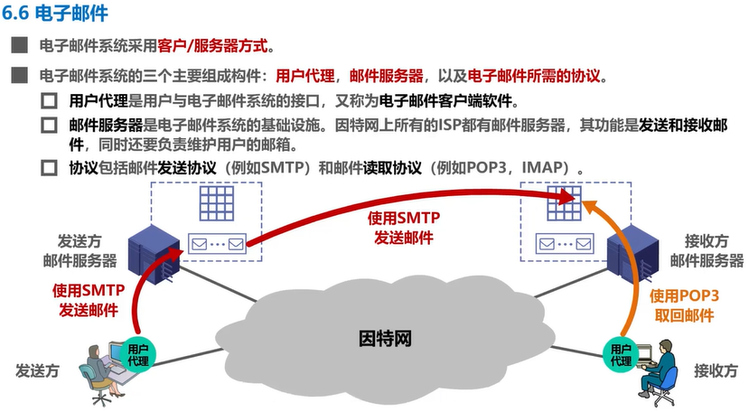

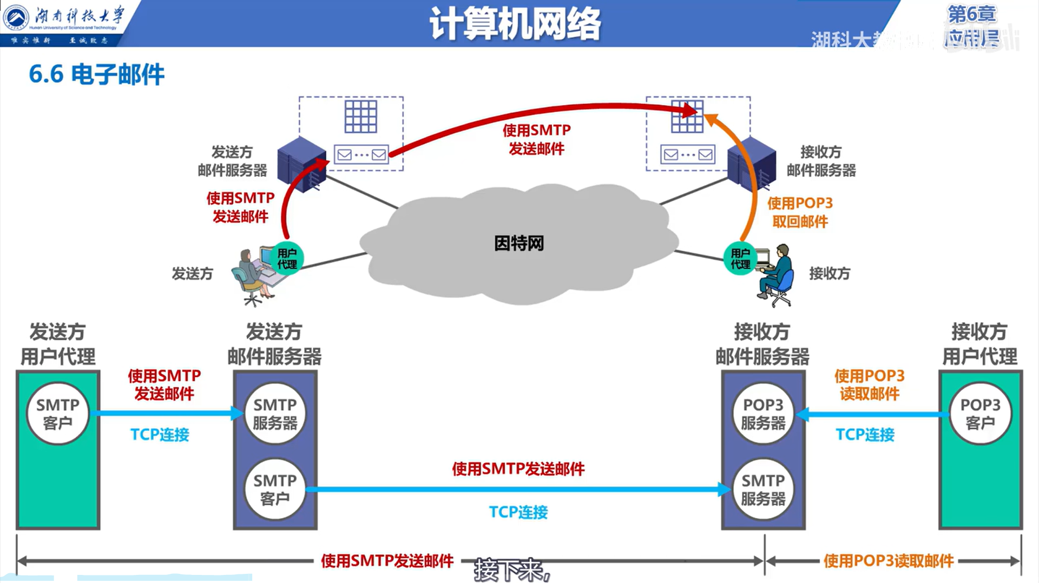

**SMTP，Simple Mail Transfer Protocol，简单邮件传输协议**