1）新建Servlet

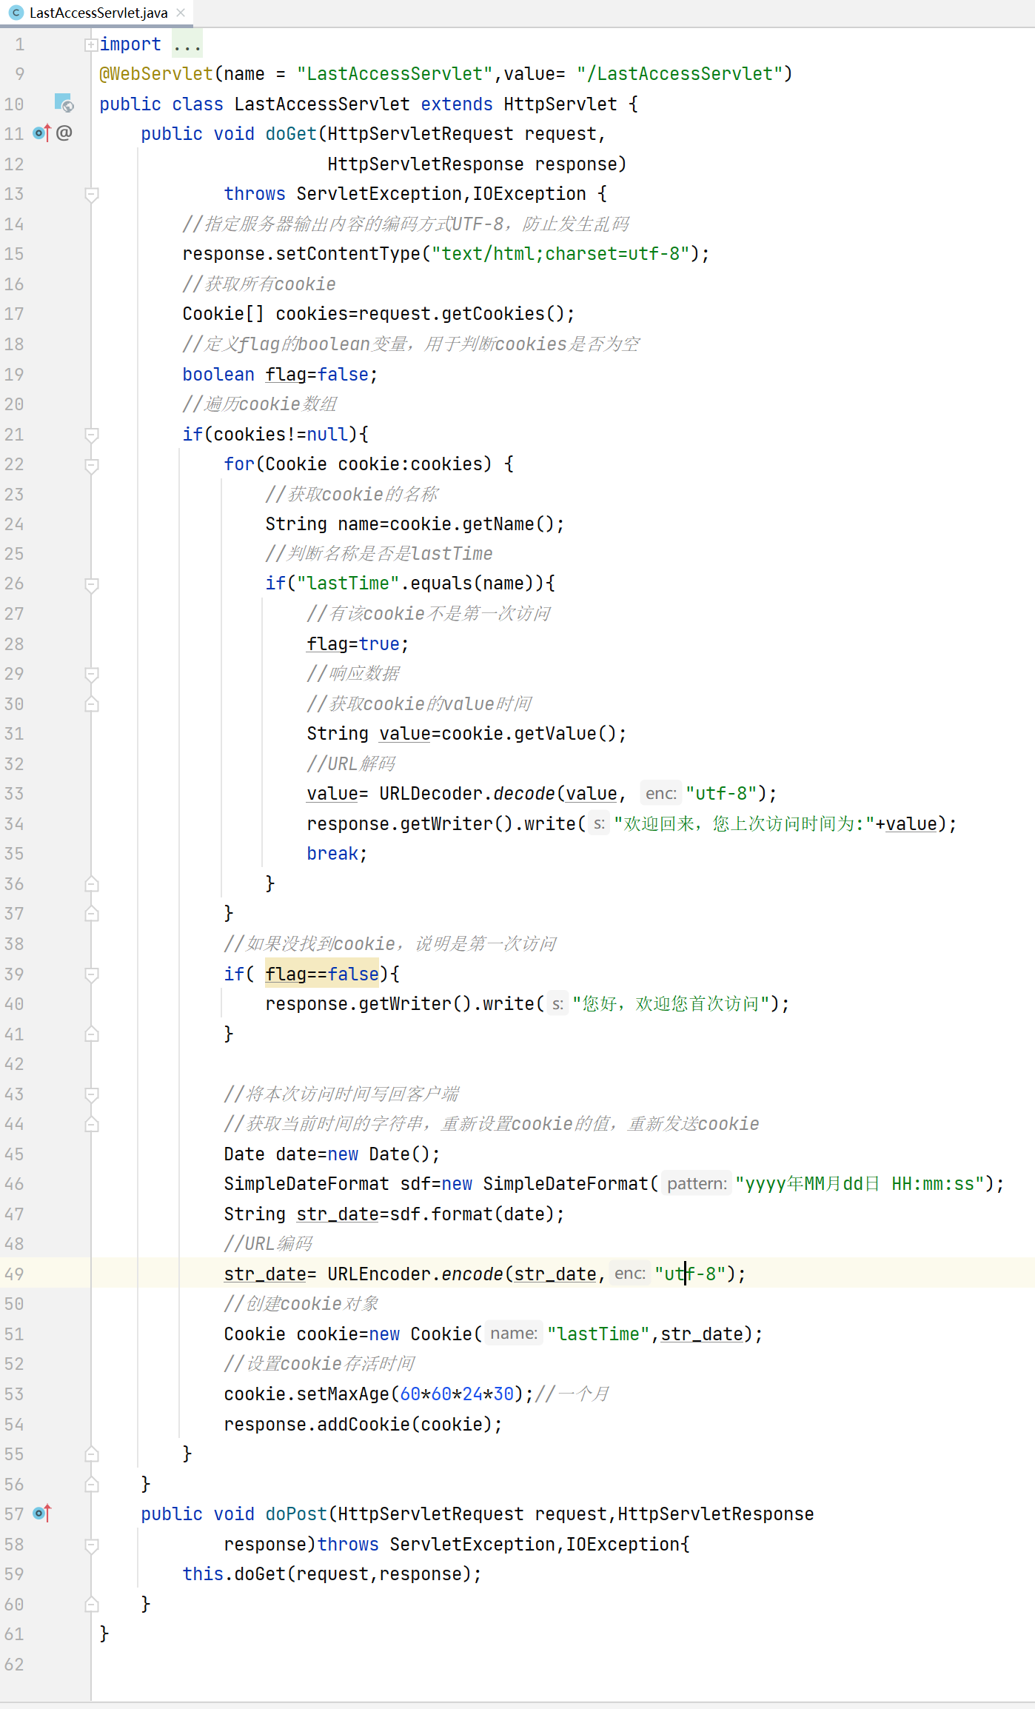

2）启动Tomcat，进行测试

http://…………………………war_exploded/LoastAccessServlet