编译原理实验报告
实验名称：词法分析
1308010327-洪传玉
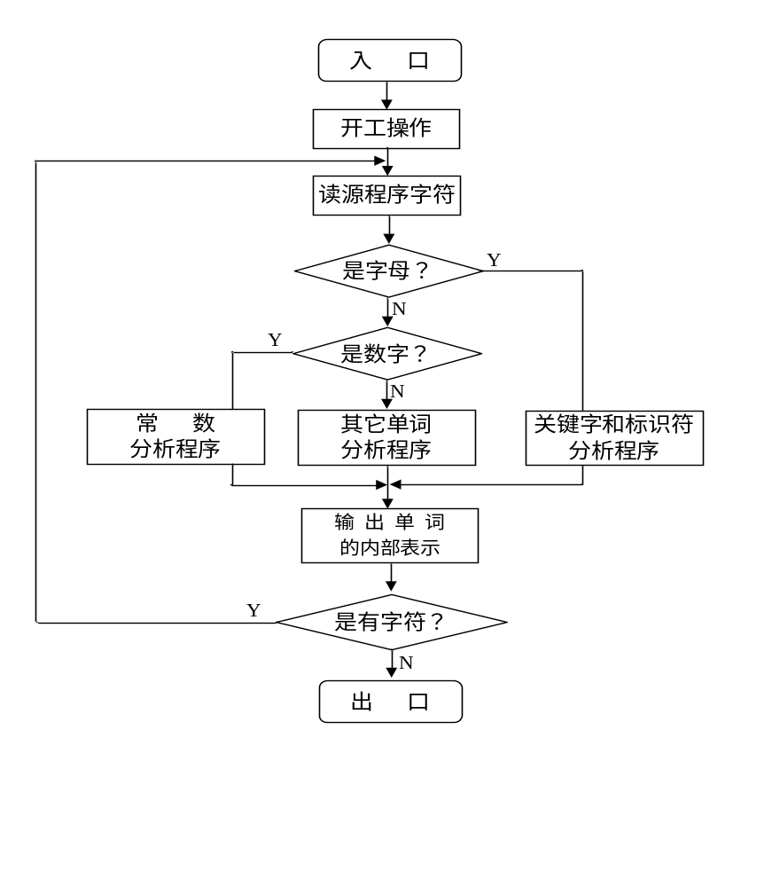

实验目的和要求：
编制一个读单词过程，从输入的源程序中，识别出各个具有独立意义的单词，即基本保留字、分隔符、标识符、常数、运算符五大类。

实验内容：
对于这个实验，总共用了四个函数，即主函数、扫描函数、建立缓冲区、取单词。主要完成的功能是从缓冲区中识别出一个个单词，并能够区分所取的单词是什么类型。

实验步骤：
1、基于实验的内容，构造程序所需的模块
2、根据已建构的模块，写出各个模块的相应程序代码
3、在主函数中调用模块来完成所要得到的效果

search ()：查找函数
alphaprocess()：识别字符函数
digitprocess()：识别常量
otherprocess()：识别特殊输入符号

四、实验代码：
// 词法分析.cpp : Defines the entry point for the console application.
//
#include "stdafx.h"

#include <stdio.h>
#include <ctype.h>
#include <malloc.h>
#include <stdlib.h>
#include <string.h>
#define NULL 0
FILE *fp;
char cbuffer;
char *key[8]={"if","else","for","while","do","return","break","continue"};
char *border[6]={",",";","{","}","(",")"};
char *arithmetic[4]={"+","-","*","/"};
char *relation[6]={"<","<=","=",">",">=","<>"};//bbbbbb
char *consts[10]={"0","1","2","3","4","5","6","7","8","9"};
char *label[20];
int constnum=0,labelnum=0;
int search(char searchchar[],int wordtype)
{
int i=0;
switch (wordtype) {
case 1:for (i=0;i<=7;i++)
{
if (strcmp(key[i],searchchar)==0)
return(i+1);
}
case 2:{for (i=0;i<=5;i++)
{
if (strcmp(border[i],searchchar)==0)
return(i+1);
} return(0);
}

case 3:{for (i=0;i<=3;i++)
{
if (strcmp(arithmetic[i],searchchar)==0)
{
return(i+1);
}
}
return(0);
}

case 4:{for (i=0;i<=5;i++)
{
if (strcmp(relation[i],searchchar)==0)
{
return(i+1);
}
}
return(0);
}

case 5:for (i=0;i<=10;i++)
{
if (strcmp(consts[i],searchchar)==0)
return(i+1);
}

case 6:{for (i=0;i<=labelnum;i++)
{
if (strcmp(label[i],searchchar)==0)
{
return(i+1);
}
}
label[i-1]=(char *)malloc(sizeof(searchchar));
strcpy(label[i-1],searchchar);
labelnum++;
return(i);
}
}
}
char alphaprocess(char buffer)
{
int atype;
int i=-1;
char alphatp[20];
while ((isalpha(buffer))||(isdigit(buffer)))
{
alphatp[++i]=buffer;
buffer=fgetc(fp);
}
alphatp[i+1]='\0';
if (atype=search(alphatp,1))
printf("%s \t(1,%d)\n",alphatp,atype-1);
else
{
atype=search(alphatp,6);
printf("%s \t(6,%d)\n",alphatp,atype-1);
}
return(buffer);
}
char digitprocess(char buffer)
{
int i=-1;
char digittp[20];
int dtype;
while ((isdigit(buffer)))
{
digittp[++i]=buffer;
buffer=fgetc(fp);
}
digittp[i+1]='\0';
dtype=search(digittp,5);
printf("%s \t(5,%d)\n",digittp,dtype-1);
return(buffer);
}
char otherprocess(char buffer)
{

int i=-1;
char othertp[20];
int otype,otypetp;
othertp[0]=buffer;
othertp[1]='\0';
if (otype=search(othertp,3))
{
printf("%s \t(3,%d)\n",othertp,otype-1);
buffer=fgetc(fp);
goto out;
}
if (otype=search(othertp,4))
{
buffer=fgetc(fp);
othertp[1]=buffer;
othertp[2]='\0';
if (otypetp=search(othertp,4))
{
printf("%s \t(4,%d)\n",othertp,otypetp-1);
goto out;
}
else
othertp[1]='\0';
printf("%s \t(4,%d)\n",othertp,otype-1);
goto out;
}

if (buffer==':')
{
buffer=fgetc(fp);
if (buffer=='=')
printf(":= (2,2)\n");
buffer=fgetc(fp);
goto out;
}
else
{
if (otype=search(othertp,2))
{
printf("%s \t(2,%d)\n",othertp,otype-1);
buffer=fgetc(fp);
goto out;
}
}

if ((buffer!='\n')&&(buffer!=' '))
printf("%c error,not a word\n",buffer);
buffer=fgetc(fp);
out: return(buffer);
}
void main()
{
int i;
for (i=0;i<=20;i++)
{
label[i]=" ";
};
if ((fp=fopen("example.c","r"))==NULL)
printf("error");
else
{
cbuffer = fgetc(fp);
while (cbuffer!=EOF)
{
if (isalpha(cbuffer))
cbuffer=alphaprocess(cbuffer);
else if (isdigit(cbuffer))
cbuffer=digitprocess(cbuffer);
else cbuffer=otherprocess(cbuffer);
}
printf("over\n");
getchar();
}
}

五、运行截图
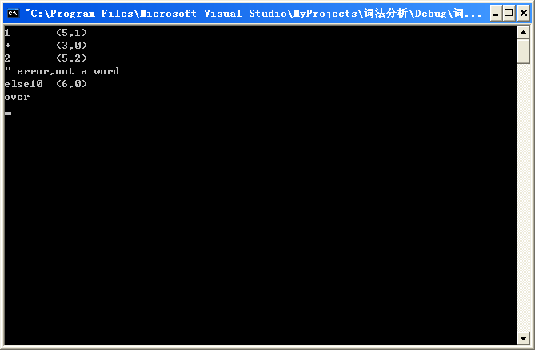

六、实验总结：
词法分析(英语:lexical analysis)是计算机科学中将字符序列转换为单词(Token)序列的过程。进行词法分析的程序或者函数叫作词法分析器(Lexical analyzer，简称Lexer)，也叫扫描器(Scanner)。词法分析器一般以函数的形式存在，供语法分析器调用。 完成词法分析任务的程序称为词法分析程序或词法分析器或扫描器。

通过编译原理的这次程序实验，在自已动手体验的情况下，更加透彻地理解了词法分析的过程，以及该算法。

