实验报告：
实验名称：LL(1)语法分析
实验目的和要求
编制一个能识别由词法分析给出的单词符号序列是否是给定文法的正确句子的程序，输出对输入符号串的分析过程。
实验内容和步骤：
一、实验内容
本实验设计了一个LL(1)语法分析器，主要包含以下功能：定义文法符号（终结符和非终结符），计算FIRST集、FOLLOW集和SELECT集，构建预测分析表，实现语法分析栈操作，对输入符号序列进行分析并输出详细过程
二、实验步骤
文法定义：
定义终结符和非终结符
创建产生式规则
程序包含三个核心函数：
parse()：主分析函数，执行语法分析过程
calculateFirstSets()：计算FIRST集合
calculateFollowSets()：计算FOLLOW集合

实验代码如下：
package com.example.byyl;
import java.util.*;
import java.util.stream.Collectors;
public class LL1SyntaxAnalyzer {
// 1. 文法符号定义
enum SymbolType { TERMINAL, NON_TERMINAL }
static class GrammarSymbol {
String value;
SymbolType type;
public GrammarSymbol(String value, SymbolType type) {
this.value = value;
this.type = type;
}
@Override
public boolean equals(Object o) {
if (this == o) return true;
if (o == null || getClass() != o.getClass()) return false;
GrammarSymbol that = (GrammarSymbol) o;
return value.equals(that.value) && type == that.type;
}
@Override
public int hashCode() {
return Objects.hash(value, type);
}
@Override
public String toString() {
return value;
}
}
// 2. 产生式定义
static class Production {
GrammarSymbol left;
List<GrammarSymbol> right;
public Production(GrammarSymbol left, List<GrammarSymbol> right) {
this.left = left;
this.right = right;
}
@Override
public String toString() {
return left + " → " + String.join(" ", right.stream()
.map(GrammarSymbol::toString)
.collect(Collectors.toList()));
}
}
// 3. 示例文法定义（简单算术表达式）
private static final GrammarSymbol E = new GrammarSymbol("E", SymbolType.NON_TERMINAL);
private static final GrammarSymbol EP = new GrammarSymbol("E'", SymbolType.NON_TERMINAL);
private static final GrammarSymbol T = new GrammarSymbol("T", SymbolType.NON_TERMINAL);
private static final GrammarSymbol TP = new GrammarSymbol("T'", SymbolType.NON_TERMINAL);
private static final GrammarSymbol F = new GrammarSymbol("F", SymbolType.NON_TERMINAL);
private static final GrammarSymbol PLUS = new GrammarSymbol("+", SymbolType.TERMINAL);
private static final GrammarSymbol MULT = new GrammarSymbol("*", SymbolType.TERMINAL);
private static final GrammarSymbol LPAREN = new GrammarSymbol("(", SymbolType.TERMINAL);
private static final GrammarSymbol RPAREN = new GrammarSymbol(")", SymbolType.TERMINAL);
private static final GrammarSymbol ID = new GrammarSymbol("id", SymbolType.TERMINAL);
private static final GrammarSymbol EPSILON = new GrammarSymbol("ε", SymbolType.TERMINAL);
private static final GrammarSymbol END = new GrammarSymbol("$", SymbolType.TERMINAL);
private static final List<Production> PRODUCTIONS = Arrays.asList(
// E → TE'
new Production(E, Arrays.asList(T, EP)),
// E' → +TE' | ε
new Production(EP, Arrays.asList(PLUS, T, EP)),
new Production(EP, Arrays.asList(EPSILON)),
// T → FT'
new Production(T, Arrays.asList(F, TP)),
// T' → *FT' | ε
new Production(TP, Arrays.asList(MULT, F, TP)),
new Production(TP, Arrays.asList(EPSILON)),
// F → (E) | id
new Production(F, Arrays.asList(LPAREN, E, RPAREN)),
new Production(F, Arrays.asList(ID))
);
// 4. FIRST集合计算
private Map<GrammarSymbol, Set<GrammarSymbol>> calculateFirstSets() {
Map<GrammarSymbol, Set<GrammarSymbol>> first = new HashMap<>();
// 初始化所有符号
Set<GrammarSymbol> allSymbols = new HashSet<>();
PRODUCTIONS.forEach(p -> {
allSymbols.add(p.left);
allSymbols.addAll(p.right);
});
// 初始化FIRST集
allSymbols.forEach(s -> {
first.put(s, new HashSet<>());
if (s.type == SymbolType.TERMINAL) {
first.get(s).add(s); // 终结符的FIRST集是它自己
}
});
// 迭代计算直到不再变化
boolean changed;
do {
changed = false;
for (Production p : PRODUCTIONS) {
Set<GrammarSymbol> firstSet = first.get(p.left);
int originalSize = firstSet.size();
// 处理产生式右部
boolean canDeriveEpsilon = true;
for (GrammarSymbol symbol : p.right) {
if (!symbol.equals(EPSILON)) {
firstSet.addAll(first.get(symbol));
if (!first.get(symbol).contains(EPSILON)) {
canDeriveEpsilon = false;
break;
}
}
}
if (canDeriveEpsilon) {
firstSet.add(EPSILON);
}
if (firstSet.size() > originalSize) {
changed = true;
}
}
} while (changed);
return first;
}
// 5. FOLLOW集合计算
private Map<GrammarSymbol, Set<GrammarSymbol>> calculateFollowSets(
Map<GrammarSymbol, Set<GrammarSymbol>> firstSets) {
Map<GrammarSymbol, Set<GrammarSymbol>> follow = new HashMap<>();
// 初始化FOLLOW集
PRODUCTIONS.stream()
.map(p -> p.left)
.distinct()
.forEach(nt -> follow.put(nt, new HashSet<>()));
// 开始符号添加$
follow.get(E).add(END);
// 迭代计算
boolean changed;
do {
changed = false;
for (Production p : PRODUCTIONS) {
for (int i = 0; i < p.right.size(); i++) {
GrammarSymbol B = p.right.get(i);
if (B.type == SymbolType.NON_TERMINAL) {
Set<GrammarSymbol> followB = follow.get(B);
int originalSize = followB.size();
// 情况1: A → αBβ
if (i < p.right.size() - 1) {
GrammarSymbol beta = p.right.get(i + 1);
Set<GrammarSymbol> firstBeta = new HashSet<>(firstSets.get(beta));
firstBeta.remove(EPSILON);
followB.addAll(firstBeta);
// 如果β能推导出ε，则加上FOLLOW(A)
if (firstSets.get(beta).contains(EPSILON)) {
}
}
// 情况2: A → αB
else {
followB.addAll(follow.get(p.left));
}
if (followB.size() > originalSize) {
changed = true;
}
}
}
}
} while (changed);
return follow;
}
// 6. SELECT集合计算
private Map<Production, Set<GrammarSymbol>> calculateSelectSets(
Map<GrammarSymbol, Set<GrammarSymbol>> firstSets,
Map<GrammarSymbol, Set<GrammarSymbol>> followSets) {
Map<Production, Set<GrammarSymbol>> select = new HashMap<>();
for (Production p : PRODUCTIONS) {
Set<GrammarSymbol> selectSet = new HashSet<>();
// 计算FIRST(α)
Set<GrammarSymbol> firstAlpha = new HashSet<>();
boolean allDeriveEpsilon = true;
for (GrammarSymbol s : p.right) {
if (s.equals(EPSILON)) {
continue;
}
firstAlpha.addAll(firstSets.get(s));
if (!firstSets.get(s).contains(EPSILON)) {
allDeriveEpsilon = false;
break;
}
}
if (allDeriveEpsilon) {
firstAlpha.add(EPSILON);
}
// SELECT(A → α) = FIRST(α) - {ε} ∪ (如果α能推导出ε则加上FOLLOW(A))
firstAlpha.remove(EPSILON);
selectSet.addAll(firstAlpha);
if (allDeriveEpsilon) {
selectSet.addAll(followSets.get(p.left));
}
select.put(p, selectSet);
}
return select;
}
// 7. LL(1)分析表构造
private Map<GrammarSymbol, Map<GrammarSymbol, Production>> buildParsingTable(
Map<Production, Set<GrammarSymbol>> selectSets) {
Map<GrammarSymbol, Map<GrammarSymbol, Production>> table = new HashMap<>();
// 初始化分析表
PRODUCTIONS.stream()
.map(p -> p.left)
.distinct()
.forEach(nt -> table.put(nt, new HashMap<>()));
// 填充分析表
for (Production p : PRODUCTIONS) {
for (GrammarSymbol a : selectSets.get(p)) {
if (!a.equals(EPSILON)) {
table.get(p.left).put(a, p);
}
}
}
return table;
}
// 8. 语法分析过程
public void parse(List<GrammarSymbol> inputTokens) {
// 计算所需集合
Map<GrammarSymbol, Set<GrammarSymbol>> firstSets = calculateFirstSets();
Map<GrammarSymbol, Set<GrammarSymbol>> followSets = calculateFollowSets(firstSets);
Map<Production, Set<GrammarSymbol>> selectSets = calculateSelectSets(firstSets, followSets);
Map<GrammarSymbol, Map<GrammarSymbol, Production>> parsingTable = buildParsingTable(selectSets);
// 打印分析表
System.out.println("LL(1)分析表:");
parsingTable.forEach((nt, row) -> {
System.out.println(nt + ":");
row.forEach((t, p) -> System.out.println(" " + t + " → " + p));
});
// 初始化分析栈
Stack<GrammarSymbol> stack = new Stack<>();
stack.push(END);
stack.push(E);
int index = 0;
GrammarSymbol lookahead = inputTokens.get(index);
System.out.println("\n开始语法分析:");
while (!stack.isEmpty()) {
GrammarSymbol top = stack.peek();
System.out.println("栈: " + stack + " 输入: " + lookahead);
if (top.type == SymbolType.TERMINAL) {
if (top.equals(lookahead)) {
stack.pop();
index++;
if (index < inputTokens.size()) {
lookahead = inputTokens.get(index);
} else {
lookahead = END;
}
System.out.println(" 匹配终结符: " + top);
} else {
throw new RuntimeException("语法错误: 期望 " + top + " 但遇到 " + lookahead);
}
} else {
Production p = parsingTable.get(top).get(lookahead);
if (p != null) {
stack.pop();
// 将产生式右部逆序压栈（跳过ε）
List<GrammarSymbol> right = p.right.stream()
.filter(s -> !s.equals(EPSILON))
.collect(Collectors.toList());
for (int i = right.size() - 1; i >= 0; i--) {
stack.push(right.get(i));
}
System.out.println(" 应用产生式: " + p);
} else {
throw new RuntimeException("语法错误: 无可用产生式 " + top + " → ? 对输入 " + lookahead);
}
}
}
System.out.println("语法分析成功完成!");
}
public static void main(String[] args) {
LL1SyntaxAnalyzer analyzer = new LL1SyntaxAnalyzer();
// 示例输入: id + id * id
List<GrammarSymbol> input = Arrays.asList(
ID, PLUS, ID, MULT, ID, END
);
analyzer.parse(input);
}
}
三、实验过程记录：
实验截图：

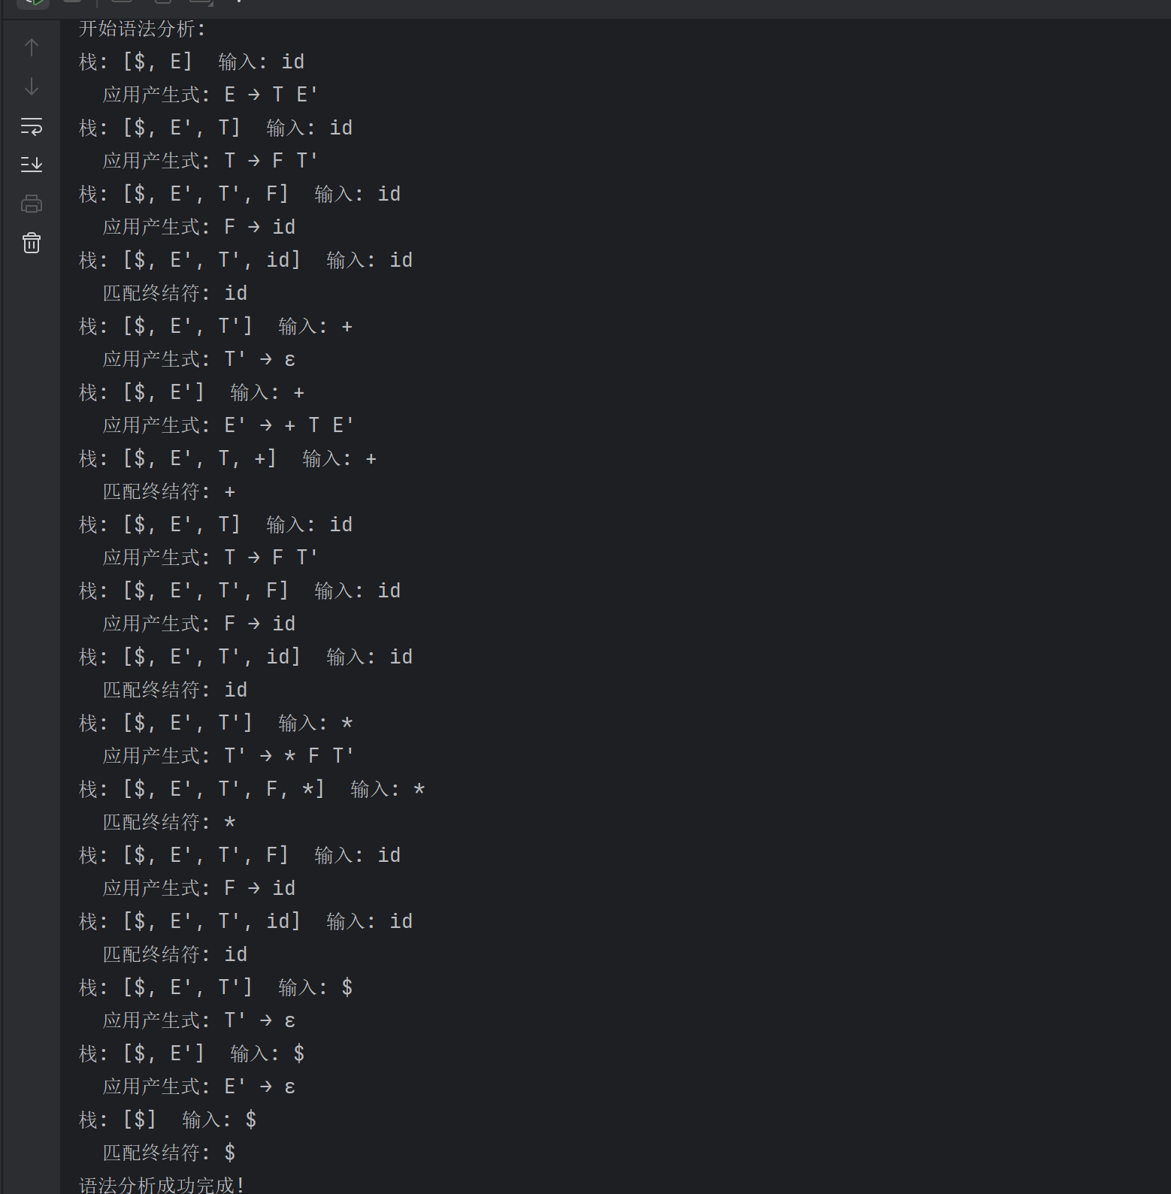
问题与解决方案
FIRST集计算循环依赖：
问题：迭代计算时陷入无限循环
解决：添加变化检测标志，仅当集合变化时继续迭代
FOLLOW集计算不完整：
问题：部分非终结符的FOLLOW集缺失
解决：增加处理产生式右部末尾符号的逻辑
四、实验总结：
通过这次实验，我认识到LL(1)语法分析是编译器设计的核心环节，需要仔细考虑文法的FIRST集、FOLLOW集和SELECT集的交集问题。一个良好的文法设计是语法分析成功的关键。

