1）新建Servlet
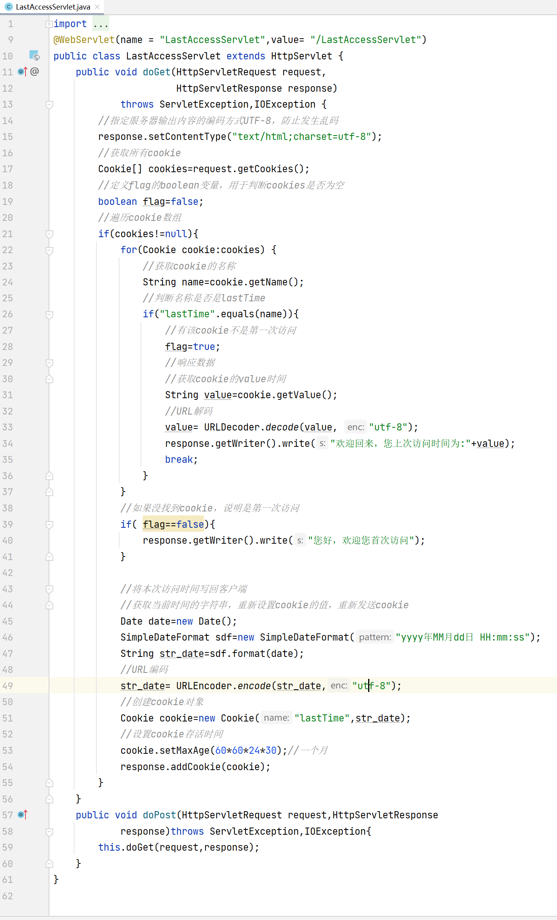
2）启动Tomcat，进行测试
http://…………………………war_exploded/LoastAccessServlet

