Deposit Quarterly Actual Num

Stationarity and Macro Model Analysis
2011Q1 to 2025Q4
Revised research report dated 4 November 2026

1 Purpose and main findings
We model quarterly actual deposit fee revenue using a linear trend, the fixed 2020Q1 slope break and a COVID indicator active only in 2020. The 2023Q3 trend break has been removed. Model development uses 2011Q1 to 2023Q3, and the final nine quarters, 2023Q4 to 2025Q4, form the chronological out-of-time sample.
At the user’s instruction, JB normality is now diagnostic only. The coefficient p-value, VIF and DW entry rules are unchanged. The forward sequence selects VIX level lag 2, bank deposits log change lag 1 and commercial and industrial loans log change lag 2, reaching the existing three-term cap. The fixed controls and AR(1) remain in the model.
IS adjusted R squared rises from 0.6569 to 0.7716. However, one-step OOT RMSE rises from 958,077 to 1,278,612, and MAPE rises from 3.15% to 4.04%. The selected macro model fits IS better but does not improve the nine-quarter holdout.
Final JB p is 0.0844, but heteroskedasticity and serial correlation through lag 4 remain. VIX’s final coefficient p is 0.0732: forward entry does not impose backward removal. All coefficient inference remains ordinary OLS, without HAC.

2 Data and regression specification
Item | Definition
Target | Quarterly actual num in original income units
Full target sample | 2011Q1 to 2025Q4; 60 unique quarters
IS and OOT | IS: 51 quarters through 2023Q3; OOT: final 9 quarters
AR and macro estimation | 2012Q1 to 2023Q3; 47 common observations after lag initialization
Macro history | 33 variables, 2010Q1 to 2025Q4; 2010 retained for changes and lags
Deterministic controls | t = 1 at 2011Q1; H = max(t - 36, 0); no second break or level step
COVID indicator | D = 1 in 2020Q1 through 2020Q4; 0 otherwise, including 2021Q1

The first four IS target quarters remain part of the dataset and the initial trend/stationarity analysis. They initialize the common AR comparison; no OOT quarter enters estimation or variable selection. Original macro column Y was intentionally excluded because its earlier observations were in DM status.

3 Direct OLS estimates
The first-stage regression uses all 51 IS quarters without autoregressive or macro terms. It estimates the original revenue target directly, retaining a constant, linear trend, the 2020Q1 hinge and the 2020-only COVID indicator.
y(t) = alpha + beta t + gamma H(t) + theta D(t) + u(t)
Fitted y(t) = 20,803,044.44 + 33,507.13 t
+ 117,079.78 H(t) - 2,997,208.03 D(t)
Table 1 Direct IS regression estimates and conventional uncertainty
Term | OLS estimate | OLS SE | OLS p | OLS 95% interval
Intercept | 20,803,044 | 326,319 | <0.0001 | 20,146,576 to 21,459,513
Time trend | 33,507 | 14,989 | 0.0302 | 3,353 to 63,662
2020Q1 slope change | 117,080 | 49,332 | 0.0218 | 17,837 to 216,322
COVID indicator | -2,997,208 | 542,775 | <0.0001 | -4,089,131 to -1,905,285
Post-break slope | 150,587 | 38,949 | 0.0003 | 72,232 to 228,942

The hinge convention is unchanged: H equals 1 in 2020Q1 and increases by one each quarter thereafter. The pre-break quarterly slope is beta; the post-break slope is beta plus gamma. The combined slope interval includes the covariance between the two estimates.
The fitted temporary gap is 2,997,208 income units per active quarter. It is a difference from the modeled trend path, not a cumulative loss or a causal estimate. Setting D back to zero in 2021Q1 removes this modeled temporary gap.
Table 2 Direct IS fit
Statistic | Value
Observations and residual degrees of freedom | 51 and 47
R squared | 0.6032
Adjusted R squared | 0.5779
RMSE | 931,974
Durbin Watson | 1.511

OLS inference
All regression coefficient standard errors, t tests, F tests and confidence intervals use ordinary nonrobust OLS covariance estimates. No HAC or other robust covariance estimator is used. Error diagnostics are reported separately; nominal significance should not be interpreted as validated inference when the error assumptions are doubtful.

4 Fitted path and residual construction
Figure 1 IS direct OLS fit and unfiltered residuals
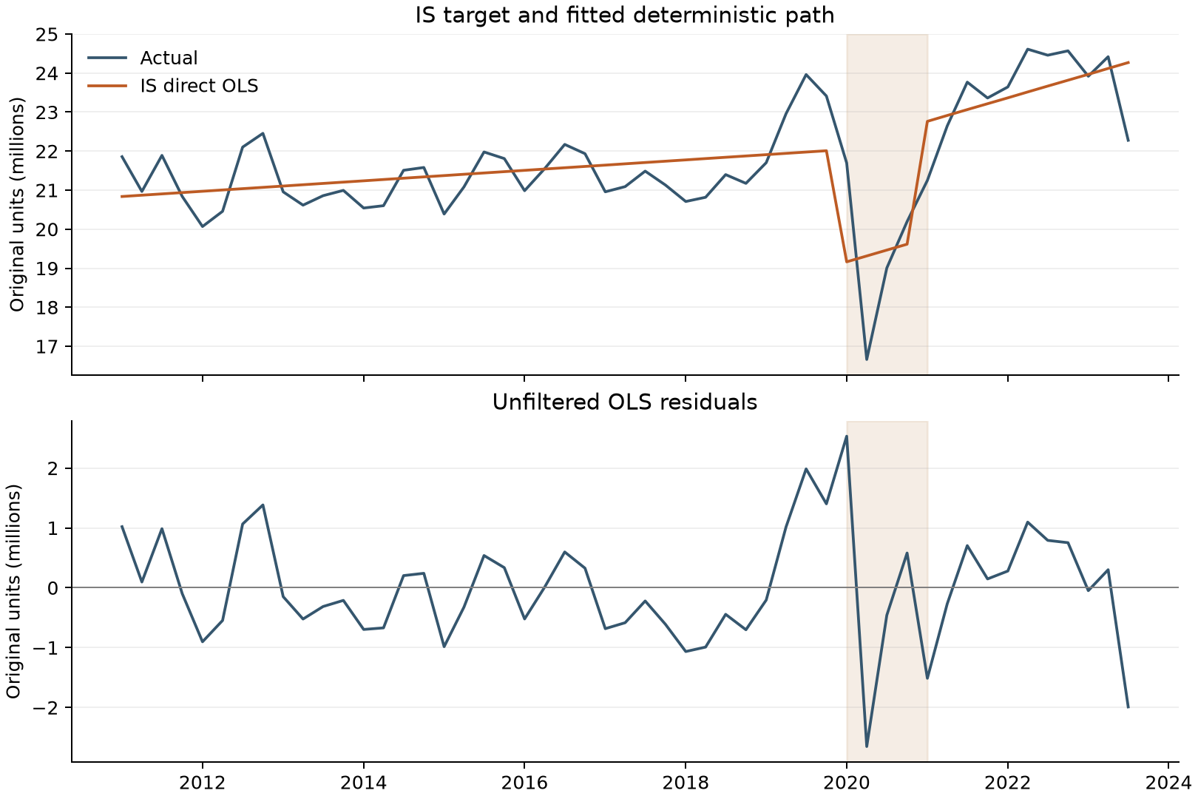
Shading covers the four active COVID quarters. Residuals are actual minus fitted revenue at each of the 51 IS observations; no AR initialization rows are removed at this stage.

5 Stationarity diagnostics for OLS residuals
Test | Statistic | Nominal p | Lag or bandwidth
ADF without extra deterministic terms | -5.4724 | <0.0001 | 0
KPSS with constant | 0.0621 | >0.1000 | 1

ADF uses a maximum of four augmentation lags and AIC selection. KPSS uses an automatic long-run variance bandwidth. Under their ordinary reference distributions, both results are consistent with stationary deviations around the fitted mean. KPSS reports a tabulated boundary, so its p-value is shown as greater than 0.10.
These are nominal residual diagnostics. Their standard critical values are not calibrated to the prior estimation of this broken trend and dummy. They are not formal break-adjusted confirmation. KPSS long-run variance estimation is internal to the test and is not a HAC adjustment to regression inference.

6 Stationarity of the pre break observations
This check uses the 36 original observations from 2011Q1 through 2019Q4, entirely within IS. It tests the original target around a constant and, separately, around a constant plus linear trend. It does not test residuals from the later sample.
Figure 2 Original target before 2020Q1
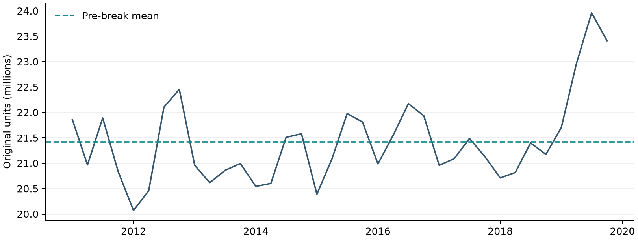
Table 3 Direct tests on the pre break target
Test and terms | Statistic | p-value | Lag or bandwidth | 5% decision
ADF  Constant | -1.9496 | 0.3091 | 4 | Do not reject unit root
KPSS  Constant | 0.3832 | 0.0844 | 2 | Do not reject stationarity
ADF  Constant and trend | -2.5776 | 0.2903 | 4 | Do not reject unit root
KPSS  Constant and trend | 0.1157 | >0.1000 | 1 | Do not reject stationarity

Both ADF specifications select four augmentation lags and use 31 effective test observations. ADF does not reject a unit root, while KPSS does not reject stationarity at 5%. This combination is inconclusive in both specifications; it does not establish level or trend stationarity.
The later regression retains the original revenue scale and the agreed deterministic controls. Residual stationarity evidence is preliminary and does not eliminate uncertainty from the short quarterly sample or establish an economic cointegrating relationship.

7 AR structure and macro forward selection

Unchanged AR selection within IS
Orders zero through four use the same fixed controls and 47 quarters, 2012Q1 through 2023Q3. The lowest-BIC dynamically stable contiguous order remains AR(1). AR(2) is only 0.045 BIC units higher; the difference is weak. Neither the AR choice nor the sample is changed by removing the JB gate.
Table 4 Quarterly AR comparison
AR order | N | BIC | Adjusted R squared | Spectral radius
0 | 47 | 1,441.76 | 0.5957 | 0.000
1 | 47 | 1,436.79 | 0.6569 | 0.354
2 | 47 | 1,436.84 | 0.6759 | 0.499
3 | 47 | 1,439.86 | 0.6736 | 0.540
4 | 47 | 1,443.33 | 0.6679 | 0.559

Unchanged transformations and revised entry rule
Each macro series is screened over 2011Q1 through 2023Q3. Level is tried first. If it fails, rates and spreads use first differences; positive amounts, counts and indices use log differences, with first differences as the fallback. Eligibility requires ADF p < 0.05 and KPSS p > 0.05. The same 24 series produce 72 candidates at lags 1, 2 and 4 quarters.
A new candidate must have ordinary OLS coefficient p < 0.05, maximum non-intercept VIF < 10 and DW within [1.5, 2.5]. Among passing candidates, the smallest coefficient p determines entry; BIC and feature name break ties. JB is recorded but does not affect entry. All coefficients are re-estimated at every trial. Previously selected macro terms remain, with no backward deletion.
Table 5 Forward selection after removing only the JB gate
Step | Selected addition | Tried / passed | Entry p | Max VIF | DW | JB p
1 | VIX level lag 2 | 72 / 3 | 0.0067 | 4.97 | 2.100 | 0.0082
2 | Bank deposits dlog lag 1 | 69 / 1 | 0.0459 | 4.99 | 2.236 | 0.0529
3 | C&I loans dlog lag 2 | 66 / 3 | 0.0057 | 5.00 | 2.385 | 0.0844

The first-round alternatives were M2 log change lag 2 and bank deposits log change lag 1; VIX had the smallest passing p-value. After VIX enters, only bank deposits passes round 2. In round 3, C&I loans outranks unemployment-rate change lag 2 and private-employment log change lag 2. Selection stops at the existing three-macro-term cap; no fourth round is run.
DW remains a screening heuristic from the reference specification, not a formal test for a model with lagged y. BG tests are reported separately and are not new selection gates. The entry threshold applies to the newly added term, not to all previously selected terms after re-estimation.

8 Final IS macro specification
The final model uses the agreed fixed controls, AR(1) and the three selected macro terms. It is estimated on 47 quarters with eight coefficients and 39 residual degrees of freedom. The 2023Q3 break remains excluded; no other break, level step or dummy has been introduced.
y(t) = alpha + beta t + gamma H(t) + theta D(t) + phi y(t-1)
+ delta1 M1(t) + delta2 M2(t) + delta3 M3(t) + u(t)
M1(t) = VIX(t-2), in index points. M2(t) = ln(Deposits(t-1)) - ln(Deposits(t-2)). M3(t) = ln(C&I loans(t-2)) - ln(C&I loans(t-3)). Log changes are unscaled natural-log units. All macro lags refer to quarters.
Table 6 Final estimates and conventional OLS inference
Term | OLS estimate | OLS SE | OLS p | OLS 95% interval
Intercept | 4,256,674 | 2,849,994 | 0.1433 | -1,507,984 to 10,021,331
Time trend | 50,035 | 14,765 | 0.0016 | 20,171 to 79,900
2020Q1 slope change | -52,788 | 54,125 | 0.3354 | -162,266 to 56,690
COVID indicator | -4,111,651 | 602,093 | <0.0001 | -5,329,500 to -2,893,803
Lagged target y(t-1) | 0.6877 | 0.1240 | <0.0001 | 0.4370 to 0.9384
VIX level lag 2 | 50,762 | 27,567 | 0.0732 | -4,998 to 106,522
Bank deposits dlog lag 1 | 34,121,079 | 10,049,120 | 0.0016 | 13,794,815 to 54,447,343
C&I loans dlog lag 2 | 12,428,007 | 4,247,437 | 0.0057 | 3,836,754 to 21,019,260

dlog denotes a first log difference. C&I loans are commercial and industrial loans at commercial banks. A coefficient on dlog multiplies an unscaled log change; approximately 1% growth corresponds to 0.01 units, not one unit.

Entry significance and final significance
VIX enters with p = 0.0067 in round 1, but its p-value rises to 0.0732 after the other terms enter. It remains under the unchanged forward-only rule. Bank deposits and C&I loans have final p-values of 0.0016 and 0.0057. These are exploratory ordinary OLS p-values, not adjusted for model selection.
The time trend is significant at 5% (p = 0.0016); the 2020Q1 hinge is not (p = 0.3354), but remains fixed by the agreed specification. Trend and hinge coefficients are conditional effects in this dynamic regression, not the unconditional slopes of the recursive forecast path. Positive macro coefficients describe conditional sample associations, not causal effects.
The final AR coefficient is 0.6877, below one in magnitude. This meets the usual AR(1) dynamic-stability condition, but does not establish forecast accuracy or stable economic relationships.

9 IS fit and residual diagnostics
Figure 3 Actual revenue baseline fit and selected macro fit
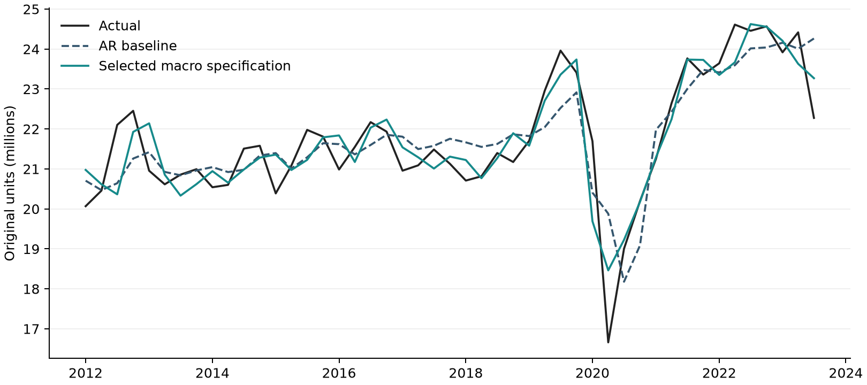
Table 7 Fit on the same 47 IS quarters
Specification | Adjusted R squared | RMSE | BIC | DW
Fixed controls without AR | 0.5957 | 941,391 | 1,441.76 | 1.537
Fixed controls plus AR1 | 0.6569 | 857,068 | 1,436.79 | 1.938
AR1 plus selected macros | 0.7716 | 673,816 | 1,425.73 | 2.385

Table 8 Final model residual checks
Diagnostic | p-value | Interpretation at 5%
BG lag 1 | 0.0694 | Do not reject no serial correlation through lag 1
BG lag 4 | <0.0001 | Reject no serial correlation through lag 4
Jarque Bera | 0.0844 | Do not reject normality
Breusch Pagan auxiliary F | <0.0001 | Reject homoskedasticity

JB p rises to 0.0844 in the final model even though JB is no longer an entry gate. The model also passes the retained VIF and DW screens. However, BG through lag 4 and the heteroskedasticity diagnostic reject their nulls. Passing DW and JB does not establish adequate residual behavior.
The 2020Q2 residual is -1.80 million, its internally studentized residual is -3.31 and Cook distance is 1.17. The observation remains influential and is retained. All coefficient standard errors and intervals are nonrobust OLS; no HAC adjustment or additional data exclusion is applied.

10 Rolling macro coefficient stability
We re-estimate the selected specification in 20-quarter rolling IS windows, without reselecting variables. Before activation, all-zero H and D columns are omitted. The window ending 2020Q1 is skipped because H and D are identical. The remaining 27 windows end from 2016Q4 to 2023Q3. Shaded bands are conventional OLS 95% intervals.
Figure 4 Selected macro coefficients across rolling IS windows
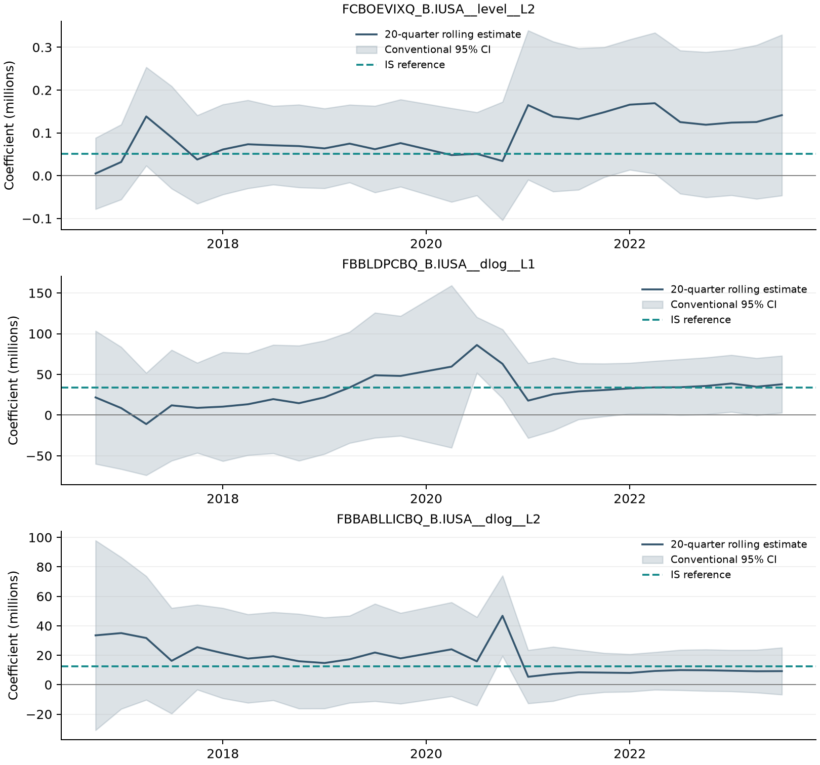
Macro term | Same sign | OLS p < 0.05 | IS estimate in CI
VIX level lag 2 | 100.0% | 11.1% | 100.0%
Bank deposits dlog lag 1 | 96.3% | 25.9% | 96.3%
C&I loans dlog lag 2 | 100.0% | 3.7% | 96.3%

Sign agreement is high, but significance is infrequent and intervals are wide. Windows overlap and are not independent replications. These descriptive checks do not establish parameter stability, especially with only 20 observations per window and nonrobust uncertainty estimates.

11 Fixed coefficient out of time evaluation
Coefficients are frozen at the IS estimates through 2023Q3. One-step predictions use actual prior target values. The recursive path uses forecast target lags after the first OOT quarter. Both use realized lagged macro inputs; the recursive path is therefore conditional on macro history, not a fully ex ante forecast. No OOT refitting is performed.
Figure 5 Actual revenue and fixed coefficient OOT predictions
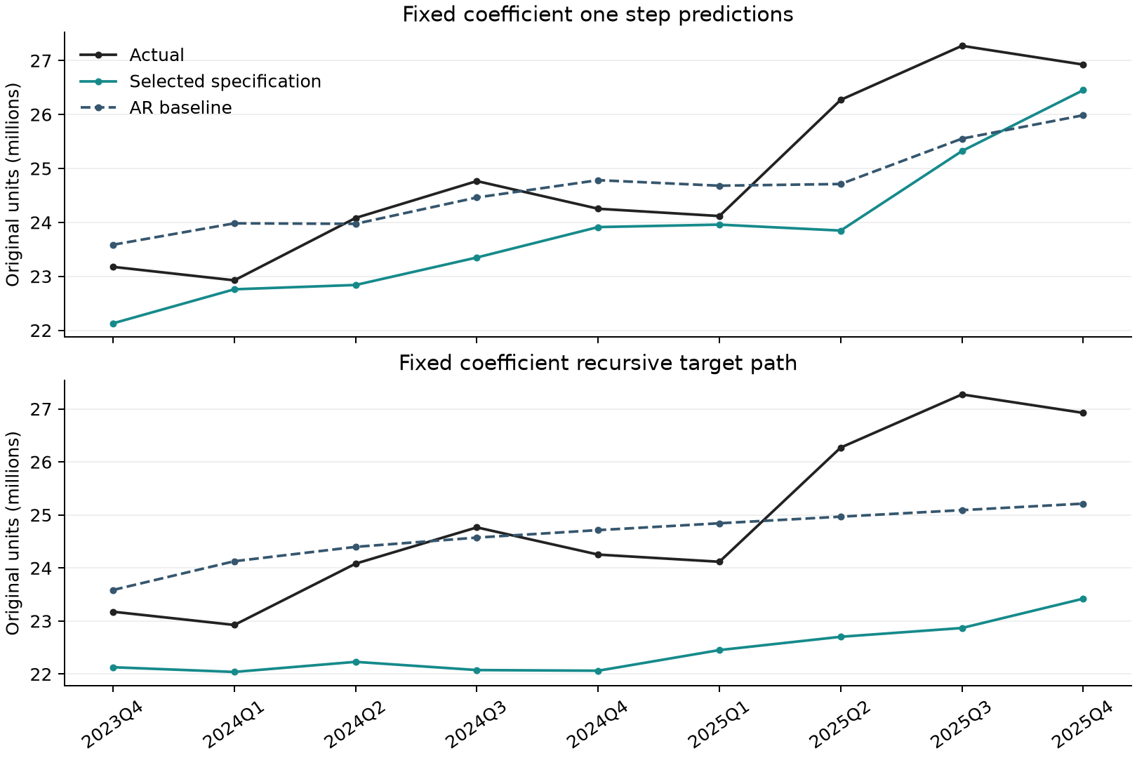
Table 9 Performance on all nine OOT quarters
Prediction design | RMSE | MAE | MAPE | Mean error
Macro one step | 1,278,612 | 1,024,252 | 4.04% | -1,024,252
AR1 baseline one step | 958,077 | 799,030 | 3.15% | -230,416
Macro recursive | 2,677,343 | 2,422,769 | 9.51% | -2,422,769
AR1 baseline recursive | 1,148,659 | 944,834 | 3.70% | -252,487
Previous quarter value | 984,090 | 793,193 | 3.15% | -516,368
Same quarter previous year | 1,826,639 | 1,649,806 | 6.51% | -1,044,676

Mean error is prediction minus actual. The macro model underpredicts all nine quarters in both designs. Naive benchmarks use observed lagged targets and are comparable to one-step prediction, not to a fixed-origin recursive path.
Macro one-step RMSE is 33.5% above the AR1 baseline. Recursive RMSE is 133.1% higher. The IS improvement does not carry over to this short OOT period; no terms are revised in response to these scores.
Table 10 Quarterly macro model OOT predictions in original units
Quarter | Actual | One step | Recursive | One step error
2023Q4 | 23,174,934 | 22,128,195 | 22,128,195 | -1,046,739
2024Q1 | 22,925,361 | 22,759,202 | 22,039,341 | -166,159
2024Q2 | 24,081,663 | 22,839,098 | 22,229,767 | -1,242,565
2024Q3 | 24,765,067 | 23,348,637 | 22,075,056 | -1,416,430
2024Q4 | 24,252,376 | 23,912,450 | 22,062,483 | -339,926
2025Q1 | 24,117,055 | 23,957,873 | 22,451,846 | -159,182
2025Q2 | 26,270,366 | 23,847,616 | 22,702,423 | -2,422,750
2025Q3 | 27,272,395 | 25,321,771 | 22,868,035 | -1,950,624
2025Q4 | 26,924,269 | 26,450,377 | 23,421,422 | -473,892

Interpretation of the holdout
All numerical fitting and variable selection use IS only. However, the full target and earlier OOT results were already reviewed before this rule revision. This is a retrospective chronological comparison, not an untouched prospective holdout. Macro data are labeled Scenario Consistent Baseline, August 2026; release lags and real-time historical vintages have not been reconstructed. Realized macro inputs make the OOT forecasts conditional.

12 Conclusions and scenario scope
Removing only the JB entry gate permits the stipulated forward procedure to select three macro terms. It improves IS fit and the final JB result, but worsens one-step and recursive OOT accuracy. The selected three-term model is the result of the authorized rule; the AR1 baseline remains the stronger comparator on these nine quarters. No automatic backward pruning or further breakpoint search is applied.
Residual heteroskedasticity, serial correlation through lag 4, short rolling windows and selection uncertainty limit the interpretation of ordinary OLS significance. VIX’s final p-value exceeds 0.05 despite meeting its entry rule. No HAC inference is introduced. S1 and S4 projections require validated future quarterly paths for the selected variables; those paths have not been supplied, so no scenario forecast is produced.

Sources and reproducibility
Target: Quarterly_Target_Data_2011Q1_2025Q4.xls, Quarterly_targets, columns A and B. Macro inputs: six confirmed intake batches, 33 series and 2,112 numeric cells. Original Y remains intentionally excluded. The target remains actual revenue, distinct from the quarterly rate.
Saved versioned outputs retain the revised protocol, every candidate trial across three rounds, selection path, frozen coefficients and all nine predictions. Independent least-squares and reconciliation checks passed. Quarterly keys, split, COVID coding, rank and lag direction were verified. Software: statsmodels 0.15.0.
Methods: ADF; KPSS; regression diagnostics; DW limitations with lagged y

Appendix Macro stationarity screening
All tests use only 2011Q1 to 2023Q3. Series codes share the suffix _B.IUSA, omitted below. Each row shows the first passing transform or, for excluded series, the last attempted transform. Level is tried first; later transformations follow the rule in Section 7. ADF includes a constant, a four-lag maximum and AIC selection. KPSS includes a constant and automatic bandwidth.
Source and code | Series | Form | ADF p | KPSS p | Screen
B FBBABLLICBQ | Commercial and industrial loans, commercial banks | dlog | <0.0001 | >0.1000 | Eligible
C FBBABLLRCBQ | Real estate loans, commercial banks | diff | 0.0840 | 0.0320 | Excluded
D FBBABLLROCCBQ | Commercial real estate loans, commercial banks | dlog | 0.0308 | 0.0923 | Eligible
E FBBACBQ | Total assets, commercial banks | dlog | <0.0001 | >0.1000 | Eligible
F FBBLDPCBQ | Deposits, commercial banks | dlog | 0.0002 | >0.1000 | Eligible
G FBCFDELLIQ | Delinquency rate, C and I loans, top 100 commercial banks | level | 0.0399 | >0.1000 | Eligible
H FBCFDELLRCQ | Delinquency rate, commercial real estate loans, top 100 commercial banks | diff | 0.2084 | <0.0100 | Excluded
I FBKB | Bankruptcies, business, total | diff | 0.4843 | 0.0234 | Excluded
J FBQCRNCOLLQ | FDIC commercial banks: net charge-offs to loans and leases | diff | 0.0671 | <0.0100 | Excluded
K FCASHFLOW | Corporate cashflow | dlog | <0.0001 | >0.1000 | Eligible
L FCBC | Consumer Confidence Index | dlog | <0.0001 | >0.1000 | Eligible
M FCBOEVIXQ | CBOE Volatility Index SP500 [VIX], period average | level | 0.0249 | >0.1000 | Eligible
N FCSENTQ | Cyclical indicators: consumer sentiment index, final | dlog | <0.0001 | >0.1000 | Eligible
O FDDEMAND$ | NIPA: real domestic demand | dlog | <0.0001 | >0.1000 | Eligible
P FDDQ | Money stock: demand deposits | diff | 0.3855 | >0.1000 | Excluded
Q FETP | Employment: total private | dlog | <0.0001 | >0.1000 | Eligible
R FGDP | NIPA: gross domestic product | dlog | <0.0001 | >0.1000 | Eligible

dlog = ln(x(t)) - ln(x(t-1)); diff = x(t) - x(t-1). Log changes are unscaled natural-log units. Changes in percentage rates/spreads retain percentage-point units; income and money aggregates retain their published SA/SAAR definitions. No annualized source series is mechanically divided by four. Eligibility is a diagnostic screen, not a formal proof of stationarity or an entry into the revenue equation.

Appendix Macro stationarity screening continued
All tests use only 2011Q1 to 2023Q3. Series codes share the suffix _B.IUSA, omitted below. Each row shows the first passing transform or, for excluded series, the last attempted transform. Level is tried first; later transformations follow the rule in Section 7. ADF includes a constant, a four-lag maximum and AIC selection. KPSS includes a constant and automatic bandwidth.
Source and code | Series | Form | ADF p | KPSS p | Screen
S FIRHYBOASQ | High-yield bonds: option-adjusted spread, USD | level | 0.0197 | 0.0856 | Eligible
T FJRFEDQ | Federal funds target rate: range midpoint | diff | 0.0791 | >0.1000 | Excluded
U FLBR | Household Survey: unemployment rate | diff | <0.0001 | >0.1000 | Eligible
V FM1Q | Money stock: M1 | dlog | <0.0001 | >0.1000 | Eligible
W FM2Q | Money stock: M2 | dlog | 0.0007 | >0.1000 | Eligible
X FRFED | Federal funds rate | diff | 0.0733 | >0.1000 | Excluded
Z FRGT10Y | Interest Rates: 10-Year Treasury Constant Maturities | diff | <0.0001 | >0.1000 | Eligible
AA FRGT1Y | Interest Rates: 1-Year Treasury Constant Maturities | diff | 0.1333 | >0.1000 | Excluded
AB FRGT2Y | Interest Rates: 2-Year Treasury Constant Maturities | diff | 0.0277 | >0.1000 | Eligible
AC FRGT30Y | Interest Rates: 30-Year Treasury Constant Maturities | diff | <0.0001 | >0.1000 | Eligible
AD FRGT5Y | Interest Rates: 5-Year Treasury Constant Maturities | diff | 0.0002 | >0.1000 | Eligible
AE FRSOFRQ | Interest rates: Secured overnight financing rate [SOFR] | diff | 0.0633 | >0.1000 | Excluded
AF FRTB3M | Interest Rates: 3-Month Treasury Bills - Secondary Market | diff | 0.0409 | >0.1000 | Eligible
AG FRTB6M | Interest Rates: 6-Month Treasury Bills - Secondary Market | diff | 0.0400 | >0.1000 | Eligible
AH FYPDPIQ | Income: Disposable Personal | dlog | 0.0032 | >0.1000 | Eligible
AI FYPQ | Income: Personal - Total | dlog | <0.0001 | >0.1000 | Eligible

dlog = ln(x(t)) - ln(x(t-1)); diff = x(t) - x(t-1). Log changes are unscaled natural-log units. Changes in percentage rates/spreads retain percentage-point units; income and money aggregates retain their published SA/SAAR definitions. No annualized source series is mechanically divided by four. Eligibility is a diagnostic screen, not a formal proof of stationarity or an entry into the revenue equation.

