Deposit Quarterly Actual Num

Stationarity and Macro Model Analysis
2011Q1 to 2025Q4
Revised research report dated 4 November 2026

1 Purpose and main findings
We model quarterly actual deposit fee revenue with a linear time trend, a COVID indicator active only in 2020, AR(1), bank deposits log change lag 1 and commercial and industrial loans log change lag 2. The final model excludes VIX and all trend breaks. Model development uses 2011Q1 to 2023Q3; the final nine quarters, 2023Q4 to 2025Q4, form the chronological out-of-time sample.
JB normality is diagnostic only. The coefficient p-value, VIF and DW entry rules are unchanged. Forward selection initially identified three macro terms. Section 7 documents the subsequent removal of VIX and the 2020Q1 slope change and the IS refit; Sections 8 onward evaluate only the resulting two-macro model.
The final two-macro model has IS adjusted R squared of 0.7638, RMSE of 0.703 and BIC of 123.31. One-step OOT RMSE is 0.799, with MAPE of 2.65%. Recursive OOT RMSE is 0.961, with MAPE of 2.95%.
All six retained coefficients have conventional OLS p-values below 0.05. Residual serial correlation through lag 4 and heteroskedasticity remain, so nominal significance needs caution. All coefficient inference uses ordinary OLS, without HAC. OOT predictions hold the IS coefficients fixed; no OOT re-estimation is performed.
All target values, fitted values, residuals, forecasts and monetary error metrics are in million $ (USD / 1,000,000). Non-AR coefficients and their uncertainty use the same scale; lagged y is also in million $, so AR coefficients are unchanged. AIC and BIC use the million-dollar likelihood scale; rankings, p-values and scale-free diagnostics are unchanged.

2 Data and regression specification
Item | Definition
Target | Quarterly actual num (million $); sum of monthly actual revenue / 1,000,000
Full target sample | 2011Q1 to 2025Q4; 60 unique quarters
IS and OOT | IS: 51 quarters through 2023Q3; OOT: final 9 quarters
AR and macro estimation | 2012Q1 to 2023Q3; 47 common observations after lag initialization
Macro history | 33 variables, 2010Q1 to 2025Q4; 2010 retained for changes and lags
Deterministic controls | Final model: intercept, t = 1 at 2011Q1 and COVID indicator; no trend break
COVID indicator | D = 1 in 2020Q1 through 2020Q4; 0 otherwise, including 2021Q1

The first four IS target quarters remain part of the dataset and the initial trend/stationarity analysis. They initialize the common AR comparison; no OOT quarter enters estimation or variable selection. Original macro column Y was intentionally excluded because its earlier observations were in DM status.

3 Direct OLS estimates
The first-stage regression uses all 51 IS quarters without autoregressive or macro terms. It estimates quarterly revenue in million $ directly, retaining a constant, linear trend, the 2020Q1 hinge and the 2020-only COVID indicator.
y(t) = alpha + beta t + gamma H(t) + theta D(t) + u(t)
Fitted y(t) = 20.803044 + 0.033507 t
+ 0.117080 H(t) - 2.997208 D(t)
Table 1 Direct IS regression estimates and conventional uncertainty
Term | OLS estimate | OLS SE | OLS p | OLS 95% interval
Intercept | 20.8030 | 0.3263 | <0.0001 | 20.1466 to 21.4595
Time trend | 0.0335 | 0.0150 | 0.0302 | 0.0034 to 0.0637
2020Q1 slope change | 0.1171 | 0.0493 | 0.0218 | 0.0178 to 0.2163
COVID indicator | -2.9972 | 0.5428 | <0.0001 | -4.0891 to -1.9053
Post-break slope | 0.1506 | 0.0389 | 0.0003 | 0.0722 to 0.2289

The hinge convention is unchanged: H equals 1 in 2020Q1 and increases by one each quarter thereafter. The pre-break quarterly slope is beta; the post-break slope is beta plus gamma. The combined slope interval includes the covariance between the two estimates.
The fitted temporary gap is 2.997 million $ per active quarter. It is a difference from the modeled trend path, not a cumulative loss or a causal estimate. Setting D back to zero in 2021Q1 removes this modeled temporary gap.
Table 2 Direct IS fit
Statistic | Value
Observations and residual degrees of freedom | 51 and 47
R squared | 0.6032
Adjusted R squared | 0.5779
RMSE | 0.932
Durbin Watson | 1.511

OLS inference
All regression coefficient standard errors, t tests, F tests and confidence intervals use ordinary nonrobust OLS covariance estimates. No HAC or other robust covariance estimator is used. Error diagnostics are reported separately; nominal significance should not be interpreted as validated inference when the error assumptions are doubtful.

4 Fitted path and residual construction
Figure 1 IS direct OLS fit and unfiltered residuals
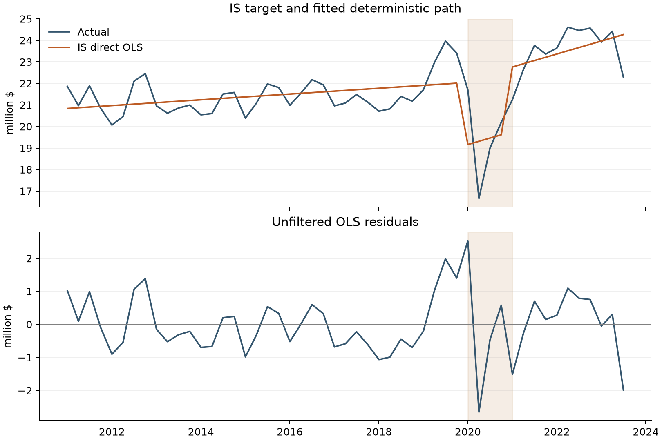
Shading covers the four active COVID quarters. Residuals are actual minus fitted revenue at each of the 51 IS observations; no AR initialization rows are removed at this stage.

5 Stationarity diagnostics for OLS residuals
Test | Statistic | Nominal p | Lag or bandwidth
ADF without extra deterministic terms | -5.4724 | <0.0001 | 0
KPSS with constant | 0.0621 | >0.1000 | 1

ADF uses a maximum of four augmentation lags and AIC selection. KPSS uses an automatic long-run variance bandwidth. Under their ordinary reference distributions, both results are consistent with stationary deviations around the fitted mean. KPSS reports a tabulated boundary, so its p-value is shown as greater than 0.10.
These are nominal residual diagnostics. Their standard critical values are not calibrated to the prior estimation of this broken trend and dummy. They are not formal break-adjusted confirmation. KPSS long-run variance estimation is internal to the test and is not a HAC adjustment to regression inference.

6 AR structure and macro forward selection

Unchanged AR selection within IS
Orders zero through four use the same fixed controls and 47 quarters, 2012Q1 through 2023Q3. The lowest-BIC dynamically stable contiguous order remains AR(1). AR(2) is only 0.045 BIC units higher; the difference is weak. Neither the AR choice nor the sample is changed by removing the JB gate.
Table 3 Quarterly AR comparison
AR order | N | BIC | Adjusted R squared | Spectral radius
0 | 47 | 143.10 | 0.5957 | 0.000
1 | 47 | 138.13 | 0.6569 | 0.354
2 | 47 | 138.18 | 0.6759 | 0.499
3 | 47 | 141.20 | 0.6736 | 0.540
4 | 47 | 144.68 | 0.6679 | 0.559

Unchanged transformations and revised entry rule
Each macro series is screened over 2011Q1 through 2023Q3. Level is tried first. If it fails, rates and spreads use first differences; positive amounts, counts and indices use log differences, with first differences as the fallback. Eligibility requires ADF p < 0.05 and KPSS p > 0.05. The same 24 series produce 72 candidates at lags 1, 2 and 4 quarters.
A new candidate must have ordinary OLS coefficient p < 0.05, maximum non-intercept VIF < 10 and DW within [1.5, 2.5]. Among passing candidates, the smallest coefficient p determines entry; BIC and feature name break ties. JB is recorded but does not affect entry. All coefficients are re-estimated at every trial. Previously selected macro terms remain, with no backward deletion.
Table 4 Forward selection after removing only the JB gate
Step | Selected addition | Tried / passed | Entry p | Max VIF | DW | JB p
1 | VIX level lag 2 | 72 / 3 | 0.0067 | 4.97 | 2.100 | 0.0082
2 | Bank deposits dlog lag 1 | 69 / 1 | 0.0459 | 4.99 | 2.236 | 0.0529
3 | C&I loans dlog lag 2 | 66 / 3 | 0.0057 | 5.00 | 2.385 | 0.0844

The first-round alternatives were M2 log change lag 2 and bank deposits log change lag 1; VIX had the smallest passing p-value. After VIX enters, only bank deposits passes round 2. In round 3, C&I loans outranks unemployment-rate change lag 2 and private-employment log change lag 2. Selection stops at the existing three-macro-term cap; no fourth round is run.
DW remains a screening heuristic from the reference specification, not a formal test for a model with lagged y. BG tests are reported separately and are not new selection gates. The entry threshold applies to the newly added term, not to all previously selected terms after re-estimation.

7 Macro estimates and reduced IS refit
The forward-selected three-macro model uses the agreed fixed controls, AR(1) and the three selected macro terms. Table 5 reports this model on 47 quarters, with eight coefficients and 39 residual degrees of freedom. The 2023Q3 break remains excluded. The subsequent reduced-model refit is presented immediately below.
y(t) = alpha + beta t + gamma H(t) + theta D(t) + phi y(t-1)
+ delta1 M1(t) + delta2 M2(t) + delta3 M3(t) + u(t)
M1(t) = VIX(t-2), in index points. M2(t) = ln(Deposits(t-1)) - ln(Deposits(t-2)). M3(t) = ln(C&I loans(t-2)) - ln(C&I loans(t-3)). Log changes are unscaled natural-log units. All macro lags refer to quarters.
Table 5 Initial three macro estimates and conventional OLS inference
Term | OLS estimate | OLS SE | OLS p | OLS 95% interval
Intercept | 4.2567 | 2.8500 | 0.1433 | -1.5080 to 10.0213
Time trend | 0.0500 | 0.0148 | 0.0016 | 0.0202 to 0.0799
2020Q1 slope change | -0.0528 | 0.0541 | 0.3354 | -0.1623 to 0.0567
COVID indicator | -4.1117 | 0.6021 | <0.0001 | -5.3295 to -2.8938
Lagged target y(t-1) | 0.6877 | 0.1240 | <0.0001 | 0.4370 to 0.9384
VIX level lag 2 | 0.0508 | 0.0276 | 0.0732 | -0.0050 to 0.1065
Bank deposits dlog lag 1 | 34.1211 | 10.0491 | 0.0016 | 13.7948 to 54.4473
C&I loans dlog lag 2 | 12.4280 | 4.2474 | 0.0057 | 3.8368 to 21.0193

dlog denotes a first log difference. C&I loans are commercial and industrial loans at commercial banks. A coefficient on dlog multiplies an unscaled log change; approximately 1% growth corresponds to 0.01 units, not one unit.

Removing the insignificant VIX and slope change terms
In Table 5, VIX lag 2 and the 2020Q1 slope-change term are not statistically significant at the 5% level, with ordinary OLS p-values of 0.0732 and 0.3354. We therefore removed both terms and refitted the model on the same 47 IS quarters, 2012Q1 through 2023Q3. The intercept, time trend, 2020-only COVID dummy, AR(1) and the two remaining macro terms were all re-estimated. No new forward selection was performed.

The two remaining macro variables
Bank deposits: Deposits, commercial banks (FBBLDPCBQ_B.IUSA), seasonally adjusted, billions of US dollars. The model uses its first log difference lagged one quarter: ln(Deposits(t-1)) - ln(Deposits(t-2)).
C&I loans: Commercial and industrial loans, commercial banks (FBBABLLICBQ_B.IUSA), seasonally adjusted, billions of US dollars. The model uses its first log difference lagged two quarters: ln(C&I loans(t-2)) - ln(C&I loans(t-3)). Both are industry aggregate series; log changes are unscaled.

Reduced model parameters and IS fit
The reduced model has six coefficients and 41 residual degrees of freedom. It expresses quarterly revenue in million $ and retains the lag definitions, while omitting VIX and the 2020Q1 slope change. Coefficient inference remains conventional nonrobust OLS, without HAC.
Fitted y(t) = 6.110581 + 0.047771 t
- 4.162438 D(t) + 0.637085 y(t-1)
+ 38.933337 Gdep(t-1) + 15.150180 Gci(t-2)
Gdep and Gci denote first log differences of commercial bank deposits and C&I loans. D equals 1 in 2020Q1-Q4 and 0 otherwise. The time trend t equals 1 in 2011Q1 and increases by one each quarter.
Table 5A Reduced model parameters and conventional OLS inference
Term | OLS estimate | OLS SE | OLS p | OLS 95% interval
Intercept | 6.1106 | 2.4735 | 0.0177 | 1.1152 to 11.1060
Time trend | 0.0478 | 0.0109 | <0.0001 | 0.0258 to 0.0697
COVID indicator | -4.1624 | 0.5973 | <0.0001 | -5.3686 to -2.9563
Lagged target y(t-1) | 0.6371 | 0.1159 | <0.0001 | 0.4029 to 0.8712
Bank deposits dlog lag 1 | 38.9333 | 9.8377 | 0.0003 | 19.0657 to 58.8010
C&I loans dlog lag 2 | 15.1502 | 3.9762 | 0.0005 | 7.1200 to 23.1804

Table 5B IS fit before and after removing VIX and the slope change
Metric | Original three macro model | Reduced two macro model
Observations | 47 | 47
Estimated coefficients | 8 | 6
R squared | 0.8064 | 0.7894
Adjusted R squared | 0.7716 | 0.7638
RMSE | 0.674 | 0.703
MAE | 0.489 | 0.521
AIC | 112.27 | 112.21
BIC | 127.07 | 123.31
Maximum non-intercept VIF | 4.999 | 2.673
Durbin Watson | 2.385 | 2.221
JB p-value | 0.0844 | 0.0937

All retained coefficients have conventional p-values below 0.05, and both macro coefficients remain positive. Adjusted R squared falls slightly, while BIC improves after accounting for the two fewer parameters. These significance results remain subject to the residual diagnostics below.

Reduced model fitted path and residual checks
Figure 2 IS fitted values and residuals before and after simplification
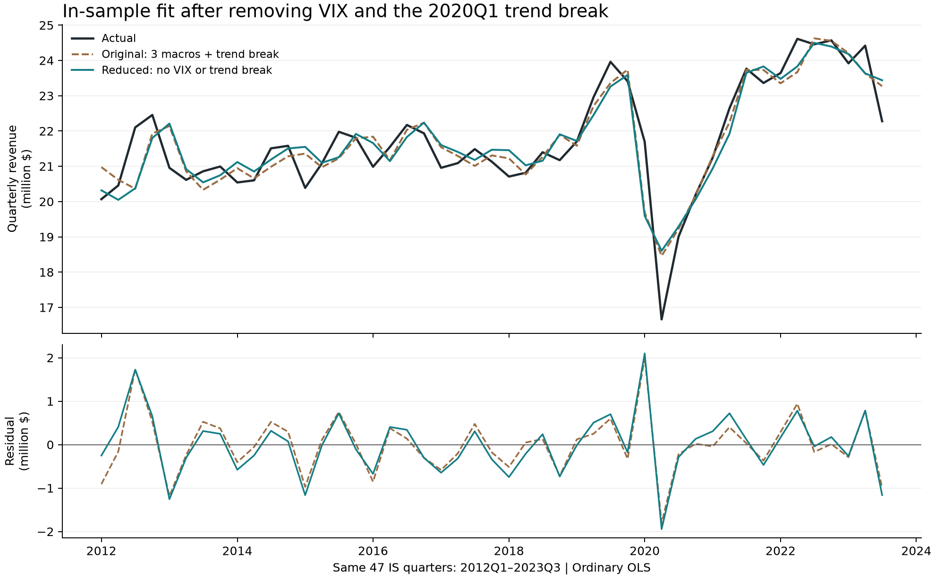
The fitted paths are similar. IS RMSE rises from 0.674 to 0.703 million $, approximately 4.3%, while BIC falls from 127.07 to 123.31. Both fits use actual lagged target values and the same 47 observations. The subsequent diagnostics, rolling stability and OOT evaluation use only the reduced model.
Table 5C Residual diagnostics for the reduced model
Diagnostic | p-value | Interpretation at 5%
BG lag 1 | 0.2563 | Do not reject no serial correlation through lag 1
BG lag 4 | 0.0042 | Reject no serial correlation through lag 4
Jarque Bera | 0.0937 | Do not reject normality
Breusch Pagan auxiliary F | <0.0001 | Reject homoskedasticity

The conventional joint F test of the restrictions that the VIX and 2020Q1 slope-change coefficients are both zero gives F(2, 39) = 1.7072, p = 0.1946. At 5%, it does not reject the restrictions, providing some support for parsimony; it does not prove that the removed terms have no effect.
Serial correlation through lag 4 and heteroskedasticity remain. The coefficient p-values, intervals and joint F test are nominal classical OLS results, with no adjustment for these violations or prior model selection. Sections 8-10 report diagnostics, rolling analysis and fixed-coefficient OOT results for the reduced two-macro model.

8 Two macro model IS diagnostics
Figure 3 Two macro model fitted revenue
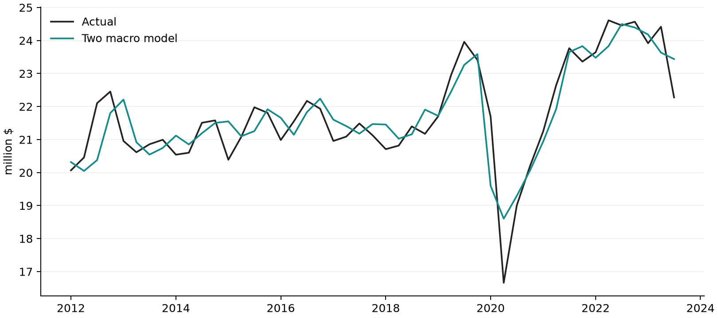
Table 6 Two macro model fit on 47 IS quarters
Adjusted R squared | RMSE | BIC | DW | Max VIF
0.7638 | 0.703 | 123.31 | 2.221 | 2.673

Table 7 Two macro model residual checks
Diagnostic | p-value | Interpretation at 5%
BG lag 1 | 0.2563 | Do not reject no serial correlation through lag 1
BG lag 4 | 0.0042 | Reject no serial correlation through lag 4
Jarque Bera | 0.0937 | Do not reject normality
Breusch Pagan auxiliary F | <0.0001 | Reject homoskedasticity

JB p is 0.0937 and remains diagnostic only. Maximum VIF is 2.673 and DW is 2.221. BG through lag 4 and the heteroskedasticity diagnostic reject their nulls. Passing the VIF and DW screens and not rejecting normality do not establish adequate residual behavior.
The 2020Q2 residual is -1.94 million $, its internally studentized residual is -3.48 and Cook distance is 1.64. The observation remains influential and is retained. All coefficient standard errors and intervals are nonrobust OLS; no HAC adjustment or additional data exclusion is applied.

9 Two macro model rolling stability
We re-estimate the two-macro specification in 20-quarter rolling IS windows without reselecting variables. The all-zero COVID column is omitted before activation. All 28 windows are full rank and retained, including the window ending 2020Q1. Window end dates run from 2016Q4 to 2023Q3. Shaded bands are conventional OLS 95% intervals.
Figure 4 Two macro coefficients across rolling IS windows
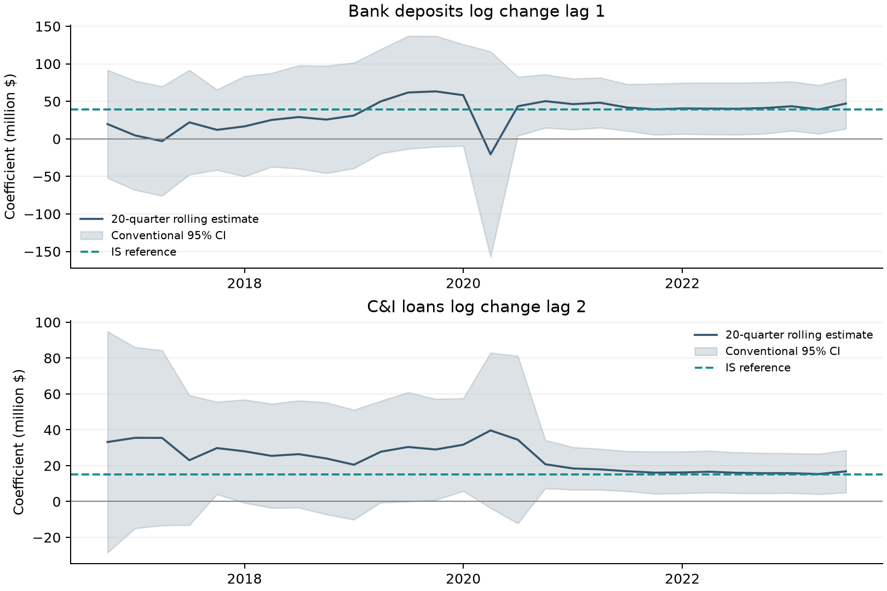
Macro term | Same sign | OLS p < 0.05 | IS estimate in CI
Bank deposits dlog lag 1 | 92.9% | 46.4% | 100.0%
C&I loans dlog lag 2 | 100.0% | 53.6% | 100.0%

The bank-deposit coefficient has the same positive sign as its full-IS estimate in 26 of 28 windows; the C&I loan coefficient is positive in all 28. Conventional significance occurs in 13 and 15 windows, respectively. Each full-IS estimate lies within every corresponding rolling 95% interval.
Windows overlap and are not independent replications. The wide intervals and short 20-quarter windows limit evidence about coefficient stability. All rolling estimates use conventional OLS uncertainty, without HAC.

10 Two macro model fixed coefficient OOT evaluation
The two-macro model retains the intercept, linear trend, 2020-only COVID indicator, AR(1), bank deposits log change lag 1 and C&I loans log change lag 2. Coefficients are frozen at the IS estimates through 2023Q3. One-step predictions use actual prior target values. The recursive path uses forecast target lags after the first OOT quarter. Both use realized lagged macro inputs; the recursive path is conditional on macro history. No OOT refitting is performed.
Figure 5 Two macro model fixed coefficient OOT predictions
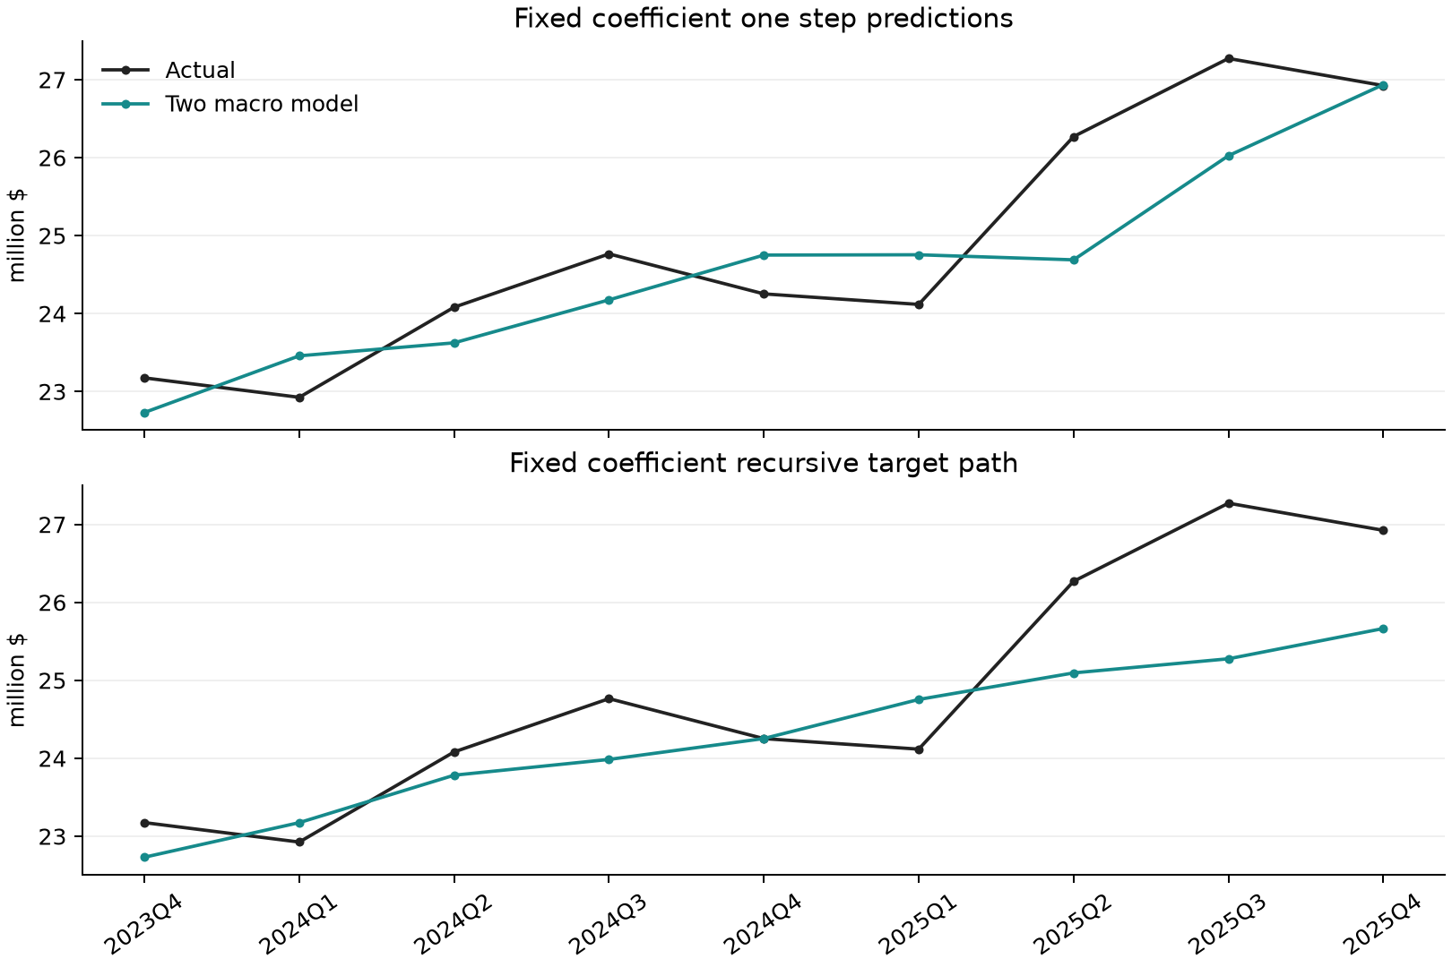
Table 8 Performance on all nine OOT quarters
Prediction design | RMSE | MAE | MAPE | Mean error
Two macro one step | 0.799 | 0.667 | 2.65% | -0.293
Two macro recursive | 0.961 | 0.760 | 2.95% | -0.563
Previous quarter value | 0.984 | 0.793 | 3.15% | -0.516
Same quarter previous year | 1.827 | 1.650 | 6.51% | -1.045

Mean error is prediction minus actual. One-step predictions underpredict 5 of 9 quarters; recursive predictions underpredict 6 of 9. Naive benchmarks use observed lagged targets and are comparable to one-step prediction, not to a fixed-origin recursive path.
One-step OOT RMSE is 0.799 and MAPE is 2.65%. Recursive RMSE is 0.961, with MAPE of 2.95%. No terms are revised in response to these scores.
Table 9 Two macro model OOT predictions in million $
Quarter | Actual | One step | Recursive | One step error
2023Q4 | 23.175 | 22.731 | 22.731 | -0.444
2024Q1 | 22.925 | 23.458 | 23.175 | 0.532
2024Q2 | 24.082 | 23.624 | 23.783 | -0.457
2024Q3 | 24.765 | 24.176 | 23.985 | -0.590
2024Q4 | 24.252 | 24.750 | 24.253 | 0.498
2025Q1 | 24.117 | 24.754 | 24.755 | 0.637
2025Q2 | 26.270 | 24.689 | 25.095 | -1.581
2025Q3 | 27.272 | 26.025 | 25.276 | -1.247
2025Q4 | 26.924 | 26.937 | 25.665 | 0.012

Interpretation of the holdout
All numerical fitting and variable selection use IS only. However, the full target and earlier OOT results were already reviewed before this rule revision. This is a retrospective chronological comparison, not an untouched prospective holdout. Macro data are labeled Scenario Consistent Baseline, August 2026; release lags and real-time historical vintages have not been reconstructed. Realized macro inputs make the OOT forecasts conditional.

11 S1 and S4 scenario comparison
We compare the two macro paths over their shared coverage, 2026Q1 through 2028Q1. S1 is the user-confirmed label for the supplied Scenario Consistent Baseline, August 2026, with source codes FBBLDPCBQ_B.IUSA and FBBABLLICBQ_B.IUSA. S4 is the supplied Alternative Scenario 4, Downside, 96th Percentile, January 2026, with the corresponding _S4.IUSA codes.
Figure 6 S1 and S4 macro paths
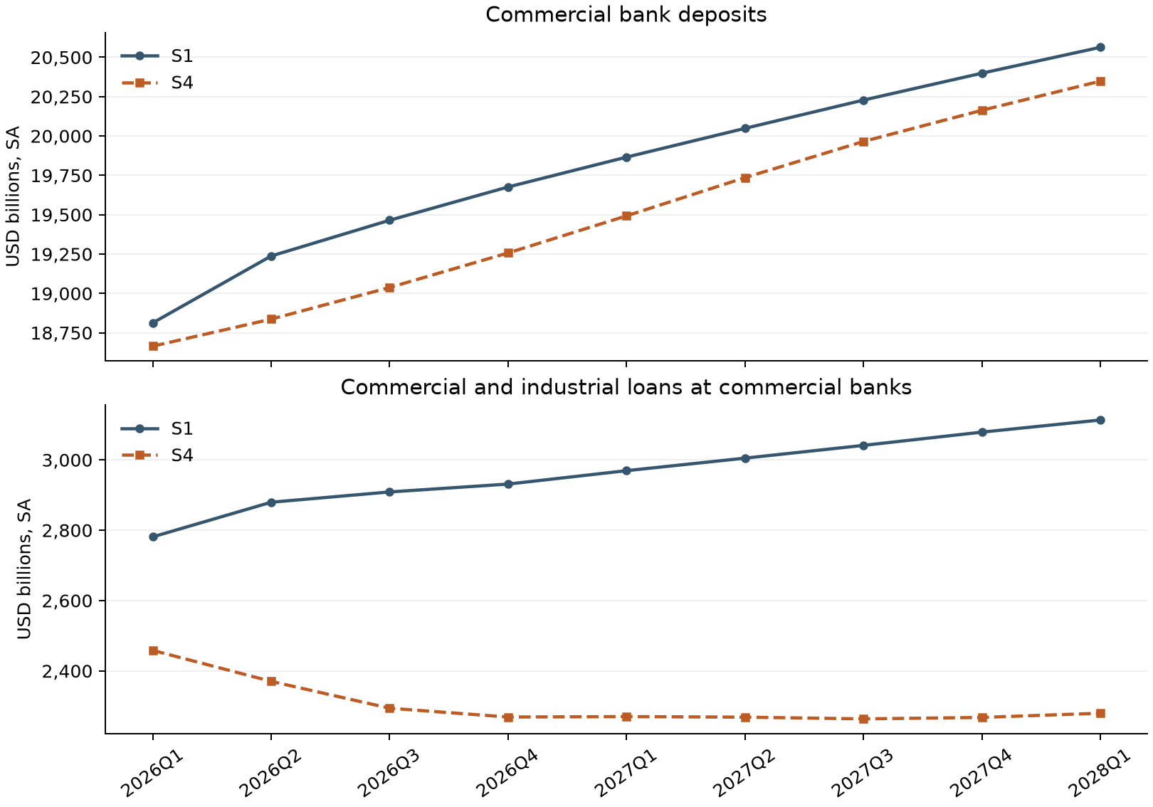
Both panels show seasonally adjusted levels in billions of US dollars. S1 uses the August 2026 vintage and S4 uses January 2026. The comparison therefore reflects both supplied scenario paths and their different vintages; it is not a same-vintage scenario comparison. S1 levels after 2028Q1 were not supplied, so the comparison stops at that quarter without extrapolation.

Mapping the macro paths into the final model
The model uses bank deposits as an unscaled first log difference lagged one quarter, and commercial and industrial loans as an unscaled first log difference lagged two quarters. The plotted levels are transformed before entering the equation. VIX and trend-break terms are absent from both scenario forecasts.

S1 and S4 fixed coefficient revenue forecasts
Both paths use the final six IS coefficients estimated through 2023Q3. We initialize the target lag with actual 2025Q4 revenue of 26.924269 million $, then use each scenario’s own predicted revenue recursively. The time index starts at 61 in 2026Q1, and the COVID indicator is zero throughout. No coefficients are re-estimated.
Figure 7 S1 and S4 quarterly revenue forecasts
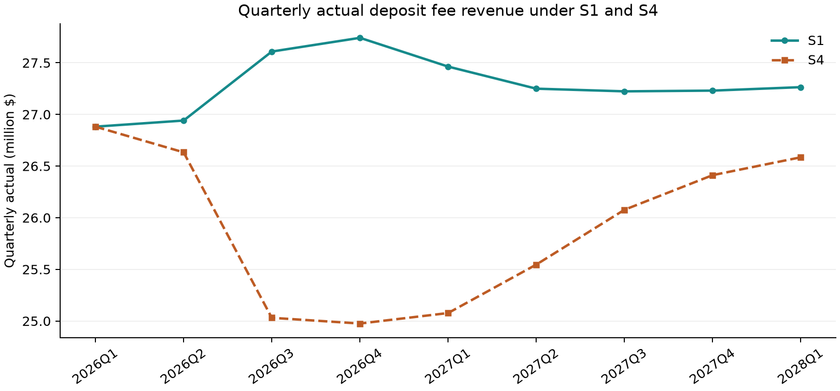
Conditional point forecasts in million $. S1 denotes Baseline, August 2026; S4 denotes the January 2026 downside scenario. These are model projections, not observed outcomes or prediction intervals.
Table 10 S1 and S4 forecasts in million $
Quarter | S1 forecast | S4 forecast | S4 minus S1 | S4 vs S1
2026Q1 | 26.881 | 26.881 | 0.000 | 0.00%
2026Q2 | 26.941 | 26.633 | -0.307 | -1.14%
2026Q3 | 27.609 | 25.031 | -2.578 | -9.34%
2026Q4 | 27.742 | 24.975 | -2.766 | -9.97%
2027Q1 | 27.463 | 25.077 | -2.386 | -8.69%
2027Q2 | 27.249 | 25.546 | -1.703 | -6.25%
2027Q3 | 27.223 | 26.077 | -1.147 | -4.21%
2027Q4 | 27.230 | 26.412 | -0.818 | -3.01%
2028Q1 | 27.264 | 26.585 | -0.679 | -2.49%

Historical bridge: both scenarios use the existing August 2026 historical macro file through 2025Q4, including 2025Q2–Q4 C&I levels and 2025Q3–Q4 deposits. No scenario-specific historical restatement or vintage adjustment is applied. The same lagged inputs make 2026Q1 forecasts equal; deposits first transmit scenario differences in 2026Q2, and C&I loans in 2026Q3.
At 2028Q1, S1 revenue is 27.264 and S4 revenue is 26.585. S4 is 0.679 lower, or 2.49% below S1 under the supplied paths.

12 Conclusions and scenario scope
The final two-macro model retains bank deposits log change lag 1 and commercial and industrial loans log change lag 2, with a time trend, COVID indicator and AR(1). IS adjusted R squared is 0.7638. Across the nine OOT quarters, one-step MAPE is 2.65% and recursive MAPE is 2.95%. Both prediction designs have a negative mean error. The model and coefficients remain fixed throughout OOT. The subsequent S1 and S4 scenario projections also retain these coefficients and use actual 2025Q4 revenue as their common starting value.
Residual heteroskedasticity, serial correlation through lag 4, short rolling windows and selection uncertainty limit the interpretation of ordinary OLS significance. No HAC inference is introduced. The S1 and S4 projections now cover their common input period, 2026Q1 through 2028Q1. They use the frozen final model and a common historical starting point. The supplied scenario vintages differ, so the gap should not be interpreted as a pure same-vintage stress effect.

Sources and reproducibility
Target: Quarterly_Target_Data_2011Q1_2025Q4.xls, Quarterly_targets, columns A and B. Macro inputs: six confirmed intake batches, 33 series and 2,112 numeric cells. Original Y remains intentionally excluded. The target remains actual revenue, distinct from the quarterly rate.
Scenario inputs: two user-supplied spreadsheet photographs, transcribed at displayed precision. S1 is a user-authorized alias for the August 2026 Baseline; S4 is January 2026. The shared nine-quarter macro paths, transformed inputs, recursive forecasts and scenario gaps are saved separately. Independent scalar predictions and the scenario-gap recursion reconcile.
Saved outputs retain the initial selection history, the two-macro IS coefficients, 28 rolling windows and all nine OOT predictions. The saved reduced IS fit was reproduced; independent least-squares and scalar OOT prediction checks passed. Quarterly keys, split, COVID coding, rank and lag direction were verified. Software: statsmodels 0.15.0.
Methods: ADF; KPSS; regression diagnostics; DW limitations with lagged y

Appendix Macro stationarity screening
All tests use only 2011Q1 to 2023Q3. Series codes share the suffix _B.IUSA, omitted below. This appendix records the original candidate screen, not additional final-model terms. Each row shows the first passing transform or, for excluded series, the last attempted transform. Level is tried first; later transformations follow the rule in Section 6. ADF includes a constant, a four-lag maximum and AIC selection. KPSS includes a constant and automatic bandwidth.
Source and code | Series | Form | ADF p | KPSS p | Screen
B FBBABLLICBQ | Commercial and industrial loans, commercial banks | dlog | <0.0001 | >0.1000 | Eligible
C FBBABLLRCBQ | Real estate loans, commercial banks | diff | 0.0840 | 0.0320 | Excluded
D FBBABLLROCCBQ | Commercial real estate loans, commercial banks | dlog | 0.0308 | 0.0923 | Eligible
E FBBACBQ | Total assets, commercial banks | dlog | <0.0001 | >0.1000 | Eligible
F FBBLDPCBQ | Deposits, commercial banks | dlog | 0.0002 | >0.1000 | Eligible
G FBCFDELLIQ | Delinquency rate, C and I loans, top 100 commercial banks | level | 0.0399 | >0.1000 | Eligible
H FBCFDELLRCQ | Delinquency rate, commercial real estate loans, top 100 commercial banks | diff | 0.2084 | <0.0100 | Excluded
I FBKB | Bankruptcies, business, total | diff | 0.4843 | 0.0234 | Excluded
J FBQCRNCOLLQ | FDIC commercial banks: net charge-offs to loans and leases | diff | 0.0671 | <0.0100 | Excluded
K FCASHFLOW | Corporate cashflow | dlog | <0.0001 | >0.1000 | Eligible
L FCBC | Consumer Confidence Index | dlog | <0.0001 | >0.1000 | Eligible
M FCBOEVIXQ | CBOE Volatility Index SP500 [VIX], period average | level | 0.0249 | >0.1000 | Eligible
N FCSENTQ | Cyclical indicators: consumer sentiment index, final | dlog | <0.0001 | >0.1000 | Eligible
O FDDEMAND$ | NIPA: real domestic demand | dlog | <0.0001 | >0.1000 | Eligible
P FDDQ | Money stock: demand deposits | diff | 0.3855 | >0.1000 | Excluded
Q FETP | Employment: total private | dlog | <0.0001 | >0.1000 | Eligible
R FGDP | NIPA: gross domestic product | dlog | <0.0001 | >0.1000 | Eligible

dlog = ln(x(t)) - ln(x(t-1)); diff = x(t) - x(t-1). Log changes are unscaled natural-log units. Changes in percentage rates/spreads retain percentage-point units; income and money aggregates retain their published SA/SAAR definitions. No annualized source series is mechanically divided by four. Eligibility is a diagnostic screen, not a formal proof of stationarity or an entry into the revenue equation.

Appendix Macro stationarity screening continued
All tests use only 2011Q1 to 2023Q3. Series codes share the suffix _B.IUSA, omitted below. This appendix records the original candidate screen, not additional final-model terms. Each row shows the first passing transform or, for excluded series, the last attempted transform. Level is tried first; later transformations follow the rule in Section 6. ADF includes a constant, a four-lag maximum and AIC selection. KPSS includes a constant and automatic bandwidth.
Source and code | Series | Form | ADF p | KPSS p | Screen
S FIRHYBOASQ | High-yield bonds: option-adjusted spread, USD | level | 0.0197 | 0.0856 | Eligible
T FJRFEDQ | Federal funds target rate: range midpoint | diff | 0.0791 | >0.1000 | Excluded
U FLBR | Household Survey: unemployment rate | diff | <0.0001 | >0.1000 | Eligible
V FM1Q | Money stock: M1 | dlog | <0.0001 | >0.1000 | Eligible
W FM2Q | Money stock: M2 | dlog | 0.0007 | >0.1000 | Eligible
X FRFED | Federal funds rate | diff | 0.0733 | >0.1000 | Excluded
Z FRGT10Y | Interest Rates: 10-Year Treasury Constant Maturities | diff | <0.0001 | >0.1000 | Eligible
AA FRGT1Y | Interest Rates: 1-Year Treasury Constant Maturities | diff | 0.1333 | >0.1000 | Excluded
AB FRGT2Y | Interest Rates: 2-Year Treasury Constant Maturities | diff | 0.0277 | >0.1000 | Eligible
AC FRGT30Y | Interest Rates: 30-Year Treasury Constant Maturities | diff | <0.0001 | >0.1000 | Eligible
AD FRGT5Y | Interest Rates: 5-Year Treasury Constant Maturities | diff | 0.0002 | >0.1000 | Eligible
AE FRSOFRQ | Interest rates: Secured overnight financing rate [SOFR] | diff | 0.0633 | >0.1000 | Excluded
AF FRTB3M | Interest Rates: 3-Month Treasury Bills - Secondary Market | diff | 0.0409 | >0.1000 | Eligible
AG FRTB6M | Interest Rates: 6-Month Treasury Bills - Secondary Market | diff | 0.0400 | >0.1000 | Eligible
AH FYPDPIQ | Income: Disposable Personal | dlog | 0.0032 | >0.1000 | Eligible
AI FYPQ | Income: Personal - Total | dlog | <0.0001 | >0.1000 | Eligible

dlog = ln(x(t)) - ln(x(t-1)); diff = x(t) - x(t-1). Log changes are unscaled natural-log units. Changes in percentage rates/spreads retain percentage-point units; income and money aggregates retain their published SA/SAAR definitions. No annualized source series is mechanically divided by four. Eligibility is a diagnostic screen, not a formal proof of stationarity or an entry into the revenue equation.

