Deposit Month Actual Num
Interval Dummy Analysis
  - January 2011 to December 2025
Research report | 3 November 2026

1 Executive findings
The fitted interval dummy model estimates a temporary reduction of 850,932 original units per month from January 2020 through January 2021, inclusive. The robust 95% confidence interval is a reduction of 305,368 to 1,396,496 units, with a two-sided p-value of 0.0022. The coefficient was estimated without imposing a negative sign.
The same model estimates a positive post-break monthly slope of 19,680 units. The pre-break slope is not statistically distinguishable from zero in this specification (robust p = 0.5193). This does not establish that the pre-break series is stationary: the separate tests in the final section do not support stationarity around a constant.
These findings support the interval dummy as an interpretable description of an average temporary shortfall conditional on the fitted trend and error model. They do not establish that the true impact was identical in every affected month or that the intervention caused the observed changes.

2 Data and study design
Item | Definition
Target | Month_Actual_num in original units
Full sample | January 2011 to December 2025; 180 months
Business breakpoint | January 2020; specified in advance for this analysis
Temporary interval | January 2020 to January 2021 inclusive; 13 months
Pre-break subsample | January 2011 to December 2019; 108 months

The target was transcribed from the supplied screenshots into the deposit_input worksheet. The analysis uses a complete, consecutive monthly sequence with no missing or nonpositive values. The report preparation cross-checks the saved fitted-series input against all 180 workbook observations and verifies the source file hash.
The study uses the target series, time, the specified breakpoint and the interval indicator. No macroeconomic candidates enter this model. Neither the target nor the errors are differenced, and the reported effects are additive units rather than percentage changes.

3 Model and estimation procedure
$y_{t} = α + βt + γH_{t} + θD_{t} + u_{t}$
$H_{t} = max(t − 108, 0)$
Time t is zero in January 2011, so January 2020 is t = 108. The interval indicator D equals one in each of the 13 months from January 2020 to January 2021 and zero otherwise. It returns to zero in February 2021. The pre-break slope is β, the change in slope is γ, and the post-break slope is β + γ.
The underlying trend is continuous at the business breakpoint. There is no separate permanent level-step regressor. The temporary indicator introduces an additive shift of θ while it is active, followed by its complete removal. A constant effect therefore means a constant gap from the underlying trend, not a constant observed monthly value.

Estimation sequence
First, ordinary least squares (OLS) estimates the deterministic terms. HAC standard errors with 12 lags allow for heteroskedasticity and autocorrelation. A second static specification adds 11 calendar-month indicators as a seasonal sensitivity check.
Next, state-space maximum likelihood jointly estimates the deterministic terms and autoregressive errors. The search considers AR orders 0, 1, 2, 3 and 4, plus a sparse AR model using lags 1 and 3. Each is estimated with and without a seasonal AR term at lag 12, producing 12 candidates. The target is divided by one million for numerical estimation and converted back for reporting.
A candidate must converge and have Ljung–Box p-values of at least 0.05 at lags 6, 12 and 24. BIC ranks the candidates that satisfy this diagnostic rule. AR(4) with a seasonal AR(1) term at period 12 is selected; its AIC is 170.569 and BIC is 202.499. The sparse AR(1,3) seasonal model has a lower BIC of 198.244 but fails the lag-24 diagnostic (p = 0.0102).
$(1 − φ_{1}L − φ_{2}L^{2} − φ_{3}L^{3} − φ_{4}L^{4})(1 − ΦL^{12})u_{t} = ε_{t}$
Here L is the lag operator. The multiplicative seasonal specification also implies cross-lag terms. Stationarity of the AR error process is imposed during fitting; the smallest fitted AR root modulus is 1.095. This is a model restriction, not independent evidence that the target is stationary.
Coefficient inference below uses the model’s robust sandwich covariance estimate. Post-break slope uncertainty is computed as a linear contrast, including the covariance between β and γ. P-values are conditional on the chosen window and error structure and do not adjust for model selection.

4 Estimated effects and fitted path
Term | Estimate | Robust 95% interval | p-value
Pre-break slope β | 2,269 | -4,631 to 9,168 | 0.5193
Slope change γ | 17,411 | 3,865 to 30,958 | 0.0118
Post-break slope β + γ | 19,680 | 11,396 to 27,965 | <0.0001
Interval effect θ | -850,932 | -1,396,496 to -305,368 | 0.0022

Slopes are changes in the target per elapsed month. The interval coefficient is a level difference for each active month. Confidence intervals and p-values use robust maximum-likelihood covariance.
Figure 1 Actual series and the interval model deterministic mean
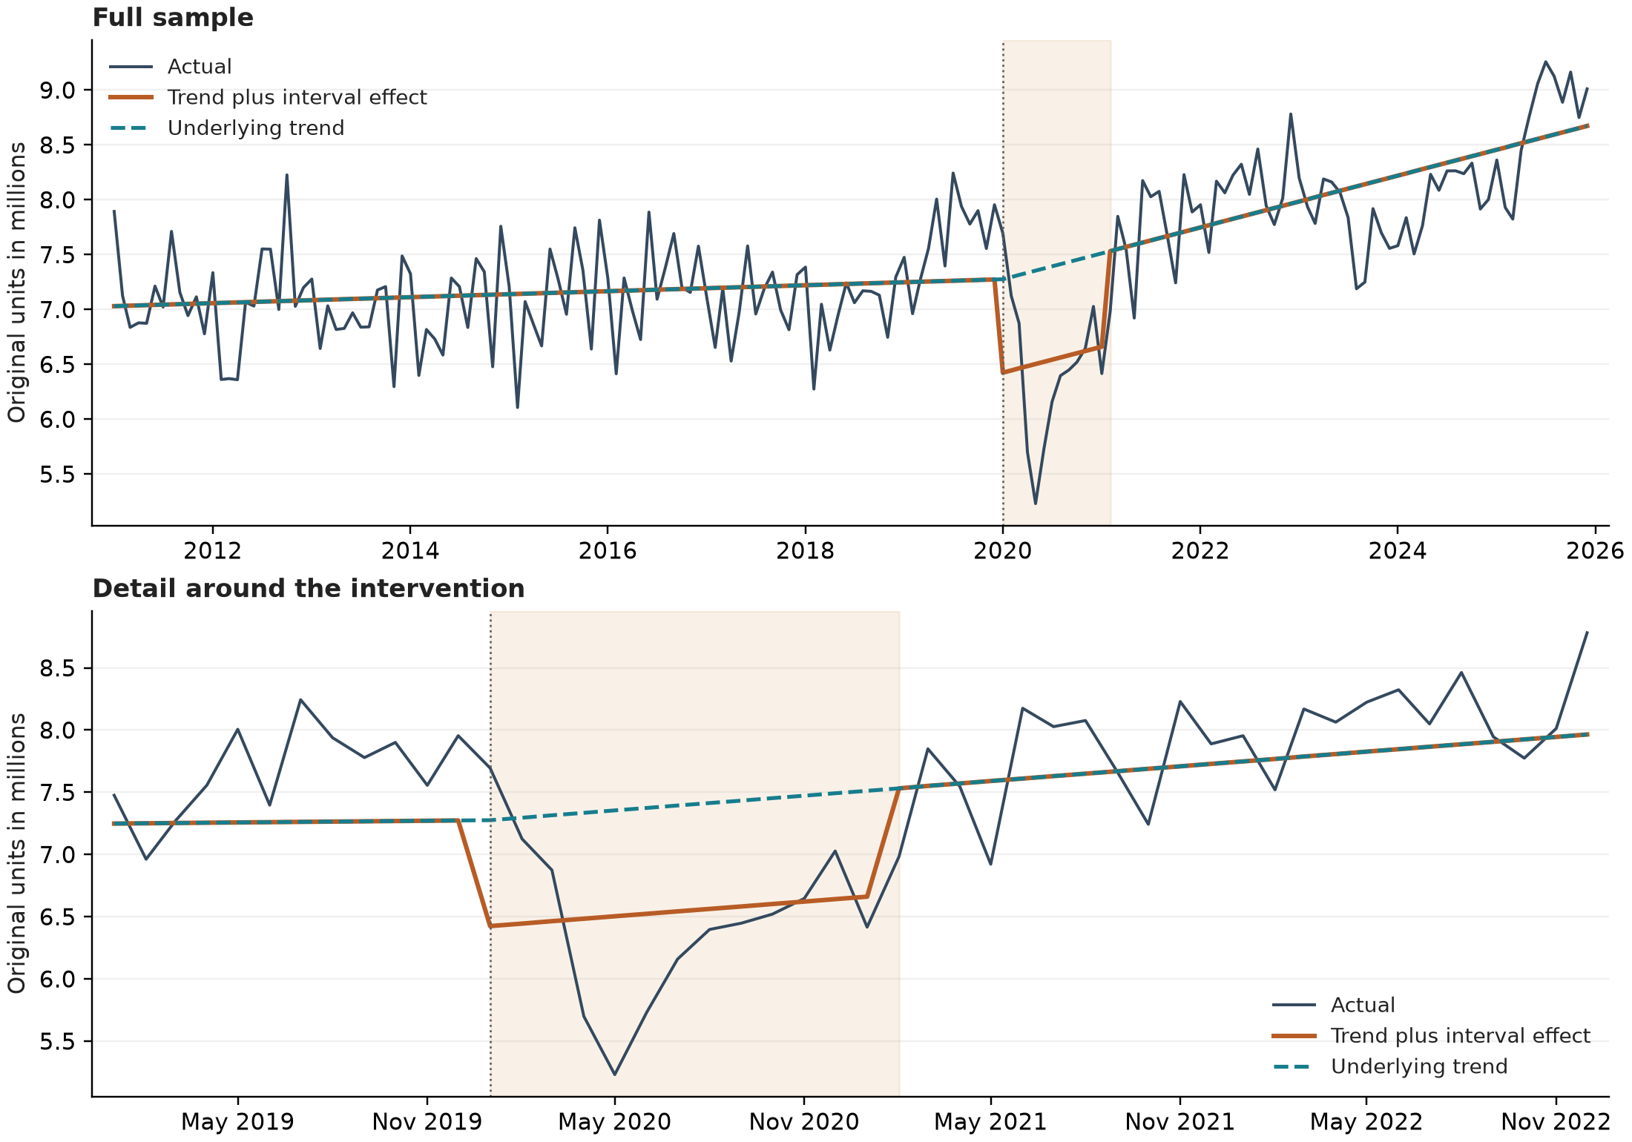
The orange line is the deterministic mean, not the AR-adjusted one-step prediction. Shading covers the 13 active months. The fitted mean and underlying trend come from the same estimated interval specification.
The estimated underlying slope rises by 17,411 units per month at the breakpoint (p = 0.0118). The resulting post-break slope is about 236,161 units per year on a linear basis, not a compounded growth rate. The observed within-window decline and recovery remain in the residual component; a significant θ does not validate a perfectly uniform monthly impact.

5 Residual diagnostics and stationarity checks

Serial correlation and distribution
Diagnostics use standardized one-step innovations after dropping the first 12 months, leaving 168 observations. Ljung–Box tests deduct five fitted AR parameters from the reference degrees of freedom: four nonseasonal terms and one seasonal term.
Diagnostic | Statistic | p-value | Interpretation
Ljung-Box lag 6 | 0.378 | 0.5389 | Not rejected at 5%
Ljung-Box lag 12 | 10.697 | 0.1524 | Not rejected at 5%
Ljung-Box lag 24 | 27.120 | 0.1019 | Not rejected at 5%
Durbin-Watson | 1.975 | — | Near 2
Jarque-Bera | 11.096 | 0.0039 | Normality rejected

No residual autocorrelation is detected at the tested horizons at 5%. The Jarque–Bera test rejects Gaussian innovations, so the report emphasizes robust coefficient inference. Passing these tests does not prove independence, constant variance or correct specification.

Detrended residuals before AR filtering
The full-sample diagnostic follows the earlier two-stage approach: remove the fitted deterministic terms, then apply ADF and KPSS to the remaining series. ADF uses no constant or trend, a maximum lag of 12 and AIC selection. KPSS uses a constant with automatic bandwidth selection.
Residual series and test | Statistic | p-value | Lag | Nominal decision
OLS detrended / ADF | -3.5506 | 0.0004 | 12 | Reject unit root
OLS detrended / KPSS | 0.0498 | >0.10 | 7 | Do not reject stationarity
MLE detrended / ADF | -3.5902 | 0.0003 | 12 | Reject unit root
MLE detrended / KPSS | 0.0510 | >0.10 | 7 | Do not reject stationarity

Lag denotes ADF lag order or KPSS bandwidth. KPSS values above the tabulated upper boundary are reported as >0.10 rather than exactly 0.10.
The nominal tests are consistent with stationary deviations around the fitted segmented mean and temporary interval effect. However, the deterministic terms were estimated from the same series. These ordinary residual-test p-values are not calibrated for the breakpoint, generated residuals or model selection, so they should not be presented as a formal break-adjusted unit-root test.
Innovation stationarity checks are not used as separate evidence about the target’s integration order. The AR model already imposes stationary errors. The direct pre-break tests in the final section address a different question on an unadjusted subsample.

6 Sensitivity and limits of interpretation
Sensitivity to seasonal controls and error treatment
Specification | Pre-break slope | Post-break slope | Interval effect | Effect p-value
OLS with HAC(12) | 3,743  (p 0.0489) | 17,239 | -989,171 | <0.0001
OLS plus month indicators | 3,745  (p 0.0448) | 16,980 | -1,009,413 | <0.0001
AR(4) plus seasonal AR(1) | 2,269  (p 0.5193) | 19,680 | -850,932 | 0.0022

The negative interval coefficient is present in all three specifications. Calendar-month indicators leave its magnitude close to one million units in the static regressions. The dynamic model estimates a smaller reduction of approximately 0.851 million units. These are sensitivity checks, not evidence that all specifications are equally adequate.
The pre-break trend inference changes with error treatment: its p-value is about 0.049 in static OLS with HAC errors and 0.519 in the selected dynamic model. The latter result means that a zero slope cannot be rejected within that model. It neither proves the slope is zero nor proves that shocks are mean-reverting.
The temporary-effect window is a business assumption. Its start and end dates are not estimated, and there is no separate test here of equal effects across the 13 months. The model mechanically removes the full dummy contribution in February 2021. The fitted shortfall is relative to a model-implied baseline, not an independently identified causal counterfactual.
A zero-pre-break-slope restriction is a possible simplification, but that restricted model has not been estimated in this study. Removing the trend solely because its coefficient is insignificant would be premature, especially given the direct pre-break stationarity results below. Out-of-sample forecast validation and break-aware or bootstrap inference remain necessary before operational use.

Reproducibility and method references
The numerical source is deposit_month_actual_num.xlsx, worksheet deposit_input. Existing model outputs are in interval_dummy_202001_202101: coefficient_contrasts.csv, ar_candidate_comparison.csv, stationarity_tests.csv, innovation_diagnostics.csv and fitted_values.csv. The model script is interval_dummy_model.py. The added subsample tests and interval-only figures are reproduced by prepare_interval_report.py; their saved results are pre_break_tests.json. All reported coefficient and diagnostic values are taken from the interval specification only.
The added analysis uses statsmodels 0.15.0. Original-unit coefficients are rounded for presentation. The ADF maximum lag is a ceiling for AIC selection, not a requirement to use 12 lags in every test. Official implementation references are linked below.
ADF test documentation KPSS test documentation SARIMAX specification

7 Stationarity of the pre break data
This check uses only the 108 original monthly observations from January 2011 through December 2019. No full-sample detrending, interval adjustment, AR filtering, differencing or month-of-year adjustment is applied. Two deterministic specifications are examined: a constant only and a constant plus a linear time trend.
ADF tests the unit-root null with a maximum lag of 12 and AIC selection. Both specifications select 12 lags, leaving 95 effective regression observations. A fixed-12-lag rerun gives identical results. KPSS tests stationarity around the specified constant or trend and selects bandwidth 3 automatically.
Test and deterministic terms | Statistic | p-value | Lag | Decision at 5%
ADF / Constant | -0.2943 | 0.9263 | 12 | Do not reject unit root
KPSS / Constant | 0.5138 | 0.0385 | 3 | Reject level stationarity
ADF / Constant and trend | -1.0398 | 0.9385 | 12 | Do not reject unit root
KPSS / Constant and trend | 0.1298 | 0.0800 | 3 | Do not reject trend stationarity

Figure 2 Pre-break monthly observations and sample mean
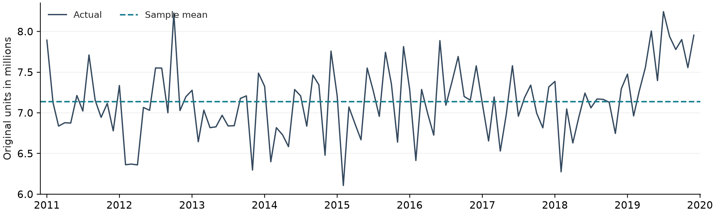
For the constant-only specification, ADF fails to reject a unit root (p = 0.9263), while KPSS rejects level stationarity (p = 0.0385). The evidence therefore does not support treating the entire pre-break period as stationary around a fixed mean.
Allowing a linear trend does not resolve the issue. ADF still fails to reject a unit root (p = 0.9385). KPSS does not reject trend stationarity at 5% (p = 0.0800), although it would reject at 10%. Together, these results are inconclusive about trend stationarity and do not establish a unit root as fact.
The full-sample pre-break slope p-value of 0.5193 concerns a deterministic coefficient; stationarity concerns the persistence of stochastic shocks. They are different hypotheses. With only nine years of data and 12 ADF lags, test power and seasonal dependence also warrant caution. The defensible conclusion is that the visual impression of a flat pre-break series is insufficient to classify it as stationary; the interval model remains a conditional descriptive specification requiring further validation.

