Noncomp Efficiency Ratio
Model Development Documentation
19 October 2026

1 Executive Summary
The Noncomp EF model projects the bank’s quarterly efficiency ratio. EF measures costs relative to income. A lower ratio means that less cost is needed to generate each unit of income. The model supports expense and profitability planning under different economic scenarios.
The selected model uses the previous quarter’s EF, the previous quarter’s change in unemployment, and a period indicator beginning in 2014Q1. Development first examined the historical trend and its break. We then estimated an ARDL with a trend. The trend p value was 0.1719, so we removed the trend and estimated the simpler equation again.

Main findings
Unemployment, the output gap and GDP gave very similar historical fit. Unemployment had the lowest one-step forecast error in the nine-quarter evaluation. Its effect also has a clear business explanation. Rising unemployment can weaken income while operating costs adjust more slowly.
Table 1 Model overview
Item | Current specification
Historical EF | 60 quarters from 2011Q1 through 2025Q4
Macro candidates | 22 quarterly series with original provider codes
Model development | 49 usable observations through 2023Q3
Historical forecast evaluation | 9 quarters from 2023Q4 through 2025Q4
Future forecasts | S1 and S4 from 2026Q1 through 2028Q1
Forecast error | 2.783 EF percentage points one step; 3.728 recursively
Implementation | Python package with CSV inputs and outputs
The final specification is re-estimated through 2025Q4 before producing future forecasts. Both scenarios start at 55.395% in 2026Q1. By 2028Q1, EF is 56.790% under S1 and 57.287% under S4. S1 is the original Baseline scenario. The code also measures the effect of moving each future unemployment path up or down by one percentage point.
The sections below explain the model design, data, results and operating process. The appendix provides the complete macro dictionary, screening results and supporting file names.

2 Model Theory and Design

What the model measures
The input EF series is a reported quarterly cost-to-income ratio. A value of 0.55 represents 55%. The code uses that supplied ratio directly. The accounting definition should remain consistent when new observations are added.

Why prior quarter EF matters
Bank costs and income usually adjust over several quarters. The previous quarter’s ratio therefore helps explain the next quarter. This carryover effect is captured by the prior-EF coefficient. The full-history estimate is 0.737. A one-percentage-point increase in prior EF raises the next fitted EF by about 0.737 percentage points when the other inputs stay the same.

Why unemployment matters
Unemployment summarizes labor-market conditions. A rise can accompany weaker customer activity and lower income. Some operating costs take time to adjust. This can raise costs relative to income. The estimated unemployment coefficient has the expected positive sign.
The model uses the change in unemployment from one quarter to the next. It uses that change with a one-quarter delay. The source column is FLBR_B.IUSA. A move from 4% to 5% is an increase of one percentage point.

How the period indicator works
The period indicator D equals zero through 2013Q4 and one from 2014Q1 onward. It allows the earlier TARP-related period to have a different average relationship. The boundary is a fixed modeling choice. The forecast holds D at one throughout the future period.

Final equation
$${EF}_{t} = c + δD_{t} + φ{EF}_{t−1} + λΔU_{t−1} + ε_{t}$$
Table 2 Terms in the forecasting equation
Term | Plain-language meaning
EF | The efficiency ratio for the quarter being estimated
c and D | A starting level and an adjustment for the historical period
Prior EF | The ratio from the preceding quarter
Prior unemployment change | The previous quarter’s change in FLBR_B.IUSA
Error | The part of EF left unexplained by these inputs
The coefficients c, δ, φ and λ are estimated weights. Each weight tells the model how much to respond to an input. The error is shown by ε.

Main assumptions
The forecasting equation assumes that the estimated relationships remain useful over the forecast horizon. It also assumes consistent EF reporting and correctly labeled unemployment scenarios. Large changes in the business, accounting definition or economic relationship require a review of the model.

3 Model Estimation

Development sequence
We first describe the historical level and trend. We then build a forecasting equation that includes prior EF. We screen the macro candidates with a trend in place. After assessing the trend coefficient, we re-estimate the chosen equation. The final model then receives forecast and diagnostic testing.

Historical level and trend break
The first regression allows the historical trend line to change in 2014Q1. It includes a time counter t, the period indicator D, and their interaction D × t. The counter starts at one in 2011Q1. It equals 13 in 2014Q1.
$${EF}_{t} = α + θD_{t} + βt + γD_{t} × t + u_{t}$$
Table 3 Full-history level and trend estimates
Term | Coefficient | p value
Constant | 0.603727 | < 0.0001
Period indicator D | 0.066791 | 0.0065
Linear time trend t | 0.014080 | < 0.0001
Change in trend D × t | −0.016607 | < 0.0001
The regression uses all 60 smoothed quarterly observations. The time and interaction coefficients show that the fitted slope changes after the selected boundary.
Figure 1 Smoothed EF and the fitted historical trend
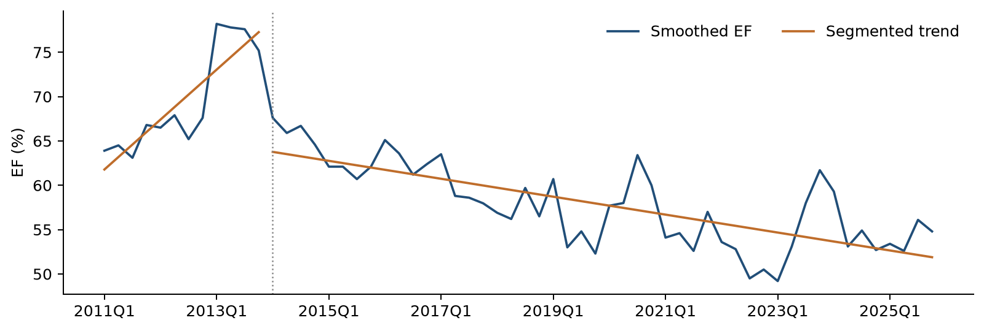
The fitted line rises before 2014Q1 and declines afterward. Separate lines allow the historical level and direction to change at the selected boundary.
Before 2014Q1, the estimated slope is +1.408 EF percentage points per quarter. After the boundary, it is −0.253 percentage points per quarter. These lines summarize the history. The forecasting equation adds prior-quarter EF to represent how the ratio adjusts over time.

Residual checks and macro selection

Checking the fluctuations around the fitted lines
A residual is the difference between actual EF and the fitted value. We check whether these differences tend to settle around a stable center over time. This behavior is called stationarity. It helps assess whether the fitted trend captures the persistent movement in the series.
The ADF test looks for evidence against a lasting random drift. A small ADF p value supports a stable residual pattern. KPSS checks the stable-pattern assumption from the other direction. A larger KPSS p value means that the test raises no stationarity concern at the chosen threshold.
Table 4 Residual stationarity checks
Sample | Check | Statistic | p value
Through 2023Q3 | ADF | −5.2240 | < 0.0001
Through 2023Q3 | KPSS | 0.0446 | > 0.10
Through 2025Q4 | ADF | −4.7569 | < 0.0001
Through 2025Q4 | KPSS | 0.1044 | > 0.10
Both checks support stationary fluctuations around the fitted level and trend break in each sample. We consider the two results together.
The p values use ordinary residual-test reference distributions. Estimating the break regression can affect those reference values. A formal break-adjusted unit-root conclusion requires a separately calibrated test. The results here serve as supporting diagnostic evidence.

Preparing the candidate macros
The candidate pool contains 22 macro series. Six use quarter-to-quarter log changes, which measure relative movement. The other 16 use changes in their original units. Every change is lagged one quarter. This gives every candidate the same 49 development observations from 2011Q3 through 2023Q3.

Forward selection
Forward selection adds one macro at a time. Each remaining candidate is fitted alongside the variables already in the equation. The starting equation contains a constant, D, t and prior-quarter EF. A candidate must pass all four checks below.
Table 5 Entry rules used in each selection round
Check | Rule | What it checks
Coefficient p value | Below 0.05 | Evidence that the added macro contributes to the fitted equation
VIF | Below 10 | Overlap between the model’s explanatory variables
Durbin–Watson | 1.5 to 2.5 | A broad check for consecutive fitting errors moving together
Jarque–Bera p value | Above 0.05 | Whether the errors have an acceptable bell-shaped pattern
These are the Consumer and Debit Cardfee screening rules. The lowest coefficient p value wins among eligible candidates. Ties use higher adjusted R² and then the fixed source-column order.
The search stops when all remaining candidates fail at least one rule. The DW range is a screening convention. Ljung–Box tests provide the final check for error patterns across quarters.

ARDL with trend and subsequent reestimation

Starting with a trend
ARDL stands for autoregressive distributed lag. In this model, it means that current EF is explained by earlier EF and an earlier macro change. The initial equation also contains the linear time trend.
$${EF}_{t} = c + δD_{t} + bt + φ{EF}_{t−1} + λΔU_{t−1} + ε_{t}$$
FLBR_B.IUSA enters in the first round with p = 0.0330. After it enters, the lowest remaining candidate p value is 0.2229. The search therefore ends with one macro.
Table 6 Selected ARDL with a trend
Term | Coefficient | p value
Constant | 0.271984 | 0.0010
Period indicator D | −0.034941 | 0.0206
Linear time trend t | −0.000807 | 0.1719
Prior quarter EF | 0.634474 | < 0.0001
Prior quarter unemployment change | 0.006204 | 0.0330
The trend p value is 0.1719. It exceeds the 0.05 decision threshold. Unemployment remains below the threshold.

Removing the trend and estimating again
We remove the time trend and keep D, prior EF and prior unemployment change. We then estimate all coefficients again on the same 49 quarters. A transition pulse is omitted throughout the ARDL analysis.
Table 7 Final development model
Term | Coefficient | p value
Constant | 0.193795 | 0.0008
Period indicator D | −0.043633 | 0.0020
Prior quarter EF | 0.738292 | < 0.0001
Prior quarter unemployment change | 0.006417 | 0.0289
All retained coefficients have p values below 0.05. The prior-EF coefficient is 0.7383. The unemployment-change coefficient is positive at 0.006417.
The historical trend regression and the ARDL answer different questions. The first describes the broad path of EF. The second asks what helps predict EF after the prior quarter’s ratio is included. Once prior EF is present, the additional linear trend contributes little evidence in this sample.
Ordinary least squares estimates each equation by minimizing the squared differences between actual and fitted EF. All coefficient tables use conventional OLS standard errors and two-sided Student-t p values. The appendix gives standard errors and t statistics.

Alternative models and the full-history refit

Comparing unemployment with the output gap and GDP
Table 8 Three no-trend alternatives
Source code | Adjusted R² | Macro p | One-step RMSE in EF pp | Recursive RMSE in EF pp
FLBR_B.IUSA | 0.826462 | 0.0289 | 2.783 | 3.728
FGAP_B.IUSA | 0.826998 | 0.0267 | 2.906 | 3.643
FGDP$_B.IUSA | 0.826748 | 0.0277 | 2.878 | 3.501
All three equations use the same 49 quarters. Their historical fit is very close. Unemployment has the lowest one-step error. GDP has the lowest recursive error. Here, pp means percentage points.
Adjusted R² summarizes historical fit while allowing for the number of variables. The values are approximately 0.827 for all three models. RMSE measures forecast error in the same units as EF and gives more weight to large misses. Smaller values indicate closer forecasts.
A separate forward search that starts without a trend selects FGAP_B.IUSA. The main sequence selects FLBR_B.IUSA while the trend is present, then removes the trend. We retain unemployment because its fit is comparable, its one-step error is lowest, and its economic meaning is direct. The complete screening records remain available.
After unemployment is retained in the no-trend model, the strongest remaining addition has p = 0.1122. This is the private compensation index FECICPQ_B.IUSA. The final equation therefore keeps one macro.

Refitting the chosen structure through 2025Q4
After development testing, we keep the chosen variables and re-estimate their weights using all 58 usable quarters through 2025Q4. These updated weights drive the S1 and S4 forecasts. Historical forecast-error scores continue to use the earlier development weights.
Table 9 Full-history coefficients for future forecasting
Term | Coefficient | p value
Constant | 0.194684 | 0.0003
Period indicator D | −0.045338 | 0.0010
Prior quarter EF | 0.736985 | < 0.0001
Prior quarter unemployment change | 0.006314 | 0.0288
The unemployment coefficient remains positive and has p = 0.0288. Its estimate changes only slightly, from 0.006417 to 0.006314.
$${EF}_{t} = 0.194684 − 0.045338D_{t} + 0.736985{EF}_{t−1} + 0.006314ΔU_{t−1} + ε_{t}$$
A one-percentage-point increase in the relevant unemployment change raises fitted EF by about 0.631 percentage points. This describes the estimated historical relationship. Actual business responses can vary with the operating environment.

4 Model Development Data

Input files and units
Table 10 Data inputs
File | Contents | Period
inputs/macro.csv | 22 macro series in their original provider columns | 2011Q1–2025Q4
inputs/ef.csv | Original EF in decimal ratio units | 2011Q1–2025Q4
scenarios/S1.csv | Baseline FLBR_B.IUSA levels in percent | 2026Q1–2028Q1
scenarios/S4.csv | S4 FLBR_B.IUSA levels in percent | 2026Q1–2028Q1
The two historical inputs support model estimation. S1 and S4 remain separate scenario files. Each file uses quarter-end dates and one header row.
The macro history starts on 31 March 2011. All 22 variables are complete over the 60-quarter history. The code checks column names, dates, units and missing values before estimation. It preserves the original inputs and calculates transformations in memory.

Smoothing the two 2017 observations
The development series smooths the sharp movement in 2017Q3 and 2017Q4. Each replacement is a three-quarter average calculated from original EF values. This local averaging reduces the influence of the two unusual points while keeping both quarters in the sample.
Table 11 EF adjustments
Quarter | Original EF | Original quarters averaged | Smoothed EF
2017Q3 | 0.508 | 2017Q2, 2017Q3, 2017Q4 | 0.586000
2017Q4 | 0.662 | 2017Q3, 2017Q4, 2018Q1 | 0.579667
The second average also uses the original 2017Q3 value. All other EF values are unchanged. The confirmed 2020Q3 value is 0.634.

Sample construction
Table 12 Observation counts
Use | Period | Quarters
Historical break regression | 2011Q1–2025Q4 | 60
Development break regression | 2011Q1–2023Q3 | 51
ARDL selection and development fit | 2011Q3–2023Q3 | 49
Historical forecast evaluation | 2023Q4–2025Q4 | 9
Fixed-structure full-history refit | 2011Q3–2025Q4 | 58
A quarterly change and its one-quarter lag require two earlier macro observations. This makes 2011Q3 the common first ARDL quarter. The first two EF levels remain available as history.
The history includes different economic environments and the pandemic period. With 49 development observations, the selection favors a small equation. The original-EF sensitivity in Section 6 shows how the smoothing choice affects results.

5 Linkages with Other Models

Upstream inputs
The model receives historical EF and macro data from the input CSV files. It also receives externally supplied S1 and S4 unemployment paths. The EF model calculates its own lagged values and macro changes. The future unemployment paths remain fixed during each forecast run.

Downstream use
The output is a quarterly EF path. Planning users can use this ratio when reviewing future costs and profitability. Any downstream conversion into a dollar amount should use the same EF definition and a consistent income measure. The current code package produces ratio forecasts.

Changes that require coordination
A revised EF definition, a macro-data revision, a new scenario vintage or a change in the scenario labels can affect the results. The operator should record each version and confirm the dates and units before running the model. Each run includes file checksums to identify the exact inputs used.

6 Model Testing

Historical fit
Table 13 Final-model fit
Measure | Development | Full history
Usable quarters | 49 | 58
Adjusted R² | 0.8265 | 0.8212
Fitted error RMSE in EF pp | 2.833 | 2.822
The development equation accounts for about 82.6% of historical variation after allowing for its number of variables. This describes fit within the estimation sample. Later-quarter forecast results provide a separate check.
Figure 2 Actual and fitted EF in the development sample
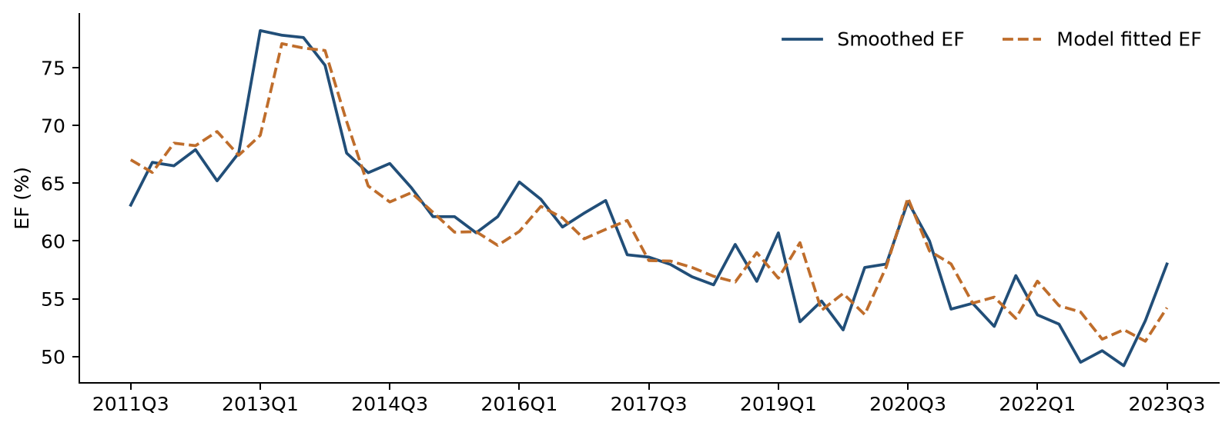
The fitted values follow the broad decline in EF and much of the quarterly movement. Some individual quarters have larger differences. Forecast testing evaluates how the equation performs after the development period.

Final-model diagnostic checks
Diagnostics examine the errors left after fitting the model. We check whether errors move together across quarters, whether their shape is unusual, and whether their cumulative pattern suggests a change in the relationship. The decision threshold is 0.05.
Table 14 Error patterns across quarters
Check | Development statistic | Development p | Full-history statistic | Full-history p
Ljung Box 4 | 5.2946 | 0.1515 | 6.7614 | 0.0799
Ljung Box 8 | 9.0562 | 0.2486 | 10.3557 | 0.1693
Durbin Watson | 2.1954 | — | 2.1631 | —
Ljung–Box checks whether an error tends to be followed by related errors over the next four or eight quarters. It uses the whole estimation sample. All p values exceed 0.05. The full-history four-quarter p value is 0.0799, so this check deserves attention in later monitoring.
DW is close to two in both samples. It provides a simple description of consecutive errors. The code reports its statistic without a p value because the equation contains prior EF.
Table 15 Error shape and stability
Check | Development statistic | Development p | Full-history statistic | Full-history p
Jarque Bera | 2.5865 | 0.2744 | 1.9093 | 0.3849
CUSUM | 0.7016 | 0.7086 | 0.8039 | 0.5379
Jarque–Bera checks whether the errors have an unusually asymmetric or heavy-tailed shape. CUSUM looks for a persistent shift in their cumulative pattern. Neither check raises a concern at the 0.05 threshold.
Table 16 Stationarity of the final-model residuals
Sample | ADF statistic | ADF p | KPSS statistic | KPSS p
Development | −7.9090 | < 0.0001 | 0.1697 | > 0.10
Full history | −5.4416 | < 0.0001 | 0.2068 | > 0.10
The residual stationarity checks also support a stable pattern. Their ordinary diagnostic interpretation follows the discussion in Section 3.
Maximum VIF is 1.611 in development and 1.641 in the full-history fit. These low values indicate limited overlap among the explanatory variables. The prior-EF coefficient is below one in both fits, so the response to a temporary shock fades over time.

Historical forecast evaluation

One-step and recursive forecasts
The evaluation covers 2023Q4 through 2025Q4. All model weights stay fixed at their development estimates. One-step forecasts use the actual EF observed in the previous quarter. Recursive forecasts begin with actual 2023Q3 EF and then use each forecast to calculate the next quarter.
Both methods use the macro values observed during the evaluation period. These results show performance conditional on those macro values. This nine-quarter window was also reviewed when choosing the final macro.
Figure 3 Actual EF and historical forecasts
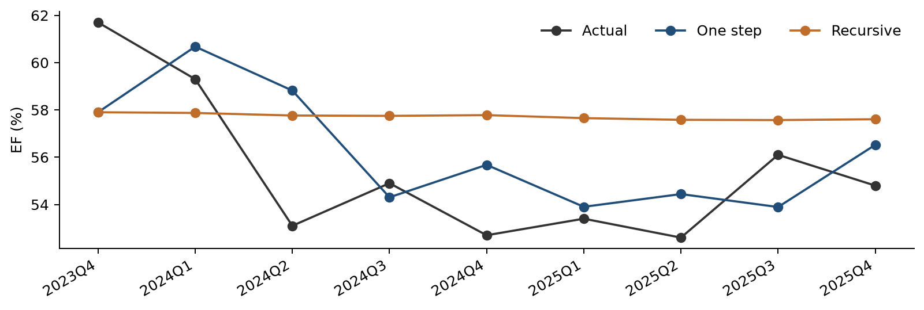
The one-step forecast responds to each new actual EF value. The recursive forecast follows a smoother path because it carries its own earlier predictions forward. The two methods share the first forecast.
Table 17 Forecast errors and simple comparisons
Forecast method | RMSE in EF pp | MAE in EF pp
Final model one step | 2.783 | 2.304
Final model recursive | 3.728 | 3.481
Prior actual EF each quarter | 3.001 | —
Keep 2023Q3 EF unchanged | 3.962 | —
Development-period average | 6.241 | —
The final model improves on both persistence comparisons. MAE is the average size of the errors. RMSE gives more weight to large errors. Both are shown in EF percentage points.
Unemployment’s one-step RMSE is 2.783 percentage points, compared with 2.906 for the output gap and 2.878 for GDP. For recursive forecasts, GDP is lower at 3.501 percentage points. The final choice considers these results together with historical fit and economic interpretation.

Scenario forecasting

S1 and S4 unemployment paths
S1 is the original Baseline path. S4 supplies a higher unemployment path. The model starts from actual 2025Q4 EF of 54.8%. It uses the full-history coefficients and forecasts nine quarters through 2028Q1. Each EF forecast becomes the prior-quarter input for the next calculation.
Figure 4 Scenario unemployment and the resulting EF forecasts
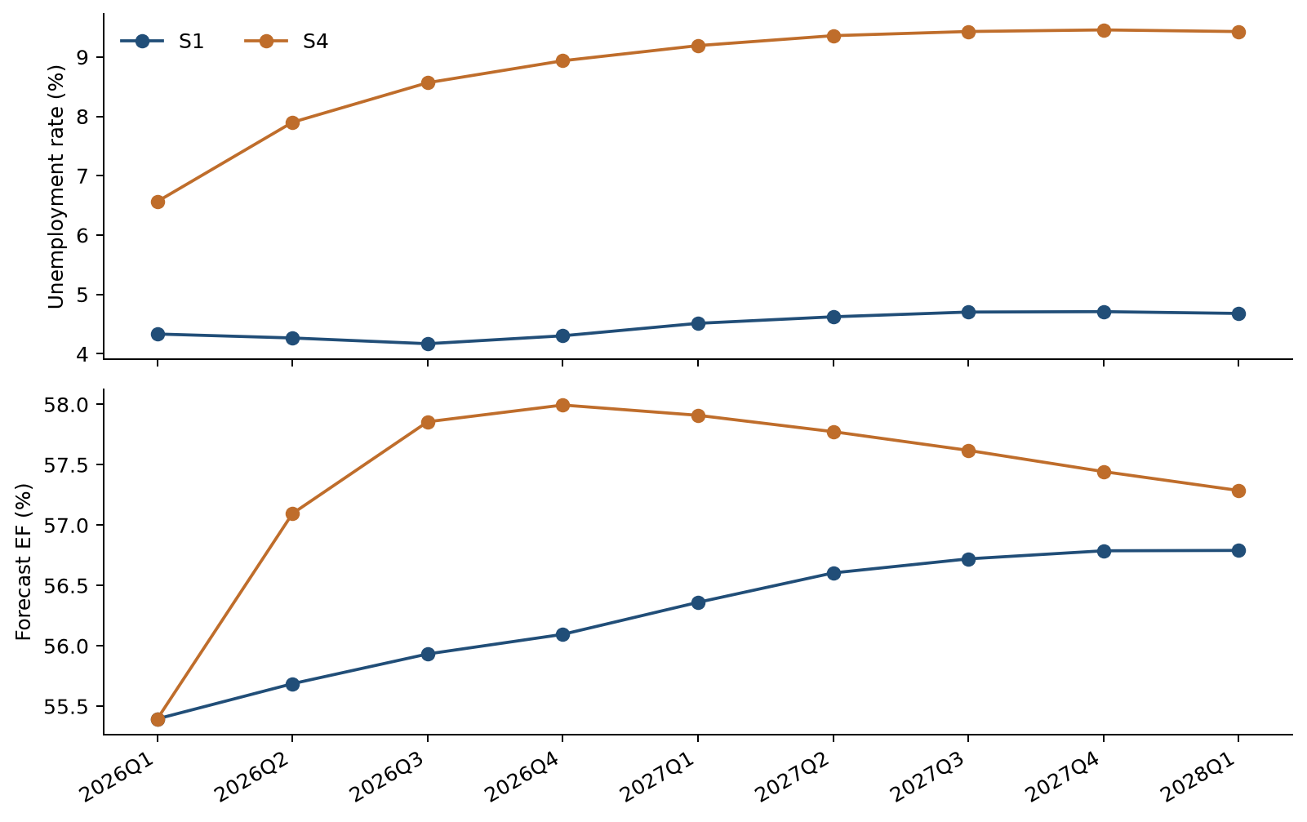
The upper panel shows the two unemployment paths. The lower panel shows the associated EF forecasts. The larger early unemployment increases under S4 produce a higher EF path from 2026Q2 onward.

Why the first quarter is the same
The 2026Q1 equation uses the unemployment change from 2025Q3 to 2025Q4. That historical change is shared by S1 and S4. The two first-quarter EF forecasts therefore both equal 55.395%. The different future unemployment paths first affect EF in 2026Q2.
The model responds to unemployment changes. Under S4, the quarterly increases become smaller. Unemployment peaks in 2027Q4 and then edges lower. The EF response eases later in the horizon. These forecasts describe the supplied economic paths and carry no assigned scenario probability.

Quarterly scenario results
Table 18 Nine-quarter scenario inputs and forecasts
Quarter | S1 unemployment % | S4 unemployment % | S1 EF % | S4 EF %
2026Q1 | 4.333 | 6.565 | 55.395 | 55.395
2026Q2 | 4.267 | 7.900 | 55.686 | 57.096
2026Q3 | 4.170 | 8.566 | 55.933 | 57.856
2026Q4 | 4.303 | 8.936 | 56.095 | 57.994
2027Q1 | 4.513 | 9.191 | 56.360 | 57.909
2027Q2 | 4.623 | 9.359 | 56.604 | 57.774
2027Q3 | 4.703 | 9.429 | 56.720 | 57.619
2027Q4 | 4.710 | 9.456 | 56.787 | 57.443
2028Q1 | 4.680 | 9.428 | 56.790 | 57.287
By 2028Q1, S1 EF is 56.790% and S4 EF is 57.287%. The 2028Q1 unemployment assumption would enter the EF equation in 2028Q2, one quarter beyond the displayed forecast.

Sensitivity to a higher or lower unemployment path
The sensitivity test moves every future unemployment level up or down by one percentage point. For example, an S1 value of 4.333% becomes 5.333% in the upward case. Historical unemployment remains unchanged. We recalculate the quarterly changes and their lags before forecasting.
The same test is applied separately to S1 and S4. The fitted relationship is linear, so the incremental effect is equal around the two scenario paths. The first effect appears in 2026Q2. Later effects shrink as the previous EF response passes through the model.
Table 19 Selected sensitivity effects
Quarter | EF effect of +1 pp unemployment | EF effect of −1 pp unemployment
2026Q1 | 0.000 pp | 0.000 pp
2026Q2 | 0.631 pp | −0.631 pp
2026Q3 | 0.465 pp | −0.465 pp
2028Q1 | 0.075 pp | −0.075 pp
The largest effect is 0.631 EF percentage points in 2026Q2. By 2028Q1, it has declined to about 0.075 percentage points. The downward shift has the opposite sign.

Sensitivity and observation influence
Figure 5 EF forecasts under the S1 unemployment sensitivity
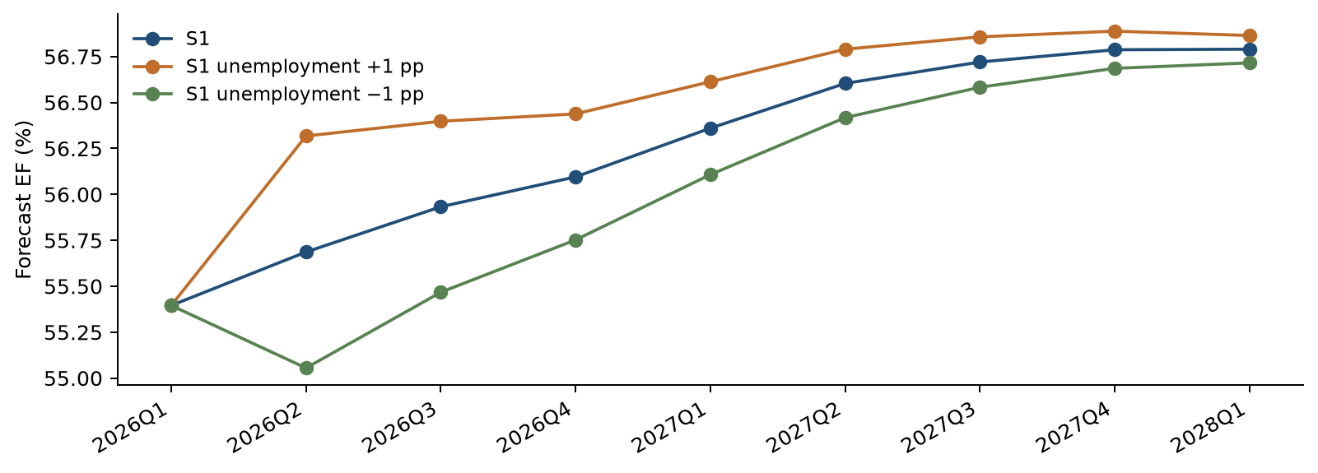
A higher unemployment path raises the EF forecast after the one-quarter delay. The separation then narrows. The permanent level shift creates one extra change at the forecast boundary, followed by the same quarterly changes as the original path.

A shock based on historical variation
A second test uses the size of a typical historical unemployment-change fluctuation. Its sample standard deviation is 1.505 percentage points. Applying that shock produces an initial EF effect of 0.951 percentage points when the shock enters the equation. The effect then declines each quarter by the estimated carryover factor of 0.737.

Sensitivity to the EF smoothing choice
Table 20 Same equation fitted to smoothed and original EF
EF series | Adjusted R² | One-step RMSE in EF pp | Recursive RMSE in EF pp
Smoothed EF | 0.8265 | 2.783 | 3.728
Original EF | 0.7188 | 2.827 | 3.919
The original-EF check keeps the same variables. The smoothed series gives closer fit and somewhat lower forecast errors. This comparison makes the effect of preprocessing visible.

Influence of individual quarters
We also remove one development observation at a time and estimate the same equation again. The unemployment coefficient stays positive. It ranges from 0.005680 to 0.007907. Its p value ranges from 0.0132 to 0.2392. This shows that significance can depend on individual quarters even when the estimated direction stays the same.
2013Q1 has the largest Cook’s distance, a measure of how much an observation can affect the fitted coefficients. 2020Q3 has high leverage because of its unusual macro input. All observations remain in the main model. These quarters should receive attention when the model is refreshed.

7 Model Implementation

Code and calculation process
The implementation is a standalone Python package named Noncomp_EF_Code_and_Data_20261019. The main program is noncomp_ef_model.py. It reads the two historical CSV inputs and the separate scenario files. It then prepares the data, screens candidates, estimates the equations and writes the results to CSV.
The code calculates the two EF adjustments from the original input. It calculates each macro transformation and lag from the common quarterly history. Selection and the decision on the trend are recalculated each time the program runs.

Operating controls
Table 21 Controls in the current package
Control | Program behavior
Input schema | Checks the expected columns and quarter-end dates
Data completeness | Stops for missing, duplicate or nonnumeric observations
Data units | Checks EF ratio units and unemployment percent bounds
Log changes | Requires positive levels for the six log-change series
Output protection | Protects a nonempty result directory unless overwrite is requested
Scenario driver | Stops scenario forecasting if selection requires an unsupported macro
Traceability | Writes input and output file checksums
Original inputs | Checks that input contents are unchanged during the run
The current calendar is fixed at 2011Q1–2025Q4, with future scenarios through 2028Q1. Extending that calendar requires a reviewed code update.

Verification completed
The package was installed and run in a clean Python environment. It was also run from a directory outside the package. All 16 automated tests passed. The checks cover smoothing, dates, coefficient calculations, screening rules, forecast timing, scenario calculations and input protection.
A separate reconciliation compared the package with the latest experiment results. All 47 checks passed across 4,413 numerical values. The largest absolute difference was about 1.7 × 10⁻¹², within floating-point precision. The package includes the verification records and calculated reference outputs.

Use of future results
The primary scenario results use the full-history coefficient set. The package also exports development-coefficient scenario results for comparison. Each row identifies the scenario and the coefficient sample. The operator should select full_history when producing the main future forecast.

8 Model Monitoring
The following process is recommended for production use. The model owner should confirm its timing and alert levels. Input checks should run whenever data or scenarios change. Forecast performance should be reviewed as new actual EF observations become available.
Table 22 Recommended monitoring checks
Area | Review signal | Action
Inputs | Missing dates, duplicate quarters, changed units or a revised EF definition | Resolve the input issue before using the results
Scenario identity | S1 and S4 files differ from the approved planning vintage | Confirm the files and rerun the forecasts
Forecast accuracy | Recent RMSE rises above the historical reference or error bias persists | Compare actuals, model forecasts and persistence benchmarks
Error pattern | Ljung–Box p falls below 0.05 or repeated errors move in one direction | Review timing, missing drivers and recent business changes
Error shape and stability | JB or CUSUM p falls below 0.05 | Inspect unusual observations and assess whether re-estimation is needed
Coefficient behavior | Unemployment coefficient changes sign or prior-EF coefficient reaches one | Review the economic explanation and forecast response
Observation influence | A small number of quarters dominate the estimates | Repeat influence and original-EF sensitivity checks
Forecast reasonableness | EF paths conflict with known business plans or produce implausible values | Review assumptions and document any proposed response
A review signal leads to investigation and a recorded decision. The current diagnostic thresholds provide useful starting points for that review.

Performance reference values
The nine-quarter development evaluation provides two reference errors: one-step RMSE of 2.783 EF percentage points and recursive RMSE of 3.728 percentage points. Compare new scores over a clearly defined window and record its size. A short window can change sharply after one unusual quarter.

Review and escalation
The developer should investigate unusual results and summarize the cause. The model owner should review the findings and decide whether to refresh coefficients, change assumptions or request redevelopment. Material issues should be referred to the responsible model-risk function before the affected forecasts are used.
An annual review should cover the period indicator, the two smoothing adjustments, alternative macros and the economic explanation. Changes in the business can require a review between scheduled cycles.

9 Procedures
The operator should retain the original inputs and use a new results folder for each controlled run. The README provides the full command-line options.
1. Confirm the historical files. macro.csv contains the 22 provider columns. ef.csv contains the original EF series. Both histories begin in 2011Q1 and end in 2025Q4.
2. Confirm the scenarios. S1.csv holds the Baseline unemployment path. S4.csv holds the separate S4 path. Each contains the nine quarters from 2026Q1 through 2028Q1.
3. Install the packages listed in requirements.txt in the working Python environment.
4. Run noncomp_ef_model.py. The default run creates a results folder. Use a new folder name for a repeat run.
5. Review run_summary.csv. Confirm 22 macro candidates, 49 development rows, 58 full-history rows and the reported trend decision.
6. Review diagnostics, OOT errors and scenario results. Confirm that S1 and S4 start with the same 2026Q1 EF forecast. Check that sensitivity effects first appear in 2026Q2.
7. Run the included tests. Save the code version, input checksums, output checksums and review decision with the final forecasting files.
To install: python -m pip install -r requirements.txt
To run: python noncomp_ef_model.py
To test: python -m unittest discover -s tests -v

10 Governance
Before production use, assign a model owner, an operator and an independent reviewer. Confirm the intended use and the route for approving changes. Retain the review record with the controlled model package.
The developer maintains the calculations, documentation and test evidence. The model owner reviews results, approves the intended use and coordinates remediation. The independent reviewer assesses the design, assumptions, controls and evidence before implementation under the organization’s model-risk process.
Changes to the EF definition, smoothing rule, break date, candidate pool, selection rules, model variables, forecast timing or operating platform should enter change control. A change record should state the reason, the affected results, the tests performed and the approval decision.
The current forecasts follow the estimated equation directly. If a management adjustment is proposed later, retain both the original model result and the adjusted result. Record the reason, amount, approval and planned review date.

11 Appendix Information

Macro dictionary
The original source codes appear below. L means a quarter-to-quarter log change. Δ means a change in the original level units. Every transformed value is lagged one quarter. The code exports the corresponding descriptive feature names in macro_dictionary.csv.
Table 23 All 22 macro candidates
Source code | Description | Level unit | Type
FAHEFI_B.IUSA | Financial activities average hourly earnings | USD per hour | L
FPCNBULC_B.IUSA | Nonfarm business unit labor costs | Index 2017=100 | L
FECICPQ_B.IUSA | Private industry total compensation ECI | Index Dec 2005=100 | L
FRFED_B.IUSA | Federal funds rate | Percent per annum | Δ
FRGT2Y_B.IUSA | Two year Treasury constant maturity rate | Percent per annum | Δ
FRGT10Y_B.IUSA | Ten year Treasury constant maturity rate | Percent per annum | Δ
FLBR_B.IUSA | Unemployment rate | Percent | Δ
FCBC_B.IUSA | Consumer confidence index | Index 1985=100 | Δ
FSBINQ_B.IUSA | Small business normalized optimism index | Index 1986=100 | Δ
FGDP$_B.IUSA | Real gross domestic product | Billion chained 2017 USD | L
FGAP_B.IUSA | Real GDP versus potential GDP output gap | Percent | Δ
FBBACBQ_B.IUSA | Commercial banks total assets | Billion USD | L
FBBABLLCBQ_B.IUSA | Commercial banks loans and leases in bank credit | Billion USD | L
FCBOEVIXQ_B.IUSA | CBOE S&P 500 volatility index period average | Index | Δ
FIRHYBOASQ_B.IUSA | High yield bond option adjusted spread | Percentage points | Δ
FPCNBCPH_B.IUSA | Nonfarm business hourly compensation | Index 2017=100 | Δ
FLBOPQ_B.IUSA | Total nonfarm job openings | Million jobs | Δ
FYPEW52Q_B.IUSA | Finance and insurance wages and salaries | Billion USD | Δ
FGDP52Q_B.IUSA | Finance and insurance gross product originating | Billion USD | Δ
FE52_B.IUSA | Finance and insurance employment | Million | Δ
FYPCPIQ_B.IUSA | Per capita income | USD | Δ
FECICCQ_B.IUSA | All civilian workers total compensation ECI | Index Dec 2005=100 | Δ
The six L variables use natural-log differences. The other 16 use level differences. The quarterly input values are used as supplied.

Complete first-round selection results
This table compares the first round with and without a trend. All first-round candidates pass the VIF, DW and JB checks. Their coefficient p values therefore determine first-round eligibility in this data set. The full CSV logs also contain every later-round trial.
Table 24 First-round screening results
Source code | With-trend p | Eligible | No-trend p | Eligible
FAHEFI_B.IUSA | 0.0832 | No | 0.4811 | No
FPCNBULC_B.IUSA | 0.4092 | No | 0.4072 | No
FECICPQ_B.IUSA | 0.1455 | No | 0.0473 | Yes
FRFED_B.IUSA | 0.1077 | No | 0.0756 | No
FRGT2Y_B.IUSA | 0.1104 | No | 0.0770 | No
FRGT10Y_B.IUSA | 0.3984 | No | 0.1839 | No
FLBR_B.IUSA | 0.0330 | Yes | 0.0289 | Yes
FCBC_B.IUSA | 0.3444 | No | 0.3969 | No
FSBINQ_B.IUSA | 0.4743 | No | 0.4813 | No
FGDP$_B.IUSA | 0.0372 | Yes | 0.0277 | Yes
FGAP_B.IUSA | 0.0344 | Yes | 0.0267 | Yes
FBBACBQ_B.IUSA | 0.1108 | No | 0.1613 | No
FBBABLLCBQ_B.IUSA | 0.1477 | No | 0.1072 | No
FCBOEVIXQ_B.IUSA | 0.5231 | No | 0.4135 | No
FIRHYBOASQ_B.IUSA | 0.4122 | No | 0.2863 | No
FPCNBCPH_B.IUSA | 0.1046 | No | 0.1655 | No
FLBOPQ_B.IUSA | 0.3242 | No | 0.3320 | No
FYPEW52Q_B.IUSA | 0.7491 | No | 0.7032 | No
FGDP52Q_B.IUSA | 0.1698 | No | 0.2203 | No
FE52_B.IUSA | 0.2432 | No | 0.2830 | No
FYPCPIQ_B.IUSA | 0.1610 | No | 0.1604 | No
FECICCQ_B.IUSA | 0.3887 | No | 0.1135 | No
The with-trend search selects FLBR_B.IUSA. The independent no-trend search selects FGAP_B.IUSA. Both searches stop after one macro enters. The main development sequence retains unemployment after removing the trend.

How to read the coefficient p values
A coefficient p value below 0.05 provides evidence that the coefficient differs from zero under the fitted model assumptions. These p values describe each fitted equation. The candidate search itself adds uncertainty, so economic meaning and forecast checks are also used in the final choice.

Detailed coefficient estimates
Each standard error measures uncertainty around an estimated coefficient. The t statistic compares the estimate with its standard error. The p value uses the Student-t distribution and the regression’s residual degrees of freedom.
Table 25 ARDL with trend through 2023Q3
Term | Estimate | Std error | t statistic | p value
Constant | 0.271984 | 0.077499 | 3.510 | 0.0010
Period indicator D | −0.034941 | 0.014548 | −2.402 | 0.0206
Linear time trend t | −0.000807 | 0.000581 | −1.389 | 0.1719
Prior quarter EF | 0.634474 | 0.106243 | 5.972 | < 0.0001
Prior quarter unemployment change | 0.006204 | 0.002819 | 2.201 | 0.0330
Table 26 Final ARDL through 2023Q3
Term | Estimate | Std error | t statistic | p value
Constant | 0.193795 | 0.053801 | 3.602 | 0.0008
Period indicator D | −0.043633 | 0.013267 | −3.289 | 0.0020
Prior quarter EF | 0.738292 | 0.076265 | 9.681 | < 0.0001
Prior quarter unemployment change | 0.006417 | 0.002844 | 2.257 | 0.0289
Table 27 Final ARDL through 2025Q4
Term | Estimate | Std error | t statistic | p value
Constant | 0.194684 | 0.050779 | 3.834 | 0.0003
Period indicator D | −0.045338 | 0.012983 | −3.492 | 0.0010
Prior quarter EF | 0.736985 | 0.071876 | 10.254 | < 0.0001
Prior quarter unemployment change | 0.006314 | 0.002810 | 2.247 | 0.0288
The development equation has 45 residual degrees of freedom. The with-trend equation has 44. The full-history equation has 54. All three use conventional OLS covariance.

The period indicator in the two regressions
The level-and-trend regression uses D together with D × t. Its D coefficient compares the two line intercepts. At the 2014Q1 boundary, the fitted separation is θ + 13γ, which equals −0.149105 in ratio units. This measures the difference between the fitted lines at the same date.
The ARDL uses D with prior EF and the macro change. Its D coefficient describes the period difference after holding those inputs fixed. The two coefficients serve different regression specifications.

Quarterly historical forecast values
Table 28 Actual EF and OOT forecasts
Quarter | Actual EF % | One-step EF % | Recursive EF %
2023Q4 | 61.700 | 57.901 | 57.901
2024Q1 | 59.300 | 60.676 | 57.871
2024Q2 | 53.100 | 58.818 | 57.763
2024Q3 | 54.900 | 54.305 | 57.748
2024Q4 | 52.700 | 55.677 | 57.779
2025Q1 | 53.400 | 53.903 | 57.653
2025Q2 | 52.600 | 54.441 | 57.581
2025Q3 | 56.100 | 53.893 | 57.570
2025Q4 | 54.800 | 56.520 | 57.605
These are the values behind the historical forecast-error measures. The first forecast uses actual 2023Q3 EF. Later recursive forecasts use earlier predictions.

Technical test settings
Table 29 Calculation settings
Check | Setting
ADF residual diagnostic | No added constant or trend; AIC selects zero to four lags
KPSS residual diagnostic | Constant; automatic bandwidth; p above 0.10 reported as a bound
Ljung–Box | Lags 4 and 8; one autoregressive degree of freedom deducted
Jarque–Bera | Error skewness and kurtosis; chi-square reference with 2 degrees of freedom
CUSUM | OLS residuals; adjustment for the number of estimated coefficients
VIF | Maximum across all explanatory variables other than the constant
Student-t inference | Residual degrees of freedom equal observations minus estimated coefficients
The same settings are used in the code package and this document. Test statistics and p values are stored at full precision in the CSV outputs.

Evidence files and version record
The supporting package is Noncomp_EF_Code_and_Data_20261019.zip. The full experiment report is dated 19 October 2026. Numeric results in this MDD follow the package’s verified calculation outputs. The Deposit MDD supplies the section structure and documentation coverage.
Table 30 Key evidence files
File or file group | Use in this MDD
macro_dictionary.csv | Macro names, descriptions, units and transformations
historical_data_and_features.csv; ef_smoothing.csv | Raw and smoothed EF, dates and calculated inputs
coefficients_static_*.csv; static_contrasts.csv | Historical level and trend estimates
static_residual_stationarity_*.csv | ADF and KPSS for the fitted historical lines
selection_*.csv | All candidate trials and screening decisions
coefficients_ardl_with_trend.csv | Initial ARDL and the trend decision
coefficients_final_*.csv | Development and full-history final coefficients
candidate_comparison.csv | Unemployment, output-gap and GDP comparison
diagnostics_*.csv; final_residual_stationarity_*.csv | Final-model diagnostics
oot_forecasts.csv; oot_metrics.csv | Historical forecast paths and errors
scenario_ef_forecasts.csv; scenario_macro_paths.csv | Labeled S1 and S4 paths
scenario_sensitivity.csv; one_sd_macro_shock.csv | Unemployment sensitivity results
influence.csv; leave_one_out.csv; raw_ef_sensitivity_metrics.csv | Observation influence and preprocessing sensitivity
verification folder | Numerical reconciliation and standalone execution checks
Files are stored in reference_outputs for the supplied snapshot and in results after a new run. Scenario rows identify both the scenario and coefficient sample.

Version verification
PACKAGE_MANIFEST.csv records the package file checksums. input_manifest.csv and output_manifest.csv record each calculation run. A checksum is a file fingerprint that changes when its contents change. Together with the software versions in run_summary.csv, these records support repeatable calculations.

