OCC Headcount Two Step Model Report
Commercial Card style modeling with I1 candidate screening
This report evaluates a practical two step model for quarterly OCC per employee. The analysis treats the target as I(1) under an intercept only unit root screen, selects a long run level relationship, and then models annual target growth with an error correction term and stationary short run predictors. The selected specification is useful for explanation, but the simpler error correction only benchmark performs better in the available OOT window.
Field | Definition
Target | Quarterly OCC three month sum divided by quarter end headcount
Sample | 2011 Q1 through 2025 Q4 with 60 quarterly observations
Windows | Development 2011 Q1 through 2023 Q3 and OOT 2023 Q4 through 2025 Q4
Method | Commercial Card style two step model with I(1) candidate screening

Executive Summary
- Fifteen of the 22 Noncomp macro candidates meet the requested I(1) rule. Finance and insurance employment is the only macro term selected in the long run equation; the development adjusted R squared is 0.969 and the residual ADF and KPSS checks support stationarity.
- The short run equation includes the lagged error correction term, one quarter lagged real GDP annual growth, and the target own annual growth at lag three. All three slope terms are significant in development, and the error correction coefficient has the expected negative sign.
- The selected static forecast has OOT MAPE of 4.99 percent. It improves on the same own lag structure without GDP, which has MAPE of 5.22 percent, but it does not beat the error correction only benchmark at 4.30 percent.
- The error correction and GDP coefficients remain significant in the full history refit. The own lag term and the Post 2019 Q1 control do not, which indicates specification instability around the more detailed terms.
- For production forecasting, the error correction only model is the current benchmark. The selected two step model should remain an exploratory challenger until a new holdout period confirms incremental macro value.

Data and Model Design
Quarterly OCC is defined as the sum of the three monthly OCC observations in each quarter. Headcount is the SNV headcount at quarter end. The target therefore measures quarterly OCC per employee. This report does not use quarter end OCC or a three month average of OCC.
The sample contains 60 quarters from 2011 Q1 through 2025 Q4. Model selection uses 2011 Q1 through 2023 Q3. Nine quarters from 2023 Q4 through 2025 Q4 form the reported OOT window. A Post 2019 Q1 step indicator is included in the long run equation to control for the acquisition related level change discussed in the business context. The coefficient is an association, not a causal acquisition estimate.
The procedure follows the broad structure of the Commercial and Small Business Card two step model. Step One screens level variables and estimates a long run equation. Step Two uses the scaled long run residual as an error correction term and selects stationary annual changes and target lags. The implementation is intentionally practical and is not presented as a full Engle Granger inference exercise.

I1 Screening
The requested integration rule uses an intercept only ADF test. A series is tentatively classified as I(1) when the level ADF fails to reject a unit root and the first difference ADF rejects at the 5 percent level. Six strictly positive growth series are screened in natural logs; the remaining candidates are screened in raw levels.
Screening item | Result | Interpretation
Target level ADF | 0.620 versus minus 2.89 | Unit root not rejected
Target first difference ADF | minus 6.659 versus minus 2.89 | Unit root rejected
Target level KPSS | 1.564 versus 0.463 | Stationarity rejected
Macro candidate pool | 22 series | Same pool as Noncomp
Tentative I(1) macro candidates | 15 series | Eligible for Step One

Table 1 Target and macro I(1) screening results
The I(1) result is sensitive to deterministic terms. An ADF specification that includes a linear trend can classify OCC per employee as trend stationary. The model therefore treats I(1) as a working selection assumption rather than definitive evidence about the data generating process.
Eligible Step One candidates are financial activities earnings, unit labor costs, Treasury rates, unemployment, consumer confidence, real GDP, the output gap, bank assets, bank loans, job openings, finance and insurance wages, finance and insurance GDP, finance and insurance employment, and per capita income. Private compensation ECI, the federal funds rate, small business optimism, VIX, high yield OAS, hourly compensation, and civilian compensation ECI do not meet the strict I(1) rule used here.

Step One Long Run Model
Forward selection starts with the Post 2019 Q1 control. A candidate must have p below 0.05, keep maximum VIF below 10, and leave a residual that rejects a unit root. Among admissible candidates, the model with the highest adjusted R squared is retained.
OCC HCₜ = −14,738.386 + 295.877 Post2019Q1ₜ + 3,472.446 FinanceInsuranceEmploymentₜ + uₜ
Term | Coefficient | Ordinary p | HAC p | VIF
Intercept | −14,738.386 | <0.001 | <0.001 | Not applicable
Post 2019 Q1 | 295.877 | 0.0139 | 0.0365 | 3.404
Finance and insurance employment | 3,472.446 | <0.001 | <0.001 | 3.404

Table 2 Step One development coefficients
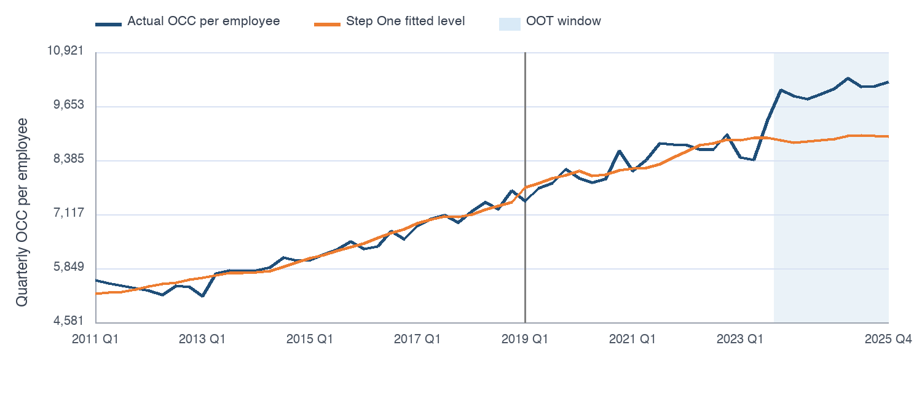
Figure 1 Actual target and Step One fitted level
Diagnostic | Statistic | 5 percent critical value | Result
Residual ADF with intercept | −3.429 | −2.89 | Stationary
Residual KPSS with intercept | 0.052 | 0.463 | Stationary
Development adjusted R squared | 0.969 | Not applicable | High in sample fit

Table 3 Step One residual stationarity and fit
The employment term is best read as a scale factor, not a causal effect. It remains significant in the full history refit, while the Post 2019 Q1 coefficient does not. The dummy is retained only as a structural control for the known acquisition period level shift.

Step Two Short Run Model
The target in Step Two is the year over year percentage change in OCC per employee. The error correction variable is the Step One residual divided by the fitted level and multiplied by 100. The quarterly adaptation uses the fourth lag of this scaled error correction term. Macro variables enter as four quarter log changes for the six logged series or as four quarter level changes for the other series. Lags zero through four are considered.
Eighteen macro families pass the short run stationarity rule. Seven macro lag terms pass the dual window partial correlation screen after controlling for the lagged error correction term. Forward selection then retains one quarter lagged real GDP annual growth. The third lag of the target annual growth is also retained.
OCC HC YoYₜ = 2.153 − 0.740 ECₜ₋₄ + 0.511 RealGDPYoYₜ₋₁ + 0.270 OCC HC YoYₜ₋₃ + eₜ
Term | Coefficient | Ordinary p | HAC p | VIF
Intercept | 2.153 | 0.0062 | 0.0165 | Not applicable
Error correction at lag four | −0.740 | <0.001 | <0.001 | 1.008
Real GDP annual log change at lag one | 0.511 | 0.0057 | <0.001 | 1.010
Target annual growth at lag three | 0.270 | 0.0178 | 0.0356 | 1.003

Table 4 Step Two development coefficients
Diagnostic | Result | Reading
Observations | 44 | Development estimation sample
Adjusted R squared | 0.429 | Moderate explanatory fit
Durbin Watson | 1.919 | Near the no autocorrelation reference
Maximum VIF | 1.010 | No material collinearity
Jarque Bera p value | 0.422 | Normality not rejected
Ljung Box lag four p value | 0.967 | Residual autocorrelation not detected

Table 5 Step Two diagnostics
The negative error correction coefficient is the key result. When OCC per employee is above its fitted long run level, subsequent annual growth tends to slow. Real GDP growth contributes positive incremental information in the development sample. The own lag term captures persistence, but its later instability limits confidence in that component.

Out of Time Results
The OOT window contains nine quarters from 2023 Q4 through 2025 Q4. Static forecasts use observed lagged target values. Dynamic forecasts recursively use prior forecasts when an own lag is required.
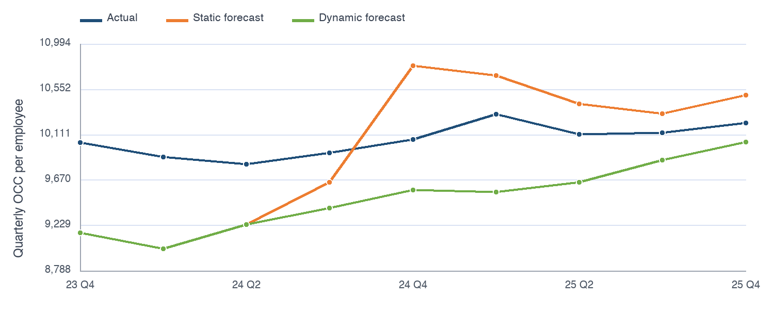
Figure 2 OOT actual and forecast target levels
Model | Forecast | RMSE | MAE | Bias | MAPE
Selected two step | Static | 562.9 | 499.9 | 88.4 | 4.99%
Selected two step | Dynamic | 608.6 | 561.6 | 561.6 | 5.60%
Same own lag without macro | Static | 590.7 | 522.5 | 99.6 | 5.22%
Same own lag without macro | Dynamic | 659.3 | 615.5 | 615.5 | 6.13%
Error correction only | Static | 495.7 | 429.1 | 180.3 | 4.30%
Error correction only | Dynamic | 583.8 | 554.7 | 554.7 | 5.53%

Table 6 OOT benchmark comparison
The selected macro model improves on the comparison that keeps the same own lag but removes GDP. The static MAPE falls from 5.22 percent to 4.99 percent. The improvement does not extend to the simpler error correction only model, whose static MAPE is 4.30 percent and RMSE is 495.7. The dynamic forecasts have a persistent positive error because predicted levels remain below actual levels across the OOT window.
The OOT results are not independent prospective validation. The OOT period is used in the dual window screening stage and in the error correction overlay. The metrics measure performance after this design choice, not performance on completely untouched future data.

Coefficient Stability
Term | Development coefficient | Full history coefficient | Full history HAC p | Assessment
Post 2019 Q1 | 295.877 | 260.467 | 0.303 | Not stable
Finance and insurance employment | 3,472.446 | 4,167.333 | <0.001 | Stable sign and significance
Error correction at lag four | −0.740 | −0.880 | <0.001 | Stable and stronger
Real GDP annual growth at lag one | 0.511 | 0.628 | <0.001 | Stable sign and significance
Target annual growth at lag three | 0.270 | 0.057 | 0.653 | Not stable

Table 7 Development and full history coefficient comparison
The long run employment term, the error correction term, and the GDP term survive the full history refit. The acquisition control and the own lag term do not. This pattern supports a parsimonious core built around long run scale, mean reversion, and GDP, but it does not support treating every selected term as structurally stable.

Limitations and Recommendation
- Only 60 quarterly observations are available. Step Two has 44 usable development observations after annual changes and lags, which makes variable selection sensitive to a small number of quarters.
- The target I(1) classification depends on using an intercept only ADF test. A deterministic trend specification can support trend stationarity instead.
- The two step residual tests support stationarity under the selected development equation, but the workflow does not implement the full critical value and inference treatment required for rigorous Engle Granger testing.
- The Post 2019 Q1 indicator controls for a visible level shift. It does not identify the acquisition effect separately from portfolio, accounting, or operating changes that occurred at the same time.
- The OOT window contributes to screening and overlay design. A new untouched holdout period is required before using the reported OOT metrics as evidence of stable production performance.
The recommended production benchmark is the error correction only model because it has the lowest OOT error with fewer moving parts. The selected two step model remains useful as an explanatory challenger: it provides a coherent long run anchor, a correctly signed correction mechanism, and a stable GDP relationship. The own lag term should be removed or retested when the model is refreshed.

Model Refresh Process
A practical refresh process should lock the current transformations and selection rules, append new quarters without using them for screening, and compare the selected model with the error correction only benchmark. The macro model should replace the benchmark only if it produces a durable reduction in OOT error and its key coefficients remain stable.

Appendix Candidate Screening and Model Rules
Stage | Rule | Outcome
Target integration | Level ADF fails and first difference ADF rejects at 5 percent | Target treated as tentative I(1)
Step One macro pool | Same 22 candidates as Noncomp and strict I(1) eligibility | 15 level candidates
Step One selection | Added term p below 0.05 and maximum VIF below 10 with stationary residual | Finance and insurance employment
Error correction | 100 times actual minus fitted divided by fitted with quarterly lag four | Fixed base term in Step Two
Step Two macro screen | Stationary annual change and same sign partial correlation in both windows | Seven candidate lag terms
Step Two selection | Added term p below 0.05 and maximum VIF below 10 | Real GDP lag one and target YoY lag three

Table 8 Model development rules and outcomes
Method reference: Commercial and Small Business Card Two Step Model Report. Model outputs were generated from the OCC headcount target and the 22 variable Noncomp candidate pool on 29 October 2026.

