Deposit Month Actual Num
Stationarity and Macro Model Analysis
  - January 2011 to December 2025
Research report dated 3 November 2026

1 Purpose and main findings
The initial stationarity stage fits the original monthly target to a linear time trend, a slope change at January 2020 and a temporary indicator for January 2020 through January 2021. It then tests the resulting OLS residuals for stationarity. The later forecasting stage retains these deterministic controls, fixes y(t-1) in the model and applies forward selection only to macroeconomic candidates.
The estimated temporary effect is a shortfall of 989,171 original units per affected month. The underlying monthly slope increases from 3,743 before the breakpoint to 17,239 afterward. The model explains 59.85% of the full-sample variation.
Ordinary ADF and KPSS diagnostics on the unfiltered OLS residuals are consistent with stationary deviations around the fitted path. Their standard reference distributions are not calibrated for the estimated broken trend and interval indicator, so this finding is preliminary rather than a formal break-adjusted confirmation. Direct tests of the pre-break observations are reported in Section 6.
Forward selection retains commercial bank total assets in dlog form at lag 1 and the C and I delinquency rate in first difference at lag 6. Their rolling coefficients preserve the development-sample signs in all 78 windows. The fixed-coefficient 27-month out-of-time test does not improve on the forced baseline, so the macro specification remains a challenger. Under the fully recursive scenario paths, the March 2028 S4 forecast is 488,978 units, or 5.5%, above S1.

2 Data and regression specification
Item | Definition
Target and sample | Month_Actual_num in original units; 180 monthly observations
Sample dates | January 2011 through December 2025
Time origin and breakpoint | t = 0 in January 2011; t = 108 in January 2020
Temporary indicator | D = 1 from January 2020 through January 2021 inclusive; 0 otherwise
$y_{t} = α + βt + γH_{t} + θD_{t} + u_{t}$
$H_{t} = max(t − 108, 0)$
The pre-break slope is β and the post-break slope is β + γ. The underlying trend is continuous at the breakpoint. There is no permanent level-step regressor. The interval effect θ shifts the mean only while D is active and is fully removed in February 2021.
Data source for Sections 1 through 6: deposit_month_actual_num.xlsx, worksheet deposit_input, originally transcribed from the supplied screenshots. The monthly sequence is complete and unique. No logarithms, differences, calendar-month indicators or macroeconomic variables enter this initial stationarity regression.

3 Direct OLS estimates
All four coefficients are estimated together by ordinary least squares, minimizing the sum of squared deviations between the original target and the specified mean path. The fitted equation in original units is
$ŷ_{t} = 6,940,821.01 + 3,742.67t + 13,496.71H_{t} − 989,171.11D_{t}$
Table 1 Coefficient estimates and uncertainty
Parameter | OLS estimate | OLS SE | OLS t | OLS p | OLS 95% interval
Intercept alpha | 6,940,821.01 | 82,302.59 | 84.333 | <0.0001 | 6,778,394 to 7,103,248
Pre-break slope beta | 3,742.67 | 1,240.82 | 3.016 | 0.0029 | 1,294 to 6,191
Slope change gamma | 13,496.71 | 2,948.13 | 4.578 | <0.0001 | 7,678 to 19,315
Interval effect theta | -989,171.11 | 139,891.24 | -7.071 | <0.0001 | -1,265,251 to -713,091
Post-break slope beta + gamma | 17,239.38 | 1,993.20 | 8.649 | <0.0001 | 13,306 to 21,173
Slopes measure original units per elapsed month. The interval coefficient is a level difference, not a monthly percentage or a cumulative decline. The post-break slope is a linear contrast of β and γ, with their covariance included.

OLS inference
All coefficient tests and confidence intervals in this report use conventional ordinary least squares covariance estimates. The estimates, fitted values and residuals are unchanged from the direct OLS regression.
The direct OLS coefficient tests use the t-reference distribution with 176 residual degrees of freedom. This inference assumes the regression error conditions required for conventional OLS standard errors. Residual serial correlation is reported separately as a diagnostic limitation.

Interpretation of the estimates
The pre-break slope is significant under conventional OLS (p = 0.0029), with a 95% interval from 1,294 to 6,191 units per month. The slope increase is 13,497 units per month (p < 0.0001), giving a post-break slope of 17,239 units per month (p < 0.0001). These are full-sample segmented-regression estimates, not a regression estimated only on pre-2020 observations.
The interval effect is negative without imposing a sign restriction. Its conventional OLS 95% interval is a reduction of 713,091 to 1,265,251 units per month. A constant effect means a constant gap from the underlying trend during the 13 months. It does not mean identical observed monthly values or an independently established causal effect.
Fit statistic | Value
R squared | 0.5985
Adjusted R squared | 0.5917
In-sample root mean squared error | 439,194
Residual standard error with 176 degrees of freedom | 444,157

4 Fitted path and residual construction
Figure 1 Original observations and direct OLS fit with unfiltered residuals
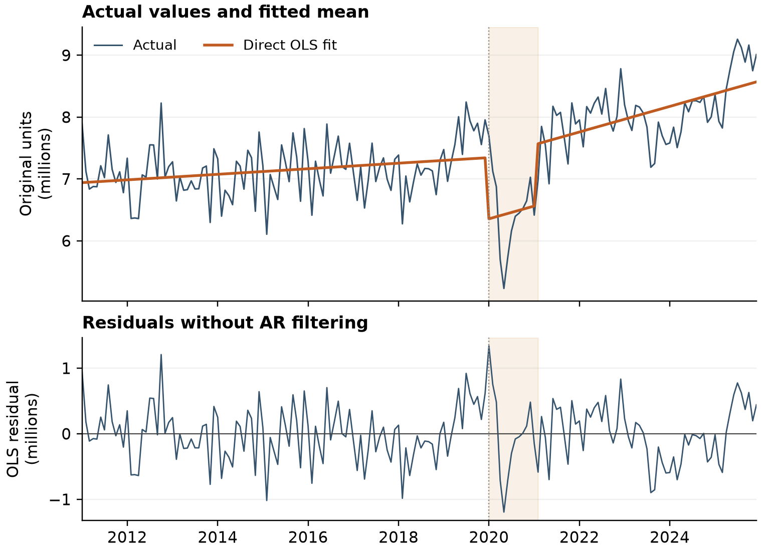
Shading identifies the 13 active dummy months. The orange line is the complete OLS fitted value, not an autoregressive forecast. The vertical dotted line marks January 2020.
$û_{t} = y_{t} − ŷ_{t}$
The residual series contains every monthly observation minus its fitted value. No residuals are discarded for an AR initialization period. The first-stage regression uses all 180 months, and the residual mean is zero up to numerical precision because the regression contains an intercept.
The indicator produces a downward shift at the start of the interval and an upward shift when the interval ends. Within the interval, the fitted path retains the post-break slope. The within-window fall and recovery visible in the data remain in the residuals because this specification imposes a constant gap rather than estimating a separate effect for each month.
For stationarity around the specified mean path, the relevant object is this unfiltered residual series. Serial correlation can remain in a stationary process. The regression therefore does not need an AR specification merely to construct the residuals for the requested diagnostics.

5 Stationarity diagnostics for OLS residuals
ADF tests a unit-root null. We use no additional constant or time trend in the residual test, set the maximum augmentation lag to 12 and choose the lag by AIC. The selected lag is 12, leaving 167 effective observations. Fixing the lag at 12 gives the same statistic. The lagged residual differences belong to the ADF auxiliary test regression; they are not AR terms in the target regression.
KPSS tests a level-stationarity null for the residual series, with a constant and automatic long-run variance bandwidth selection. The selected bandwidth is 7. Both tests operate directly on the OLS residuals shown in Figure 1.
Table 2 Ordinary residual tests using standard reference distributions
Test | Statistic | Nominal p | Lag or bandwidth | Standard 5% decision
ADF | -3.5506 | 0.000403 | 12 | Reject unit root
KPSS | 0.0498 | >0.10 | 7 | Do not reject stationarity
The exact ordinary ADF p-value is 0.0004027417. KPSS reports a tabulated boundary of 0.10 with a warning that the actual p-value is larger; the result is therefore shown as >0.10.

Interpretation and inference limits
Under the ordinary reference distributions, the tests agree with stationary deviations around the fitted mean. However, the mean path and interval coefficient were estimated from the same target. These standard p-values do not reproduce the two-stage detrending procedure with the fixed hinge and interval regressors. They are nominal diagnostics, not a formally calibrated break-adjusted unit-root or stationarity test.
We therefore treat the evidence as preliminary. A test with critical values matched to this deterministic specification, or a validated bootstrap that reproduces estimation and lag selection under the null, would be needed for formal confirmation. No such calibration is included in this report.

Residual autocorrelation
Ljung Box horizon | Statistic | p-value
6 months | 45.428 | 3.85e-08
12 months | 66.153 | 1.67e-09
24 months | 117.923 | 2.27e-14
Residual autocorrelation is detected at all three horizons. It does not by itself contradict residual stationarity. No HAC adjustment or AR error model is applied to the direct stationarity regression; the later forecasting model includes y(t-1) explicitly and is reported in Section 7.

Reproducibility and method references
The source workbook hash matches both the direct OLS rerun and the pre-break analysis. OLS coefficients were independently checked with a least-squares solution, and fitted values plus residuals reconcile to every observation. Calculations use statsmodels 0.15.0. Sections 1 through 6 report the direct OLS stationarity work; Sections 7 through 10 report the subsequent macro model analysis.

6 Stationarity of the pre break observations
This final check uses only the 108 original observations from January 2011 through December 2019. It does not use the full-sample fitted residuals. We evaluate stationarity around a constant and, separately, around a linear trend. The results address the pre-break sample alone and need not match diagnostics of a full-sample fitted residual series.
Figure 2 Original target before the business breakpoint
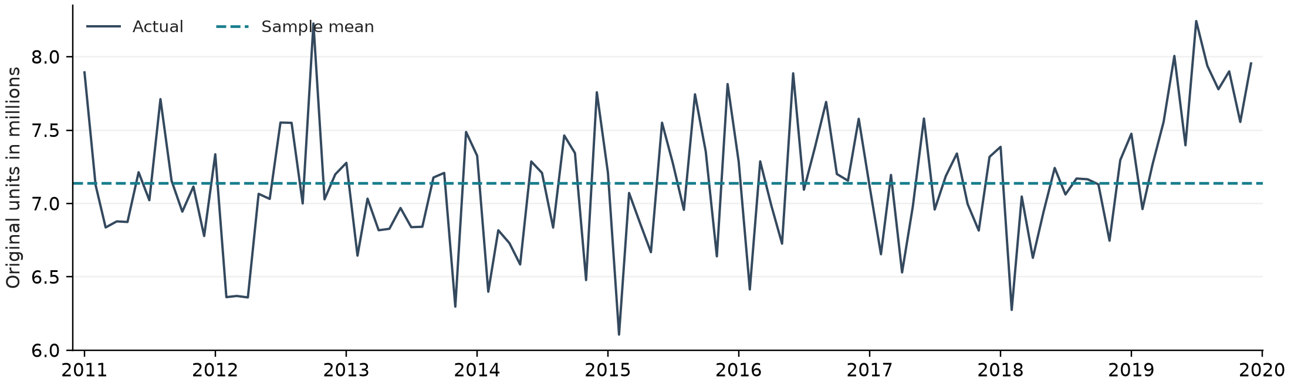
Table 3 Direct pre-break tests on the original observations
Test and deterministic terms | Statistic | p-value | Lag or bandwidth | 5% decision
ADF  Constant | -0.2943 | 0.9263 | 12 | Do not reject unit root
KPSS  Constant | 0.5138 | 0.0385 | 3 | Reject stationarity
ADF  Constant and trend | -1.0398 | 0.9385 | 12 | Do not reject unit root
KPSS  Constant and trend | 0.1298 | 0.0800 | 3 | Do not reject trend stationarity
Both ADF specifications use maximum lag 12 and AIC selection, which selects 12; each uses 95 effective observations. KPSS automatic bandwidth selection gives 3 in both specifications.
For stationarity around a constant, ADF fails to reject the unit root (p = 0.9263) and KPSS rejects stationarity (p = 0.0385). Taken together, these tests do not support level stationarity of the unadjusted pre-break series at 5%.
With a linear trend, ADF still fails to reject a unit root (p = 0.9385), while KPSS does not reject trend stationarity at 5% (p = 0.0800). This combination is inconclusive; it is not affirmative evidence of trend stationarity. A visually flat series or an insignificant trend coefficient would not, by itself, settle the integration question.

7 Macro model construction through forward selection
The macro model fixes the constant, time trend, January 2020 trend-break term, January 2020 through January 2021 interval indicator and y(t-1). Forward selection is applied only to macroeconomic candidates. The development sample runs from January 2013 through December 2022. Candidate transformations are screened with ADF and KPSS tests, and eligible variables are evaluated at lags 1, 3, 6 and 12.
A candidate enters only when its ordinary OLS coefficient p-value is below 0.05, the maximum explanatory-variable VIF is below 10, the Durbin-Watson statistic is between 1.5 and 2.5 and the Jarque-Bera p-value is above 0.05. Among candidates that pass all four rules, the lowest coefficient p-value determines entry.
Table 4 Forward selection path
Round | Macro variable | Transform | Lag | Coefficient p | Max VIF | DW | JB p
1 | Commercial bank total assets | dlog | 1 | 0.0004 | 2.95 | 2.179 | 0.8848
2 | C and I delinquency rate | diff | 6 | 0.0149 | 2.96 | 2.201 | 0.7126
Round 1 selects commercial bank total assets in dlog form at lag 1. Round 2 selects the C and I delinquency rate in first difference at lag 6. No remaining candidate passes all four entry rules in round 3.

Latest coefficient refit
After the specification is fixed, the model is re-estimated through December 2025. The latest refit uses 156 observations from January 2013 through December 2025 and conventional OLS inference.
Table 5 Latest macro challenger coefficient estimates
Term | Coefficient | OLS SE | OLS t | OLS p | OLS 95% interval
Intercept | 4,544,883.041 | 484,532.342 | 9.380 | <0.0001 | 3,587,441 to 5,502,325
Time trend | 4,410.286 | 1,626.629 | 2.711 | 0.0075 | 1,196 to 7,625
Trend break H | 5,527.715 | 3,170.215 | 1.744 | 0.0833 | -737 to 11,792
Interval dummy D | -696,253.772 | 150,373.518 | -4.630 | <0.0001 | -993,394 to -399,114
y(t-1) | 0.331 | 0.069 | 4.773 | <0.0001 | 0.194 to 0.469
Bank assets dlog lag 1 | -13,726,137.853 | 4,678,391.892 | -2.934 | 0.0039 | -22,970,702 to -4,481,574
C and I delinquency diff lag 6 | 1,246,320.113 | 692,440.710 | 1.800 | 0.0739 | -121,952 to 2,614,592
The delinquency coefficient has p = 0.0739 in the 2025 refit. This does not reopen forward selection: entry was determined on the development sample, and the selected specification is held fixed for validation and scenario analysis.

8 Rolling coefficient stability
The stability check re-estimates the two macro coefficients over 78 rolling windows of 60 months. The first window spans August 2011 through July 2016, and the last spans January 2018 through December 2022. Early windows include t and y(t-1); H and D are added when the window end reaches February 2020. All intervals use conventional OLS standard errors.
Figure 3 Sixty month rolling macro coefficients and OLS confidence intervals
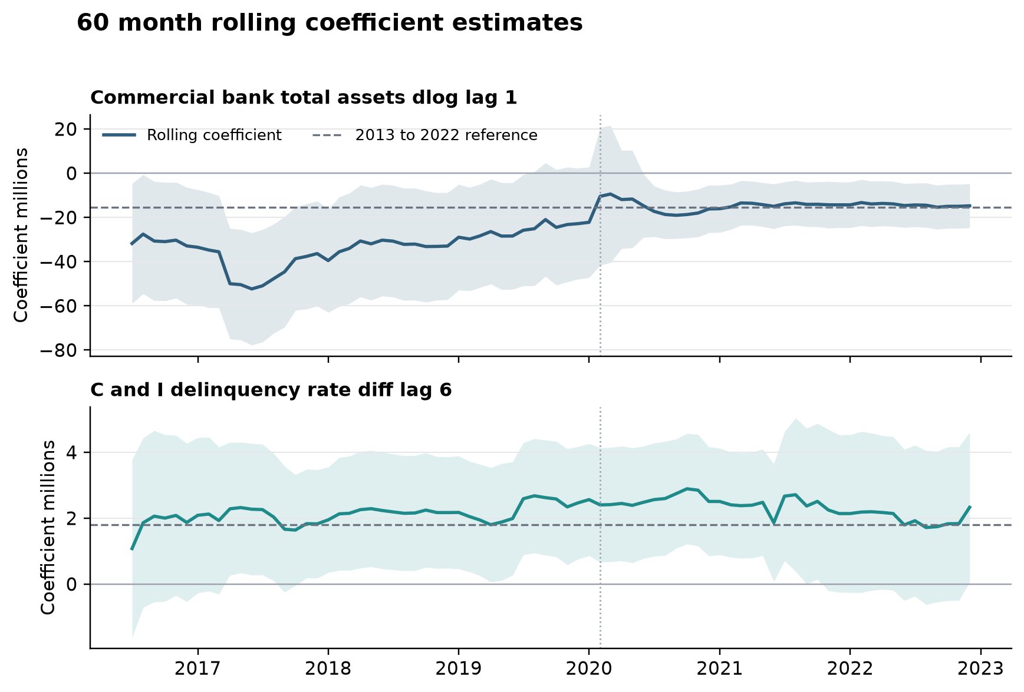
Table 6 Rolling coefficient stability summary
Macro term | Windows | Same sign | OLS p below 0.05 | Reference in 95% CI | Coefficient range millions
Bank assets dlog lag 1 | 78 | 100% | 87.2% | 91.0% | -52.36 to -9.43
C and I delinquency diff lag 6 | 78 | 100% | 69.2% | 100.0% | 1.08 to 2.89
Both coefficients preserve their development-sample signs in every window and neither changes sign. The bank-assets coefficient is significant in 87.2% of windows, while the delinquency coefficient is significant in 69.2%. The rolling evidence supports sign stability, but it does not replace the independent forecast test.

9 Fixed coefficient out of time test
The out-of-time test estimates each specification once on August 2011 through December 2022 and evaluates January 2023 through March 2025, a 27-month holdout. Predictions use actual y(t-1) and realized macro inputs. Coefficients are not re-estimated during the holdout. The forced baseline contains the constant, t, H, D and y(t-1); the challenger adds the two selected macro terms.
Figure 4 Actual values and fixed coefficient out of time predictions
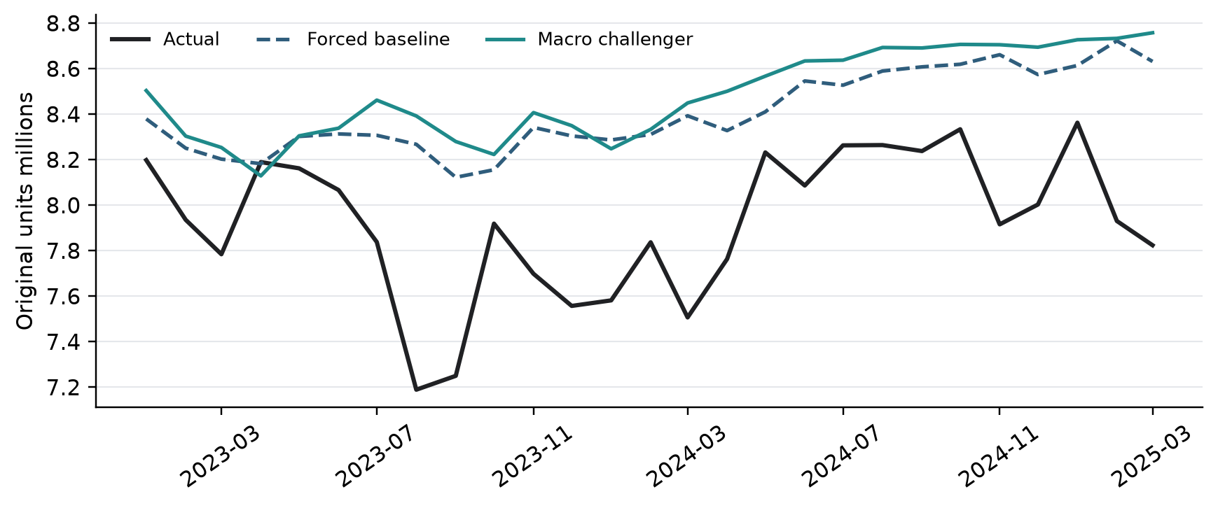
Table 7 Fixed coefficient out of time results
Model | N | RMSE | MAE | MAPE | RMSE vs baseline | MAE vs baseline | OOS R squared
Forced baseline | 27 | 552,729 | 482,842 | 6.22% | +0.0% | +0.0% | 0.000
Macro challenger | 27 | 627,160 | 563,548 | 7.24% | +13.5% | +16.7% | -0.287
The macro challenger increases RMSE by 13.5% and MAE by 16.7% relative to the forced baseline. Its out-of-sample R squared is -0.287. The fixed baseline therefore remains the primary specification, and the selected macro model is retained only as a challenger and scenario-sensitivity model.

10 S1 and S4 scenario forecasts
The scenario exercise fixes the December 2025 coefficient estimates and forecasts January 2026 through March 2028. January 2026 uses the observed December 2025 target as y(t-1). Each later month uses the preceding forecast from the same scenario, so the 27-month path is fully recursive. S1 is the Scenario Consistent Baseline and S4 is the downside path supplied for the two selected macro variables.
The bank-assets term enters at lag 1 and the delinquency change enters at lag 6. The two forecasts are therefore identical in January 2026; the first asset-path effect appears in February, and the first delinquency-path effect appears in July.
Figure 5 S1 and S4 recursive forecast paths
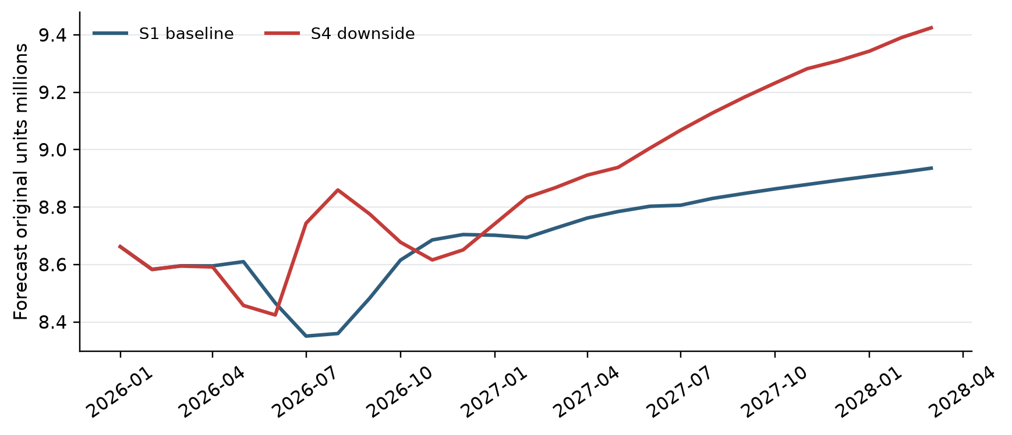
Table 8 Selected points on the scenario forecast paths
Month | S1 forecast | S4 forecast | S4 minus S1 | S4 relative to S1
2026-01 | 8,662,045 | 8,662,045 | 0 | 0.0%
2026-08 | 8,359,509 | 8,859,589 | 500,080 | 6.0%
2026-12 | 8,704,341 | 8,650,894 | -53,448 | -0.6%
2027-12 | 8,893,196 | 9,309,250 | 416,054 | 4.7%
2028-03 | 8,935,559 | 9,424,538 | 488,978 | 5.5%
The maximum absolute scenario gap is 500,080 units in August 2026, when S4 is 6.0% above S1. By March 2028, S1 reaches 8,935,559 and S4 reaches 9,424,538, leaving S4 488,978 units, or 5.5%, above S1. The path is not monotonic because the model uses changes and lags rather than the macro levels directly.
Interpretation: these scenario paths describe the forward-selected macro challenger under fixed coefficients. Because that challenger underperforms the forced baseline in the 27-month out-of-time test, the scenario results should be treated as sensitivity analysis rather than as the preferred unconditional forecast.

