Bank Efficiency Ratio Residual
Stationarity and ARDL Report
Two step analysis for instructor discussion
Smoothed EF history 2011Q1 to 2025Q4 Prepared October 15 2026

Purpose and main findings
This report examines a two step approach. First, we fit EF to a constant, a TARP dummy and a linear trend. We test the estimated residuals with ADF and KPSS. Second, we fit an ARDL directly to EF in levels, following the earlier model development approach. The ARDL has neither a linear trend nor a pulse term.
The residual diagnostics support stationarity after the trend and TARP level effect are removed. The level ARDL selects lagged unemployment change from the 22 candidate macro variables. The question for review is whether the first result provides an appropriate basis for the second specification. This is a discussion report, not a final MDD decision.
Table 1 Main results
Measure | Result
Step 1 development residual ADF | Statistic −3.9347; nominal p = 0.0018
Step 1 development residual KPSS | Statistic 0.0870; nominal p > 0.10
Step 2 adjusted R² | 0.8256
Step 2 OOT RMSE | One step 0.02785; recursive 0.03733

Data preparation and sample
EF is stored as a decimal ratio. For example, 0.548 is 54.8%. We retain the confirmed 2020Q3 value of 0.634. We apply the two agreed local averages using original observations, without sequentially reusing a smoothed value.
Table 2 Local smoothing
Quarter | Original EF | Average of original quarters | Prepared EF
2017Q3 | 0.508 | 2017Q2, 2017Q3, 2017Q4 | 0.586000
2017Q4 | 0.662 | 2017Q3, 2017Q4, 2018Q1 | 0.579667
Step 1 uses 51 continuous quarters through 2023Q3, including prepared 2017Q4. A 60-quarter full-history check is reported separately. Step 2 uses 2011Q2–2023Q3 and excludes the 2017Q4 response, giving 49 observations. The prepared 2017Q4 value remains the EF lag for 2018Q1. OOT validation covers 2023Q4–2025Q4. Scenario forecasts cover 2026Q1–2028Q1.

Step 1 Trend and TARP residual diagnostics
We first estimate the following equation by ordinary least squares. The time index t equals one in 2011Q1 and increases by one each quarter. D equals one through 2013Q4 and zero from 2014Q1 onward. It allows a level shift, with the same linear slope on both sides of the break.
$$\begin{aligned}{EF}_{t} = μ + δD_{t} + βt + u_{t}\end{aligned}$$
Table 3 Deterministic component estimates
Sample | N | Constant μ | TARP δ | Trend β
2011Q1–2023Q3 | 51 | 0.682238 | 0.032989 | −0.003073
2011Q1–2025Q4 | 60 | 0.661252 | 0.048773 | −0.002273
The residual is actual EF minus this fitted deterministic component. The development residuals have mean zero by construction. The full-history equation is estimated separately and is a supporting check.

ADF and KPSS settings
ADF tests the unit-root null. We include a constant, allow zero to four lagged differences and select the lag count by AIC. KPSS tests the level-stationarity null. We use its constant specification and automatic bandwidth. Both tests are applied to the estimated residuals, not to the raw EF level. No either-test-pass rule is used. [1–2]
Table 4 Residual test results
Sample | Test | Statistic | Nominal p | Lags | 5% decision
Development | ADF | −3.9347 | 0.0018 | 2 | Reject unit root
Development | KPSS | 0.0870 | >0.10 | 4 | Do not reject stationarity
Full history | ADF | −4.1765 | 0.0007 | 2 | Reject unit root
Full history | KPSS | 0.0885 | >0.10 | 4 | Do not reject stationarity
ADF selects two lags in both samples. Its effective sample sizes are 48 and 57. KPSS uses bandwidth four and retains 51 and 60 observations. The 5% KPSS critical value is 0.463. Its reported p-value exceeds the upper table boundary of 0.10; it is not an exact p-value of 0.10. [1–2]

Finding
At the reported nominal 5% level, ADF rejects a unit root and KPSS does not reject stationarity in both samples. These results give consistent diagnostic support for a stationary residual around the fitted linear trend and TARP level shift.
As a specification check, ADF without a constant also selects two lags. Its statistics are −3.9383 and −4.1965, with nominal p-values below 0.001 in both samples.
Calibration note. These are standard software p-values after an estimated detrending regression. They are presented as residual diagnostics, not as a formally calibrated Perron test. Whether break-adjusted critical values are needed is reserved for the instructor discussion. [1–3]

Step 1 Fitted path and residual behavior
The development fit removes two deterministic components: the common time slope and the TARP-period level effect. The gray area below marks the quarters for which D equals one. The fitted line changes level at 2014Q1; the slope remains unchanged.
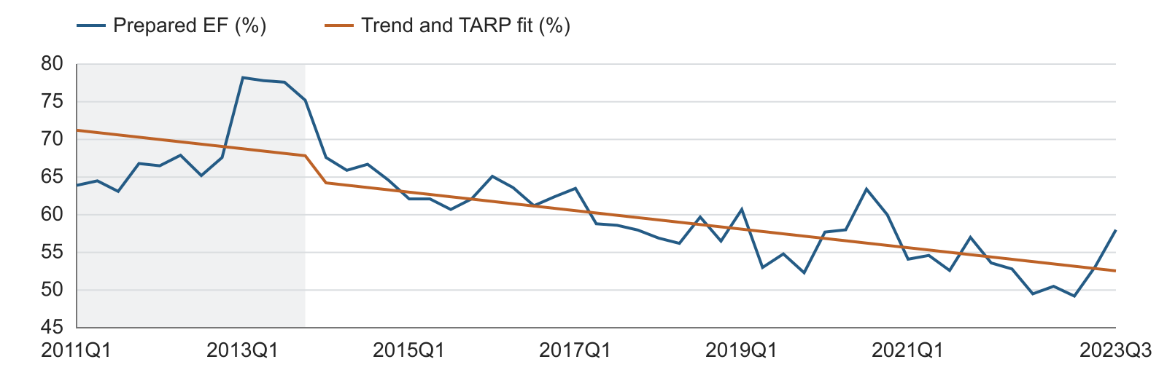
Figure 1 Prepared EF and the fitted deterministic component through 2023Q3
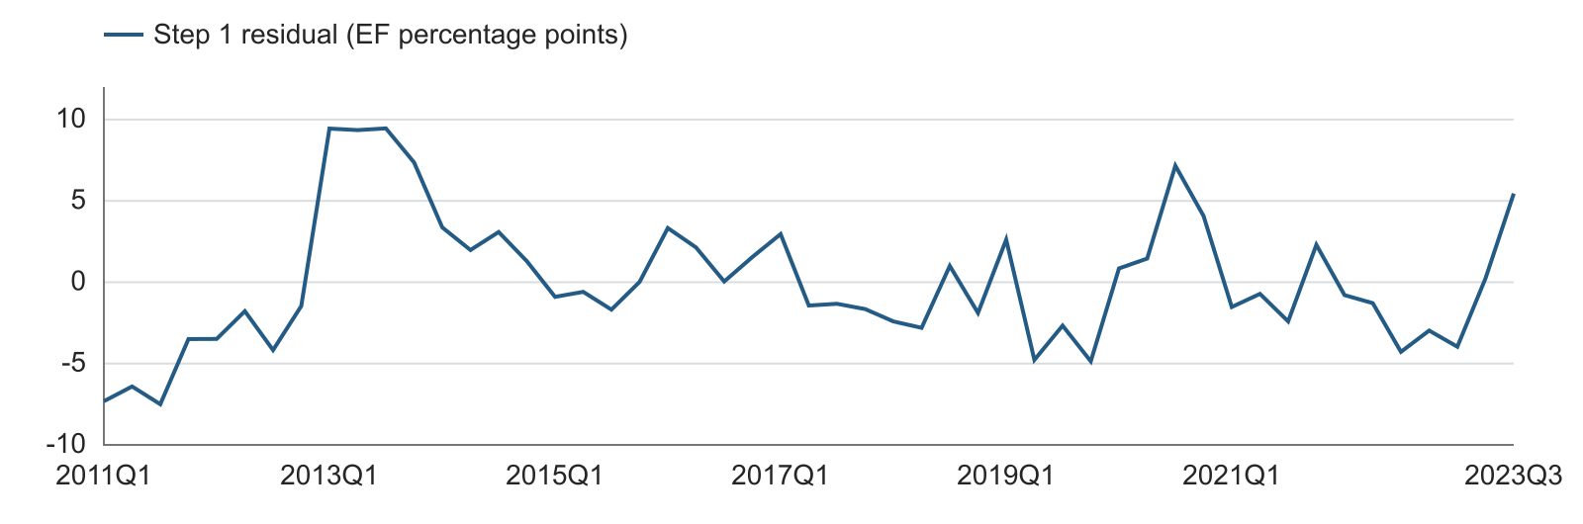
Figure 2 Residuals from Step 1 in EF percentage points

What is stationary in this step
The stationarity evidence concerns the residual around the fitted path. It does not say that the EF level fluctuates around one fixed mean throughout 2011–2025. The fitted path contains a time trend and a level break.
Step 2 does not use these residuals as its dependent variable. It returns to the prepared EF level and estimates the original ARDL form. The two steps therefore answer different questions: Step 1 describes deviations from a deterministic path; Step 2 evaluates a parsimonious forecasting equation.
The stationary-residual finding is the starting evidence for review. Whether the trend can be left out of the forecasting equation remains the central specification question. The report keeps the two steps separate so that this choice can be assessed directly.

Step 2 ARDL fitted directly to EF
The dependent variable is the prepared EF level. The fixed controls are a constant, the TARP dummy and prior-quarter EF. Macro candidates enter as transformed values lagged one quarter. The selected model is:
$$\begin{aligned}{EF}_{t} = c + θD_{t} + φ{EF}_{t-1} + γΔU_{t-1} + ε_{t}\end{aligned}$$
U is the unemployment rate in percent. ΔU is the quarterly change in percentage points. This equation has no linear trend and no pulse term. Its regression error ε is different from the Step 1 residual u.
$$\begin{aligned}{EF}_{t} = 0.146773 + 0.041366D_{t} + 0.744191{EF}_{t-1} \\ + 0.006477ΔU_{t-1} + ε_{t}\end{aligned}$$
Table 5 ARDL coefficient estimates
Term | Coefficient | Std error | p value
Constant | 0.146773 | 0.044827 | 0.0020
TARP dummy | 0.041366 | 0.012740 | 0.0022
EF lag 1 | 0.744191 | 0.075783 | <0.001
Unemployment change lag 1 | 0.006477 | 0.002851 | 0.0280
The EF lag coefficient is 0.7442. A temporary EF deviation therefore decays when the other inputs follow the same path. A one-percentage-point rise in unemployment is associated with a 0.006477 increase in EF one quarter later, holding other regressors fixed. This equals 0.6477 percentage points of EF. It is a predictive association, not a causal estimate.
Table 6 Fit and regression diagnostics
Measure | Result | Interpretation
Estimation observations | 49 | 2011Q2–2023Q3, excluding 2017Q4 response
Adjusted R² / in-sample RMSE | 0.8256 / 0.02842 | Fit in EF ratio units
Serial correlation at 4 lags | p = 0.3616 | No rejection at 5%
Breusch–Pagan variance test | p = 0.7076 | No rejection at 5%
Jarque–Bera normality test | p = 0.2008 | No rejection at 5%
OLS residual CUSUM | p = 0.7347 | No rejection at 5%
Maximum VIF | 1.5817 | Low regressor collinearity
The serial-correlation test preserves calendar-quarter lags and uses 41 complete observations. Coefficient p-values are conventional OLS t-test results. All forecasts use unrounded coefficients estimated through 2023Q3; no later EF data are used to refit them.

Macro pool and forward selection
The candidate pool contains 22 supplied variables. The six amount or index series use quarterly natural-log changes. The remaining sixteen series use quarterly level differences. Every transformed macro is lagged one quarter before screening.
Table 7 The complete 22 variable pool
Group | Count | Source variable names
Log change | 6 | earnings, ulc, eci, gdp, assets, loans
Level difference | 16 | fed, t2y, t10y, unemp, confidence, optimism, gap, vix, hy, FPCNBCPH_B.IUSA, FLBOPQ_B.IUSA, FYPEW52Q_B.IUSA, FGDP52Q_B.IUSA, FE52_B.IUSA, FYPCPIQ_B.IUSA, FECICCQ_B.IUSA

Selection rule
Forward selection starts with the fixed controls. At each round, we add each remaining macro separately and compare the added term’s two-sided t-test p-value. The lowest p-value enters if it is below 0.05. We then repeat the search conditional on the terms already included. The process stops when no additional variable qualifies. There is no backward deletion.
Table 8 Forward selection decisions
Round | Best added candidate | p value | Decision
1 | Unemployment change lag 1 | 0.0280 | Add unemployment
2 | ECI log change lag 1 | 0.1167 | Stop
The primary search uses each candidate’s available complete observations. Unemployment, gap and GDP use 49 observations; the other nineteen use 48 because their initial lagged changes are unavailable. A common 48-observation check selects gap instead. Thus unemployment is the primary-screen choice, not a unique winner under every sample convention.

Comparison with gap and GDP
Table 9 Leading one macro models on the same 49 observations
Macro | Entry p | Adjusted R² | One step RMSE | Recursive RMSE
Unemployment | 0.0280 | 0.8256 | 0.02785 | 0.03733
Gap | 0.0298 | 0.8251 | 0.02904 | 0.03626
GDP | 0.0312 | 0.8248 | 0.02877 | 0.03485
Unemployment has the lowest entry p-value and the lowest one-step OOT RMSE among these three models. It also offers a direct economic interpretation. The gap and GDP models have lower recursive OOT RMSE, so the choice is not based on a claim that unemployment dominates every forecast measure.
We retain unemployment here to follow the requested ARDL development approach. OOT results provide a model comparison; they are not part of the forward-selection entry rule. Reported in-model p-values do not adjust for the full candidate search.

Out of time forecast performance
The nine-quarter OOT period is 2023Q4–2025Q4. One-step forecasts use actual EF from the preceding quarter. Recursive forecasts start from actual 2023Q3 EF and then use the preceding forecast. Both use the supplied historical unemployment path and the same fixed coefficients.
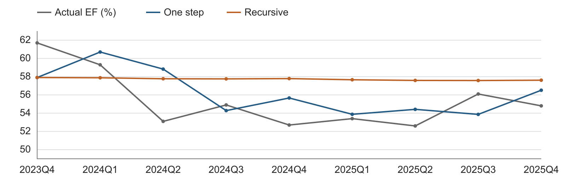
Figure 3 Actual EF and the two OOT forecast methods
Table 10 Quarterly OOT forecasts in EF ratio units
Quarter | Actual EF | One step | Recursive
2023Q4 | 0.61700 | 0.57905 | 0.57905
2024Q1 | 0.59300 | 0.60702 | 0.57878
2024Q2 | 0.53100 | 0.58829 | 0.57771
2024Q3 | 0.54900 | 0.54280 | 0.57756
2024Q4 | 0.52700 | 0.55663 | 0.57789
2025Q1 | 0.53400 | 0.53875 | 0.57661
2025Q2 | 0.52600 | 0.54417 | 0.57588
2025Q3 | 0.56100 | 0.53865 | 0.57577
2025Q4 | 0.54800 | 0.56513 | 0.57612
Table 11 OOT error summary
Method | RMSE | MAE
One step | 0.02785 | 0.02305
Recursive | 0.03733 | 0.03486
One-step RMSE is 0.02785, or 2.785 percentage points of EF. Recursive RMSE is 0.03733, or 3.733 percentage points. The difference shows how forecast errors can persist when actual lagged EF is no longer supplied.
This is a conditional historical validation. It uses the available macro series rather than a reconstruction of the data vintages available on each past forecast date.

Nine quarter baseline and S4 forecasts
Both scenarios start from actual EF of 0.548 in 2025Q4 and use recursive forecasts for 2026Q1–2028Q1. Baseline and S4 labels follow their supplied paths. Only future unemployment differs. The first-quarter EF forecasts are identical because the macro change enters with one quarter of lag.
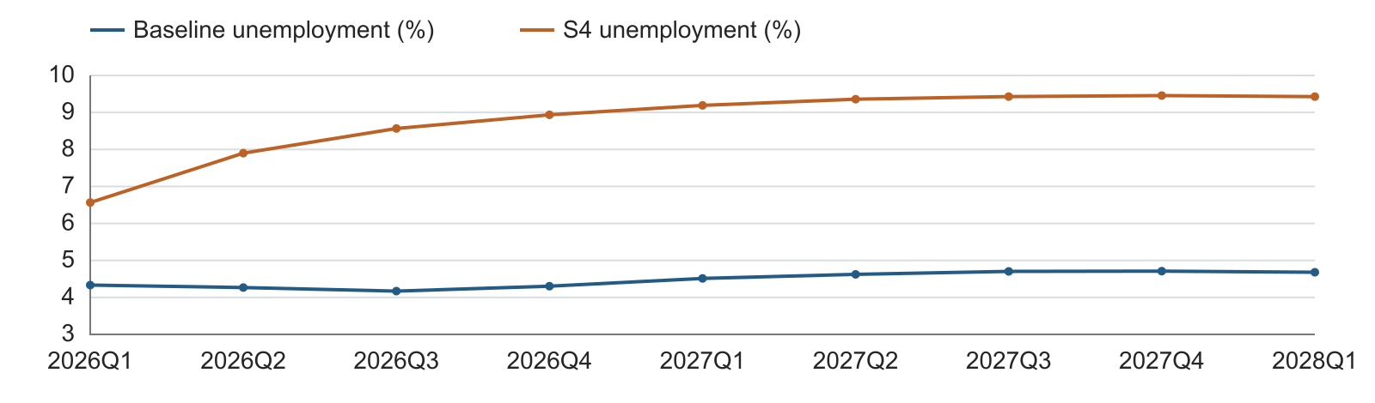
Figure 4 Baseline and S4 unemployment paths in percent
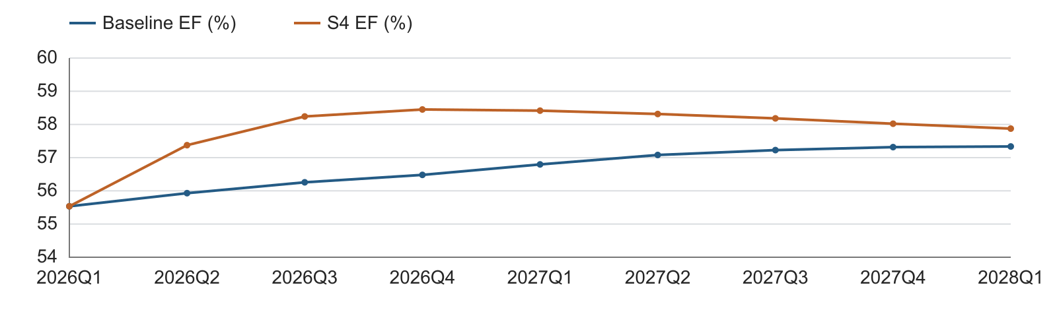
Figure 5 Conditional EF forecasts under the two paths
Table 12 Scenario inputs and forecasts
Quarter | Baseline U % | S4 U % | Baseline EF | S4 EF
2026Q1 | 4.333 | 6.565 | 0.55535 | 0.55535
2026Q2 | 4.267 | 7.900 | 0.55930 | 0.57376
2026Q3 | 4.170 | 8.566 | 0.56257 | 0.58240
2026Q4 | 4.303 | 8.936 | 0.56480 | 0.58451
2027Q1 | 4.513 | 9.191 | 0.56796 | 0.58415
2027Q2 | 4.623 | 9.359 | 0.57080 | 0.58315
2027Q3 | 4.703 | 9.429 | 0.57227 | 0.58183
2027Q4 | 4.710 | 9.456 | 0.57317 | 0.58022
2028Q1 | 4.680 | 9.428 | 0.57336 | 0.57874
The S4 effect is driven by changes in unemployment, not its level alone. As the stress path stabilizes, the incremental EF effect declines through the lag structure. These are conditional point forecasts, not probability-weighted outcomes.

Unemployment sensitivity test
We shift every future baseline unemployment rate up by one percentage point and down by one percentage point from 2026Q1 onward. Historical unemployment and the 2025Q4 EF anchor remain unchanged. A one-point shift means 4.3% becomes 5.3% or 3.3%; it does not mean a relative change of 1%.
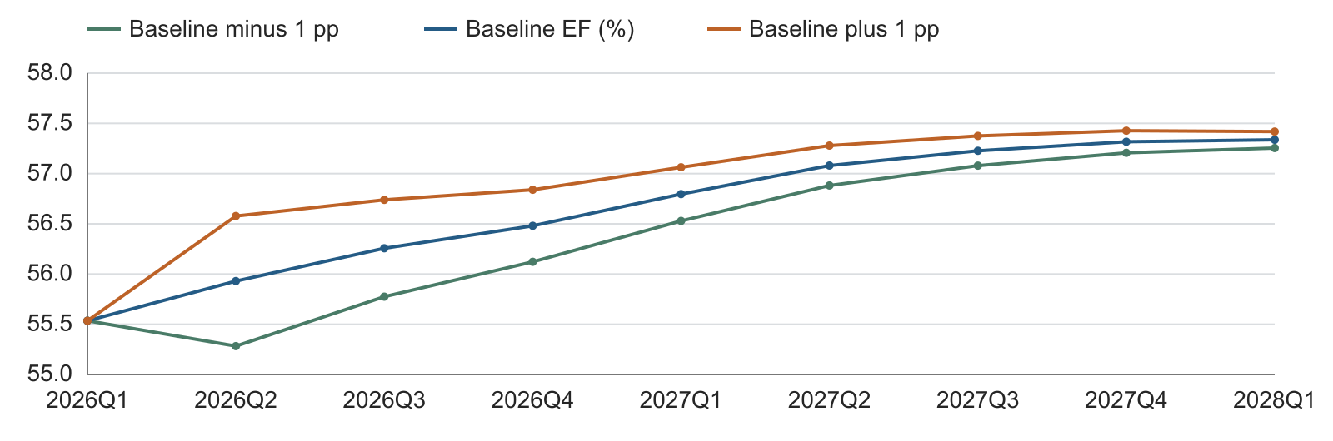
Figure 6 Baseline EF with permanent plus and minus one point unemployment shifts
Table 13 EF sensitivity forecasts
Quarter | Minus 1 pp | Baseline | Plus 1 pp | Upward effect in EF pp
2026Q1 | 0.55535 | 0.55535 | 0.55535 | 0.0000
2026Q2 | 0.55282 | 0.55930 | 0.56578 | 0.6477
2026Q3 | 0.55775 | 0.56257 | 0.56739 | 0.4820
2026Q4 | 0.56122 | 0.56480 | 0.56839 | 0.3587
2027Q1 | 0.56529 | 0.56796 | 0.57063 | 0.2669
2027Q2 | 0.56882 | 0.57080 | 0.57279 | 0.1986
2027Q3 | 0.57079 | 0.57227 | 0.57375 | 0.1478
2027Q4 | 0.57207 | 0.57317 | 0.57427 | 0.1100
2028Q1 | 0.57255 | 0.57336 | 0.57418 | 0.0819

Timing and interpretation
There is no effect in 2026Q1. The first changed unemployment difference enters the EF forecast in 2026Q2. The initial EF effect is ±0.006477, or ±0.6477 percentage points. Thereafter, the permanent level shift adds no new quarterly difference, so the EF effect decays by the lag coefficient of 0.7442 each quarter.
By 2028Q1, the EF effect is approximately ±0.000819 in ratio units, or ±0.0819 percentage points. The positive and negative responses are symmetric because the model is linear.
This exercise measures a change in the supplied unemployment level path. A one-point extra increase every quarter would be a different scenario and is not used here.

Questions for instructor review

Main specification question
Step 1 gives diagnostic support for stationary deviations around a linear trend and a TARP level shift. Step 2 fits EF in levels with a TARP dummy and lagged EF, but without a trend or pulse. Can this second equation be used as a parsimonious forecast model after the first diagnostic step, or should the deterministic trend be carried into the forecasting specification?

Why this question matters
An EF lag below one controls persistence, but does not by itself reproduce a continuing linear trend. After the TARP period, if unemployment stops changing, the Step 2 equation approaches c / (1 − φ), approximately 0.57376. This is a constant level. Step 1 instead allows the fitted EF path to keep changing with time.
The reported residual stationarity and the useful one-step forecast performance are evidence to consider. They do not, by themselves, make the two specifications equivalent. We therefore seek a judgment on the forecasting specification before changing the MDD.

Specific points to confirm
1. Are the residual ADF and KPSS diagnostics sufficient for this application, or should the inference use a formal known-break test with an appropriate calibration?
2. If EF is treated as trend stationary with a TARP level break, is the no-trend level ARDL acceptable for the intended nine-quarter horizon?
3. Should the final specification be judged mainly by its deterministic assumptions, its one-step accuracy, its recursive accuracy, or a documented combination of these?
4. Should the standing exclusion of the 2017Q4 response remain after smoothing, while its prepared value is retained as the lag for 2018Q1?

Status of this report
This report documents the requested two step analysis. It does not select a final MDD specification and does not alter the existing MDD or formal code package. The decision will follow the instructor discussion.

Data and method references
Data basis. Supplied EF history, 22-variable macro candidate data, baseline unemployment path and separate S4 unemployment path. The earlier Bank Efficiency Ratio ARDL Model Development Report provides the Step 2 development structure. All numerical results shown here use the smoothed EF series and confirmed 2020Q3 value.
[1] statsmodels documentation Augmented Dickey Fuller test. Method reference
[2] statsmodels documentation KPSS test. Method reference
[3] EViews documentation Unit root tests with a breakpoint. Method reference
Software check. Residual tests use statsmodels 0.14.3. ARDL coefficients were independently checked against statsmodels OLS. The displayed figures are rounded; calculations retain full precision.

