Noncomp Efficiency Ratio Model
Development Documentation
Smoothed EF with a linear trend and fixed TARP level break
Development draft. Version 1.0. October 15, 2026.
Table 0.1. Document scope
Item | Coverage
Model output | Quarterly efficiency ratio (EF)
Historical data | 2011Q1–2025Q4
Estimation cutoff | 2023Q3
Out-of-time assessment | 2023Q4–2025Q4
Scenario horizon | 2026Q1–2028Q1
Current status | Development documentation for review
Table 0.1 shows the data windows and status of this model version.

Contents
1. Executive Summary
2. Model Theory and Design
3. Model Estimation
4. Model Development Data
5. Linkages with Other Models
6. Model Testing
7. Model Implementation
8. Model Monitoring
9. Procedures
10. Governance
11. Appendix Information

1. Executive Summary

1.1 Model overview and purpose
The model forecasts the quarterly efficiency ratio, called EF in this document. It supports the noncomp workstream by showing how the ratio may change under different unemployment paths. The output is a ratio. Conversion to noncomp expense dollars requires a consistent revenue basis and a separate compensation adjustment.
The model uses the prior-quarter EF, the prior-quarter change in unemployment, a linear time trend and fixed TARP-period controls. These terms separate persistent ratio movements from the economic cycle and the historical level shift.

1.2 Development approach
The development sequence starts with a fixed-break Perron test. It then applies forward selection to 22 macro candidates. Model testing covers residual behavior, out-of-time forecasts, baseline and S4 scenarios, and unemployment sensitivity.
Two EF observations are locally smoothed. The remaining values are unchanged. The estimation sample ends in 2023Q3. The following nine quarters are used to assess forecast performance.
Table 1.1. Main development results
Measure | Result
Perron test, development history | Reject unit root at 5% under the stated lag rule
Macro selected by forward selection | Lagged quarterly change in unemployment
Effective estimation observations | 49
Adjusted R² | 0.8278
One-step OOT RMSE | 0.02668
Recursive OOT RMSE | 0.02587
Forecast horizon | Nine quarters, Baseline and S4
Table 1.1 shows support for the trend-and-break specification and the forecast performance of the selected model. RMSE is measured in EF ratio units.

1.3 Main findings
Unemployment is selected first. No second macro meets the entry rule. It also gives lower one-step and recursive RMSE than the gap and GDP alternatives. Its positive coefficient has a clear interpretation: a rise in unemployment is associated with a higher EF in the next quarter, with other model inputs held constant.

1.4 Intended use and key controls
The model is intended for conditional nine-quarter planning and scenario analysis. Its trend and break terms remain fixed in structure. Scenario inputs determine the macro path. Model owners should review the ratio definition, scenario vintage and forecast reasonableness before using the output. This draft documents development results and proposed operating controls.

2. Model Theory and Design

2.1 Business interpretation
An efficiency ratio relates operating expense to revenue under the source reporting definition. A higher value means more expense per unit of revenue. This model uses the supplied EF series. It does not separately identify the expense and revenue contributions to a change in the ratio.
Unemployment provides an intuitive measure of economic conditions. A weaker labor market can put pressure on revenue while some operating costs adjust more slowly. This gives a business rationale for a positive relationship between unemployment changes and EF. The estimated relationship is predictive, rather than a causal estimate of either channel.

2.2 Trend and TARP level break
The deterministic component contains a constant, a linear trend and a TARP-period step. The step equals one from 2011Q1 through 2013Q4. It equals zero from 2014Q1 onward. The date is fixed by the development specification. The trend has the same slope on both sides of the break.
$$\begin{aligned}{EF}_{t} = μ + δD_{t} + βt + u_{t}\end{aligned}$$
The Perron test asks whether deviations from this trend-and-break path are stationary. The model therefore keeps EF in levels and includes the deterministic controls in the forecasting equation.

2.3 Forecasting equation
$$\begin{aligned}{EF}_{t} = c + dD_{t} + bt + ωP_{t} \\ + φ{EF}_{t-1} + γΔU_{t-1} + ε_{t}\end{aligned}$$
U is the unemployment rate in percent. ΔU is its quarterly change in percentage points. P equals one in 2014Q1 only. This transition control allows the first post-TARP quarter to adjust separately from the lagged EF effect. It is zero throughout the forecast horizon.

2.4 Persistence and macro transmission
The EF lag coefficient is 0.6961. About 70% of a temporary EF deviation carries into the next quarter. The remaining effect declines over time. The unemployment term enters with one quarter of lag. This timing is used consistently in estimation and forecasting.

2.5 Model scope
The specification uses one fixed level break and a common linear trend. It does not estimate a new break date each run. The nine-quarter forecasts use the supplied macro paths. Changes in business structure or accounting definitions require a separate review of the model and its inputs.

3. Model Estimation

3.1 Perron test specification
A known-break, additive-outlier Perron test is used. The first step fits EF on a constant, the TARP step and a linear trend. The second step tests the resulting residuals with lagged differences and break-pulse controls. This is the corrected two-step procedure described by Perron and Vogelsang [1–2].
The main lag rule starts with four quarterly lags. The last lag is removed until it is significant at 10%, or no lags remain. This rule selects two lags in both samples. The four-lag maximum allows one year of short-run dependence while preserving observations [3].
Table 3.1. Fixed-break Perron test
Sample | N | Lags | Test statistic | 5% critical value | Decision
2011Q1–2023Q3 | 51 | 2 | −3.7963 | −3.7665 | Reject unit root
2011Q1–2025Q4 | 60 | 2 | −4.2442 | −3.7700 | Reject unit root
Table 3.1 shows rejection of the unit-root null in both samples under the stated specification. This supports a linear trend-stationary EF process with a fixed TARP level break.
Critical values come from Perron (1989), Table IV.B. The break fractions are 12/51 and 12/60. The first critical value is linearly interpolated. These are asymptotic fixed-break critical values. The full-history test is a supporting check. It is not used to estimate the forecasting coefficients.

3.2 Implication for estimation
The forecasting model is estimated in EF levels with the trend and break controls included. It models short-run deviations around that deterministic structure. The Perron result supports this choice under the documented lag rule. Alternative lag rules are recorded in Appendix 11.2.

3.3 Selected macro stationarity
Table 3.2. Quarterly unemployment change
Test | Statistic | p-value | Result at 5%
ADF, constant, AIC up to 4 lags | −8.7430 | <0.001 | Reject unit root
KPSS, constant, automatic bandwidth | 0.1321 | >0.10 | Do not reject stationarity
Table 3.2 shows consistent stationarity evidence for the unemployment change used by the model. The tests use 51 continuous quarterly changes through 2023Q3.
ADF and KPSS answer different questions. Here both results support the same interpretation. No either-test-pass rule is used.

3.4 Candidate transformations and forward selection
Table 3.3. Macro transformations
Group | Steps | Final regressor
6 amount or index series | Take natural logs, difference, then lag one quarter | ln(Xₜ₋₁) − ln(Xₜ₋₂)
16 rate or level series | Difference, then lag one quarter | Xₜ₋₁ − Xₜ₋₂
Table 3.3 shows the two transformation rules applied to the 22-variable candidate pool. No contemporaneous macro term enters the screen.
The constant, TARP step, trend, transition pulse and EF lag are held in every candidate model. Forward selection starts with these controls. Each remaining macro is added separately to the current model. The variable with the lowest conventional two-sided t-test p-value enters if that p-value is below 0.05.
After a variable enters, the procedure tests all remaining candidates again. It stops when none qualifies. Ties are resolved by higher adjusted R² and then the fixed candidate order. There is no backward deletion. The deterministic controls are retained for model structure and are not subject to the macro entry rule.
Table 3.4. Forward-selection decisions
Round | Best candidate | p-value | Action
1 | Unemployment change, lag 1 | 0.0300 | Add unemployment
2 | FGDP52Q_B.IUSA change, lag 1 | 0.3044 | Stop; no second macro
Table 3.4 shows why the final model contains one macro driver. Appendix 11.1 records the complete first-round screen.
The primary screen uses the available complete observations for each candidate. Unemployment, gap and GDP use 49 observations. The other candidates use 48 because their initial lagged changes are unavailable. A common-sample check using 48 observations also selects unemployment alone.

3.5 Economic choice and alternative models
Table 3.5. Leading one-macro alternatives
Macro | Adjusted R² | Entry p-value | One-step RMSE | Recursive RMSE
Unemployment | 0.8278 | 0.0300 | 0.02668 | 0.02587
Gap | 0.8264 | 0.0369 | 0.02828 | 0.02685
GDP | 0.8258 | 0.0399 | 0.02818 | 0.02694
Table 3.5 shows that unemployment performs best among these three models on both OOT error measures. All three use the same 49 estimation observations and deterministic controls.
Unemployment combines a clear business interpretation with the lowest entry p-value. Its OOT performance provides additional support. OOT results are used as a development assessment and are not fed into the forward-selection algorithm. Reported coefficient p-values are conventional in-model statistics, without a multiple-search adjustment.

3.6 Final model and coefficient interpretation
$$\begin{aligned}{EF}_{t} = 0.197857 + 0.028203D_{t} - 0.000682t \\ - 0.034565P_{t} + 0.696127{EF}_{t-1} + 0.006364ΔU_{t-1} + ε_{t}\end{aligned}$$
The time index equals one in 2011Q1 and rises by one each quarter. Calculations use unrounded coefficients. EF is a decimal ratio. An EF of 0.548 equals 54.8%. The unemployment input is stored in percent, so a move from 4% to 5% is a one-point change.
Table 3.6. OLS coefficient estimates
Term | Coefficient | Std. error | t-statistic | p-value
Constant | 0.197857 | 0.077796 | 2.543 | 0.0147
TARP step | 0.028203 | 0.015133 | 1.864 | 0.0692
Linear trend | −0.000682 | 0.000571 | −1.194 | 0.2389
2014Q1 pulse | −0.034565 | 0.032963 | −1.049 | 0.3002
EF, lag 1 | 0.696127 | 0.109899 | 6.334 | <0.001
Unemployment change, lag 1 | 0.006364 | 0.002836 | 2.244 | 0.0300
Table 3.6 shows the estimated terms in the forecasting equation. The EF lag and unemployment term are significant at 5%. Trend and break terms remain as structural controls.

3.7 Reading the coefficients
The EF lag carries past conditions into the next quarter. Its value is below one, so a temporary deviation decays if other inputs follow the same path.
A one-percentage-point increase in unemployment raises next-quarter EF by 0.006364, with other regressors fixed. This equals 0.6364 percentage points of EF. Later effects pass through the EF lag.
The trend coefficient is the direct quarterly effect after controlling for the lag. It should not be read as the total long-run slope. With unchanged unemployment, the implied post-break slope is b/(1 − φ), or about −0.002245 ratio units per quarter.
Table 3.7. Model development progression
Stage | Variables added or retained | Adjusted R²
Trend and break | TARP step, linear trend, transition pulse | 0.6706
Add persistence | Prior-quarter EF | 0.8120
Final model | Prior-quarter unemployment change | 0.8278
Table 3.7 shows the improvement in fit as persistence and the macro driver are added. Every stage includes a constant and uses the same 49 observations.

4. Model Development Data

4.1 Inputs and sample
Table 4.1. Input inventory
Input file | Content | Use
er_rate.csv | 60 quarterly EF observations | Target, EF lag and forecast origin
macro_candidates.csv | 22 candidate series; baseline macro path | Transformations, screening and baseline forecast
s4_unemployment.csv | 9 quarterly S4 unemployment values | S4 forecast input
Table 4.1 shows the three inputs used for this model version. Scenario labels follow the input files.
EF history runs from 2011Q1 to 2025Q4. The ARDL estimation window is 2011Q2–2023Q3. The first EF observation supplies the lag. The 2017Q4 response is excluded under the standing estimation rule. Its prepared value remains available as the lag for 2018Q1. This produces 49 observations.
Stationarity tests use the continuous EF history, including the prepared 2017Q4 value. They contain 51 observations through the estimation cutoff and 60 through 2025Q4. The distinction preserves quarterly spacing in the unit-root tests.

4.2 Local EF adjustments
Table 4.2. Prepared EF values
Quarter | Original EF | Calculation using original values | Prepared EF
2017Q3 | 0.508 | (0.588 + 0.508 + 0.662) / 3 | 0.586000
2017Q4 | 0.662 | (0.508 + 0.662 + 0.569) / 3 | 0.579667
Table 4.2 shows the local averages used for the two designated potential outliers. Both averages use the original neighboring values. All other EF values are unchanged, including 2020Q3 at 0.634.
These adjustments define the historical development series. They use adjacent-quarter information and are not applied as a live forecasting filter. Full precision is retained in all calculations.
Figure 4.1. Prepared EF history
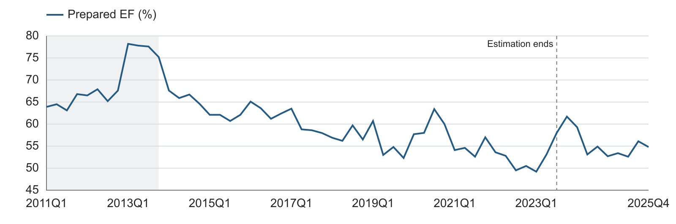
Figure 4.1 shows the broad decline in EF across the historical sample. The shaded area identifies the TARP-period coding. The dashed line marks the estimation cutoff.

4.3 Complete macro candidate inventory
The pool contains 22 supplied variables. Both transformations include a one-quarter lag. Additional scenario indicators retain their source codes.
Table 4.3. All 22 macro candidates
No. | Source variable | Description | Transformation
1 | earnings | Earnings measure | Log change
2 | ulc | Unit labor cost | Log change
3 | eci | Employment cost index | Log change
4 | gdp | Gross domestic product | Log change
5 | assets | Asset measure | Log change
6 | loans | Loan measure | Log change
7 | fed | Policy rate | Level change
8 | t2y | 2-year Treasury rate | Level change
9 | t10y | 10-year Treasury rate | Level change
10 | unemp | Unemployment rate | Level change
11 | confidence | Confidence indicator | Level change
12 | optimism | Optimism indicator | Level change
13 | gap | Economic gap measure | Level change
14 | vix | Volatility indicator | Level change
15 | hy | High-yield indicator | Level change
16 | FPCNBCPH_B.IUSA | Additional scenario indicator | Level change
17 | FLBOPQ_B.IUSA | Additional scenario indicator | Level change
18 | FYPEW52Q_B.IUSA | Additional scenario indicator | Level change
19 | FGDP52Q_B.IUSA | Additional scenario indicator | Level change
20 | FE52_B.IUSA | Additional scenario indicator | Level change
21 | FYPCPIQ_B.IUSA | Additional scenario indicator | Level change
22 | FECICCQ_B.IUSA | Additional scenario indicator | Level change
Table 4.3 shows the full candidate universe. The first six listed variables use log changes. The remaining sixteen use level changes.

4.4 Missing-data assessment
Table 4.4. Completeness of required inputs
Assessment area | Missing observations | Result
EF history, 2011Q1–2025Q4 | 0 | 60 quarters present
Final-model estimation fields | 0 within 49 selected rows | Complete model sample
Candidate initial lagged change | 19 candidates lack 2011Q2 | 48 observations for those candidates
Baseline and S4, 2026Q1–2028Q1 | 0 | Nine quarters in each path
Table 4.4 shows where complete-case treatment affects sample size. Missing candidate history is not filled with zero.

5. Linkages with Other Models

5.1 Upstream dependencies
The model receives EF history and unemployment assumptions. Baseline unemployment comes from the macro-candidate input. S4 unemployment comes from the separate scenario input. Both paths are checked by quarter before the model runs.
The model does not generate its own unemployment forecast. A change to the supplied scenario path changes the EF forecast through the lagged unemployment difference. The coefficients remain fixed unless a separate recalibration is approved.

5.2 Downstream use
The EF output can support expense planning when it is combined with the corresponding revenue definition. If the source EF includes compensation, a separate compensation forecast is needed to derive noncomp expense. The downstream calculation must use the same accounting scope as the historical ratio.
Table 5.1. Model dependencies and checks
Dependency | Information exchanged | Required check
Historical reporting | Quarterly EF ratio | Confirm ratio definition and period
Baseline macro scenario | Quarterly unemployment rate | Confirm units, scenario label and vintage
S4 macro scenario | Quarterly unemployment rate | Confirm quarter alignment and history anchor
Expense planning | EF forecast and matching revenue basis | Reconcile accounting scope and compensation treatment
Table 5.1 shows how information enters and leaves the EF model. These checks keep the ratio forecast consistent with downstream planning calculations.

5.3 Scenario alignment
All scenarios start from the same observed EF of 0.548 in 2025Q4. They use the same historical unemployment observations. Only future unemployment differs. No output from the EF model is used to alter the macro input.

5.4 Change control
A new scenario vintage is recorded with the forecast run. A change in the historical EF definition, macro transformation or downstream expense mapping requires an impact assessment. The model owner should review the change before the revised output is used.

6. Model Testing

6.1 Testing approach and in-sample fit
Testing checks whether the model explains historical movements and produces useful conditional forecasts. The same coefficient set is used for the OOT assessment and the nine-quarter scenarios. No OOT EF observation is used to re-estimate these coefficients.
Table 6.1. In-sample performance
Observations | R² | Adjusted R² | RMSE
49 | 0.8458 | 0.8278 | 0.02760
Table 6.1 shows the fit of the final model over the estimation sample. The adjusted R² is 0.8278 and the in-sample RMSE is 0.02760.
Figure 6.1. Actual and fitted EF
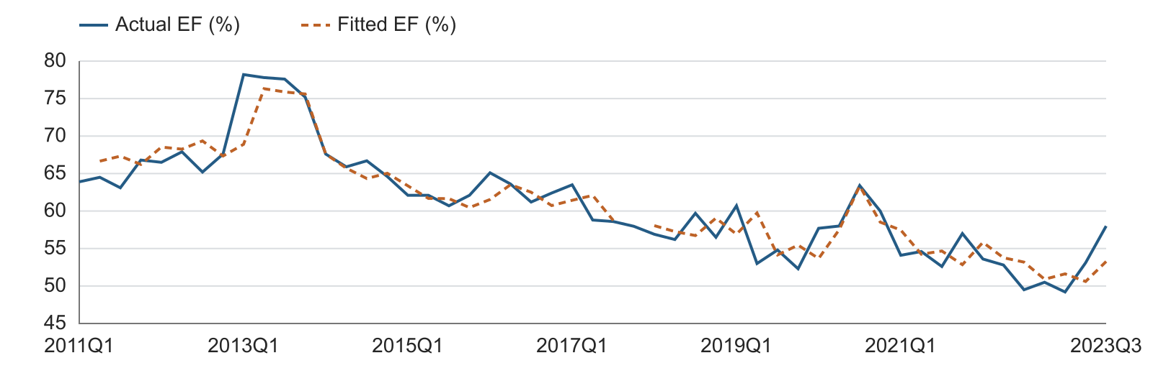
Figure 6.1 shows that the fitted model follows the main historical EF pattern. The gap in the fitted line corresponds to the excluded 2017Q4 response.
Figure 6.2. Regression residuals
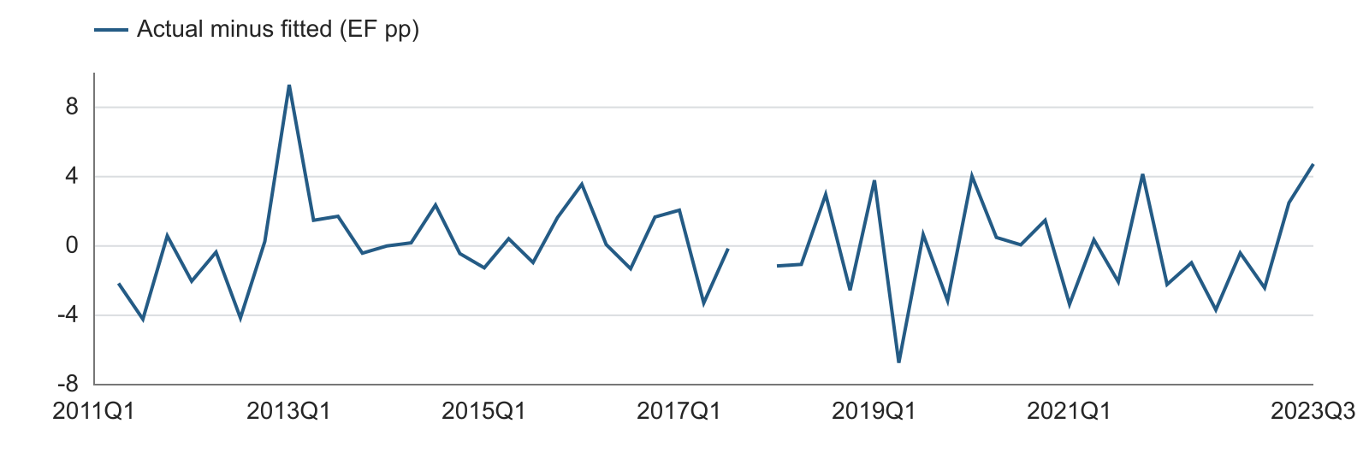
Figure 6.2 shows the quarterly differences between actual and fitted EF. Positive values indicate that the model understated EF. Residuals are shown in EF percentage points.

6.2 Residual diagnostics and stability
Table 6.2. Diagnostic results
Assessment | Statistic / p-value | Interpretation
Multicollinearity | Maximum VIF 3.9127 | Below the review level of 5
Serial correlation, 4 lags | F = 1.5245; p = 0.2194 | No rejection at 5%
Breusch–Pagan | F = 0.5968; p = 0.7025 | No rejection of constant variance at 5%
Jarque–Bera | JB = 6.2151; p = 0.0447 | Normality rejected at 5%
OLS-residual CUSUM | Statistic = 0.5980; p = 0.8669 | No rejection at 5%
Table 6.2 shows support for the serial-correlation, variance and stability checks. Normality is rejected at 5%, so the report focuses on point-forecast performance and does not present normal-theory prediction bands.
The serial-correlation check preserves calendar-quarter lags. It drops rows with unavailable lagged residuals around the 2017Q4 exclusion and uses 41 observations. CUSUM is a supplementary check on the ordered estimation residuals. These diagnostics assess different parts of model behavior.

6.3 Expanding-sample coefficient review
Table 6.3. Fixed-specification expanding estimates
End quarter | N | EF lag | Unemployment change
2019Q4 | 34 | 0.7503 | −0.016555
2020Q4 | 38 | 0.7245 | 0.005608
2021Q4 | 42 | 0.6931 | 0.006076
2022Q4 | 46 | 0.6973 | 0.006348
2023Q3 | 49 | 0.6961 | 0.006364
Table 6.3 shows that the EF lag stays below one in every window. The unemployment coefficient is positive from the 2020Q4 window onward and is close to its final estimate in the later windows.
The earlier 2019Q4 window has a negative unemployment coefficient. This indicates that the positive macro relationship is informed by the later stress-period experience. Monitoring should track the unemployment response as more quarters become available. The full estimation sample remains the basis for the documented forecast.

6.4 Testing interpretation
The model combines trend-and-break stationarity evidence, a stable EF propagation coefficient and measurable OOT accuracy. The normality and window results define specific monitoring priorities. They do not change the documented point-forecast calculations.

6.5 Out-of-time forecast assessment
The OOT period covers 2023Q4–2025Q4. One-step forecasts use the actual EF from the previous quarter. Recursive forecasts start from actual EF in 2023Q3 and then use the preceding model forecast. Both methods use the supplied historical unemployment path.
This is a conditional OOT assessment using the available macro series. It does not recreate the macro data releases or forecast vintages available at each historical date.
Figure 6.3. Nine-quarter OOT forecasts
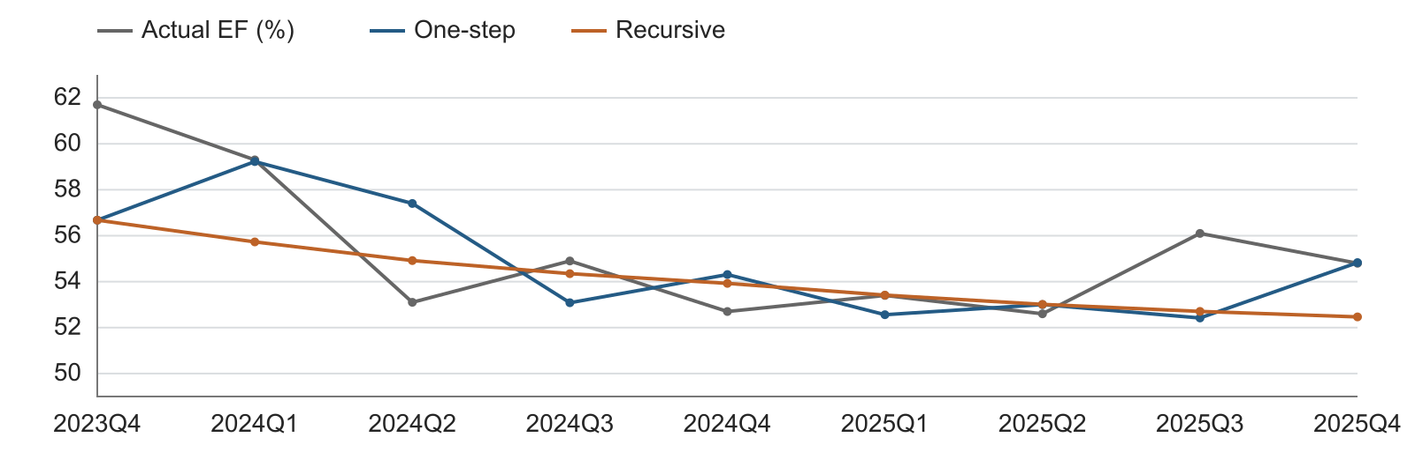
Figure 6.3 shows the actual EF and both forecast methods over the same nine quarters. The recursive path remains close to the level of the later observations.
Table 6.4. OOT forecast errors
Method | RMSE | MAE | Mean error
Model, one-step | 0.02668 | 0.01975 | 0.00566
Model, recursive | 0.02587 | 0.02038 | 0.01268
Prior-quarter EF, one-step | 0.03001 | 0.02511 | −0.00356
Fixed 2023Q3 EF, recursive | 0.03962 | 0.03711 | −0.02600
Table 6.4 shows that the model improves RMSE relative to the simple persistence benchmarks in both forecast modes. Mean error is actual minus forecast. All errors use EF ratio units.

6.6 Interpretation and overlay
The one-step RMSE is 0.02668, equivalent to 2.668 EF percentage points. Recursive RMSE is 0.02587. The positive mean errors indicate some underprediction over this window. No management overlay is applied to the results in this document.
Nine OOT quarters provide a focused assessment of this period. Future quarterly monitoring will add observations and track both the size and direction of forecast errors.

6.7 Baseline and S4 scenario paths
The nine-quarter horizon runs from 2026Q1 to 2028Q1. Parameters remain at their 2023Q3 estimation values. Forecast recursion starts from actual EF in 2025Q4. The Baseline and S4 paths are taken directly from their designated inputs.
Figure 6.4. Unemployment assumptions
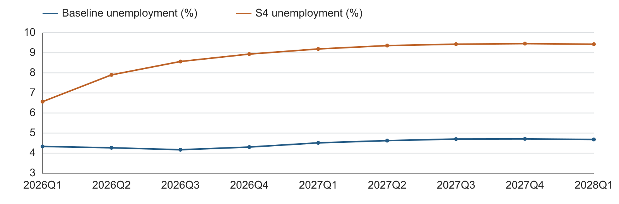
Figure 6.4 shows the Baseline and S4 unemployment paths on one chart. S4 has the higher unemployment rate throughout the forecast horizon.
Figure 6.5. Baseline and S4 EF forecasts
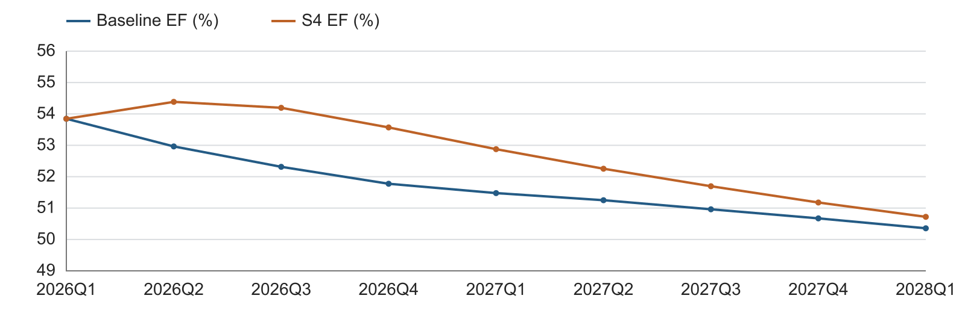
Figure 6.5 shows that the S4 EF path rises above Baseline after the first forecast quarter. The gap then narrows as unemployment changes moderate and past effects decay.

6.8 Scenario interpretation
Both EF paths start at 0.53846 in 2026Q1. The first forecast uses the same observed unemployment change from 2025Q4. Scenario differences first affect EF in 2026Q2 because the macro driver is lagged one quarter.
The model responds to changes in unemployment. A higher unemployment level alone does not create a fresh effect every quarter. This explains why the EF paths can move closer even while the unemployment levels remain separated.

6.9 Nine-quarter forecast results
Table 6.5. Scenario inputs and EF forecasts
Quarter | Baseline U (%) | S4 U (%) | Baseline EF (%) | S4 EF (%)
2026Q1 | 4.333 | 6.565 | 53.846 | 53.846
2026Q2 | 4.267 | 7.900 | 52.964 | 54.385
2026Q3 | 4.170 | 8.566 | 52.314 | 54.195
2026Q4 | 4.303 | 8.936 | 51.775 | 53.569
2027Q1 | 4.513 | 9.191 | 51.477 | 52.877
2027Q2 | 4.623 | 9.359 | 51.251 | 52.254
2027Q3 | 4.703 | 9.429 | 50.961 | 51.696
2027Q4 | 4.710 | 9.456 | 50.672 | 51.177
2028Q1 | 4.680 | 9.428 | 50.356 | 50.721
Table 6.5 shows the macro inputs and corresponding EF outputs by quarter. The 2028Q1 forecasts are 50.356% for Baseline and 50.721% for S4.

6.10 Unemployment sensitivity design
The sensitivity test shifts every future Baseline unemployment level by plus or minus one percentage point. For example, 4% becomes 5% in the upward case. Historical unemployment, starting EF, coefficients and the time trend stay unchanged.
The level shift begins in 2026Q1. It creates a one-point difference in the first future unemployment change. The model applies that change one quarter later. The peak EF difference therefore occurs in 2026Q2. It equals 0.006364 ratio units, or 0.6364 EF percentage points.
Table 6.6. Sensitivity response relative to Baseline
Forecast quarter | Upward shock (EF pp) | Downward shock (EF pp)
2026Q1 | 0.0000 | 0.0000
2026Q2 | 0.6364 | −0.6364
2026Q4 | 0.3084 | −0.3084
2027Q2 | 0.1494 | −0.1494
2028Q1 | 0.0504 | −0.0504
Table 6.6 shows the equal and opposite EF responses to the two unemployment shifts. After the initial impact, the effect declines with the EF lag coefficient.

6.11 Sensitivity forecast paths
Figure 6.6. EF sensitivity to a one-point unemployment shift
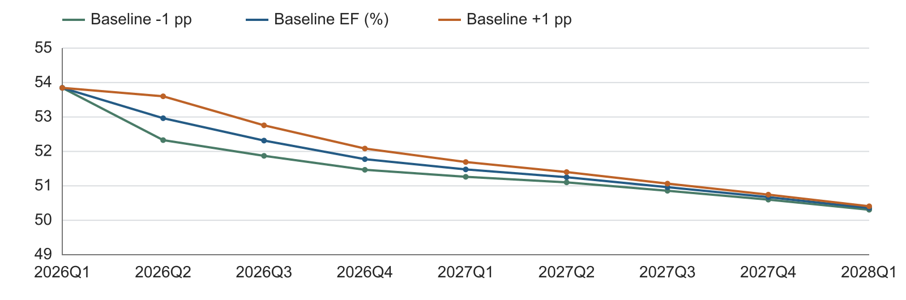
Figure 6.6 shows the three EF paths under Baseline and the two unemployment shifts. The first-quarter outputs coincide. The later separation is limited and declines over time.
Table 6.7. Sensitivity forecasts, EF percent
Quarter | Unemployment −1 pp | Baseline | Unemployment +1 pp
2026Q1 | 53.846 | 53.846 | 53.846
2026Q2 | 52.328 | 52.964 | 53.601
2026Q3 | 51.871 | 52.314 | 52.757
2026Q4 | 51.466 | 51.775 | 52.083
2027Q1 | 51.263 | 51.477 | 51.692
2027Q2 | 51.101 | 51.251 | 51.400
2027Q3 | 50.857 | 50.961 | 51.065
2027Q4 | 50.600 | 50.672 | 50.745
2028Q1 | 50.306 | 50.356 | 50.406
Table 6.7 shows the full nine-quarter sensitivity outputs. The direction of the response is consistent with the positive unemployment coefficient.

6.12 Development testing conclusion
The fixed-break Perron result supports the stated trend-stationary modeling basis. Forward selection retains unemployment alone. The resulting model improves OOT RMSE over the persistence benchmarks and the gap and GDP alternatives. Baseline, S4 and sensitivity paths follow the documented lag structure.
These results support the model as a conditional EF forecasting approach for the stated horizon. The proposed monitoring plan tracks forecast error, macro response and the continued relevance of the trend-and-break structure.

7. Model Implementation

7.1 Development implementation
The development calculations read three input files. They validate quarterly keys, prepare EF, calculate macro changes and lags, estimate the model and produce forecasts. The trend and the 2014Q1 pulse are included in this version. All tables and figures in this MDD use that same specification.
Coefficient estimates were checked against an independent OLS calculation. Scenario timing was checked against the model equation. The plus and minus one-point sensitivity responses were checked against the analytical lag response. Input file hashes were unchanged after the run.

7.2 Release controls
Before a production release, the implemented model should reproduce the approved development coefficients and forecast values. The review should cover quarter alignment, units, scenario labels, recursive timing and output rounding. Access to inputs, code and published results should follow the approved operating process.
Table 7.1. Implementation review checklist
Control | Expected evidence
Input version | Saved copies of all three inputs with scenario vintage
Numerical agreement | Coefficients and forecasts match at unrounded precision
Scenario mapping | Baseline and S4 linked to their designated input fields
Timing | 2026Q1 uses the 2025Q4 unemployment change
Change approval | Recorded review of specification and output changes
Release record | Version, run date, reviewer and approved use
Table 7.1 shows the checks needed to move from development output to a controlled release. Formal production acceptance is a separate approval step.

7.3 Current documentation status
This document records the development model and its calculations. Production deployment, independent validation and user acceptance are not asserted here. Their completion should be recorded in the release documentation.

8. Model Monitoring

8.1 Purpose and frequency
Monitoring should confirm that the model continues to produce useful EF forecasts. It should identify input errors, persistent forecast bias and changes in the economic relationship. The proposed cycle is quarterly after new EF data are available, with a fuller annual review.
An additional review should follow a material accounting change, business restructuring, macro-data revision or model change. The owner should retain the monitoring results and the actions taken.

8.2 Roles and responsibilities
Table 8.1. Proposed monitoring responsibilities
Role | Responsibility
Model owner | Review performance, approve actions and escalate material issues.
Model developer | Run checks, investigate exceptions and maintain the evidence.
Finance / model user | Review business meaning, scenario use and downstream reconciliation.
Independent reviewer / MRM | Challenge the method, monitoring results and proposed material changes.
Table 8.1 shows the proposed division of monitoring work. Named owners and approval authorities should be recorded in the model inventory.

8.3 Monitoring components
Input monitoring checks completeness, quarterly alignment and percent units. Output monitoring compares new forecasts with the prior vintage. Accuracy monitoring compares forecast EF with realized EF. Separate one-step and recursive results should be retained because they use different information.
Assumption monitoring reviews the fixed TARP break, the linear trend and the unemployment response. Coefficient review checks whether the EF lag remains below one and whether the macro effect remains positive. Any overlay should be documented separately from the model forecast.

8.4 Annual review
The annual review should update OOT evidence, reassess the candidate set and review whether the trend remains appropriate for the planning horizon. Re-estimation should be treated as a controlled model change. The current coefficients should not be overwritten by a routine forecast refresh.

8.5 Proposed monitoring thresholds
The following thresholds are proposed review triggers. They are not approved policy limits. A trigger calls for investigation and a documented response. It does not by itself establish model failure.
Table 8.2. Monitoring metrics and proposed triggers
Area | Metric | Review trigger
Input quality | Missing, duplicate or misaligned quarter | Any required input fails the check
Unit consistency | EF ratio and unemployment percent | Any mismatch with the documented scale
Forecast accuracy | Rolling four-quarter one-step RMSE | Above 0.0400 ratio units
Forecast bias | Mean actual minus forecast over four quarters | Absolute value above 0.0200
Persistence | Re-estimated EF lag coefficient | Outside the interval 0 to 1
Macro response | Re-estimated unemployment coefficient | Sign reversal or material change in sensitivity
Scenario output | EF path and Baseline/S4 timing | Unexplained jump or inconsistent lag response
Model assumptions | Trend, break or accounting scope | Evidence that a key assumption has changed
Table 8.2 shows the proposed monitoring triggers. The RMSE trigger is about 1.5 times the development OOT one-step RMSE. Thresholds should be approved before operational use.

8.6 Escalation and remediation
The developer first checks the data, transformations and forecast timing. The owner then reviews the business explanation and the size of the effect. Material findings should be sent to the model user and the independent review function.
Remediation may include correcting an input, updating an assumption, reviewing the trend or recalibrating the model. An overlay requires a separate rationale, amount, duration and approval. The original model forecast should remain available for comparison.

8.7 Monitoring conclusion
Quarterly monitoring provides a direct link between the documented development evidence and actual forecast use. It focuses on the ratio definition, forecast error and unemployment response. This makes the main model assumptions observable and reviewable.

9. Procedures

9.1 Forecast refresh
Table 9.1. Proposed operating sequence
Step | Action | Evidence retained
1 | Freeze the three inputs and record their vintage. | Input files and run record
2 | Check quarters, units and required values. | Data-quality results
3 | Apply the documented historical EF preparation. | Prepared EF series and adjustment log
4 | Calculate macro changes and one-quarter lags. | Transformed modeling data
5 | Load the approved coefficient version. | Coefficient record
6 | Start recursion from the latest observed EF. | Forecast-origin record
7 | Run Baseline, S4 and the ±1-point sensitivity. | Quarterly forecasts by scenario
8 | Review results and reconcile downstream use. | Review notes and release decision
Table 9.1 shows the sequence for a controlled forecast refresh. Re-estimation is a separate activity and should not occur automatically during a routine refresh.

9.2 Re-estimation procedure
A re-estimation run should preserve the prior model version. It should rerun stationarity checks, candidate selection, residual diagnostics and OOT comparisons. The developer should explain changes in coefficients and forecast outputs. The owner should obtain the required review before using a revised version.

9.3 Review and retention
Retain the inputs, prepared data, coefficients, diagnostics, forecasts and review notes together. Keep the Baseline and S4 labels visible in every output. Record any manual adjustment separately. This allows a reviewer to trace a forecast back to its assumptions and model version.

10. Governance

10.1 Governance purpose
The proposed governance process assigns responsibility for development, use, review and change. It also separates model output from management judgment. The model inventory should identify the owner, intended use, version and review status.

10.2 Review responsibilities
The model owner is responsible for performance oversight and documentation. The developer maintains the calculations and investigates issues. Finance reviews business interpretation and downstream use. Independent validation or MRM reviews the methodology, assumptions, testing and controls under the applicable internal process.
Internal Audit may assess whether the required governance and change controls are followed. Specific personnel and completed review dates should be entered only when confirmed.

10.3 Material changes
Table 10.1. Changes requiring impact review
Change | Reason for review
EF definition or expense mapping | Changes the meaning of the modeled ratio
Smoothing rule or sample exclusion | Changes the historical estimation series
Trend or TARP-break specification | Changes the stationarity and forecasting structure
Macro variable, lag or transformation | Changes the economic response
Coefficient recalibration | Changes the projected EF path
Forecast use or horizon | Changes the scope of supporting evidence
Overlay or monitoring threshold | Changes how output is used or assessed
Table 10.1 shows the model changes that should receive a documented impact assessment before release.

10.4 Change record and approval
The change log should state what changed, why it changed and how the output was affected. It should identify the reviewer and approval date. The prior version should remain recoverable. New versions should include updated data, tests, forecasts and documentation.

10.5 Governance conclusion
This MDD provides the development evidence for review. The proposed governance process keeps ownership, independent challenge and change control explicit. Approval records should be maintained separately from the statistical results.

11. Appendix Information

11.1 Complete first-round macro screen
Table 11.1. First-round results
Candidate | N | Coefficient | p-value | Adjusted R²
unemp | 49 | 0.006364 | 0.0300 | 0.8278
gap | 49 | −0.005744 | 0.0369 | 0.8264
gdp | 49 | −0.540688 | 0.0399 | 0.8258
earnings | 48 | 1.994335 | 0.0841 | 0.8227
FPCNBCPH_B.IUSA | 48 | 0.005946 | 0.0993 | 0.8216
assets | 48 | 0.473055 | 0.1051 | 0.8212
t2y | 48 | −0.020497 | 0.1188 | 0.8204
fed | 48 | −0.018299 | 0.1349 | 0.8195
FYPCPIQ_B.IUSA | 48 | 0.000005 | 0.1587 | 0.8184
loans | 48 | 0.591990 | 0.1618 | 0.8183
FE52_B.IUSA | 48 | −0.459794 | 0.1744 | 0.8178
eci | 48 | −3.007541 | 0.1887 | 0.8173
FGDP52Q_B.IUSA | 48 | −0.000172 | 0.2315 | 0.8160
confidence | 48 | −0.000631 | 0.2586 | 0.8153
FLBOPQ_B.IUSA | 48 | −0.009513 | 0.3116 | 0.8142
optimism | 48 | −0.001817 | 0.3502 | 0.8135
t10y | 48 | −0.011964 | 0.3970 | 0.8128
hy | 48 | 0.005327 | 0.4145 | 0.8126
ulc | 48 | 0.299961 | 0.4214 | 0.8125
FECICCQ_B.IUSA | 48 | −0.013832 | 0.4880 | 0.8117
vix | 48 | 0.000620 | 0.5163 | 0.8114
FYPEW52Q_B.IUSA | 48 | −0.000085 | 0.7543 | 0.8100
Table 11.1 shows all 22 candidate results, ordered by the entry p-value. Every model includes the same forced controls. Coefficient magnitudes use the transformed source units.
After unemployment enters, the smallest remaining entry p-value is 0.3044. No additional macro passes 0.05. The 48-observation common-sample check reaches the same selected variable set.

11.2 Perron implementation and lag sensitivity
The first-stage residual is obtained from EFₜ = μ + δDₜ + βt + uₜ. The second stage includes the lagged residual, k lagged residual differences and the current and k lagged break pulses. It contains no additional intercept or trend. The t-statistic on the lagged residual tests a zero coefficient in the differenced form [2].
$$\begin{aligned}Δe_{t} = ρe_{t-1} + \sum_{j = 1}^{k}{φ_{j}Δe_{t-j}} \\ + \sum_{j = 0}^{k}{ω_{j}P_{t-j}} + v_{t}\end{aligned}$$
P equals one in 2014Q1. The break is the transition after 2013Q4. Coding the step as pre-break or post-break gives the same detrended residuals. The critical values are specific to a fixed level break with a linear trend [1–2].
Table 11.2. Perron lag-rule sensitivity
Rule | Max lag | Train k | Train statistic | Full k | Full statistic
Sequential t, 10% | 4 | 2 | −3.7963 | 2 | −4.2442
AIC | 4 | 0 | −3.0644 | 0 | −3.4370
BIC | 4 | 0 | −3.0644 | 0 | −3.4370
Sequential t, 10% | 8 | 7 | −4.6408 | 7 | −3.2972
AIC | 8 | 2 | −3.7963 | 2 | −4.2442
BIC | 8 | 0 | −3.0644 | 0 | −3.4370
Table 11.2 shows how the statistic changes with the lag rule. The main four-lag sequential rule supports rejection at 5% in both samples. The AIC/BIC four-lag checks select zero lags and do not reject at 5%.
The evidence therefore supports the stated specification and lag rule, rather than rejection under every possible lag choice. At the selected two-lag specification, four-lag residual serial-correlation F-test p-values are 0.5477 for the development history and 0.8449 for the full history.

11.3 Coefficient uncertainty
Table 11.3. Conventional 95% coefficient intervals
Term | Lower bound | Upper bound
Constant | 0.040967 | 0.354748
TARP step | −0.002316 | 0.058722
Linear trend | −0.001834 | 0.000470
2014Q1 pulse | −0.101041 | 0.031910
EF, lag 1 | 0.474495 | 0.917760
Unemployment change, lag 1 | 0.000645 | 0.012083
Table 11.3 shows the conventional OLS intervals conditional on this specification. They do not account for the candidate search or macro-scenario uncertainty.

11.4 Quarterly OOT values
Table 11.4. OOT values, EF ratio units
Quarter | Actual EF | One-step forecast | Recursive forecast
2023Q4 | 0.61700 | 0.56677 | 0.56677
2024Q1 | 0.59300 | 0.59226 | 0.55730
2024Q2 | 0.53100 | 0.57403 | 0.54917
2024Q3 | 0.54900 | 0.53082 | 0.54347
2024Q4 | 0.52700 | 0.54309 | 0.53924
2025Q1 | 0.53400 | 0.52561 | 0.53413
2025Q2 | 0.52600 | 0.53001 | 0.53011
2025Q3 | 0.56100 | 0.52419 | 0.52705
2025Q4 | 0.54800 | 0.54829 | 0.52466
Table 11.4 shows the values underlying the OOT error measures in Section 6. The two forecasts share the same starting information in the first OOT quarter.

11.5 Variable dictionary
Table 11.5. Final-model variables
Symbol | Definition
EFₜ | Prepared quarterly efficiency ratio, stored as a decimal
Dₜ | 1 through 2013Q4, then 0
t | Quarter counter; 2011Q1 = 1
Pₜ | 1 in 2014Q1 only, then 0
EFₜ₋₁ | Prepared EF from the prior calendar quarter
ΔUₜ₋₁ | Uₜ₋₁ − Uₜ₋₂, in unemployment percentage points
εₜ | Forecasting-equation error
Table 11.5 shows the exact variable meanings and timing used in the final equation.

11.6 Source and method references
Data: er_rate.csv, macro_candidates.csv and s4_unemployment.csv in the prepared development input set. The EF history contains the two documented 2017 adjustments. Scenario values follow the supplied Baseline and S4 files.
[1] Perron, P. (1989). The Great Crash, the Oil Price Shock, and the Unit Root Hypothesis. Econometrica, 57(6), 1361–1401. Table IV.B. https://web.pdx.edu/~crkl/ec572/readings/perron89a.pdf
[2] Perron, P., and Vogelsang, T. J. (1993). A Note on the Asymptotic Distributions of Unit Root Tests in the Additive Outlier Model with Breaks. Revista de Econometria, 13(2), 181–201. Equation (11).
[3] EViews. Unit Root Tests with a Breakpoint. Lag Selection and Additive Outlier Tests. https://www.eviews.com/help/content/advtimeser-Unit_Root_Tests_with_a_Breakpoint.html

