Quarterly Deposit Fee Rate Model
Final AR(1) model with C&I loan growth · 2011Q1–2025Q4
Research report dated 5 November 2026

1 Model and validation findings
Commercial and industrial (C&I) loan growth two quarters earlier is the final model’s only macro variable. M1 changed sign across rolling windows. Consumer sentiment had a consistently negative coefficient, but the available data offered little explanation for the four-quarter lagged relationship. The final fit retains AR(1), the common trend and both event indicators.
Both forecast paths underestimated the fee rate in every OOT quarter. Updating the lagged rate each quarter limited the average shortfall to 0.01752 pp. Allowing forecasts to feed into the next quarter increased the average shortfall to 0.03976 pp.
Table 1 Final model fit and forecast errors
Evaluation | Quarters | RMSE (pp) | MAE (pp)
IS one-step fit | 47 | 0.01288 | 0.00927
OOT one-step | 9 | 0.02024 | 0.01752
OOT recursive | 9 | 0.04608 | 0.03976

2 Target and sample
The annualized fee rate divides four times quarterly deposit fee revenue by average deposits. Average deposits equal the sum of the three monthly balances divided by three. Rebuilding both quantities from the target workbook gave a maximum absolute difference of zero across all 60 quarters.
Period or unit | Treatment
Model target | 100 × Quarterly_rate. A stored value of 0.004 corresponds to 0.4%.
2011Q1–2023Q3 | 51 in-sample (IS) quarters for trend work and stationarity screening.
2012Q1–2023Q3 | 47 common observations for the baseline and all macro regressions.
2023Q4–2025Q4 | Nine out-of-time (OOT) quarters previously reviewed. Coefficients are fixed at the IS estimates.
Changes and errors | Percentage points (pp). Relative errors such as MAPE are in percent.

3 Two declines in the historical rate
The two largest in-sample quarterly declines came from different movements in fee revenue and average deposits. In early 2019 the denominator expanded sharply while fee revenue rose slightly. In the second quarter of 2020, fee revenue contracted as average deposits continued to grow.
Figure 1 Annualized fee rate and the start of the holdout
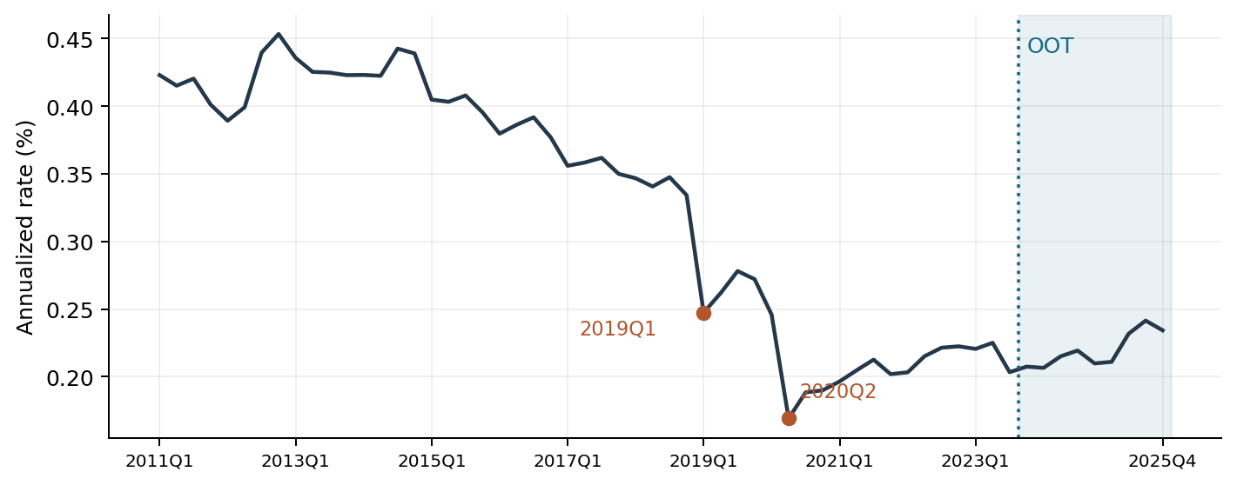
Table 2 Event quarters and the components of the rate
Quarter | Fee rate (%) | Change (pp) | Fee revenue QoQ | Avg deposits QoQ
2018Q4 | 0.33418 | -0.01328 | -1.05% | 2.88%
2019Q1 | 0.24739 | -0.08680 | 2.50% | 38.47%
2019Q4 | 0.27204 | -0.00601 | -2.29% | -0.14%
2020Q1 | 0.24580 | -0.02624 | -7.33% | 2.56%
2020Q2 | 0.16912 | -0.07668 | -23.20% | 11.62%
2020Q4 | 0.18990 | 0.00156 | 6.26% | 5.39%

By 2019Q4, average deposits remained 35.82% above 2018Q4, while fee revenue was up 10.57%. A merger with different consolidation dates for balances and fees could explain part of the gap. Verification would require the effective date and the scope of fee consolidation.
Between 2019Q4 and 2020Q2, the rate fell 0.10292 pp. The model treats 2019Q1 as a single-quarter pulse and 2020 as a four-quarter level effect. Both indicators are zero throughout OOT.

4 Trend specification
The model uses one quarterly time slope throughout the study. The equation below gives the initial OLS estimates on 51 quarters (2011Q1–2023Q3). Section 7 gives the final estimates after adding the lagged fee rate and C&I loan growth.
Selected trend specification
$y_{t} = 0.476915 − 0.005340 t − 0.053313 P_{t} − 0.073041 D_{t} + ε_{t}$
The annualized fee rate y equals 100 × Quarterly_rate and is measured in percent. Time t starts at 1 in 2011Q1 and increases by 1 each quarter. The error term is ε.
P equals 1 in 2019Q1 only. D equals 1 from 2020Q1 through 2020Q4. Each indicator is zero in all other quarters. They shift the fitted level for those quarters. The underlying trend falls by 0.00534 pp per quarter throughout.
Figure 2 Common-trend OLS fit and residuals
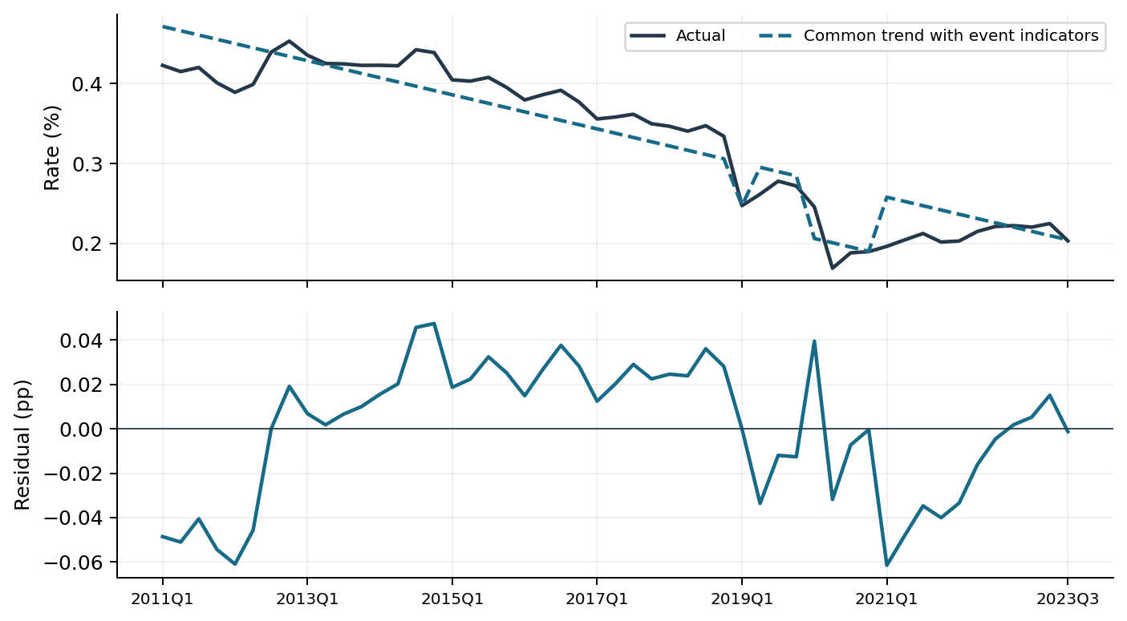
Table 3 Common-trend OLS fit on 51 IS quarters
Trend | Adj. R² | RMSE (pp) | AIC | BIC | DW
Common slope | 0.8841 | 0.03018 | -204.32 | -196.59 | 0.472

The estimated level shifts are −0.05331 pp in 2019Q1 (p = 0.1011) and −0.07304 pp during 2020 (p < 0.0001). Both p-values use conventional OLS standard errors. The DW statistic of 0.472 indicates persistent residuals, motivating the test of a lagged fee rate in section 5.

5 Autoregression and macro selection
With both event indicators and the common trend fixed, adding last quarter’s actual rate reduced IS RMSE from 0.02658 to 0.01364 pp on the same 47 quarters. DW rose from 0.638 to 2.103. The baseline AR coefficient was 0.72208 and the largest non-intercept VIF was 8.23.
At 2021Q1 the static trend overestimated the rate by 0.05792 pp. The one-quarter lag reduced that error to 0.01103 pp because the low fee rate in 2020Q4 carried forward even as the COVID indicator switched off.
Table 4 Screening rules and samples
Step | Rule
Transformation | Test level first. For positive amounts and indices, next test the quarterly log change, then the first difference. For rates or series with nonpositive IS values, next test the first difference.
Stationarity | Use the first transform with ADF p < 0.05 and KPSS p > 0.05 over 51 IS quarters. Both include a constant. ADF uses AIC up to 4 lags and KPSS uses automatic bandwidth.
Candidate set | 24 of 33 variables qualified: 3 levels, 14 log changes and 7 first differences. Lags of 1, 2 and 4 quarters yielded 72 terms. The 2010 history initializes changes and lags.
Entry and ranking | Added-term p < 0.05, maximum VIF over all non-intercept terms < 10 and DW between 1.5 and 2.5 inclusive. Take the smallest passing p; BIC and feature name break ties.
Stopping | One lag per macro series, at most three macro terms. Calculate JB once for the resulting model after the round decision.

Table 5 Forward selection on the 47-quarter sample
Round | Added log change | Pass / tried | Entry p | Max VIF | DW | JB p
1 | Consumer sentiment, L4 | 4 / 72 | 0.0263 | 8.764 | 2.027 | <0.0001
2 | C&I loans, L2 | 5 / 69 | 0.0130 | 8.872 | 2.235 | 0.0407
3 | M1, L1 | 5 / 66 | 0.0034 | 9.459 | 1.998 | 0.5532

The third addition reached the prespecified cap. The early rounds’ low JB p-values describe residual shape and did not affect the ranking. Entry p-values are conditional on the terms already present in that round.

6 Rolling coefficients of the three selected macros
The three selected macro terms enter each rolling regression together with the AR(1) baseline. The 20-quarter window advances one quarter at a time across the 47 IS observations. All 28 windows had full rank after omitting any event indicator that was zero throughout that window.
Figure 3 Rolling estimates and 95% intervals, by window end
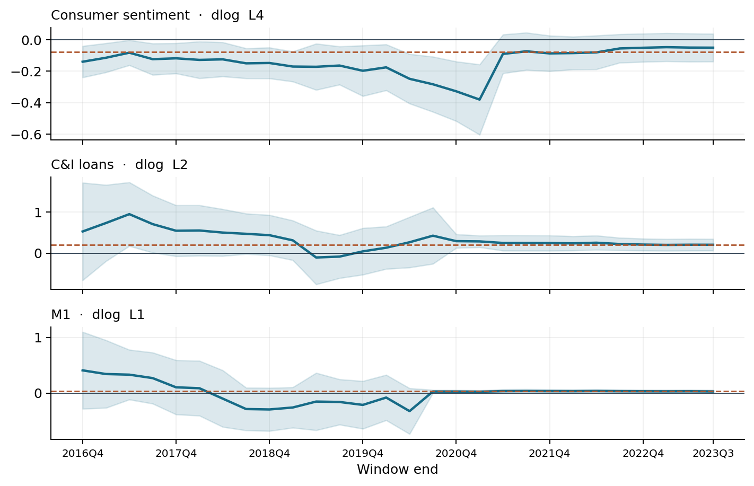
Table 6 Signs and significance across 28 windows
Lagged log change | Full IS | Rolling range | Positive | Negative | p < 0.05
Consumer sentiment, L4 | -0.0773 | -0.380 to -0.047 | 0 | 28 | 18
C&I loans, L2 | 0.1998 | -0.102 to 0.953 | 26 | 2 | 14
M1, L1 | 0.0344 | -0.322 to 0.410 | 19 | 9 | 13

The dashed line marks each full-IS coefficient. Shading gives the conventional 95% interval for each window. Sentiment stayed negative in all 28 windows. C&I loans stayed positive in 26, although the size of the estimate varied.
M1 was negative for nine consecutive window ends (2018Q2–2020Q2), then positive and significant in the last 13. This change in direction led to its removal.
Without M1, sentiment still had a coefficient of -0.07897 (p = 0.0111). The negative sign was consistent across the screening windows. The economic link between an earlier improvement in sentiment and a lower fee rate four quarters later was unclear, so the final refit retained C&I loans alone among the selected macros.

7 Final model equation and specification
The dependent variable is the annualized deposit fee rate in percent. Ordinary least squares estimates all six coefficients on the same 47 quarters, 2012Q1–2023Q3. The equation below rounds the estimates to six decimals. Predictions use full precision.
Estimated equation
$y_{t} = 0.142501 − 0.001653 t − 0.077944 P_{t} − 0.043130 D_{t}$
$+ 0.702995 y_{t−1} + 0.147487 c_{t−2} + ε_{t}$
Time t starts at 1 in 2011Q1 and increases by 1 each quarter. P equals 1 in 2019Q1 only. D equals 1 in 2020Q1–2020Q4. Both indicators equal zero in other quarters. The lagged rate is the prior quarter’s annualized percentage rate.
The lowercase c is the quarterly natural-log change in C&I loans. For quarter t, the loan input is ln(C[t−2] / C[t−3]), where C is the loan balance. The log change is unscaled.
Table 7 Final coefficients and conventional OLS inference
Regressor | Estimate | SE | p | 95% interval | VIF
Intercept | 0.142501 | 0.03215 | <0.0001 | 0.0776 to 0.2074 | —
Quarterly trend | -0.001653 | 0.00041 | 0.0002 | -0.0025 to -0.0008 | 7.57
2019Q1 pulse | -0.077944 | 0.01414 | <0.0001 | -0.1065 to -0.0494 | 1.03
2020 indicator | -0.043130 | 0.00905 | <0.0001 | -0.0614 to -0.0249 | 1.57
Fee rate, lag 1 | 0.702995 | 0.06425 | <0.0001 | 0.5732 to 0.8327 | 8.38
C&I loans, L2 | 0.147487 | 0.06606 | 0.0311 | 0.0141 to 0.2809 | 1.28

Holding other inputs fixed, a 0.01 increase in loan log growth two quarters earlier corresponds to a 0.00147 pp increase in the current fee rate. VIF measures how strongly each regressor overlaps with the others. The largest non-intercept VIF is 8.38, below the limit of 10. The p-values and intervals use ordinary standard errors and are conditional on the chosen specification.

8 Final in-sample fit and residuals
Figure 4 Final one-step fit and residuals on the 47 IS quarters
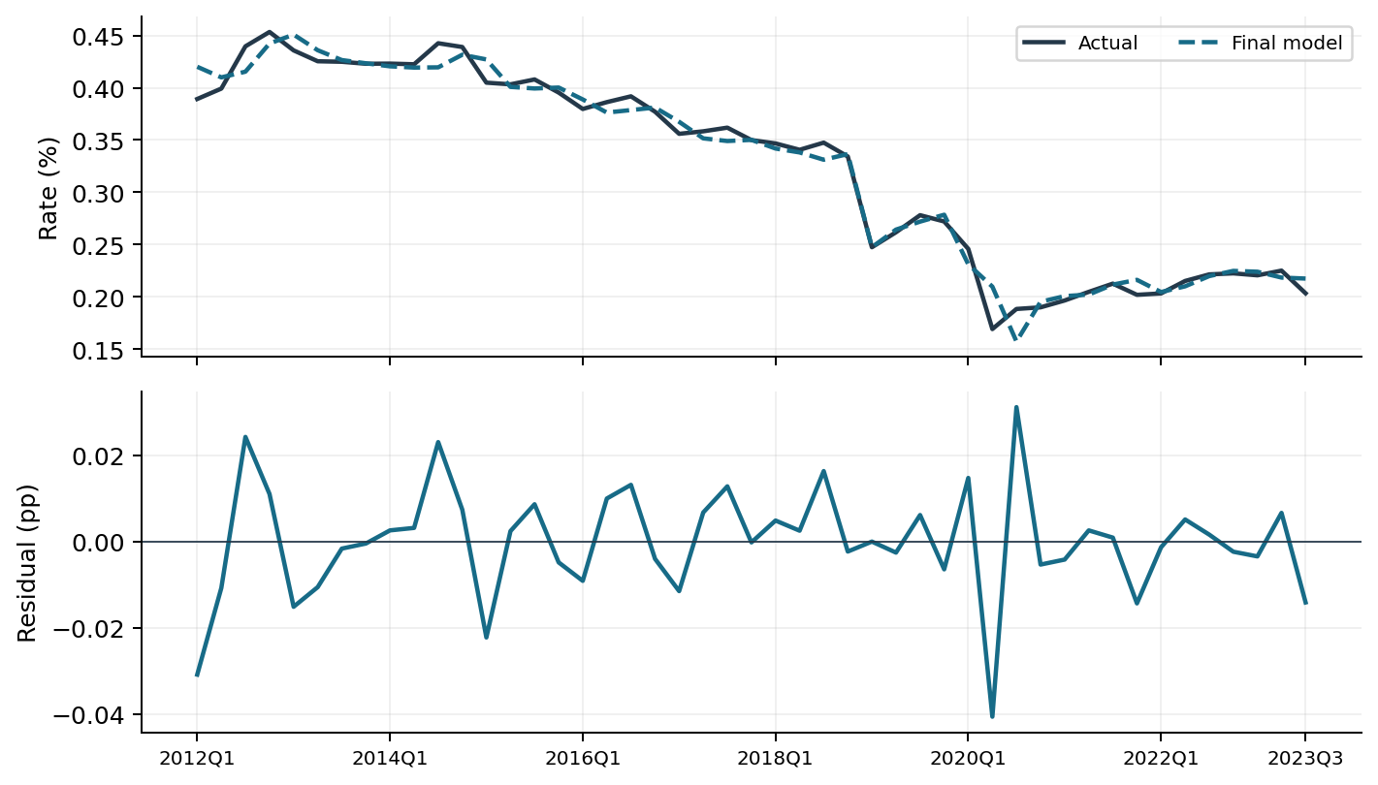
Table 8 Final model in-sample fit, 2012Q1–2023Q3 (47 quarters)
Specification | Adj. R² | RMSE (pp) | AIC | BIC | DW | Max VIF
C&I loans only | 0.9779 | 0.01288 | -263.70 | -252.60 | 2.317 | 8.381

DW meets the selection range, but the four-lag Breusch–Godfrey LM test detects residual autocorrelation (p = 0.0136). At one lag, p = 0.0572. The Jarque–Bera normality test (p = 0.0444) and Breusch–Pagan variance test (F-test p = 0.0002) also qualify the conventional OLS inference in Table 7.
The largest defined Cook’s distance is 1.165 in 2020Q2. The single-quarter pulse fits 2019Q1 exactly. Its unit leverage makes deletion-based influence measures undefined for that observation.

9 Final model performance over nine OOT quarters
Coefficients are fixed at their IS estimates. One-step forecasts use the previous actual fee rate. The recursive path starts from the same 2023Q3 actual (0.20332%) and feeds each forecast into the next quarter. Both paths use realized lagged macro data, so the recursive results are conditional on the observed macro path.
Figure 5 Actual fee rate and final-model forecasts
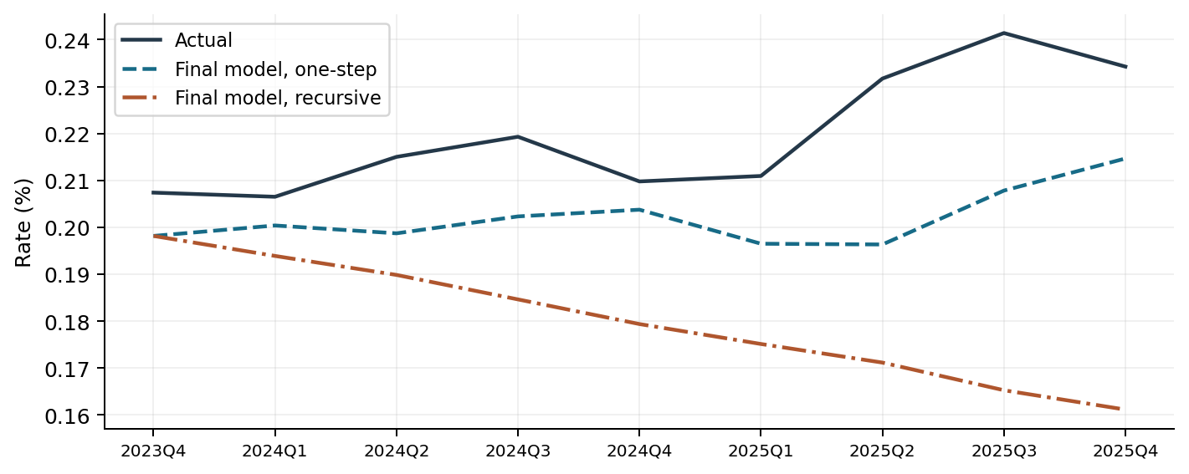
Table 9 Errors over 2023Q4–2025Q4
Forecast | RMSE (pp) | MAE (pp) | Bias (pp) | MAPE | Below actual
One-step | 0.02024 | 0.01752 | -0.01752 | 7.78% | 9 / 9
Recursive | 0.04608 | 0.03976 | -0.03976 | 17.61% | 9 / 9

Table 10 Quarterly forecasts and errors (forecast minus actual)
Quarter | Actual (%) | One-step (%) | Error (pp) | Recursive (%) | Error (pp)
2023Q4 | 0.20739 | 0.19815 | -0.00924 | 0.19815 | -0.00924
2024Q1 | 0.20651 | 0.20038 | -0.00612 | 0.19389 | -0.01262
2024Q2 | 0.21501 | 0.19871 | -0.01630 | 0.18984 | -0.02517
2024Q3 | 0.21930 | 0.20232 | -0.01699 | 0.18462 | -0.03469
2024Q4 | 0.20978 | 0.20375 | -0.00603 | 0.17936 | -0.03041
2025Q1 | 0.21094 | 0.19649 | -0.01445 | 0.17511 | -0.03583
2025Q2 | 0.23171 | 0.19633 | -0.03538 | 0.17115 | -0.06057
2025Q3 | 0.24142 | 0.20782 | -0.03359 | 0.16525 | -0.07617
2025Q4 | 0.23426 | 0.21467 | -0.01959 | 0.16112 | -0.07314

The two forecasts coincide in the first quarter. By 2025Q4, the one-step shortfall was 0.01959 pp. Carrying forward the prior recursive error at the estimated AR weight of 0.7030 added 0.05355 pp, for a total shortfall of 0.07314 pp.

10 C&I loan paths under S1 and S4
C&I loans are the final model’s only macro input. S1 is the August 2026 baseline and S4 is the January 2026 downside scenario (96th percentile). Both paths use the same historical loan balance of $2,698.71 billion in 2025Q4 as their starting point. The scenario vintages differ.
Figure 6 Commercial and industrial loan balances, USD billions
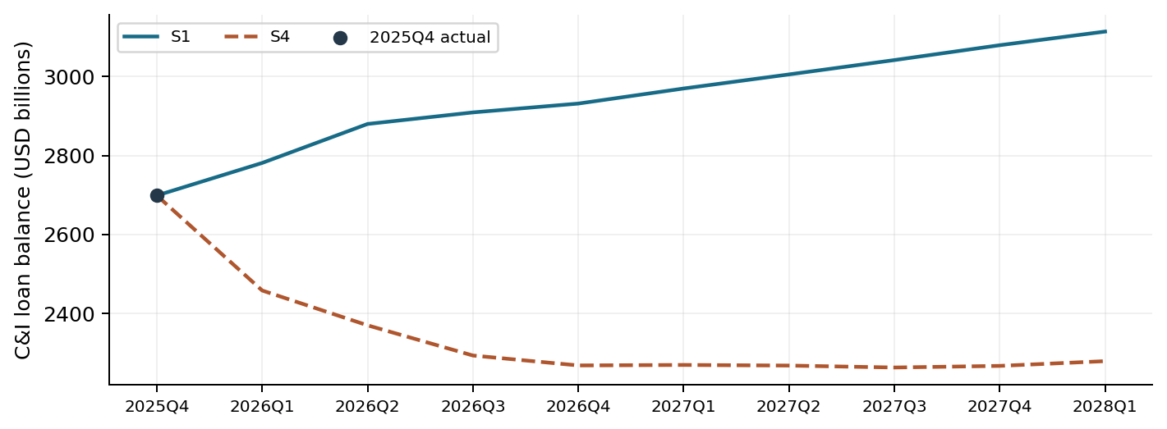
Table 11 Loan balances and the lagged log changes used for each forecast
Forecast quarter | S1 balance ($bn) | S4 balance ($bn) | S1 log change, L2 | S4 log change, L2
2026Q1 | 2,781.11 | 2,458.34 | 0.02130 | 0.02130
2026Q2 | 2,879.65 | 2,370.29 | 0.01017 | 0.01017
2026Q3 | 2,908.90 | 2,293.86 | 0.03008 | -0.09329
2026Q4 | 2,931.27 | 2,268.79 | 0.03482 | -0.03647
2027Q1 | 2,969.40 | 2,270.03 | 0.01011 | -0.03277
2027Q2 | 3,005.01 | 2,268.46 | 0.00766 | -0.01099
2027Q3 | 3,041.28 | 2,263.56 | 0.01292 | 0.00054
2027Q4 | 3,078.95 | 2,267.66 | 0.01192 | -0.00069
2028Q1 | 3,113.44 | 2,279.65 | 0.01200 | -0.00216

Balances are seasonally adjusted. The last two columns are unscaled natural-log changes from two quarters earlier. For the 2026Q3 forecast they compare each scenario’s 2026Q1 balance with the common 2025Q4 actual. The table covers the nine quarters supplied for both paths. S4 also includes balances through 2028Q4.

11 S1 and S4 fee rate forecasts
Both forecasts start from the observed 2025Q4 annualized fee rate of 0.23426%. The model uses the 47-quarter IS coefficients, continues the common trend and sets both event indicators to zero. From 2026Q2 onward, each scenario uses its own prior fee rate forecast as the AR(1) input.
Figure 7 Recursive forecasts of the annualized deposit fee rate
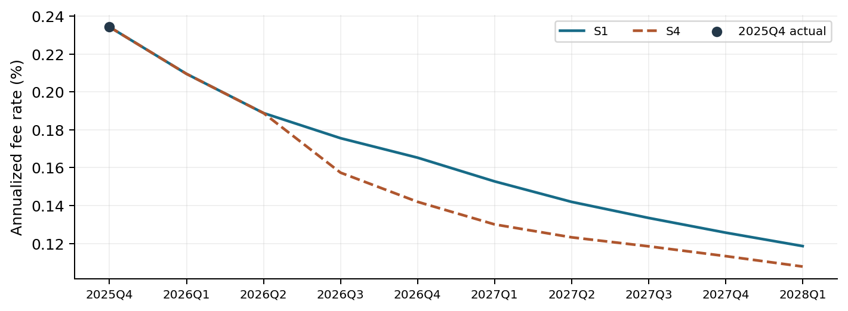
Table 12 Quarterly fee rate forecasts and downside gap
Quarter | S1 fee rate (%) | S4 fee rate (%) | S4 minus S1 (pp)
2026Q1 | 0.20951 | 0.20951 | 0.00000
2026Q2 | 0.18881 | 0.18881 | 0.00000
2026Q3 | 0.17555 | 0.15735 | -0.01819
2026Q4 | 0.16527 | 0.14196 | -0.02331
2027Q1 | 0.15274 | 0.13003 | -0.02271
2027Q2 | 0.14192 | 0.12321 | -0.01871
2027Q3 | 0.13344 | 0.11846 | -0.01498
2027Q4 | 0.12568 | 0.11329 | -0.01239
2028Q1 | 0.11858 | 0.10778 | -0.01080

The common downward trend contributes to the decline in both paths. Their first two forecasts coincide because the lagged loan changes come entirely from history. S4 first falls below S1 in 2026Q3. The gap peaks at 0.02331 pp in 2026Q4 and narrows to 0.01080 pp by 2028Q1 as S4 loan growth recovers.

