Noncomp Efficiency Ratio
Model Development Documentation
22 October 2026

1 Executive Summary

1.1 Model Overview
The Noncomp Efficiency Ratio (EF) Model provides quarterly projections of operating costs relative to income under alternative macroeconomic scenarios. EF is expressed as a decimal ratio. The selected specification is an autoregressive distributed lag model estimated in ratio levels. It combines lagged EF (the ratio observed one quarter earlier), lagged unemployment changes (quarterly unemployment-rate changes observed one quarter earlier, in percentage points) and a post-TARP period indicator (zero before 2014Q1 and one afterward). This document records the conceptual basis, estimation decisions, development data, performance assessment and operating controls for the model.

1.2 Business Purpose and Intended Use
EF expresses operating costs relative to income. A higher ratio indicates greater cost per unit of income and therefore weaker operating efficiency, holding the accounting definition constant. Projecting EF supports expense and profitability planning and provides a consistent measure for comparing baseline and stressed economic conditions. The current implementation produces quarterly ratio forecasts. Any downstream conversion to expense dollars requires a separately supplied income forecast with a compatible accounting definition.

1.3 Development Summary
Development began with 60 quarterly EF observations and 22 macroeconomic candidates spanning 2011Q1 through 2025Q4. Two observations in 2017 were smoothed using documented local averages. A level-and-trend break analysis characterized the historical transition around 2014Q1. Macro selection then began with a dynamic equation containing a linear trend. The trend coefficient had a p value of 0.1719; it was removed and the retained equation was re-estimated on the same development sample.

1.4 Final Model Structure
Table 1.1 Final model variable summary
Variable | Construction | Model role
Lagged EF | Smoothed EF observed one quarter earlier | Persistence in operating efficiency
FLBR_B.IUSA  U.S. unemployment rate | Unemployment is in percent; its quarterly change is lagged one quarter and measured in percentage points | Lagged labor-market transmission
D  Post-TARP period indicator | 0 through 2013Q4; 1 from 2014Q1 | Post-TARP period adjustment
The final equation contains a constant and the three terms above. It excludes a deterministic trend and transition pulse. Future forecasts use the same structure re-estimated through 2025Q4, while out-of-time performance is measured using coefficients fixed at the 2023Q3 development cutoff.

1.5 Performance and Out of Time Results
Table 1.2 Key performance measures
Measure | Development model | Full-history refit
Estimation period | 2011Q3–2023Q3 | 2011Q3–2025Q4
Observations | 49 | 58
Adjusted R² | 0.8265 | 0.8212
Fitted RMSE in EF percentage points | 2.833 | 2.822
The development model achieved a one-step out-of-time RMSE of 2.783 EF percentage points and a recursive RMSE of 3.728 percentage points over 2023Q4–2025Q4. Both improve on the corresponding persistence benchmarks. Unemployment, output-gap (the percentage difference between actual and potential real GDP) and real GDP (inflation-adjusted gross domestic product) specifications have closely comparable adjusted R² values. Unemployment produces the lowest one-step error; GDP produces the lowest recursive error. The final choice combines these results with the direct economic interpretation of labor-market deterioration.

1.6 Scenario and Sensitivity Summary
S1 represents the Baseline scenario and S4 supplies the alternative higher-unemployment path. Nine-quarter forecasts cover 2026Q1–2028Q1. Both begin at 55.395% because the first forecast uses a common historical unemployment change. Terminal EF is 56.790% under S1 and 57.287% under S4. A parallel one-percentage-point increase in future unemployment levels has a maximum incremental effect of 0.631 EF percentage points in 2026Q2, followed by gradual decay.

1.7 Key Assumptions
The specification assumes that EF reporting remains comparable, lagged EF continues to capture persistence and the positive relationship between unemployment changes and EF remains informative over the projection horizon.

1.8 Key Strengths
Its principal strengths are a transparent dynamic structure, a common sample for all 22 macro candidates, explicit trend assessment, traceable preprocessing and reproducible scenario calculations. The full-history unemployment coefficient remains close to its development estimate.

1.9 Limitations
The development sample contains 49 usable quarters, and the forecast evaluation contains nine quarters. Individual observations can affect coefficient significance. The model summarizes an aggregate cost-to-income relationship and cannot separately attribute changes to expense or revenue initiatives. These limitations are addressed through challenger comparisons, influence analysis, original-data sensitivity and a proposed monitoring program. The forecast evaluation also informed model selection, so subsequent forecasting vintages will provide additional evidence of performance.

1.10 Governance and Ownership
The model is governed under applicable Model Risk Management standards and SR 26-2 guidance. Performance is subject to periodic review, monitoring, and validation. Material changes to methodology, assumptions, inputs, implementation, or intended use require review and approval through established governance processes.

2 Model Theory and Design

2.1 Business Purpose and Conceptual Framework
The model links quarterly operating efficiency to its recent history and the economic environment. Cost and income components adjust at different speeds. Staffing, technology and servicing commitments can persist after customer activity or revenue conditions change. This adjustment pattern motivates a dynamic specification in which the previous quarter’s EF captures continuity in the operating cost base and income generation.

2.2 Business Context and Structural Transition
The historical series covers the early TARP-related period and subsequent operating conditions. The boundary beginning in 2014Q1 is treated as a fixed development assumption. A post-TARP indicator permits a shift in the conditional level of EF. The initial descriptive regression also allows the time slope to change at that boundary, enabling the early and later portions of the series to be examined separately.
The indicator summarizes a historical regime difference. Its coefficient may reflect several contemporaneous changes in the business and operating environment. The analysis therefore uses the boundary as a modeling convention and does not assign the entire estimated shift to a causal effect of TARP repayment.

2.3 Modeling Philosophy
Specification selection balances statistical evidence, economic interpretation and forecast behavior. All macro candidates are evaluated on the same calendar and under common transformation and entry rules. The initial dynamic equation includes a trend so that its incremental contribution can be assessed explicitly. The subsequent reduction removes the unsupported trend term while preserving the selected macroeconomic relationship and re-estimating all retained coefficients.

2.4 Rationale for Modeling EF in Levels
Ratio-level modeling preserves the quantity used in planning and allows each forecast to be carried directly into the next quarter. The level-and-trend break regression provides a preliminary description of deterministic movements. Residual ADF and KPSS diagnostics support the working representation of fluctuations around those fitted paths. The dynamic model is then assessed on its own conditional specification, residual behavior and forecasting performance.
The static break regression and the ARDL have different conditioning information. A significant trend in a regression without lagged EF does not require a significant additional time trend once lagged EF is present. Removal of the dynamic trend is based on its estimated contribution within the ARDL and the performance of the reduced equation. Ordinary residual diagnostics retain the inferential qualification described in Section 3.3.

2.5 Persistence and Macroeconomic Transmission
The autoregressive coefficient measures the persistence of EF after controlling for the period indicator and unemployment change. The full-history estimate of 0.736985 implies that a one-percentage-point increase in lagged EF raises the conditional next-quarter value by approximately 0.737 percentage points. Because this coefficient is below one, the response to a temporary disturbance decays across successive quarters when the other inputs are held fixed.
Unemployment provides an interpretable measure of broad labor-market conditions. Deterioration can coincide with reduced customer activity and income pressure, while parts of the operating cost base adjust more slowly. A positive coefficient on lagged unemployment change is consistent with a higher cost-to-income ratio under those conditions. This interpretation describes an aggregate predictive association; separate expense and income equations would be required to identify the underlying channels.

2.6 Final Specification and Forecast Mechanics
In the equation below, t is the quarterly time index, starting at one in 2011Q1. U is the unemployment rate represented by FLBR_B.IUSA. Δ denotes a quarterly difference, so ΔU(t−1) = U(t−1) − U(t−2). The parameters c, δ, φ and λ are the intercept, post-TARP indicator coefficient, lagged-EF coefficient and lagged unemployment-change coefficient, respectively. The error ε(t) represents unexplained quarterly variation in EF.
$${EF}_{t} = c + δD_{t} + φ{EF}_{t−1} + λΔU_{t−1} + ε_{t}$$
Table 2.1 Specification definitions
Term | Definition | Expected behavior
EF(t) | Smoothed quarterly EF, in decimal ratio units | Forecast target
D(t) | Post-TARP indicator beginning in 2014Q1 | Conditional period adjustment
EF(t−1) | Lagged EF | Positive persistence below one
ΔU(t−1) | FLBR_B.IUSA(t−1) − FLBR_B.IUSA(t−2) | Positive effect on EF
ε(t) | Unexplained quarterly EF variation | Centered residual variation
The macro input remains in percentage-point units, while EF remains in decimal ratio units. Recursive forecasts set future innovations to zero and use the preceding EF forecast as the next lagged dependent variable.

2.7 Alternative Macroeconomic Explanations
The output gap (FGAP_B.IUSA) and real GDP growth, calculated from FGDP$_B.IUSA, provide plausible activity-based explanations of efficiency. Their adjusted R² values are close to the unemployment specification, so in-sample fit alone offers little separation. Unemployment is retained for the main forecasting model because it combines competitive fit, the lowest one-step forecast error and a direct interpretation of deteriorating economic conditions. The GDP advantage under recursive evaluation remains part of the challenger evidence in Section 3.7.

2.8 Assumptions
Table 2.2 Assumptions inventory
Assumption
Historical and future EF ratios use comparable cost and income definitions.
Lagged EF remains informative, and the effects of temporary shocks decay over time.
Labor-market deterioration retains a positive conditional association with EF throughout the forecast horizon.
The post-2014 period remains an applicable reference regime for forecasting.
S1 and S4 unemployment paths have correct scenario labels, consistent units and aligned quarter-end dates.
A common set of linear coefficients provides an adequate approximation over the forecast horizon.

2.9 Limitations and Mitigants
The limited sample constrains the number of independently estimated effects. The selected equation contains four parameters, with 49 observations in development. Macro selection and the evaluation of several alternatives add model-selection uncertainty beyond individual coefficient p values. The comparison period supplies useful evidence for choosing a specification, while ongoing forecasting will be needed to assess performance on additional observations.
The 2017 smoothing choice changes both the dependent variable and subsequent lagged EF. The package retains original values, applies the adjustment explicitly and reports a same-specification original-data sensitivity. Pandemic unemployment changes also create influential observations. Leave-one-out analysis and influence statistics identify where estimated sensitivity depends most strongly on the historical sample.
Business initiatives, accounting changes and different expense or revenue dynamics can alter EF without a corresponding unemployment movement. Scenario forecasts are conditional on supplied paths and omit future innovations. They provide point projections rather than a complete probability distribution. These risks call for comparison with business plans, forecast-error monitoring and documented review of any proposed management adjustment.

2.10 Design Conclusion
The selected framework uses a limited number of economically interpretable terms and preserves a direct link between the historical regression and scenario projections. The design is supported by comparable challenger fit, residual diagnostics and forecast testing. Continued use should be accompanied by data, assumption and performance reviews.

3 Model Estimation

3.1 Overview of the Estimation Process
We first describe the historical level and trend. We then build a forecasting equation that includes lagged EF. We screen the macro candidates with a trend in place. After assessing the trend coefficient, we re-estimate the chosen equation. The final model then receives forecast and diagnostic testing.

3.2 Historical Level and Trend Break Analysis
The first regression allows the historical trend line to change in 2014Q1. It includes a time counter t, the period indicator D, and their interaction D × t. The counter starts at one in 2011Q1. It equals 13 in 2014Q1. The interaction D × t is zero before 2014Q1 and equals t afterward. In this regression, α is the prebreak intercept, θ is the difference between the postbreak and prebreak intercepts, β is the prebreak slope, γ is the slope change, and u(t) is the residual.
$${EF}_{t} = α + θD_{t} + βt + γD_{t} × t + u_{t}$$
Table 3.1 Full-history level and trend estimates
Term | Coefficient | Std error | t statistic | p value
Constant α | 0.603727 | 0.019710 | 30.630 | 1.143e-36
Intercept difference θ | 0.066791 | 0.023626 | 2.827 | 0.0065
Prebreak slope β | 0.014080 | 0.002678 | 5.258 | 2.364e-06
Slope change γ | −0.016607 | 0.002699 | −6.154 | 8.542e-08
The regression uses all 60 smoothed quarterly observations. The time and interaction coefficients show that the fitted slope changes after the selected boundary.
Figure 3.1 Smoothed EF and the fitted historical trend
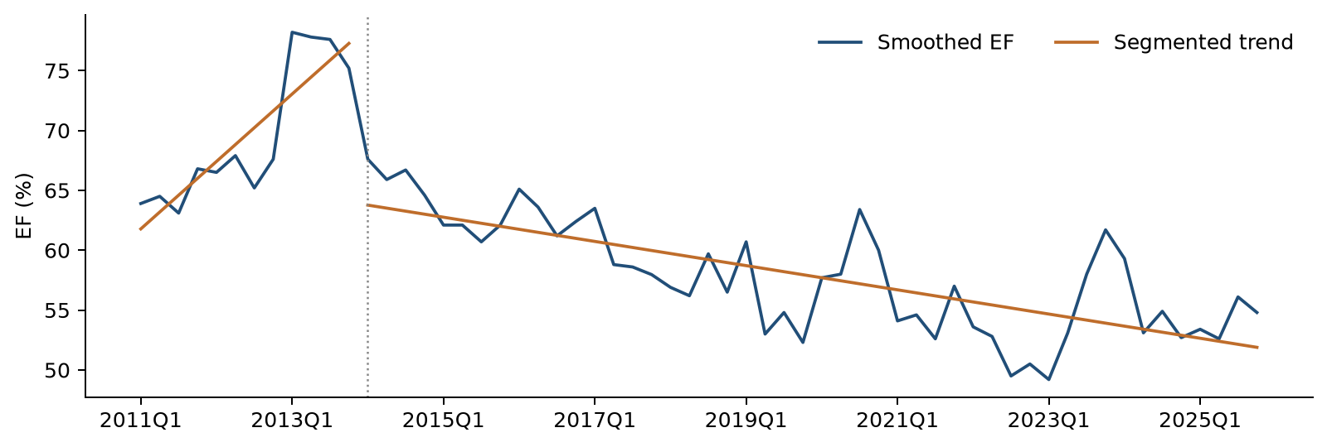
The fitted line rises before 2014Q1 and declines afterward. Separate lines allow the historical level and direction to change at the selected boundary.
Before 2014Q1, the estimated slope is +1.408 EF percentage points per quarter. After the boundary, it is −0.253 percentage points per quarter. These lines summarize the history. The forecasting equation adds lagged EF to represent how the ratio adjusts over time.

3.3 Residual Stationarity Assessment
ADF and KPSS diagnostics assess the residual process after fitting the level-and-trend break regression.
ADF evaluates a unit-root null, while KPSS evaluates a stationarity null. The reported ADF p values are below 0.05 and KPSS does not reject stationarity. Taken together, the results support the working representation of EF around fitted level-and-slope breaks.
Table 3.2 Residual stationarity checks
Sample | Check | Statistic | p value
Through 2023Q3 | ADF | −5.2240 | < 0.0001
Through 2023Q3 | KPSS | 0.0446 | > 0.10
Through 2025Q4 | ADF | −4.7569 | < 0.0001
Through 2025Q4 | KPSS | 0.1044 | > 0.10
Both checks support stationary fluctuations around the fitted level and trend break in each sample. We consider the two results together.
The p values use ordinary residual-test reference distributions. Estimating the break regression can affect those reference values. A formal break-adjusted unit-root conclusion requires a separately calibrated test. The results here serve as supporting diagnostic evidence.

3.4 Candidate Universe and Data Transformations
The candidate pool contains 22 macro series. Six use quarter-to-quarter log changes, which measure relative movement. The other 16 use changes in their original units. Every change is lagged one quarter. This gives every candidate the same 49 development observations from 2011Q3 through 2023Q3.

3.5 Forward Selection Framework
Forward selection adds one macro at a time. Each remaining candidate is fitted alongside the variables already in the equation. The starting equation contains a constant, D, t and lagged EF. A candidate must pass all four checks below.
Table 3.3 Entry rules used in each selection round
Check | Rule | What it checks
Coefficient p value | Below 0.05 | Evidence that the added macro contributes to the fitted equation
VIF | Below 10 | Multicollinearity among explanatory variables
Durbin–Watson | 1.5 to 2.5 | Serial-dependence screening convention
Jarque–Bera p value | Above 0.05 | Residual normality screening based on skewness and kurtosis
The lowest coefficient p value wins among eligible candidates. Ties use higher adjusted R² and then the fixed source-column order.
The search stops when all remaining candidates fail at least one rule. The DW range is a screening convention. Ljung–Box tests provide the final check for error patterns across quarters.

3.6 ARDL with Trend and Subsequent Reestimation
The initial ARDL includes a constant, the post-TARP indicator, a deterministic linear trend, lagged EF and the macro selected by forward screening. The coefficient b measures the additional linear time-trend contribution. Conventional OLS covariance and two-sided Student-t tests are used throughout. No HAC adjustment or transition pulse is included.
$${EF}_{t} = c + δD_{t} + bt + φ{EF}_{t−1} + λΔU_{t−1} + ε_{t}$$
FLBR_B.IUSA enters in the first round with p = 0.0330. After it enters, the lowest remaining candidate p value is 0.2229. The search therefore ends with one macro.
Table 3.4 Selected ARDL with a trend
Term | Coefficient | p value
Constant | 0.271984 | 0.0010
Period indicator D | −0.034941 | 0.0206
Linear time trend t | −0.000807 | 0.1719
Lagged EF | 0.634474 | < 0.0001
Lagged ΔUnemployment | 0.006204 | 0.0330
The trend p value is 0.1719. It exceeds the 0.05 decision threshold. Unemployment remains below the threshold.

Trend assessment and specification reduction
We remove the time trend and keep D, lagged EF and lagged ΔUnemployment. We then estimate all coefficients again on the same 49 quarters. A transition pulse is omitted throughout the ARDL analysis.
$${EF}_{t} = c + δD_{t} + φ{EF}_{t−1} + λΔU_{t−1} + ε_{t}$$
Table 3.5 Final development model
Term | Coefficient | p value
Constant | 0.193795 | 0.0008
Period indicator D | −0.043633 | 0.0020
Lagged EF | 0.738292 | < 0.0001
Lagged ΔUnemployment | 0.006417 | 0.0289
All retained coefficients have p-values below 0.05. The coefficient on lagged EF is 0.738292, and the coefficient on lagged ΔUnemployment is positive at 0.006417. The restricted equation re-estimates all coefficients after trend removal, avoiding the carryover of estimates from the with-trend specification. Appendix C provides the corresponding standard errors and t-statistics for each estimation stage. Taken together, these results support selecting the specification without a linear time trend as the final model.

3.7 Challenger Comparison and Final Specification Selection
Table 3.6 Three no-trend alternatives
Candidate | Coefficient | p-value | Adjusted R² | BIC | Validation RMSE
FLBR_B.IUSA  Unemployment rate  Lagged quarterly change | 0.006417 | 0.0289 | 0.826462 | -194.638 | 0.02783
FGAP_B.IUSA  Output gap  Lagged quarterly change | -0.006066 | 0.0267 | 0.826998 | -194.790 | 0.02906
FGDP$_B.IUSA  Real GDP  Lagged quarterly log change | -0.575334 | 0.0277 | 0.826748 | -194.719 | 0.02878
All three equations use the same 49 quarters. Their historical fit is very close. Unemployment has the lowest one-step error. GDP has the lowest recursive error. Validation RMSE is the one-step OOT RMSE in EF ratio units.
The adjusted R² values differ by less than 0.001 across the three specifications. Their similar fit supports consideration of forecast behavior and economic interpretation when choosing the main macro. Validation RMSE values are reported in EF ratio units.
We retain unemployment because its fit is comparable, its one-step error is lowest, and its economic meaning is direct. The complete screening records remain available.
After unemployment is retained in the no-trend model, the strongest remaining addition has a p-value greater than 0.05. The final equation therefore keeps one macroeconomic variable.

3.8 Full History Reestimation and Coefficient Interpretation
After development testing, we keep the chosen variables and re-estimate their weights using all 58 usable quarters through 2025Q4. These updated weights drive the S1 and S4 forecasts. Historical forecast-error scores continue to use the earlier development weights.
Table 3.7 Full-history coefficients for future forecasting
Term | Coefficient | p value
Constant | 0.194684 | 0.0003
Period indicator D | −0.045338 | 0.0010
Lagged EF | 0.736985 | < 0.0001
Lagged ΔUnemployment | 0.006314 | 0.0288
The unemployment coefficient remains positive and has p = 0.0288. Its estimate changes only slightly, from 0.006417 to 0.006314.
$${EF}_{t} = 0.194684 − 0.045338D_{t} + 0.736985{EF}_{t−1} + 0.006314ΔU_{t−1} + ε_{t}$$
A one-percentage-point increase in the relevant unemployment change raises fitted EF by about 0.631 percentage points. This describes the estimated historical relationship. Actual business responses can vary with the operating environment.

4 Model Development Data

4.1 Purpose and Scope of Development Data
The development dataset links a single quarterly EF series to a common history of potential macroeconomic drivers. The data architecture preserves original inputs, records each transformation and distinguishes historical estimation from future scenario assumptions. All available quarters within the specified calendar are retained after the documented 2017 adjustment; no random sampling is applied.

4.2 Historical Sample and Quarterly Frequency
The historical files contain 60 quarters from 31 March 2011 through 31 December 2025. Quarterly frequency aligns the supplied EF observations and macro series. The development cutoff is 2023Q3, followed by a nine-quarter out-of-time period. Differencing the macro input and then applying a one-quarter lag makes 2011Q3 the first common ARDL observation.
Table 4.1 Sample construction
Analysis | Period | Observations
Full-history static break regression | 2011Q1–2025Q4 | 60
Development static break regression | 2011Q1–2023Q3 | 51
ARDL selection and development estimation | 2011Q3–2023Q3 | 49
Out-of-time forecast assessment | 2023Q4–2025Q4 | 9
Fixed-specification full-history refit | 2011Q3–2025Q4 | 58

4.3 Internal EF Data
The file inputs/ef.csv contains Quarter (the quarter-end date) and EF. EF is supplied in decimal ratio units, so 0.548 represents 54.8%. The model accepts the reported ratio and does not reconstruct its accounting numerator or denominator.

4.4 External Macro and Scenario Data
The file inputs/macro.csv contains the same quarter-end calendar and 22 original provider-coded columns. The universe covers labor conditions, output, income and compensation, rates, credit conditions and sentiment. All candidates begin in 2011Q1. Appendix A records the descriptions, units and transformations for every source code.
The separate files scenarios/S1.csv and scenarios/S4.csv contain nine future FLBR_B.IUSA unemployment levels, expressed in percent. S1 is the Baseline path. Scenario observations remain outside the historical inputs and cannot enter estimation. The code joins them to the historical unemployment anchors only when constructing future lagged changes.

4.5 Data Lineage and Preparation
Table 4.2 Data lineage and transformation inventory
Final Variable | Source File(s) | Description | Transformation Steps | Final Formula | Model Role
EF | inputs/  ef.csv | Quarterly efficiency ratio in decimal units | Retain raw values; replace the two documented 2017 observations with original-value local averages. | Raw EF(t);  Table 4.3  for 2017  changes | Dependent variable
Lagged EF | inputs/  ef.csv | Smoothed EF observed one quarter earlier | Apply smoothing; shift the complete series by one quarter. | EF(t−1) | Autoregressive term
22 macro candidate features | inputs/  macro.csv | X is a source macro level; series are listed in Appendix A. | Align quarters; take log differences for six series and level differences for 16; lag one quarter. | ln X(t−1)  − ln X(t−2)  or  X(t−1)  − X(t−2) | Candidate screening
Lagged  ΔUnemployment | inputs/  macro.csv | Quarterly change in FLBR_B.IUSA, in percentage points | Difference unemployment levels; shift the change by one quarter. | U(t−1)  − U(t−2) | Retained macro driver
D, t and D × t | Quarter in historical inputs | Post-TARP indicator, time index and interaction | Set t = 1 in 2011Q1 and D = 1 from 2014Q1; multiply D by t. | D = 0 or 1;  t = quarter  index;  D × t | Period adjustment and trend analysis
Scenario lagged  ΔUnemployment | scenarios/  S1.csv;  scenarios/  S4.csv;  inputs/  macro.csv | Separate future unemployment paths with historical anchors | Join each scenario to historical unemployment; difference and lag on the quarterly calendar. | U(t−1)  − U(t−2) | Recursive scenario forecasts
Estimated coefficients | Historical features from inputs/  ef.csv and inputs/  macro.csv | Separate development and full-history estimates | Estimate the selected equation on each sample; identify the results separately. | c, δ, φ, λ | Development estimates for OOT; full-history estimates for scenarios
The preparation sequence is deterministic. The program validates schemas and dates, retains the original EF values, calculates smoothing, aligns the macro history, constructs transformations and then forms the common estimation samples. All six log-change series must have positive source values. Transformations are calculated from the complete quarterly calendar.

4.6 Outlier Assessment and Adjustment
Two sharp EF movements in 2017 are treated as potential local outliers. The selected development series replaces each point with a three-quarter average based exclusively on original values. This reduces the local discontinuity while preserving both observations and their calendar positions.
Table 4.3 Documented EF smoothing
Quarter | Original EF | Original observations averaged | Adjusted EF
2017Q3 | 0.508 | 2017Q2, 2017Q3, 2017Q4 | 0.586000
2017Q4 | 0.662 | 2017Q3, 2017Q4, 2018Q1 | 0.579667
Both replacements use the original series values. The calculation is applied in code, leaving the input file unchanged. These centered averages use adjacent historical quarters and constitute a retrospective preprocessing choice. Both adjustments precede the out-of-time evaluation. All other EF observations, including the pandemic period, remain unchanged.

4.7 Data Quality and Inclusion Criteria
Table 4.4 Input quality controls
Review Area | Assessment Performed | Result
Completeness | Review observation counts and availability of every historical macro column. | 60 quarters of EF and all 22 macro series are available on the common historical calendar.
Time-Series Alignment | Check quarter-end dates and exact historical and scenario calendars. | Historical series use the same quarterly calendar; S1 and S4 use the required nine-quarter forecast horizon.
Uniqueness | Check for duplicate dates before estimation. | Duplicate dates are rejected by input validation.
Numeric Integrity | Check for missing and nonnumeric observations. | Missing and nonnumeric values are rejected before feature construction.
Unit Consistency | Check EF decimal-ratio units and unemployment percent units. | Input validation applies EF and unemployment range checks.
Transformation Validity | Check source values for all log-change candidates. | The six log-change series must contain strictly positive source values.
Source Preservation | Compare input checksums before and after execution and retain transformed outputs separately. | Raw input files are preserved; adjustments and derived features are exported separately.
The sample loses two initial observations because the lagged macro change requires two historical levels. This is a transformation requirement rather than a missing-data adjustment. The first two EF values remain available as historical anchors. No additional quarter is removed from the smoothed development or full-history ARDL sample.

4.8 Data Relevance and Sufficiency
The dataset is considered relevant because the target variable and primary explanatory drivers originate directly from the business process being modeled. The sample is also considered sufficient because it spans multiple economic cycles and includes materially different interest-rate, liquidity, and operating environments. The inclusion of both benign and stressed periods enhances confidence that estimated relationships represent persistent patterns rather than isolated events.

4.9 Data Assumptions and Limitations
The development dataset is assumed to be complete, accurate and consistent throughout the observation period. Reporting definitions for EF are assumed to remain materially comparable over time. Provider-coded macroeconomic data are assumed to be reliable and representative of economic conditions relevant to EF. Historical observations, including the COVID-19 period and subsequent economic adjustment, remain in the estimation samples. The two documented 2017 EF observations are smoothed using local averages calculated from original values.
Despite the breadth of the historical period, limitations remain. Business developments, service launches, pricing initiatives and management actions are difficult to represent using the EF ratio and macroeconomic variables alone. The dataset may therefore omit sources of future variation in EF. The limited quarterly sample and the two smoothing adjustments also affect estimation. Challenger analysis, OOT testing and periodic review provide supporting assessments of these limitations.

5 Linkages with Other Models

6 Model Testing

6.1 Testing Philosophy
Model testing evaluates the statistical adequacy, stability, forecast accuracy and economic reasonableness of the Noncomp Efficiency Ratio model. The assessment combines historical fit, coefficient inference, residual diagnostics, out-of-time forecasts, challenger models and scenario sensitivity. The results support retaining the reduced ARDL specification, with forecast bias and observation influence included in the ongoing review framework.
The development sample contains 49 usable quarters from 2011Q3 through 2023Q3. The out-of-time evaluation covers nine quarters from 2023Q4 through 2025Q4. The final specification is subsequently re-estimated using 58 usable quarters through 2025Q4 for forward scenario forecasting. EF is expressed as a decimal ratio; multiplying by 100 gives EF percent. Forecast errors are reported in EF percentage points where indicated.

6.2 In-Sample Performance Assessment
The development model achieves an adjusted R² of 0.8265 and a fitted-value RMSE of 0.02833. The full-history refit achieves an adjusted R² of 0.8212 and an RMSE of 0.02822. Actual and fitted values show that the model captures the broad historical movement in EF while allowing for quarterly variation. Similar fit across the two samples supports the consistency of the selected specification.
Table 6.1 In-Sample Performance Metrics
Metric | Development | Full history
Observations | 49 | 58
R-squared | 0.8373 | 0.8306
Adjusted R-squared | 0.8265 | 0.8212
RMSE in EF ratio units | 0.02833 | 0.02822
Residual standard error | 0.02956 | 0.02924
Both estimates contain an intercept and three explanatory terms. Full-history fit includes the nine OOT quarters and is reported separately from OOT performance.
Figure 6.1 Actual versus Fitted Values
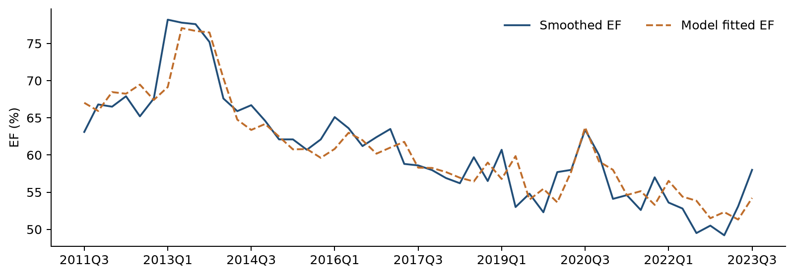
Smoothed actual EF and fitted EF over the development period. The fitted series uses observed lagged EF and the development coefficients.

6.3 Coefficient Significance Testing
The initial ARDL includes the post-TARP indicator, a linear trend, lagged EF and the lagged quarterly change in FLBR_B.IUSA. The trend coefficient has p = 0.1719 and is removed. The remaining specification is re-estimated on the same development observations. No transition pulse is included at either stage.
All retained terms are significant at the 5% level in the development model and the full-history refit. The unemployment coefficient is positive, consistent with higher costs relative to income during weakening labor-market conditions. The coefficient on lagged EF is positive and below one, indicating persistence with a declining response to a temporary disturbance. The post-TARP indicator captures the historical level difference associated with the fixed 2014Q1 boundary.
Table 6.2 Development Coefficient Estimates
Variable | Coefficient | Std error | t statistic | p value | 95% CI
Intercept | 0.193795 | 0.053801 | 3.602 | 0.0008 | [0.085434, 0.302155]
D | −0.043633 | 0.013267 | −3.289 | 0.0020 | [−0.070354, −0.016912]
Lagged EF | 0.738292 | 0.076265 | 9.681 | < 0.0001 | [0.584685, 0.891898]
Lagged ΔUnemployment | 0.006417 | 0.002844 | 2.257 | 0.0289 | [0.000689, 0.012144]
Table 6.3 Full-History Coefficient Estimates
Variable | Coefficient | Std error | t statistic | p value | 95% CI
Intercept | 0.194684 | 0.050779 | 3.834 | 0.0003 | [0.092879, 0.296489]
D | −0.045338 | 0.012983 | −3.492 | 0.0010 | [−0.071368, −0.019308]
Lagged EF | 0.736985 | 0.071876 | 10.254 | < 0.0001 | [0.592882, 0.881088]
Lagged ΔUnemployment | 0.006314 | 0.002810 | 2.247 | 0.0288 | [0.000680, 0.011947]
D equals zero before 2014Q1 and one from 2014Q1 onward. ΔFLBR_B.IUSA is the quarterly unemployment-rate change in percentage points, lagged one quarter. Standard errors, two-sided Student-t p values and confidence intervals use conventional OLS covariance, with 45 and 54 residual degrees of freedom, respectively. The coefficient p values are conditional on the selected specification and do not adjust for the macro screening process.

6.4 Multicollinearity Assessment
Variance Inflation Factors assess shared information among the explanatory variables. The maximum nonconstant VIF is 1.6114 in development and 1.6414 after the full-history refit, well below the screening limit of 10. These results indicate limited multicollinearity in the retained specification.
Table 6.4 Variance Inflation Factors
Variable | Development | Full history
D | 1.6032 | 1.6315
Lagged EF | 1.6114 | 1.6414
Lagged ΔUnemployment | 1.0065 | 1.0078
The intercept is excluded from the VIF assessment.

6.5 Residual Diagnostics
Residual diagnostics assess serial dependence and distributional shape. Ljung-Box tests at four and eight quarterly lags do not reject the absence of residual autocorrelation at the 5% level in either sample. Jarque-Bera p values are 0.2744 and 0.3849. These results support the assessed residual properties of the final model.
Table 6.5 Residual Diagnostic Statistics
Diagnostic | Development statistic | Development p | Full-history statistic | Full-history p
Ljung Box 4 | 5.2946 | 0.1515 | 6.7614 | 0.0799
Ljung Box 8 | 9.0562 | 0.2486 | 10.3557 | 0.1693
Jarque Bera | 2.5865 | 0.2744 | 1.9093 | 0.3849
Durbin Watson | 2.1954 | — | 2.1631 | —
Ljung-Box reference degrees of freedom are three and seven after allowing for one fitted autoregressive term. The full-history four-lag p value of 0.0799 warrants monitoring. Durbin-Watson values of 2.1954 and 2.1631 are within the development screening range of 1.5 to 2.5. Durbin-Watson is interpreted descriptively because lagged EF is an explanatory variable; no DW p value is assigned.
Figure 6.2 Residuals over Time
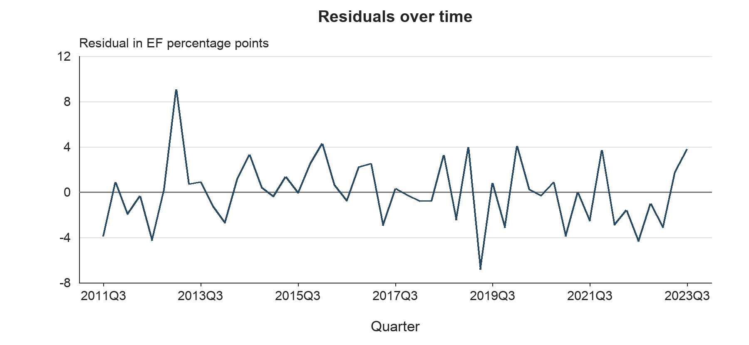
The development residuals fluctuate on both sides of zero without a sustained upward or downward trend. The largest positive residual occurs in 2013Q1. Ljung-Box p-values of 0.1515 at lag four and 0.2486 at lag eight provide supporting evidence on residual serial dependence.
Figure 6.3 Residuals versus Fitted EF
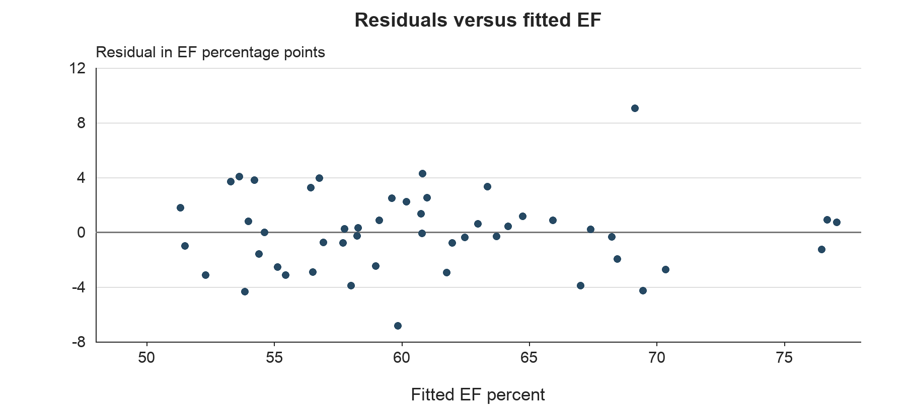
Residuals are dispersed around zero across the fitted EF range, with several larger errors at higher fitted values. The scatter shows no pronounced curved pattern. The spread and isolated larger residuals remain relevant when assessing the linear specification.
Figure 6.4 Normal Q–Q Plot
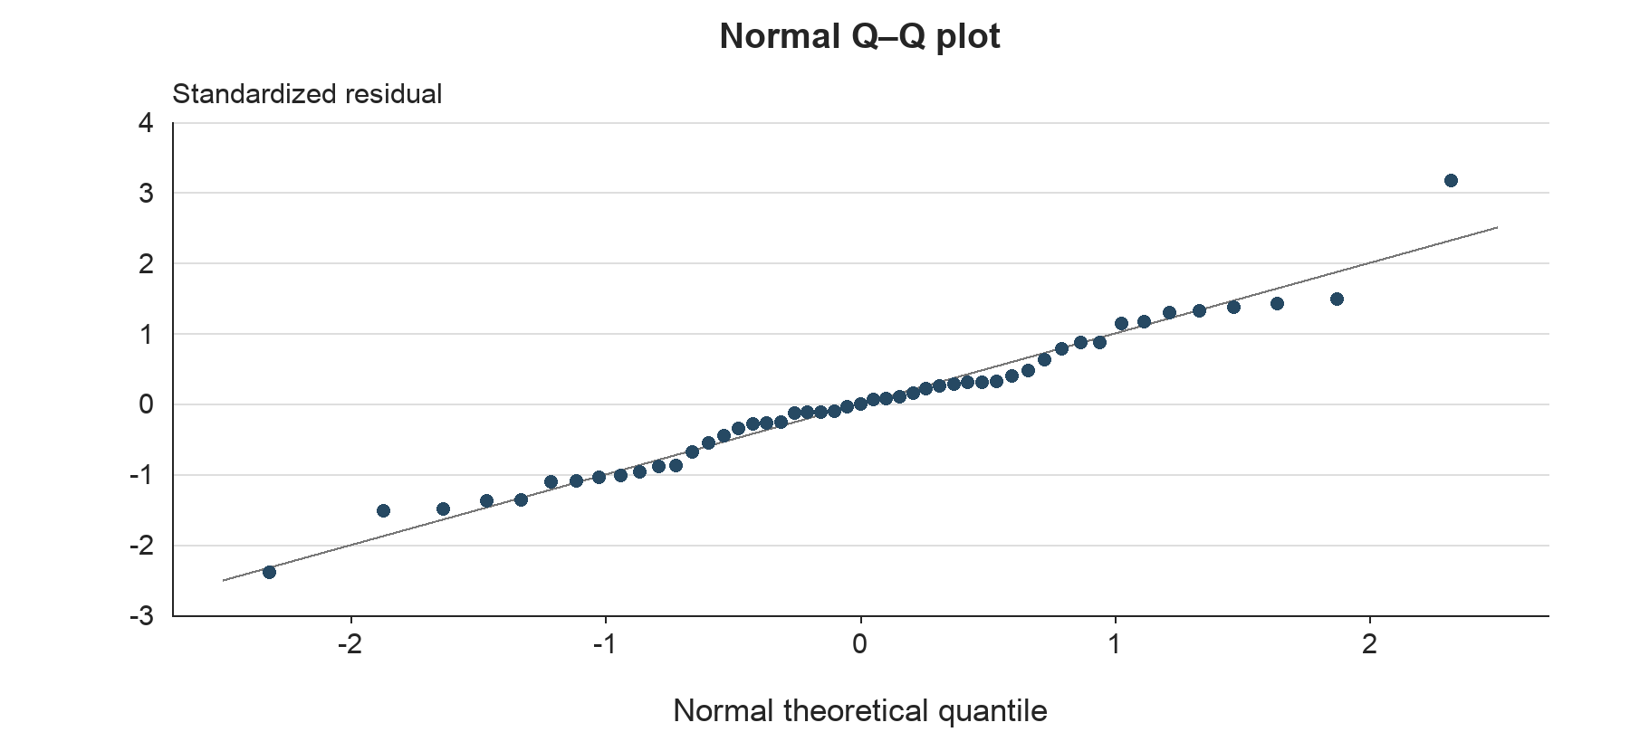
Most standardized residuals lie close to the normal reference line, with a more visible deviation at the upper tail. The development Jarque-Bera p-value of 0.2744 does not reject normality at the 5% level. The plot and test provide complementary evidence on residual distributional shape.

6.5.1 Evaluation of Statistical Assumptions
The assessment considers the time-series specification, collinearity, serial dependence, residual normality and dynamic behavior together. The preliminary segmented-trend analysis produces residual ADF and KPSS results consistent with stationary deviations around a trend with a level and slope break. These are ordinary residual diagnostics; their p values do not incorporate first-stage breakpoint detrending. The final ARDL is also assessed directly through its residual diagnostics and forecast behavior.
Table 6.6 Statistical Assumption Assessment
Assessment area | Evidence | Interpretation
Time-series behavior | Final residual ADF p < 0.0001 and KPSS p > 0.10 in both samples | Supportive residual diagnostics
Multicollinearity | Maximum nonconstant VIF of 1.6114 and 1.6414 | Limited shared information
Serial dependence | Ljung-Box p > 0.05 at lags 4 and 8 | No rejection at 5%; monitor lag 4
Residual normality | JB p = 0.2744 and 0.3849 | No rejection at 5%
Dynamic persistence | Lagged EF coefficients of 0.7383 and 0.7370 | Temporary effects decay
Economic interpretation | Positive coefficient on lagged unemployment change | Consistent with cost-to-income pressure
These checks address the properties reported above. They do not establish exogeneity or constant error variance. Conventional OLS inference remains conditional on the regression assumptions, and monitoring should consider residual plots and business changes alongside formal test results.

6.6 Stability Testing Framework
Stability testing examines whether the estimated relationships remain consistent as the observation set changes and whether cumulative residual behavior indicates a shift in the fitted relationship. The completed assessment uses OLS-residual CUSUM, comparison of development and full-history estimates, and leave-one-out estimation. These checks complement the historical forecast evaluation.
Table 6.7 CUSUM Stability Results
Sample | CUSUM statistic | p value
Development | 0.7016 | 0.7086
Full history | 0.8039 | 0.5379
CUSUM does not reject coefficient stability at the 5% level in either sample. The result is considered together with coefficient comparisons and forecast errors because a single stability test cannot rule out every form of parameter change.

6.7 Rolling Coefficient Stability
A sequential rolling-window coefficient analysis remains a further monitoring test. The completed development evidence compares the original estimation period with the full-history refit and assesses sensitivity to individual observations. The two estimation samples produce the same coefficient signs and similar coefficient magnitudes.
Table 6.8 Coefficient Comparison Across Estimation Samples
Variable | Development | Full history
Intercept | 0.193795 | 0.194684
D | −0.043633 | −0.045338
Lagged EF | 0.738292 | 0.736985
Lagged ΔUnemployment | 0.006417 | 0.006314
The lagged-EF coefficient changes from 0.738292 to 0.736985, and the unemployment coefficient changes from 0.006417 to 0.006314. The latter remains significant at 5% in both samples. These results support consistency across the two samples. A future rolling exercise should track coefficient signs and uncertainty using a documented window convention, with particular care when the window no longer contains pre-2014 observations needed to identify D separately from the intercept.

6.8 Rolling Prediction Error Analysis
The available sequential forecast assessment updates observed lagged EF each quarter while holding the development coefficients fixed. This produces nine one-step forecast errors. A second path uses recursive EF forecasts throughout the same period. The evaluation therefore measures the value of updating the EF state as new observations arrive; rolling-window coefficient re-estimation has not been performed.
One-step errors include both overprediction and underprediction. Recursive forecasts exceed actual EF in each quarter from 2024Q2 through 2025Q4. This pattern is reflected in the signed mean errors reported in Section 6.10 and is relevant to the model’s use for an uninterrupted multi-quarter forecast.

6.9 Out-of-Time Testing Framework
Out-of-time testing uses 2023Q4 through 2025Q4. Coefficients are frozen at their development estimates through 2023Q3. One-step forecasts use the actual EF from the preceding quarter. Recursive forecasts begin with actual 2023Q3 EF and then substitute the previous forecast into the lagged-EF term. The first-quarter predictions are identical under the two methods.
Both methods use observed historical macro inputs, so the scores evaluate EF forecasts conditional on the realized macro path. The nine-quarter window was reviewed during model selection. It provides development validation evidence, while an additional future period is needed for a fresh confirmation assessment. Full-history coefficients are reserved for future S1 and S4 projections.

6.10 OOT Results and Interpretation
The final model produces one-step RMSE of 0.02783 and recursive RMSE of 0.03728, equivalent to 2.783 and 3.728 EF percentage points. Both improve on their corresponding persistence benchmarks. Updating actual lagged EF reduces forecast error relative to a fully recursive path.
Table 6.9 OOT Forecast Performance
Forecast method | RMSE in EF pp | MAE in EF pp | Mean error in EF pp
Final ARDL one step | 2.783 | 2.304 | −0.837
Final ARDL recursive | 3.728 | 3.481 | −2.319
Error is actual EF minus forecast EF. Negative mean errors indicate average overprediction. Persistence uses the previous actual EF for one-step forecasts and fixed 2023Q3 EF for recursive forecasts.
Figure 6.5 Out-of-Time Actual and Forecast EF
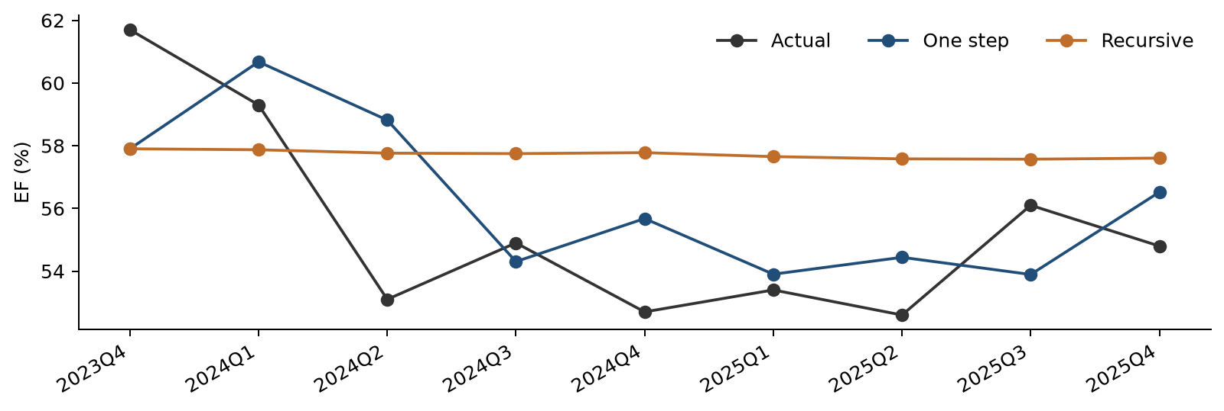
Quarterly actual EF compared with frozen-coefficient one-step and recursive forecasts over the nine-quarter OOT period.
The mean error is −0.837 EF percentage points for one-step forecasts and −2.319 for recursive forecasts. The recursive path is smoother and remains close to 57.6% late in the evaluation period, whereas most corresponding actual values are lower. This indicates a tendency to overpredict over the observed multi-quarter horizon.

6.11 Root Cause Assessment
The difference between one-step and recursive performance is consistent with the model’s forecast mechanism. One-step forecasts incorporate each newly observed EF level. Recursive forecasts propagate the previous prediction, so an initial level discrepancy can persist through the lagged-EF coefficient. Small subsequent unemployment changes provide limited additional movement in the recursive path.
The observed error pattern identifies a forecasting limitation that requires monitoring. It does not, by itself, establish a change in accounting, pricing, expense management or other business behavior. A business attribution would require a review of the underlying income and expense components. CUSUM and the full-history coefficient comparison provide supporting stability evidence, but neither identifies the business cause of a forecast error.

6.12 Overlay Support Analysis
No management overlay is applied to the historical forecasts or the S1 and S4 projections. The current outputs retain the estimated model response. The nine-quarter bias assessment does not provide a sufficient basis for a permanent additive or multiplicative correction without further calibration and business support.
If a recurring bias leads to a proposed overlay, its rationale should identify the relevant business development, quantify its expected EF impact and distinguish that adjustment from model re-estimation. Approval should specify the adjustment method, application period, monitoring criteria and conditions for withdrawal. Unadjusted model forecasts should remain available for comparison.

6.13 Scenario Testing
Scenario testing uses the fixed final specification re-estimated through 2025Q4. S1 is the original Baseline unemployment path. S4 is maintained as a separate unemployment path. Forecasts cover 2026Q1 through 2028Q1, begin with actual 2025Q4 EF of 0.548, hold D at one and recursively use each predicted EF in the following quarter.
The macro input is the lagged quarterly percentage-point change in FLBR_B.IUSA. Both scenarios therefore produce the same EF forecast in 2026Q1 because that quarter uses the shared unemployment change from 2025Q3 to 2025Q4. Scenario-specific changes first affect EF in 2026Q2. The 2028Q1 unemployment input would enter EF in 2028Q2, beyond the displayed horizon.

6.14 Scenario Results and Reasonableness Assessment
Both scenarios begin at EF of 55.395%. S4 produces higher EF from 2026Q2 onward as larger unemployment increases enter the model. S4 EF peaks at 57.994% in 2026Q4 and then moderates as the unemployment increases become smaller and earlier effects decay. By 2028Q1, EF is 56.790% under S1 and 57.287% under S4, a difference of approximately 0.50 percentage points.
Table 6.10 Scenario Inputs and Recursive EF Forecasts
Quarter | S1 FLBR_B.IUSA % | S4 FLBR_B.IUSA % | S1 EF % | S4 EF %
2026Q1 | 4.333 | 6.565 | 55.395 | 55.395
2026Q2 | 4.267 | 7.900 | 55.686 | 57.096
2026Q3 | 4.170 | 8.566 | 55.933 | 57.856
2026Q4 | 4.303 | 8.936 | 56.095 | 57.994
2027Q1 | 4.513 | 9.191 | 56.360 | 57.909
2027Q2 | 4.623 | 9.359 | 56.604 | 57.774
2027Q3 | 4.703 | 9.429 | 56.720 | 57.619
2027Q4 | 4.710 | 9.456 | 56.787 | 57.443
2028Q1 | 4.680 | 9.428 | 56.790 | 57.287
Figure 6.6 S1 and S4 Macro Paths and EF Forecasts
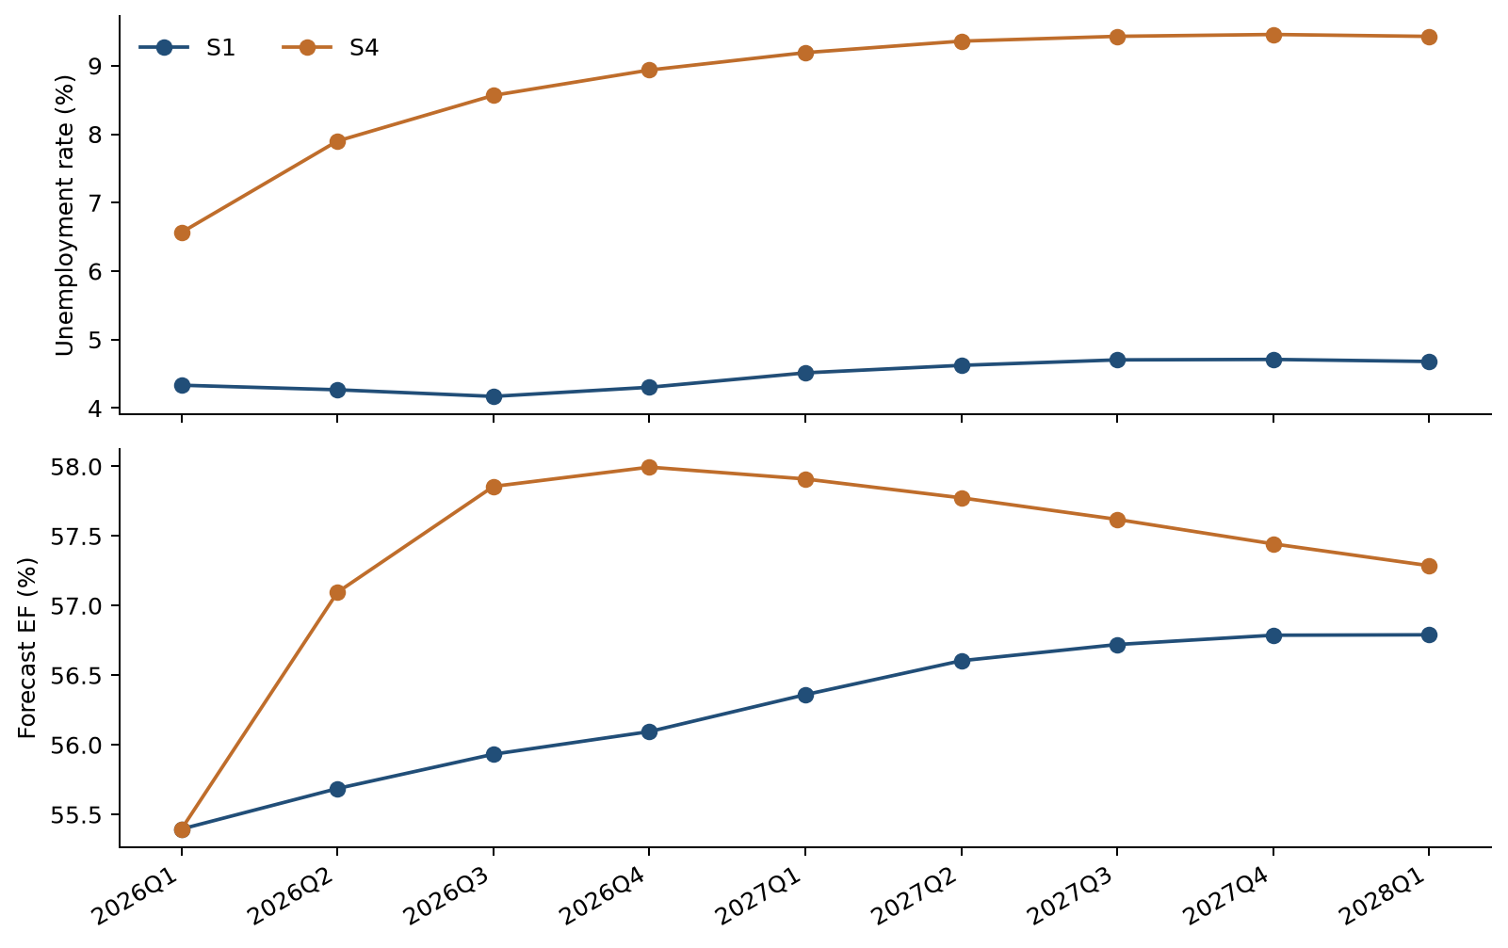
The unemployment paths are shown above the corresponding recursive EF forecasts. Higher EF represents greater costs relative to income. Scenario separation follows the timing of lagged unemployment changes.
The paths remain within the historical EF range and exhibit bounded responses under the supplied scenarios. The positive unemployment coefficient gives an economically interpretable direction of stress. The later narrowing of the paths follows from using unemployment changes together with a lagged-EF coefficient below one. Scenario forecasts are conditional point estimates and carry no assigned scenario probabilities.

6.15 Benchmarking Against Literature
Published Federal Reserve PPNR methodology provides a methodological reference for linking bank performance to macroeconomic conditions and recent performance measures. Its 2025 model descriptions include autoregressive and panel-regression specifications for revenue and expense ratios. The Noncomp EF specification follows the general practice of combining persistence with a macroeconomic driver. Differences in targets, data and model design preclude treating that comparison as a quantitative ranking of forecast accuracy.
Source: Federal Reserve, 2025 Supervisory Stress Test Methodology, Descriptions of Supervisory Models, Pre-provision Net Revenue.
Quantitative benchmarking uses alternative models estimated on the same development sample and evaluated over the same OOT quarters. The FLBR_B.IUSA, FGAP_B.IUSA and FGDP$_B.IUSA specifications have closely comparable adjusted R² values. FLBR_B.IUSA has the lowest one-step RMSE, while FGDP$_B.IUSA has the lowest recursive RMSE.
Table 6.11 Internal Challenger Model Comparison
Macro | Adjusted R² | One-step RMSE | Recursive RMSE | Selection
FLBR_B.IUSA | 0.8265 | 0.02783 | 0.03728 | Selected
FGAP_B.IUSA | 0.8270 | 0.02906 | 0.03643 | Challenger
FGDP$_B.IUSA | 0.8267 | 0.02878 | 0.03501 | Challenger
RMSE values are in EF ratio units. Each model contains an intercept, D, lagged EF and one lagged transformed macro variable.
FLBR_B.IUSA is retained based on its comparable historical fit, lower one-step validation error and direct labor-market interpretation. The GDP and output-gap models remain useful challengers for monitoring multi-quarter forecasting performance.

6.16 User Review and Acceptance
User review should address the EF accounting definition, preprocessing of the two 2017 observations, the interpretation of FLBR_B.IUSA, the distinction between one-step and recursive forecasts, and the labeling of S1 and S4. Business users should also assess the materiality of the historical recursive forecast bias before approving the model’s operational use.
Formal production User Acceptance Testing and business sign-off remain pending. The development package passed 16 automated tests and numerical reconciliation of 4,413 reported values across 47 verification checks, with a maximum absolute difference of approximately 1.72 × 10⁻¹². These checks establish reproducibility of the packaged calculations. Production UAT should additionally confirm input ingestion, scenario handling, output reconciliation, access controls and the documented operating process.

6.17 Sensitivity Analysis
Sensitivity testing applies a parallel increase or decrease of one percentage point to every future FLBR_B.IUSA level, separately for S1 and S4. Historical levels remain unchanged. Quarterly changes and their one-quarter lags are recalculated before the recursive forecasts are generated. This isolates the response to a higher or lower unemployment path while preserving the model coefficients and all other inputs.
Table 6.12 Sensitivity to a Parallel Unemployment Level Shift
Quarter | EF effect of +1 pp | EF effect of −1 pp
2026Q1 | 0.0000 | 0.0000
2026Q2 | 0.6314 | −0.6314
2026Q3 | 0.4653 | −0.4653
2026Q4 | 0.3429 | −0.3429
2028Q1 | 0.0746 | −0.0746
Effects are in EF percentage points. Incremental effects are identical around S1 and S4 because the forecasting equation is linear.
Figure 6.7 Unemployment Path Sensitivity
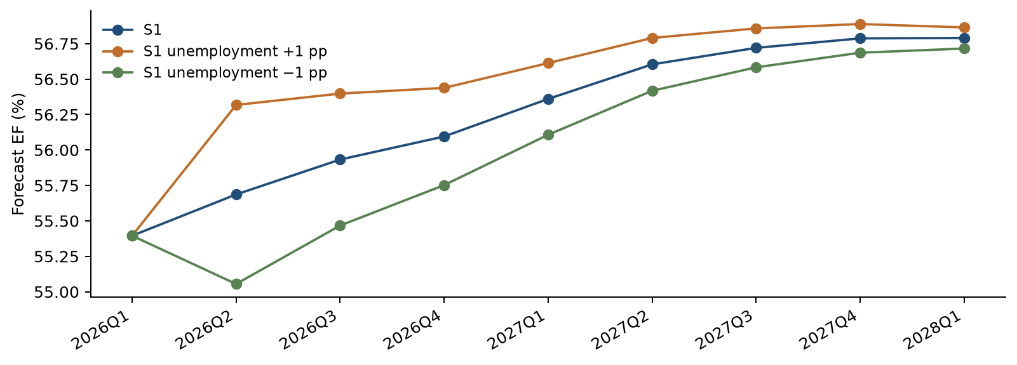
S1 EF forecasts under the original unemployment path and parallel level shifts of plus or minus one percentage point. Forecast separation begins after the model’s one-quarter macro lag.

6.18 Testing Conclusions
The testing results support the reduced ARDL as the retained Noncomp EF forecasting specification. Historical fit is similar in development and full history, retained coefficients are significant under conventional OLS inference, and VIF, Ljung-Box, Jarque-Bera and CUSUM results support the assessed model properties. Forecast responses to S1, S4 and the unemployment sensitivity tests are bounded and consistent with the estimated lag structure.
OOT accuracy exceeds the corresponding persistence benchmarks, and FLBR_B.IUSA has the lowest one-step error among the three principal macro alternatives. Recursive overprediction, the GDP challenger’s lower recursive RMSE and individual-observation sensitivity define specific areas for continued monitoring.

7 Model Implementation

7.1 Implementation Platform and Calculation Flow
The implementation is a standalone Python package named Noncomp_EF_Code_and_Data_20261019. The main program is noncomp_ef_model.py. It reads the two historical CSV inputs and the separate scenario files. It then prepares the data, screens candidates, estimates the equations and writes the results to CSV.
The code calculates the two EF adjustments from the original input. It calculates each macro transformation and lag from the common quarterly history. Selection and the decision on the trend are recalculated each time the program runs.

7.2 Implementation Controls
Table 7.1 Controls in the current package
Control | Program behavior
Input schema | Checks the expected columns and quarter-end dates
Data completeness | Stops for missing, duplicate or nonnumeric observations
Data units | Checks EF ratio units and unemployment percent bounds
Log changes | Requires positive levels for the six log-change series
Output protection | Protects a nonempty result directory unless overwrite is requested
Scenario driver | Stops scenario forecasting if selection requires an unsupported macro
Traceability | Writes input and output file checksums
Original inputs | Checks that input contents are unchanged during the run
The current calendar is fixed at 2011Q1–2025Q4, with future scenarios through 2028Q1. Extending that calendar requires a reviewed code update.

7.3 Implementation Verification
The package was installed and run in a clean Python environment. It was also run from a directory outside the package. All 16 automated tests passed. The checks cover smoothing, dates, coefficient calculations, screening rules, forecast timing, scenario calculations and input protection.
A separate reconciliation compared the package with the latest experiment results. All 47 checks passed across 4,413 numerical values. The largest absolute difference was about 1.7 × 10⁻¹², within floating-point precision. The package includes the verification records and calculated reference outputs.

7.4 Forecast Output Identification
The primary scenario results use the full-history coefficient set. The package also exports development-coefficient scenario results for comparison. Each row identifies the scenario and the coefficient sample. The operator should select full_history when producing the main future forecast.

8 Model Monitoring

9 Procedures

10 Governance

11 Appendix Information

11.1 Appendix A Variable Dictionary
The original source codes appear below. L means a quarter-to-quarter log change. Δ means a change in the original level units. Every transformed value is lagged one quarter. The code exports the corresponding descriptive feature names in macro_dictionary.csv.
Table 11.1 All 22 macro candidates
Source code | Description | Level unit | Type
FAHEFI_B.IUSA | Financial activities average hourly earnings | USD per hour | L
FPCNBULC_B.IUSA | Nonfarm business unit labor costs | Index 2017=100 | L
FECICPQ_B.IUSA | Private industry total compensation Employment Cost Index (ECI) | Index Dec 2005=100 | L
FRFED_B.IUSA | Federal funds rate | Percent per annum | Δ
FRGT2Y_B.IUSA | Two year Treasury constant maturity rate | Percent per annum | Δ
FRGT10Y_B.IUSA | Ten year Treasury constant maturity rate | Percent per annum | Δ
FLBR_B.IUSA | Unemployment rate | Percent | Δ
FCBC_B.IUSA | Consumer confidence index | Index 1985=100 | Δ
FSBINQ_B.IUSA | Small business normalized optimism index | Index 1986=100 | Δ
FGDP$_B.IUSA | Real gross domestic product | Billion chained 2017 USD | L
FGAP_B.IUSA | Real GDP versus potential GDP output gap | Percent | Δ
FBBACBQ_B.IUSA | Commercial banks total assets | Billion USD | L
FBBABLLCBQ_B.IUSA | Commercial banks loans and leases in bank credit | Billion USD | L
FCBOEVIXQ_B.IUSA | CBOE S&P 500 volatility index period average | Index | Δ
FIRHYBOASQ_B.IUSA | High yield bond option adjusted spread | Percentage points | Δ
FPCNBCPH_B.IUSA | Nonfarm business hourly compensation | Index 2017=100 | Δ
FLBOPQ_B.IUSA | Total nonfarm job openings | Million jobs | Δ
FYPEW52Q_B.IUSA | Finance and insurance wages and salaries | Billion USD | Δ
FGDP52Q_B.IUSA | Finance and insurance gross product originating | Billion USD | Δ
FE52_B.IUSA | Finance and insurance employment | Million | Δ
FYPCPIQ_B.IUSA | Per capita income | USD | Δ
FECICCQ_B.IUSA | All civilian workers total compensation Employment Cost Index (ECI) | Index Dec 2005=100 | Δ
The six L variables use natural-log differences. The other 16 use level differences. The quarterly input values are used as supplied.

11.2 Appendix B Feature Selection Documentation
This table compares the first round with and without a trend. All first-round candidates pass the VIF, DW and JB checks. Their coefficient p values therefore determine first-round eligibility in this data set. The full CSV logs also contain every later-round trial.
Table 11.2 First-round screening results
Source code | With-trend p | Eligible | No-trend p | Eligible
FAHEFI_B.IUSA | 0.0832 | No | 0.4811 | No
FPCNBULC_B.IUSA | 0.4092 | No | 0.4072 | No
FECICPQ_B.IUSA | 0.1455 | No | 0.0473 | Yes
FRFED_B.IUSA | 0.1077 | No | 0.0756 | No
FRGT2Y_B.IUSA | 0.1104 | No | 0.0770 | No
FRGT10Y_B.IUSA | 0.3984 | No | 0.1839 | No
FLBR_B.IUSA | 0.0330 | Yes | 0.0289 | Yes
FCBC_B.IUSA | 0.3444 | No | 0.3969 | No
FSBINQ_B.IUSA | 0.4743 | No | 0.4813 | No
FGDP$_B.IUSA | 0.0372 | Yes | 0.0277 | Yes
FGAP_B.IUSA | 0.0344 | Yes | 0.0267 | Yes
FBBACBQ_B.IUSA | 0.1108 | No | 0.1613 | No
FBBABLLCBQ_B.IUSA | 0.1477 | No | 0.1072 | No
FCBOEVIXQ_B.IUSA | 0.5231 | No | 0.4135 | No
FIRHYBOASQ_B.IUSA | 0.4122 | No | 0.2863 | No
FPCNBCPH_B.IUSA | 0.1046 | No | 0.1655 | No
FLBOPQ_B.IUSA | 0.3242 | No | 0.3320 | No
FYPEW52Q_B.IUSA | 0.7491 | No | 0.7032 | No
FGDP52Q_B.IUSA | 0.1698 | No | 0.2203 | No
FE52_B.IUSA | 0.2432 | No | 0.2830 | No
FYPCPIQ_B.IUSA | 0.1610 | No | 0.1604 | No
FECICCQ_B.IUSA | 0.3887 | No | 0.1135 | No
The with-trend search selects FLBR_B.IUSA. The independent no-trend search selects FGAP_B.IUSA. Both searches stop after one macro enters. The main development sequence retains unemployment after removing the trend.

Inference following variable selection
A coefficient p value below 0.05 provides evidence that the coefficient differs from zero under the fitted model assumptions. These p values describe each fitted equation. The candidate search itself adds uncertainty, so economic meaning and forecast checks are also used in the final choice.

11.3 Appendix C Regression Outputs
The tables report conventional OLS standard errors, t statistics and two-sided Student-t p values. The development specification, its trend-augmented predecessor and the full-history refit remain separately identified.
Table 11.3 ARDL with trend through 2023Q3
Term | Estimate | Std error | t statistic | p value
Constant | 0.271984 | 0.077499 | 3.510 | 0.0010
Period indicator D | −0.034941 | 0.014548 | −2.402 | 0.0206
Linear time trend t | −0.000807 | 0.000581 | −1.389 | 0.1719
Lagged EF | 0.634474 | 0.106243 | 5.972 | < 0.0001
Lagged ΔUnemployment | 0.006204 | 0.002819 | 2.201 | 0.0330
Table 11.4 Final ARDL through 2023Q3
Term | Estimate | Std error | t statistic | p value
Constant | 0.193795 | 0.053801 | 3.602 | 0.0008
Period indicator D | −0.043633 | 0.013267 | −3.289 | 0.0020
Lagged EF | 0.738292 | 0.076265 | 9.681 | < 0.0001
Lagged ΔUnemployment | 0.006417 | 0.002844 | 2.257 | 0.0289
Table 11.5 Final ARDL through 2025Q4
Term | Estimate | Std error | t statistic | p value
Constant | 0.194684 | 0.050779 | 3.834 | 0.0003
Period indicator D | −0.045338 | 0.012983 | −3.492 | 0.0010
Lagged EF | 0.736985 | 0.071876 | 10.254 | < 0.0001
Lagged ΔUnemployment | 0.006314 | 0.002810 | 2.247 | 0.0288
The development equation has 45 residual degrees of freedom. The with-trend equation has 44. The full-history equation has 54. All three use conventional OLS covariance.

The period indicator in the two regressions
The level-and-trend regression uses D together with D × t. Its D coefficient compares the two line intercepts. At the 2014Q1 boundary, the fitted separation is θ + 13γ, which equals −0.149105 in ratio units. This measures the difference between the fitted lines at the same date.
The ARDL uses D with lagged EF and the macro change. Its D coefficient describes the period difference after holding those inputs fixed. The two coefficients serve different regression specifications.

11.4 Appendix D Forecast Evaluation and Diagnostic Settings
Table 11.6 Actual EF and OOT forecasts
Quarter | Actual EF % | One-step EF % | Recursive EF %
2023Q4 | 61.700 | 57.901 | 57.901
2024Q1 | 59.300 | 60.676 | 57.871
2024Q2 | 53.100 | 58.818 | 57.763
2024Q3 | 54.900 | 54.305 | 57.748
2024Q4 | 52.700 | 55.677 | 57.779
2025Q1 | 53.400 | 53.903 | 57.653
2025Q2 | 52.600 | 54.441 | 57.581
2025Q3 | 56.100 | 53.893 | 57.570
2025Q4 | 54.800 | 56.520 | 57.605
These are the values behind the historical forecast-error measures. The first forecast uses actual 2023Q3 EF. Later recursive forecasts use earlier predictions.

Technical test settings
Table 11.7 Calculation settings
Check | Setting
ADF residual diagnostic | No added constant or trend; AIC selects zero to four lags
KPSS residual diagnostic | Constant; automatic bandwidth; p above 0.10 reported as a bound
Ljung–Box | Lags 4 and 8; one autoregressive degree of freedom deducted
Jarque–Bera | Error skewness and kurtosis; chi-square reference with 2 degrees of freedom
CUSUM | OLS residuals; adjustment for the number of estimated coefficients
VIF | Maximum across all explanatory variables other than the constant
Student-t inference | Residual degrees of freedom equal observations minus estimated coefficients
The same settings are used in the code package and this document. Test statistics and p values are stored at full precision in the CSV outputs.

11.5 Appendix E Evidence Inventory and Version Control
The supporting package is Noncomp_EF_Code_and_Data_20261019.zip. Numerical results correspond to the full experiment report dated 19 October 2026 and the package’s verified reference outputs. The evidence inventory below supports traceability from documented conclusions to calculation records.
Table 11.8 Key evidence files
File or file group | Use in this MDD
macro_dictionary.csv | Macro names, descriptions, units and transformations
historical_data_and_features.csv; ef_smoothing.csv | Raw and smoothed EF, dates and calculated inputs
coefficients_static_*.csv; static_contrasts.csv | Historical level and trend estimates
static_residual_stationarity_*.csv | ADF and KPSS for the fitted historical lines
selection_*.csv | All candidate trials and screening decisions
coefficients_ardl_with_trend.csv | Initial ARDL and the trend decision
coefficients_final_*.csv | Development and full-history final coefficients
candidate_comparison.csv | Unemployment, output-gap and GDP comparison
diagnostics_*.csv; final_residual_stationarity_*.csv | Final-model diagnostics
oot_forecasts.csv; oot_metrics.csv | Historical forecast paths and errors
scenario_ef_forecasts.csv; scenario_macro_paths.csv | Labeled S1 and S4 paths
scenario_sensitivity.csv; one_sd_macro_shock.csv | Unemployment sensitivity results
influence.csv; leave_one_out.csv; raw_ef_sensitivity_metrics.csv | Observation influence and preprocessing sensitivity
verification folder | Numerical reconciliation and standalone execution checks
Files are stored in reference_outputs for the supplied snapshot and in results after a new run. Scenario rows identify both the scenario and coefficient sample.

Version verification
PACKAGE_MANIFEST.csv records release-level file checksums. input_manifest.csv and output_manifest.csv identify the contents of each calculation run. Combined with software versions in run_summary.csv and the retained source files, these records support version traceability and reproducible execution.

