Bank Efficiency Ratio Trend Stationarity
and ARDL Comparison
Smoothed Noncomp EF 2011Q1 to 2025Q4 October 16 2026

Purpose and main findings
We first estimate a linear trend and a TARP level effect in smoothed EF, then apply a fixed-break Perron test. We compare three reestimated ARDLs. Full includes trend and pulse. Trend-only retains trend and removes pulse. Reduced removes both. All retain the TARP dummy, lagged EF and lagged unemployment change.
OLS shows a declining fitted path. The primary Perron procedure supports trend stationarity with a TARP level break at 5%, with sensitivity to the lag rule. Trend-only has the lowest historical forecast errors, narrowly ahead of Full, and no significant diagnostic rejection at 5%. Reduced has the lowest AIC and BIC but higher recursive forecast errors.

Data preparation
EF is a decimal ratio, so 0.548 means 54.8%. The confirmed 2020Q3 value is 0.634. Only the two observations below are smoothed. Each average uses original values, not a previously smoothed value.
Table 1 Smoothing rules
Quarter | Original EF | Original quarters averaged | Smoothed EF
2017Q3 | 0.508 | 2017Q2, 2017Q3, 2017Q4 | 0.586000
2017Q4 | 0.662 | 2017Q3, 2017Q4, 2018Q1 | 0.579667

Sample design
Table 2 Samples and uses
Analysis | Period | Observations
OLS and Perron primary sample | 2011Q1–2023Q3 | 51 continuous quarters
OLS and Perron supporting check | 2011Q1–2025Q4 | 60 continuous quarters
All three ARDL models | 2011Q2–2023Q3 | 49 estimation rows
Out of time comparison | 2023Q4–2025Q4 | 9 quarters
Conditional scenario projections | 2026Q1–2028Q1 | 9 quarters
OLS and Perron retain the smoothed 2017Q4 value to preserve quarterly spacing. All three ARDL models exclude the 2017Q4 response under the standing estimation rule. Its smoothed value remains the EF lag for 2018Q1. This exclusion is held fixed so that the model comparison changes only the trend and pulse controls.
The 60-quarter check does not refit the ARDL or select its macro variable. All three forecasting equations use coefficients estimated through 2023Q3. Scenario projections start from observed EF in 2025Q4. This report supports a specification discussion before a final MDD decision.

1 OLS trend regression
We estimate EF on a constant, a TARP dummy and a linear time trend. The time index starts at one in 2011Q1. D equals one through 2013Q4 and zero from 2014Q1 onward. The slope is the same on both sides of this fixed level break.
$$\begin{aligned}{EF}_{t} = μ + δD_{t} + βt + u_{t}\end{aligned}$$
Table 3 OLS estimates and conventional p values
Sample | Term | Coefficient | Std error | p value
Development | Constant | 0.682238 | 0.019699 | 1.3e-35
Development | TARP dummy D | 0.032989 | 0.020120 | 0.1076
Development | Linear trend t | −0.003073 | 0.000580 | 2.87e-06
Full history | Constant | 0.661252 | 0.016605 | 2.67e-43
Full history | TARP dummy D | 0.048773 | 0.018396 | 0.0104
Full history | Linear trend t | −0.002273 | 0.000425 | 1.62e-06
The time slope is negative and significant in both samples under conventional OLS inference. The development slope is −0.003073 per quarter, or −0.3073 EF percentage points. The full-history slope is −0.002273, or −0.2273 percentage points. These are fitted average slopes, not a claim that EF falls in every quarter.
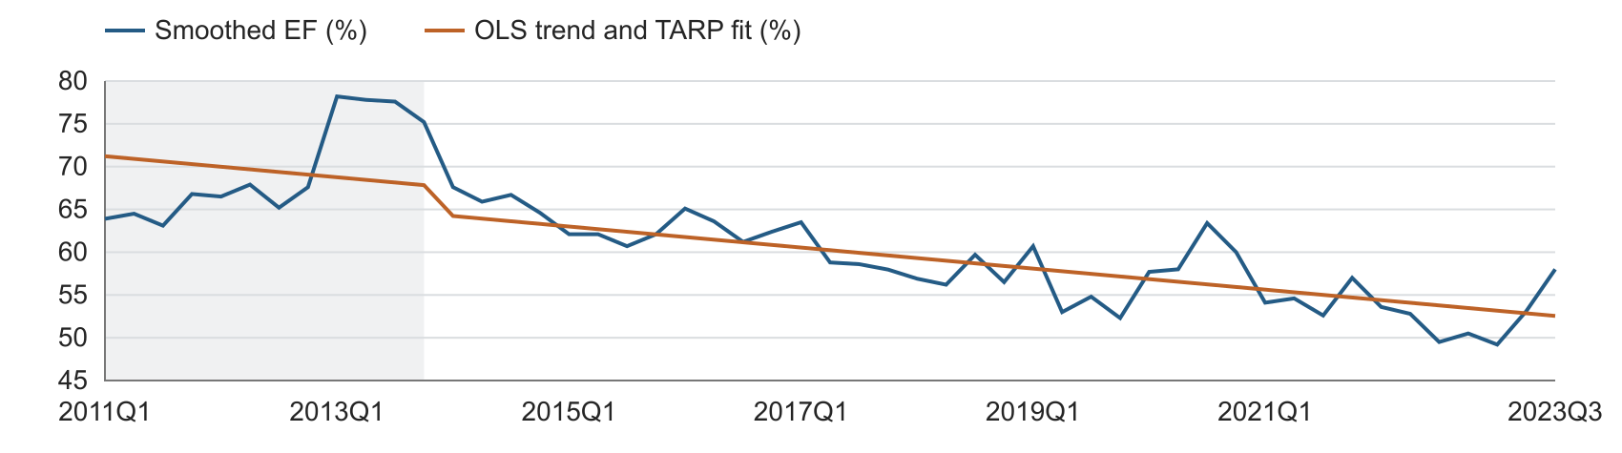
Figure 1 Development sample EF and OLS fitted path with the TARP period shaded

What this regression establishes
The coefficient test evaluates whether β is zero within this linear specification. It provides evidence of a downward sample trend after controlling for D. It does not test whether the disturbance u is stationary. The fitted path is allowed to shift down when D changes from one to zero. [1]
As a serial-correlation sensitivity check, HAC standard errors with four lags also give trend p-values below 0.001: 2.18e-07 for development and 5.05e-06 for full history. This uses Bartlett weights, a finite-sample correction and t-based inference. HAC addresses the covariance estimate; it is not a unit-root test. [2]
The next section tests a different claim: whether EF can be represented as a linear trend with a fixed TARP level break plus stationary fluctuations. A significant time coefficient alone is insufficient to establish that claim.

OLS residual stationarity checks
We apply ADF and KPSS checks to the residuals from the OLS trend and TARP regression. Each sample has its own fitted regression and residual series. Development uses 2011Q1–2023Q3 (51 quarters). Full history uses 2011Q1–2025Q4 (60 quarters). The smoothed 2017Q4 observation remains in both continuous samples.

Test settings
The ADF null is a unit root. The main diagnostic includes a constant and no additional trend. AIC selects the difference lag from zero to four quarters. The KPSS null is level stationarity. We use the constant specification and an automatic bandwidth for the Newey–West long-run variance. No additional time trend is fitted because the first-stage OLS has already removed the linear trend.
Table 4 Ordinary residual ADF and KPSS diagnostics
Sample | Test | Statistic | Lag or  bandwidth | Nominal  p value | Ordinary  5% critical
Development | ADF | −3.9347 | 2 | 0.001794 | −2.9240
Development | KPSS | 0.0870 | 4 | >0.10 | 0.4630
Full history | ADF | −4.1765 | 2 | 0.000722 | −2.9138
Full history | KPSS | 0.0885 | 4 | >0.10 | 0.4630
AIC selects two ADF lags in both samples. The effective ADF sample sizes are 48 and 57. KPSS uses bandwidth four in both samples. Its statistics fall below the 10% table threshold, so the p-values are reported as greater than 0.10, not as exact values of 0.10.

Results and interpretation
Using ordinary reference distributions, ADF rejects a unit root at 5% in both samples. KPSS does not reject level stationarity. The two diagnostics therefore point in the same direction and are consistent with stationary residual fluctuations. Non-rejection by KPSS alone is not proof of stationarity.
As a specification check, ADF without a constant or trend also selects two lags. Its statistics are -3.9383 and -4.1965, with nominal p-values of 9.33e-05 and 3.34e-05, respectively. This gives the same ordinary-reference decision.
These are residual diagnostics, not a second formal Perron test. The residuals were estimated after removing a constant, a trend and a TARP level break. The ordinary software p-values and critical values do not adjust for that first-stage break regression. We therefore label them nominal and do not use them as calibrated significance levels for the original EF series. Section 2 retains the break-adjusted Perron test as the formal unit-root assessment.
Method reference: statsmodels ADF settings and ordinary p-values. Source
Method reference: statsmodels KPSS settings and p-value table limits. Source

2 Perron test with a fixed TARP break
We use the corrected additive-outlier Perron procedure. The OLS equation in Section 1 removes the constant, common trend and TARP level break. Its residuals enter the unit-root regression below. The first post-break quarter is fixed at 2014Q1. We do not search over break dates. [3–4]
$$\begin{aligned}{Δû}_{t} = a{û}_{t-1} + \sum_{j=1}^{k}{b_{j}{Δû}_{t-j}} + \sum_{j=0}^{k}{c_{j}P_{t-j}} + v_{t}\end{aligned}$$
P equals one in 2014Q1 only. The regression includes k lagged residual differences and k+1 pulse controls. No constant or trend is added at this stage. The unit-root null is a = 0. We compare its t-ratio with the break-adjusted critical values. [3–5]

Lag selection rule
The main rule starts at k = 4. This one-year upper limit balances short-run quarterly dynamics against the small sample. We test the highest difference lag using a two-sided t-test. If its p-value is at least 0.10, we remove that lag and refit. We stop when the highest lag has p < 0.10, or at k = 0. All lower difference lags remain. The pulse controls follow the selected k. [5]
Each sequential regression uses all observations available for its lag order. The same rule is applied to both samples. The 10% threshold selects nuisance lags. It is separate from the 5% significance level of the unit-root test. Lag selection does not use the unit-root p-value.
Table 5 Sequential lag selection with a four-quarter maximum
Highest lag k | Development p | Full history p | Action
4 | 0.7641 | 0.7159 | Delete lag 4
3 | 0.8347 | 0.4728 | Delete lag 3
2 | 0.0236 | 0.0171 | Retain lags 1 and 2
Table 6 Primary Perron results
Sample | N | k | Statistic | 5% critical | Decision at 5%
Development | 51 | 2 | −3.7963 | −3.7665 | Reject unit root
Full history | 60 | 2 | −4.2442 | −3.7700 | Reject unit root
Both samples select k = 2 and reject the unit-root null at 5%. The second-stage regressions contain 48 and 57 observations. Critical values come from Perron (1989), Table IV.B, at break fractions 12/51 and 12/60. We linearly interpolate the development critical value. Its rejection is close to the 5% boundary. [3]
The published asymptotic thresholds imply approximate p-value ranges of 0.025 < p < 0.05 for development and 0.01 < p < 0.025 for full history. We do not calculate an exact Perron p-value or substitute an ordinary ADF p-value.

2 Continued residual diagnostics and lag sensitivity

Residual serial correlation
We check the second-stage regression errors v, not the first-stage detrended residuals u. Breusch–Godfrey tests assess whether serial correlation remains through four and eight quarters. The table reports their conventional F-test p-values. These are diagnostic p-values, not Perron unit-root p-values. [6]
Table 7 Residual diagnostics for the selected two-lag regressions
Sample | Regression N | BG through lag 4 p | BG through lag 8 p
Development | 48 | 0.5477 | 0.2425
Full history | 57 | 0.8449 | 0.6912
Neither diagnostic rejects no serial correlation at 5%. The checks support using the selected two-lag regressions. They do not prove that the errors are independent or remove the uncertainty associated with a small sample.

Lag rule sensitivity
We compare the main rule with AIC, BIC and an eight-quarter maximum. AIC and BIC compare lag orders on the same observations within each upper limit. The selected order is then refitted on its available sample. A common-sample version of the sequential rule also selects two lags at maximum four and seven lags at maximum eight in both samples.
Table 8 Alternative lag rules and unit-root decisions
Rule | Maximum k | Selected k | Development statistic | Full history statistic | Reject at 5%  Dev / Full
AIC and BIC | 4 | 0 | −3.0644 | −3.4370 | No / No
AIC | 8 | 2 | −3.7963 | −4.2442 | Yes / Yes
BIC | 8 | 0 | −3.0644 | −3.4370 | No / No
Sequential 10% | 8 | 7 | −4.6408 | −3.2972 | Yes / No
At maximum four, AIC and BIC select zero lags and do not reject a unit root. Those zero-lag regressions also have BG four-lag p-values above 0.05: 0.3465 for development and 0.2161 for full history. We therefore do not dismiss zero lags on the basis of detected residual serial correlation.
At maximum eight, AIC selects two lags and both samples reject. BIC still selects zero. The sequential rule selects seven lags: development rejects, but full history does not. These alternatives are reported as sensitivity checks and are not used to choose the strongest rejection.

Interpretation
The primary procedure supports stationary fluctuations around a linear trend with a fixed TARP level break, and its residual checks detect no significant serial correlation. The evidence depends on the lag rule and upper limit. It supports the stated working specification, rather than a conclusion that is invariant to these choices. The tests apply to the smoothed EF series. The full-history result is a supporting check, not an independent validation sample.

3 ARDL with a trend and a transition pulse
We now return to smoothed EF in levels, rather than using the OLS residual as the dependent variable. The full forecasting equation includes the TARP dummy, linear trend, 2014Q1 pulse, prior-quarter EF and prior-quarter unemployment change.
$$\begin{aligned}{EF}_{t} = c + θD_{t} + bt + ωP_{t} \\ + φ{EF}_{t-1} + γΔU_{t-1} + ε_{t}\end{aligned}$$
U is the unemployment rate in percent. Its quarterly change ΔU is measured in percentage points. P allows a separate one-quarter adjustment at the TARP transition. It is zero in every other quarter. The pulse is a deterministic control, not a macro candidate. The Perron test controls and forecasting controls serve different purposes.
$$\begin{aligned}{EF}_{t} = 0.197857 + 0.028203D_{t} - 0.000682t \\ - 0.034565P_{t} + 0.696127{EF}_{t-1} + 0.006364ΔU_{t-1} + ε_{t}\end{aligned}$$
Table 9 Full ARDL estimates on 49 observations
Term | Coefficient | Std error | t statistic | p value
Constant | 0.197857 | 0.077796 | 2.543 | 0.0147
TARP dummy D | 0.028203 | 0.015133 | 1.864 | 0.0692
Linear trend t | −0.000682 | 0.000571 | −1.194 | 0.2389
2014Q1 pulse P | −0.034565 | 0.032963 | −1.049 | 0.3002
EF lag 1 | 0.696127 | 0.109899 | 6.334 | <0.001
Unemployment change lag 1 | 0.006364 | 0.002836 | 2.244 | 0.0300

Macro selection
The 22-variable pool is screened using forward selection on the development data. The fixed controls remain in the model. At each round, the remaining macro with the lowest added-term p-value enters if p < 0.05. Unemployment enters at p = 0.0300. The best second candidate has p = 0.3044, so the search stops. The full pool and sample conventions appear in Section 9.

Coefficient interpretation
The EF lag is 0.6961. A one-percentage-point rise in unemployment is associated with a 0.006364 rise in EF one quarter later, or 0.6364 EF percentage points, conditional on the other regressors. This is a forecasting association, not a causal estimate.
The trend has p = 0.2389 and the pulse has p = 0.3002. Neither is individually significant at 5%. The ARDL trend coefficient b is conditional on lagged EF. It is not the same parameter as β in the OLS trend regression.

4 ARDL with trend and no pulse
The Trend-only model removes P from the Full model and retains the linear trend. The constant, TARP dummy, lagged EF and lagged unemployment change also remain. We reestimate all five coefficients on the same 49 observations.
$\begin{aligned}{EF}_{t} = c + θD_{t} + bt + φ{EF}_{t−1} \\ + γΔU_{t−1} + ε_{t}\end{aligned}$
$\begin{aligned}{EF}_{t} = 0.220238 + 0.032658D_{t} − 0.000698t \\ + 0.657387{EF}_{t−1} + 0.006324ΔU_{t−1} + ε_{t}\end{aligned}$
Table 10 Trend-only ARDL estimates on 49 observations
Term | Coefficient | Std error | t statistic | p value
Constant | 0.220238 | 0.074896 | 2.941 | 0.0052
TARP dummy D | 0.032658 | 0.014541 | 2.246 | 0.0298
Linear trend t | −0.000698 | 0.000572 | −1.221 | 0.2287
EF lag 1 | 0.657387 | 0.103620 | 6.344 | <0.001
Unemployment change lag 1 | 0.006324 | 0.002839 | 2.228 | 0.0310

Estimation and macro selection
The EF lag falls from 0.6961 in Full to 0.6574 in Trend-only. The unemployment coefficient changes little, from 0.006364 to 0.006324. Its p-value is 0.0310. The TARP dummy has p = 0.0298. The trend remains negative, with p = 0.2287.
Forward selection again selects unemployment alone. It enters at p = 0.0310. The best second candidate, FGDP52Q_B.IUSA, has p = 0.2303, so no additional macro enters. Trend-only refers only to the trend and pulse choice, not to an equation containing trend alone.

Relationship to the Perron specification
Retaining t and D preserves a trend and a TARP level effect in the forecasting equation. Removing P changes its treatment of the transition quarter. The break adjustment is then governed by D and the autoregressive dynamics, without a separate pulse coefficient. This is not an exact reparameterization of the immediate-break AO model. [5]
The pulse controls in the Perron test remain unchanged. That test does not require every forecasting control to be retained, and it does not establish that the pulse is unnecessary. Trend-only is assessed by its estimates, diagnostics and forecasts. Its trend is retained for the stated specification comparison, not because it is individually significant.

5 ARDL after removing trend and pulse
We delete only t and P from the full ARDL. We keep the constant, TARP dummy, EF lag and unemployment change lag. All remaining coefficients are reestimated on exactly the same 49 observations. This is not a forecast obtained by setting two coefficients to zero while leaving the others unchanged.
$$\begin{aligned}{EF}_{t} = c + θD_{t} + φ{EF}_{t-1} + γΔU_{t-1} + ε_{t}\end{aligned}$$
$$\begin{aligned}{EF}_{t} = 0.146773 + 0.041366D_{t} + 0.744191{EF}_{t-1} \\ + 0.006477ΔU_{t-1} + ε_{t}\end{aligned}$$
Table 11 Reestimated reduced ARDL
Term | Coefficient | Std error | t statistic | p value
Constant | 0.146773 | 0.044827 | 3.274 | 0.0020
TARP dummy D | 0.041366 | 0.012740 | 3.247 | 0.0022
EF lag 1 | 0.744191 | 0.075783 | 9.820 | <0.001
Unemployment change lag 1 | 0.006477 | 0.002851 | 2.271 | 0.0280

Relationship to the direct EF model
The reduced model is numerically identical to the earlier direct-level ARDL fitted to the same smoothed EF series. The data, sample, regressors and OLS estimator are the same. Coefficients and forecasts agree within numerical precision. It is not identical to the earlier unsmoothed-data estimates.
Rerunning forward selection with the reduced controls also selects unemployment alone under the primary sample policy. Its entry p-value is 0.0280. The best additional macro, ECI, has p = 0.1167, so no second macro enters.

Why the two trend results differ
The OLS trend regression measures the time pattern after controlling for the TARP step. The ARDLs with a trend ask whether time adds information after also controlling for prior EF, unemployment change and, for Full, the transition pulse. Lagged EF carries much of the slow-moving pattern. A significant OLS trend and an insignificant conditional ARDL trend are therefore not contradictory.

6 Estimates and regression diagnostics
All three models use the same smoothed EF series, unemployment regressor and 49 estimation rows. Full has six coefficients, Trend-only has five and Reduced has four. Every restricted model is refitted. The table shows each estimate followed by its conventional OLS p-value in parentheses.
Table 12 Coefficient comparison with p values
Term | Full | Trend-only | Reduced
Constant | 0.197857  (0.0147) | 0.220238  (0.0052) | 0.146773  (0.0020)
TARP dummy D | 0.028203  (0.0692) | 0.032658  (0.0298) | 0.041366  (0.0022)
Linear trend t | −0.000682  (0.2389) | −0.000698  (0.2287) | Not included
2014Q1 pulse P | −0.034565  (0.3002) | Not included | Not included
EF lag 1 | 0.696127  (<0.001) | 0.657387  (<0.001) | 0.744191  (<0.001)
Unemployment change lag 1 | 0.006364  (0.0300) | 0.006324  (0.0310) | 0.006477  (0.0280)
The unemployment coefficients are close across all three models. The trend estimates in Full and Trend-only are also close. Removing the pulse changes the estimated EF persistence and TARP coefficient, even though the pulse is zero in the forecast periods.
Table 13 Regression diagnostics
Diagnostic | Full | Trend-only | Reduced
Serial correlation through lag 4 p | 0.2194 | 0.4973 | 0.3616
Breusch–Pagan variance test p | 0.7025 | 0.6028 | 0.7076
Jarque–Bera normality test p | 0.0447 | 0.1130 | 0.2008
OLS residual CUSUM p | 0.8669 | 0.8095 | 0.7347
Maximum regressor VIF | 3.9127 | 3.9100 | 1.5817
No model rejects the nulls of no serial correlation, constant error variance or parameter stability at 5%. Full rejects residual normality, with p = 0.0447. Trend-only and Reduced do not. Maximum VIF is about 3.91 for the two models with trend and 1.58 for Reduced. VIF is not a p-value.
The serial-correlation test uses calendar-aligned residual lags and 41 complete rows. The excluded 2017Q4 response does not compress time. Breusch–Pagan results use its F form. Coefficient p-values are conventional OLS values and do not adjust for the prior macro search. Non-rejection does not prove that a model is correctly specified.

6 Continued fit and forecast comparison
All out-of-time comparisons cover 2023Q4–2025Q4. Forecasts use coefficients estimated through 2023Q3 and the same observed unemployment path. Lower RMSE, MAE, AIC and BIC values are preferred. Error measures are in EF ratio units.
Table 14 Fit and forecast comparison
Measure | Full | Trend-only | Reduced
Number of coefficients | 6 | 5 | 4
Adjusted R² | 0.8278 | 0.8274 | 0.8256
In-sample RMSE | 0.02760 | 0.02795 | 0.02842
AIC | −200.744 | −201.507 | −201.875
BIC | −189.393 | −192.048 | −194.307
OOT one-step RMSE | 0.02668 | 0.02640 | 0.02785
OOT recursive RMSE | 0.02587 | 0.02576 | 0.03733
OOT one-step MAE | 0.01975 | 0.01969 | 0.02305
OOT recursive MAE | 0.02038 | 0.02036 | 0.03486

Removing the pulse while retaining trend
Trend-only preserves almost all of the Full model fit. Adjusted R² changes from 0.8278 to 0.8274. Both AIC and BIC decrease. One-step RMSE falls from 0.02668 to 0.02640, and recursive RMSE falls from 0.02587 to 0.02576. Both MAEs also decrease slightly. These are small descriptive improvements, not evidence of statistically significant forecast superiority.

Removing both trend and pulse
Reduced has the lowest AIC and BIC and the fewest coefficients. Its one-step RMSE is 0.02785 and its recursive RMSE is 0.03733. The recursive error is materially higher than for either model that retains the trend. In this comparison, deleting the trend matters more for the recursive forecast than deleting the pulse.

Implications for specification choice
Trend-only is a useful candidate for further review. It keeps the trend structure, removes one coefficient and has the lowest errors in this nine-quarter comparison. The trend itself remains individually insignificant. The OOT window has been reviewed during development, so it is not an untouched final validation set. These results do not establish a permanent ranking or designate a final MDD model.

7 Out of time one step forecasts
One-step forecasts use actual EF from the preceding quarter. All three equations use the same historical unemployment inputs and fixed development-sample coefficients. The EF scale is percent in the figure and a decimal ratio in the table.
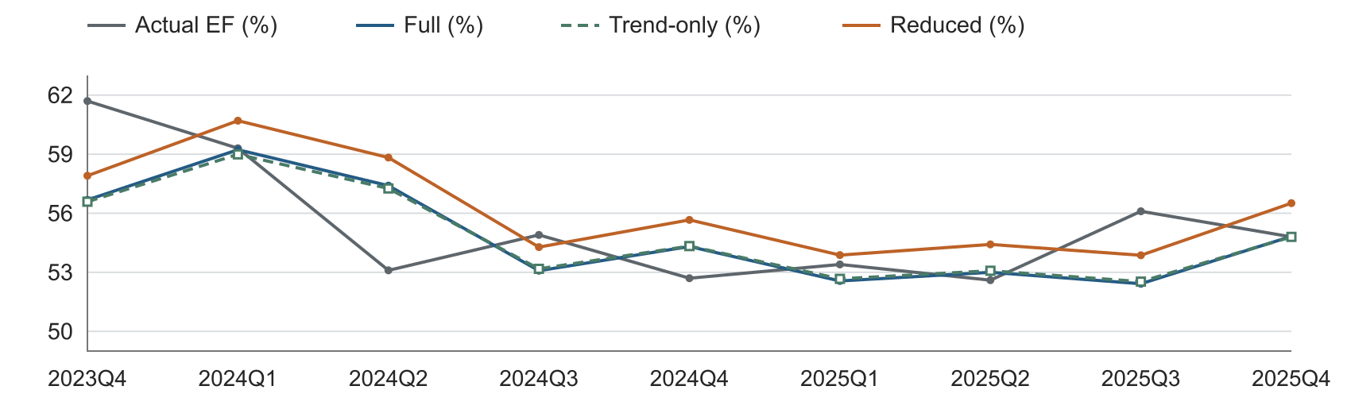
Figure 2 One-step OOT forecasts for all three ARDL models in EF percent
Table 15 One-step OOT forecasts in EF ratio units
Quarter | Actual | Full | Trend-only | Reduced
2023Q4 | 0.617 | 0.56677 | 0.56586 | 0.57905
2024Q1 | 0.593 | 0.59226 | 0.58991 | 0.60702
2024Q2 | 0.531 | 0.57403 | 0.57259 | 0.58829
2024Q3 | 0.549 | 0.53082 | 0.53177 | 0.54280
2024Q4 | 0.527 | 0.54309 | 0.54332 | 0.55663
2025Q1 | 0.534 | 0.52561 | 0.52669 | 0.53875
2025Q2 | 0.526 | 0.53001 | 0.53080 | 0.54417
2025Q3 | 0.561 | 0.52419 | 0.52527 | 0.53865
2025Q4 | 0.548 | 0.54829 | 0.54800 | 0.56513
Trend-only has the lowest one-step RMSE, 0.02640, compared with 0.02668 for Full and 0.02785 for Reduced. The Full and Trend-only paths are close. Updating the lagged EF with each observed quarter limits the accumulation of earlier forecast errors.

7 Continued recursive forecasts
Recursive forecasts start from actual 2023Q3 EF. Each later quarter uses the previous forecast instead of observed lagged EF. Actual EF after the forecast origin is used only to score errors. The historical unemployment path remains common to all three models.
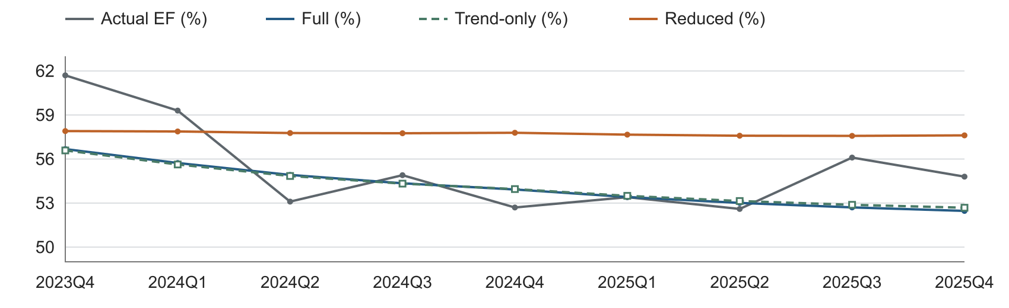
Figure 3 Recursive OOT forecasts for all three ARDL models in EF percent
Table 16 Recursive OOT forecasts in EF ratio units
Quarter | Actual | Full | Trend-only | Reduced
2023Q4 | 0.617 | 0.56677 | 0.56586 | 0.57905
2024Q1 | 0.593 | 0.55730 | 0.55629 | 0.57878
2024Q2 | 0.531 | 0.54917 | 0.54846 | 0.57771
2024Q3 | 0.549 | 0.54347 | 0.54324 | 0.57756
2024Q4 | 0.527 | 0.53924 | 0.53954 | 0.57789
2025Q1 | 0.534 | 0.53413 | 0.53493 | 0.57661
2025Q2 | 0.526 | 0.53011 | 0.53141 | 0.57588
2025Q3 | 0.561 | 0.52705 | 0.52883 | 0.57577
2025Q4 | 0.548 | 0.52466 | 0.52685 | 0.57612
Full and Trend-only produce similar declining recursive paths. Reduced remains above most later OOT observations. Its recursive RMSE is 0.03733, compared with 0.02587 for Full and 0.02576 for Trend-only. A small difference in in-sample fit can coexist with a larger difference in multi-quarter forecast errors.
These are conditional historical comparisons, not forecasts reconstructed from real-time data vintages. There are only nine evaluation quarters. The small error difference between Full and Trend-only should be interpreted accordingly.

8 Nine quarter baseline projections
Baseline and S4 projections cover 2026Q1–2028Q1. All three models start from observed 2025Q4 EF of 0.548 and forecast recursively. D and P are zero. Full and Trend-only continue the time index. Reduced has no trend. No coefficients are refitted with OOT data.
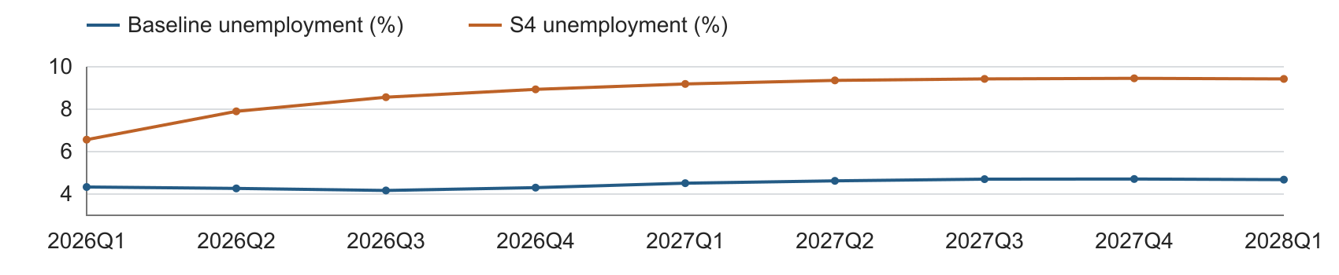
Figure 4 Shared baseline and S4 unemployment inputs in percent
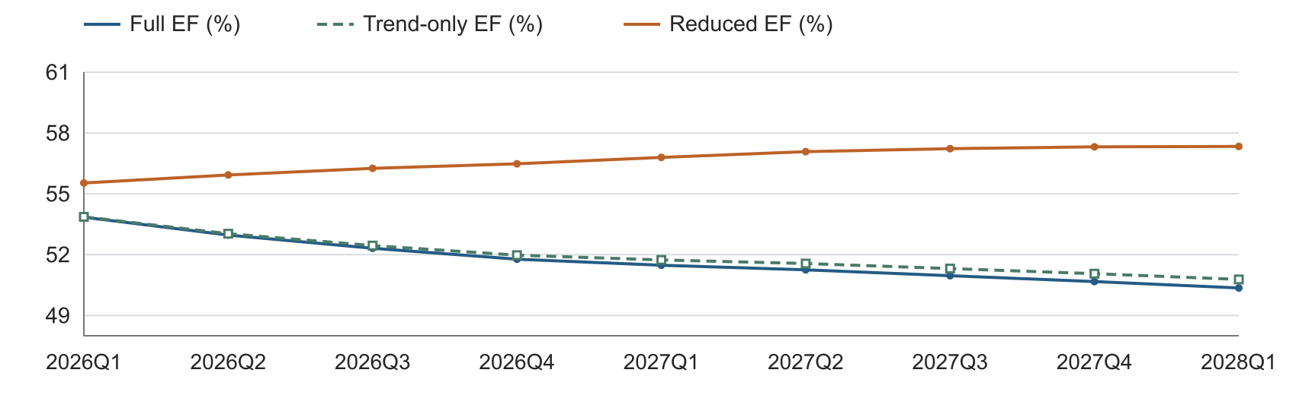
Figure 5 Baseline EF projections for all three ARDL models in percent
Table 17 Baseline inputs and EF ratio forecasts
Quarter | U percent | Full | Trend-only | Reduced
2026Q1 | 4.333 | 0.53846 | 0.53865 | 0.55535
2026Q2 | 4.267 | 0.52964 | 0.53033 | 0.55930
2026Q3 | 4.170 | 0.52314 | 0.52448 | 0.56257
2026Q4 | 4.303 | 0.51775 | 0.51974 | 0.56480
2027Q1 | 4.513 | 0.51477 | 0.51739 | 0.56796
2027Q2 | 4.623 | 0.51251 | 0.51562 | 0.57080
2027Q3 | 4.703 | 0.50961 | 0.51314 | 0.57227
2027Q4 | 4.710 | 0.50672 | 0.51061 | 0.57317
2028Q1 | 4.680 | 0.50356 | 0.50779 | 0.57336
Full and Trend-only retain declining deterministic paths. Reduced moves toward a higher long-run level. The same baseline macro path is used for every equation, so the differences arise from their deterministic terms and reestimated coefficients.

8 Continued S4 projections
S4 uses the separate higher-unemployment scenario shown on the preceding page. Only the unemployment input path changes. The starting EF, model coefficients and forecast timing are held fixed. These are conditional scenario projections, not prediction intervals.
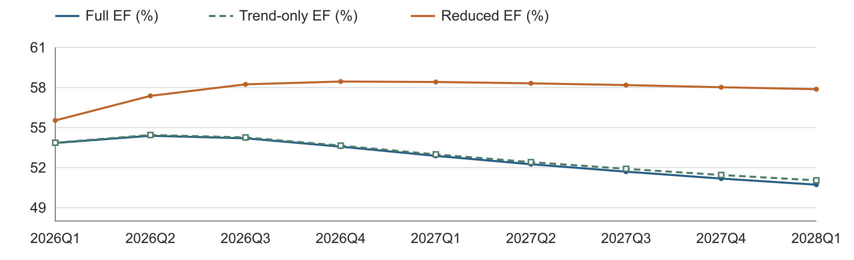
Figure 6 S4 EF projections for all three ARDL models in percent
Table 18 S4 inputs and EF ratio forecasts
Quarter | U percent | Full | Trend-only | Reduced
2026Q1 | 6.565 | 0.53846 | 0.53865 | 0.55535
2026Q2 | 7.900 | 0.54385 | 0.54444 | 0.57376
2026Q3 | 8.566 | 0.54195 | 0.54262 | 0.58240
2026Q4 | 8.936 | 0.53569 | 0.53649 | 0.58451
2027Q1 | 9.191 | 0.52877 | 0.52990 | 0.58415
2027Q2 | 9.359 | 0.52254 | 0.52413 | 0.58315
2027Q3 | 9.429 | 0.51696 | 0.51909 | 0.58183
2027Q4 | 9.456 | 0.51177 | 0.51447 | 0.58022
2028Q1 | 9.428 | 0.50721 | 0.51045 | 0.57874
Within every model, Baseline and S4 first differ in 2026Q2 because unemployment changes enter with a one-quarter lag. The 2028Q1 unemployment level first affects EF in 2028Q2, outside this horizon. The regressor is the quarterly change in unemployment, not its level alone.
The pulse is zero throughout both scenarios. Removing it still changes forecasts because the remaining coefficients are reestimated. Retaining the trend preserves a continuing deterministic slope. Removing that trend changes the long-run projection behavior.

8 Continued sensitivity and interpretation
The sensitivity test raises or lowers every baseline unemployment level by one percentage point from 2026Q1 onward. Historical inputs stay unchanged. For example, 4.3% becomes 5.3% or 3.3%. This is a parallel level shift, not a relative 1% change or an extra one-point increase every quarter.
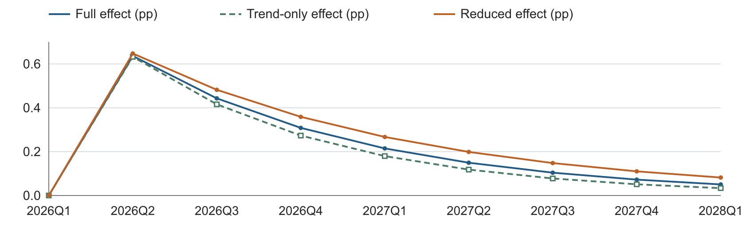
Figure 7 EF effect of a one-point upward unemployment shift relative to each baseline
Table 19 Effect of the upward shift in EF percentage points
Quarter | Full | Trend-only | Reduced
2026Q1 | 0.0000 | 0.0000 | 0.0000
2026Q2 | 0.6364 | 0.6324 | 0.6477
2026Q3 | 0.4430 | 0.4158 | 0.4820
2026Q4 | 0.3084 | 0.2733 | 0.3587
2027Q1 | 0.2147 | 0.1797 | 0.2669
2027Q2 | 0.1494 | 0.1181 | 0.1986
2027Q3 | 0.1040 | 0.0776 | 0.1478
2027Q4 | 0.0724 | 0.0510 | 0.1100
2028Q1 | 0.0504 | 0.0336 | 0.0819
The downward shift produces the same response with the opposite sign. The first EF effect occurs in 2026Q2. Later unemployment changes are unchanged, so the effect decays through the EF lag. Trend-only has a slightly smaller initial response and faster decay than Full or Reduced.

Overall interpretation
If unemployment becomes constant after the break, Reduced approaches EF of 0.57376. Full and Trend-only instead permit long-run deterministic slopes of b / (1 − φ), estimated at −0.002245 and −0.002037 per quarter. These linear trends should not be extrapolated indefinitely.
The primary Perron result supports the specified trend-stationary interpretation, with lag sensitivity. Trend-only preserves a trend and TARP effect while changing the transition dynamics. Its estimates, diagnostics and OOT results support keeping it in the model comparison. They do not make it an exact AO representation or resolve the final specification choice.

9 Macro selection and method references

Complete candidate pool
The pool contains 22 supplied variables. Six use natural-log differences, without multiplying by 100. Sixteen use level differences. Every transformed macro enters with one quarter of lag. Unemployment is labeled unemp in the input and U in the equations.
Table 20 Macro transformations
Transformation | Count | Input variable names
Quarterly log change | 6 | earnings, ulc, eci, gdp, assets, loans
Quarterly level change | 16 | fed, t2y, t10y, unemp, confidence, optimism, gap, vix, hy, FPCNBCPH_B.IUSA, FLBOPQ_B.IUSA, FYPEW52Q_B.IUSA, FGDP52Q_B.IUSA, FE52_B.IUSA, FYPCPIQ_B.IUSA, FECICCQ_B.IUSA
The primary forward screen uses complete observations available for each candidate. Unemployment, gap and GDP have 49 rows. The other candidates have 48 because their initial lagged changes are unavailable. All three selected unemployment models use the same 49 rows. No backward deletion is applied during macro selection.
Table 21 Forward selection decisions
Model | Round | Best candidate | p value | Action
Full | 1 | unemp | 0.0300 | Enter
Full | 2 | FGDP52Q_B.IUSA | 0.3044 | Stop
Trend-only | 1 | unemp | 0.0310 | Enter
Trend-only | 2 | FGDP52Q_B.IUSA | 0.2303 | Stop
Reduced | 1 | unemp | 0.0280 | Enter
Reduced | 2 | eci | 0.1167 | Stop
On a common 48-row sample for all candidates, Full and Trend-only still select unemployment; Reduced selects gap. That sensitivity does not alter this comparison, which holds the unemployment regressor and the 49 estimation rows constant.

Data and methods
Data inputs are supplied EF history, 22 macro candidates with baseline paths, and a separate S4 unemployment path. Calculations use full precision; displayed results are rounded. All estimates and forecasts were independently cross-checked.
[1] EViews. Trend Tests. Linear trend coefficient testing. Source
[2] statsmodels. RegressionResults.get_robustcov_results. HAC covariance options. Source
[3] Perron, P. (1989). The Great Crash, the Oil Price Shock, and the Unit Root Hypothesis. Econometrica 57(6), 1361–1401. Table IV.B. Source
[4] Perron, P., and Vogelsang, T. J. (1993). A Note on the Asymptotic Distributions of Unit Root Tests in the Additive Outlier Model With Breaks. Revista de Econometria 13(2), 181–201. Equation (11). Source
[5] EViews. Unit Root Tests with a Breakpoint. AO specification and lag selection. Source
[6] statsmodels. acorr_breusch_godfrey. Residual serial-correlation diagnostics. Source
Software: statsmodels 0.14.3 for retained OLS, Full and Reduced estimates; 0.15.0 for updated Perron and Trend-only calculations. All three ARDLs were cross-checked.

