The data support the view that, from June 2023 onward, QualPay continued the pre-2021 Sponsorship trend in revenue scale and upward direction. The main evidence is as follows.

1 Similar revenue scale
Historical Sponsorship time-trend model S1 regresses monthly revenue for 2011–2020 on time, without month-of-year effects. Its coefficients are then held fixed to extrapolate into the QualPay period. From June 2023 to December 2024, QualPay’s actual mean monthly revenue was 983.63, compared with an S1 extrapolated mean of 982.68 for the same months, a difference of +0.10%.
Comparison sample | QualPay actual  monthly mean | S1 extrapolated  monthly mean | Relative difference  in means
Initial 19 months  Jun 2023–Dec 2024 | 983.63 | 982.68 | +0.10%
Excluding Q1 2025  Remaining 28 months | 1,023.14 | 1,002.17 | +2.09%
Full 31 months  Jun 2023–Dec 2025 | 1,085.26 | 1,004.08 | +8.08%

After excluding the three potentially anomalous high values in January–March 2025, the mean signed difference was +20.97 in the original revenue units, and the relative difference in means was +2.09%. With all 31 months retained, the actual mean exceeded the S1 extrapolated mean by 8.08%.
Relative difference in means = 100 × (actual mean ÷ extrapolated mean for the same months − 1)%. Each row compares the same calendar months. Positive and negative errors can offset in the mean signed difference; similar means do not imply small month-by-month errors.
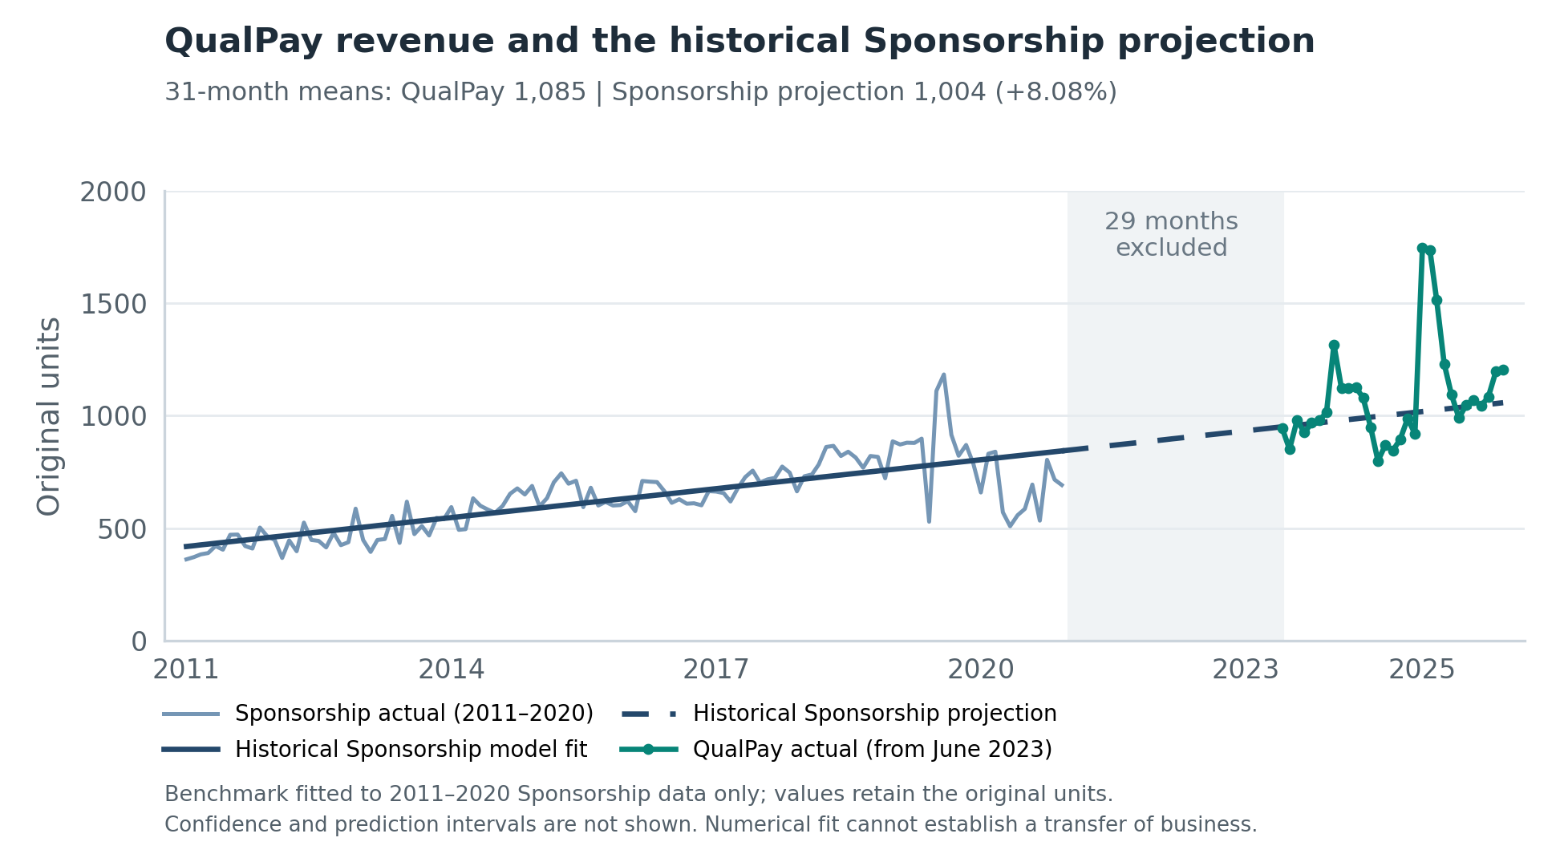
Figure 1. Historical Sponsorship model fit and extrapolation, and actual QualPay revenue. The dashed line shows S1 extrapolated values. All QualPay observations are retained; confidence and prediction intervals are not shown.

2 Upward trends in both periods
After controlling for month-of-year effects, the historical Sponsorship and full QualPay samples both have significantly positive slopes. Excluding January–March 2025 leaves a QualPay slope of +5.747, indicating that the estimated upward direction is not entirely driven by these three high values.
Sample | Monthly slope | 95% confidence interval | Two-sided  p-value
Historical Sponsorship | +3.565 | [2.244, 4.886] | < 0.0001
QualPay full sample | +8.851 | [1.925, 15.777] | 0.0151
QualPay excluding Q1  Sensitivity analysis | +5.747 | [0.776, 10.719] | 0.0263

Slopes are in original revenue units per month. The historical sample uses HAC(6); both QualPay samples use HAC(3). For the sample excluding Q1, HAC(6) and HAC(12) give p-values of 0.0502 and 0.0670, respectively, which do not meet the 5% significance threshold.
Excluding the first quarter is solely a sensitivity analysis; these observations have not been formally classified as outliers.

Modeling details

Samples and time coding
The historical Sponsorship sample covers January 2011–December 2020, with 120 months. QualPay covers June 2023–December 2025, with 31 months. The intervening 29 months are excluded from estimation. Revenue is used in its original levels, and QualPay is not added to remaining Sponsorship revenue.
The time variable is t = 12 × (year − 2011) + month − 1. Historical observations have t = 0 to 119, and QualPay has t = 149 to 179. Removing the January–March 2025 values of 1,747, 1,735 and 1,513 leaves 28 observations; calendar time is not renumbered.

S1 revenue scale extrapolation model
$$S1: S_{t} = α + βt + ε_{t}$$
S1 is estimated by ordinary least squares (OLS) using only historical Sponsorship data. The intercept is 419.020110, the slope is 3.567449, and R² = 0.6042. These coefficients are held fixed, and QualPay-period t values are substituted to obtain extrapolated values. Means are then compared over matching months. Excluding the quarter removes both actual and corresponding extrapolated values; S1 is not refitted.

Growth model with month-of-year effects
$$y_{g,t} = α_{g} + β_{g}t + \sum_{m = 2}^{12}{δ_{g,m}D_{m,t}} + ε_{g,t}, g ∈ \{H, Q, Q_{r}\}$$
H, Q and Qᵣ denote historical Sponsorship, the full QualPay sample and QualPay excluding the first quarter, respectively. Each sample is fitted separately by OLS, estimating an intercept, a time slope and 11 month coefficients. D denotes month indicators, with January as the reference month. Each model has 13 parameters; residual degrees of freedom are 107, 18 and 15, respectively. β denotes the absolute monthly change after controlling for month-of-year differences.

HAC inference and limitations
HAC estimates uncertainty in the slope by adjusting standard errors, confidence intervals and p-values; it does not change the OLS slope. The main settings are HAC(6) for the historical sample and HAC(3) for both QualPay samples, with Bartlett weights wₕ = 1 − h/(L + 1). The covariance matrix is multiplied by n/(n − 13) as a finite-sample correction. The null hypothesis is β = 0. Two-sided tests and 95% intervals use a t distribution with the degrees of freedom stated above.
For the sample excluding Q1, HAC pairs residual information by actual calendar-month distance: December 2024 and April 2025, for example, are four months apart. After exclusion, January–March 2024 each have only one observation, which the month indicators fit exactly. The common slope is identified by months observed in more than one year. The short sample and choice of lag length affect significance assessments.
Data and reproducibility: see qualpay_scale_sensitivity.py for revenue scale results; qualpay_evidence.py for historical and full-sample slopes; and qualpay_q1_exclusion.py for slopes after excluding Q1 and calendar-based HAC. Run instructions are in README_FINAL_EN.md in the code package; full coefficients are retained in the result files.
Revenue scale comparisons use S1 fitted to 2011–2020 as their baseline and are descriptive. Slope intervals depend on the stated model and approximate inference settings. This is an exploratory analysis without adjustment for multiple comparisons.

